Supplementary Materials and Methods
Immunocytochemical analysis of αS binding to the membrane of SH-SY5Y cells
SH-SY5Y cells were seeded on six-well plates containing glass coverslips at a density of 40 000 cells per well. Cells were treated for 60 min with OB* and SF at 0.3 μM (monomer equivalents). Cellular membranes were counterstained with 633-conjugated wheat germ agglutinin (Thermo Fisher Scientific); αS was detected with 1:250 diluted rabbit polyclonal anti-αS Abs (ab52168 Abcam) and with 1:1000 diluted Alexa-Fluor-488-conjugated anti-rabbit secondary Abs (Thermo Fisher Scientific). Fluorescence emission was detected after double excitation at 488 and 633 nm by a TCS SP8 scanning confocal microscope (Leica Microsystems) equipped with an argon laser source. A series of 1.0 μm thick optical sections (1024 × 1024 pixels) was taken through the cell depth for each sample using a Leica Plan Apo 63× oil immersion objective. The confocal microscope was set at optimal acquisition conditions, e.g., pinhole diameters, detector gain and laser powers. Settings were maintained constant for each analysis. The degree of colocalization between αS species and the plasma membrane was determined as reported in the Main Text.
Analysis of the binding of αS species to neuronal membranes
SH-SY5Y cells seeded on glass coverslips were treated for 10 min with αS OB* and SF at 0.3 μM (monomer equivalents). In another set of experiments, SH-SY5Y cells were pre-treated with different concentrations of mouse monoclonal anti-PrP^{C} Ab (sc47730, Santa Cruz Biotechnology) (from 0.03 μM to 0.3 μM), with αS/ anti-PrP^{C} Ab molar ratios of 1:0.1, 1:0.25, 1:0.5, and 1:1, and then treated with OB* and SF at 0,3 µM for 10 min. In another set of experiments, SH-SY5Y cells seeded on glass coverslips were pre-treated with 0.05% trypsin on ice for 10 min, washed twice with PBS and then treated for 10 min with OB* at 0.3 μM (monomer equivalents). The analysis was then performed as reported in the Main Text.

Measurement of intracellular Ca²⁺
In a set of experiments, SH-SY5Y cells were treated for different lengths of time (0, 5, 10, 15, 30, 60 and 180 min) with OB* at 0.3 μM (monomer equivalents) in the absence or in the presence of a pre-treatment for 30 min with anti-PrP^{C} Ab at OB*:Ab molar ratios of 1:0.5, and 1:1 (monomer equivalents). In another set of experiments, SH-SY5Y cells were pre-treated with 0.05% trypsin on ice for 10 min and then treated with OB* and SF at 0.3 μM (monomer equivalents) for 0, 5, 10, 15, 30, 60, 120 and 180 min. Fluorescence emission was detected after excitation at 488 nm with the TCS SP8 scanning confocal microscope described above, and expressed as the percentage of that observed in untreated cells, taken as 100%.

Analysis of the interaction and internalization of αS species in SH-SY5Y cells
In a set of experiments, αS species were added to the culture medium of SH-SY5Y cells seeded on glass coverslips for 60 min at 0.3 μM (monomer equivalents), in the absence or presence of a 10 min pre-treatment with 0.05% trypsin on ice. Cellular membranes were counterstained with 633-conjugated wheat germ agglutinin and αS with 1:250 diluted rabbit polyclonal anti-αS Abs (ab52168 Abcam) and with 1:1000 diluted Alexa-Fluor-488-conjugated anti-rabbit secondary Abs. Then, fluorescence emission was detected after double excitation at 488 and 633 nm by the TCS SP8 scanning confocal microscope described above, and expressed as the percentage of that observed in untreated cells, taken as 100%. In the first experiment, four optical median sections were merged and referred to as median planes.

Analysis of the alteration of membrane permeability
The membrane integrity disruption was assessed as reported in the Main Text, in SH-SY5Y cells treated for 60 min with αS OB* and SF at 0.3 μM (monomer equivalents), in the absence or in the presence of a pre-treatment with 0.05% trypsin on ice.

Supplementary figures and legends
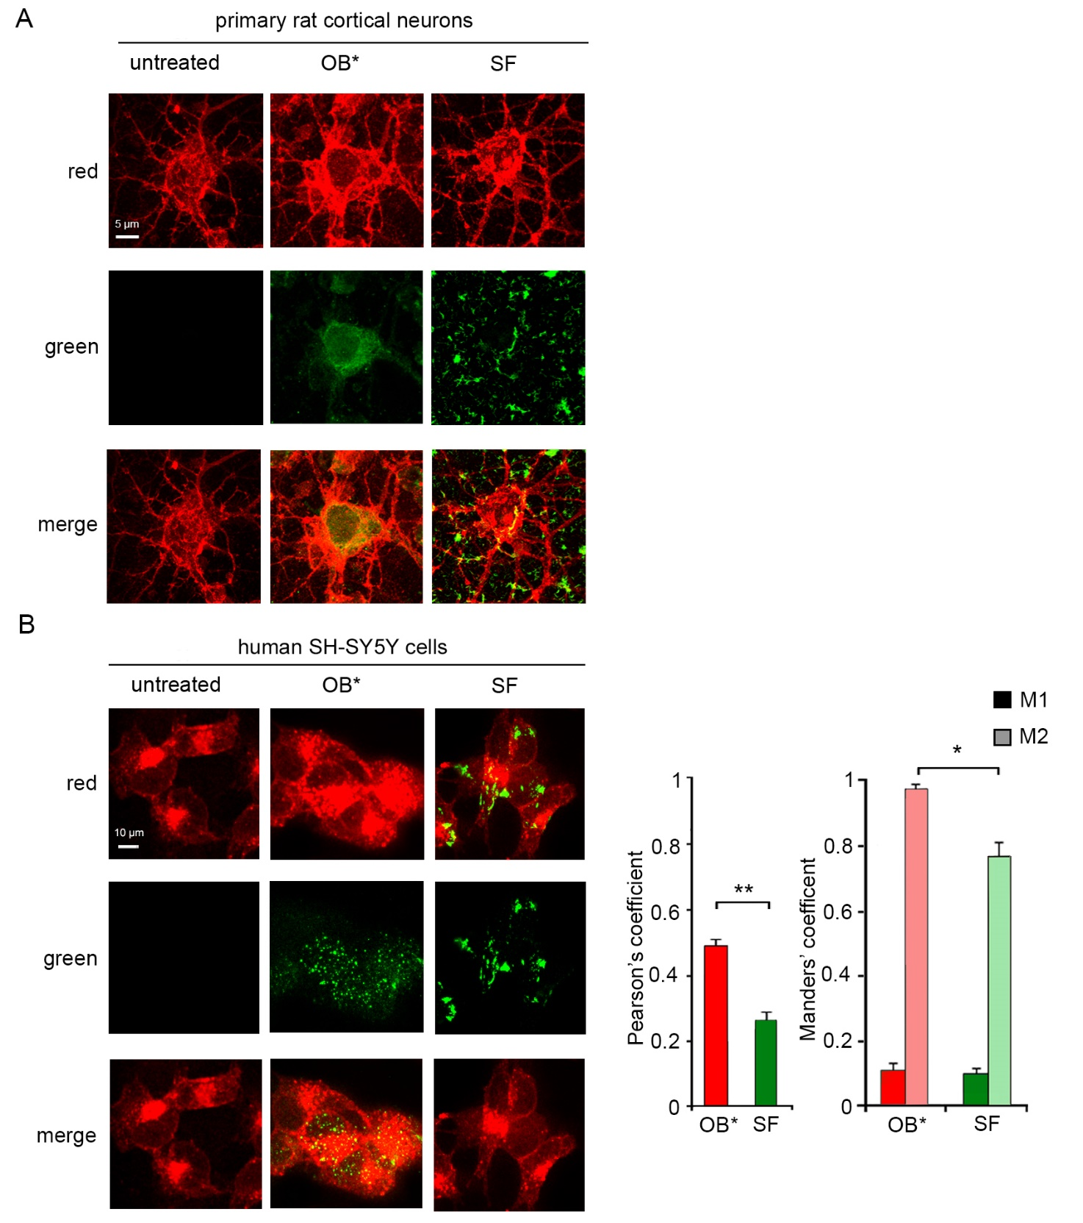
Supplementary Figure 1 – Analysis of αS species binding to neuronal membranes. (A-B) Representative STED microscopy images showing primary rat cortical neurons (A) and SH-SY5Y cells (B) treated for 60 min with OB* and SF at 0.3 µM (monomer equivalents). Red and green fluorescence: cell membranes and the αS species revealed by WGA and the mouse monoclonal 211 Ab (sc12767, Santa Cruz Biotechnology), respectively. The histograms show the Pearson’s and Manders' coefficients (M1 and M2) determined for SH-SY5Y cells as reported in the Main Text. Experimental errors are S.E.M. (n=3). Samples were analyzed by Student t test (* P < 0.05 and ** P < 0.01).
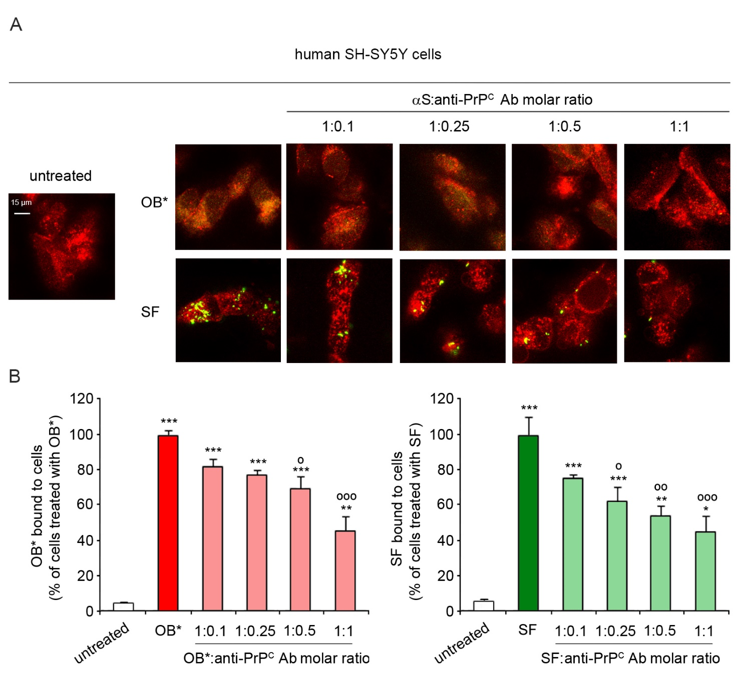

Supplementary Figure 2 – PrP^{C} mediates the binding of αS species to neuronal membranes. (A) (A) Representative confocal microscopy images of SH-SY5Y cells treated for 10 min with OB* and SF at 0.3 μM (monomer equivalents) in the absence or in the presence of a pre-treatment for 30 min with anti-PrP^{C} Ab at OB*:Ab molar ratios of 1:0.1, 1:0.25, 1:0.5, and 1:1 (monomer equivalents). (C) The histograms show the semi-quantitative analysis of the green fluorescence measured following incubation under the conditions represented in panel B. Experimental errors are S.E.M. (n=3). Samples were analyzed by Student t test (panel A; ** P < 0.01 relative to control siRNA), or by one-way ANOVA followed by Bonferroni’s multiple comparison test (panels C-D; * P < 0.05, ** P < 0.01 and *** P < 0.001 relative to untreated cells; ° P < 0.05, °° P < 0.01 and °°° P < 0.001 relative to cells treated with OB* or SF without Ab).

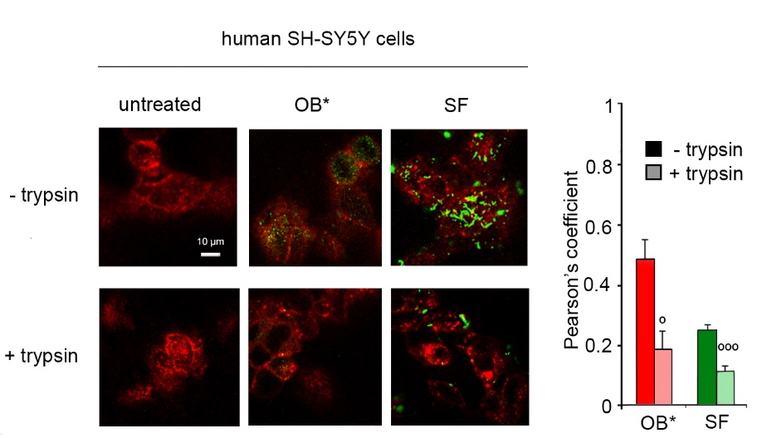

Supplementary Figure 3 - Influence of exposed membrane proteins on the binding of αS species. (A) Representative confocal microscopy images of the apical sections of SH-SY5Y cells treated for 10 min with αS species at 0.3 μM (monomer equivalents) in the absence or in the presence of a pre-treatment with 0.05% trypsin on ice for 10 min. Red and green fluorescence indicates the cell membranes and the αS species revealed with polyclonal anti-αS Abs (ab52168), respectively. (B) The histogram shows the percentage of colocalization of the indicated αS species with the plasma membranes on regions of interest determined by using the ImageJ software and JACOP plugin. Experimental errors are S.E.M. (n=4). Samples were analyzed by Student t test relative to cells treated with corresponding αS species without any pre-treatment (º P < 0.05, ººº P < 0.001).

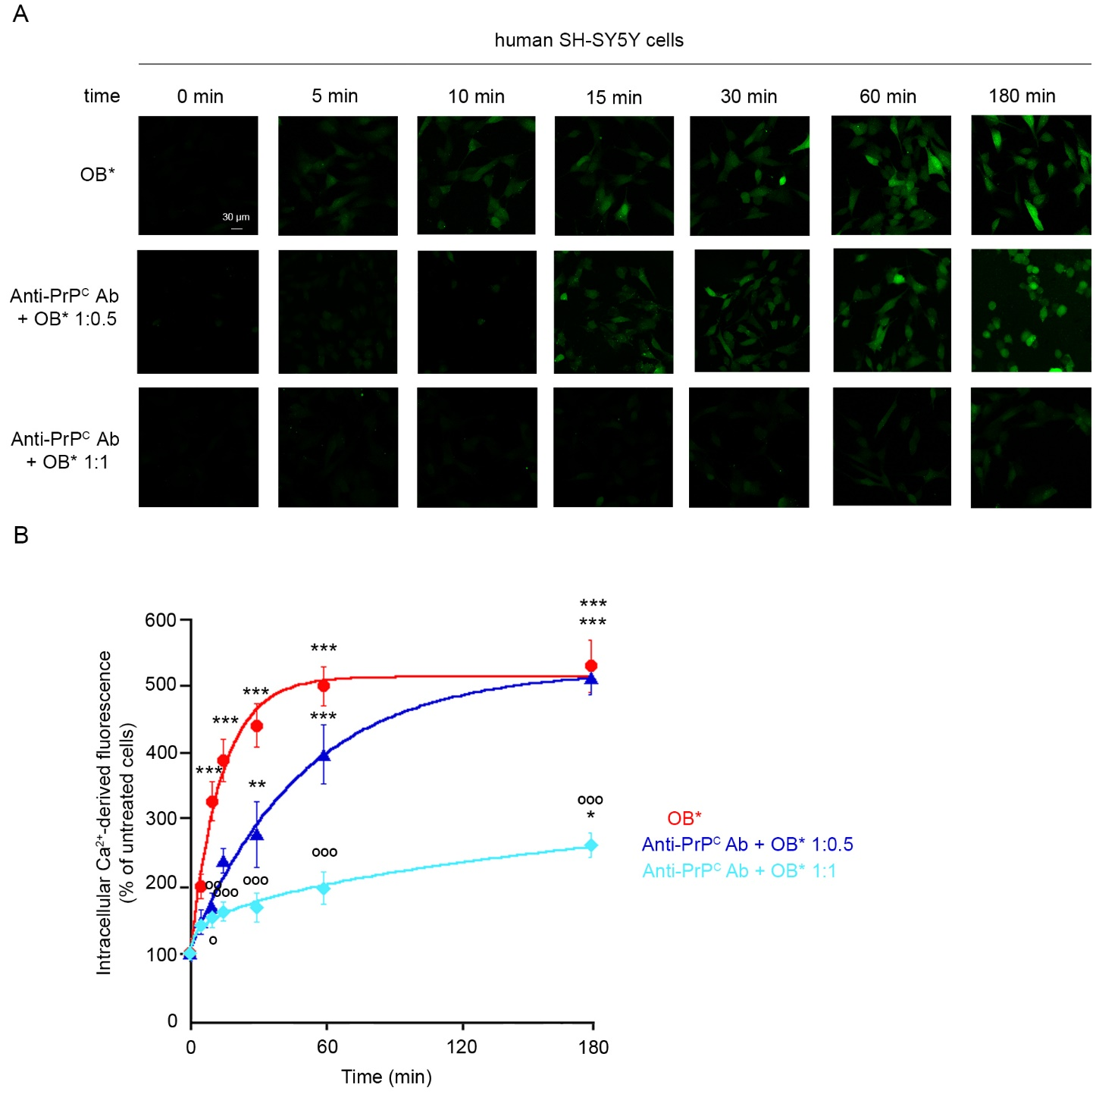
Supplementary Figure 4 - Effect of PrP^{C} blockade on Ca²⁺ dyshomeostasis induced by OB*. (A) Representative confocal microscopy images of SH-SY5Y cells treated for the indicated lengths of time with OB* at 0.3 μM (monomer equivalents) in the absence or presence of a 30-min pre-treatment with anti-PrP^{C} Ab at OB*:Ab molar ratios of 1:0.5, and 1:1 (monomer equivalents). Cells were then loaded with Fluo-4 AM probe. (B) The results of a semiquantitative analysis of Ca²⁺-derived fluorescence, expressed as the percentage of the values for untreated cells. The lines through the experimental points represent the best fits to exponential and sigmoidal functions, reported in detail in the Methods section. Experimental errors are S.E.M. (n=3). Samples were analyzed by one-way ANOVA followed by Bonferroni’s multiple comparison test relative to untreated cells (* P < 0.05, ** P < 0.01, *** P < 0.001), or relative to cells treated with OB* at corresponding lengths of time without pre-treatment with anti-PrP^{C} Ab (º P < 0.05, ºº P <0.01, and ººº P <0.001).

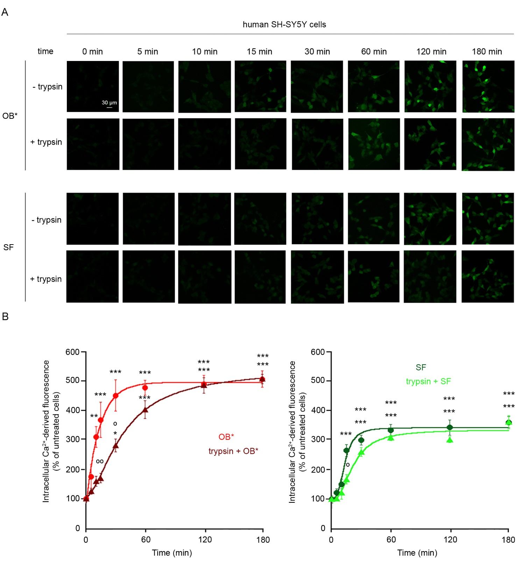
Supplementary Figure 5 – Influence of exposed membrane proteins on Ca²⁺ dyshomeostasis induced by αS OB* and SF. (A) Representative confocal microscopy images showing SH-SY5Y pre-treated for 10 min with 0.05% trypsin and then treated for the indicated lengths of time with αS species at 0.3 μM (monomer equivalents). Cells were then loaded with Fluo-4 AM probe. (B) The semi-quantitative analysis of Ca²⁺-derived fluorescence was expressed as the percentage of the values for untreated cells. The continuous lines through the experimental points represent the best fits to exponential or sigmoidal functions, as reported in the Methods section. Experimental errors are S.E.M. (n=3). Samples were analysed by one-way ANOVA followed by Bonferroni’s multiple comparison test relative to untreated cells (** P < 0.01 and *** P < 0.001), or to cells treated with αS species without pre-treatment at corresponding time points (º P < 0.05 and ºº P < 0.01).

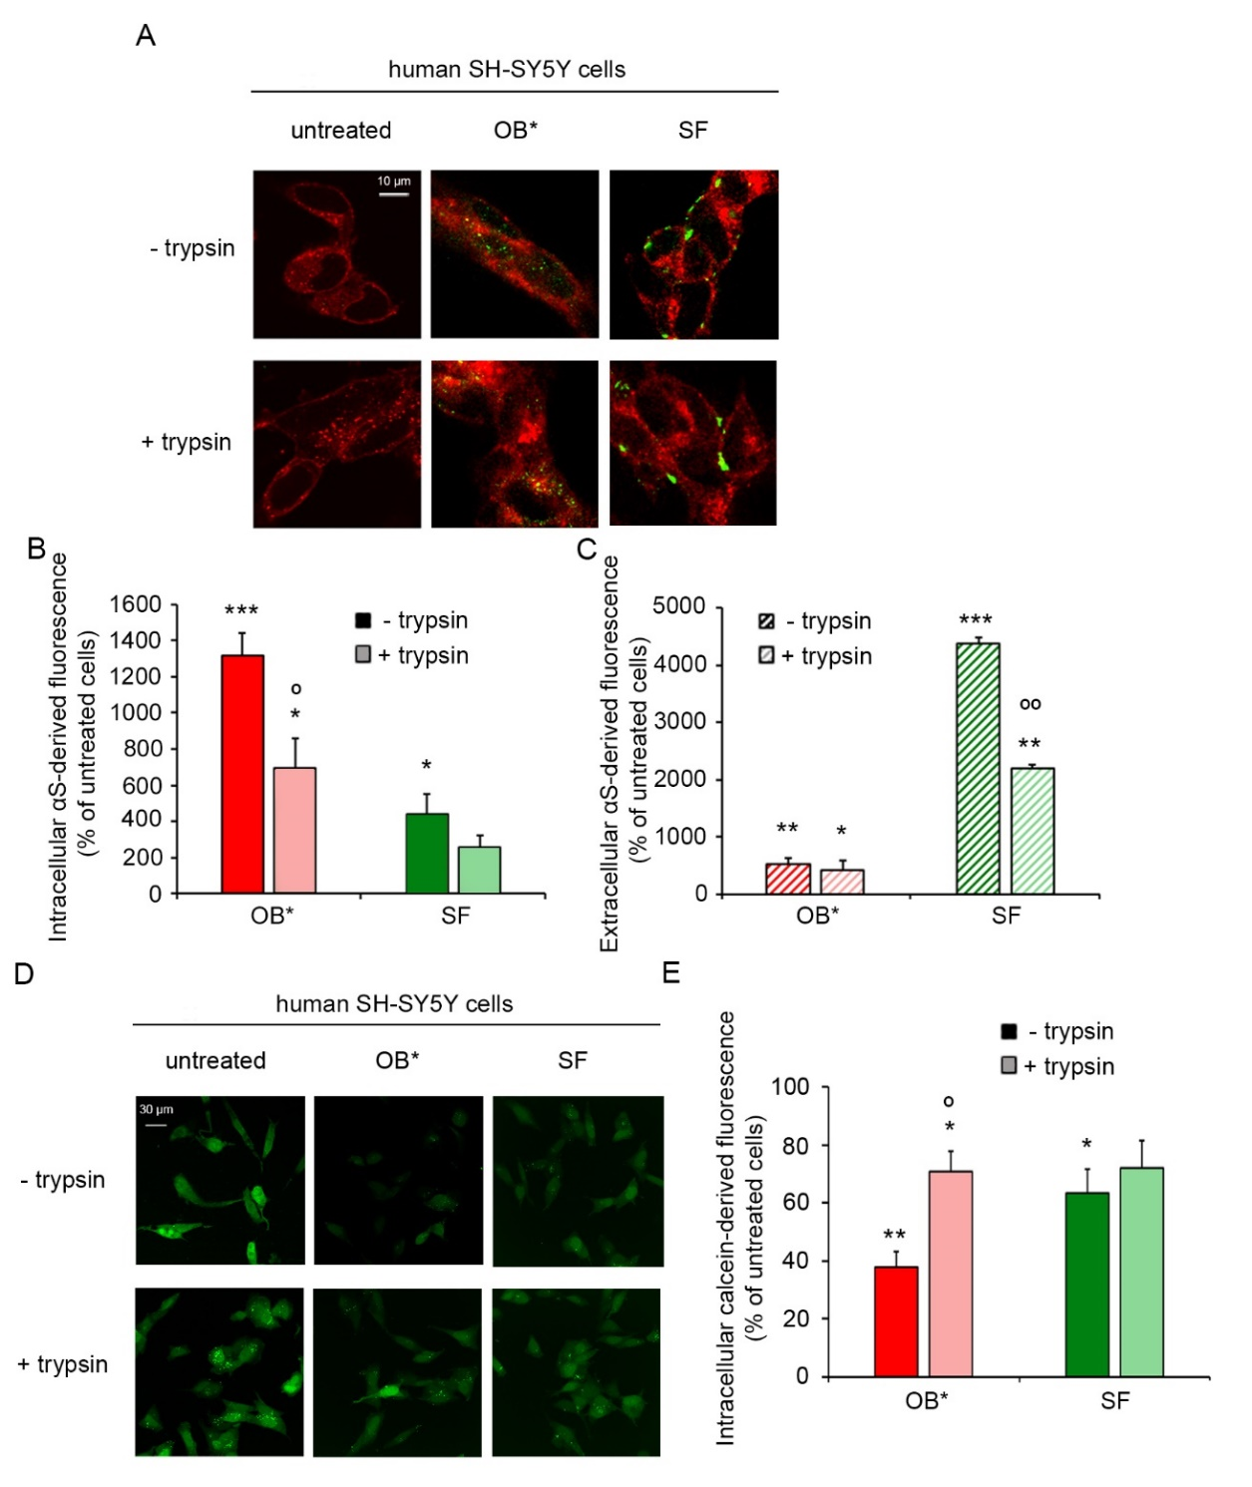
Supplementary Figure 6 – Influence of exposed membrane proteins on the interaction and internalization of αS species in neuronal cells and on their ability to perturb neuronal membranes. (A) Representative confocal microscopy images of the median sections of SH-SY5Y cells treated for 60 min with the indicated αS species at 0.3 μM (monomer equivalents), in the absence or presence of a pre-treatment for 10 min with 0.05% trypsin on ice. Red and green fluorescence: cell membranes and αS species revealed with rabbit anti-αS Abs (ab52168), respectively. (B,C) The semi-quantitative analysis of the intracellular (B) and extracellular (C) αS-derived fluorescence, expressed as the percentage of endogenous αS fluorescence in untreated cells (taken as 100%). (D) Representative confocal microscopy images of SH-SY5Y cells loaded with the calcein-AM probe for 30 min and then treated for 60 min with the indicated αS species at 0.3 μM (monomer equivalents), in the absence or in the presence of a pre-treatment for 10 min with 0.05% trypsin on ice. (E) Semi-quantitative analysis of the calcein-derived green fluorescence, expressed as the percentage of the values for untreated cells, taken as 100%. Experimental errors are S.E.M. (n=3). Samples were analysed by one-way ANOVA followed by Student t test relative to untreated cells (* P < 0.05, ** P < 0.01, and *** P < 0.001), or to cells treated with the same αS species, without pre-treatment (º P < 0.05, ººº P < 0.01).

