Supplementary Material

THE OLFACTORY RESPONSE OF PREDATOR Chrysoperla externa (HAGEN, 1861) (NEUROPTERA: CHRYSOPIDAE) TO VOLATILE ORGANIC COMPOUNDS OF Eucalyptus urograndis (MYRTACEAE) LEAVES

DAVID JACKSON VIEIRA BORGES*¹, RAFAEL APARECIDO CARVALHO SOUZA², ALBERTO DE OLIVEIRA², RAQUEL MARIA FERREIRA DE SOUSA², JEAN CARLOS SANTOS^{3*}

¹Pos-graduate Program in Ecology and Conservation of Natural Resources, Federal University of Uberlândia, Uberlândia, Minas Gerais, Brazil.
E-mail: davidvieirabiologo@gmail.com
ORCID ID: 0000-0001-7451-2349

²Institute of Chemistry, Federal University of Uberlândia , Uberlândia,, Minas Gerais, Brazil.
E-mail:rafasouza27@ufu.br; alberto@ufu.br; rsousa@ufu.br
ORCID ID: 0000-0003-3472-4026; ORCID ID: 0000-0002-7210-164X; ORCID ID: 0000-0003-1509-2721

^{3*}Department of Ecology, Federal University of Sergipe, São Cristóvão, Brazil.
E-mail: jcsantosbio@gmail.com
ORCID ID: 0000-0001-6031-9193

* Corresponding author - E-mail address: jcsantosbio@gmail.com
Tel.: +55 34 99929-8545

Supporting Information

Figure S1 | Page 2
Tables S1 | Pages 3 – 15
Fig. S1. Chromatographic profile of the essential oils of the leaves of E. urograndis. Expansion (5.0 to 40.0 minutes) showing a higher concentration of compounds Eucalyptol (1), α-Terpineol (11), and α-Terpinyl acetate (21).
a) young leaves without damage (YL)
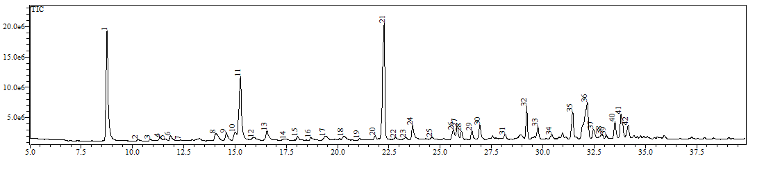
b) young leaves with damage (YL/D)
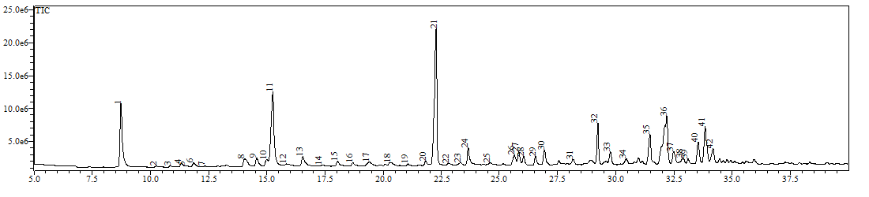
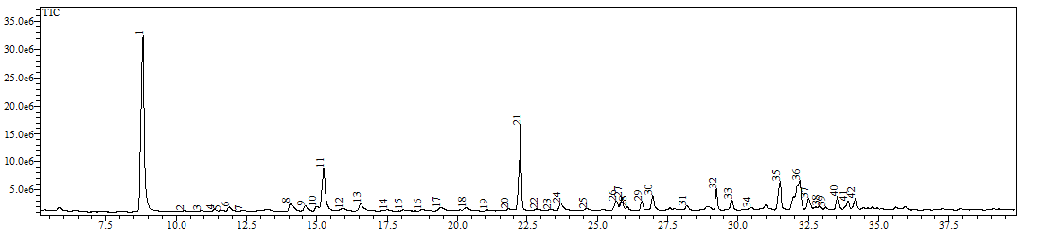
c) mature leaves without damage (ML)
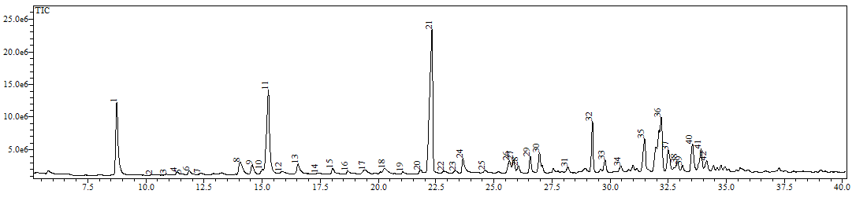
d) mature leaves with damage (ML/D)

Table S1. Arithmetic index of the identified compounds of the EO from young leaves without damage (YL), young leaves with damage (YL/D), mature leaves without damage (ML), mature leaves with damage (ML/D) of E. urograndis leaves.
Peak | Compound | Sample | Retention time (min) | AIª Literature | AI Calculated | SI^{b} | Library
1 | Eucalyptol | YL | 8.8 | 1026 | 1026 | 97 | Nist08
 |  | YL/D | 8.7 | 1026 | 1024 | 97 | Wiley229
 |  | ML | 8.8 | 1026 | 1026 | 97 | Nist08
 |  | ML/D | 8.7 | 1026 | 1024 | 97 | Wiley229
2 | Linalool oxide <cis-> (furanoid) | YL | 10.3 | 1067 | 1061 | 94 | Shim2205
 |  | YL/D | 10.3 | 1067 | 1062 | 91 | Wiley229
 |  | ML | 10.3 | 1067 | 1062 | 90 | Nist08
 |  | ML/D | 10.3 | 1067 | 1062 | 92 | Wiley229
3 | Linalool oxide <trans-> (furanoid) | YL | 10.9 | 1084 | 1076 | 91 | Wiley229
 |  | YL/D | 10.9 | 1084 | 1076 | 90 | Wiley229
 |  | ML | 10.9 | 1084 | 1076 | 93 | Wiley229
 |  | ML/D | 10.9 | 1084 | 1076 | 93 | Wiley229
4 | Linalool | YL | 11.3 | 1095 | 1085 | 90 | Shim2205
 |  | YL/D | 11.3 | 1095 | 1086 | 90 | Shim225
 |  | ML | 11.4 | 1095 | 1088 | 94 | Wiley139
 |  | ML/D | 11.3 | 1095 | 1086 | 94 | Wiley229
5 | Not identified | YL | 11.6 | - | - | - | -
 |  | YL/D | 11.5 | - | - | - | -
 |  | ML | 11.6 | - | - | - | -
 |  | ML/D | 11.5 | - | - | - | -
6 | Fenchol <endo-> | YL | 11.9 | 1114 | 1100 | 90 | Shim2205
 |  | YL/D | 11.9 | 1114 | 1100 | 92 | Shim225
 |  | ML | 11.9 | 1114 | 1100 | 94 | Shim2205
 |  | ML/D | 11.9 | 1114 | 1100 | 95 | Shim2205
7 | Campholenal <α-> | YL | 12.4 | 1122 | 1114 | 94 | Shim2205
 |  | YL/D | 12.3 | 1122 | 1111 | 80 | Shim225
 |  | ML | 12.4 | 1122 | 1114 | 94 | Shim2205
 |  | ML/D | 12.3 | 1122 | 1111 | 94 | Shim2205
8 | Borneol | YL | 14.0 | 1165 | 1157 | 97 | Wiley229
 |  | YL/D | 14.0 | 1165 | 1157 | 92 | Shim225
 |  | ML | 14.1 | 1165 | 1160 | 97 | Wiley229
 |  | ML/D | 14.1 | 1165 | 1160 | 95 | Wiley229
9 | Terpinen-4-ol | YL | 14.6 | 1174 | 1173 | 92 | Wiley229
 |  | YL/D | 14.6 | 1174 | 1173 | 90 | Shim225
 |  | ML | 14.6 | 1174 | 1173 | 78 | Nist08
 |  | ML/D | 14.6 | 1174 | 1173 | 85 | Nist08
10 | p-Cymen-8-ol | YL | 15.0 | 1179 | 1184 | 90 | Wiley229
 |  | YL/D | 15.0 | 1179 | 1184 | 90 | Wiley229
 |  | ML | 15.0 | 1179 | 1184 | 90 | Nist08
 |  | ML/D | 15.0 | 1179 | 1184 | 88 | Nist08
11 | α-Terpineol | YL | 15.2 | 1186 | 1190 | 97 | Wiley229
 |  | YL/D | 15.3 | 1186 | 1192 | 95 | Wiley229
 |  | ML | 15.3 | 1186 | 1192 | 95 | Wiley229
 |  | ML/D | 15.3 | 1186 | 1192 | 95 | Wiley229
12 | Verbenone | YL | 15.9 | 1204 | 1206 | 92 | Wiley229
 |  | YL/D | 15.8 | - | - | - | -
 |  | ML | 15.9 | 1204 | 1206 | 91 | Nist08
 |  | ML/D | 15.9 | - | - | - | -
13 | 2-hydroxy-1,8-cineole | YL | 16.5 | 1227 | 1217 | 93 | Nist08
 |  | YL/D | 16.5 | 1227 | 1217 | 94 | Nist08
 |  | ML | 16.6 | 1227 | 1219 | 93 | Nist08
 |  | ML/D | 16.5 | 1227 | 1217 | 93 | Nist08
14 | Neral | YL | 17.5 | 1235 | 1235 | 90 | Wiley229
 |  | YL/D | 17.4 | 1235 | 1233 | 91 | Wiley229
 |  | ML | 17.4 | 1235 | 1233 | 85 | Nist08
 |  | ML/D | 17.4 | 1235 | 1233 | 90 | Nist08
 | Carvone | YL | 17.5 | 1239 | 1235 | 91 | Wiley229
 |  | YL/D | 17.4 | 1239 | 1233 | 80 | Wiley229
 |  | ML | 17.4 | 1239 | 1233 | 85 | Nist08
 |  | ML/D | 17.4 | 1239 | 1233 | 90 | Nist08
15 | Geraniol | YL | 18.0 | 1249 | 1245 | 80 | Wiley139
 |  | YL/D | 18.0 | 1249 | 1245 | 84 | Wiley229
 |  | ML | 18.1 | 1249 | 1246 | 80 | Nist08
 |  | ML/D | 18.0 | 1249 | 1245 | 88 | Nist08
16 | Geranial | YL | 18.7 | 1264 | 1257 | 96 | Wiley229
 |  | YL/D | 18.7 | 1264 | 1257 | 96 | Wiley229
 |  | ML | 18.7 | 1264 | 1257 | 97 | Wiley229
 |  | ML/D | 18.7 | 1264 | 1257 | 97 | Wiley229
17 | Not identified | YL | 19.4 | - | - | - | -
 |  | YL/D | 19.4 | - | - | - | -
 |  | ML | 19.4 | - | - | - | -
 |  | ML/D | 19.4 | - | - | - | -
18 | Not identified | YL | 20.3 | - | - | - | -
 |  | YL/D | 20.3 | - | - | - | -
 |  | ML | 20.3 | - | - | - | -
 |  | ML/D | 20.3 | - | - | - | -
19 | Verbenyl acetate-trans | YL | 21.1 | 1291 | 1301 | 79 | Shim2205
 |  | YL/D | 21.1 | 1291 | 1301 | 74 | Nist08
 |  | ML | 21.1 | 1291 | 1301 | 80 | Shim2205
 |  | ML/D | 21.0 | 1291 | 1300 | 80 | Shim2205
20 | exo-2-Hydroxy-cineole acetate | YL | 21.8 | 1342 | 1323 | 87 | Nist08
 |  | YL/D | 21.8 | 1342 | 1323 | 91 | Nist08
 |  | ML | 21.8 | 1342 | 1323 | 90 | Nist08
 |  | ML/D | 21.8 | 1342 | 1323 | 91 | Nist08
21 | α-Terpinyl acetate | YL | 22.3 | 1346 | 1338 | 93 | Nist08
 |  | YL/D | 22.3 | 1346 | 1337 | 92 | Wiley229
 |  | ML | 22.3 | 1346 | 1338 | 94 | Shim2205
 |  | ML/D | 22.3 | 1346 | 1338 | 93 | Wiley229
22 | Not identified | YL | 22.8 | - | - | - | -
 |  | YL/D | 22.8 | - | - | - | -
 |  | ML | 22.9 | - | - | - | -
 |  | ML/D | 22.8 | - | - | - | -
23 | alpha.-Copaene | YL | 23.3 | 1374 | 1367 | 90 | Willey229
 |  | YL/D | 23.3 | 1374 | 1367 | 87 | Willey229
 |  | ML | 23.4 | 1374 | 1370 | 86 | Willey229
 |  | ML/D | 23.3 | 1374 | 1367 | 80 | Willey229
24 | Geranyl acetate | YL | 23.7 | 1379 | 1367 | 90 | Wiley229
 |  | YL/D | 23.7 | 1359 | 1379 | 93 | Wiley229
 |  | ML | 23.7 | 1379 | 1379 | 90 | Wiley229
 |  | ML/D | 23.7 | 1379 | 1379 | 90 | Wiley139
25 | Not identified | YL | 24.6 | - | - | - | -
 |  | YL/D | 24.6 | - | - | - | -
 |  | ML | 24.6 | - | - | - | -
 |  | ML/D | 24.6 | - | - | - | -
26 | Carvone hydrate | YL | 25.6 | 1422 | 1429 | 94 | Shim2205
 |  | YL/D | 25.7 | 1422 | 1432 | 93 | Shim225
 |  | ML | 25.7 | 1422 | 1432 | 93 | Shim2205
 |  | ML/D | 25.7 | 1422 | 1432 | 93 | Shim2205
27 | Not identified | YL | 25.8 | - | - | - | -
 |  | YL/D | 25.8 | - | - | - | -
 |  | ML | 25.9 | - | - | - | -
 |  | ML/D | 25.9 | - | - | - | -
28 | Aromadendrene | YL | 26.0 | 1439 | 1440 | 95 | Wiley229
 |  | YL/D | 26.1 | 1439 | 1442 | 95 | Wiley229
 |  | ML | 26.1 | 1439 | 1442 | 94 | Wiley229
 |  | ML/D | 26.0 | 1439 | 1440 | 93 | Wiley229
29 | Not identified | YL | 26.6 | - | - | - | -
 |  | YL/D | 26.6 | - | - | - | -
 |  | ML | 26.6 | - | - | - | -
 |  | ML/D | 26.6 | - | - | - | -
30 | Not identified | YL | 26.9 | - | - | - | -
 |  | YL/D | 27.0 | - | - | - | -
 |  | ML | 27.0 | - | - | - | -
 |  | ML/D | 27.0 | - | - | - | -
31 | Not identified | YL | 28.2 | - | - | - | -
 |  | YL/D | 28.2 | - | - | - | -
 |  | ML | 28.2 | - | - | - | -
 |  | ML/D | 28.2 | - | - | - | -
32 | Geranyl isobutyrate | YL | 29.2 | 1514 | 1518 | 95 | Willey 139
 |  | YL/D | 29.2 | 1514 | 1518 | 93 | Willey 139
 |  | ML | 29.3 | 1514 | 1521 | 93 | Shim2205
 |  | ML/D | 29.2 | 1518 | 1518 | 94 | Willey229
33 | Not identified | YL | 29.8 | - | - | - | -
 |  | YL/D | 29.8 | - | - | - | -
 |  | ML | 29.8 | - | - | - | -
 |  | ML/D | 29.8 | - | - | - | -
34 | Flavesone | YL | 30.5 | 1545 | 1548 | 82 | Shim2205
 |  | YL/D | 30.5 | 1545 | 1548 | 81 | Shim225
 |  | ML | 30.5 | 1545 | 1578 | 81 | Shim2205
 |  | ML/D | 30.5 | 1545 | 1548 | 84 | Shim2205
35 | 8-acetoxy-Carvotanacetone | YL | 31.4 | 1564 | 1569 | 86 | Nist08
 |  | YL/D | 31.5 | 1564 | 1571 | 86 | Nist08
 |  | ML | 31.5 | 1564 | 1571 | 86 | Shim2205
 |  | ML/D | 31.5 | 1564 | 1571 | 86 | Shim2205
36 | Spathulenol | YL | 32.2 | 1577 | 1587 | 90 | Wiley229
 |  | YL/D | 32.2 | 1577 | 1587 | 85 | Wiley229
 |  | ML | 32.2 | 1577 | 1587 | 91 | Nist08
 |  | ML/D | 32.2 | 1577 | 1587 | 86 | Wiley229
 | Caryophyllene oxide | YL | 32.2 | 1582 | - | 87 | Wiley229
 |  | YL/D | 32.2 | 1582 | - | 74 | Wiley229
 |  | ML | 32.2 | 1582 | - | 82 | Wiley229
 |  | ML/D | 32.2 | 1582 | - | 80 | Wiley229
 | Globulol | YL | 32.2 | 1590 | - | 75 | Wiley229
 |  | YL/D | 32.2 | 1590 | - | 83 | Wiley229
 |  | ML | 32.2 | 1590 | - | 81 | Wiley229
 |  | ML/D | 32.2 | 1590 | - | 86 | Wiley139
37 | Viridiflorol | YL | 32.5 | 1592 | 1594 | 91 | Willey229
 |  | YL/D | 32.5 | 1592 | 1594 | 90 | Shim2205
 |  | ML | 32.5 | 1592 | 1594 | 92 | Willey229
 |  | ML/D | 32.5 | 1592 | 1594 | 91 | Willey229
38 | Not identified | YL | 32.9 | - | - | - | -
 |  | YL/D | 32.9 | - | - | - | -
 |  | ML | 32.9 | - | - | - | -
 |  | ML/D | 32.9 | - | - | - | -
39 | Humulene epoxide II | YL | 33.1 | 1608 | 1609 | 86 | Shim2205
 |  | YL/D | 33.1 | 1608 | 1609 | 85 | Shim2205
 |  | ML | 33.1 | 1608 | 1609 | 83 | Shim2205
 |  | ML/D | 33.1 | 1608 | 1609 | 85 | Nist08
40 | Leptospermone<iso-> | YL | 33.5 | 1621 | 1619 | 85 | Shim2205
 |  | YL/D | 33.5 | 1621 | 1619 | 90 | Shim2205
 |  | ML | 33.6 | 1621 | 1622 | 89 | Shim2205
 |  | ML/D | 33.5 | 1621 | 1619 | 82 | Shim2205
41 | Not identified | YL | 33.8 | - | - | - | -
 |  | YL/D | 33.8 | - | - | - | -
 |  | ML | 33.9 | - | - | - | -
 |  | ML/D | 33.9 | - | - | - | -
42 | Isobornyl isobutanoate<5-hydroxy-> | YL | 34.1 | 1658 | 1635 | 83 | Shim2205
 |  | YL/D | 34.2 | 1656 | 1637 | 83 | Shim2205
 |  | ML | 34.1 | 1658 | 1635 | 83 | Shim2205
 |  | ML/D | 34.2 | 1656 | 1637 | 84 | Shim2205
Note: ªArithmetic index, ^{b}Identification method by similarity index with mass spectral database: Nist08, Wiley139, Wiley229, Shim225.

