Supplemental Material 1
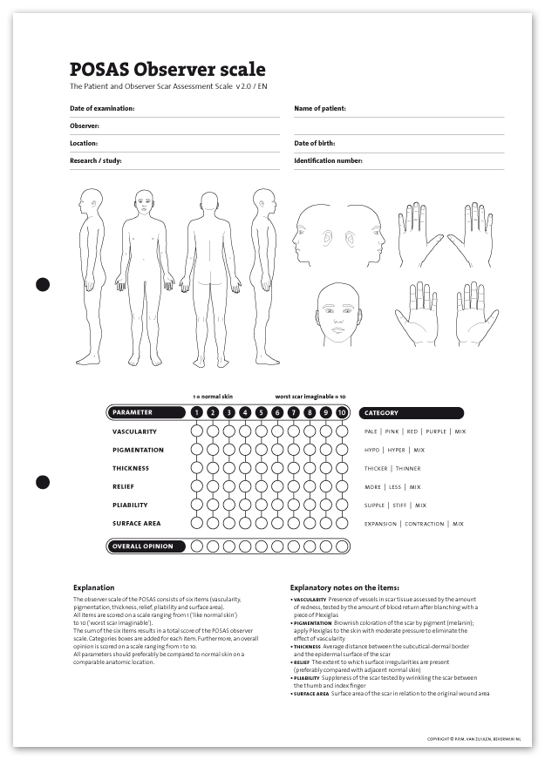

Supplemental Material 2
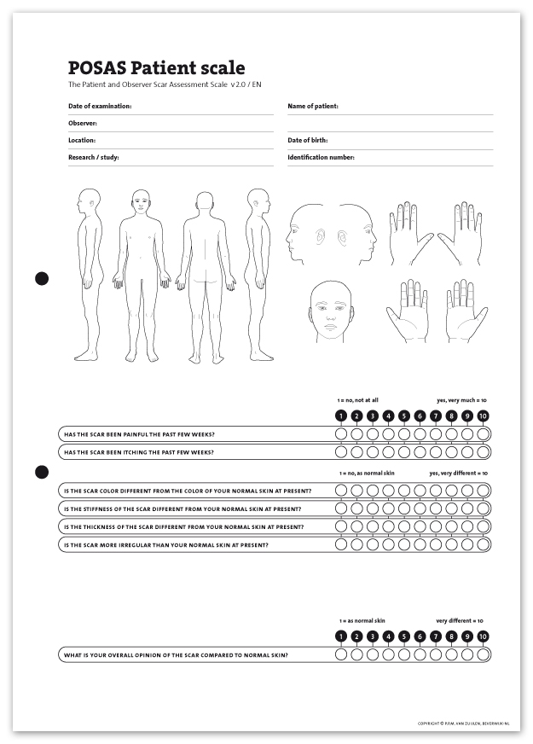

Supplemental Material 3
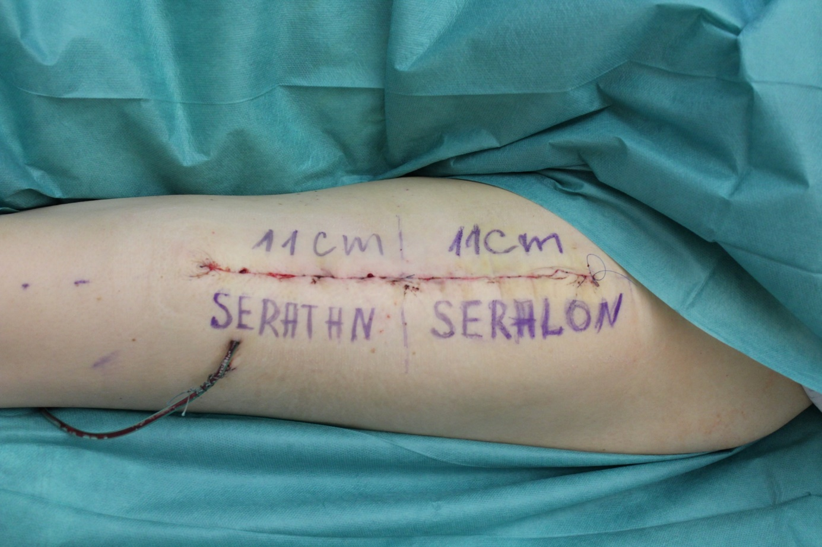

Supplemental Material 4
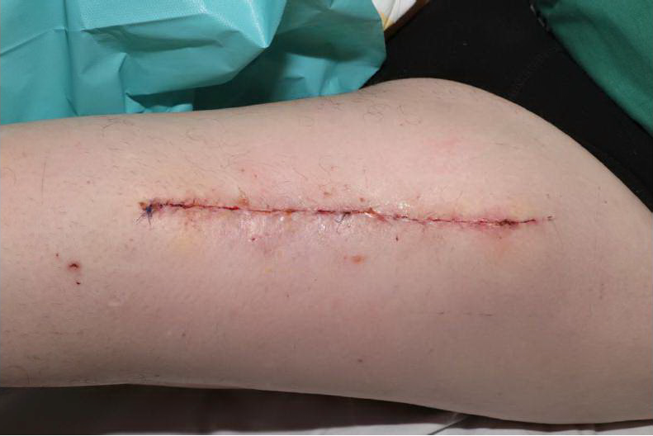

Figure Legends
Figure 1 POSAS Overall Opinion of Observers (a) and Patients (b) on follow-up days 14, 42, 72 and 180 for titanium-coated suture material (blue bar) and non-coated suture material (red bar).

Figure 2 Correlation analysis between POSAS Overall Opinion for observers (a) and patients (b) and diabetes mellitus type II on follow-up days 14, 42, 72 and 180 for titanium-coated suture material and non-coated suture material.

Figure 3 Correlation analysis between POSAS Overall Opinion for observers (a) and patients (b) and chronic renal failure on follow-up days 14, 42, 72 and 180 for titanium-coated suture material and non-coated suture material.

Figure 4 Correlation analysis between POSAS Overall Opinion for observers (a) and patients (b) and smoking on follow-up days 14, 42, 72 and 180 for titanium-coated suture material and non-coated suture material.

Figure 5 Correlation analysis between POSAS Overall Opinion and Body Mass Index (BMI) on follow-up day 180 for titanium-coated suture material and non-coated suture material.

Supplemental Material 1 Patient Observer and Patient Scale Assessment Scale for Observers. The scale is designed for scar evaluating of professionals and contains six items that are scored numerically on a ten-step scale. The items should be compared to regular skin at a comparable anatomic area. To ensure quality of examination, more than one professional should evaluate the POSAS. The items for professionals include Vascularity, Pigmentation, Thickness, Relief, Pliability and Surface Area. Furthermore, it asks for an Overall Opinion. With kind permission of P.P.M. van Zuijlen, Beverwijk-NL.

Supplemental Material 2 Patient Observer and Patient Scale Assessment Scale for patients. The scale is designed for scar evaluating of non-professionals/patients and contains six items that are scored numerically on a ten-step scale. Items include pain, itching, color difference, stiffness, thickness and irregularity in comparison with regular skin. Also, just like in the Observers Score, it asks for an Overall Opinion. With kind permission of P.P.M. van Zuijlen, Beverwijk-NL.

Supplemental Material 3 Intraoperative photographic documentation of wound closure in ALT donor site. You can see the 50:50 fashion that was assessed using titanium coated suture material (Seratan®) for one half of the wound closure and non-titanium coated material (Seralon®) for the other half. Markings were only made for illustration reasons and removed immediately after taking the photograph to ensure single blinding of the patient.

Supplemental Material 4 Photographic documentation of wound closure in ALT donor site on day 14.

