Supplemental Data 7: The detailed procedure of creating the .XML file essential for the “Divergence Time Analysis of Morus species based on the chloroplast genome” using BEAUti within BEAST software.
We followed the BEAST tutorial by Heath¹ for the divergence time analysis. The XML file required for the BEAST analysis was created using the BEAUti2. The Markov Chain Monte Carlo (MCMC) method through the Bayesian Evolutionary Analysis Sampling Trees (BEAST) v2.7.6² was used for the divergence time analysis. The Artocarpus heterophyllus chloroplast genome was used as an outgroup for the fossil-based molecular clock calibration. The steps followed for creating the XML file for the divergence time analysis are as follows.
Steps for creating the XML file using BEAUti2:
- The multiple sequence aligned fasta file was imported to BEAUti2. After importing the file into BEAUti2, it looks like in Figure 1.
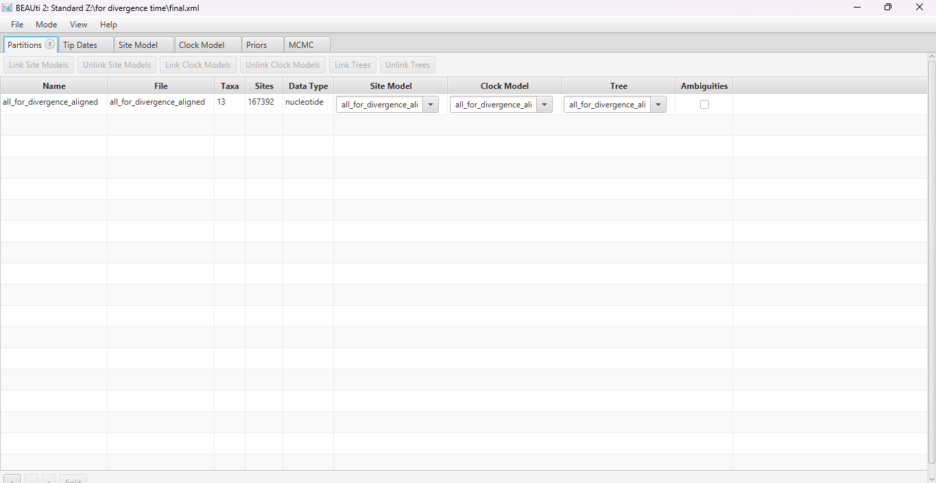
Figure 1. Loading of the sequence aligned fasta file for creating the XML file.

- The Tip Dates for Artocarpus heterophyllus was selected as 64 Million years ago (MYA), whereas the dates for Morus species were selected as zero. See Figure 2 for a detailed overview.
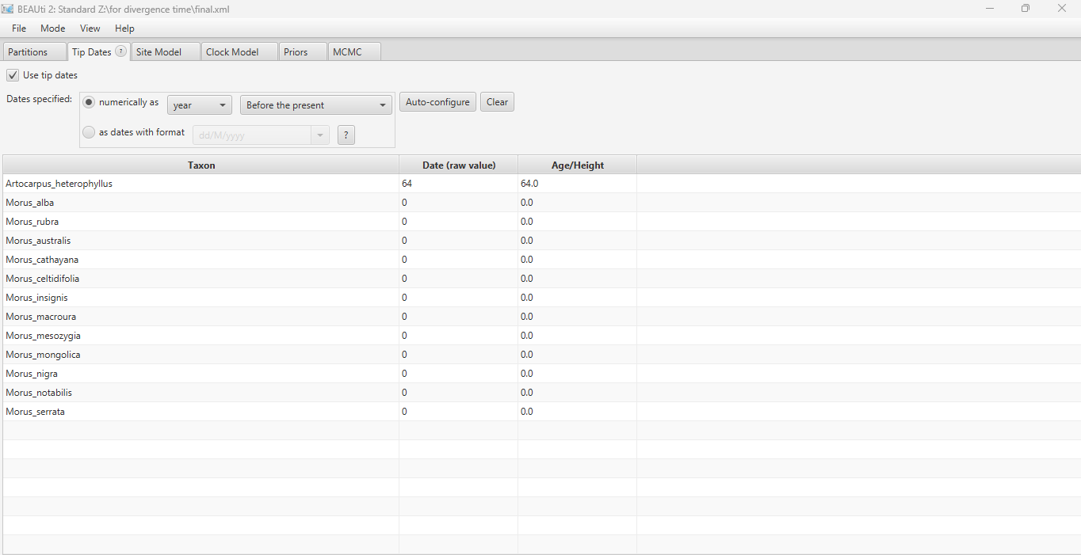
Figure 2. Selection of the tip dates.
- The Site Model was selected as the Gamma Site Model with the attributes as shown in Figure 3.
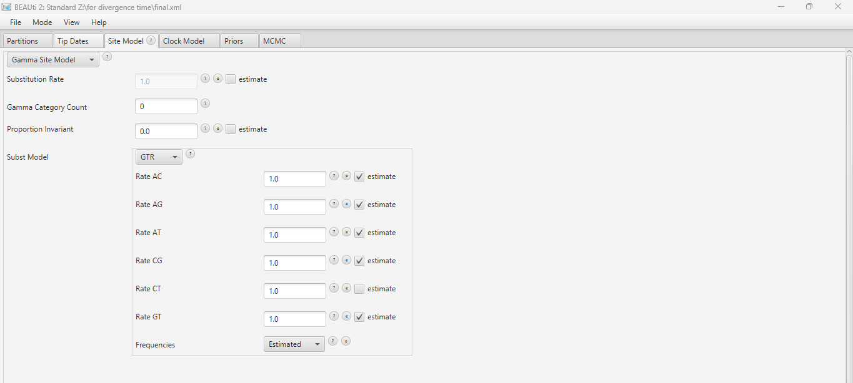
Figure 3. Site Model Selection.
- The Optimised Relaxed Clock as Clock Model with the Mean clock rate of 1.0 was selected as in Figure 4.
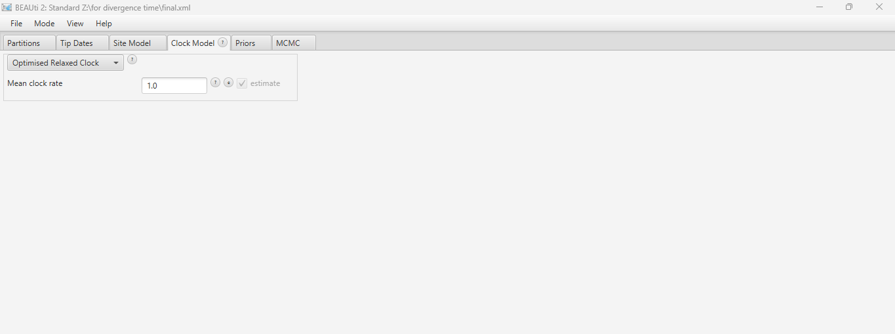
Figure 4. Selection of the Clock Model.
- Priors selection: The Fossilized Birth Death Model with the different parameters for the Proirs were set as shown in Fig. 5 a-h.
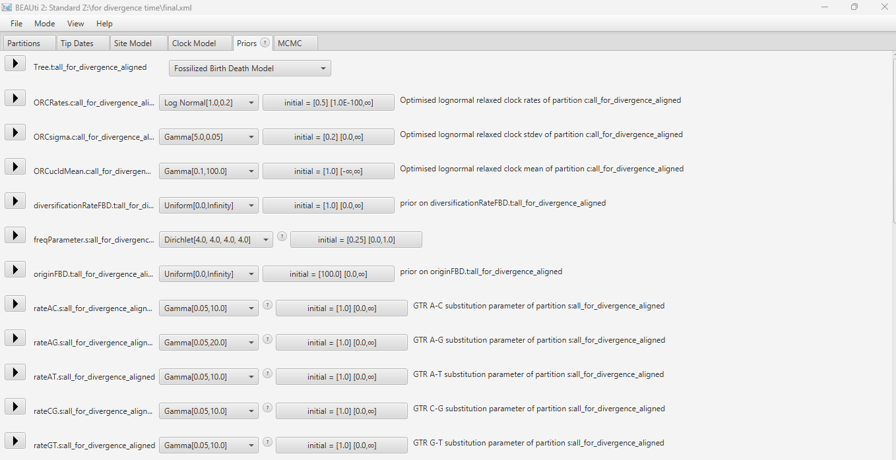
Figure 5a. Selection of Fossilized Birth Death Model with different parameter rates.
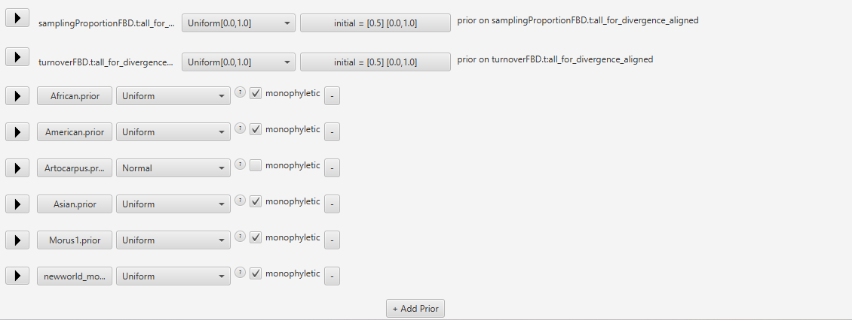
Figure 5b. The description of different prior including A. heterophyllus and Morus species based on geographical distribution.
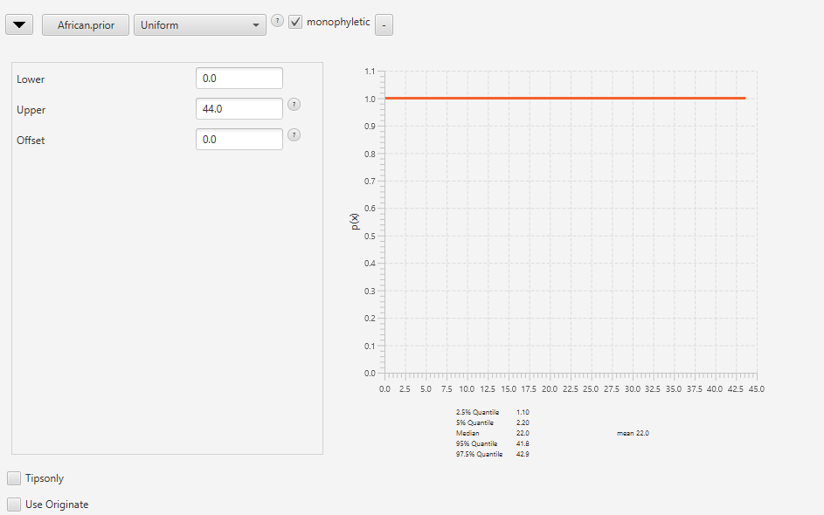
Figure 5c. The details selected for African Morus.
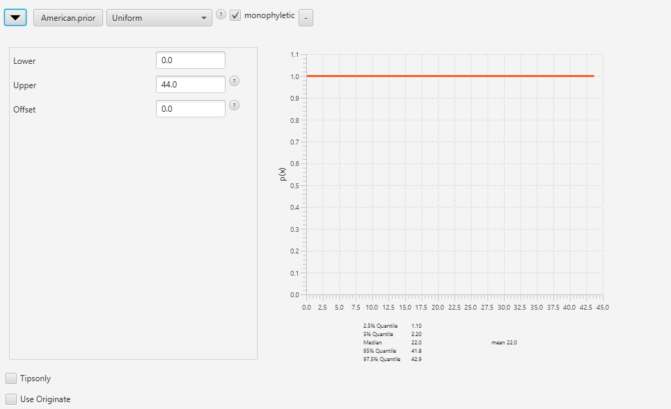
Figure 5d. The details selected for American Morus.

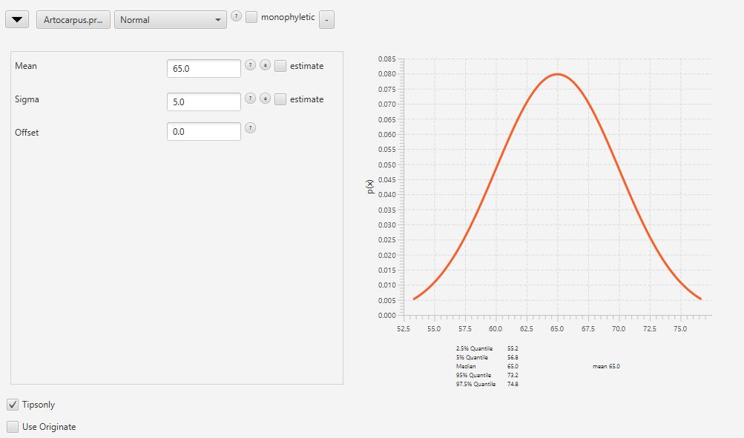
Figure 5e. The details selected for A. heterophyllus.

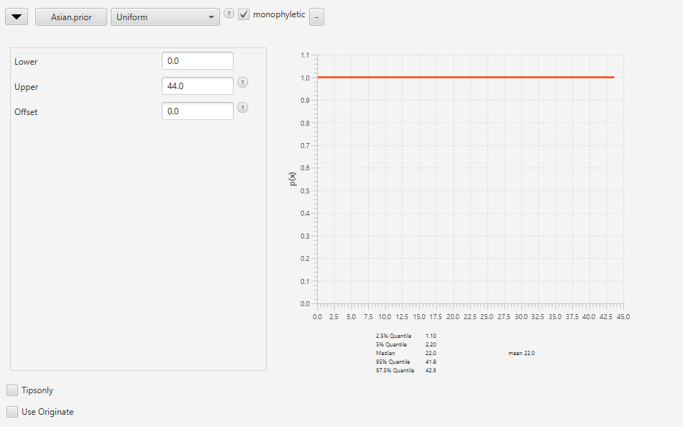
Figure 5f. The details selected for Asian Morus.

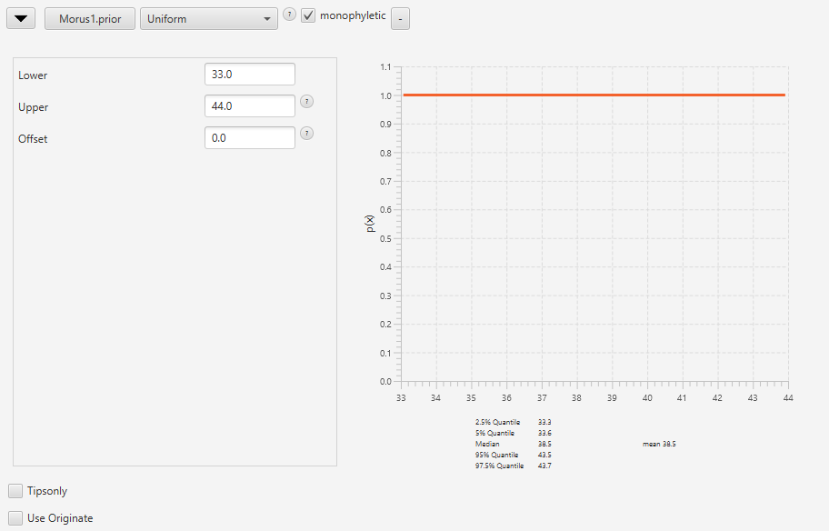
Figure 5g. The M. mesogyzia and M. insignis were selected as the prior 1 with the selection of the parameters as above.

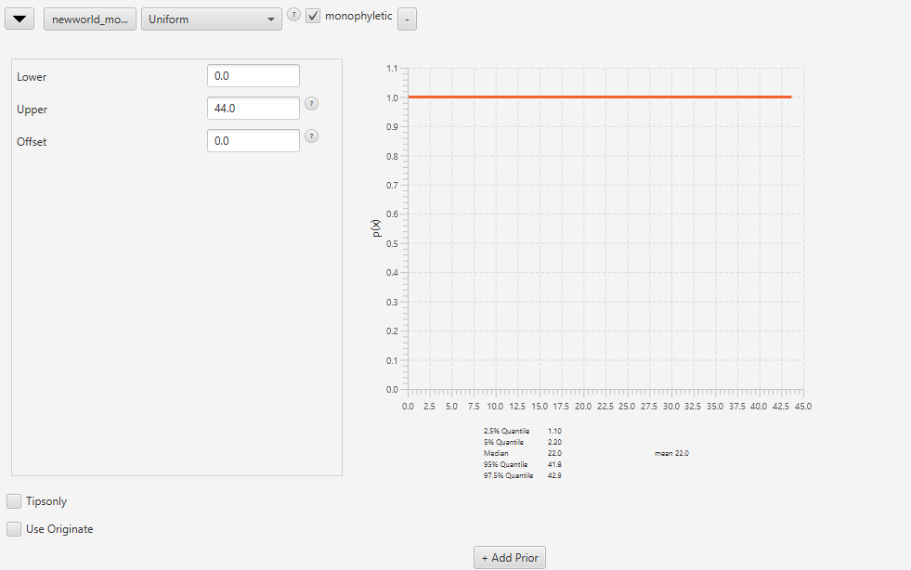
Figure 5h. All Morus, except for M. mesogyzia and M. insignis were selected as the new world species.

1 Heath, T. A. Divergence time estimation using BEAST v2. (2015).
2 Bouckaert, R. et al. BEAST 2.5: An advanced software platform for Bayesian evolutionary analysis. PLoS computational biology 15, e1006650 (2019).

