Supplementary information for
Synergy between SDGs 12.3 and 2.1 in lower-middle-income countries through the lens of food waste and energy imbalance

SI-1 Food supply in target countries
Mass-based food supply, which can potentially be transformed to household food waste, is summarized in Supplementary Figure S1. The figure shows per capita food supply for the eight countries of groups B and C, tallying data as food supply quantity (kg/capita/year) per item group (https://www.fao.org/faostat/en/). The legend shows the definition of FAOSTAT’s item group code, as listed in Supplementary Table S1. Cereals, starchy roots, vegetables, fruits, and dairy products in the main text correspond to FAOSTAT’s item group codes 2905, 2907, 2918, 2919, and 2948, respectively.

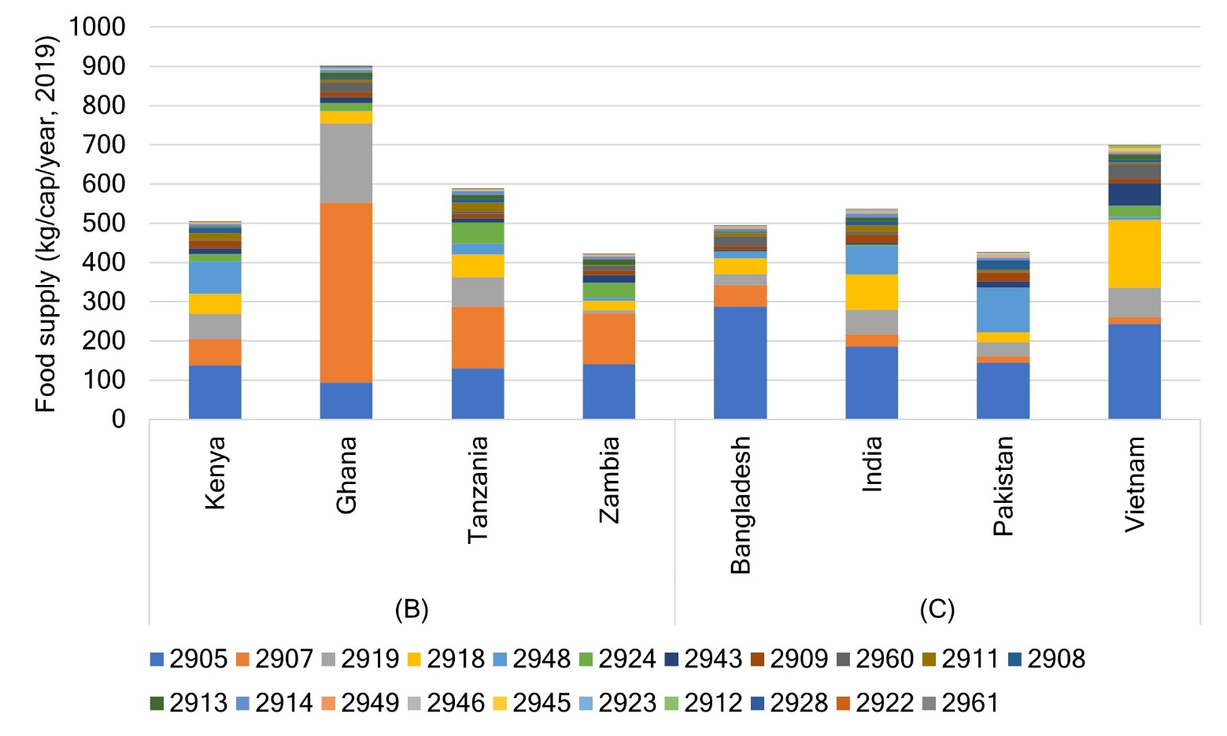
Supplementary Fig. S1 Per capita food supply in target countries (2019)

Supplementary Table S1 Item groups and their codes in the food balance sheet (FBS) in FAOSTAT
Item group code | Item group | Item group code | Item group
2905* | Cereals - excluding beer | 2923 | Spices
2907* | Starchy roots | 2924 | Alcoholic beverages
2908 | Sugar crops | 2928 | Miscellaneous
2909 | Sugar and sweeteners | 2943 | Meat
2911 | Pulses | 2945 | Offals
2912 | Treenuts | 2946 | Animal fats
2913 | Oilcrops | 2948* | Milk - excluding butter
2914 | Vegetable oils | 2949 | Eggs
2918* | Vegetables | 2960 | Fish and seafood
2919* | Fruits - excluding wine | 2961 | Aquatic products and others
2922 | Stimulants
Notes: Please refer to definitions and standards used in FAOSTAT (https://www.fao.org/faostat/en/#definitions). * Item groups discussed in the main text

SI-2 Dataset for edible portion estimates of food in data-available target countries
The actual dataset is separately compiled as “Supplementary Table S2.xlsx ” using the food composition tables (FCTs) of Kenya¹, Ghana (Western Africa²), Bangladesh³, and Vietnam⁴. The list consists of six columns as “Group” (B or C), “Country,” “Name of food item” (in the FCT), “Original item code” (of the FCT), “FBS_Item group code” (Supplementary Table S1), and “Edible portion.”

SI-3 Dataset for food shelf-life in data-available target countries
In this study, we compiled data on food shelf-life in Kenya, Ghana, Tanzania, India, Pakistan, Bangladesh, and Vietnam according to food item and storage, and 2,776 data points were obtained. Among them, 2,718 data points were obtained from FoodKeeper App (https://www.foodsafety.gov/keep-food-safe/foodkeeper-app), and the other 58 data points from literature review. Because baked or dried cassava can be stored for several months⁵, the shelf-life of dried cassava in pantry storage is assumed to span 5−8 months. Cassava is mostly stored for 1−3 days in households in Ghana⁶, and based on this, it is assumed that raw cassava can be stored for 1−3 days in a pantry. A guideline for Kenya (https://kilimo.go.ke/wp-content/uploads/2021/01/Guidelines-for-sustaining-healthy-diets-at-household-level.pdf) mentions that peeled cassava in water can be stored in a refrigerator for 1 month, defining its shelf-life. The FoodKeeper App defines shelf-life of milk (plain or flavored) in a refrigerator as package use-by date; therefore, the shelf-life of unidentified items of raw milk was assumed to be 1−2 days (https://milk-ed.eu/wp-content/uploads/2022/06/Shelf-life-and-storage-of-milk-and-milk-products_EN.pdf). The final dataset is referred to as “Supplementary Table S3.xlsx ”. The final dataset consists of 10 columns as “Group” (B or C), “Country,” “Name of food item” (in the FCT), “Original item code” (of the FCT), “FBS_Item group code” (Supplementary Table S1), “Storage” (pantry, refrigerator, or freezer), “Max-Min” (maximum or minimum value), “Food shelf-life (days),” “Reference item in FoodKeep App”, and “Other references.”

SI-4 Estimated food energy imbalance and its input data of per capita GDP
The results of food energy imbalance (kcal/day/cap) estimated using log-linear models, where we adopted the moderate-case formula because the lower- and upper-case formulas⁷ show reasonable gaps with reality. Per capita GDP (2005 International$) data were calculated using World Bank Open Data (https://data.worldbank.org/) as the input data from 2005 to 2018 for 199 countries are summarized in a file named “Supplementary Table S4.xlsx ”

SI-5 Output files of regression analysis for Fig. 1 and 5
The practical input data and outputs for Figs. 1 and 5 are presented in Excel files labelled “Supplementary Table S5a.xlsx” and “Supplementary Table S5b.xlsx” respectively.

References
1 FAO & Government of Kenya. Kenya Food Composition Tables. 254 (Nairobi, 2018).
2 Vincent, A. et al. FAO/INFOODS Food Composition Table for Western Africa (2019) User Guide & Condensed Food Composition Table. (FAO, Rome, 2020).
3 Shaheen, N. et al. Food Composition Table for Bangladesh. Report No. 978984337522-3, (Institute of Nutrition and Food Science, Centre for Advanced Research in Sciences, University of Dhaka, Dhaka, Bangladesh, 2013).
4 Ministry of Health & Nutritional Institute. Vietnamese Food Composition Table. 527 (Medical Publishing House, Hanoi, 2007).
5 International Fund for Agricultural Development (IFAD) & FAO. The world cassava economy - Facts, trends and outlook. (FAO and IFAD, Rome, 2000).
6 Afriyie, E. et al. Determinants of Household-Level Food Storage Practices and Outcomes on Food Safety and Security in Accra, Ghana. Foods 11 (2022).
7 Verma, M. v. d. B., de Vreede, L., Achterbosch, T. & Rutten, M. M. Consumers discard a lot more food than widely believed: Estimates of global food waste using an energy gap approach and affluence elasticity of food waste. PLOS ONE 15, e0228369 (2020). https://doi.org:10.1371/journal.pone.0228369

