Supplementary Information for
Community-level foliar stable carbon isotope is more influenced by leaf functional traits under drought conditions

Xu Wang^{1,2}, Yingying Bai^{1,2}, Shan Jiang^{1,2}, Kuan Li², Zhiyong Li^{1,2}, Huamin Liu^{1,2}, Lixin Wang^{1,2}, Yang Wang⁴, Lei Dong⁵, Cunzhu Liang^{1,2}, Jinghui Zhang^{1,2*}

Affiliations
¹Ministry of Education Key Laboratory of Ecology and Resource Use of the Mongolian Plateau & Inner Mongolia Key Laboratory of Grassland Ecology and the Candidate State Key Laboratory of Ministry of Science and Technology & Observation and Research Station for the Typical Steppe Ecosystem of the Ministry of Education, Hohhot 010021, China;
²School of Ecology and Environment, Inner Mongolia University, Hohhot 010021, China;
³Inner Mongolia Meteorological Institute, Hohhot 010051, China;
⁴College of Life Science and Technology, Inner Mongolia Normal University, Hohhot 010022, China;
⁵Institute of Water Resources for Pastoral Areas, Ministry of Water Resources, Hohhot 010020, China
*Correspondence: Jinghui Zhang, Email: jhzhang1001@126.com.

This file includes:
Supplementary Figures 1-8
Supplementary Tables 1-5

Supplementary Figures
Supplementary Fig. 1 Principal component analysis for LFT_{CWM} and soil factors in meadow steppe. a and b Biplots resulting from the principal component analysis for LFT_{CWM} and soil factors. Grey points: different sites. c Bar plots of the contributions; LT, leaf thickness; LDMC, leaf dry matter content; SLA, specific leaf area; LCC, leaf carbon content; LNC, leaf nitrogen content; LPC, leaf phosphorus content; pH, soil pH; BD, soil bulk density; STN, soil total nitrogen; SOC, soil organic carbon; SC, soil clay content; SM, soil moisture.

Supplementary Fig. 2. Principal component analysis for LFT_{CWM} and soil factors in typical steppe. a and b Biplots resulting from the principal component analysis for LFT_{CWM} and soil factors. Grey points: different sites. c Bar plots of the contributions; LT, leaf thickness; LDMC, leaf dry matter content; SLA, specific leaf area; LCC, leaf carbon content; LNC, leaf nitrogen content; LPC, leaf phosphorus content; pH, soil pH; BD, soil bulk density; STN, soil total nitrogen; SOC, soil organic carbon; SC, soil clay content; SM, soil moisture.
Supplementary Fig. 3. Principal component analysis for LFT_{CWM} and soil factors in desert steppe. a and b Biplots resulting from the principal component analysis for LFT_{CWM} and soil factors. Grey points: different sites. c Bar plots of the contributions; LT, leaf thickness; LDMC, leaf dry matter content; SLA, specific leaf area; LCC, leaf carbon content; LNC, leaf nitrogen content; LPC, leaf phosphorus content; pH, soil pH; BD, soil bulk density; STN, soil total nitrogen; SOC, soil organic carbon; SC, soil clay content; SM, soil moisture.
Supplementary Fig. 4. Principal component analysis for LFT_{CWM} and soil factors in Inner Mongolia grassland. a and b Biplots resulting from the principal component analysis for LFT_{CWM} and soil factors. Grey points: different sites. c Bar plots of the contributions; LT, leaf thickness; LDMC, leaf dry matter content; SLA, specific leaf area; LCC, leaf carbon content; LNC, leaf nitrogen content; LPC, leaf phosphorus content; pH, soil pH; BD, soil bulk density; STN, soil total nitrogen; SOC, soil organic carbon; SC, soil clay content; SM, soil moisture.

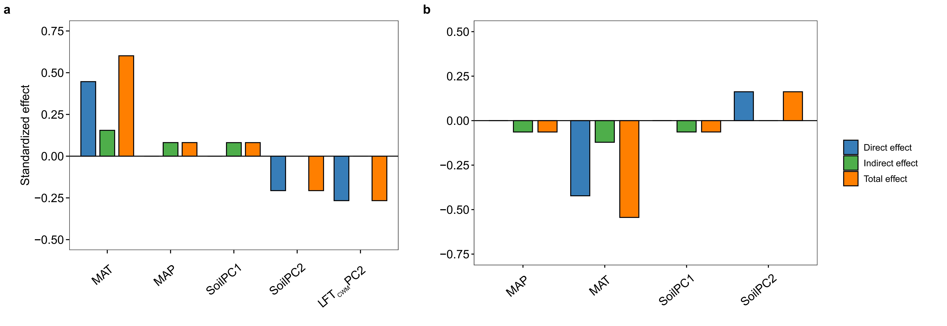
Supplementary Fig. 5. Direct, indirect, and total effects in the structural equation model for meadow steppe. Direct, indirect and total effects (direct plus indirect effects) of LFT_{CWM}, climate factors, and soil factors on foliar δ¹³C_{CWM} a and the aboveground biomass b derived from the structural equation model.

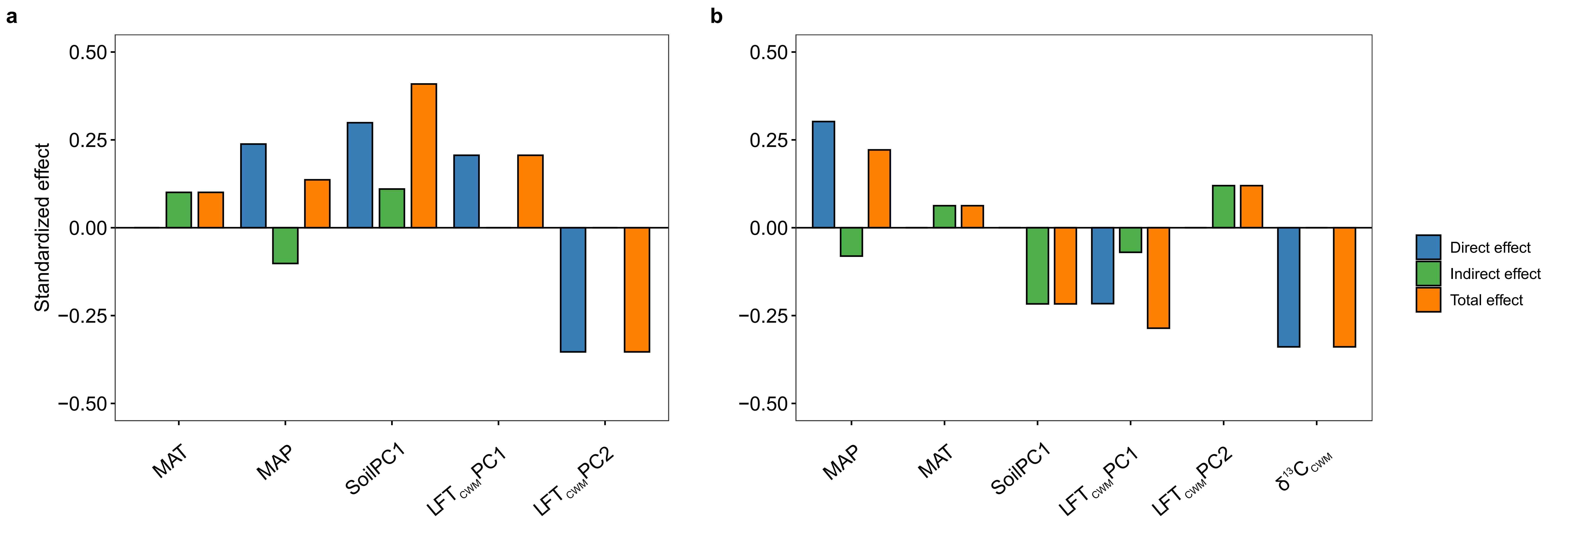
Supplementary Fig. 6. Direct, indirect, and total effects in the structural equation model for typical steppe. Direct, indirect and total effects (direct plus indirect effects) of LFT_{CWM}, climate factors, and soil factors on foliar δ¹³C_{CWM} a and the aboveground biomass b derived from the structural equation model.
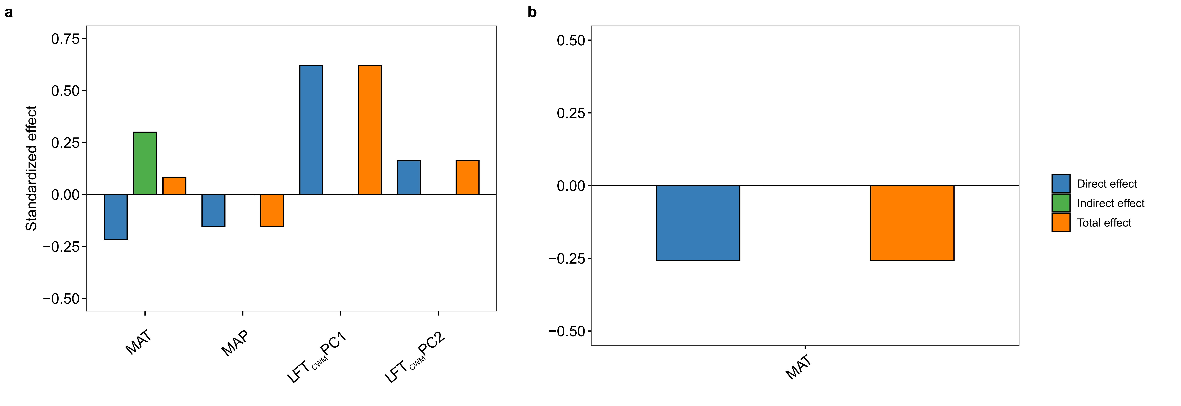
Supplementary Fig. 7. Direct, indirect, and total effects in the structural equation model for desert steppe. Direct, indirect and total effects (direct plus indirect effects) of LFT_{CWM}, climate factors, and soil factors on foliar δ¹³C_{CWM} a and the aboveground biomass b derived from the structural equation model.

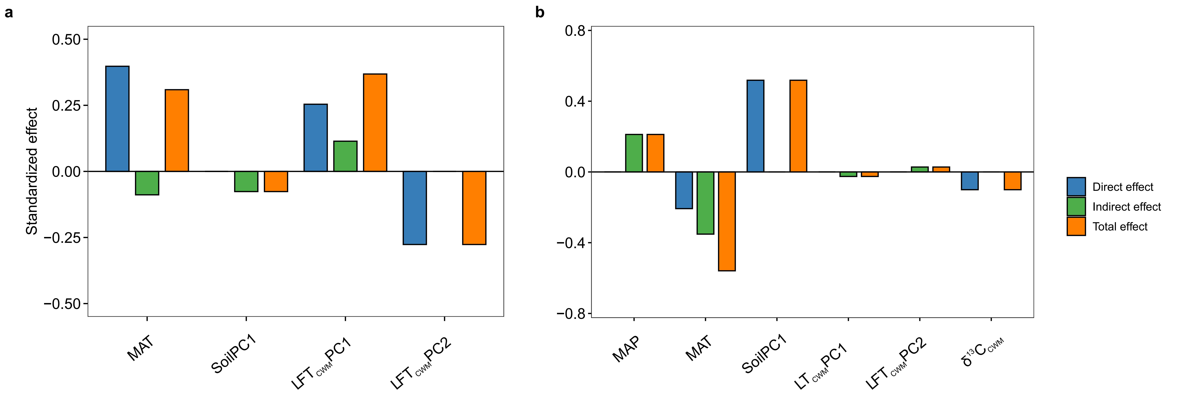
Supplementary Fig. 8. Direct, indirect, and total effects in the structural equation model for Inner Mongolia grassland. Direct, indirect and total effects (direct plus indirect effects) of LFT_{CWM}, climate factors, and soil factors on foliar δ¹³C_{CWM} a and the aboveground biomass b derived from the structural equation model.

Supplementary Tables
Supplementary Table 1. The general information samples collected and the average value of δ¹³C_{leaf} of the different steppe types.
Steppe types | Samples | δ¹³C_{leaf} (‰)
MS | 144 | −26.73±0.12
TS | 125 | −25.61±0.21
DS | 130 | −23.81±0.31
ALL | 399 | −25.43±0.14
The steppe types are defined as follows: MS, meadow steppe; TS, Typical steppe; DS, Desert steppe; ALL, Inner Mongolia grassland.

Supplementary Table 2. Standardized path coefficients of meadow steppe SEM-model
Response variable | Predictor | Estimate | Std.error | P value | Std. Estimate | C  statistic | P of C (df)
δ¹³C_{CWM} | LFT_{CWM}PC1 | -0.33 | 0.09 | <0.001 | -0.27 | 21.695 | 0.795(28)
δ¹³C_{CWM} | SoilPC2 | -0.26 | 0.09 | 0.004 | -0.21
δ¹³C_{CWM} | MAT | 0.83 | 0.13 | <0.001 | 0.45
LFT_{CWM}PC1 | SoilPC1 | -0.27 | 0.07 | <0.001 | -0.30
SoilPC1 | MAT | -1.63 | 0.12 | <0.001 | -0.72
SoilPC1 | MAP | 0.01 | 0.00 | <0.001 | 0.20
SoilPC2 | MAT | -1.13 | 0.19 | <0.001 | -0.75
SoilPC2 | MAP | -0.01 | 0.00 | <0.001 | -0.39
SoilPC2 | SoilPC1 | -0.26 | 0.09 | <0.001 | -0.39
AGB | MAT | -39.42 | 7.05 | <0.001 | -0.42
AGB | SoilPC2 | 10.08 | 4.69 | 0.033 | 0.16

Supplementary Table 3. Standardized path coefficients of typical steppe SEM-model
Response variable | Predictor | Estimate | Std.error | P value | Std. Estimate | C  statistic | P of C (df)
δ¹³C_{CWM} | MAP | 0.02 | 0.00 | 0.012 | 0.23 | 23.524 | 0.603(26)
δ¹³C_{CWM} | LFT_{CWM}PC1 | 0.29 | 0.11 | 0.01 | 0.22
δ¹³C_{CWM} | LFT_{CWM}PC2 | -0.61 | 0.14 | <0.001 | -0.35
δ¹³C_{CWM} | SoilPC1 | -0.40 | 0.13 | 0.003 | -0.29
LFT_{CWM}PC1 | SoilPC1 | -0.58 | 0.12 | <0.001 | -0.56
LFT_{CWM}PC1 | MAT | -0.70 | 0.25 | 0.005 | -0.34
SoilPC1 | MAT | -1.23 | 0.12 | <0.001 | -0.61
SoilPC1 | MAP | 0.02 | 0.00 | <0.001 | 0.29
SoilPC2 | MAP | -0.02 | 0.00 | 0.002 | -0.27
AGB | MAP | 0.52 | 0.13 | <0.001 | 0.30
AGB | LFT_{CWM}PC1 | -6.25 | 2.33 | 0.008 | -0.22
AGB | δ¹³C_{CWM} | -7.38 | 1.73 | 0.033 | -0.34

Supplementary Table 4. Standardized path coefficients of desert steppe SEM-model
Response variable | Predictor | Estimate | Std.error | P value | Std. Estimate | C  statistic | P of C (df)
δ¹³C_{CWM} | MAP | -0.01 | 0.01 | 0.041 | -0.16 | 20.225 | 0.569(22)
δ¹³C_{CWM} | MAT | -1.06 | 0.41 | 0.012 | -0.22
δ¹³C_{CWM} | LFT_{CWM}PC1 | 1.39 | 0.18 | <0.001 | 0.62
δ¹³C_{CWM} | LFT_{CWM}PC2 | 0.43 | 0.20 | 0.031 | 0.16
LFT_{CWM}PC1 | MAT | 0.94 | 0.17 | <0.001 | 0.43
LFT_{CWM}PC2 | MAT | 0.34 | 0.16 | 0.034 | 0.18
SoilPC1 | MAT | -0.84 | 0.15 | <0.001 | -0.40
SoilPC1 | MAP | 0.02 | 0.00 | <0.001 | 0.37
AGB | MAT | -7.72 | 2.56 | 0.003 | -0.26

Supplementary Table 5. Standardized path coefficients of Inner Mongolia grassland SEM-model
Response variable | Predictor | Estimate | Std.error | P value | Std. Estimate | C  statistic | P of C (df)
δ¹³C_{CWM} | MAT | 0.35 | 0.05 | <0.001 | 0.40 | 18.177 | 0.314(16)
δ¹³C_{CWM} | LFT_{CWM}PC1 | 0.43 | 0.10 | <0.001 | 0.25
δ¹³C_{CWM} | LFT_{CWM}PC2 | -0.67 | 0.11 | <0.001 | -0.28
LFT_{CWM}PC1 | MAT | 0.33 | 0.02 | <0.001 | 0.64
LFT_{CWM}PC2 | MAT | 0.33 | 0.04 | <0.001 | 0.91
LFT_{CWM}PC2 | SoilPC1 | 0.16 | 0.06 | 0.008 | 0.28
LFT_{CWM}PC2 | LFT_{CWM}PC2 | -0.29 | 0.04 | <0.001 | -0.41
SoilPC1 | MAT | -0.37 | 0.01 | <0.001 | -0.60
SoilPC1 | MAP | 0.01 | 0.00 | <0.001 | 0.41
AGB | MAT | -4.78 | 1.80 | 0.008 | -0.21
AGB | SoilPC1 | 19.62 | 2.97 | <0.001 | 0.52
AGB | δ¹³C_{CWM} | -2.65 | 0.97 | 0.007 | -0.10

