Appendix I: Observed Idiopathic Scoliosis
The following aredorsal and ventral views of the same MPTP-administered mouse observed with idiopathic scoliosis.
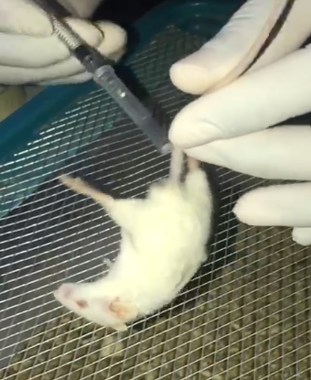
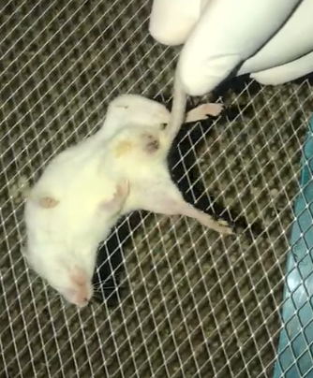
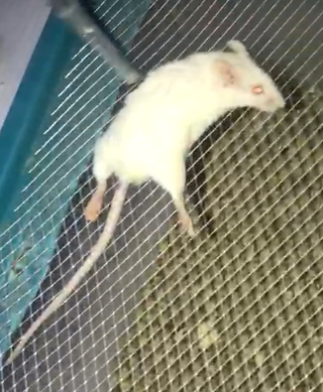
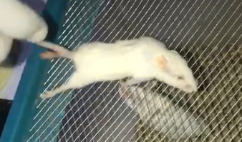
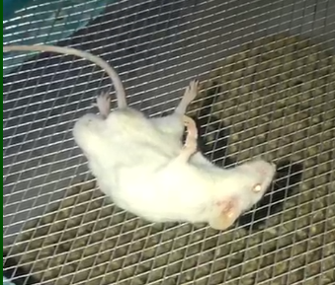
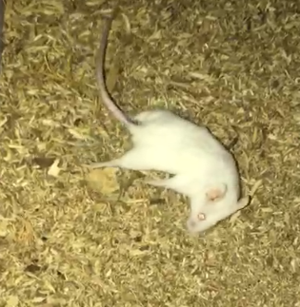
Appendix 1 Dorsal and ventral views of the scoliotic mouse at rest and in motion (Arrows indicate spinal curvatures)

