Supplementary material
Unravelling the anti-biofilm properties of Laurinterol on pioneer biofouling bacteria from the red seaweed Laurencia johnstonii

Martha Patricia Agúndez-Salas¹, Ruth Noemí Aguila-Ramírez¹, Ana Laura González-Castro², Sara García-Davis³ & Mauricio Muñoz-Ochoa¹*
*Corresponding author: mmunozo@ipn.mx

Fig 1. Chromatogram acquired at 280 nm by HPLC. F2C2A fraction of Laurencia johnstonii extract 280 nm.

Fig 2. ¹H NMR (500 MHz, CDCl₃) spectrum of laurinterol.

Fig 3. ¹H NMR (500 MHz, CDCl₃) spectrum of laurinterol. A) Laurinterol reference standard previously isolated. B) Laurinterol compound isolated from L. johnstonii.

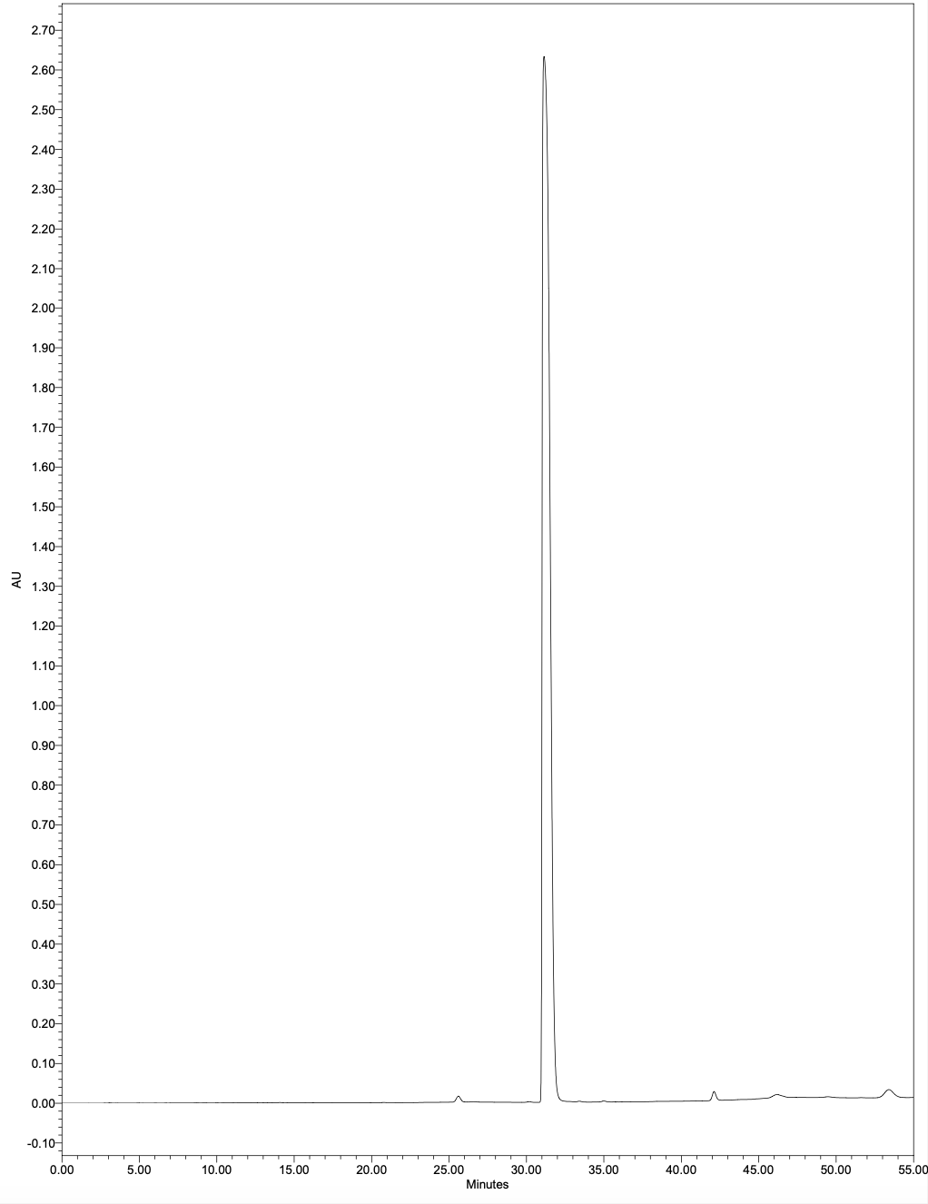
Fig 1. Chromatogram acquired at 280 nm by HPLC. F2C2A fraction of Laurencia johnstonii extract 280 nm.
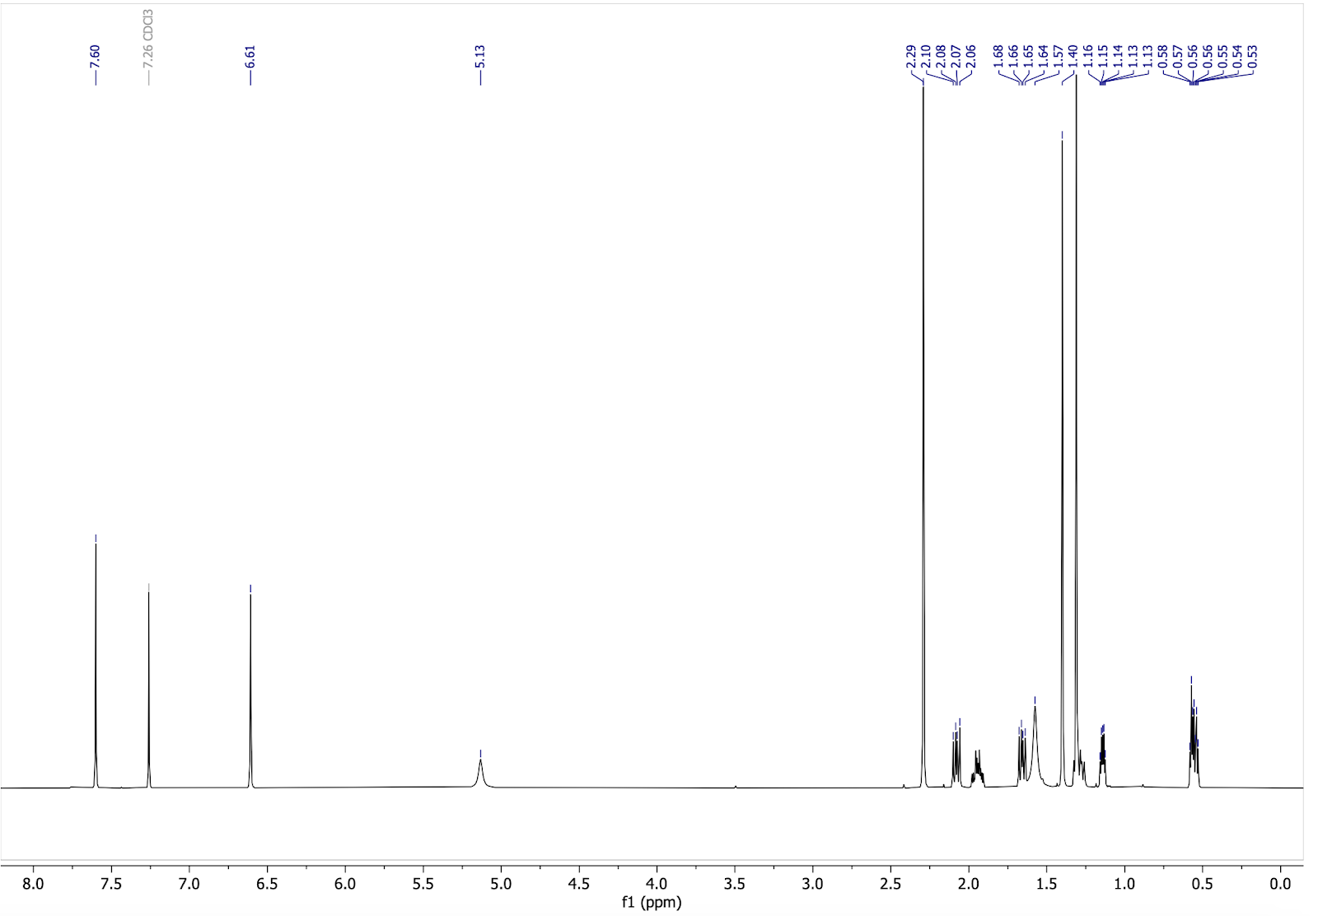
Fig 2. ¹H NMR (500 MHz, CDCl₃) spectrum of laurinterol

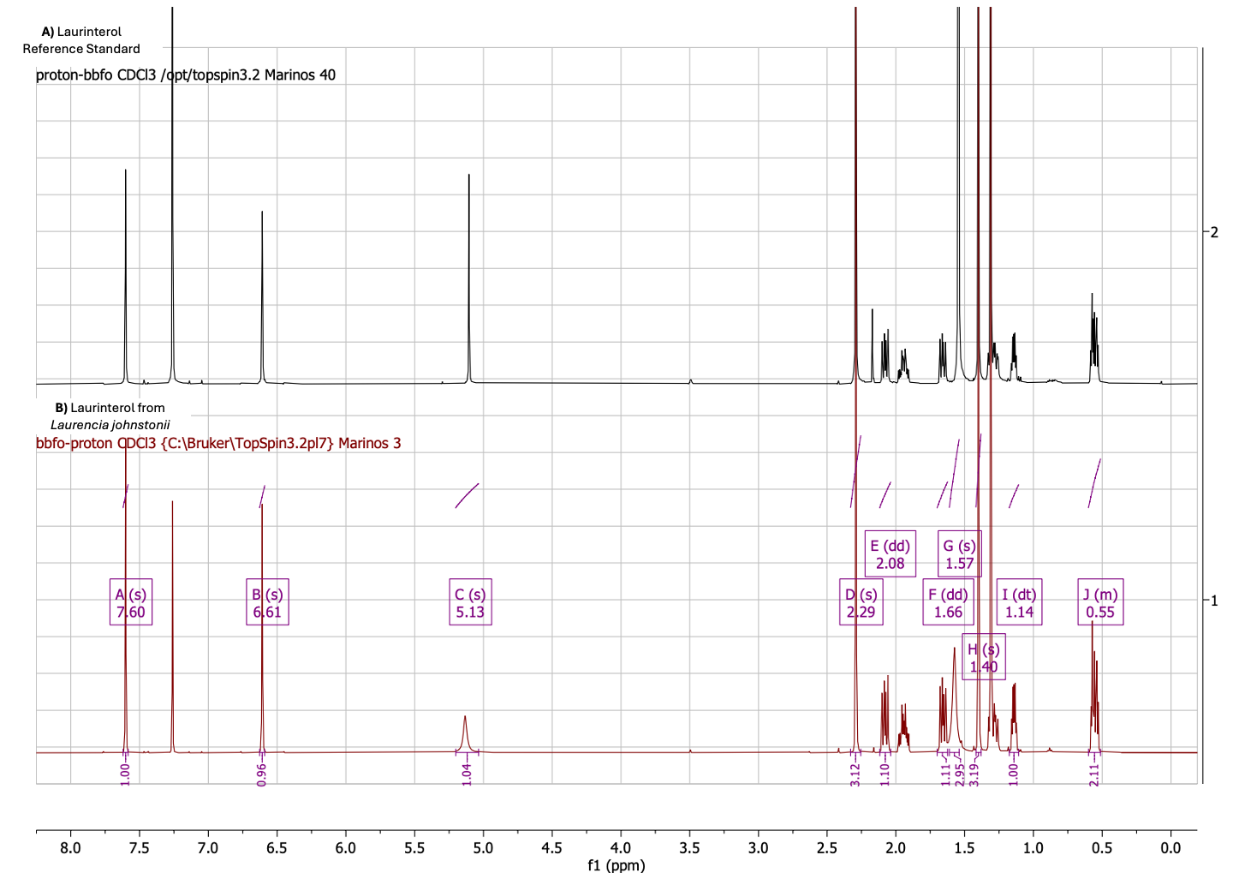
Fig 3. ¹H NMR (500 MHz, CDCl₃) spectrum of laurinterol. A) Laurinterol reference standard previously isolated. B) Laurinterol compound isolated from L. johnstonii.

