Supplemental material
Video legend. CMM in case 1 harboring the MCF2 variant [NM_001171876.2: c.31C>T p.(R11W)]
Symmetric contralateral mirror movements are observed upon fine finger movements and distal upper limb muscles bilaterally rated 3/5 according to the Woods and Teuber scale(Woods & Teuber, 1978). Proband is able to write the same sentence simultaneously using both hands in a mirrored fashion.
Supplemental table 1

Rare genetic variants identified in case 1 by exome sequencing.

Supplemental figures

Figure S1. The MCF2^{E427K} and MCF2^{T934I} variants have no impact on MCF2 GEF activity.

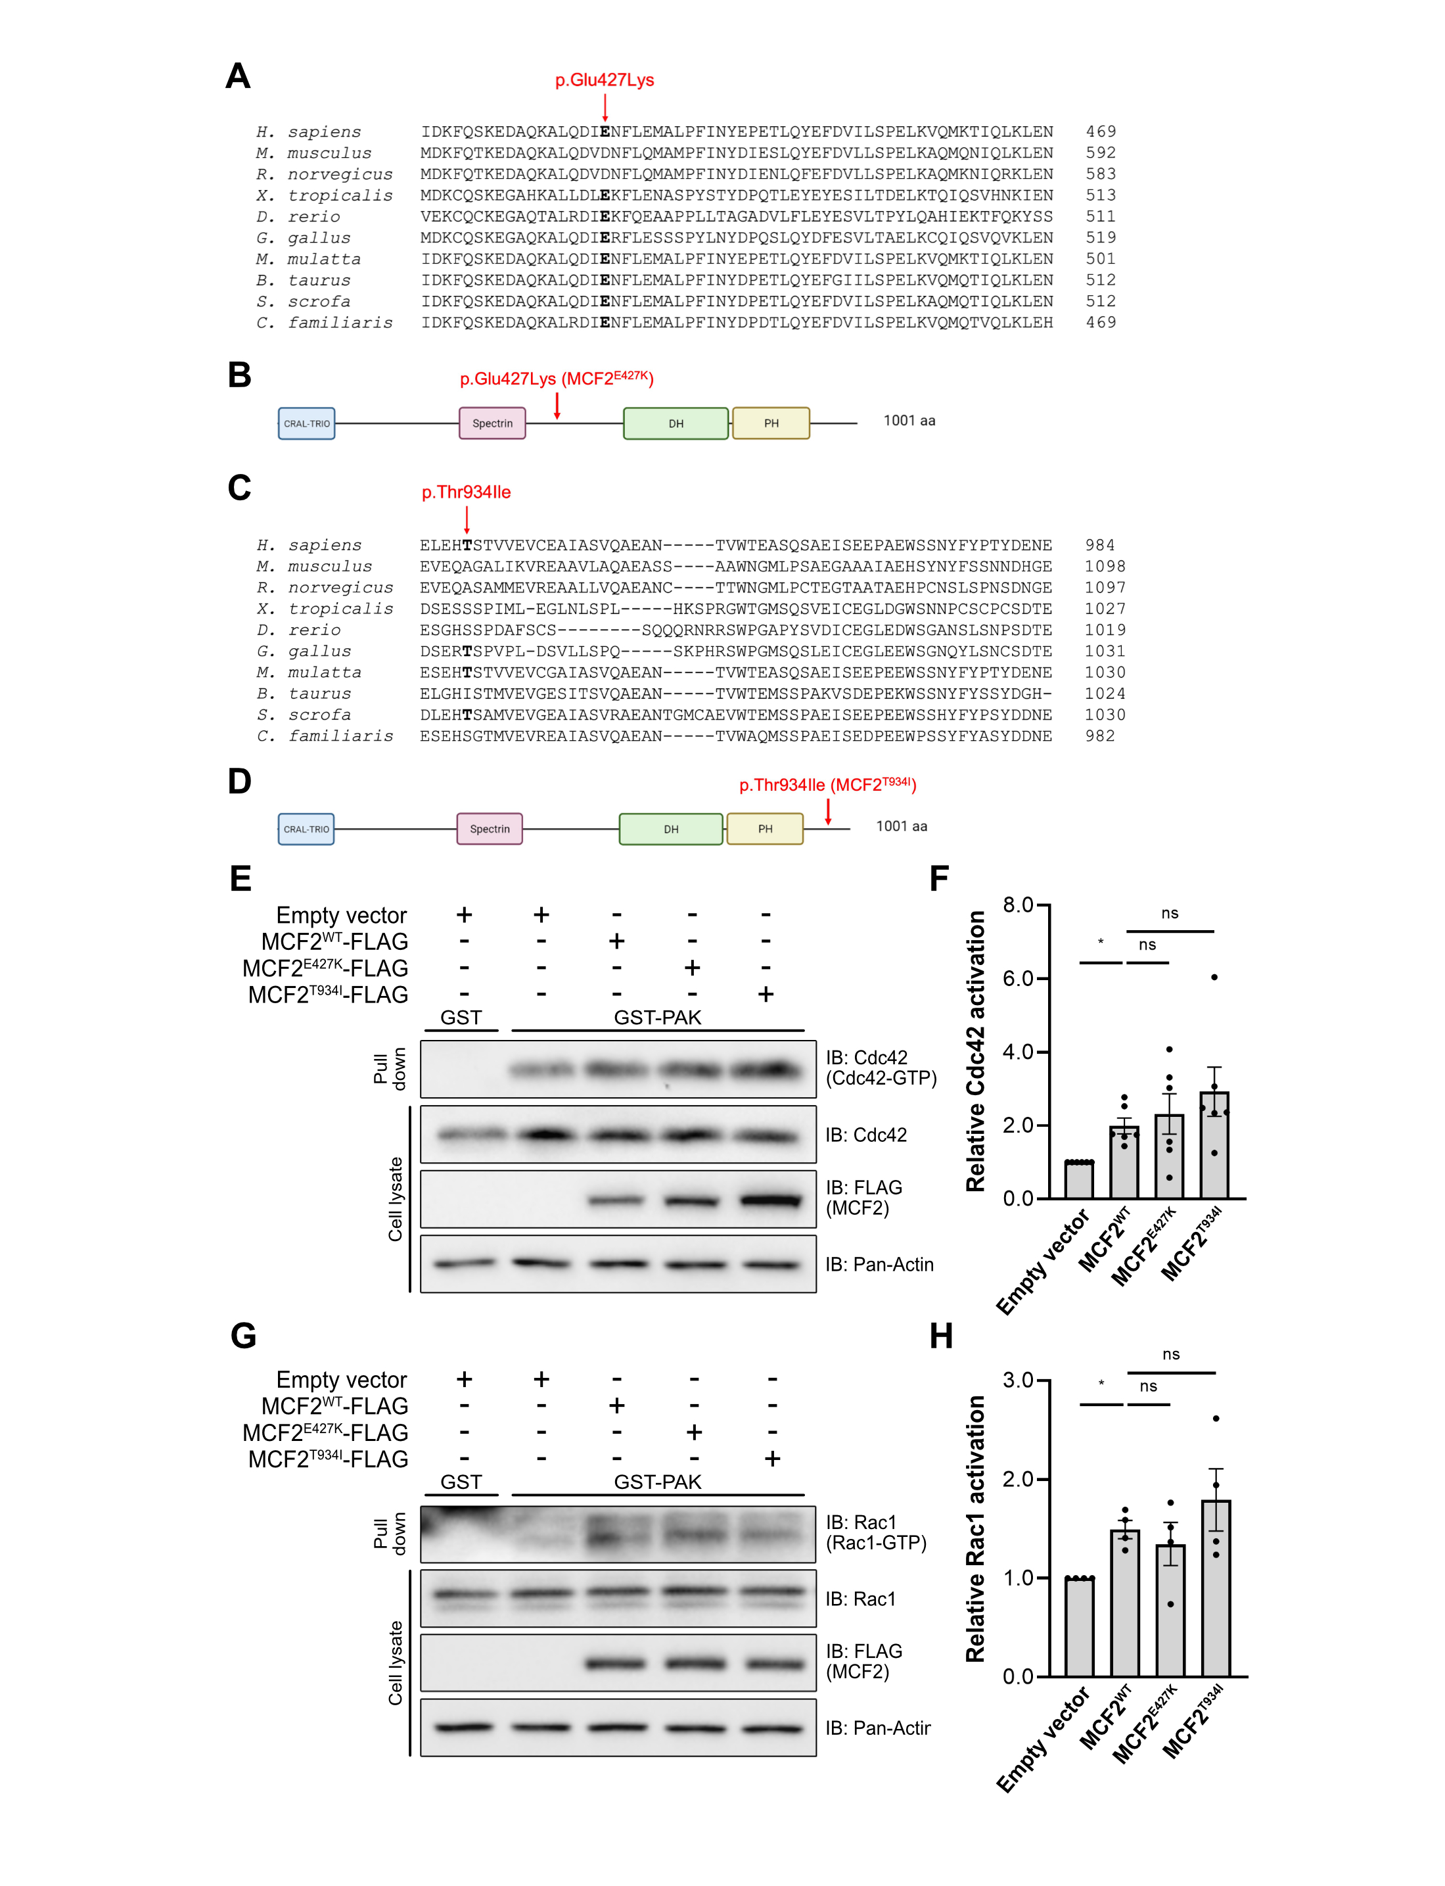
(A, C) Amino acid alignment of human MCF2 and its predicted orthologs shows that residue Glu427 is conserved across 8 out of 10 species and the residue Thr934 is conserved across 4 out of 10 species. (B, D) MCF2 schematic. The position of MCF2^{E427K} and MCF2^{T934I} are depicted. (E, G) COS7 cells were transfected with an empty vector, MCF2^{WT}-FLAG, MCF2^{E427K}-FLAG and MCF2^{T934I}-FLAG, as indicated. Cells were lysed and assayed for active GTPases by pull-down of active Cdc42 (E) and Rac1 (G) using GST-PAK-coated beads. The amount of Cdc42 and Rac1 in pull-downs and in total cell lysates was detected by immunoblotting (IB) with the indicated antibodies. Relative activity of Cdc42 (F) and Rac1 (H) (mean ± SEM) was normalized to the total amount of each corresponding protein. MCF2^{E427K} and MCF2^{T934I} promote Cdc42 and Rac1 activation to similar levels as MCF2^{WT}. n = 6 experiments for Cdc42 and n = 4 experiments for Rac1, RM one-way ANOVA, Tukey’s multiple comparison post-test, *p < 0.05, ns = not significant.

Figure S2. MCF2^{WT} and MCF2^{R11W} affect actin-based structures in the cell.
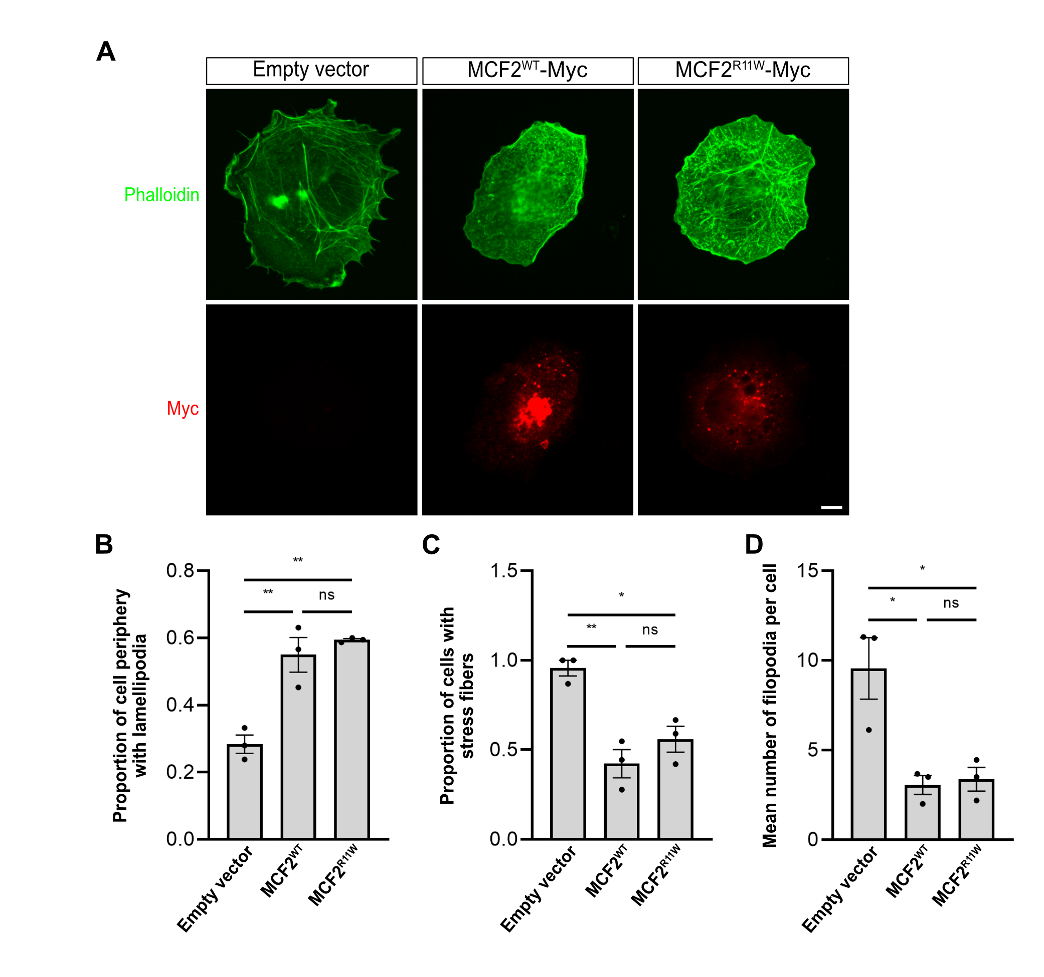
(A) COS7 cells were transfected with an empty vector, MCF2^{WT}-Myc or MCF2^{R11W}-Myc, as indicated. Cells were fixed and F-actin was detected with phalloidin and MCF2 was detected by immunostaining. Scale bar: 10 μm. (B) Proportion of cell periphery displaying lamellipodia (mean ± SEM). Cells transfected with MCF2^{WT} and MCF2^{R11W} have significantly more lamellipodia compared to control cells. (C) Proportion of cells displaying stress fibers (mean ± SEM). Cells transfected with MCF2^{WT} and MCF2^{R11W} have significantly less stress fibers compared to control cells. (D) Mean number of filopodia per cell (mean ± SEM). Cells transfected with MCF2^{WT} and MCF2^{R11W} have significantly less filopodia compared to control cells. (B, C, D) n = 3, One-way ANOVA, Tukey’s multiple comparison test, *p < 0.05 and **p < 0.01, ns = not significant.

Figure S3. MCF2^{E427K} and MCF2^{T934I} interact with DCC and induce its relocalization from the cell periphery as efficiently as MCF2^{WT}.

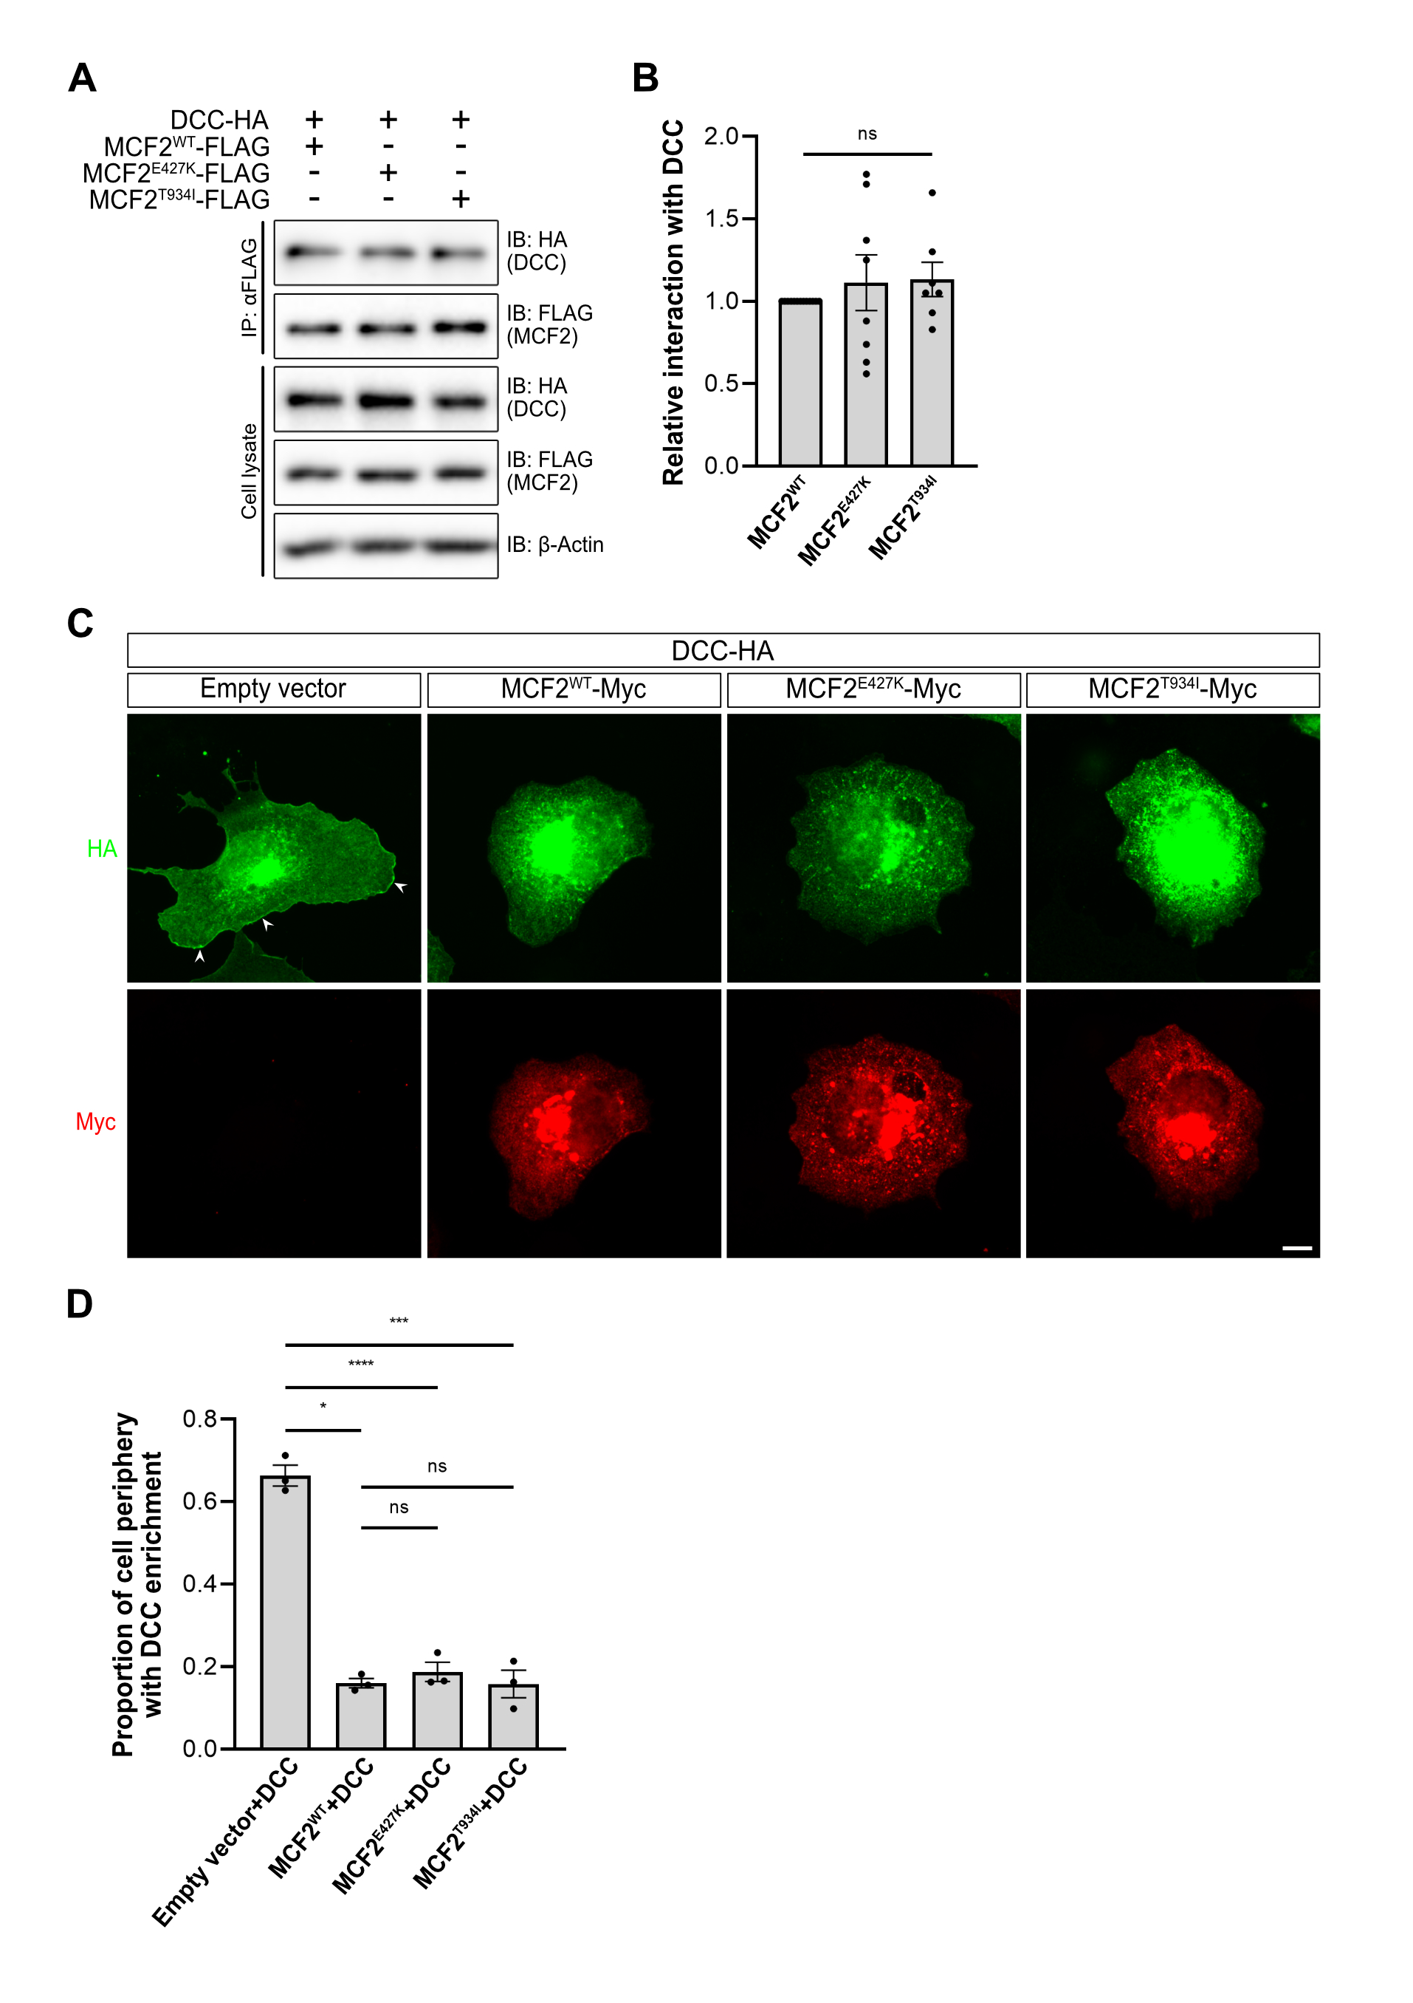
(A) COS7 cells were transfected with DCC-HA, MCF2^{WT}-FLAG, MCF2^{E427K}-FLAG and MCF2^{T934I}-FLAG, as indicated. The cell lysates were immunoprecipitated (IP) with an anti-FLAG antibody and the immunoprecipitates were analyzed by immunoblotting (IB) with the indicated antibodies. DCC co-immunoprecipitates with MCF2^{WT}-FLAG, MCF2^{E427K}-FLAG and MCF2^{T934I}-FLAG. (B) The relative amount of DCC interacting with MCF2^{WT}, MCF2^{E427K} and MCF2^{T934I} (mean ± SEM), normalized to total DCC in the cell lysate. MCF2^{E427K} and MCF2^{T934I} have a similar level of interaction with DCC as MCF2^{WT}. n = 8 for MCF2^{E427K} and n = 7 for MCF2^{T934I}, one-way ANOVA, Tukey’s multiple comparison post-test. ns = not significant. (C) COS7 cells were transfected with empty vector, DCC-HA, MCF2^{WT}-Myc, MCF2^{E427K}-Myc and MCF2^{T934I}-Myc, as indicated. Cells were fixed and DCC and MCF2 were detected by immunostaining. White arrowheads indicate regions of the cell periphery with DCC enrichment. Scale bar: 10 μm. (D) Proportion of cell periphery with DCC enrichment (mean ± SEM). MCF2^{E427K} and MCF2^{T934I} significantly decrease DCC enrichment at the cell periphery to the same level as MCF2^{WT}. n = 3, RM two-way ANOVA, Tukey’s multiple comparison test, *p < 0.05, ***p < 0.001 and ****p < 0.0001, ns = not significant.

References:

Woods, B. T., & Teuber, H. L. (1978). Mirror movements after childhood hemiparesis. Neurology, 28(11), 1152–1157. https://doi.org/10.1212/wnl.28.11.1152

