Supplementary material

Leukocyte telomere length and amyotrophic lateral sclerosis: a Mendelian randomization study

Journal name: Molecular Neurobiology

Kailin Xia^{a,b}, Linjing Zhang^{a,b}, Gan Zhang^{a,b}, Yajun Wang^{a,b}, Tao Huang*^{,c,d}, Dongsheng Fan*^{,a,b,e}

ªDepartment of Neurology, Peking University Third Hospital, Beijing, China
^{b}Beijing Municipal Key Laboratory of Biomarker and Translational Research in Neurodegenerative Diseases, Beijing, China
^{c}Department of Epidemiology and Biostatistics, School of Public Health, Peking University, Beijing, China
^{d}Key Laboratory of Molecular Cardiovascular Sciences (Peking University), Ministry of Education, Beijing, China
^{e}Key Laboratory for Neuroscience, National Health Commission/Ministry of Education, Peking University, Beijing, China
*These authors contributed to this work equally
Corresponding authors
Tao Huang, huangtao@bjmu.edu.cn
Dongsheng Fan, dsfan@sina.com
Postal address: 49 North Garden Road, Haidian District, 100191, Beijing, China

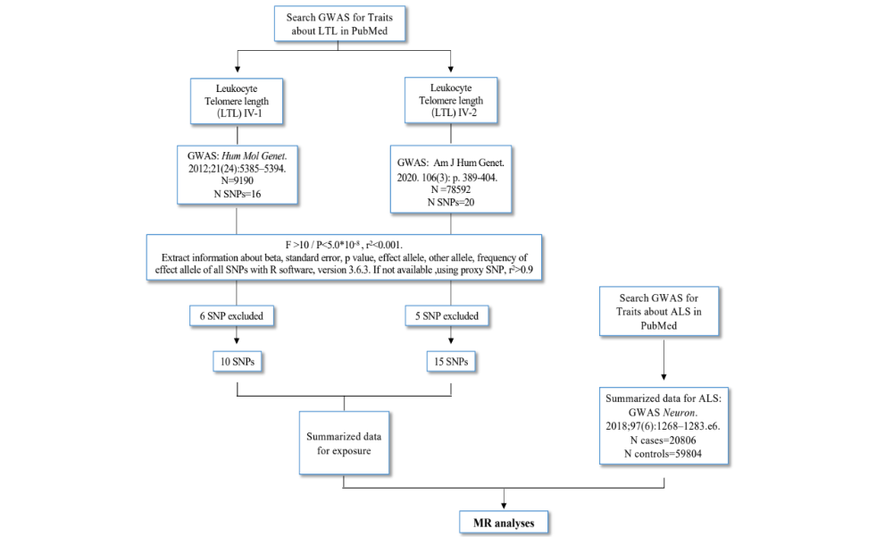

Supplementary Fig. 1 Flow chart for dataset preparation for MR analyses
GWAS, genome-wide association study; MR, Mendelian randomization; ALS, amyotrophic lateral sclerosis

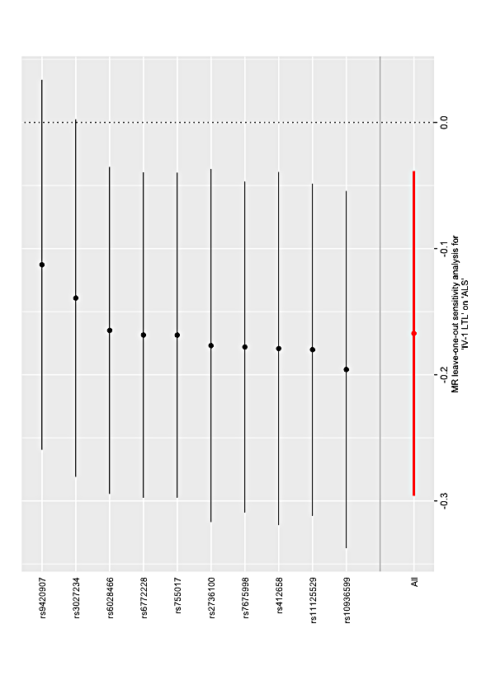
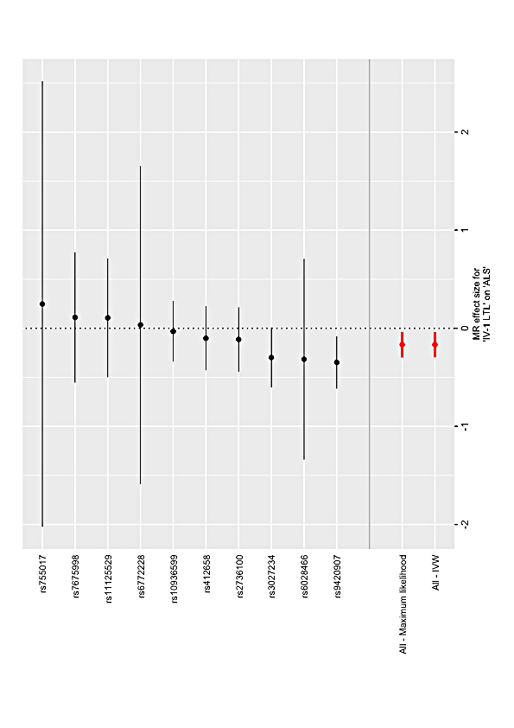
b
a
Supplementary Fig. 2 the effect of single nucleotide polymorphisms (SNPs) on amyotrophic lateral sclerosis (ALS) based on IV-1
Round dots represent the odds ratio of ALS per genetically predicted 1 standard deviation (SD) increase in LTL; horizontal lines represent 95% confidence intervals (CIs).
a Association between leukocyte telomere length (LTL) and ALS measured by single SNPs
b Leave-one-out analysis of leukocyte telomere length (LTL) in ALS
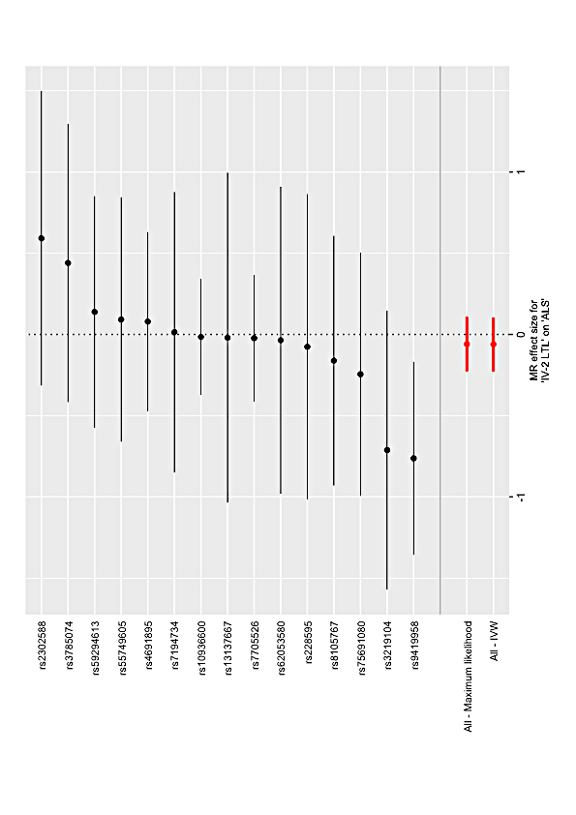

Supplementary Fig. 3 Association between leukocyte telomere length (LTL) and amyotrophic lateral sclerosis (ALS) measured by single nucleotide polymorphisms (SNPs) based on IV-2
Round dots represent the odds ratio of ALS per genetically predicted 1 standard deviation (SD) increase in LTL; horizontal lines represent 95% confidence intervals (CIs)

Supplementary Table 1. Characteristics of instrumental variables (IVs) associated with leukocyte telomere length.
SNP | a1 | a2 | a1_freq | beta | SE | p-value | Traits
rs11125529 | A | C | 0.16 | 0.065 | 0.012 | 6.06E-03 | IV-1 LTL
rs6772228 | T | A | 0.87 | 0.041 | 0.014 | 4.97E-02 | IV-1 LTL
rs12696304 | C | G | 0.74 | 0.09 | 0.011 | 5.41E-08 | IV-1 LTL
rs10936599 | C | T | 0.76 | 0.1 | 0.011 | 1.76E-09 | IV-1 LTL
rs1317082 | A | G | 0.71 | 0.097 | 0.011 | 4.57E-09 | IV-1 LTL
rs10936601 | C | T | 0.74 | 0.087 | 0.011 | 8.64E-08 | IV-1 LTL
rs7675998 | G | A | 0.8 | 0.048 | 0.012 | 1.00E-02 | IV-1 LTL
rs2736100 | C | A | 0.52 | 0.085 | 0.013 | 2.14E-05 | IV-1 LTL
rs9419958 | T | C | 0.13 | 0.129 | 0.013 | 5.26E-11 | IV-1 LTL
rs9420907 | C | A | 0.14 | 0.142 | 0.014 | 1.14E-11 | IV-1 LTL
rs4387287 | A | C | 0.14 | 0.12 | 0.013 | 1.40E-09 | IV-1 LTL
rs3027234 | C | T | 0.83 | 0.103 | 0.012 | 2.75E-08 | IV-1 LTL
rs8105767 | G | A | 0.25 | 0.064 | 0.011 | 1.00E-03 | IV-1 LTL
rs412658 | T | C | 0.35 | 0.086 | 0.01 | 1.83E-08 | IV-1 LTL
rs6028466 | A | G | 0.17 | 0.058 | 0.013 | 4.00E-03 | IV-1 LTL
rs755017 | G | A | 0.17 | 0.019 | 0.013 | 3.40E-01 | IV-1 LTL
rs3219104 | C | A | 0.83 | 0.042 | 0.006 | 9.60E-11 | IV-2 LTL
rs10936600 | T | A | 0.24 | -0.086 | 0.006 | 7.18E-51 | IV-2 LTL
rs4691895 | C | G | 0.78 | 0.058 | 0.006 | 1.58E-21 | IV-2 LTL
rs7705526 | A | C | 0.33 | 0.082 | 0.006 | 5.34E-45 | IV-2 LTL
rs59294613 | A | C | 0.29 | -0.041 | 0.006 | 1.17E-13 | IV-2 LTL
rs9419958 | C | T | 0.86 | -0.064 | 0.007 | 5.05E-19 | IV-2 LTL
rs228595 | A | G | 0.42 | -0.029 | 0.005 | 1.43E-08 | IV-2 LTL
rs2302588 | C | G | 0.1 | 0.048 | 0.008 | 1.68E-08 | IV-2 LTL
rs7194734 | T | C | 0.78 | -0.037 | 0.006 | 6.94E-10 | IV-2 LTL
rs8105767 | G | A | 0.3 | 0.039 | 0.005 | 5.42E-13 | IV-2 LTL
rs75691080 | T | C | 0.09 | -0.067 | 0.009 | 5.99E-14 | IV-2 LTL
rs55749605 | A | C | 0.58 | -0.037 | 0.007 | 2.45E-08 | IV-2 LTL
rs13137667 | C | T | 0.96 | 0.077 | 0.014 | 2.43E-08 | IV-2 LTL
rs34991172 | G | T | 0.07 | -0.061 | 0.011 | 6.19E-09 | IV-2 LTL
rs2736176 | C | G | 0.31 | 0.035 | 0.006 | 3.53E-10 | IV-2 LTL
rs3785074 | G | A | 0.26 | 0.035 | 0.006 | 4.64E-10 | IV-2 LTL
rs62053580 | G | A | 0.17 | -0.039 | 0.007 | 4.08E-08 | IV-2 LTL
rs34978822 | G | C | 0.02 | -0.14 | 0.023 | 7.26E-10 | IV-2 LTL
rs73624724 | C | T | 0.13 | 0.051 | 0.007 | 6.33E-12 | IV-2 LTL
rs2853677 | A | G | 0.59 | -0.064 | 0.006 | 3.35E-31 | IV-2 LTL

Abbreviation: a1: effect allele; a2; the other allele; a1_freq: the frequency of a1; SE: standard error

