Additional file 3
Methods
From Fig. S14 to S17
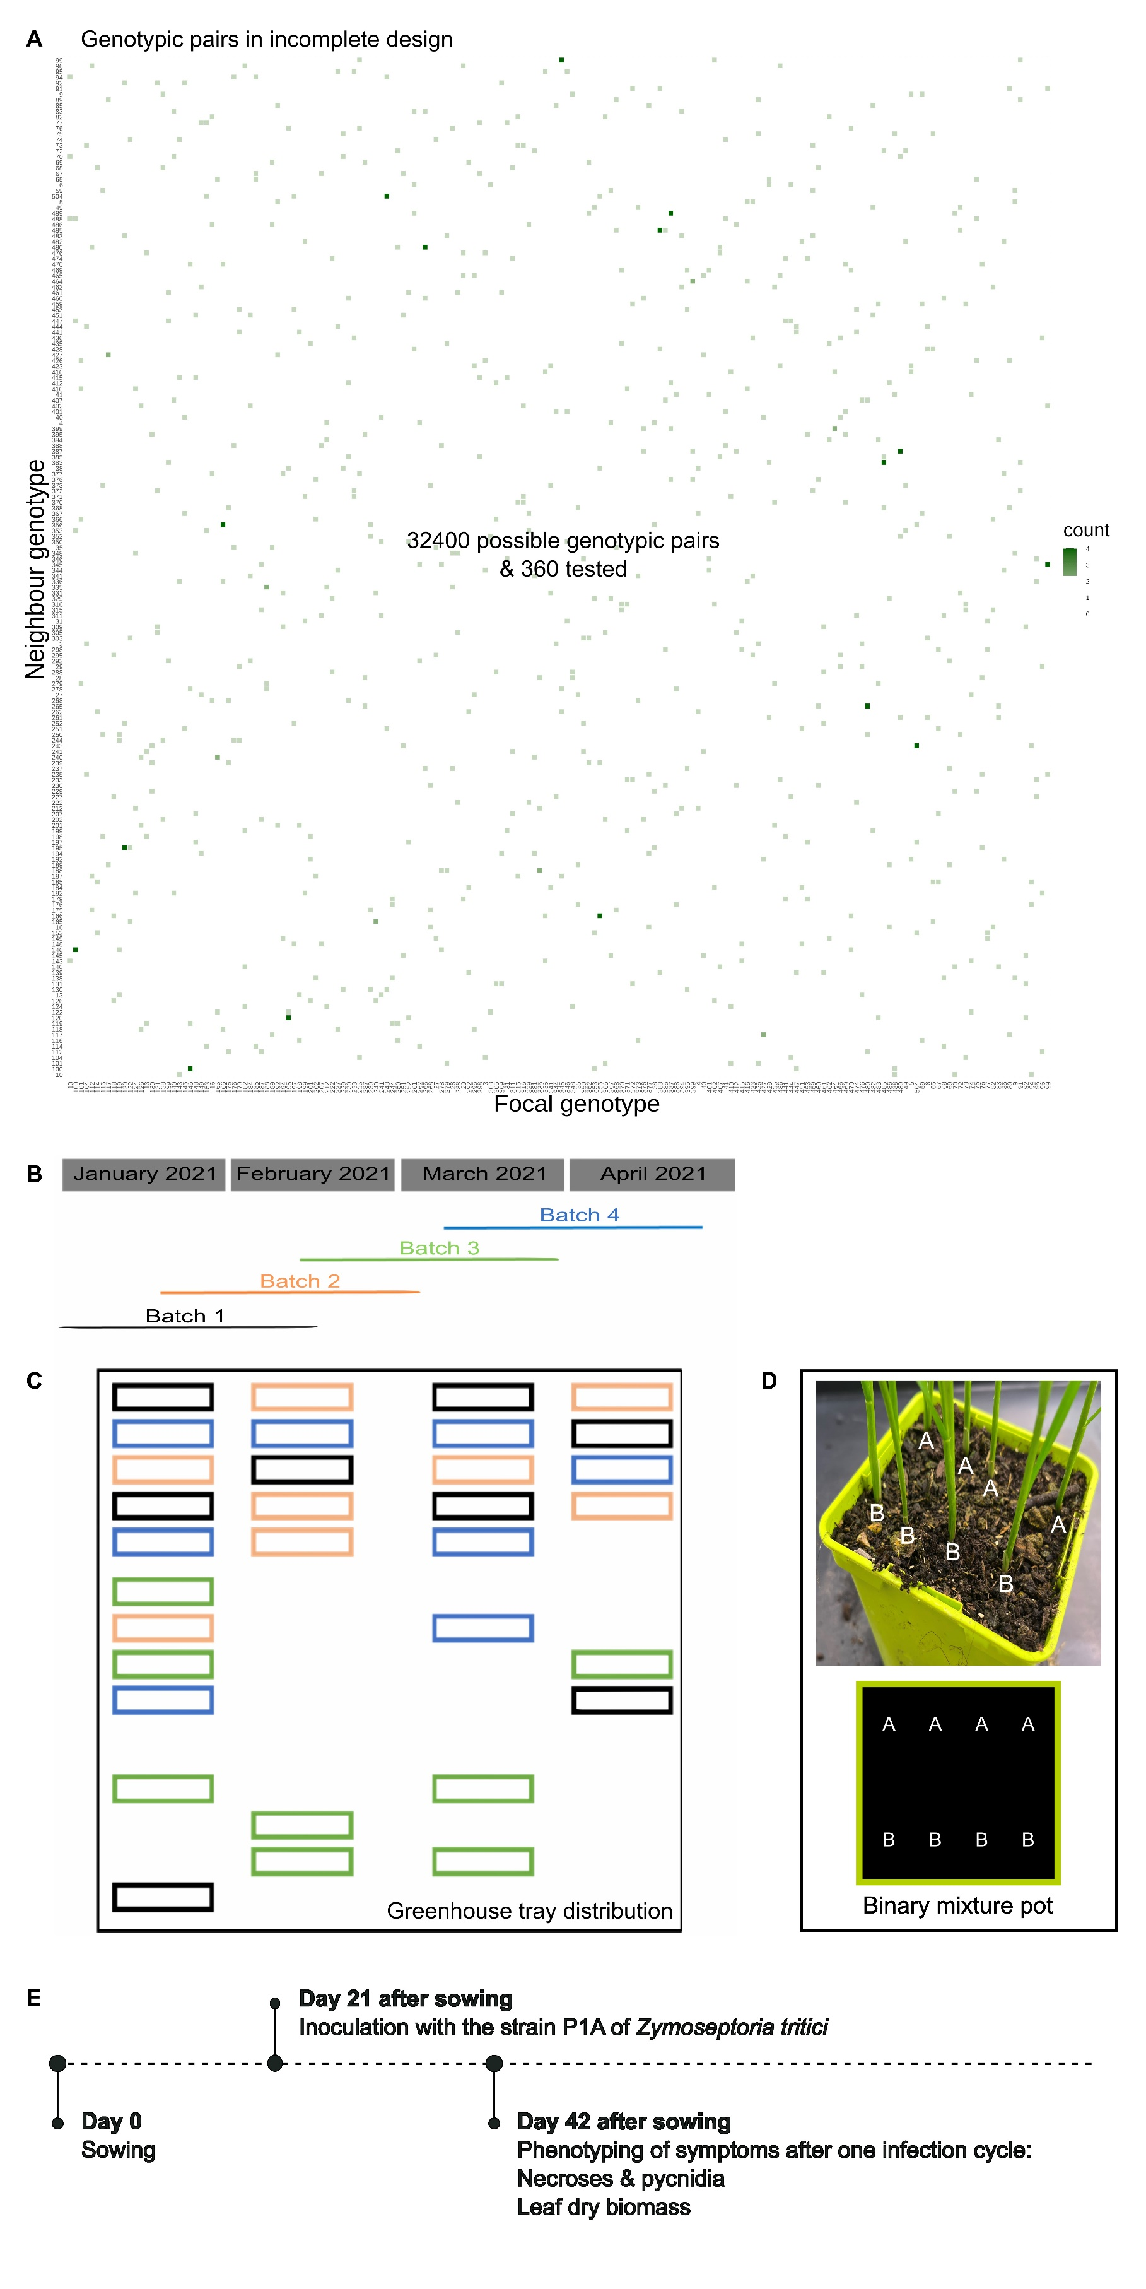
Fig. S14. Experimental design for studying the genetic determinants of plant-plant interactions in durum wheat cultivar mixtures. A Genotypic pairs tested. An incomplete design of 360 binary cultivar mixtures from 180 EPO-derived lines was used to assess genetic interactions between plants. B Batch distribution. The four overlapping batches were conducted between January and April 2021. C Tray arrangement in the greenhouse. The trays were randomly distributed in the greenhouse, with each batch color-coded: batch 1 (black), batch 2 (orange), batch 3 (green), and batch 4 (blue). D Pot configuration. Each pot contains a binary mixture of two lines, with one line per genotype. Each line contains four plants of the same genotype. E Description of interventions performed during each experimental batch. The last ligated leaf of each plant was inoculated with the strain P1A of Zymoseptoria tritici at 21 days after sowing. STB symptoms were scored 21 days after inoculation to estimate total necrotic area and total necrotic area with pycnidia, and leaf dry biomass was measured for each genotype per pot at 42 days after sowing.

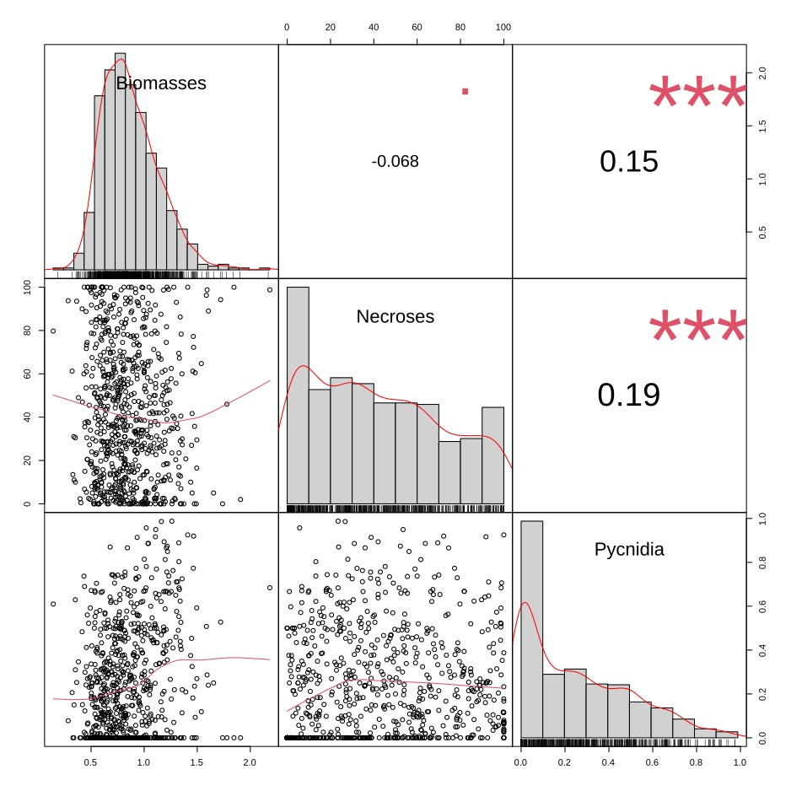
Fig. S15. Correlation matrix between the phenotypic traits in durum wheat. The diagonal shows the distribution of each trait. Below the diagonal, bivariate scatter plots with fitted regression lines are displayed. Above the diagonal, Spearman correlation coefficients and their significance levels are indicated by stars: p-values < 0.001 (***), 0.001 to 0.01 (**), 0.01 to 0.05 (*), 0.05 to 0.1 (.), and > 0.1 (no symbol).

Fig. S16. Residus of models for A biomass, B necrosis and C pycnidia phenotype. Normal quantile-quantile plots are presented for each trait.

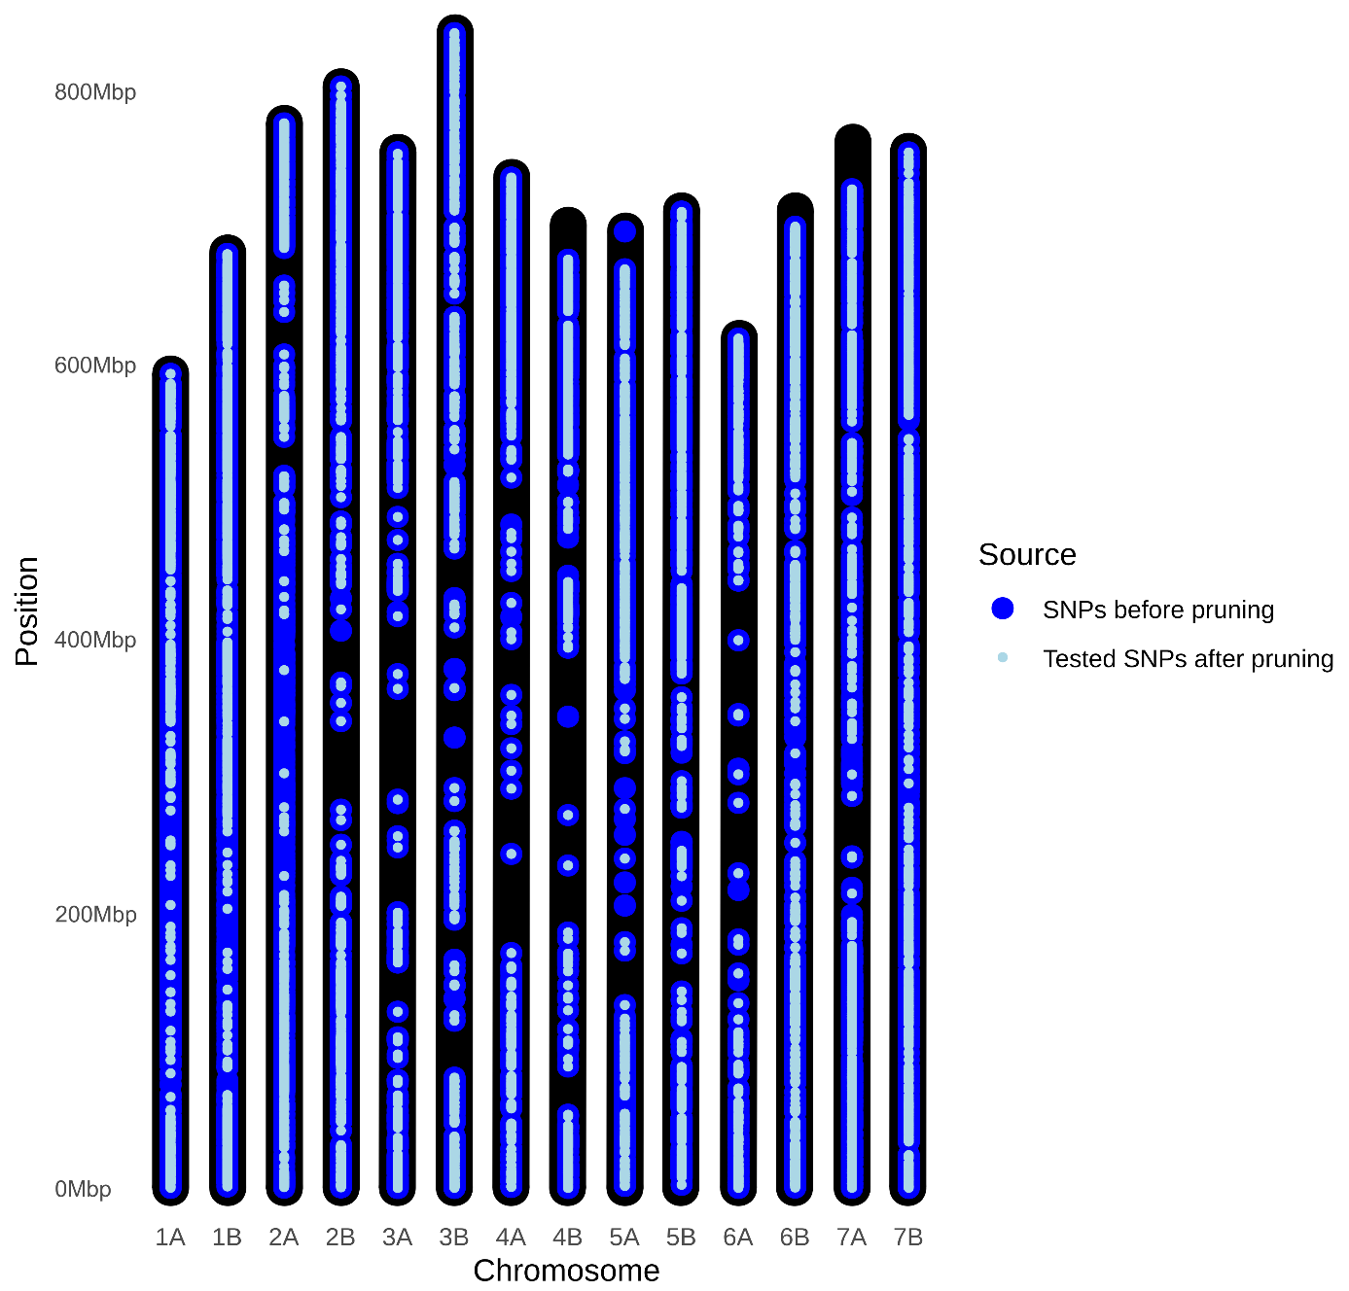
Fig. S17. Physical map of SNPs before and after pruning in durum wheat EPO-derived lines for co-GWAS. A Physical map showing the positions of the initial set of 43509 SNPs (blue) used for both DGE-based and IGE-based GWAS in durum wheat cultivar mixtures. B Physical map of the subset of 26316 SNPs (light blue) selected after pruning the initial 43509 SNPs for co-GWAS.

