Additional file 1
Direct genetic effects (DGE) and indirect genetic effects (IGE)
From Fig. S1 to S6

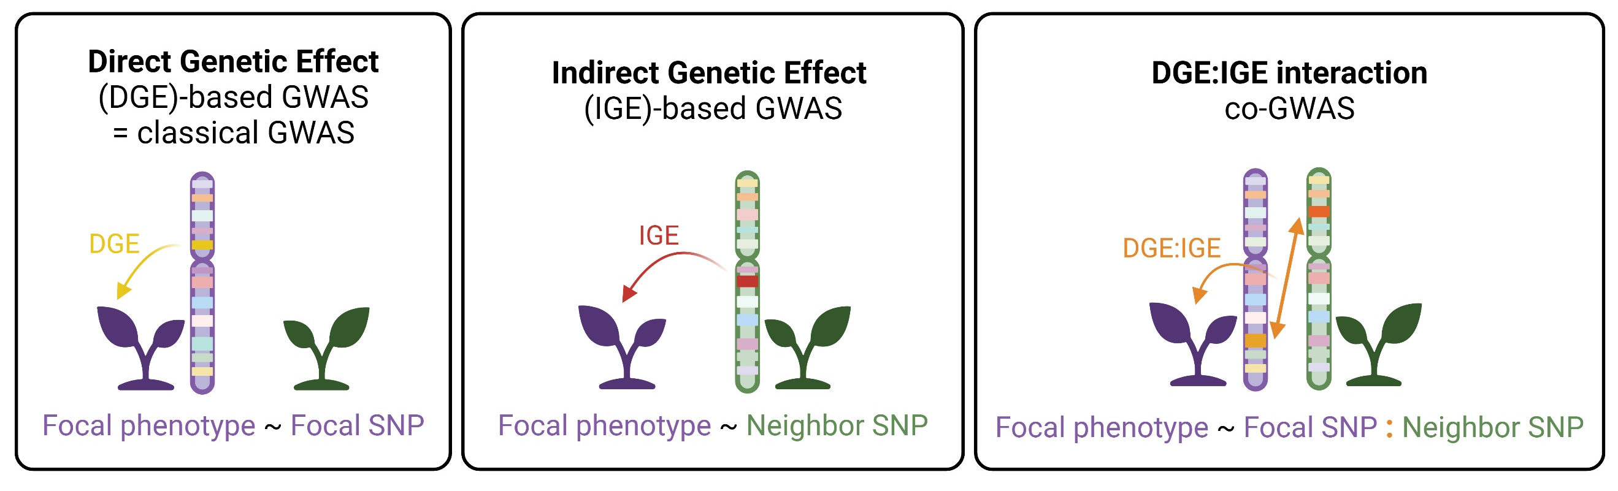
Fig. S1. Scheme of direct and indirect genetic effects (DGE/IGE) and associated GWAS to study these effects. DGE represents the effect of a genotype on its own phenotype, while IGE is the effect of a neighboring genotype on the phenotypes of focal plants. DGE:IGE interactions reflect the specific interaction between two genotypes affecting the phenotype of the focal genotype. In these models, DGE and IGE constitute the additive genetic component, while DGE:IGE interactions contribute to the non-additive genetic component. To identify the genetic determinants of these effects, classical GWAS / DGE-based GWAS associates the focal phenotype with focal SNPs to study DGE, IGE-based GWAS links the phenotype of focal genotypes with neighbor SNPs and co-GWAS reveals the genetic determinants of DGE:IGE interactions by associating the allelic focal SNP-by-neighbor SNP interaction with focal phenotype. This can be performed by testing allelic combination effects at the same SNP or all allelic combinations between different SNPs. Created with BioRender.com under agreement #YF27DKJKHP.

Fig. S2. Direct genetic effect (DGE)-based GWAS results revealing focal loci modulating focal phenotypes. Focal SNPs associated with modification in focal A biomass, B necrosis, and C pycnidia in durum wheat binary mixtures. Left panel: Manhattan plots reporting -log10 transformed p-values for the association tests between focal phenotypic traits and focal SNPs across 43509 SNPs distributed along the durum wheat genome. The solid blue line represents the family-wise error rate (FWER) of 5% computed with the Galwey method. The significant SNPs are highlighted in green. Right panel: Quantile-quantile (q-q) plots of p-value distributions. The red solid line shows the expected quantiles under the null hypothesis and the black lines indicate their 95% confidence interval.

Fig. S3. Significant focal genomic regions associated with focal phenotypic modifications in wheat binary mixtures. Left panel : Linkage disequilibrium (LD) in the focal genomic regions significantly associated with focal modifications in A biomass, B necrosis and C pycnidia. The upper part of each chart represents the -log10 transformed p-values from the association test between the focal phenotype and the focal SNPs present in the region. The lower part depicts the LD (r²) between the different SNPs, with lighter squares representing low LD and red squares indicating high LD. SNP positions reflect their relative physical position on the chromosome. Right panel : Focal modification in A biomass, B necrosis and C pycnidia across different alleles at the most significant SNP in the focal region.

Fig. S4. Percent of phenotypic variance explained by direct and indirect genetic effects (DGE/IGE) in wheat mixtures. The variance values represent the effect contributions to the total phenotypic variance.

Fig. S5. Indirect genetic effect (IGE)-based GWAS results revealing a neighbor locus associated with phenotypic modifications. Neighbor SNPs associated with modification in focal A biomass, B necrosis, and C pycnidia in durum wheat binary mixtures. Left panel: Manhattan plots reporting -log10 transformed p-values for the association tests between focal phenotypic traits and neighbor SNPs across 43509 SNPs distributed along the durum wheat genome. The solid blue line represents the family-wise error rate (FWER) of 5% computed with the Galwey method. The significant SNPs are highlighted in green. Right panel: Quantile-quantile (q-q) plots of p-value distributions. The red solid line shows the expected quantiles under the null hypothesis and the black lines indicate their 95% confidence interval.
Fig. S6. Significant neighbor genomic region associated with focal pycnidia modifications in wheat binary mixtures. Left panel : Linkage disequilibrium (LD) in the neighbor genomic regions significantly associated with focal modifications in pycnidia. The upper part of the chart represents the -log10 transformed p-values from the association test between the focal phenotype and the neighbor SNPs present in the region. The lower part depicts the LD (r²) between the different SNPs, with lighter squares representing low LD and red squares indicating high LD. SNP positions reflect their relative physical position on the chromosome. Right panel : Focal modification in pycnidia across different alleles at the most significant SNP in the neighbor region.

