Additional file 2
DGE:IGE interactions
From Fig. S7 to S13

Fig. S7. co-GWAS results for A biomass, B necrosis and C pycnidia in durum wheat cultivar mixtures. Left panel : Heatmaps reporting -log10 transformed p-values for the association tests between focal phenotypic traits and focal SNP-by-neighbor SNP interactions across 26316 SNPs distributed along the durum wheat genome. Right panel : Quantile-quantile (q-q) plots representing the observed versus expected quantiles of the p-value distribution. The red solid line shows the expected quantiles under the null hypothesis and the black lines indicate their 95% confidence interval.

Fig. S8. Patterns of the significant allelic interactions associated with focal biomass modifications. Linkage disequilibrium (LD) blocks defined with an r² threshold of 0.7 were used to group interactions between SNPs and form interactions between QTLs. In durum wheat cultivar mixtures, a total of 16 focal QTL-by-neighbor QTL interactions are associated with modifications in the focal biomass, each with a p-value lower than 10⁻⁶.
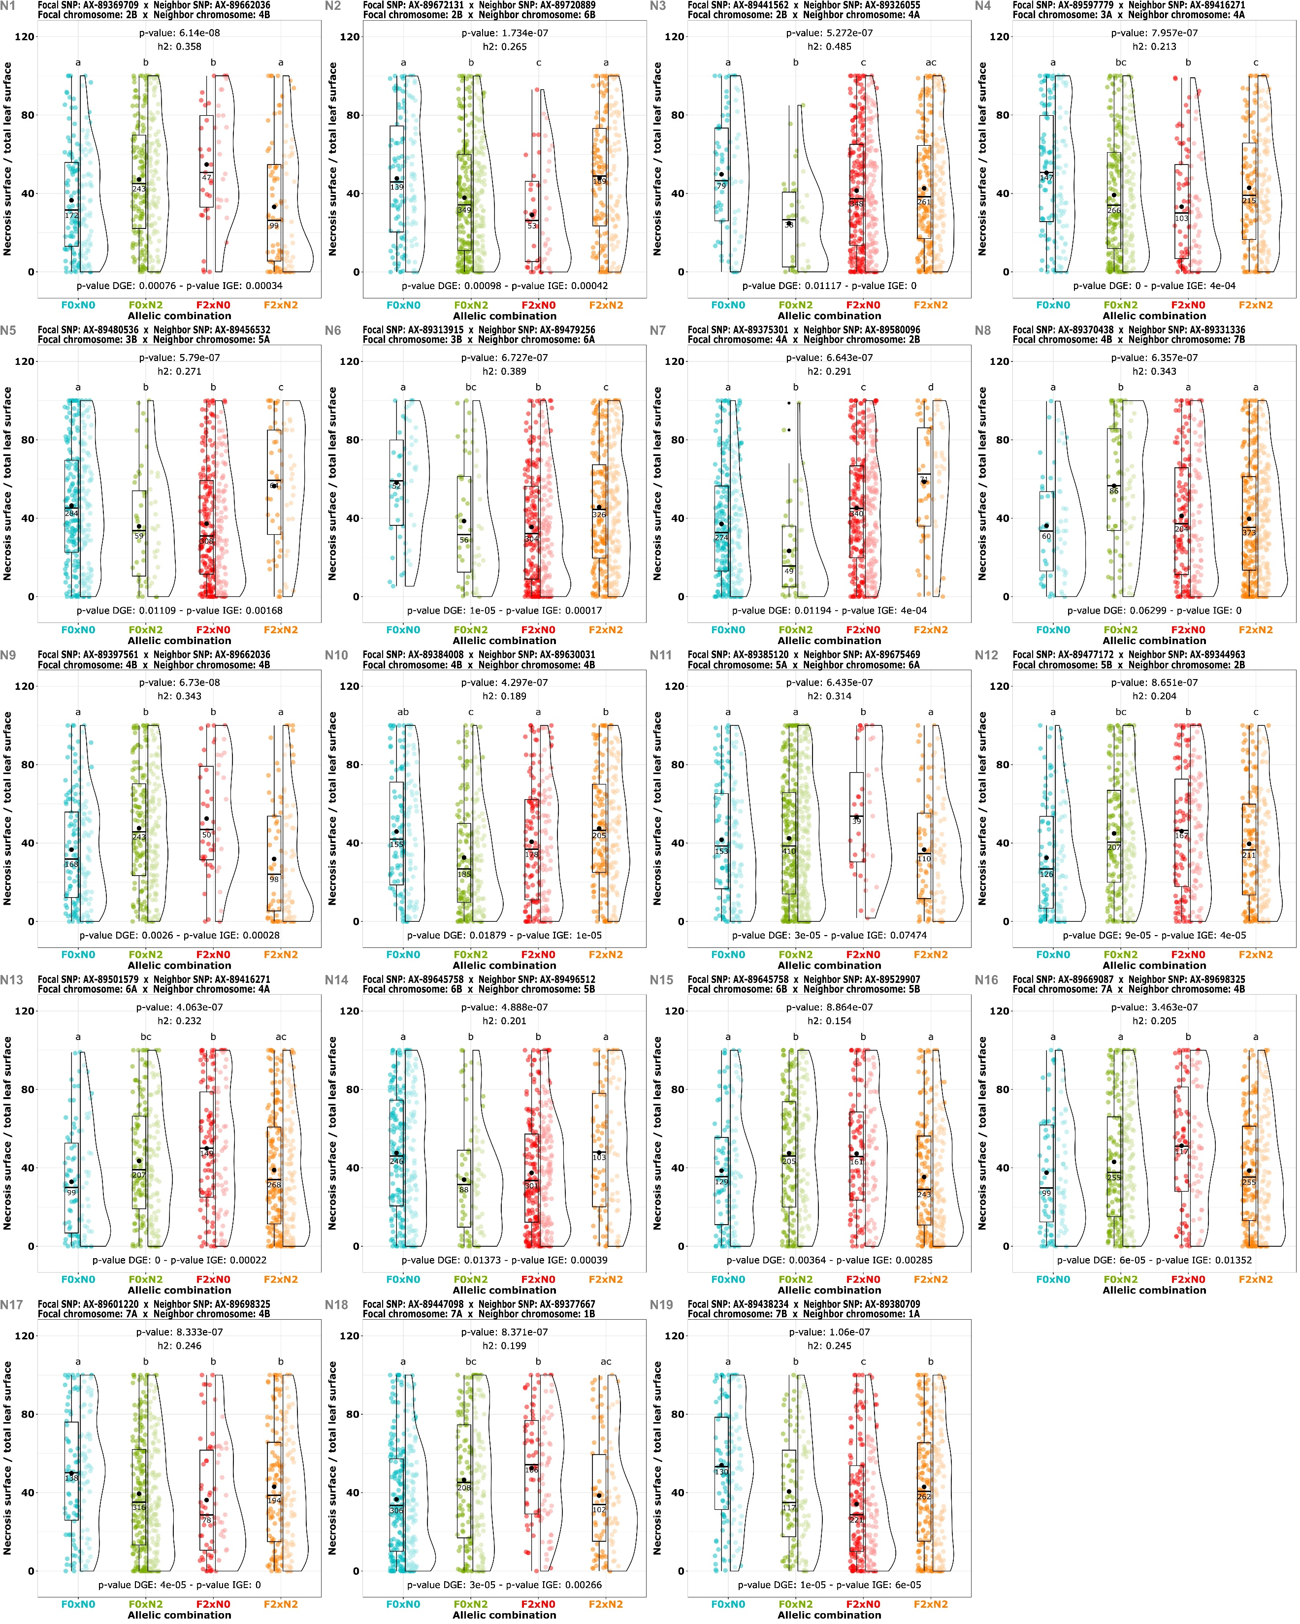
Fig. S9. Patterns of the significant allelic interactions associated with focal necrosis modifications. Linkage disequilibrium (LD) blocks defined with an r² threshold of 0.7 were used to group interactions between SNPs and form interactions between QTLs. In durum wheat cultivar mixtures, a total of 19 focal QTL-by-neighbor QTL interactions are associated with modifications in the focal necrosis, each with a p-value lower than 10⁻⁶.
Fig. S10. Patterns of the significant allelic interactions associated with focal pycnidia modifications. Linkage disequilibrium (LD) blocks defined with an r² threshold of 0.7 were used to group interactions between SNPs and form interactions between QTLs. In durum wheat cultivar mixtures, a total of 19 focal QTL-by-neighbor QTL interactions are associated with modifications in the focal pycnidia, each with a p-value lower than 10⁻⁶.

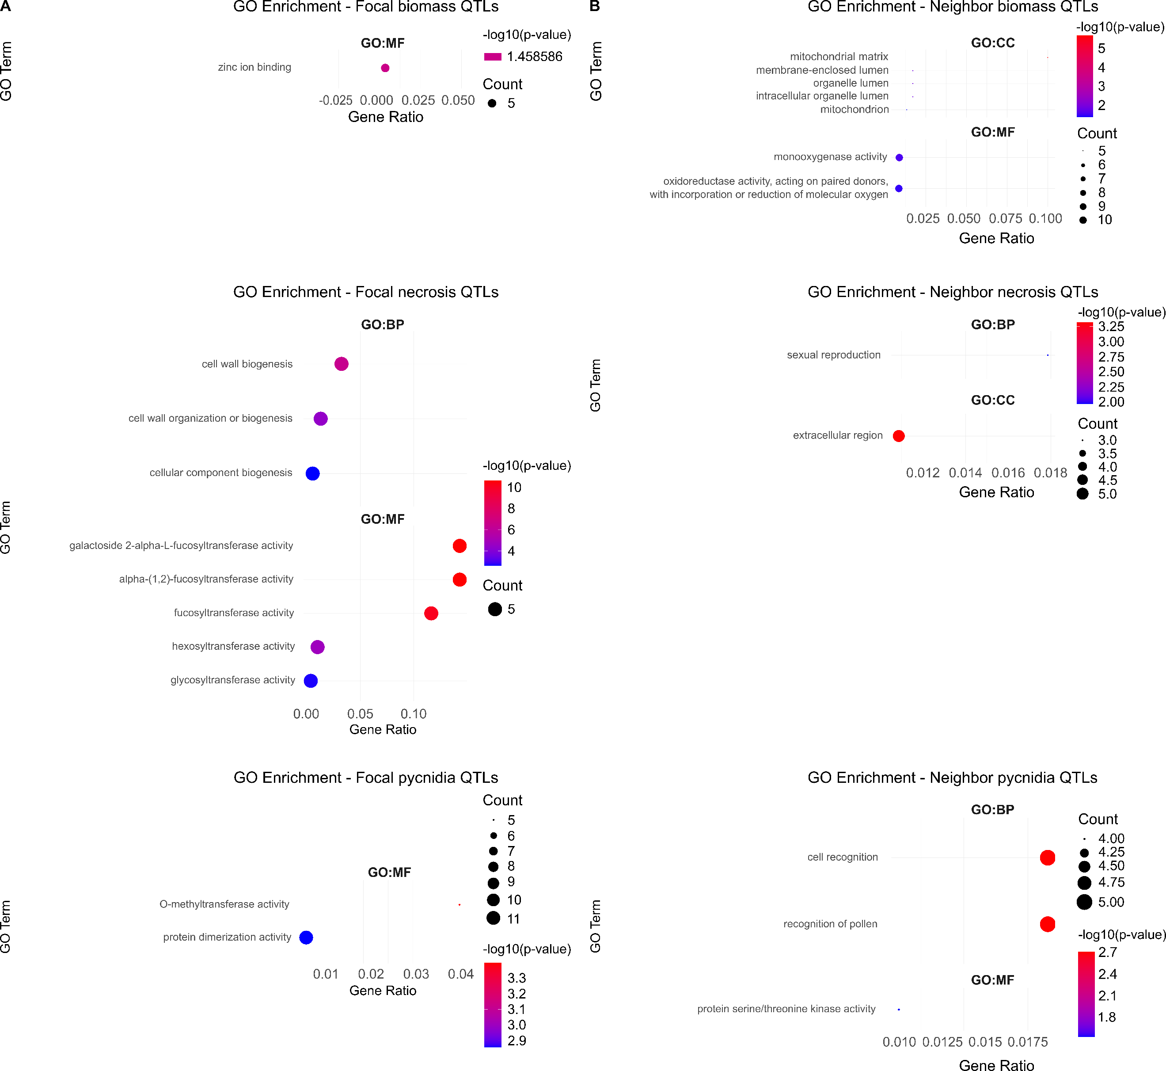
Fig. S11. Gene ontology (GO) enrichments of QTLs involved in the allelic interactions.
A GO enrichments for focal QTLs smaller than the median LD block size, associated with significant allelic interactions (p-value < 10⁻⁶) and focal modifications in biomass, necrosis, and pycnidia.
B GO enrichments for neighbor QTLs smaller than the median LD block size, involved in significant allelic interactions (p-value < 10⁻⁶) and focal modifications in biomass, necrosis, and pycnidia.

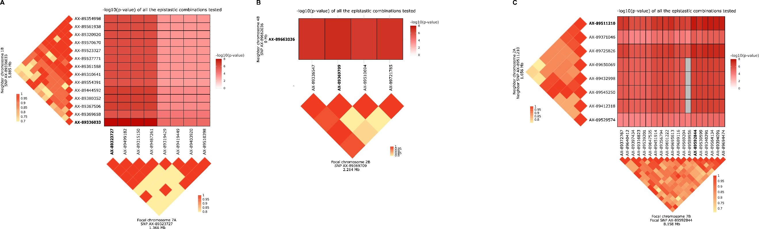
Fig. S12. Detailed maps of most significant allelic focal-by-neighbor interactions in wheat cultivar mixtures. Maps of -log10 transformed p-value interactions between the focal linkage disequilibrium (LD) block and the neighbor LD block of SNPs involved in the most significant interaction for A biomass, B necrosis, and C pycnidia. The heatmap part of the chart represents the -log10 transformed p-values of the association tests between the focal phenotype and the focal SNP-by-neighbor SNP interactions. The triangle parts depict the LD (r²) between the different SNPs, with lighter squares representing low LD and red squares indicating high LD. SNP positions reflect their relative physical position on the chromosomes. Linkage disequilibrium (LD) blocks were defined with an r² threshold of 0.7 to delineate the QTLs. The SNPs involved in the most significant interaction are highlighted in bold.
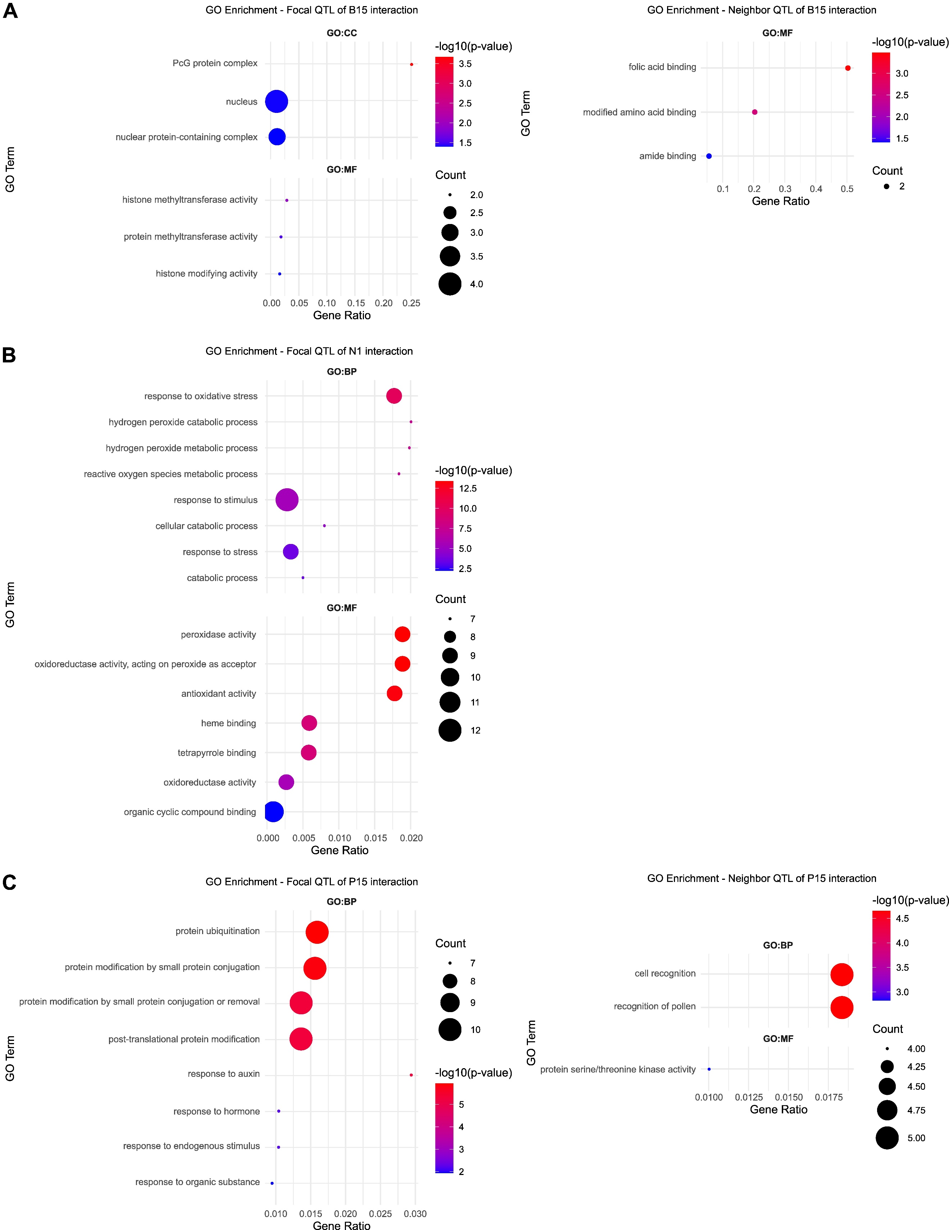
Fig. S13. Gene ontology (GO) enrichments of QTLs involved in the most significant allelic interactions. GO enrichments for the focal QTL (left) and the neighbor QTL (right) of the most significant allelic interaction modulating A biomass, B necrosis, and C pycnidia.

