Supplemental S1: Non-response analysis
No.=number of patients; SD=standard deviation; KPS=Karnofsky Performance Status; WHO=World Health Organization.

 | Lamo/laco  n = 139 | Other  n = 1296 | p-value
Gender, male, no. (%) | 81 (58%) | 851 (66%) | 0.083
Mean age (SD) | 48.0 (13.3) | 53.7 (14.5) | <0.001
Age group, no. (%) |  |  | 0.035
≤ 40 year | 39 (28%) | 264 (20%)
> 40 year | 100 (72%) | 1032 (80%)
KPS, no. (%) |  |  | <0.001
≥70 | 132 (95%) | 1203 (93%)
<70 | 5 (4%) | 93 (7%)
Unknown | 2 (1%) | 0 (0%)
WHO diagnosis (%) |  |  | <0.001
Grade 2
Diffuse astrocytoma NOS | 17 (12%) | 100 (8%)
Diffuse astrocytoma IDH-mutant | 17 (12%) | 66 (5%)
Oligodendroglioma NOS | 12 (9%) | 45 (4%)
Oligodendroglioma IDH-mutant  1p/19q codeletion | 14 (10%) | 81 (6%)
Oligoastrocytoma NOS | 2 (1%) | 13 (1%)
Pleiomorphic xanthoastrocytoma | 0 (0%) | 3 (0.2%)
Grade 3
Anaplastic astrocytoma NOS | 7 (5%) | 60 (5%)
Anaplastic astrocytoma  IDH-mutant | 5 (4%) | 19 (2%)
Anaplastic oligodendroglioma NOS | 7 (5%) | 35 (3%)
Anaplastic oligodendroglioma  IDH-mutant 1p/19q codeletion | 4 (3%) | 25 (2%)
Anaplastic oligoastrocytoma NOS | 1 (1%) | 4 (0%)
Grade 4
Diffuse astrocytoma wildtype | 4 (3%) | 24 (2%)
Anaplastic astrocytoma wildtype | 4 (3%) | 14 (1%)
Glioblastoma NOS | 22 (16%) | 600 (46%)
Glioblastoma wildtype | 21 (15%) | 187 (14%)
Glioblastoma IDH-mutant | 2 (1%) | 20 (2%)
No.=number of patients; SD=standard deviation; KPS=Karnofsky Performance Status; WHO=World Health Organization.

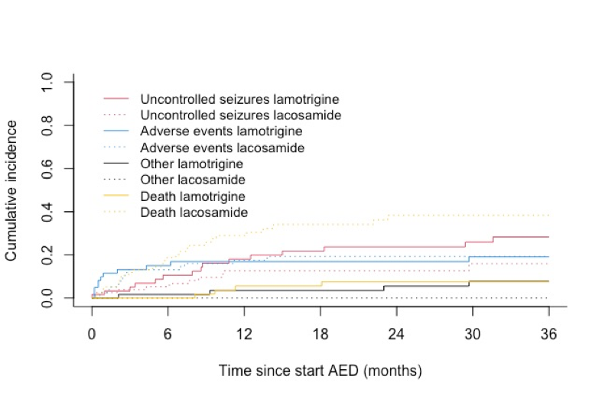
Supplemental S2: Estimated cumulative incidences corresponding to each competing event for the groups lamotrigine and lacosamide

Supplemental S3: Cumulative incidence functions for treatment failures and death
Time in months | 0 | 3 | 6 | 12 | 24 | 36 | p-value
No. at risk
Lamotrigine, no. | 61 | 45 | 39 | 30 | 23 | 0
Lacosamide, no. | 78 | 52 | 44 | 27 | 14 | 0
No. censored
Lamotrigine, no. | 0 | 4 | 6 | 6 | 8 | 27
Lacosamide, no. | 0 | 4 | 6 | 8 | 15 | 28
Treatment failure
Event uncontrolled seizures |  |  |  |  |  |  | 0.088
CIF (95%CI), lamotrigine | 2 (0-8) | 5 (1-13) | 11 (4-20) | 18 (9-29) | 24 (13-36) | 28 (17-41)
CIF (95%CI), lacosamide | 0 (NA) | 4 (1-10) | 5 (2-12) | 11 (5-20) | 11 (5-20) | 14 (6-25)
Event adverse events |  |  |  |  |  |  | 0.876
CIF (95%CI), lamotrigine | 0 (NA) | 13 (6-23) | 15 (7-25) | 17 (9-28) | 17 (9-28) | 19 (10-30)
CIF (95%CI), lacosamide | 0 (NA) | 13 (7-22) | 13 (7-22) | 19 (11-29) | 21 (12-31) | 21 (12-31)
Event other reasons¹ |  |  |  |  |  |  | 0.041
CIF (95%CI), lamotrigine | 0 (NA) | 2 (0-8) | 2 (0-8) | 4 (1-11) | 6 (1-14) | 8 (2-17)
CIF (95%CI), lacosamide | 0 (NA) | 0 (NA) | 0 (NA) | 0 (NA) | 0 (NA) | 0 (NA)
Event death |  |  |  |  |  |  | <0.001
CIF (95%CI), lamotrigine | 0 (NA) | 0 (NA) | 0 (NA) | 6 (1-14) | 7 (2-17) | 7 (2-17)
CIF (95%CI), lacosamide | 0 (NA) | 12 (6-20) | 19 (11-28) | 29 (19-40) | 38 (26-50) | 38 (26-50)
¹Other encompassed withdrawal due to remission (i.e. discontinuation of the antiepileptic drugs with consent of the physician, n=3) and unknown reasons (n=1); CI=confidence interval; CIF=cumulative incidence function; NA=not available; No.=number of patients

Supplemental S4: Detailed overview of adverse effects which led to treatment failure
Adverse Effects According to the CTCAE 5.0 | Lamotrigine |  |  |  |  |  |  | Lacosamide
Adverse Effects According to the CTCAE 5.0 | Grade, no. |  |  |  | Improved, no.¹ |  |  | Grade, no. |  |  |  | Improved, no.
Adverse Effects According to the CTCAE 5.0 | I & II | III & IV | ? | Total | Yes | No | ? | I & II | III & IV | ? | Total | Yes | No | ?
Blood and lymphatic system disorders
Lymphadenopathy | - | - | 1 | 1 | 1 | - | - | - | - | - | 0 | - | - | -
Gastrointestinal disorders
Dyspepsia | - | - | - | 0 | - | - | - | 1 | - | - | 1 | 1 | - | -
General and administration site conditions
Clinical deterioration | - | - | - | 0 | - | - | - | 1 | - | - | 1 | - | - | 1
Fatigue | 1 | - | - | 1 | 1 | - | - | - | - | - | 0 | - | - | -
Metabolism and nutrition disorders
Anorexia | - | - | - | 0 | - | - | - | 1 | - | - | 1 | - | 1 | -
Nervous system disorders
Ataxia | 1 | - | - | 1 | 1 | - | - | - | - | - | 0 | - | - | -
Concentration impairment | 1 | - | - | 1 | 1 | - | - | 2 | - | - | 2 | 1 | 1 | -
Dizziness | 2 | - | - | 2 | 1 | - | 1 | - | - | - | 0 | - | - | -
Encephalopathy | - | 1 | - | 1 | 1 | - | - | - | - | - | 0 | - | - | -
Headache | 1 | - | - | 1 | 1 | - | - | 2 | - | - | 2 | - | 2 | -
Memory impairment | - | - | - | 0 | - | - | - | 1 | - | - | 1 | - | 1 | -
Paresthesia | 1 | - | - | 1 | 1 | - | - | - | - | - | 0 | - | - | -
Presyncope | - | - | - | 0 | - | - | - | 1 | - | - | 1 | 1 | - | -
Somnolence | 1 | - | - | 1 | - | - | 1 | 1 | - | - | 1 | 1 | -
Tremor | 1 | - | - | 1 | 1 | - | - | - | - | - | 0 | - | - | -
Psychiatric disorders
Agitation | 3 | - | - | 3 | 2 | - | 1 | 2 | - | - | 2 | 1 | 1 | -
Depression | - | 1 | - | 1 | - | 1 | - | 3 | - | - | 3 | 2 | 1 | -
Hallucinations | 1 | - | - | 1 | 1 | - | - | - | - | - | 0 | - | - | -
Insomnia | - | - | - | 0 | - | - | - | 1 | - | - | 1 | 1 | - | -
Psychosis | - | 1 | - | 1 | - | 1 | - | - | - | - | 0 | - | - | -
Skin and subcutaneous tissue disorders
Rash | 1 | - | - | 1 | 1 | - | - | 1 | - | - | 1 | - | 1 | -
Unknown
Unknown | - | - | - | 0 | - | - | - | - | - | 2 | 2 | 2 | - | -
Total all adverse effects | 14 | 3 | 1 | 18 | 13 | 2 | 3 | 17 | 0 | 2 | 19 | 10 | 8 | 1
?=Unknown; ¹=Improvement after discontinuation of the current therapy with lamotrigine or lacosamide; CTCAE=Common Terminology Criteria for Adverse Events; No.=Number of patients

