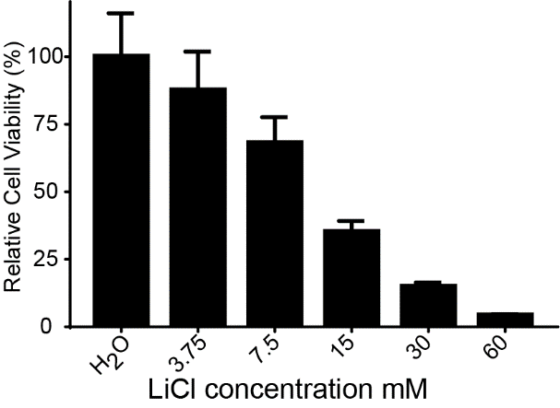

Supplementary Figure 1. LiCl reduces the viability of HTS cells

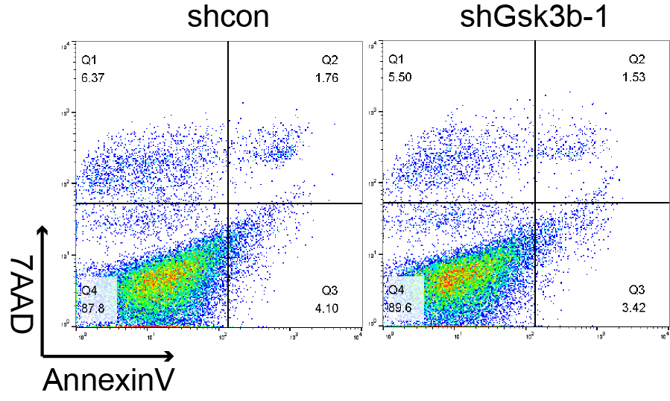
Supplementary Figure 2. Effect of Gsk3β knocking down on apoptosis of HTS cells.

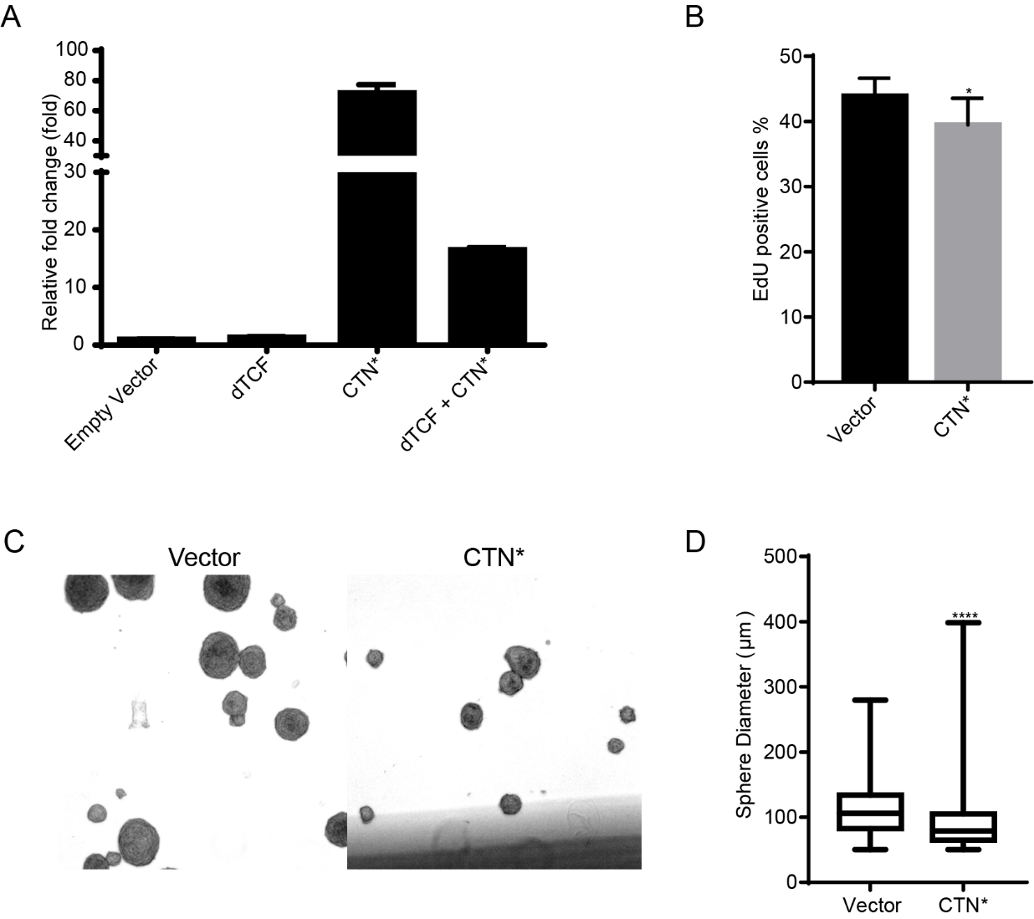
Supplementary Figure 3. Effect of CTN* overexpression on HTS cells. (A) Change in 7×TCF reporter activity after CTN* and dTCF transfection in 293T cells. (B) Quantification of EdU-positive cells from HTS cells overexpressing CTN*. (C & D) Representative image (C) and result of sphere diameter quantification (D) of sphere formation assay of HTS cells overexpressing the control vector or CTN*.

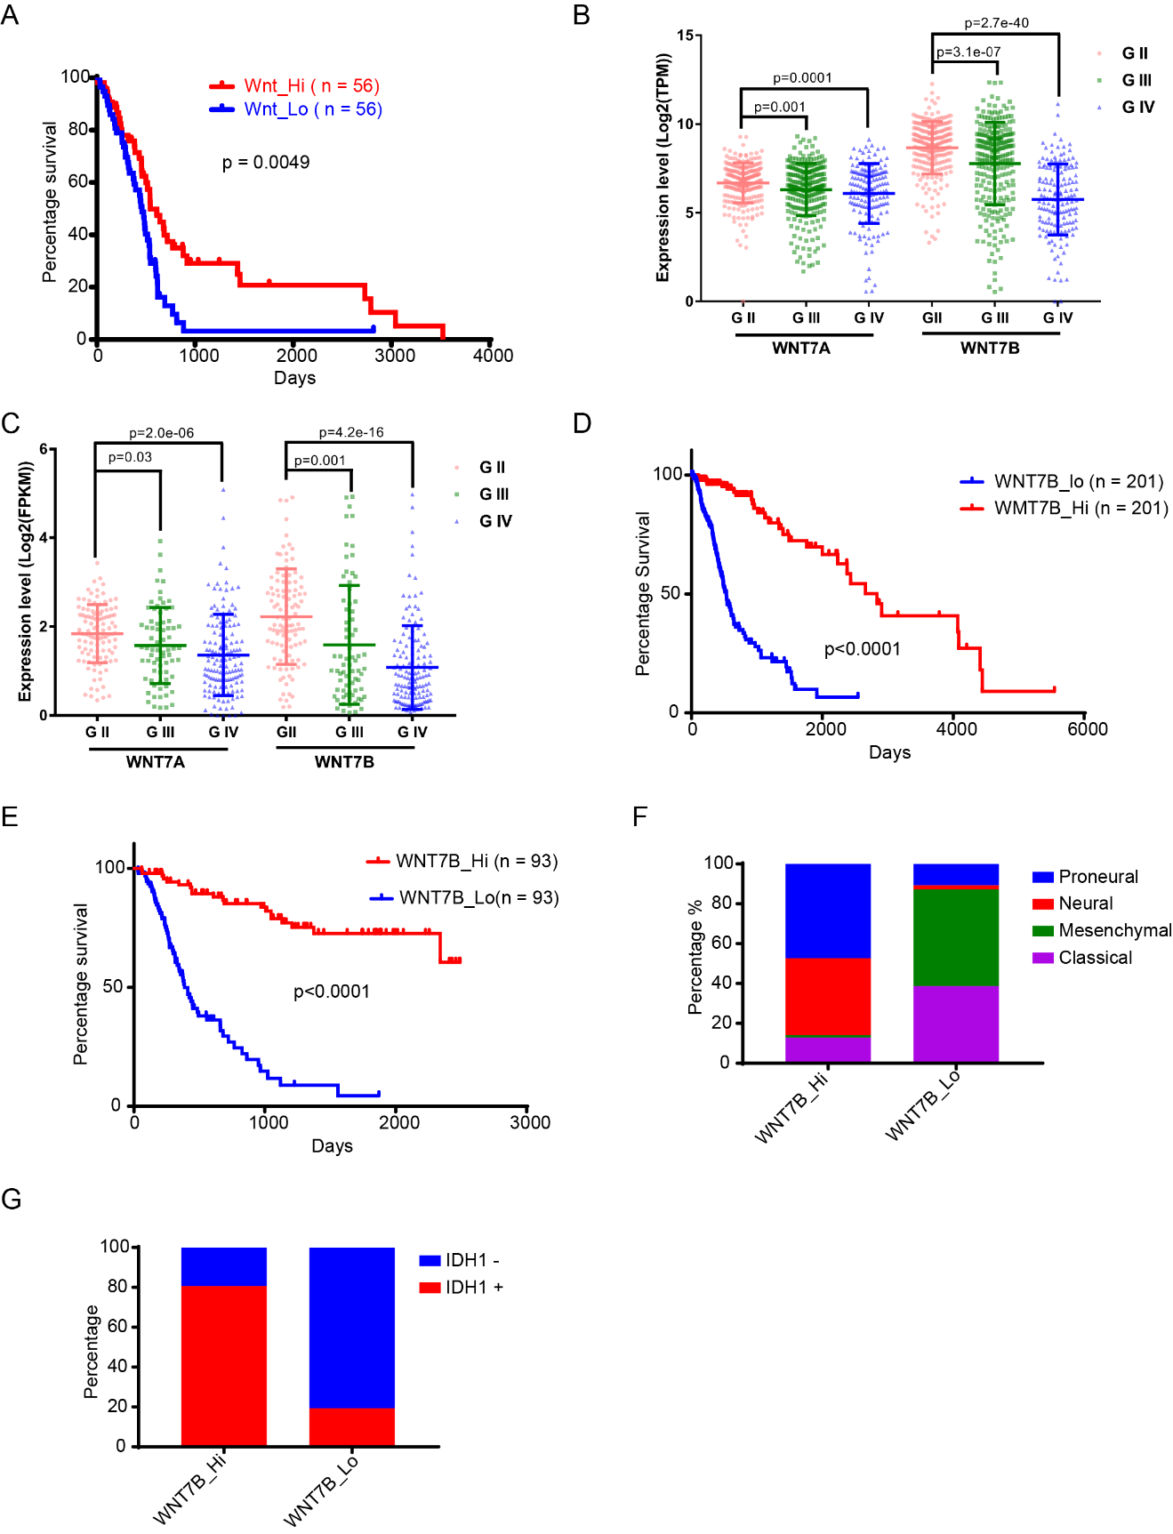
Supplementary Figure 4. Correlation of WNT expression with glioma tumor grade and patient prognosis. (A) Prognosis of the top 30% and bottom 30% of patients classified according to the canonical WNT ssGSEA score in the TCGA GBM dataset. (B & C) Expression level of WNT7A and WNT7B in gliomas of different grades from the TCGA (B) and CGGA (B) dataset. (D & E) Prognosis of the top 30% and bottom 30% of patients classified by WNT7B expression level in the TCGA (D) and CGGA (E) dataset. (F & G) Molecular tumor subtype (F) or IDH1 status (G) of the 30% or bottom 30% of patients in the bottom ranks according to their canonical WNT ssGSEA score from the CGGA dataset.
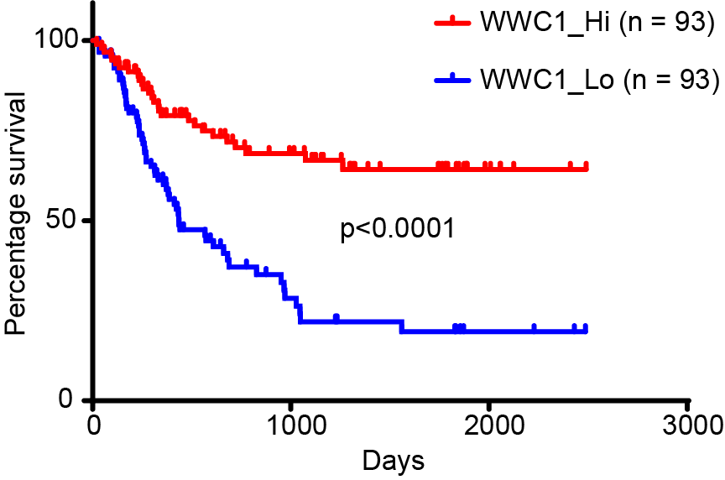
Supplementary Figure 5. Prognosis of patients with high WWC1 expression (top 30%) and low WWC1 expression (bottom 30%) in the CGGA dataset.
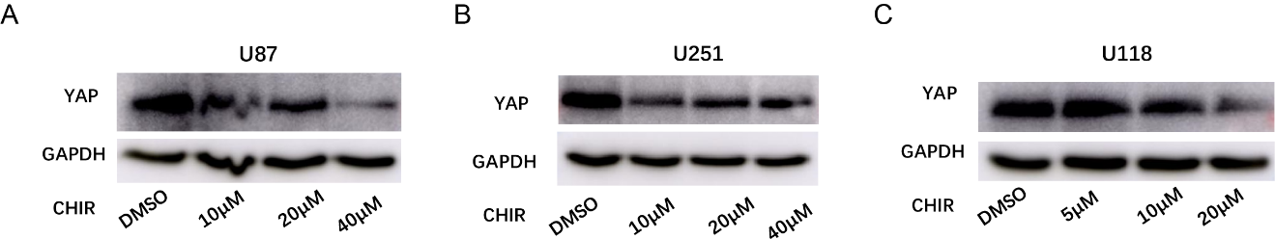
Supplementary Figure 6. YAP protein levels in U87 (A), U251 (B) and U118 (C) after different concentrations of CHIR stimulation.
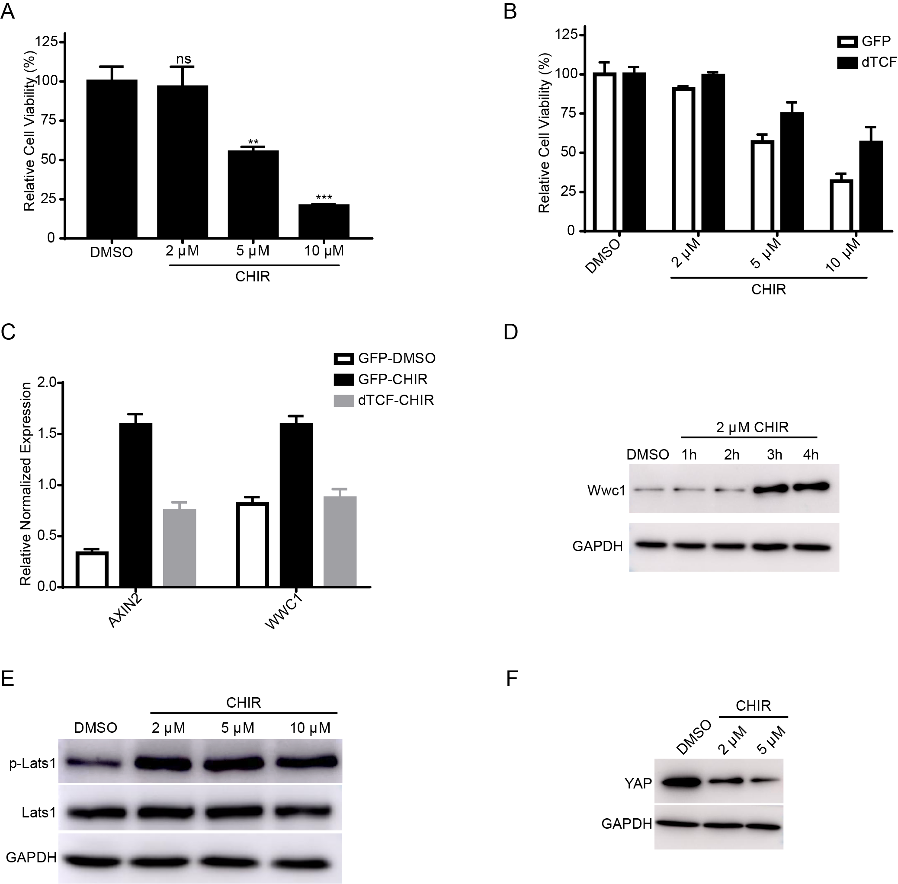
Supplementary Figure 7. The CHIR-WWC1-LATS1-YAP axis is conserved in the A375 melanoma cell line. (A) Viability of A375 cells after treatment with different concentrations of CHIR. (B) Overexpression of dTCF partially rescued the effect of CHIR on cell viability. (C) The expression of AXIN2 and WWC1 after CHIR treatment in GFP- or dTCF-overexpressing A375 cells. (D) WWC1 protein levels in A375 cells after 2 μM CHIR treatment at different time points. (E) The phosphorylation of Lats1 protein after different concentrations of CHIR treatment. (F) The protein level of YAP after different concentrations of CHIR treatment.

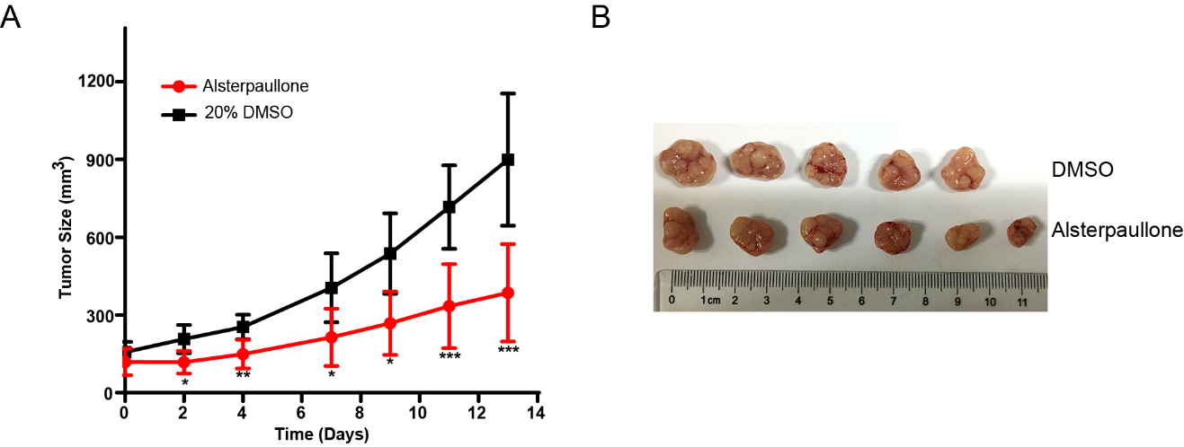
Supplementary Figure 8. Asterpaullone inhibits the growth of A375 tumors in vivo. (A & B) Tumor volume (A) and image (B) of nude mice treated with DMSO or alsterpaullone with subcutaneous A375 transplantation.

