Supplementary Materials

SI: Table of countries included in analysis

Official Name | ISO3
Angola | AGO
Burundi | BDI
Benin | BEN
Burkina Faso | BFA
Bouvet Island | BVT
Botswana | BWA
Central African Republic | CAF
Ivory Coast | CIV
Cameroon | CMR
Democratic Republic of the Congo | COD
Congo | COG
Comoros | COM
Cabo Verde | CPV
Djibouti | DJI
Algeria | DZA
Egypt | EGY
Eritrea | ERI
Western Sahara | ESH
Ethiopia | ETH
Gabon | GAB
Ghana | GHA
Guinea | GIN
Gambia | GMB
Guinea-Bissau | GNB
Equatorial Guinea | GNQ
Kenya | KEN
Liberia | LBR
Libya | LBY
Lesotho | LSO
Morocco | MAR
Madagascar | MDG
Mali | MLI
Mozambique | MOZ
Mauritania | MRT
Mauritius | MUS
Malawi | MWI
Mayotte | MYT
Namibia | NAM
Niger | NER
Nigeria | NGA
State of Palestine | PSE
Reunion | REU
Rwanda | RWA
Sudan | SDN
Senegal | SEN
Saint Helena | SHN
Sierra Leone | SLE
Somalia | SOM
Sao Tome and Principe | STP
Eswatini | SWZ
Seychelles | SYC
Chad | TCD
Togo | TGO
Tunisia | TUN
United Republic of Tanzania | TZA
Uganda | UGA
South Africa | ZAF
Zambia | ZMB
Zimbabwe | ZWE
Aruba | ABW
Aruba | ABW
Argentina | ARG
Bolivia (Plurinational State of) | BOL
Brazil | BRA
Chile | CHL
Colombia | COL
Colombia | COL
Ecuador | ECU
Falkland Islands (Malvinas) | FLK
French Guiana | GUF
Guyana | GUY
Panama | PAN
Panama | PAN
Peru | PER
Paraguay | PRY
Suriname | SUR
Trinidad and Tobago | TTO
Trinidad and Tobago | TTO
Uruguay | URY
Venezuela (Bolivarian Republic of) | VEN
Venezuela (Bolivarian Republic of) | VEN
Anguilla | AIA
Antigua and Barbuda | ATG
Bonaire, Sint Eustatius and Saba | BES
Bahamas | BHS
Belize | BLZ
Barbados | BRB
Costa Rica | CRI
Cuba | CUB
Cayman Islands | CYM
Dominica | DMA
Dominican Republic | DOM
Guadeloupe | GLP
Grenada | GRD
Guatemala | GTM
Honduras | HND
Haiti | HTI
Jamaica | JAM
Saint Kitts and Nevis | KNA
Saint Lucia | LCA
Mexico | MEX
Montserrat | MSR
Martinique | MTQ
Nicaragua | NIC
Puerto Rico | PRI
El Salvador | SLV
Turks and Caicos Islands | TCA
Saint Vincent and the Grenadines | VCT
British Virgin Islands | VGB
United States Virgin Islands | VIR
Brunei Darussalam | BRN
Indonesia | IDN
Malaysia | MYS
Philippines | PHL
Singapore | SGP
Timor-Leste | TLS
South Sudan | SSD
Table S1: list of countries included in analysis.

SII: Spatial distribution of low-lying buildings in Suriname and Ghana
The spatial distribution of buildings and topographic details within a country influence the vulnerability to SLR, as exemplified by a comparison of Suriname and Ghana. For 15m local SLR, Ghana and Suriname lose 7% and 91% of their total buildings, respectively, despite being similarly sized and having nearly the same length of coastline. This difference is largely attributable to the very different coastal slopes of the two countries, with over four times as much area falling at or below 20 m elevation in Suriname compared to Ghana. However, Ghana and Suriname also demonstrate that the relationship between hypsometry (i.e., area of land as a function of elevation) and building distribution can vary significantly (Fig. S2). Ghana has relatively few buildings along the coast, whereas in Suriname the buildings are concentrated along the coastline so that the proportion of inundated buildings rises much more quickly than the proportion of inundated land (Fig. S2). This comparison exemplifies that elevation distribution alone is not sufficient to predict the rate of building inundating from SLR, due to the complexities that land use, population, economic activity, materials, and culture contribute to determining how urban environments develop.
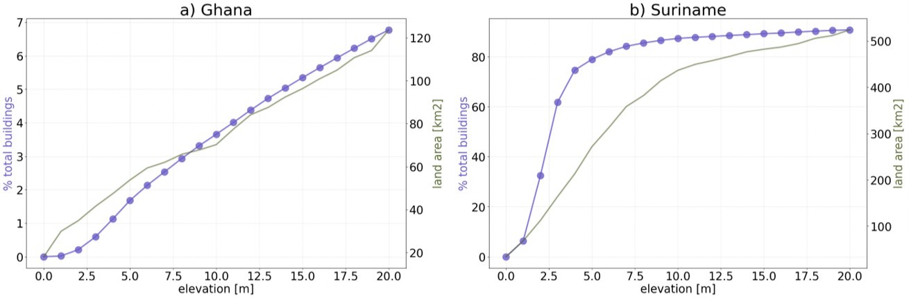
Fig. S2: The elevation distribution of buildings land area for (a) Ghana and (b) Suriname. Regions where the land area curve falls below the building fraction indicate elevations where there is a higher rate of increase in infrastructure density than there is land area. Note that elevations are taken at high tide (see Methods).

SIII: Open Buildings Polygons Uncertainty Analysis
To provide a preliminary assessment of the data contained in the Open Buildings Polygon Dataset we identified 12 areas across the Buildings layer for closer inspection. Areas were chosen by arbitrarily zooming in Earth Engine to a given part of a target coastline included in the dataset, adjusting slightly if the zoom didn’t cover buildings at first. This was repeated in several different countries with varying terrains and building density until 15,000 buildings were included. We then compared the Buildings layer’s delineations against the Earth Engine background Satellite layer. The Satellite layer is produced with relatively high-resolution (<4m) images, allowing any user to view close-up details. Particularly in areas of high social concern, such as coastlines, highly populated areas, and threatened forests, the coverage is generally kept quite current, updated between every few months and every few years. Because the Buildings layer was built in the past (and using a different set of images), we assessed that the Buildings layer represents a snapshot that is at the same time as or perhaps slightly earlier than the Satellite backdrop layer against which we compared, We drew 1km x 1km boxes and used a small script with which Earth Engine counted the number of objects (buildings) in the buildings layer inside that 1km2 area (Table S3. We then carefully scanned for errors of omission or commission at high resolution through the 1km2 area, moving systematically from North to South and East to West- approximately like reading.
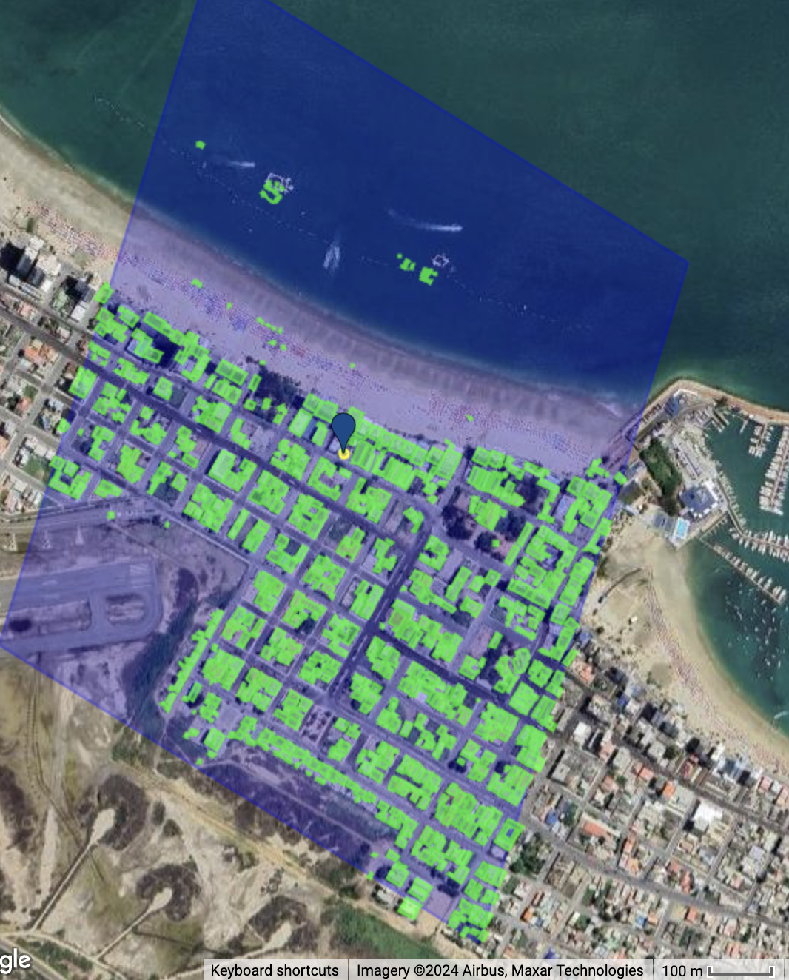

Fig. S3: Google Open Buildings Dataset test site. Visualization of the inspection process used to validate the accuracy of the Open Buildings Dataset for one test site.
Region | Location (longitude, latitude) of center of 1 km x 1 km region | Number of buildings identified in Google Buildings layer | Number of buildings on Earth Engine background Satellite layer missing from Buildings dataset | Number of buildings identified by the dataset not present in Earth Engine background Satellite layer
Mexico | -102.65, 18.05 | 53 | 1 (1.9%) | 1 (1.9%)
Haiti | -73.82, 18.03 | 96 | 1 (1.0%) | 0
Ecuador | -80.98, -2.20 | 1007 | 1 (0.1%) | 1 (0.1%)
Senegal | -17.46, 14.69 | 1812 | 4 (0.2%) | 1 (0.1%)
Gabon | 9.39, 0.50 | 2025 | 16 (0.8%) | 1 (0.1%)
Malaysia | 101.49, 3.00 | 1064 | 4 (0.4%) | 2 (0.2%)
Honduras | -87.26, 15.77 | 440 | 14 (3.2%) | 1 (0.2%)
South Africa | 25.56, -33.91 | 1032 | 2 (0.2%) | 0
Indonesia | 119.41, 5.13 | 2993 | 12 (0.4%) | 5 (0.2%)
Philippines | 121.61, 13.92 | 2617 | 9 (0.3%) | 2 (0.1%)
Egypt | 27.86, 31.21 | 221 | 6 (2.7%) | 0
Table S3: Areas inspected for accuracy of building identification. The average % buildings visible by satellite not identified by dataset was 1.1%, and the average % identified by dataset that were not visible by satellite was 0.3%.

While we recognized this assessment does not encapsulate the entirety of the dataset, the consistently low discrepancies across coastal regions, climates, and building densities shows confidence in the accuracy of the dataset for our purposes.

SIV: Assessment of methodological inundation assumptions
To determine what infrastructure is at risk of inundation for SLR, we incorporated high tides rather than depending on mean sea level values. Due to seawalls and other flood preventative infrastructure, there are currently buildings at or below sea level that do not experience regular inundation which have been included in our assumption for inundation risk. It is likely in the coming years as sea level encroaches onto higher elevations that these techniques will be utilized to reduce the impact. To quantify how much this impacts our results, we have identified the percent of total buildings in the dataset considered currently at 0 or below sea level, which can be found in Table S3:
Region | Percent of buildings marked as risk of inundation at high tide for 0m SLR
Caribbean + Mexico | 0.007%
SE Asia | 0.008%
Africa | 0.04%
South America | 0.02%
Table S4: fraction of the total buildings in the dataset currently identified as below high tide by region.
Table S4 indicates that while there are regions that exist below our defined inundation threshold, they are extremely small in comparison to the total volume of buildings considered.

