SI
Bioinspired structural color hydrogel skin from colloidal crystal arrays for epidermal sensing

Changyi Liu, Qingyu Zhao, Yucheng Cao, Xiaohui Li, Kexin Peng, and Fanfan Fu*

School of Environmental and Biological Engineering, Nanjing University of Science and Technology, Nanjing 210094, China

Supporting Figures
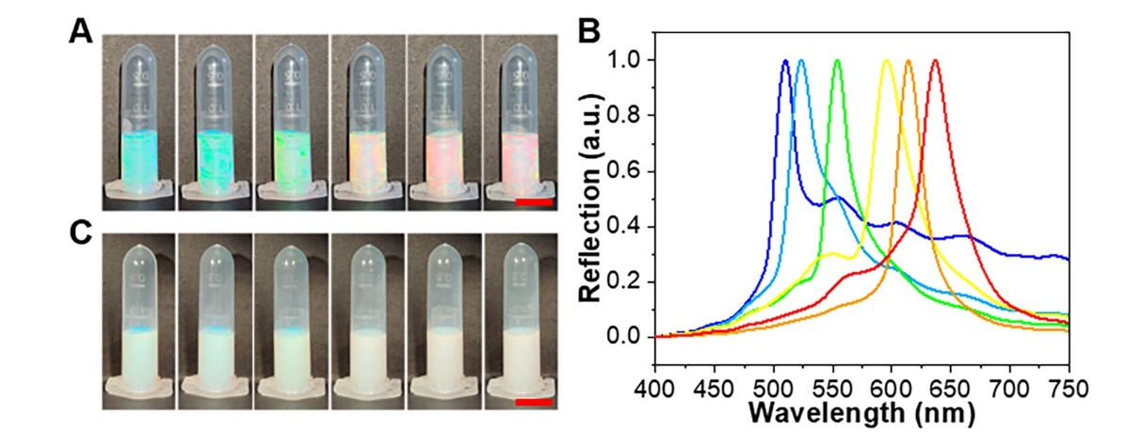
Figure S1. Optical images and reflection spectra of the colloidal particle suspensions in deionized water. (A) Optical images of suspensions with different concentrations of colloidal particles (from left to right, the concentrations were 0.172, 0.151, 0.135, 0.091, 0.084, and 0.080 g mL⁻¹, respectively). (B) Reflection spectra of suspensions in (A). (C) Optical images of suspensions after 10 days in (A). The scale bars were 1 cm in (A) and (C).
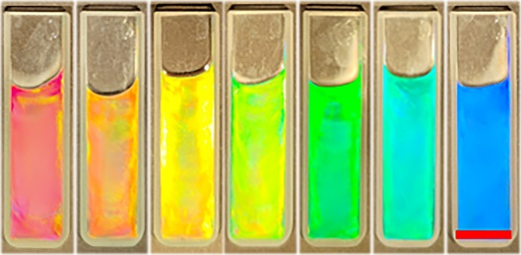
Figure S2. Optical images of the colloidal particle suspensions with MXene in Figure 2(C) after 30 days. The scale bar was 1 cm.
Figure S3. Schematic diagram of the synthesis process of ThyA and AdeA and the preparation process of PAA-(Ade/Thy)/MXene-based structural color hydrogel.
Figure S4. Optical images and reflection spectra of the colloidal particle suspensions with AA, AdeA, ThyA, and MXene. (A) Optical images of suspensions with different concentrations of colloidal particles (from left to right, the concentrations were 0.061, 0.07, 0.081, 0.117, 0.135, and 0.204 g mL⁻¹, respectively). The concentration of MXene in the suspension was 0.375 mg mL⁻¹. (B) Reflection spectra of suspensions in (A). The scale bar was 1 cm in (A).
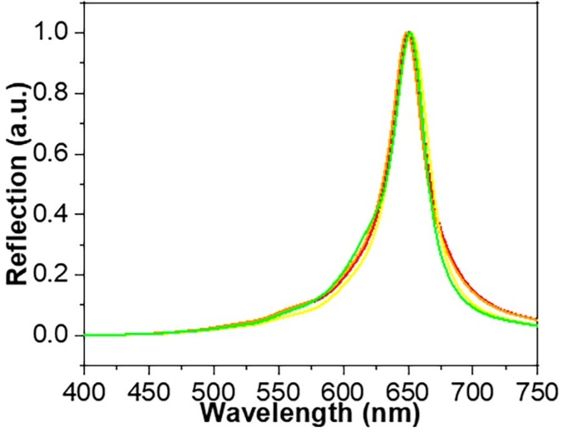
Figure S5. Reflection spectra of 4 pieces of hydrogels prepared from the same pre-gel suspension.
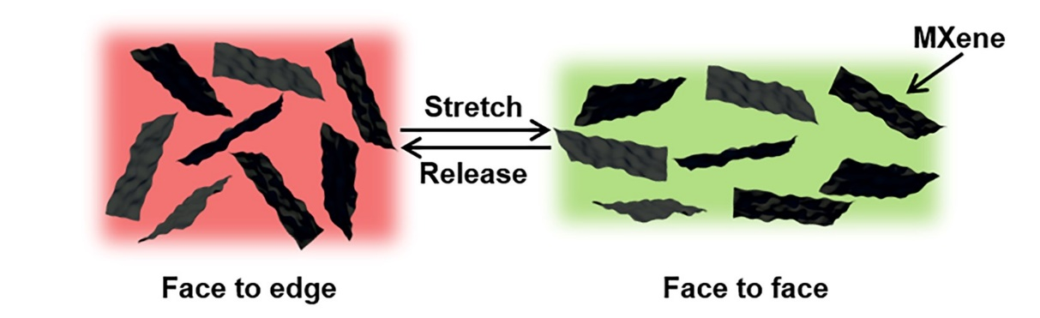
Figure S6. Schematic diagram of the change of MXene state before and after hydrogel stretching.
Figure S7. The trend of electrical resistance during hydrogel stretching.
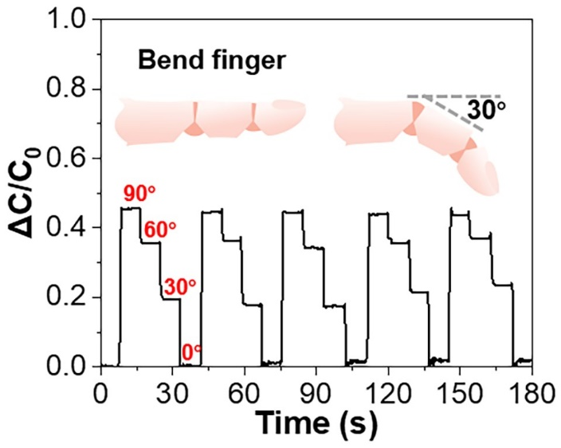
Figure S8. The trend of capacitance variation when hydrogel capacitor was bent with a finger.
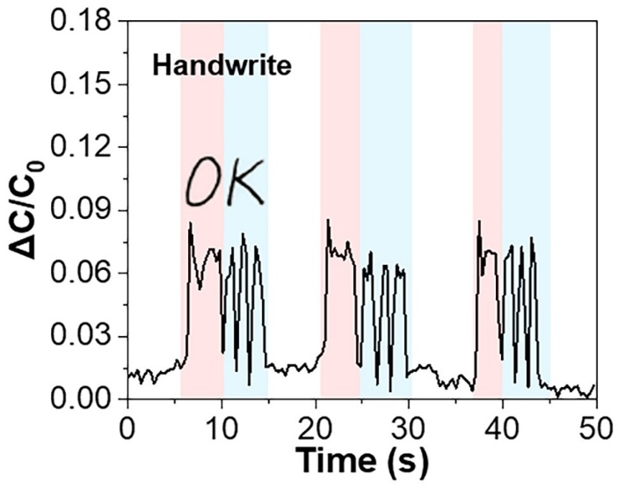
Figure S9. The trend of capacitance variation when writing on hydrogel capacitor.
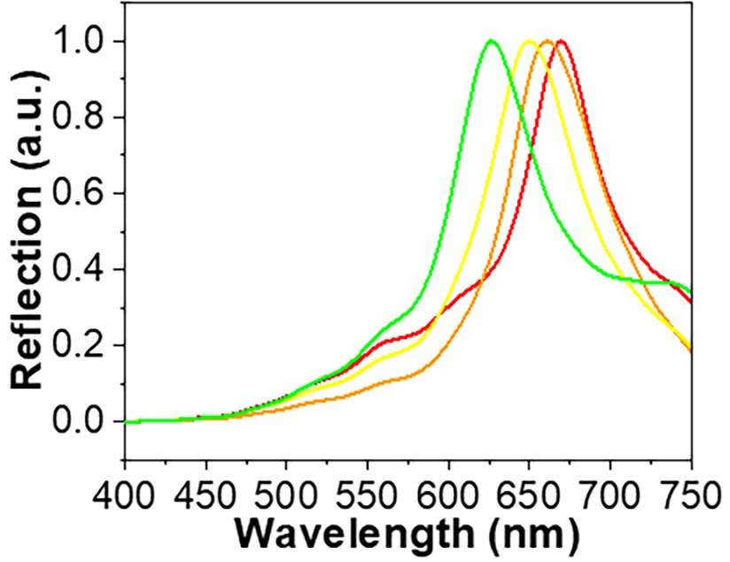
Figure S10. Reflection spectra of the hydrogel capacitor when pressed.
Supporting Movies
Movie S1: Optical images of hydrogel in a mechanical test.
Movie S2: Optical images of hydrogel bending with a finger.

