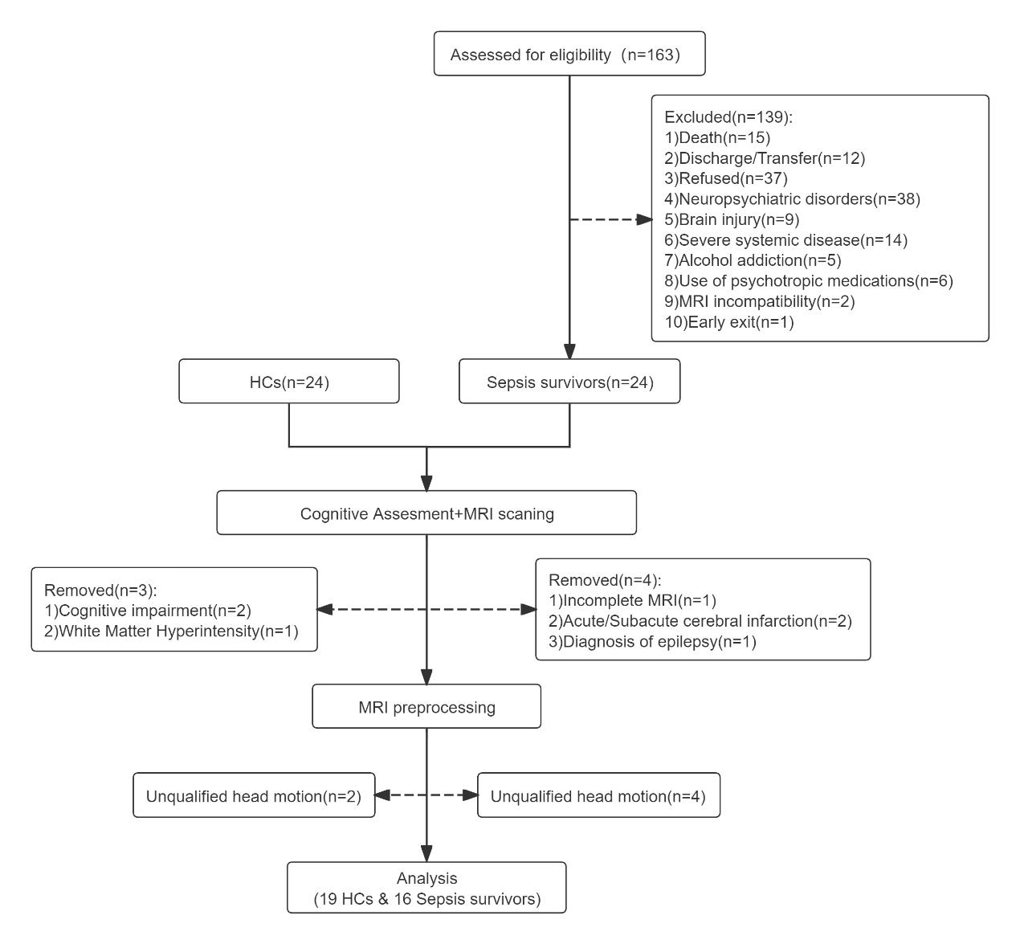
Supplementary Figure 1. Flow diagram of the participants throughout the study

