supplementary material

eAppendix 1: Introduction of the ablation methods

eAppendix 2: Introduction of CT equipment

eAppendix 3: Specific imaging and semantic feature interpretation

eAppendix 4: Specific Settings of the Pyradiomics software package for radiomics extraction features

eAppendix 5: The 3D ResNet-18 settings used for feature extraction

eAppendix 6: Specific interpretation and steps of feature mapping
Figure S1: Note of some imaging semantic features.
Figure S2: Radiomics and deep learning feature screening process.
Table S1: To extract the number of radiomics features
Table S2: Number of features after ICC-Lasso-RFE screening
Table S3: Extract the number of deep learning features
Table S4: Number of features after ICC-Lasso-RFE screening
Table S5:Radiomics and Deep Learning Features Correlation Coefficient
Table S6:The performance comparison of different models.
Table S7: Comparison results of NRI and IDI for different models

eAppendix 1: Introduction of the ablation methods
The ablation was performed by experienced physicians. The patient was comprehensively evaluated before treatment, and the appropriate ablation method (RFA or MWA,One needle or more) was selected according to the shape,size,location of the tumor and the adjacent relationship with the surrounding organs. Patients are in supine or oblique position with US(ultrasound) guided positioning before puncture to determine the precise and safe access. Subsequently, 1% lidocaine was injected between the skin and the peritoneum along the predetermined path, and intravenous anesthesia was given during the ablation. All ablation needles were placed to the target lesion under US. During ablation, the surgeon monitored whether the ablation area (hyperechoic area) completely covers the target lesion. After the ablation, a US examination was performed to assess whether a complete ablation was achieved. Complete ablation was defined as an ablation margin covering at least 5 mm of peritumor liver tissue. The ablation was performed by microwave treatment system (ECO-100C; Nanjing Yigao, China) or cold pole RF tumor system (HCCF-3000; Zhuhai Hejia, China).

eAppendix 2: Introduction of CT equipment
Contrast-enhanced computed tomography (CECT) was performed using a GE Lightspeed 4-slice, GE Discovery CT, or GE Lightspeed VCT 64-slice 128-layer spiral CT scanner. An initial routine abdominal CT scan was conducted to determine the extent of the lesion. The abdominal CT parameters were as follows: tube voltage 120 kVp, tube current 250–350 mA, slice thickness 5 mm, slice interval 5 mm, field of view (FOV) 35–50 cm, matrix size 512 × 512, rotation time 0.7 s, and pitch 1.375:1. Following the scan, a non-ionic iodinated contrast agent was administered at a rate of 3.0 mL/s using a high-pressure injector, with a dosage of 1.5 mL/kg. The arterial phase (A) scan was initiated automatically 35 seconds after the descending aorta's density reached 95 HU, as monitored by an automatic scan triggering software. The portal venous phase (P) and delayed phase (D) scans were commenced 35 seconds and 3 minutes after the AP scan, respectively.

eAppendix 3: Specific imaging and semantic feature interpretation
- Tumor Margins: Tumor margins are categorized into smooth and irregular types. This classification aids in the accurate description and assessment of the tumor's growth characteristics and its relationship with surrounding tissues. In the smooth margin type, the tumor appears nodular on imaging, with well-defined boundaries, clearly demarcated from the surrounding liver parenchyma, and without evidence of tumor cell invasion into adjacent liver tissue. Conversely, the irregular margin type is characterized by blurred edges on imaging, with the tumor displaying an infiltrative growth pattern that invades the surrounding liver tissue.
- Tumor Capsule: An enhanced ring observed around the tumor in the portal venous phase or delayed phase;
- Intra-tumoral Vessels: Visible hepatic artery branch vessels within the tumor during the arterial phase, specifically appearing as continuous linear high-density streaks within the tumor;
- Tumor Growth Pattern: The tumor growth pattern is classified into two types: growth beyond the liver boundary into the extrahepatic area and growth confined within the liver parenchyma without breaching the liver margin;
- Intra-tumoral Necrosis: Unenhanced low-density areas observed across all three enhanced phases;
- Peri-tumoral Enhancement: Patchy enhancement of peri-tumoral liver tissue observed in the late arterial phase or early portal venous phase.

eAppendix 4: Specific Settings of the Pyradiomics software package for radiomics extraction features
Prior to feature extraction, the following settings were applied: given the original slice thickness of 5 mm for this cohort of patients, resampling was performed on coronal and sagittal planes to achieve a voxel size of 1 mm × 1 mm × 5 mm. The image types included the original image (Original) and transformations applied to the original image, such as square (Square), square root (SquareRoot), logarithm (Logarithm), exponential (Exponential), gradient (Gradient), Laplacian of Gaussian filtering (LoG), and wavelet filtering (Wavelet). These settings allow for further processing and analysis of the original images to extract additional relevant feature information. The extracted original features included the following: (1)Nineteen first-order features; (2)Seventeen 3D shape features; (3)Ten 2D shape features; (4)Twenty-four Gray Level Co-occurrence Matrix (GLCM) features; (5)Sixteen Gray Level Size Zone Matrix (GLSZM) features; (6)Sixteen Gray Level Run Length Matrix (GLRLM) features; (7)Five Neighboring Gray Tone Difference Matrix (NGTDM) features; (8)Fourteen Gray Level Dependence Matrix (GLDM) features.

eAppendix 5: The 3D ResNet-18 settings used for feature extraction
We utilized a pre-trained 3D ResNet-18 in PyTorch 2.1.2 for deep feature extraction. Since the model is designed to handle three-channel 3D input images, and CT images are single-channel 3D grayscale images, adaptive adjustments were made to the input layer of the 3D ResNet-18 to accommodate single-channel images as input. Furthermore, the network structure was optimized by removing the final fully connected layer, enabling the model to output deep learning features consisting of 512 feature vectors.

eAppendix 6: Specific interpretation and steps of feature mapping
Feature Mapping refers to transforming the original 3D image data into a new representation that reveals specific characteristics or patterns within the image. In radiomic image analysis, feature mapping is typically used to extract radiomic features from images, reflecting properties such as texture, shape, and intensity distribution.
The steps for feature mapping are as follows:
(1)Reading Images and Mask Files: Image and corresponding mask files were read using Simple ITK.
(2)Executing Feature Extraction: The execute method of the PyRadiomics extractor was used to perform feature extraction in a voxel-based mode. In this study, only the Coarseness feature from all filter types was extracted, while other types of features were disabled.
(3)Processing Extracted Features: The extracted features were processed through feature mapping, allowing them to be displayed as pixel values at corresponding locations on the contrast-enhanced CT images.
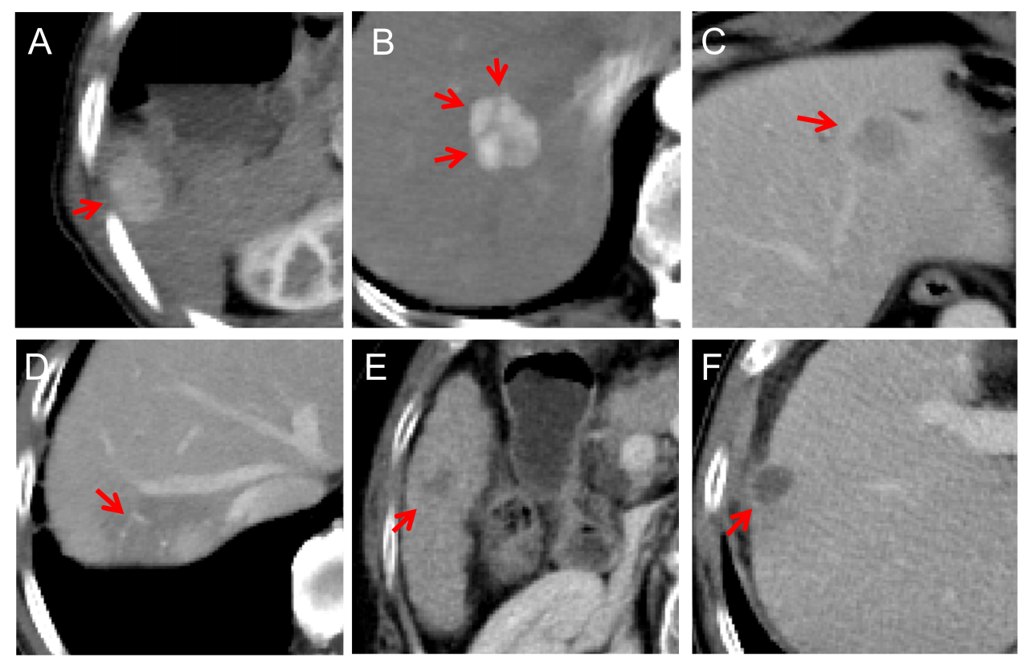
Figure S1: Note of some imaging semantic features.(A)Tumor growth mode, the direction of the arrow shows the tumor growth toward outside the liver. (B) Tumor margin, the arrow direction shows the smooth tumor margin and the clear boundary from the surrounding liver tissue.(C) tumor capsule, tumor capsule in the direction of the arrow, showing peritumoral high density in the portal stage.(D) intratumoral vessels, intratumoral vessels in the direction of red arrow, and showed high density in arterial stage.(E) Tumor margin, the arrow direction shows the non-smooth tumor margin.(F) Intratumoral necrosis, intratumoral necrosis in the direction of red arrow.
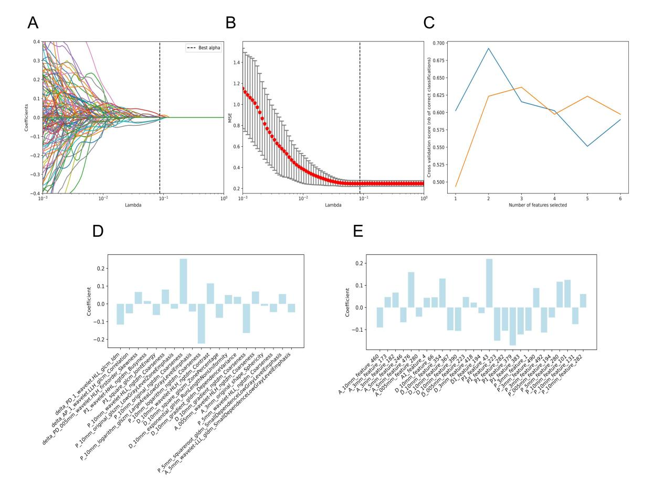
Figure S2: Radiomics and deep learning feature screening process.
(A) MSE plot from LASSO; (B) Correlation coefficient plot from LASSO; (C) RFE optimal feature selection plot, showing that the P1 phase achieves the best performance with 2 features, leading to the selection of 2 features from the P1 phase after RFE; (D) Feature importance plot displaying the 20 radiomic features selected through the three-step feature selection process; (E) Feature importance plot displaying the 27 deep learning features selected through the three-step feature selection process.

Table S1: To extract the number of radiomics features
stage | -5mm | tumour | 3mm | 5mm | 10mm | Residual liver
A | 1507 | 1515 | 1507 | 1507 | 1507 | 1515
P | 1507 | 1515 | 1507 | 1507 | 1507 | 1515
D | 1507 | 1515 | 1507 | 1507 | 1507 | 1515
A:arterial phase; P:Portal phase; D:delay phase.

Table S2: Number of features after ICC-Lasso-RFE screening
stage | -5mm | tumour | 3mm | 5mm | 10mm | Residual liver
A | 1 | 0 | 1 | 1 | 0 | 0
P | 0 | 2 | 0 | 2 | 5 | 0
D | 0 | 0 | 0 | 0 | 5 | 0
Table S3: Extract the number of deep learning features
stage | -5mm | tumour | 3mm | 5mm | 10mm | Residual liver
A | 512 | 512 | 512 | 512 | 512 | 512
P | 512 | 512 | 512 | 512 | 512 | 512
D | 512 | 512 | 512 | 512 | 512 | 512

Table S4: Number of features after ICC-Lasso-RFE screening of deep learning features
stage | -5mm | tumour | 3mm | 5mm | 10mm | Residual liver
A | 1 | 1 | 2 | 2 | 1 | 0
P | 1 | 1 | 1 | 0 | 4 | 0
D | 5 | 1 | 3 | 1 | 3 | 0

Table S5:Radiomics and Deep Learning Features Correlation Coefficient
特征名称 | 相关系数
delta_PD_1_wavelet.HLL_glcm_Idm | -0.11402920857855818
delta_AP_1_wavelet.LLH_glcm_Correlation | -0.04775441344548855
delta_PD_05mm_wavelet.HLH_firstorder_Skewness | 0.06662610443317281
P1_wavelet-HHL_ngtdm_Busyness | 0.018111860662227357
P1_square_glcm_JointEnergy | -0.05620872923513806
P_10mm_wavelet-HLL_ngtdm_Coarseness | -0.0055955829926134446
P_10mm_original_glszm_LowGrayLevelZoneEmphasis | -0.032337483033381596
P_10mm_original_ngtdm_Coarseness | 0.05350188779662486
P_10mm_logarithm_glszm_LargeAreaLowGrayLevelEmphasis | -0.039602215265394196
P_10mm_logarithm_ngtdm_Coarseness | -0.08188540717811152
D_10mm_wavelet-HLH_ngtdm_Contrast | 0.11094357137015953
D_10mm_square_glszm_ZonePercentage | -0.08822691759092977
D_10mm_exponential_glrlm_RunLengthNonUniformity | 0.05616801080983007
D_10mm_gradient_gldm_DependenceVariance | 0.03513534360658586
D_10mm_gradient_ngtdm_Coarseness | -0.16420202504946538
A_05mm_wavelet-HLH_ngtdm_Coarseness | 0.08167042909926239
A_3mm_original_shape_Sphericity | -0.008362655451061692
P_5mm_wavelet-HLL_ngtdm_Coarseness | 0.09768127919745359
P_5mm_squareroot_gldm_SmallDependenceLowGrayLevelEmphasis | 0.044283584126454494
A_5mm_wavelet-LLL_gldm_SmallDependenceLowGrayLevelEmphasis | -0.05423148416605686
A_10mm_feature_460 | -0.05443517719691115
A_3mm_feature_173 | 0.107107923410338
A_3mm_feature_182 | 0.08130525011889196
A_5mm_feature_246 | -0.04882375899472586
A_5mm_feature_476 | 0.16827004038732477
A_05mm_feature_280 | -0.04795791400752543
A1_feature_4 | -0.009333817559491557
D_10mm_feature_66 | 0.046641792621237396
D_10mm_feature_354 | 0.10651896604425931
D_10mm_feature_367 | -0.11587371839152336
D_10mm_feature_390 | -0.14235068560216788
D_05mm_feature_223 | 0.0545557875808658
D_3mm_feature_418 | 0.04678717816230968
D1_feature_194 | -0.018788192787670605
P1_feature_43 | 0.15157805251225398
P1_feature_223 | -0.16475319768563726
P1_feature_282 | -0.1303352777025135
P1_feature_379 | -0.19945487579881632
P1_feature_383 | -0.10544119564151942
P_3mm_feature_1 | -0.10213267257589126
P_3mm_feature_490 | 0.11977551377381096
P_3mm_feature_492 | -0.12751396888689276
P_05mm_feature_194 | -0.03007325117402239
P_5mm_feature_280 | 0.12025320218092422
P_10mm_feature_101 | 0.13949128767208974
P_10mm_feature_131 | -0.06311439441850951
P_10mm_feature_282 | 0.05919561652644271

Table S6:The performance comparison of different models.
 |  |  | Train cohort |  |  |  | Test cohort
 | Model | ACC | NPV | PPV | AUC （95%CI ） |  | ACC | NPV | PPV | AUC （95%CI ）
Cli | SVM | 0.69 | 0.581 | 0.763 | 0.695(0.677-0.714) |  | 0.612 | 0 | 1 | 0.500(0.500-0.500)
Cli | LR | 0.652 | 0.742 | 0.591 | 0.708(0.684-0.732) |  | 0.612 | 0 | 1 | 0.493(0.493-0.493)
Cli | RF | 0.69 | 0.581 | 0.763 | 0.712(0.686-0.738) |  | 0.612 | 0.654 | 0.585 | 0.690(0.649-0.731)
Cli | KNN | 0.69 | 0.581 | 0.763 | 0.697(0.669-0.725) |  | 0.612 | 0.654 | 0.585 | 0.621(0.579-0.662)
Cli | XGBoost | 0.69 | 0.581 | 0.763 | 0.715(0.697-0.732) |  | 0.612 | 0.654 | 0.585 | 0.658(0.628-0.687)
Cli | LightGBM | 0.69 | 0.581 | 0.763 | 0.698(0.671-0.726) |  | 0.612 | 0.654 | 0.585 | 0.690(0.647-0.733)
Rads | SVM | 0.761 | 0.71 | 0.796 | 0.826(0.785-0.867) |  | 0.701 | 0.615 | 0.756 | 0.772(0.709-0.835)
Rads | LR | 0.774 | 0.806 | 0.753 | 0.826(0.790-0.862) |  | 0.716 | 0.692 | 0.732 | 0.772(0.718-0.826)
Rads | RF | 0.781 | 0.806 | 0.763 | 0.872(0.826-0.919) |  | 0.716 | 0.692 | 0.732 | 0.735(0.662-0.808)
Rads | KNN | 0.781 | 0.774 | 0.785 | 0.825(0.785-0.866) |  | 0.731 | 0.692 | 0.756 | 0.725(0.661-0.789)
Rads | XGBoost | 0.839 | 0.726 | 0.914 | 0.935(0.885-0.986) |  | 0.642 | 0.385 | 0.805 | 0.730(0.655-0.804)
Rads | LightGBM | 0.781 | 0.774 | 0.785 | 0.872(0.826-0.918) |  | 0.731 | 0.692 | 0.756 | 0.770(0.701-0.840)
DLR | SVM | 0.819 | 0.71 | 0.892 | 0.901(0.847-0.955) |  | 0.776 | 0.692 | 0.829 | 0.860(0.779-0.941)
DLR | LR | 0.839 | 0.823 | 0.849 | 0.908(0.858-0.957) |  | 0.776 | 0.769 | 0.78 | 0.870(0.794-0.946)
DLR | RF | 0.852 | 0.726 | 0.935 | 0.901(0.837-0.965) |  | 0.791 | 0.731 | 0.829 | 0.733(0.624-0.842)
DLR | KNN | 0.832 | 0.774 | 0.871 | 0.908(0.855-0.961) |  | 0.791 | 0.731 | 0.829 | 0.874(0.795-0.953)
DLR | XGBoost | 0.89 | 0.839 | 0.925 | 0.929(0.894-0.964) |  | 0.776 | 0.731 | 0.805 | 0.847(0.793-0.900)
DLR | LightGBM | 0.845 | 0.823 | 0.86 | 0.924(0.888-0.960) |  | 0.776 | 0.731 | 0.805 | 0.867(0.812-0.922)
CR | SVM | 0.794 | 0.758 | 0.817 | 0.850(0.811-0.890) |  | 0.612 | 0 | 1 | 0.597(0.597-0.597)
CR | LR | 0.768 | 0.839 | 0.72 | 0.852(0.810-0.893) |  | 0.612 | 0 | 1 | 0.508(0.508-0.508)
CR | RF | 0.806 | 0.742 | 0.849 | 0.878(0.841-0.914) |  | 0.731 | 0.654 | 0.78 | 0.807(0.748-0.865)
CR | KNN | 0.781 | 0.613 | 0.892 | 0.852(0.812-0.893) |  | 0.791 | 0.654 | 0.878 | 0.795(0.724-0.865)
CR | XGBoost | 0.858 | 0.774 | 0.914 | 0.933(0.903-0.963) |  | 0.746 | 0.692 | 0.78 | 0.809(0.760-0.858)
CR | LightGBM | 0.832 | 0.806 | 0.849 | 0.906(0.857-0.956) |  | 0.776 | 0.769 | 0.78 | 0.842(0.759-0.926)
CD | SVM | 0.858 | 0.774 | 0.914 | 0.916(0.861-0.970) |  | 0.612 | 0 | 1 | 0.500(0.500-0.500)
CD | LR | 0.865 | 0.855 | 0.871 | 0.920(0.865-0.975) |  | 0.612 | 0 | 1 | 0.624(0.624-0.624)
CD | RF | 0.871 | 0.839 | 0.892 | 0.920(0.876-0.963) |  | 0.821 | 0.846 | 0.805 | 0.863(0.796-0.930)
CD | KNN | 1 | 1 | 1 | 1.000(0.922-1.078) |  | 0.761 | 0.615 | 0.854 | 0.810(0.767-0.852)
CD | XGBoost | 0.942 | 0.903 | 0.968 | 0.982(0.921-1.043) |  | 0.806 | 0.808 | 0.805 | 0.844(0.746-0.941)
CD | LightGBM | 0.884 | 0.855 | 0.903 | 0.947(0.889-1.005) |  | 0.791 | 0.808 | 0.78 | 0.869(0.781-0.958)
DLRR | SVM | 0.871 | 0.758 | 0.946 | 0.940(0.881-1.000) |  | 0.821 | 0.808 | 0.829 | 0.890(0.798-0.982)
DLRR | LR | 0.877 | 0.871 | 0.882 | 0.945(0.891-0.998) |  | 0.821 | 0.846 | 0.805 | 0.907(0.823-0.991)
DLRR | RF | 0.91 | 0.871 | 0.935 | 0.979(0.918-1.040) |  | 0.866 | 0.846 | 0.878 | 0.897(0.807-0.987)
DLRR | KNN | 0.897 | 0.855 | 0.925 | 0.950(0.889-1.011) |  | 0.821 | 0.846 | 0.805 | 0.886(0.795-0.977)
DLRR | XGBoost | 0.897 | 0.823 | 0.946 | 0.968(0.930-1.006) |  | 0.851 | 0.769 | 0.902 | 0.896(0.837-0.954)
DLRR | LightGBM | 0.916 | 0.871 | 0.946 | 0.981(0.917-1.044) |  | 0.851 | 0.769 | 0.902 | 0.910(0.815-1.006)
Combined | SVM | 0.89 | 0.823 | 0.935 | 0.944(0.886-1.002) |  | 0.612 | 0 | 1 | 0.605(0.605-0.605)
Combined | LR | 0.897 | 0.903 | 0.892 | 0.946(0.889-1.004) |  | 0.612 | 0 | 1 | 0.707(0.707-0.707)
Combined | RF | 0.897 | 0.806 | 0.957 | 0.952(0.908-0.996) |  | 0.851 | 0.769 | 0.902 | 0.904(0.839-0.968)
Combined | KNN | 1 | 1 | 1 | 1.000(0.922-1.078) |  | 0.761 | 0.615 | 0.854 | 0.840(0.796-0.883)
Combined | XGBoost | 0.948 | 0.903 | 0.978 | 0.996(0.931-1.061) |  | 0.851 | 0.808 | 0.878 | 0.914(0.817-1.011)
Combined | LightGBM | 0.916 | 0.871 | 0.946 | 0.983(0.920-1.047) |  | 0.821 | 0.769 | 0.854 | 0.904(0.809-1.000)
Cli, clinical imaging model; Rad, radiomics model;DLR,Deep-learning model;CR,clinical imaging and Rad-Score combined model;CDL,clinical imaging and DL-Score combined model;
DLRR,Rad-Score and DL-Score combined model;Combined,a comprehensive model combining all features.

Table S7: Comparison results of NRI and IDI for different models
 | Model | Model | NRI(P value) | IDI（P value）
1 | Cli | Rad | 0.00249 | 0.00432
 | Cli | DLR | ＜0.0001 | ＜0.0001
 | Cli | CR | 0.00499 | ＜0.0001
 | Cli | CDL | ＜0.0001 | ＜0.0001
 | Cli | DLRR | ＜0.0001 | ＜0.0001
 | Cli | Combined | ＜0.0001 | ＜0.0001
2 | Rad | DLR | 0.68106 | 0.03994
 | Rad | CR | 0.78397 | 0.03876
 | Rad | CDL | 0.09243 | 0.02861
 | Rad | DLRR | 0.00173 | ＜0.0001
 | Rad | Combined | 0.00059 | 0.00001
3 | DLR | CR | 0.88638 | 0.33792
 | DLR | CDL | 0.07059 | 0.81155
 | DLR | DLRR | 0.0009 | 0.00033
 | DLR | Combined | 0.00026 | 0.00041
4 | CR | CDL | 0.09369 | 0.19788
 | CR | DLRR | 0.00935 | 0.00052
 | CR | Combined | 0.00202 | 0.00048
5 | CDL | DLRR | 0.17608 | 0.00311
 | CDL | Combined | 0.05709 | 0.00019
6 | DLRR | Combined | 0.56118 | 0.36086

