Immune and microbial signatures in immunocompetent and immunocompromised patients with pneumonia

Figure S1. The microbial composition of ICH and ICO patients with pneumonia. A, Relative abundance of different microbial species in BALF samples from ICH and ICO patients. B, Comparison of top 10 abundant microbial species in BALF samples from ICH and ICO patients. C, Relative abundance of different microbial species in sputum samples from ICH and ICO patients. D, Comparison of top 10 abundant microbial species in sputum samples from ICH and ICO patients. *,**, and *** represent P<0.05, P<0.01, and P<0.001, respectively.

Figure S2. Comparison of PSI score between ICH and ICO patients. The PSI scores of individual patients in ICH and ICO groups were shown in Box-plot. **** represents P<1×10⁻⁴.

Figure S3. The microbial composition of respiratory tract among pneumonia patients with different PSI scores. A, Relative abundances of different microbial species in BALF samples from pneumonia patients with different PSI scores. B, Comparison of top 10 abundant microbial species in BALF samples from pneumonia patients with different PSI scores. C, Relative abundances of different microbial species in sputum samples from pneumonia patients with different PSI scores. D, Comparison of top 10 abundant microbial species in sputum samples from pneumonia patients with different PSI scores. *,**, and *** represent P<0.05, P<0.01, and P<0.001, respectively.

Figure S4. The difference of EBV abundance between ICH and ICO patients. EBV abundances in both ICH and ICO patients were calculated using metagenomic and metatranscriptomic sequencing of BALF (A and E), blood (B and F), sputum (C and G), and swab (D and H). * and ** represent P<0.05 and P<0.01, respectively, while ns means insignificant.

Figure S5. EBV detection in different types of samples. The numbers of EBV-detected and EBV not-detected patients in ICH and ICO groups were revealed using metagenomic and metatranscriptomic sequencing of BALF (A), blood (B), sputum (C), and swab (D) samples, respectively.

Figure S6. The difference of microbial composition between EBV-detected and not-detected pneumonia patients. A, Relative abundance of different microbial species in BALF samples from EBV-detected and EBV not-detected pneumonia patients. B, Comparison of the relative abundance of top 10 microbial species in balf samples from EBV-detected and EBV not-detected pneumonia patients. C, Relative abundance of different microbial species in sputum samples from EBV-detected and EBV not-detected pneumonia patients. D, Comparison of the relative abundance of top 10 microbial species in sputum samples EBV-detected and EBV not-detected pneumonia patients. * represents P<0.05.

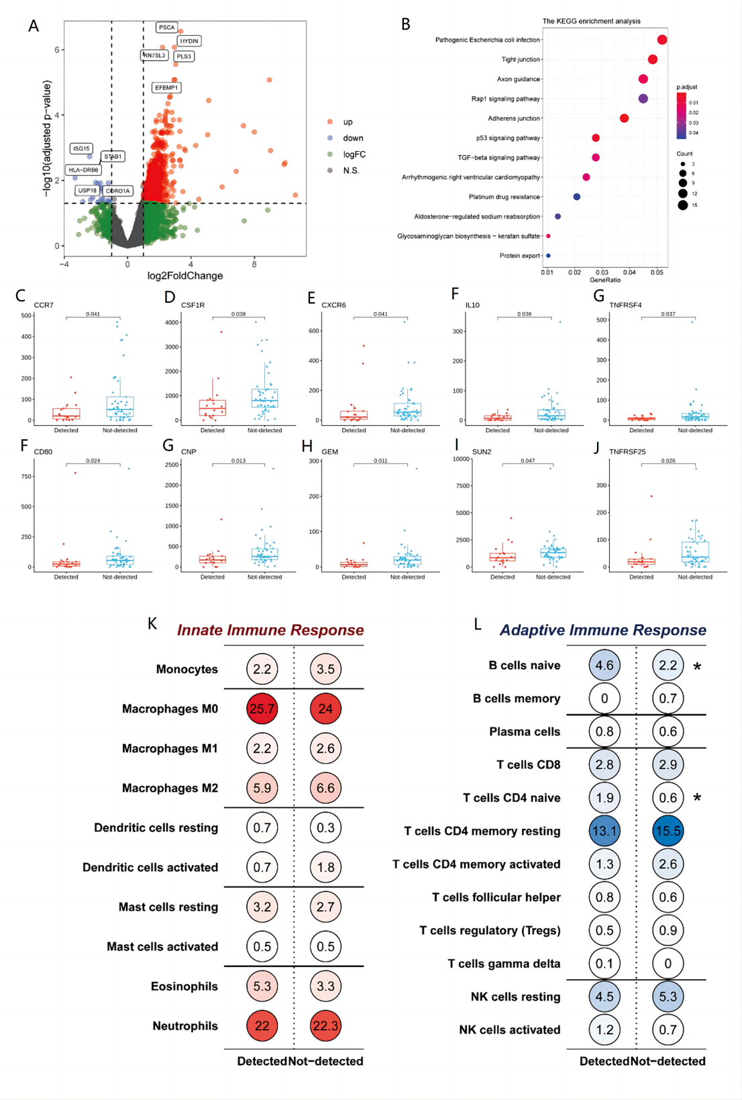
Figure S7. Comparison of BALF metatranscriptomic profiles between EBV-detected and not-detected groups. A, Volcano Plot demonstrates the differentially expressed genes (DEGs)between EBV-detected and not-detected patients. B, Gene functional classification of DEGs. C-J, The difference in expression of IRGs and ISGs between EBV-detected and not-detected patients. M and N, The proportion of immune cell types involved in innate immune response (M) and adaptive immune response (N) in EBV-detected and not-detected patients.

