Supplementary Information

Impact of Frequent ARID1A Mutations on Protein Stability: Insights into Cancer Pathogenesis
Rajen K Goutam¹, Gangtong Huang¹, Exequiel Medina², Feng Ding¹, William J. Edenfield³, Hugo Sanabria^{1,*}
- Department of Physics and Astronomy, Clemson University, Clemson, 29634, SC, USA
- Departamento de Bioquímica y Biología Molecular, Facultad de Ciencias Químicas y Farmacéuticas, Universidad de Chile, Chile.
- Institute for Translational Oncology Research, Prisma Health, Greenville, SC, USA.

* Corresponding author: hsanabr@clemson.edu

Table of contents

 | Title | Page
Supplementary Table 1 | Proteins with ARID domains used in our study to sort the frequency of missense mutation | 3
Supplementary Table 2 | Plasmid of ARID (WT) and by designing the primers for obtaining the mutants | 4
Supplementary Figure 1 | Plasmid vector pET-28a (+) and linear restriction sites | 5
Supplementary Figure 2 | Change in folding free energy | 6
Supplementary Figure 3 | rexDMD showed variation on the molecular parameters | 7
Supplementary Figure 4 | 2D PMF plot from rexDMD | 8
Supplementary Figure 5 | Thermal denaturation spectra for all the samples | 9
Supplementary Figure 6 | Thermal denaturation parameters for all the mutants | 10
Supplementary Figure 7 | Chemical denaturation spectra for all the samples | 11
Supplementary Figure 8 | Chemical denaturation parameters for all samples | 12
Supplementary Figure 9 | CD Spectra at different %TFE showed M1022K most stabilizing | 13
Supplementary Figure 10 | Interacting sites for WT and mutants in specific position using DDMut | 14
Supplementary Figure 11 | The native state spectra for the mutants showed variation | 15
Supplementary Figure 12 | The AlphaMissense Score showed all mutants are pathogenic correlate with overall impact | 16

Table 1: Proteins with ARID domains used in our study to sort the frequency of missense mutation.
Number | Name (protein id, range)
1 | P41229-1 (76-165)
2 | A6NKF2(110-201)
3 | Q9UGL (94-183)
4 | Q92833-2 (618-709)
5 | KDM5C (21-~150)
6 | Q4LE (303-392)
7 | Q8NFD5-2(1050-1140)
8 | P29374(306-397)
9 | Q9BY66-1(80-170)
10 | 014497 (1018-1109)

Table 2: The primers for obtaining the mutants using plasmid of ARID (WT).
Mutants | sequence
R1020S_F | 5’taagatgtgggttgatCGCTATCTGGCTTTCACTG3’
R1020S_R | 5’ctttccggctcaccaccTAACTCGTACAGTTTGGTG3’
M1022K_F | 5’gtgggttgatcgctatCTGGCTTTCACTGAGGAAAAAG3’
M1022K_R | 5’ttcttacgttccggctcACCACCTAACTCGTACAG3’
K1047Q_F | 5’caaccgctggacctgTACCGCCTGTACGTGAGC3’
K1047Q_R | 5’acggccaactgccggCAGGTTCGTCATACCCATGG3’
G1063V_F | 5’tttgacccaggttaatAAGAACAAGAAGTGGCGTGAATTG3’
G1063V_R | 5’acgccaatttctttgacGCTCACGTACAGGCGGTA3’
A1089T_F | 5’ctcgagcgctACCagctccctga3’
A1089T_R | 5’tcagggagctGGTagcgctcgag3’

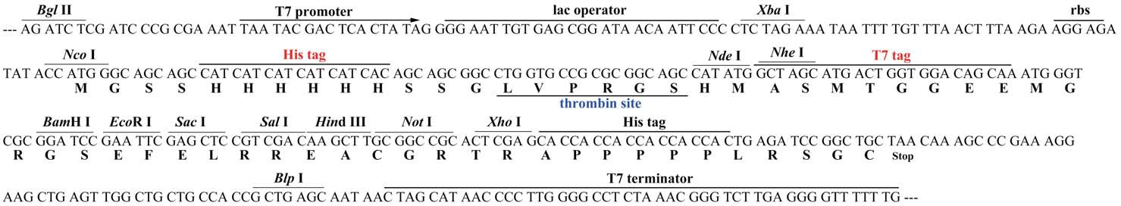
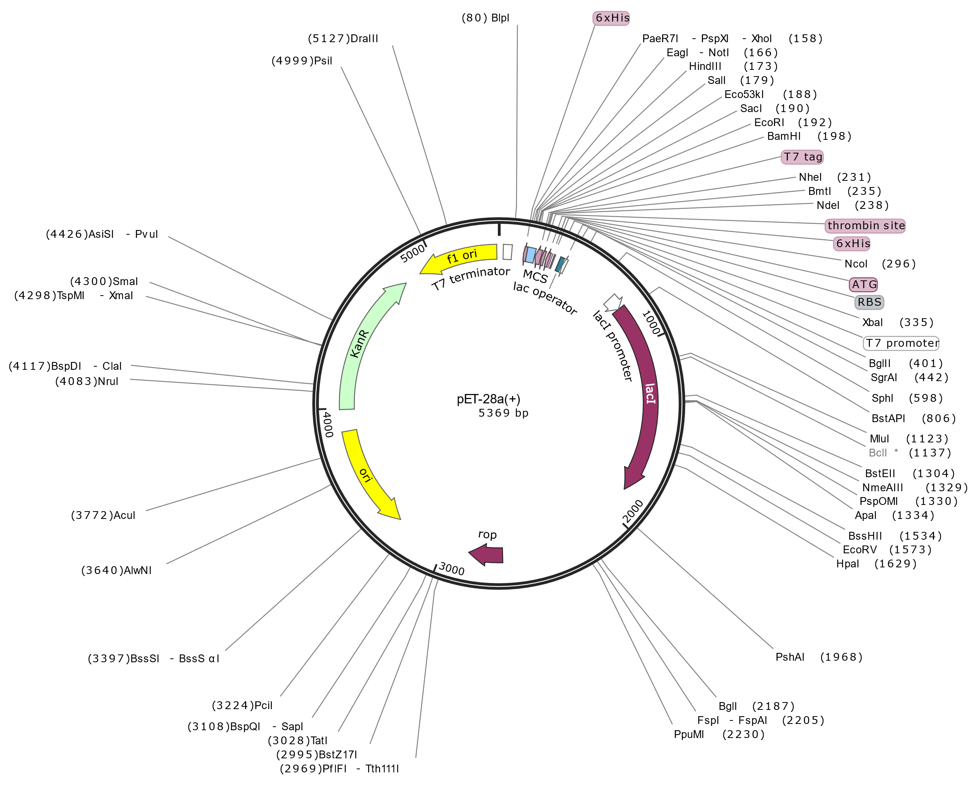

Fig1 S1: Plasmid vector pET-28a (+) and linear restriction sites. The top section shows the circular vector with unique restriction sites, an N-terminal His-Tag/thrombin/T7-Tag configuration. The T7 expression region is reversed due to pBR322 sequence numbering. The f1 origin orientation supports single-stranded DNA production for sequencing with the T7 terminator primer. The bottom section shows the cloning/expression region.

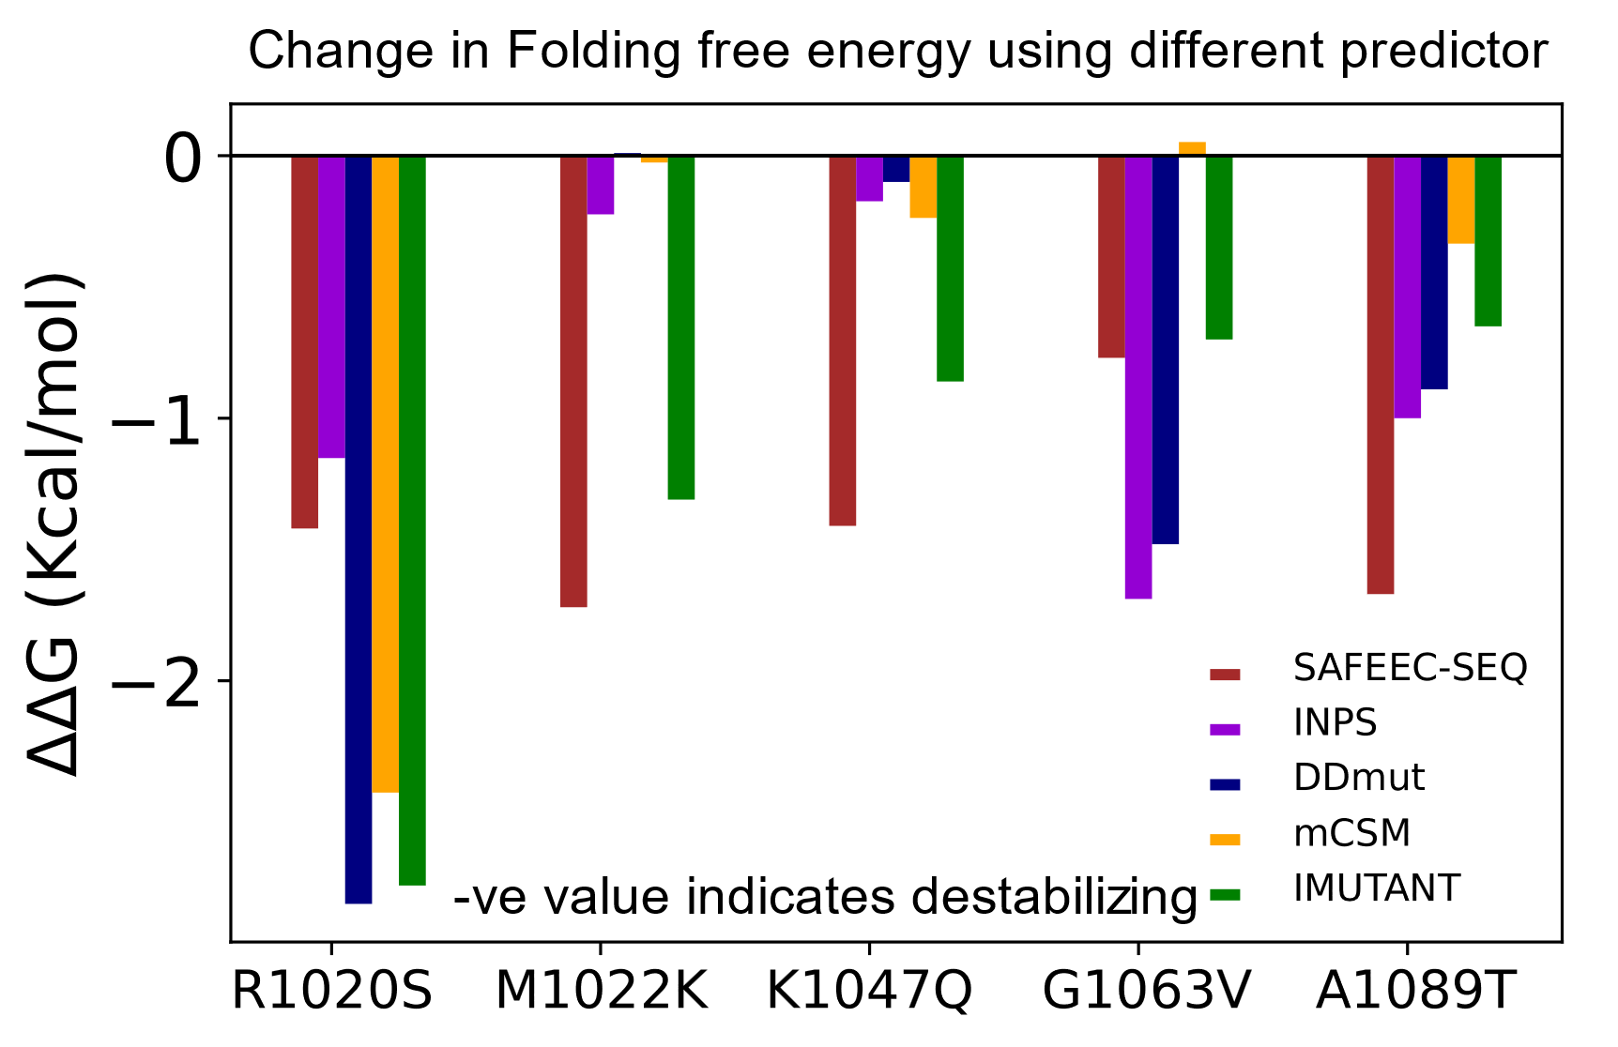
Fig. S2 Stability changes in ARID1A predicted by both sequence-based and structure-based models with respect to the selected mutations.: The position and amino acid mutations are indicated by x axis along with the different web server tools as shown by the legend. Most of the mutations of interest show -ve value which means they are destabilizing.

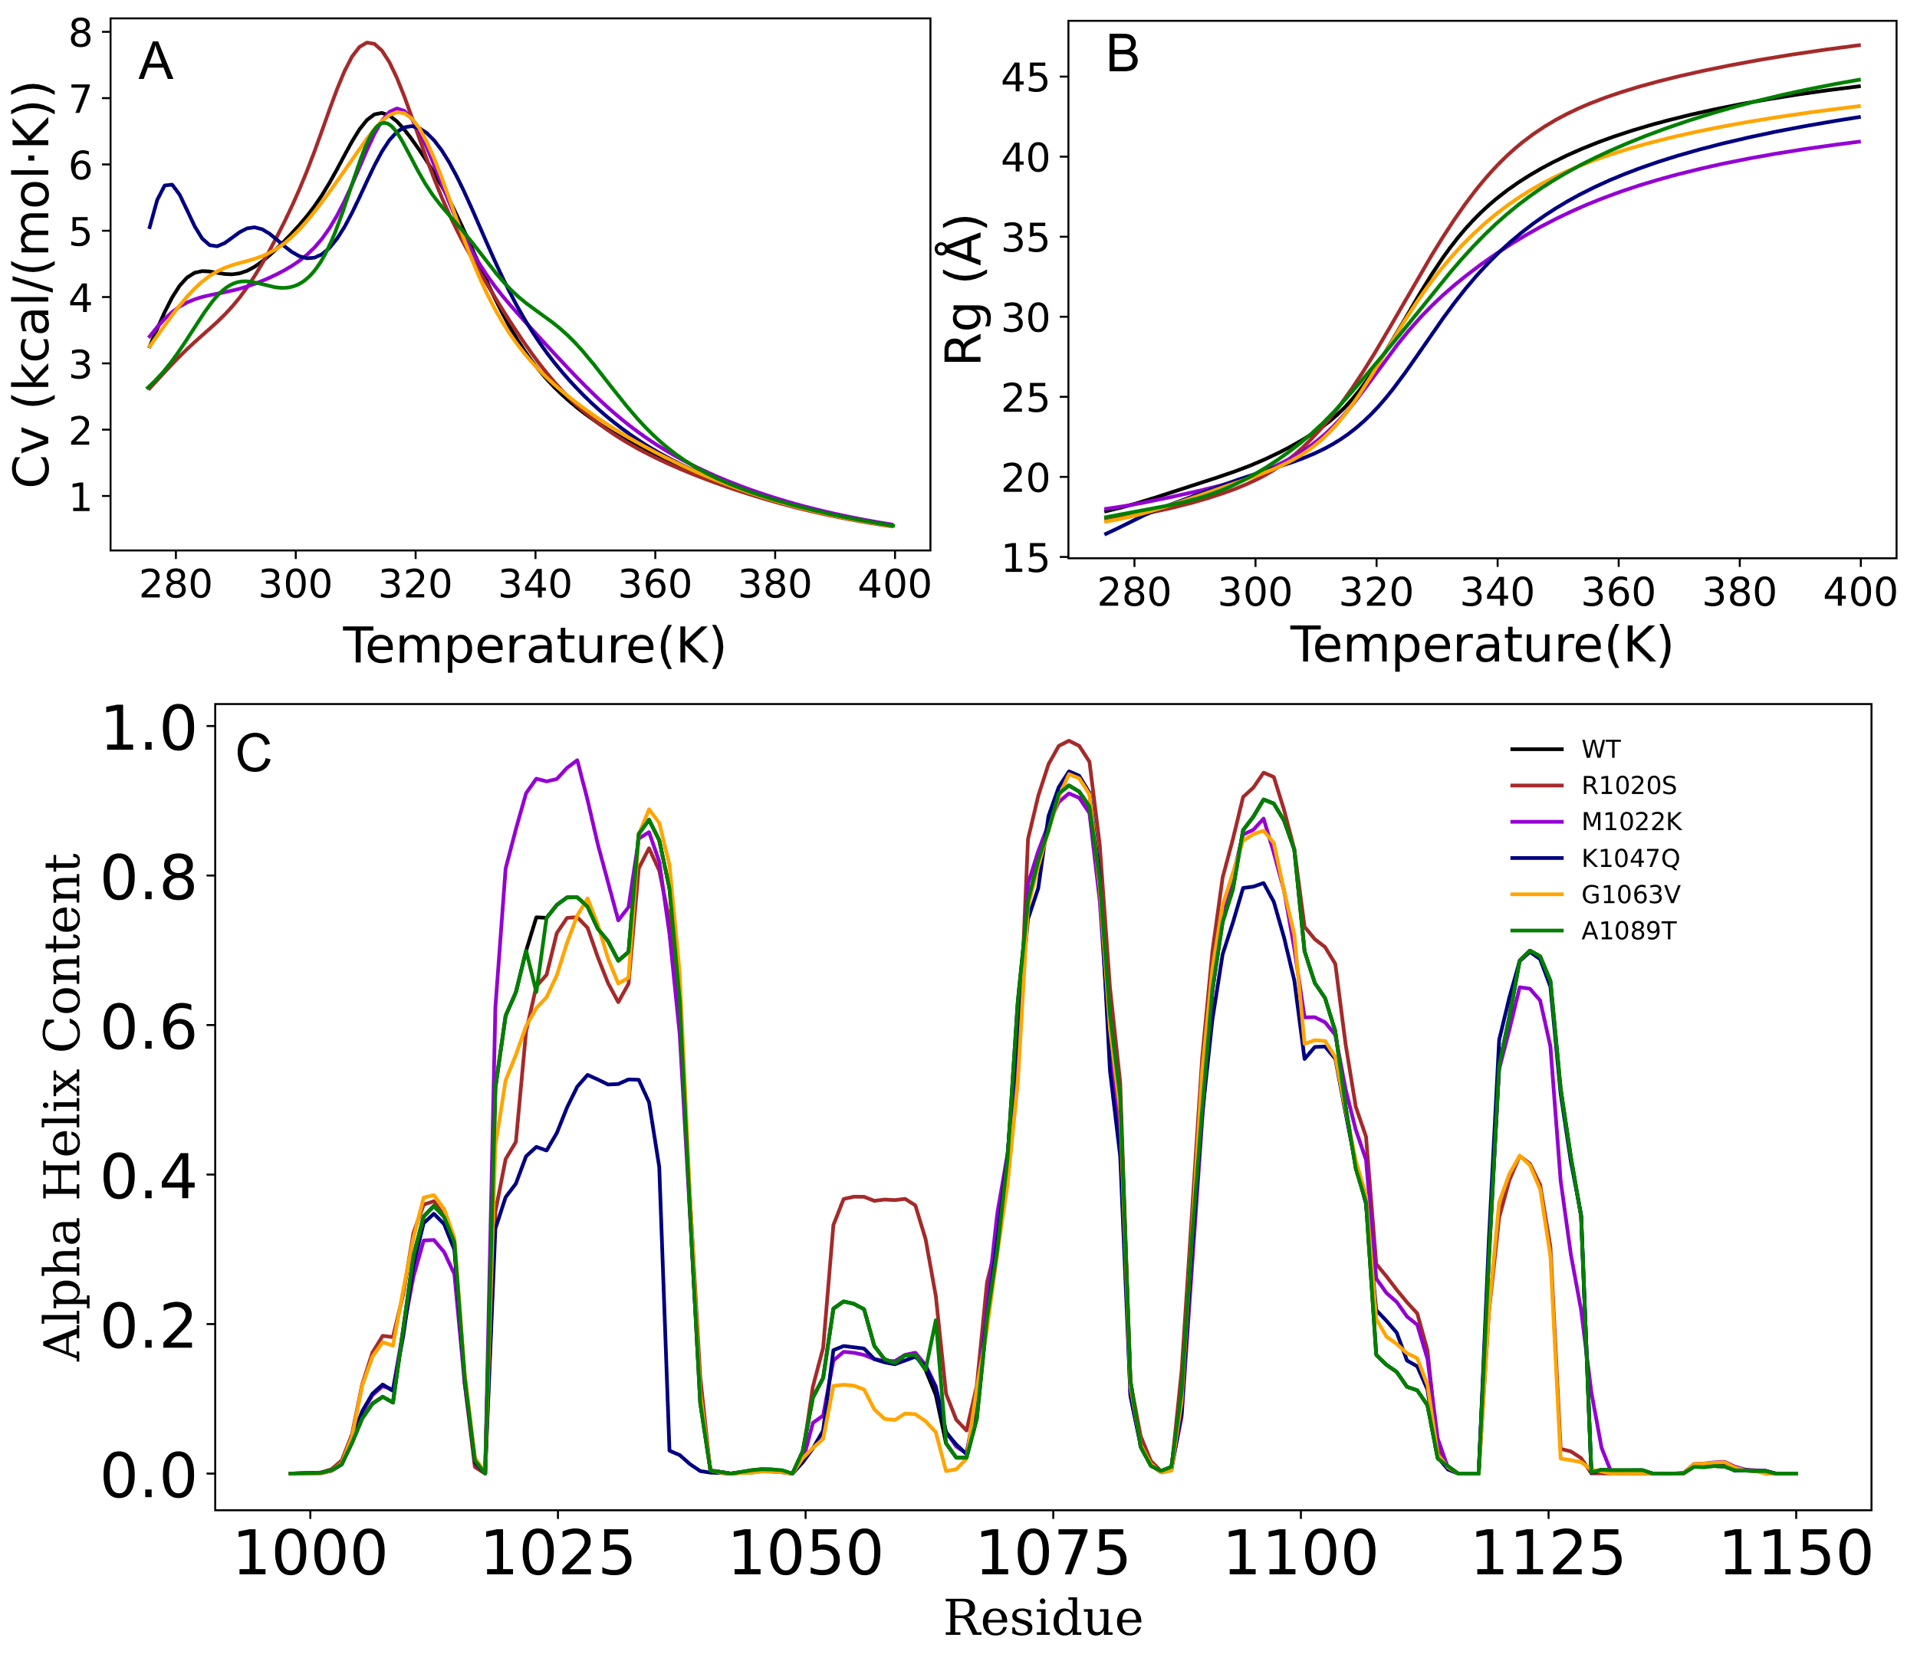
Fig: S3. rexDMD showed variation on the molecular parameters. A) The Cv as a function of temperature which peak value shows the Tm for the mutants, B) The average radius of gyrations (Rg) obtained for all the mutants as a function of temperature, C) The alpha-helix content for the mutants which shows M1022K has highest content compared to other mutants.

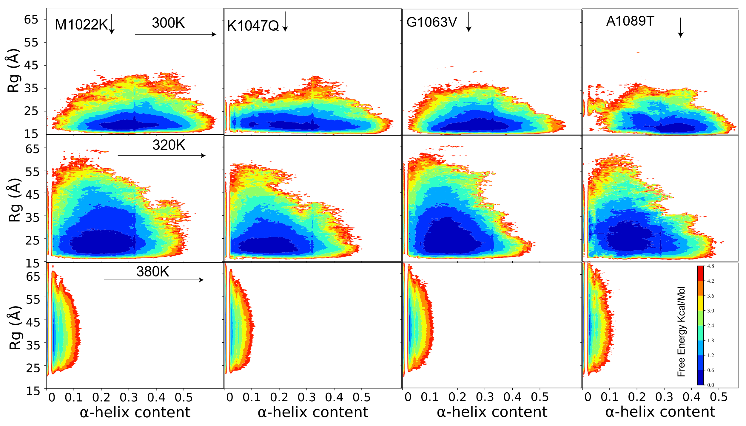
Fig. S4. 2D PMF plot from rexDMD. The 2D PMF plot of the mutants at different temperatures. Top row at 300K, middle row at 320K and bottom row at 380K. The first column M1022K, second column for K1047Q, third column for G1063V followed by A1089T. Within the same temperature there are different dynamics of structure for different mutants as shown by the alpha-helices contents. As the temperatures increases there is reduction in alpha-helices content and the increment of $R_{g}$ for all samples.

Fig: S4. 2D PMF plot from rexDMD. The 2D PMF plot of the mutants at different temperatures. Top row at 300K, middle row at 320K and bottom row at 380K. The first column M1022K, second column for K1047Q, third column for G1063V followed by A1089T. Within the same temperature there are different dynamics of structure for different mutants as shown by the alpha-helices contents. As the temperatures increases there is reduction in alpha-helices content and the increment of Rg for all samples.

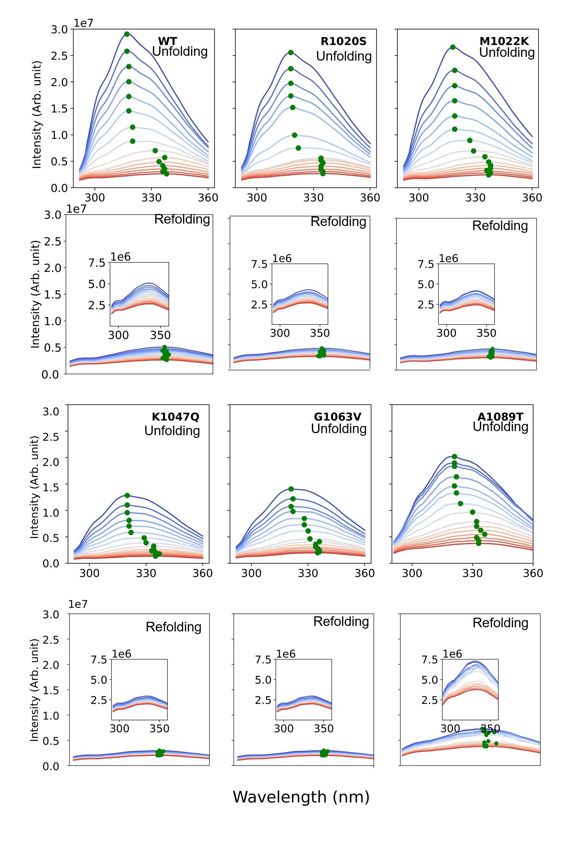
Fig. S5. Thermal denaturation spectra for all the samples. The first and third rows represent the unfolding whereas the second and fourth rows represent the refolding for the mutants as shown by legend in the unfolding curve. The inset in refolding curve is the zoom in view for clarity with different scale. This spectrum shows the wavelength shift at, maximum intensity (green dots) shift towards right as well as the fluorescence intensity quenched for unfolding on refolding the reverse is not true only partial recovery of fluorescence but not blue shifting of the green dots i.e. maximum wavelength for confirming irreversibility of the process.

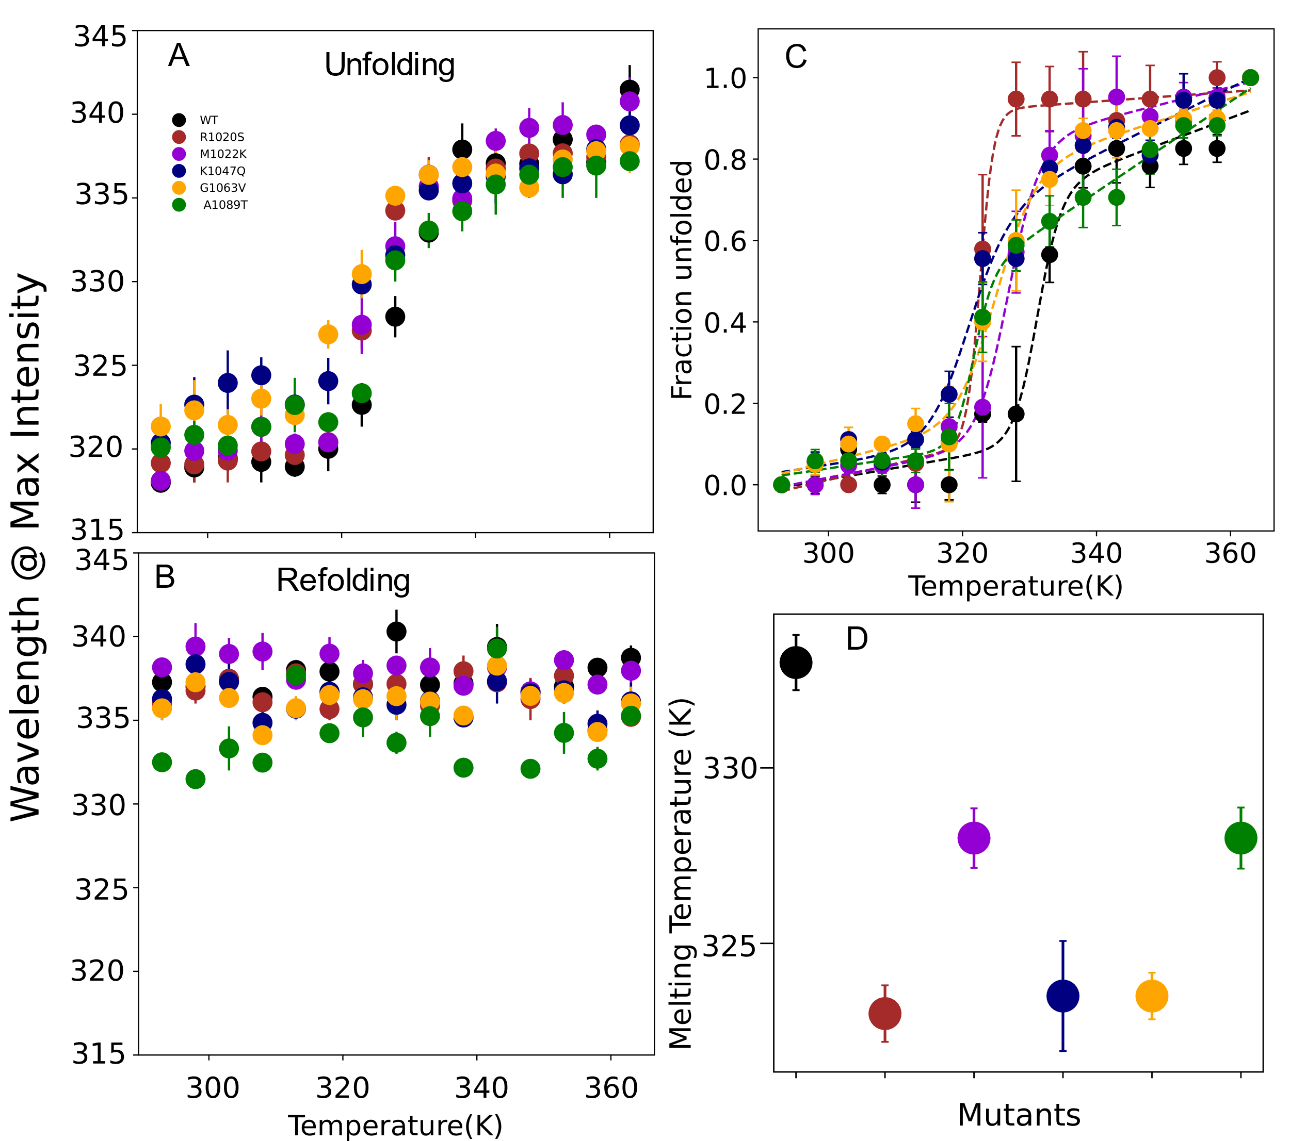
Fig. S6. Thermal denaturation parameters for all the mutants. A) Wavelength shift at maximum intensity for unfolding as a function of temperature, B) Wavelength shift at maximum intensity for refolding as a function of temperature, C) Normalized unfolded fraction with fit function for unfolding. D) The melting temperature for the mutants obtained from fit function at which unfolded fraction is 50%.

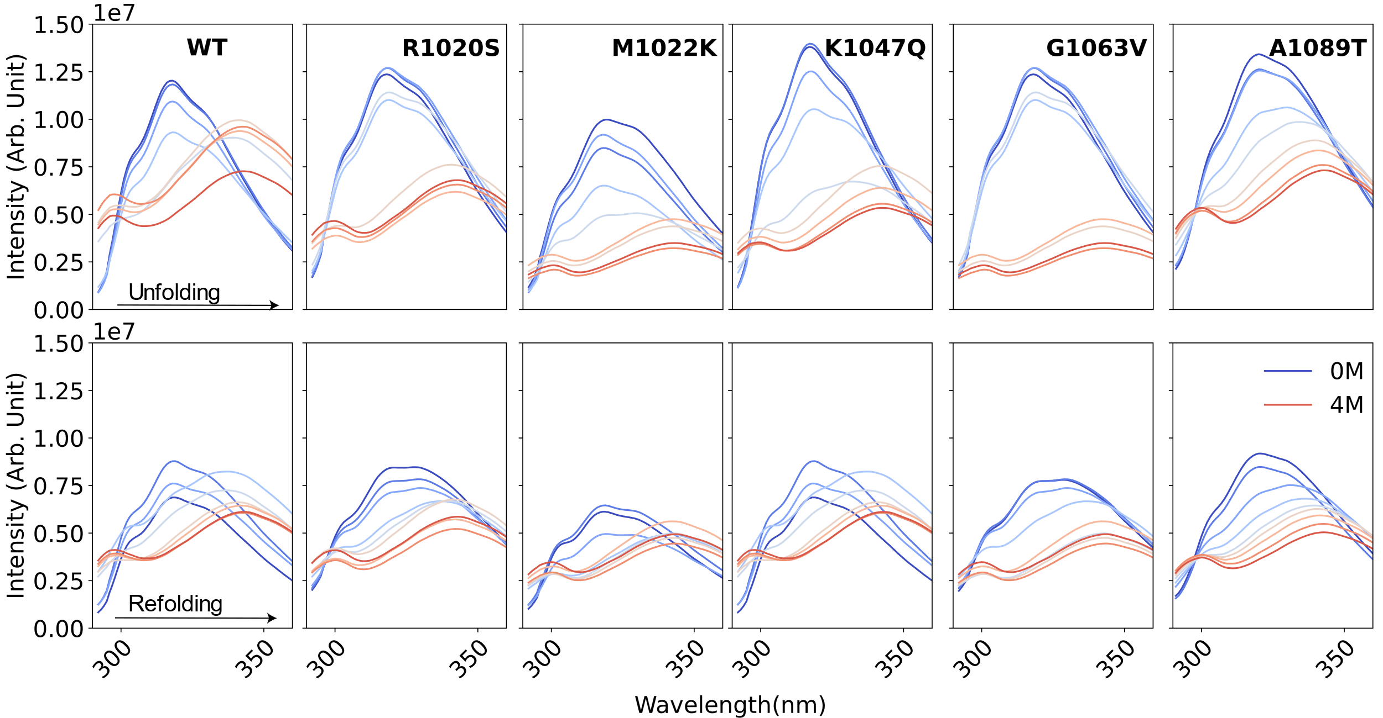
Fig. S7. Chemical denaturation spectra for all the samples. The top row represents the unfolding whereas the bottom row represents refolding. This clearly shows wavelength shift towards red as well as fluorescence quenching on unfolding. Similarly for the refolding process blue shifting and regain in the fluorescence confirms the reversibility of the process.

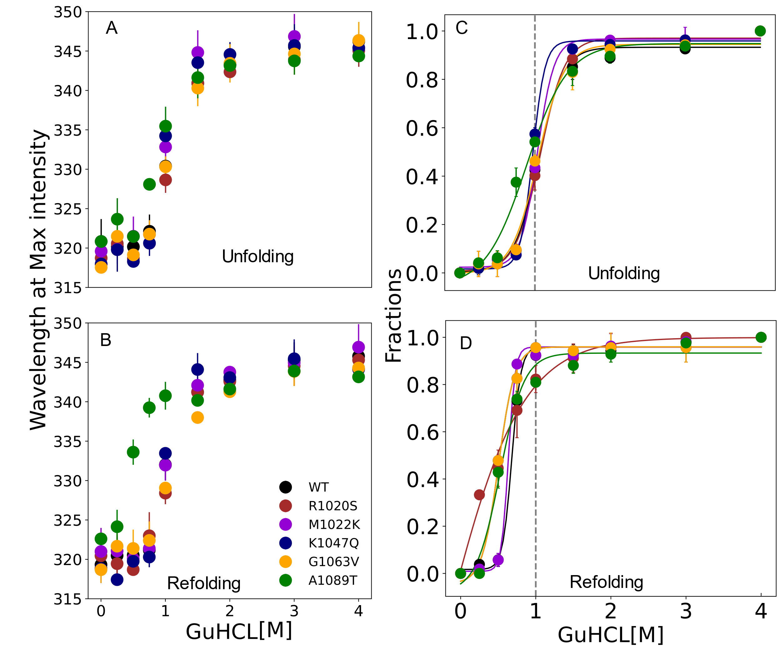
Fig. S8. Chemical denaturation parameters for all samples. A: Wavelength shift at maximum intensity unfolding, B: Wavelength shift at maximum intensity refolding, C: normalized unfolded fraction for unfolding and D: normalized refolded fraction for refolding.

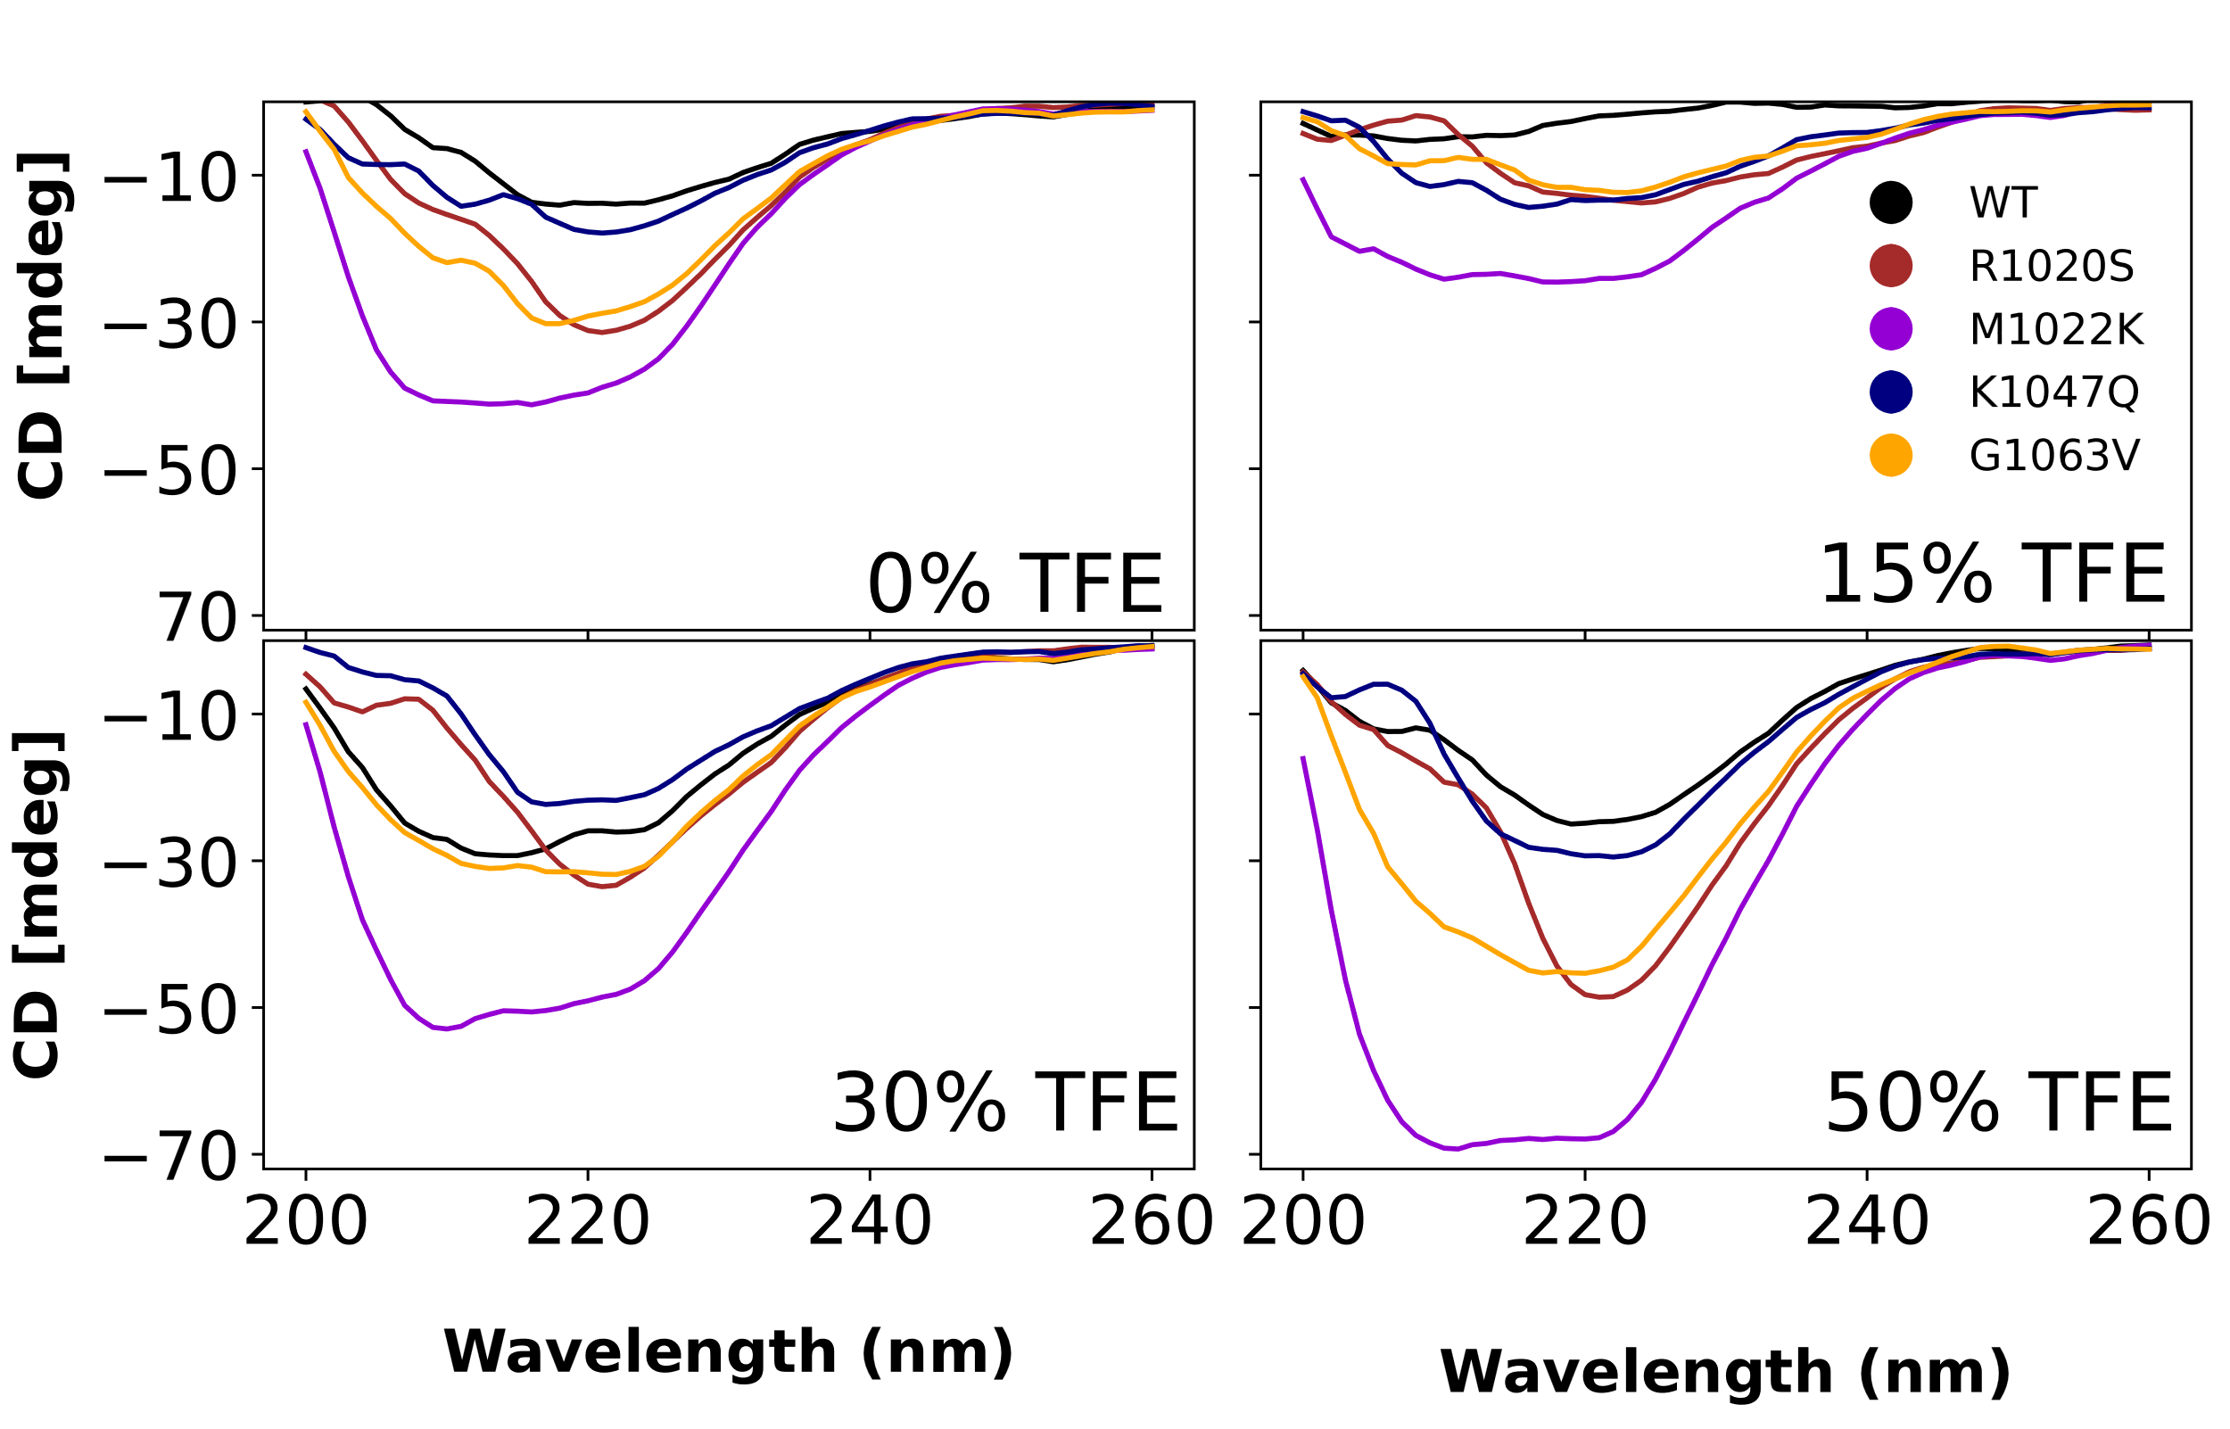
Fig. S9. CD Spectra at different %TFE (trifluoroethanol) showed M1022K most stabilizing. As the percentage of TFE (trifluoroethanol) increased, the stability of the helical content improved, with this effect being particularly pronounced for the M1022K mutation, where the depth of the signal increased with higher TFE concentrations. The A1089T mutation is absent from this figure because the sample was not purified during the measurements.

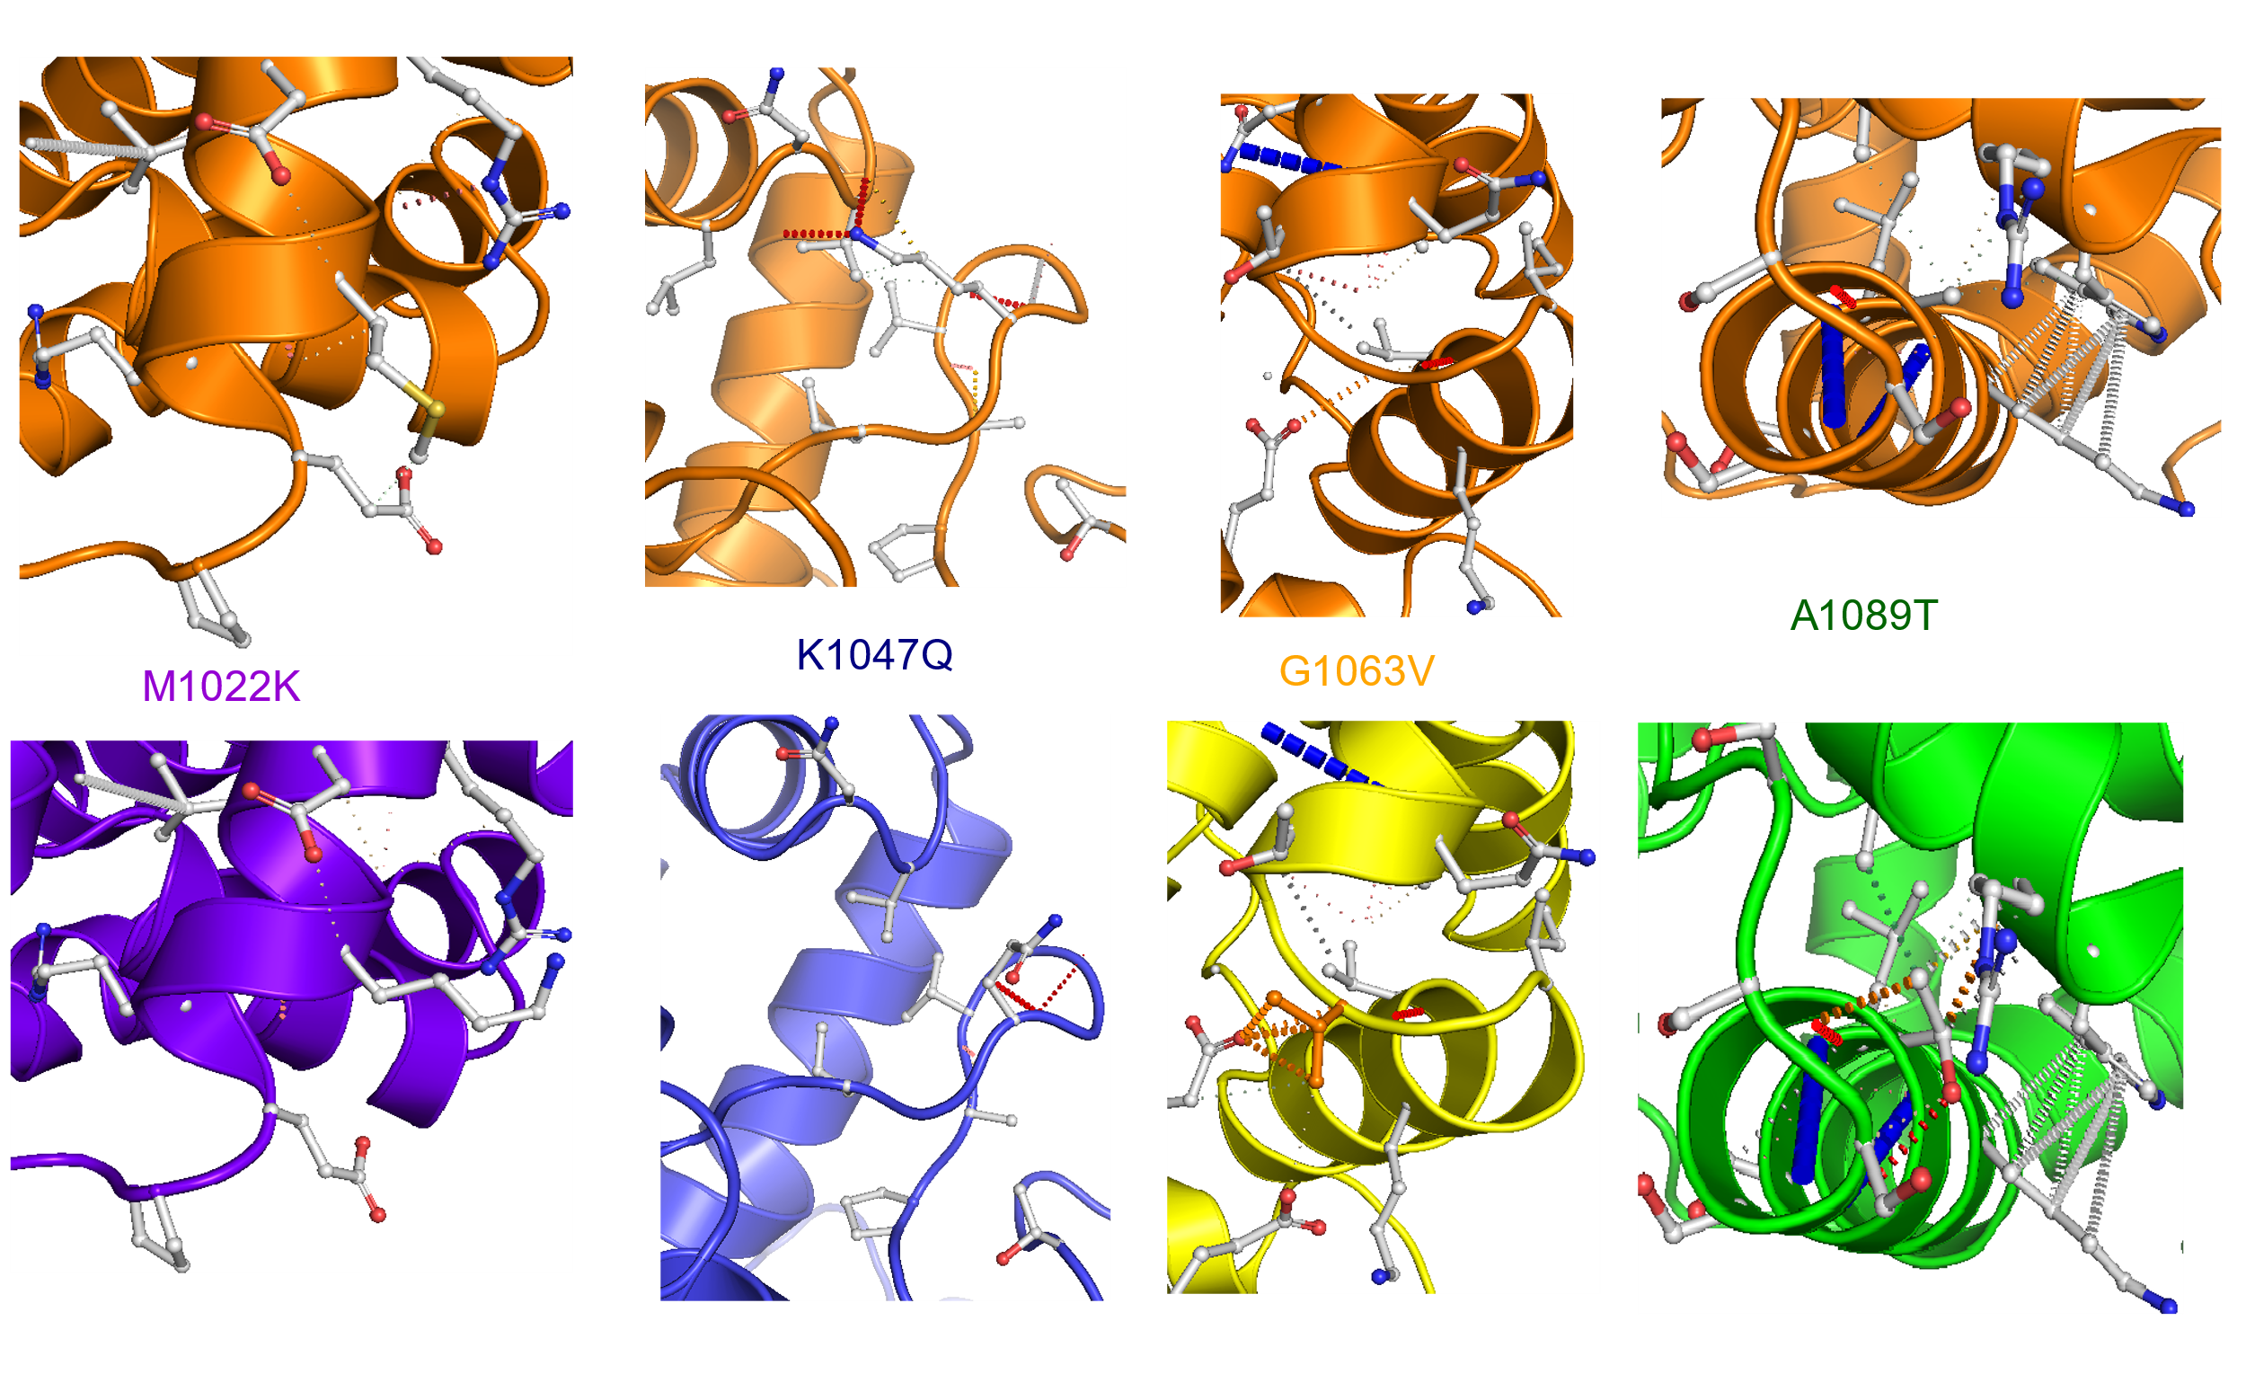
Fig. S10: Interacting sites for WT and mutants in specific position (top panel) represents interacting sites for WT (unmutated) for M1022K, K1047Q, G1063V and A1089T. (bottom panel) represents the interacting for the mutant accordingly.

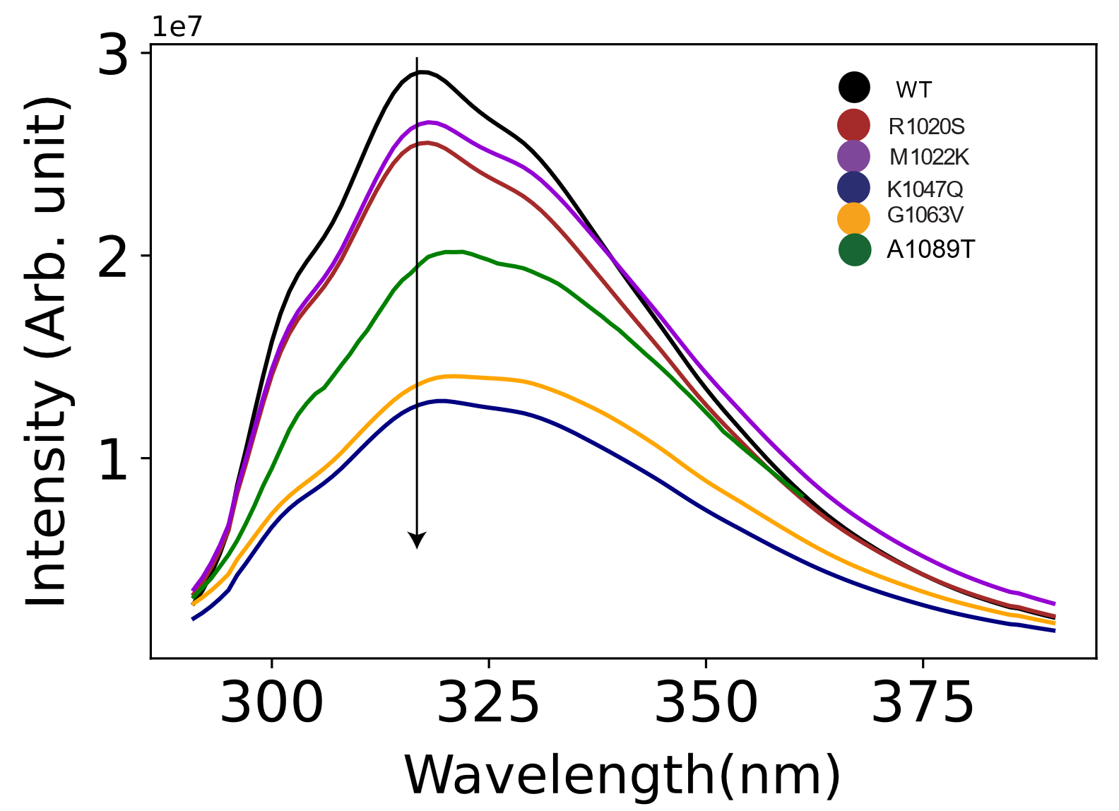
Fig. S11: The native state spectra for the mutants showed variation. For the same concentration and under the same condition the native states vary both in intensity and maximum wavelength.

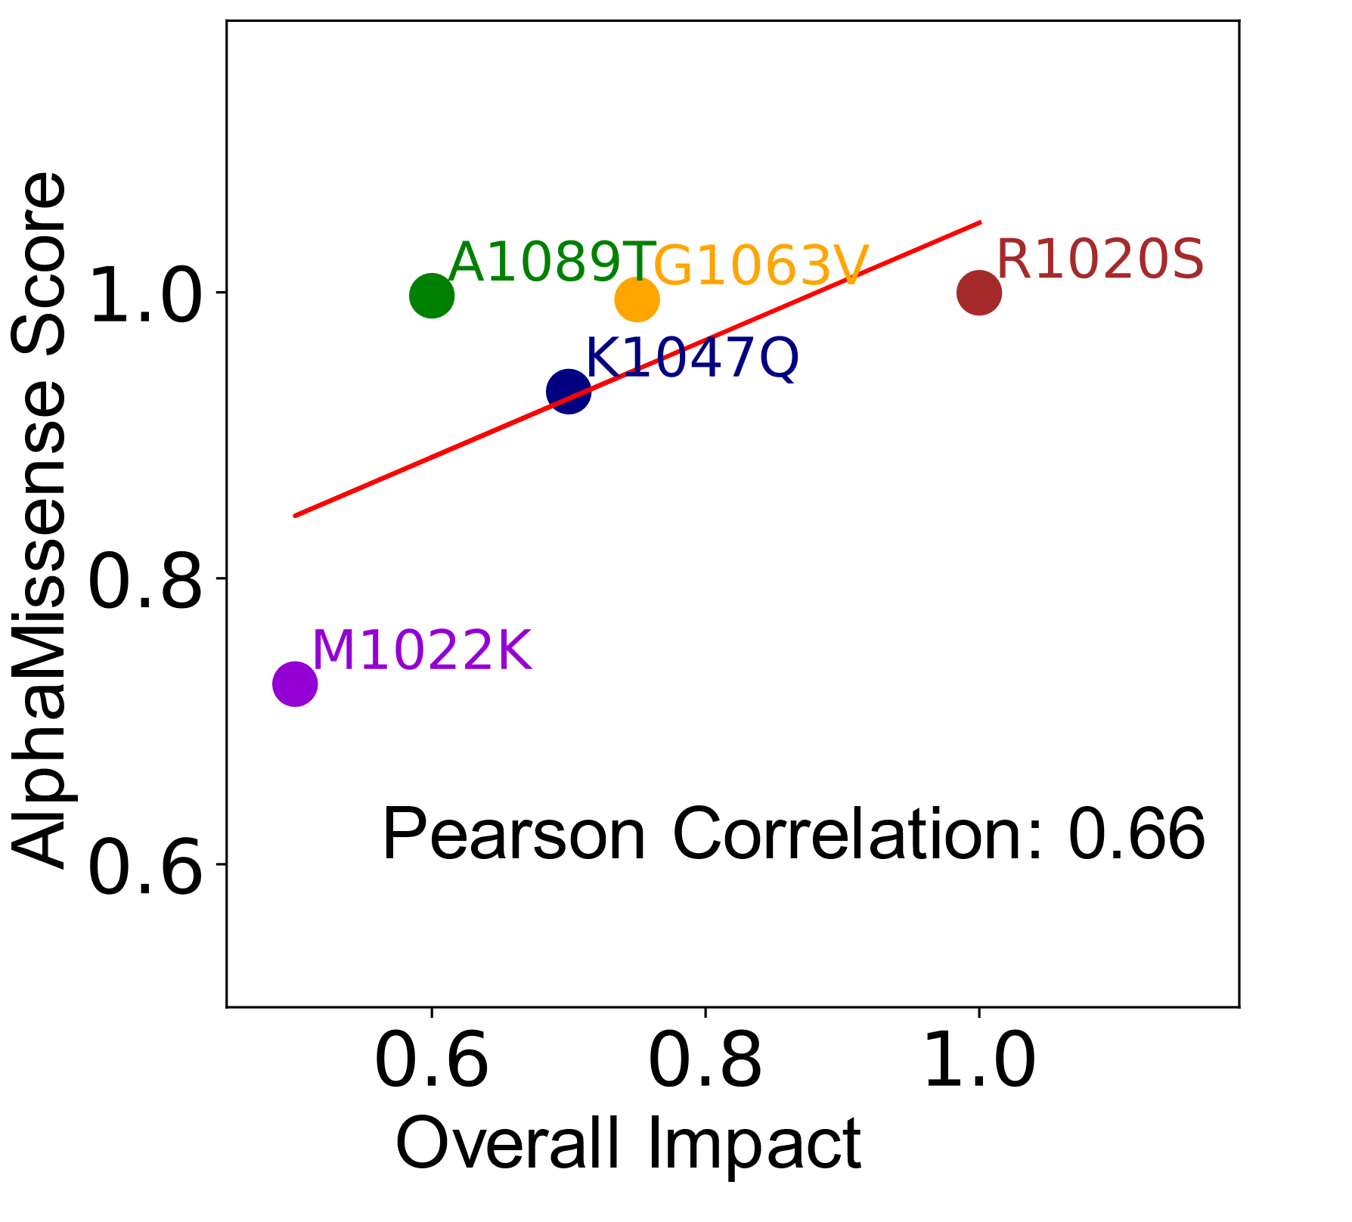
Fig. S12: The AlphaMissense Score showed all mutants are pathogenic correlate with overall impact. The Pearson correlation score is 0.66 agreements with our overall impacts for the most impacted mutants R1020S and least impacted mutants M1022K.

