Supporting Information
Dual-Metal-Doped Perovskite Adsorbents for Efficient Removal of Humic Acid
Lekai Zhao^{1,#}, Shuang Han^{1,#}, Xiao Ma¹, Ming Zhou¹, Qiuyue Wang¹, Shasha Feng¹, Ze-Xian Low¹*, Zhaoxiang Zhong^{1,2*}, Weihong Xing^{1,3,4}*
¹State Key Laboratory of Materials-Oriented Chemical Engineering, National Engineering Research Center for Special Separation Membrane, Nanjing Tech University, Nanjing, China.
²School of Environmental Science and Engineering, Nanjing Tech University, Nanjing, China.
³Energy and Environmental Materials Research Department, Suzhou Laboratory, Suzhou, China
⁴Jiangsu University, Zhenjiang, China.

Corresponding authors:
Ze-Xian Low: nicholas.low@njtech.edu.cn
Zhaoxiang Zhong: zhongzx@njtech.edu.cn
Weihong Xing: xingwh@njtech.edu.cn

#These authors contributed equally to this paper

Table of Contents
Methodology
1. Computational simulation.
2. Static Experiments.
3. Dynamic Experiments.

Fig. S1. Dynamic adsorption experimental setup.
Fig. S2. (a-d) SEM images and (e) EDX analysis of LFCTO.
Fig. S3. XPS analysis of (a) La 3d and (b) Ti 2p of LFTCO-0.3 and LFO.
Fig. S4. Adsorption performance of (a) LFO, LFTO, LFCO, and (b) LFCTO.
Fig. S5. Adsorption capacity of LFCTO (C_{HA}= 10, 30, and 50 mg/L).
Fig. S6. Removal efficiency towards different contaminations.
Fig. S7. Maximum adsorption capacity (a) of LFCTO-0.3 on humic acid. Adsorption kinetics of LFCTO-0.3 on humic acid using (b) PFO model and (c) ID model fitting (C_{HA} from 10 mg/L to 300 mg/L).
Fig. S8. The lowest unoccupied molecular orbital (LUMO = -2.837 eV); the highest occupied molecular orbital (HOMO = -7.377 eV). The blue ellipsoids represent the positive phase of the molecular orbitals, while the white indicates the negative phase.
Fig. S9. Water stability of LFCTO-0.3 with ICP analysis on metal ion dissolution in water over multiple cycles.
Fig. S10. XRD pattern of LFTCO-0.3 after 1, 3, and 5 cycles of experiments.

Table S1. Physiochemical property parameters of LFCTO.
Table S2. Kinetic parameters of humic acid adsorption on LFCTO-0.3.
Table S3. Adsorption isotherm parameters for humic acid adsorption on LFCTO-0.3.
Table S4. Thermodynamic parameters for humic acid adsorption on LFCTO-0.3.
Table S5. Surface oxygen species proportion of LFO and LFCTO-0.3 by XPS O 1s spectra analysis.
Table S6. BDST model parameters and breakthrough time error.
Table S7. Predicted breakthrough time of BDST model after changing concentration.
Table S8. Predicted breakthrough time of BDST model after changing flow rate.
Table S9. Thomas model and Yoon-Nelson model fitting parameters under different conditions.
Table S10. Maximum adsorption capacity (q_{max}) and analysis of the adsorbents for removing humic acid in water.
1. Computational simulation
To further elucidate the experimental phenomena, theoretical validation of the hypothesized mechanism was undertaken. Thus, Density Functional Theory (DFT) calculations were performed on the small molecules, lanthanum ferrate crystals, and their doped variants involved in the experiments. The calculational software employed were Gaussian16 and CP2K. The small molecules were optimized at the B3LYP-D3BJ/6-311+G**-CPCM(water) level to obtain stationary structures, while the lanthanum ferrate system was optimized using PBEsol+U/DZVP-MOLOPT-SR-GTH, achieving stable structures with a total energy cutoff of 1000 eV. The D3BJ dispersion correction was applied to enhance the robustness of the system, with the Hubbard U parameter (Ueff) for lanthanum atoms at 3.27 eV. The charge and spin multiplicity for the periodic systems were determined based on the actual conditions and magnetic characteristics of the system. Upon completion of these calculations, the wavefunction files obtained were analyzed using Multiwfn software, and the results were visualized with VMD and ChimeraX.

2. Static Experiments
The adsorption experiment by the prepared adsorbents (0.2 g /L) was performed under the conditions of C_{HA} = 30 mg/L and pH at 7 under room temperature. The adsorption performance of dual-doped perovskite oxides was investigated using humic acid (C_{HA} from 10 mg/L ~ 50 mg/L) in batch experiments at room temperature. Subsequently, parameter exploration was carried out to investigate the effects of pH (3 ~ 11), amount of adsorbent (0.1 ~ 0.4 g/L), temperature (298 ~ 318 K) and types of contaminants on the adsorption performance of the perovskite oxide-type adsorbent. pH was adjusted using diluted hydrochloric acid and sodium hydroxide.
The equilibrium adsorption capacity (q_{e}) and removal efficiency (R) of the adsorbent on the target contaminant were calculated according to equations (1) and (2).
 | $$q_{e}=\frac{\left(C_{0}-C_{t}\right)}{M}×V$$ | (1)
 | $$R=\frac{(C_{0}-C_{t})}{C_{0}}×100\%$$ | (2)
where C₀ is humic acid initial concentration in solution, mg/L; C_{t} is the concentration of solution at time t, mg/L; M is the mass, g; and V is the volume of solution, L.
In these static adsorption experiments, pseudo-first order kinetic model, pseudo-second order kinetic model and interparticle diffusion model were employed for analysis, as follows:
Pseudo-first order kinetic model:
 | $$\ln\left(q_{e}-q_{t}\right)= lnq_{e}-K_{1}t$$ | (3)
Pseudo-second order kinetic model:
 | $$\frac{t}{q_{t}}= \frac{1}{K_{2}{q_{e}}^{2}} + \frac{1}{q_{e}}t$$ | (4)
Intra-particle diffusion model:
 | $$q_{t}= k_{i}t^{\frac{1}{2}}+C_{i}$$ | (5)
where q_{t} is the adsorption capacity of humic acid at time t, mg/g; K₁ is the pseudo-first order absorption kinetic rate constant, min⁻¹; K₂ is the absorption pseudo-second order kinetic rate constant, g/mg·min⁻¹; k_{i} is the intra-particle diffusion rate constant, mg/(g·min^{1/2}); and C_{i} is the boundary layer thickness constant, mg/g.
Adsorption isotherm was a method used to describe the distribution of adsorbate molecules between the solid and liquid phases at equilibrium when the adsorbent/adsorbate reaches a state of equilibrium. Langmuir and Freundlich isotherms were the most commonly used dual-parameter isotherm models to describe the adsorption process of materials.
The Langmuir equation assumes that all sites are equivalent, indicating that the monolayer coverage of the adsorbent is occupied by the adsorbate and no further adsorption occurs at that site. The equation for this model is as follows:
Langmuir model:
 | $$q_{e}= \frac{q_{m}K_{L}C_{e}}{1+K_{L}C_{e}}$$ | (6)
The Freundlich equation is an empirical equation that describes heterogeneous systems by assuming that the amount of adsorbate on the adsorbent increases with the concentration of adsorbate and is expressed as follows:
Freundlich model:
 | $${ln⁡(q}_{e})=ln{(K}_{F})+\frac{1}{n}ln{(C}_{e})$$ | (7)
where q_{m} is the maximum adsorption capacity, mg/g; C_{e} is the equilibrium concentration of humic acid aqueous solution, mg/L; K_{L} is the Langmuir rate constant, L/mg; K_{F} is the Freundlich rate constant, mg/g; and n is the index (range 2 > 1/n > 0.1), (L/mg)^{n}.
In the thermodynamic study, the thermodynamic parameters were determined using equations (8), (9) and (10).
 | $$K_{d}=\frac{q_{e}}{C_{e}}$$ | (8)
 | $$lnK_{d}=\frac{∆S^{θ}}{R}-\frac{∆H^{θ}}{RT}$$ | (9)
 | $$∆G^{θ}=-RTlnK_{d}$$ | (10)
where K_{d} is the thermodynamic equilibrium constant, L/mol; ∆G is the change in Gibbs free energy, kJ/mol; ∆H is the change in total enthalpy, kJ/mol; ∆S is the change in entropy, J/(K·mol); R is the standard gas constant, 8.314 J/(mol·K); and T is the absolute temperature, K.
3. Dynamic Experiments
Dynamic adsorption experiments were investigated in a fixed-bed column, with a height of 18 cm and an inner diameter of 1.2 cm (Fig. S1, Supporting Information). Prior to the experiment, the perovskite oxide was pre-wetted using deionized water. The flow rate of the influent solution was controlled by a peristaltic pump. The humic acid solution was introduced from the top of the adsorption bed column and the solution was collected at regular intervals. The effluent concentration was measured after being filtered using a 0.45 µm microporous filter head.
In order to investigate the dynamic adsorption characteristics of absorbent on humic acid, the following experimental parameters were adjusted step: the flow rate of the solution ranged from 0.7 to 4.0 mL/min, the bed height ranged from 1.2 to 4.8 cm, and the concentration of the influent water ranged from 10 to 50 mg/L. The times at which the effluent concentration reached 10% and 90% of the feed concentration were selected and defined as the breakthrough and adsorption saturation times.
The equilibrium adsorption capacity (Q_{eq}) and removal efficiency (η) of perovskite oxide for humic acid in the adsorption column were determined using equations (11) and (12).
 | $$Q_{eq} =\frac{v}{1000M}\int_{0}^{t_{total}}{\left(C_{0}-C_{t}\right)}dt$$ | (11)
 | $$η = \left(\frac{Q_{eq}M}{C_{0}vt_{total}}\right)×100$$ | (12)
where v is the flow rate of the solution, ml/min; A is the area of the breakthrough curve; t_{total} is the total time of the dynamic adsorption process, min; C₀ is the initial concentration of humic acid in the influent solution, mg/L; and C_{t} is the concentration of humic acid in the effluent solution at time t, mg/L.
The dynamic adsorption process involves highly complex components, including solvents, adsorbents, and adsorbates, along with various variable operating conditions. In order to gain a better understanding of the dynamic adsorption behavior of absorbent towards humic acid and to determine the optimal parameters for dynamic adsorption conditions, several widely-used models were used to fit and analyze the breakthrough curves.
The BDST model was applied to elucidate dynamic adsorption processes that differed from instantaneous equilibrium adsorption processes, focusing mainly on the investigation of the initial stages of the adsorption process. The linear expression of the BDST model was given by equation (13).
 | $$t =\frac{N_{0}}{C_{0}v}H-\frac{1}{C_{0}K}ln⁡(\frac{C_{0}}{C_{t}}-1)$$ | (13)
where t is the breakthrough time, min; N₀ is the adsorption capacity of the adsorption column, mg/L; K is the adsorption rate constant of the BDST model, L/(min·mg); H is the height of the adsorption column, cm.

The Thomas model could be used to predict the equilibrium adsorption capacity and adsorption rate constants of the calculated adsorbent assuming that both internal and external diffusion resistances of the adsorption column have no significant effect and that the adsorption process was assumed to follow pseudo-second order kinetic model and Langmuir isotherm model. The equation of the Thomas model is given below (equation (14)).
 | $$ln\left(\frac{C_{0}}{C_{t}}-1\right)=\frac{K_{Th}}{v}QM-K_{Th}C_{0}$$ | (14)
where K_{Th} is the Thomas model adsorption rate constant, mL/(min·mg); and Q is the Thomas model theoretical equilibrium adsorption capacity for humic acid, mg/g.

The Yoon-Nelson model assumed that the rate of adsorption decline of adsorbates during adsorption was linearly correlated to the probability of each adsorbate breaking through the adsorption column. The model was described by equation (15).
 | $$ln\frac{C_{t}}{C_{0}-C_{t}}=K_{YN}t-τ K_{YN}$$ | (15)
where K_{YN} is the Yoon-Nelson model adsorption rate constant, (L/min); and τ is the time required for humic acid effluent concentration to reach half the feed concentration, min.

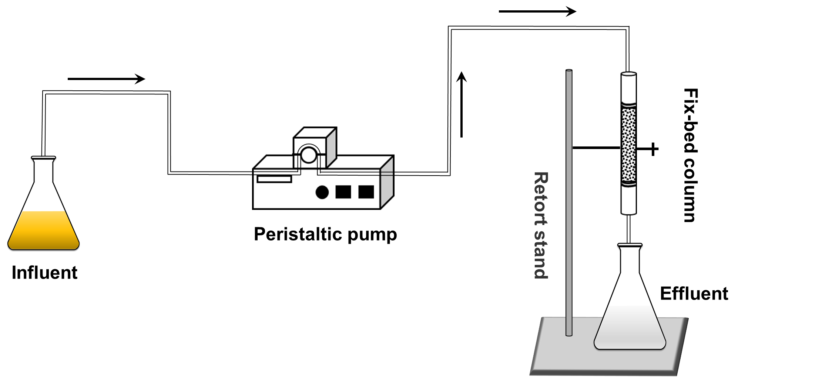
Fig. S1. Dynamic adsorption experimental setup.
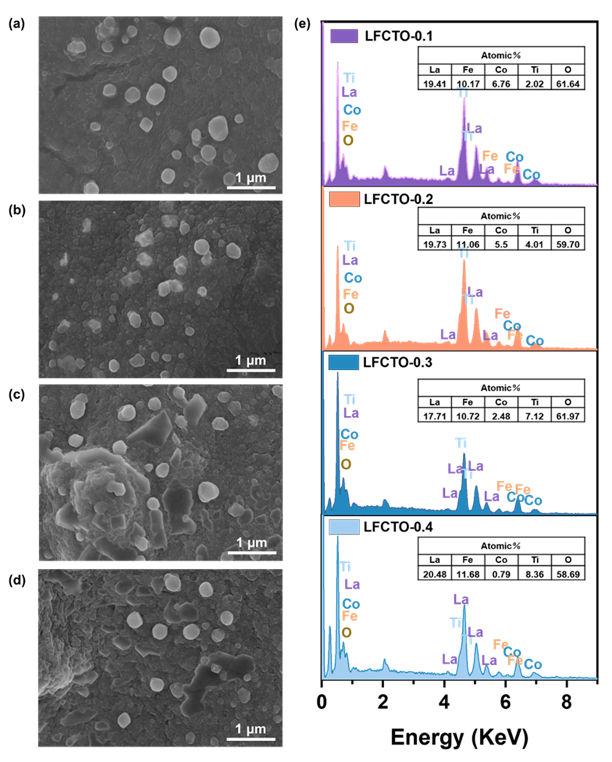
Fig. S2. (a-d) SEM images and (e) EDX analysis of LFCTO.
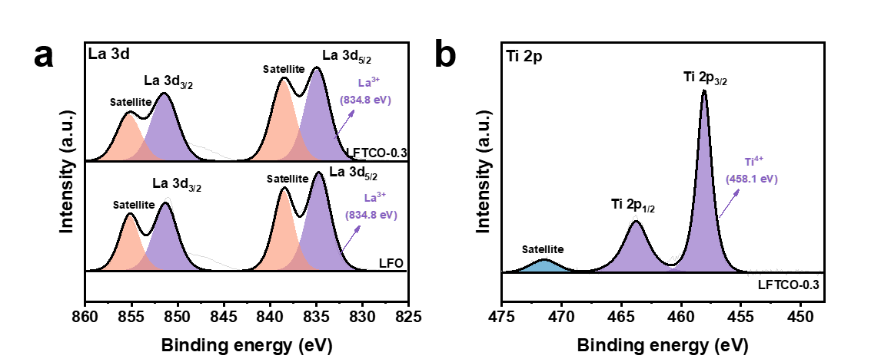
Fig. S3. XPS analysis of (a) La 3d and (b) Ti 2p of LFTCO-0.3 and LFO.
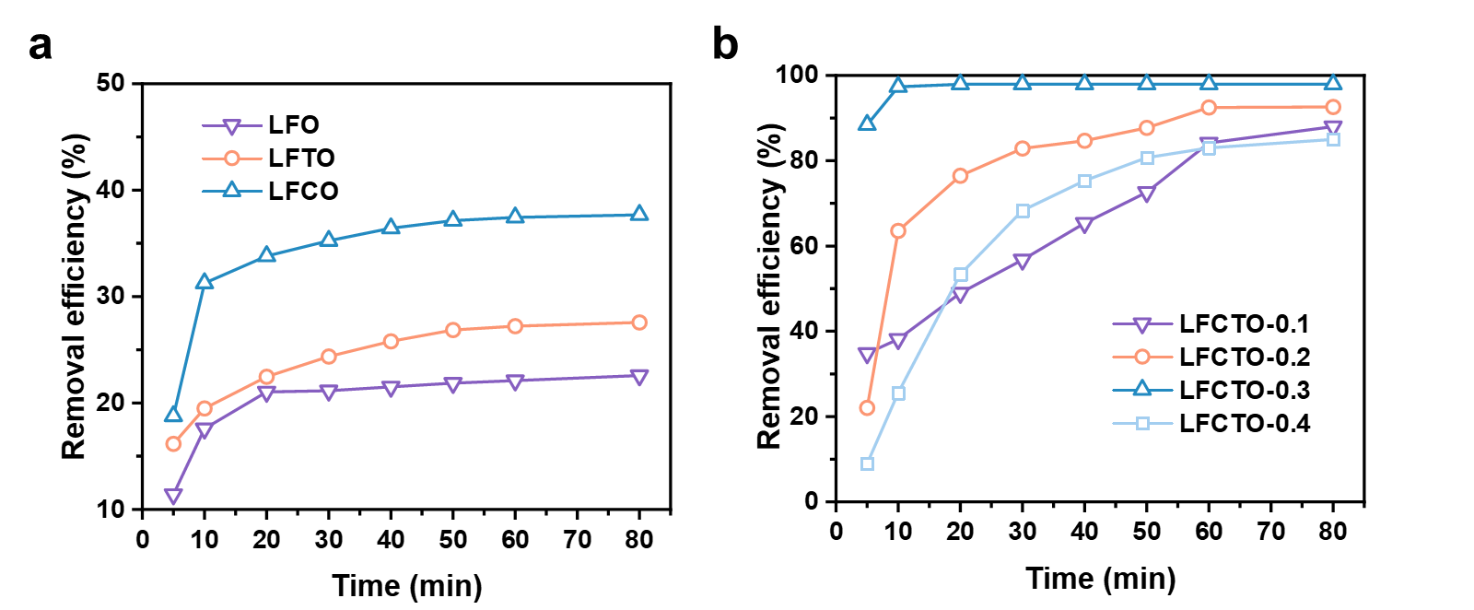Fig. S4. Adsorption performance of (a) LFO, LFTO, LFCO, and (b) LFCTO.

The adsorption performance of different perovskite absorbents (LFO、LFTO、LFCO and LFCTO) was tested using humic acid. The removal efficiency of humic acid (Fig. S4) in water showed that dual-doped LFCTO had the most significant adsorption effect on humic acid, in which the performance of LFCTO-0.3 was best; single-doped LFTO and LFCO had the next best adsorption performance for humic acid, and the performance of LFCO in removing humic acid in water was slightly superior to that of LFTO; LFO had the weakest performance in removing humic acid in water.

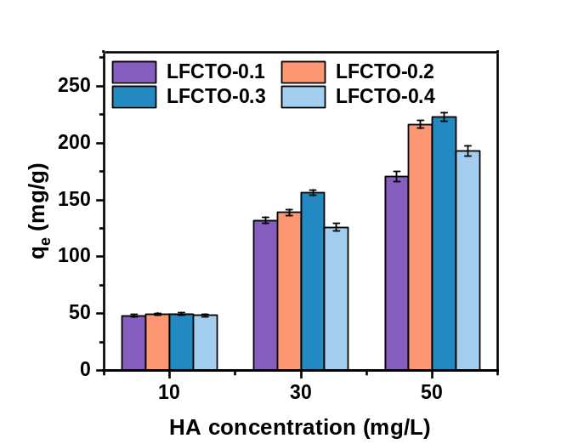
Fig. S5. Adsorption capacity of LFCTO (CHA= 10, 30, and 50 mg/L).

When the concentration of humic acid gradually increased from 10 mg/L to 50 mg/L, it was observed that the adsorption capacity of LFCTO with different dual-doped ratios also increased. Among the four different doping ratios, the adsorption performance of perovskite-type adsorbents for humic acid showed the following trend: LFCTO-0.3 > LFCTO-0.2 > LFCTO-0.4 > LFCTO-0.1, where LFCTO-0.3 consistently exhibited the best adsorption performance regardless of the concentration conditions.
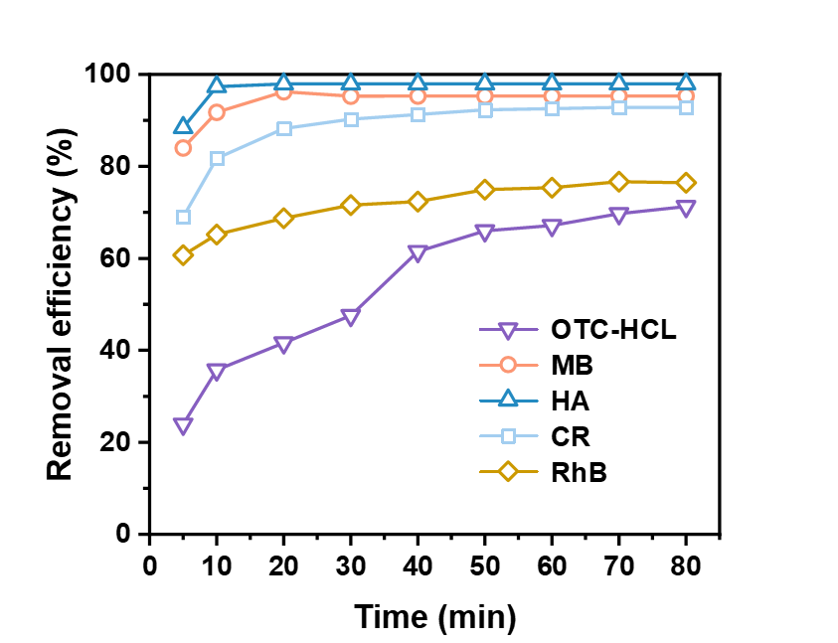
Fig. S6. Removal efficiency towards different contaminations.

In order to investigate the applicability of LFCTO-0.3 to different contaminants, five organic contaminants, namely oxytetracycline hydrochloride (OTC-HCL), methyl blue (MB), humic acid (HA), Congo red (CR), and rhodamine B (RhB), were selected as target contaminants. LFCTO-0.3 (Fig. S6) exhibited superior adsorption effects on the three anionic contaminants, MB, HA, and CR, and the removal efficiencies were as high as 95.3%, 97.9%, and 92.9%, respectively. For OTC-HCL and RhB, LFCTO-0.3 also showed good adsorption performance, with removal efficiencies of 71.3% and 76.5%, respectively.

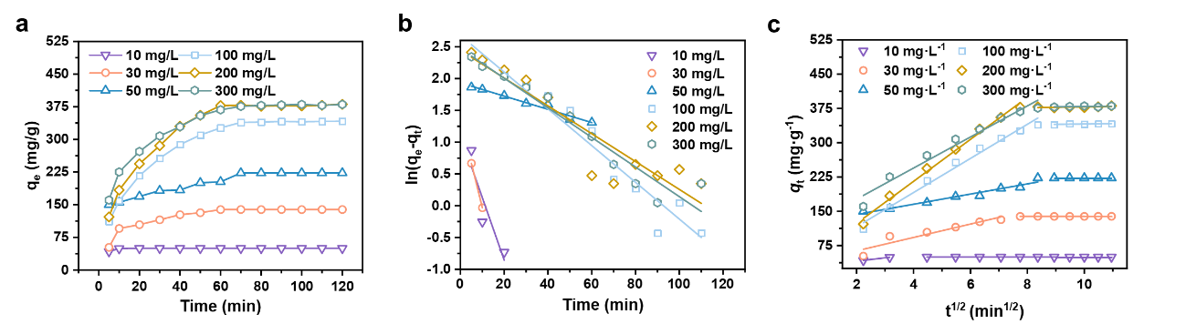
Fig. S7. Maximum adsorption capacity (a) of LFCTO-0.3 on humic acid. Adsorption kinetics of LFCTO-0.3 on humic acid using (b) PFO model and (c) ID model fitting (CHA from 10 mg/L to 300 mg/L).

When the concentration was lower, the adsorption experiment could quickly achieve efficient removal of humic acid and reach adsorption equilibrium around 10 min; however, as the concentration increased, the time required to reach adsorption equilibrium was extended, and the corresponding adsorption capacity increased. When the humic acid concentration rose to 200 and 300 mg/L, its adsorption capacity reached 381 and 380 mg/g, respectively. It was worth noting that as the concentration increased, the adsorption performance did not further improve, indicating that adsorption saturation was reached at a concentration of 200 mg/L, and the maximum adsorption capacity of LFCTO-0.3 for humic acid was approximately 381 mg/g.

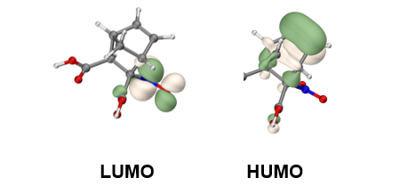
Fig. S8. he lowest unoccupied molecular orbital (LUMO = -2.837 eV); the highest occupied molecular orbital (HOMO = -7.377 eV). The blue ellipsoids represent the positive phase of the molecular orbitals, while the white indicates the negative phase.

To understand the molecular interactions, density functional theory calculations were performed to determine the molecular orbital structure (Fig. S8). The energies of the highest occupied molecular orbital (HOMO) and the lowest unoccupied molecular orbital (LUMO) of the HA molecule were found to be -7.377 eV and -2.837 eV, respectively. These values indicate that HA molecules exhibit nucleophilicity, are prone to electron loss, and are easily oxidized, which confirms the experimental feasibility of using H₂O₂ for the oxidative removal of HA molecules.

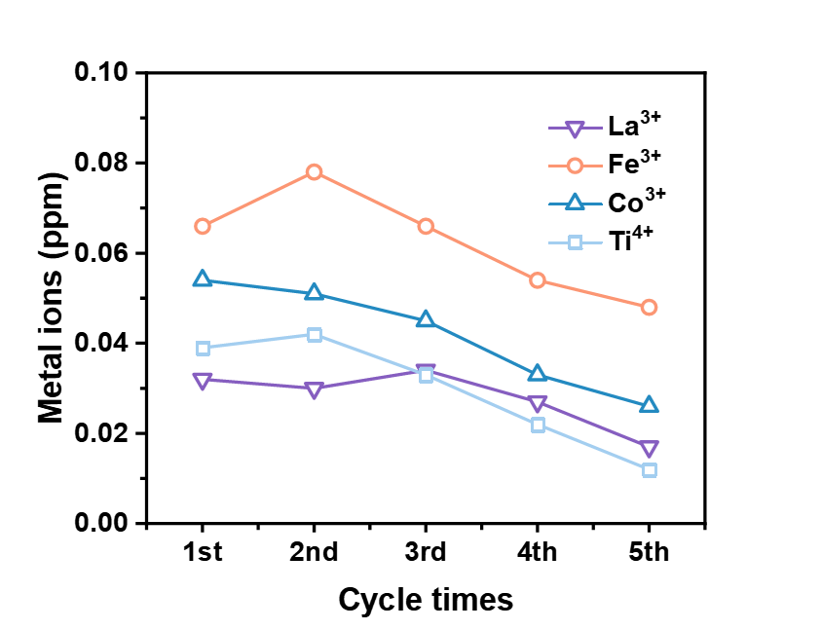
Fig. S9. Water stability of LFCTO-0.3 with ICP analysis on metal ion dissolution in water over multiple cycles.
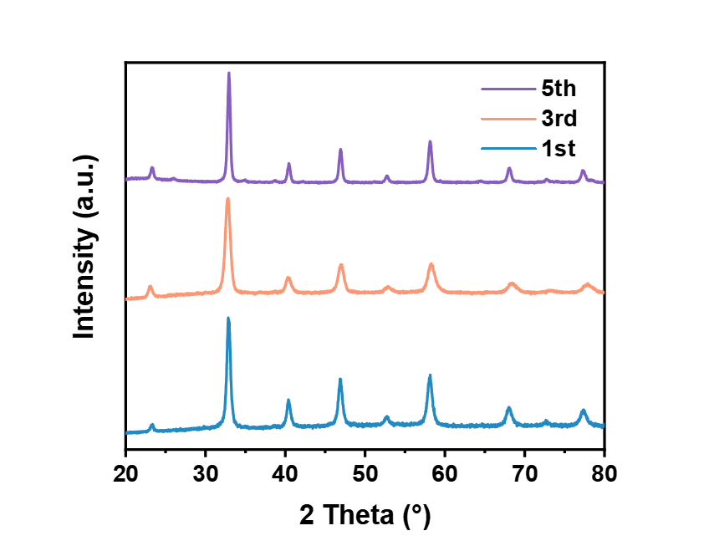
Fig. S10. XRD pattern of LFTCO-0.3 after 1, 3, and 5 cycles of experiments.

Table S1. Physiochemical property parameters of LFCTO.
Adsorbent | Saturate magnetization  Ms (emu/g) | S_{BET}  (m²/g) | Total pore volume  (cm³/g)
LFCTO-0.1 | 0.95 | 24.99 | 0.039
LFCTO-0.2 | 5.24 | 32.31 | 0.038
LFCTO-0.3 | 7.36 | 38.65 | 0.040
LFCTO-0.4 | 0.58 | 31.41 | 0.037

Table S2. Kinetic parameters of humic acid adsorption on LFCTO-0.3.
Kinetic models | Parameters | Humic acid concentration (mg/L)
Kinetic models | Parameters | 10 | 30 | 50 | 100 | 200 | 300
Kinetic models | q_{e,exp} (mg/g) | 49 | 146 | 223 | 334 | 381 | 380
PFO | K₁ | 0.09836 | 0.13979 | 0.01041 | 0.02889 | 0.02190 | 0.02330
PFO | q_{e, cal}  (mg/g) | 12.54 | 23.24 | 85.67 | 477.51 | 279.45 | 296.37
PFO | R² | 0.834 | 0.990 | 0.965 | 0.948 | 0.865 | 0.933
PSO | K₂ | 0.0716 | 11.3602 | 0.0006 | 0.0002 | 0.0002 | 0.0003
PSO | q_{e, cal}  (mg/g) | 50.075 | 153.374 | 236.407 | 387.597 | 427.350 | 411.523
PSO | R² | 0.999 | 0.999 | 0.996 | 0.998 | 0.996 | 0.999
ID | k₁ | 0.02 | 0.04 | 0.01 | 0.74 | 0.90 | 0.67
ID | C₁ | 0.06 | 0.04 | 222.89 | 333.47 | 369.33 | 372.47
ID | R² | 0.329 | 0.185 | 0.999 | 0.632 | 0.319 | 0.229
ID | k₂ | 7.43 | 14.62 | 11.13 | 37.35 | 45.97 | 34.00
ID | C₂ | 25.87 | 34.19 | 120.80 | 41.49 | 31.53 | 108.52
ID | R² | 0.999 | 0.880 | 0.959 | 0.984 | 0.991 | 0.967

Table S3. Adsorption isotherm parameters for humic acid adsorption on LFCTO-0.3.
Model | R² | Parameters | Parameters value
Langmuir | 0.983 | q_{max} | 410.81
Langmuir | 0.983 | K_{L} | 0.104
Freundlich | 0.979 | K_{F} | 97.64
Freundlich | 0.979 | 1/n | 0.327

Table S4. Thermodynamic parameters for humic acid adsorption on LFCTO-0.3.
Contaminant | T  (K) | ∆G  (kJ.mol⁻¹) | ∆S  (J.mol⁻¹K⁻¹) | ∆H  (kJ.mol⁻¹)
Humic acid | 298 | -24.43 | 199.11 | 34.89
Humic acid | 308 | -26.45 | 199.11 | 34.89
Humic acid | 318 | -28.41 | 199.11 | 34.89

Table S5. Surface oxygen species proportion of LFO and LFCTO-0.3 by XPS O 1s spectra analysis.
Sample | Molar ratio (Oxygen)
Sample | O_{L} | O_{V} | O_{V/L}
LFO | 0.4823 | 0.2933 | 0.608
LFCTO | 0.4409 | 0.4628 | 1.050

Table S6. BDST model parameters and breakthrough time error.
Bed height (cm) | 1.2 | 2.4 | 3.6 | 4.8
t_{0.1(exp)} | 450 | 1070 | 1570 | 2120
t_{0.1(exp)} | 476 | 1027 | 1578 | 2129
ε | 1.45% | 1.01% | 0.13% | 0.14%

Table S7. Predicted breakthrough time of BDST model after changing concentration.
a₁  (min/cm) | b₁  (ml/min) | C₀  (mg/L) | C₁  (mg/L) | a₂  (min/cm) | b₂  (ml/min) | t_{0.1(exp)}  (min) | t_{0.1(theo)}  (min) | ε
551 | 75 | 30.16 | 10.06 | 1660 | 226 | 2960 | 3094 | 1.51%
551 | 75 | 30.16 | 30.16 | 551 | 75 | 1070 | 1027 | 1.00%
551 | 75 | 30.16 | 50.10 | 333 | 45 | 780 | 621 | 6.79%

Table S8. Predicted breakthrough time of BDST model after changing flow rate.
a₁  (min/cm) | b₁  (ml/min) | v₀  (ml/min) | v₁  (mg/min) | a₂  (min/cm) | b₂  (ml/min) | t_{0.1(exp)}  (min) | t_{0.1(theo)}  (min) | ε
551 | 75 | 1.4 | 0.7 | 1120 | 75 | 2480 | 2165 | 3.18%
551 | 75 | 1.4 | 1.4  2.0 | 551  388 | 75 | 1070  710 | 1027  700 | 1.00%  0.35%
551 | 75 | 1.4 | 4.0 | 193 | 75 | 280 | 311 | 2.77%

Table S9. Thomas model and Yoon-Nelson model fitting parameters under different conditions.
C₀  (mg/L) | V  (ml/min) | Bed height  (cm) | M  g | K_{Th}/10⁻³  (L/min) | Q_{(exp)}  (mg/g) | Q_{(theo)}  (mg/g) | K_{YN}  (min⁻¹) | τ_{(exp)}  (min) | τ_{(theo)}  (min) | R²
30.16 | 1.4 | 1.2 | 0.25 | 0.36251 | 107.17 | 107.08 | 0.01099 | 631 | 640 | 0.991
30.16 | 1.4 | 2.4 | 0.50 | 0.16526 | 120.38 | 117.35 | 0.00501 | 1382 | 1445 | 0.987
30.16 | 1.4 | 3.6 | 0.75 | 0.10522 | 120.33 | 117.91 | 0.00319 | 2083 | 2030 | 0.984
30.16 | 1.4 | 4.8 | 1.00 | 0.08345 | 118.83 | 115.52 | 0.00253 | 2723 | 2760 | 0.984
30.16 | 0.7 | 2.4 | 0.50 | 0.07653 | 130.49 | 126.51 | 0.00232 | 2980 | 2480 | 0.981
30.16 | 1.4 | 2.4 | 0.50 | 0.16526 | 120.38 | 117.35 | 0.00501 | 1382 | 1445 | 0.986
30.16 | 2.0 | 2.4 | 0.50 | 0.24970 | 113.62 | 108.67 | 0.00757 | 896 | 960 | 0.980
30.16 | 4.0 | 2.4 | 0.50 | 0.57066 | 96.80 | 92.94 | 0.01730 | 383 | 390 | 0.971
10.08 | 1.4 | 2.4 | 0.50 | 0.06069 | 110.72 | 106.84 | 0.00184 | 3756 | 3870 | 0.980
30.16 | 1.4 | 2.4 | 0.50 | 0.16526 | 120.38 | 117.35 | 0.00501 | 1382 | 1445 | 0.986
50.10 | 1.4 | 2.4 | 0.50 | 0.24607 | 138.78 | 136.25 | 0.00746 | 972 | 950 | 0.981

Table S10. Maximum adsorption capacity (q_{max}) and analysis of the adsorbents for removing humic acid in water.
Adsorbent | q_{max}  (mg/g) | S_{BET}  (m²/g) | Adsorption saturation time (h) | Magnetic property | Regeneration rate  and method | Ref.
Ziziphus jujuba | 76.92 | 970 | 5 | -- | -- | ¹
Activated Carbon Commercial Grade (ACC) | 97.35 | 177 | 25 | -- | <50% (5 times), Calcination | ²
Cullar D (Cm1) | 0.146 | 900 | 2 | -- | -- | ³
AC-nZVI | 86.95 | 821.56 | 0.67 | -- | <74.96% (5 times), NaOH | ⁴
Activated Carbon (AC) | 42.94 | -- | 1 | -- | 98% (5 times), Ultrasonication | ⁵
DPCS0.05 | 99.27 | 1325 | 12 | -- | -- | ⁶
MWCNTs | 31.37 | 270 | 3 | -- | -- | ⁷
Magnetic MWCNTs coated calcium (MMC) | 181.82 | 139.43 | 24 | -- | 89.20% (5 times), Ultrasonication | ⁸
Y-Na⁺ | 115 | 36.29 | 5 | -- | -- | ⁹
Bentonite | 58.21 | 210-250 | 1 | -- | -- | ¹⁰
Montmorillonite | 48.2 | -- | 1 | -- | -- | ¹⁰
ZnO-30N-zeolite | 34.157 | -- | 0.25 | -- | -- | ¹¹
Chitosan-encapsulated activated carbon | 72 | 316 | 4 | -- | -- | ¹²
Nano-ZIF-8 | 42.9 | 1400 | 2 | -- | <85% (4 times), Hot, cold water and methanol | ¹³
Modified HDTMA-bentonite | 104.77 | 36.5 | 6 | -- | 89.2% (3 times), NaOH | ¹⁴
MWCNT-ZAg | 20.242 | -- | 3 | -- | -- | ¹⁵
ZA-Ag | 46.86 | -- | 2 | -- | -- | ¹⁶
PANI-coated mask | 11.11 | -- | 1 | -- | -- | ¹⁷
PANI-/H-TNB | 339.46 | -- | 24 | -- | -- | ¹⁸
Zr-MOF | 150.15 | 277.1 | 10 |  |  | ¹⁹
CoFe₂O₄@PBC LDH | 240.58 | 116.10 | 24 | Yes | <72% (7 times), NaOH | ²⁰
CoFe₂O₄@BBC LDH | 337.83 | 178.78 | 24 | Yes | <55% (7 times), NaOH | ²⁰
AC/Fe₃O₄@SiO₂-APTMS | 14.68 | 534.43 | 0.42 | -- | 65.28% (4 times), NaOH | ²¹
Modification Biochar (BC) | 68.49 | 1161.99 | 3 | -- | <60% (5 times), HCL | ²²
Oyster shell nZVI | 0.96 | 16.88 | 1.75 | -- | -- | ²³
nACP | 248.3 | -- | 24 | -- | 86% (4 times), NaOH | ²⁴
Fe@Fe₂O₃ core-shell | 65.51 | 31.1 | 2 | -- | -- | ²⁵
CA/CS nanofibers | 238.1 | -- | 1.5 | -- | -- | ²⁶
CS/CA-CNC | 151.41 | -- | 18 | -- | -- | ²⁷
Protonated Cotton Linter (PCL) | 250 | -- | 24 | -- | 75.98% (1 times), NaOH | ²⁸
Quaternized Cotton Linter (QCL) | 333 | -- | 24 | -- | 30.86% (1 times), NaOH | ²⁸
Fe₃O₄@HPEI | 476.2 | 38.13 | 0.5 | Yes | 82.83% (4 times), NaOH | ²⁹
Garnet | 0.001 | 0.32 | 3 | -- | -- | ³⁰
NH₂-UiO-66 (0.7) | 108.93 | 1547 | 24 | -- | -- | ³¹
Fe₃O₄@Na-BP-PEI | 160.04 | -- | 24 | Yes | 81.23% (6 times), NaOH | ³²
ppAA coated quartz | 0.055 | -- | 0.5 | -- | -- | ³³
Raw pumice | 38.22 | -- | 1.25 | -- | -- | ³⁴
HNO₃-MP | 57.312 | -- | 1.25 | -- | -- | ³⁴
H₂SO₄-MP | 65.71 | -- | 1.25 | -- | -- | ³⁴
C₂H₄O₂-MP | 52.28 | -- | 1.25 | -- | -- | ³⁴
HCl-MP | 45.05 | -- | 1.25 | -- | -- | ³⁴
Modified aged refuse | 29.18 | -- | 2 | -- | -- | ³⁵
Eggshell powder | 126.58 | -- | 1 | -- | 82% (1 times), HCl | ³⁶
Eggshell powder | 101 | 7.43 | 1 | -- | -- | ³⁷
MPC-300 | 95.92 | 63 | 2 | YES | -- | ³⁸
M Zn/Al CLDH | 173.61 | 80 | 6 | YES | <60% (5 times), Calcination | ³⁹
LDHs/HCMSs | 300.46 | 231 | 24 | -- | -- | ⁴⁰
FLDH | 84 | -- | 25 | -- | (5 times), KNO₃ and Calcination | ⁴¹
MLDH | 60 | -- | 25 | -- | (5 times), KNO₃ and Calcination | ⁴¹
Nano-MgO | 1260 | 66.83 | 24 | -- | 99.8% (10 times), Calcination | ⁴²
LFO | 115.6 | -- | 2 | -- | -- | This work
LFCTO-0.1 | 156.3 | 24.99 | 2 | Yes | -- | This work
LFCTO-0.2 | 285.5 | 32.31 | 1.66 | Yes | -- | This work
LFCTO-0.4 | 138.1 | 31.41 | 2 | Yes | -- | This work
LFCTO-0.3 | 380.7 | 38.65 | 1.33 | YES | 89.87% (5 times), H₂O₂ | This work

The adsorption performance of the adsorbent was assessed based on its saturated adsorption capacity and equilibrium adsorption time. Since the saturated adsorption capacity is mainly affected by the concentration of pollutants and the amount of adsorbent, the concentration-to-dosage ratio for LFCTO and referenced literature was limited to the range between 0 and 1. LFTCO-0.3 exhibited a maximum adsorption capacity of 381 mg/g for HA within 2 hours. For other adsorbent materials with a maximum adsorption capacity of 300 mg/g, the adsorption saturation time exceeds 12 hours to reach saturation and typically necessitated regeneration through solvent elution or calcination. Adsorbents with similar adsorption saturation time generally had lower saturated adsorption capacity (<150 mg/g). In particular, the saturation adsorption capacity of Nano-MgO reaches 1260 mg/g after 24 hours, which is an outliner and therefore not included in the comparison. The co-doping of Co and Ti at the B-site significantly enhanced the number of adsorption sites and increased the crystal anisotropy, resulting in greater adsorption capacity and a notably reduced saturation time compared to the original LaFeO₃ crystal.

References
1. Bouras, H. D. et al. The use of an agricultural waste material from Ziziphus jujuba as a novel adsorbent for humic acid removal from aqueous solutions. J. Mol. Liq. 211, 1039-1046 (2015).
2. Rauthula, M. S. and Srivastava, V. C. Studies on adsorption/desorption of nitrobenzene and humic acid onto/from activated carbon. Chem. Eng. J. 168, 35-43 (2011).
3. Habuda-Stanic, M. et al. Adsorption of humic acid from water using chemically modified bituminous coal-based activated carbons. Chem. Biochem. Eng. Q. 35, 189-203 (2021).
4. Rashtbari, Y. et al. Potential of using green adsorbent of humic acid removal from aqueous solutions: equilibrium, kinetics, thermodynamic and regeneration studies. Int. J. Environ. Anal. Chem. 102, 5373-5390 (2022).
5. Naghizadeh, A. et al. Study of ultrasonic regeneration and adsorption of humic acid on activated carbon. Health Scope. 7, 2 (2018).
6. Yu, H. et al. Dual-pore carbon shells for efficient removal of humic acid from water. Chem. Eur. J. 23, 16249-16256 (2017).
7. Moussavi, S. P. et al. Efficiency of multi-walled carbon nanotubes in adsorbing humic acid from aqueous solutions. Asian J. Chem. 26, 821-826 (2014).
8. Li, S. et al. Removal of humic acid from aqueous solution by magnetic multi-walled carbon nanotubes decorated with calcium. J. Mol. Liq. 230, 520-528 (2017).
9. Gueu, S. et al. Physicochemical characterization of three natural clays used as adsorbent for the humic acid removal from aqueous solution. Adsorpt. Sci. Technol. 37, 77-94 (2019).
10. Derakhshani, E. and Naghizadeh, A. Optimization of humic acid removal by adsorption onto bentonite and montmorillonite nanoparticles. J. Mol. Liq. 259, 76-81 (2018).
11. Wang, L. et al. Removal of humic acid and Cr(VI) from water using ZnO-30N-zeolite. Chemosphere. 279, 130491 (2021).
12. Wu, F. C. et al. Adsorption of dyes and humic acid from water using chitosan-encapsulated activated carbon. J. Chem. Technol. Biotechnol. 77, 1269-1279 (2002).
13. Jampa, S. S. K. et al. Adsorption and recyclability aspects of humic acid using nano-ZIF-8 adsorbent. Environ. Technol. Innovation. 19, 100927 (2020).
14. Anirudhan, T. S. and Ramachandran, M. Surfactant-modified bentonite as adsorbent for the removal of humic acid from wastewaters. Appl. Clay Sci. 35, 276-281 (2007).
15. Orha, C. et al. Composite material based on silver-doped zeolite and multi-wall carbon nanotubes for humic acid removal. Environ. Eng. Manage. J. 12, 917-921 (2013).
16. Orha, C. et al. Silver doped natural and synthetic zeolites for removal of humic acid from water. Environ. Eng. Manage. J. 11, 641-649 (2012).
17. Goh, J. M. S. et al. Surface modification of recycled fabric materials with conductive polyaniline and its role in organic matter adsorption. Int. J. Environ. Sci. Technol. 19, 8945-8956 (2022).
18. Wen, T. et al. A core-shell structure of polyaniline coated protonic titanate nanobelt composites for both Cr(VI) and humic acid removal. Polym. Chem. 7, 785-794 (2016).
19. Jiang, Y. et al. Effective removal of humic acid by Zr-MOFs with Surface Modification. Water. 14, 1800 (2022).
20. Zhang, J. et al. Adsorption and mechanistic study for humic acid removal by magnetic biochar derived from forestry wastes functionalized with Mg/Al-LDH. Sep. Purif. Technol. 276, 119296 (2021).
21. Hosseinzehi, M. et al. Eco-environmental preparation of magnetic activated carbon modified with 3-aminopropyltrimethoxysilane (APTMS) from sawdust waste as a novel efficient adsorbent for humic acid removal: Characterisation, modelling, optimisation and equilibrium studies. Int. J. Environ. Anal. Chem. 103, 4339-4359 (2023).
22. Zhang, L. et al. Performance and mechanism of MnCO₃ /NaOH co-activated corncob-derived biochar for humic acid removal: XDLVO and DFT calculation. Appl. Surf. Sci. 649, 159119 (2024).
23. Shi, M. et al. Humic acid removal by combining the magnetic property of maghemite with the adsorption property of nanosized hydroxyapatite. J. Dispersion Sci. Technol. 37, 1724-1737 (2016).
24. Jiang, L. et al. Enhanced removal of humic acid from aqueous solution by novel stabilized nano-amorphous calcium phosphate: Behaviors and mechanisms. Appl. Surf. Sci. 427, 965-975 (2018).
25. Wu, H. et al. Anoxic and oxic removal of humic acids with Fe@Fe₂O₃ core-shell nanowires: A comparative study. Water Res. 52, 92-100 (2014).
26. Zhang, Y. et al. Electrospun cellulose acetate/chitosan fibers for humic acid removal: construction guided by intermolecular interaction study. ACS Appl. Polym. Mater. 3, 5022-5029 (2021).
27. Zhang, Y. and Wang, Y. Electrospun cellulose-acetate/chitosan fibers for humic-acid removal: improved efficiency and robustness with a core-sheath design. Nanomaterials. 12, 1284 (2022).
28. Du, J. et al. Fabrication of cotton linter-based adsorbents by radiation grafting polymerization for humic acid removal from aqueous solution. Polymers. 11, 962 (2019).
29. Pormazar, S. M. et al. Application of amine-functioned Fe₃O₄ nanoparticles with HPEI for effective humic acid removal from aqueous solution: Modeling and optimization. Korean J. Chem. Eng. 37, 93-104 (2020).
30. Huifang, W. et al. Filtration characteristics of garnet media before and after modification. J. Water Reuse Desalin. 10, 133-145 (2020).
31. Zhu, Z. et al. Effective removal of humic acid by mesoporous Zr-MOF adjusted through SDBS. Environ. Sci. Pollut. Res. 29, 73043-73051 (2022).
32. Zhang, J. et al. Effective removal of humic acid from aqueous solution using adsorbents prepared from the modified waste bamboo powder. Microchem. J. 153, 104272 (2020).
33. Kyzas, G. Z. and Kostoglou, M. Green adsorbents for wastewaters: a critical review. Materials. 7, 333-364 (2014).
34. Soleimani, H. et al. Effect of modification by five different acids on pumice stone as natural and low-cost adsorbent for removal of humic acid from aqueous solutions - application of response surface methodology. J. Mol. Liq. 290, 111181 (2019).
35. Zhang, A. et al. Mechanism of adsorption of humic acid by modified aged refuse. RSC Adv. 8, 33642-33651 (2018).
36. Zulfikar, M. A. et al. Removal of humic acid from peat water using untreated powdered eggshell as a low cost adsorbent. Int. J. Environ. Sci. Technol. 10, 1357-1366 (2013).
37. Mehri, A. et al. Investigating the efficiency of humic acid removal from aquatic solutions with eggshell adsorbent. Desalin. Water Treat. 266, 247-255 (2022).
38. Wen, T. et al. Magnetic porous carbonaceous material produced from tea waste for efficient removal of As(V), Cr(VI), humic acid, and dyes. ACS Sustainable Chem. Eng. 5, 4371-4380 (2017).
39. Li, S. et al. Adsorption of humic acid from aqueous solution by magnetic Zn/Al calcined layered double hydroxides. Appl. Clay Sci. 188, 105414 (2020).
40. Huang, S. et al. Construction of layered double hydroxides/hollow carbon microsphere composites and its applications for mutual removal of Pb(II) and humic acid from aqueous solutions. ACS Sustainable Chem. Eng. 5, 11268-11279 (2017).
41. Khoshalhan Davoudli, H. et al. Investigating the role of the morphology of the Zn-Al LDH on the adsorption of humic acid from aqueous solutions. Water Sci. Technol. 84, 1663-1677 (2021).
42. Zhou, J. et al. Efficient natural organic matter removal from water using nano-MgO coupled with microfiltration membrane separation. Sci. Total Environ. 711, 135120 (2020).

