We would like to propose, on behalf of all authors of the manuscript titled "Dynamic Rigidity Changes Enable Rapid Cell Migration on Soft Substrates" (Manuscript ID: NCOMMS-24-74023C), a minor adjustment to the author order. Specifically, we would like to switch the positions of the corresponding authors, Prof. Qiang Wei and Prof. Yi Cao, to accurately reflect a shift in their nearly equal contributions that arose during the revision process. For clarity, the manuscript file in this submission does not yet reflect this proposed change and maintains the current author order.
Prof. Yi Cao and Prof. Qiang Wei contributed nearly equally to this work. Initially, Prof. Cao was listed last due to a slightly greater contribution. However, after accounting for the additional work done during the revision, Prof. Wei's contribution now slightly outweighs. We would therefore like to switch their order in the author list, while keeping both as corresponding authors. There are no changes to the order of the other authors, and no authors have been added or removed.
The revised author order is as follows:
Jiapeng Yang^{#, 1, 2, 3}, Yu Zhang^{#, 1, 2}, Shuo Wang^{#, 4}, Peng Wang³, Liang Dong², Luofei Li², Yuanqi Cheng², Xiaoyu Huang², Bin Xue², Wei Wang², Chunping Jiang^{*, 1, 4}, Xiaosong Gu^{1, 4, 6}, Yi Cao^{*, 1, 2, 5, 7} and Qiang Wei^{*, 3}
We understand that policies on authorship changes at this stage are strict. Should this adjustment not be permissible, please be assured that all authors have unanimously agreed to maintain the author order as currently submitted to ensure a timely publication.
To confirm that all authors are informed and in agreement with this modification, we have attached handwritten signatures from each co-author. Please do not hesitate to contact us if you have any questions or require further information.
Jiapeng Yang:

Yu Zhang:
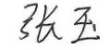
Shuo Wang:
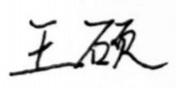
Peng Wang:

Liang Dong:
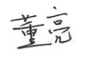
Luofei Li:
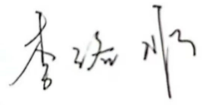
Yuanqi Cheng:
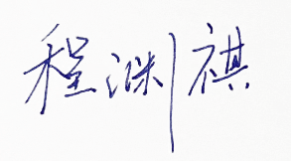
Xiaoyu Huang:

Bin Xue:

Wei Wang:
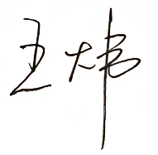
Chunping Jiang:
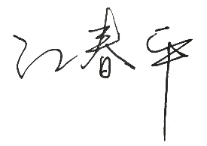
Xiaosong Gu:
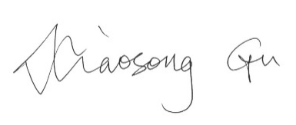
Yi Cao:

Qiang Wei:
