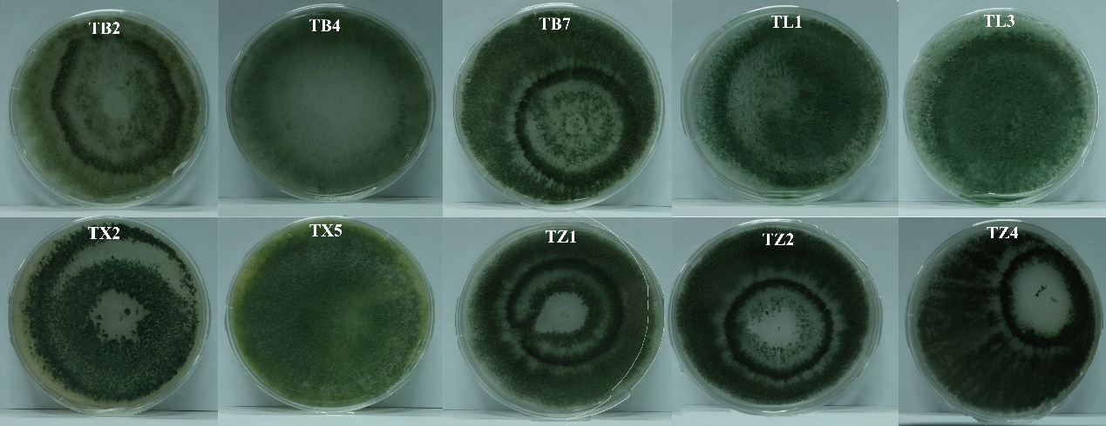Fig. S1. Ten Trichoderma strains produced green mature conidia after 5 days of cultivation on PDA.

Fig. S2. Growth-Promoting Effects of Ten Trichoderma Strains on Pear Seedling Roots
(A) Representative images of pear seedling roots treated with ten Trichoderma strains.(B) Root diameter of pear seedlings treated with ten Trichoderma strains.(C) Root volume of pear seedlings treated with ten Trichoderma strains.(D) Root length of pear seedlings treated with ten Trichoderma strains.(E) Number of root tips in pear seedlings treated with ten Trichoderma strains.
Fig. S3. Growth-Promoting Effects of Trichoderma TB2 on Cucumber Root Growth. (A) Representative images of cucumber roots treated with Trichoderma TB2.(B) Root volume of cucumber seedlings treated with Trichoderma TB2.(C) Number of root tips in cucumber seedlings treated with Trichoderma TB2.(D) Root volume of cucumber seedlings treated with Trichoderma TB2.(E) Root length of cucumber seedlings treated with Trichoderma TB2.

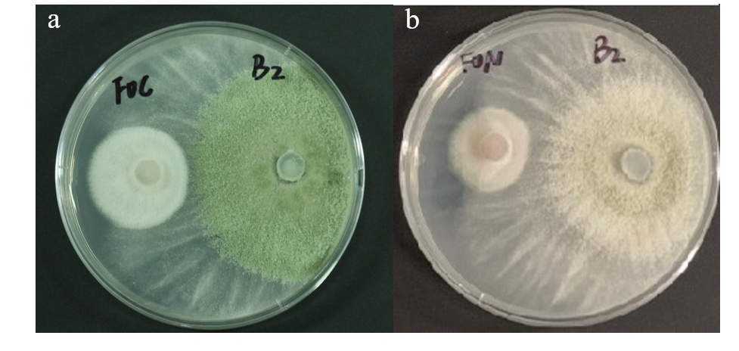
Fig.S4 Antagonism of Trichoderma TB2 against Fusarium oxysporum (Schl.) F.sp cucumerinum Owen（a） and Fusarium oxysporum f. sp. Niveum (b)

Table S1 Genomic features of the Trichoderma brevicompactum TB2
Sample | TB2
Genome Size | 38703597
scaffold no | 18
GC Content(%) | 47.877
CDS No. | 10436
Scaf N50(bp) | 6059655

Table S2 Assessment of genome assembly integrity of the TB2
Sample Name | BUSCO | CEGMA
Complete (%) | 99.1 | 95.97
Complete Duplicated (%) | 0.3 | 97.98
Fragmented (%) | 0 | 262
Missing (%) | 0.9 | 1.1

Table S3 Secondary metabolite biosynthesis gene clusters in the TB2
location | start | end | gene_num | type
Scaffold1 | 189713 | 211183 | 8 | Terpene
Scaffold1 | 357729 | 412481 | 17 | Nonribosomal peptide synthetases (NRPS)
Scaffold1 | 3802751 | 3859501 | 13 | Nonribosomal peptide synthetases (NRPS)
Scaffold1 | 4381662 | 4402636 | 9 | Terpene
Scaffold1 | 4592287 | 4640765 | 10 | Type Ⅰ polyketide synthases (T1PKS)
Scaffold1 | 6808742 | 6882967 | 12 | Nonribosomal peptide synthetases (NRPS)
Scaffold2 | 1238693 | 1259979 | 5 | Terpene
Scaffold2 | 1594864 | 1616453 | 5 | Terpene
Scaffold2 | 2829037 | 2897875 | 20 | Nonribosomal peptide synthetases (NRPS)
Scaffold2 | 4344315 | 4387671 | 12 | Nonribosomal peptide synthetases (NRPS)
Scaffold2 | 5677394 | 5761109 | 13 | T1PKS-NRPS
Scaffold2 | 6684120 | 6744362 | 15 | Type Ⅰ polyketide synthases (T1PKS)-Terpene
Scaffold3 | 172761 | 219882 | 5 | Type Ⅰ polyketide synthases (T1PKS)
Scaffold3 | 251690 | 299792 | 7 | Type Ⅰ polyketide synthases (T1PKS)
Scaffold3 | 4088103 | 4140403 | 8 | T1PKS-NRPS
Scaffold3 | 5137038 | 5184045 | 13 | Type Ⅰ polyketide synthases (T1PKS)
Scaffold3 | 5559154 | 5580693 | 6 | Terpene
Scaffold3 | 5757493 | 5831457 | 19 | T1PKS-NRPS
Scaffold3 | 5836463 | 5886386 | 15 | Type Ⅰ polyketide synthases (T1PKS)
Scaffold3 | 5926017 | 6014160 | 25 | T1PKS-NRPS
Scaffold4 | 17553 | 64953 | 16 | Nonribosomal peptide synthetases (NRPS)
Scaffold4 | 2035691 | 2080161 | 20 | Nonribosomal peptide synthetases (NRPS)
Scaffold4 | 3184614 | 3256364 | 21 | indole-Nonribosomal peptide synthetases (NRPS)
Scaffold4 | 3932938 | 3979325 | 13 | Type Ⅰ polyketide synthases (T1PKS)
Scaffold4 | 4315082 | 4421887 | 16 | T1PKS-NRPS
Scaffold4 | 4507361 | 4554669 | 14 | Type Ⅰ polyketide synthases (T1PKS)
Scaffold4 | 5085616 | 5139506 | 13 | T1PKS-NRPS
Scaffold5 | 35130 | 83594 | 2 | Type Ⅰ polyketide synthases (T1PKS)
Scaffold5 | 85491 | 133663 | 9 | Type Ⅰ polyketide synthases (T1PKS)
Scaffold5 | 162987 | 222461 | 12 | Nonribosomal peptide synthetases (NRPS)
Scaffold5 | 638378 | 787348 | 26 | T1PKS-NRPS
Scaffold5 | 961541 | 983022 | 7 | Terpene
Scaffold5 | 1525351 | 1634983 | 11 | T1PKS-NRPS
Scaffold5 | 2318555 | 2367724 | 14 | Nonribosomal peptide synthetases (NRPS)
Scaffold5 | 2636266 | 2684266 | 14 | Type Ⅰ polyketide synthases (T1PKS)
Scaffold5 | 3348077 | 3395988 | 14 | Type Ⅰ polyketide synthases (T1PKS)
Scaffold5 | 4011046 | 4067241 | 11 | Type Ⅰ polyketide synthases (T1PKS)
Scaffold5 | 4091580 | 4141846 | 14 | Type Ⅰ polyketide synthases (T1PKS)
Scaffold6 | 126657 | 211677 | 21 | T1PKS-NRPS
Scaffold6 | 1590744 | 1661283 | 16 | T1PKS-NRPS
Scaffold6 | 2698601 | 2747592 | 15 | Type Ⅰ polyketide synthases (T1PKS)
Scaffold6 | 3474862 | 3523394 | 12 | Type Ⅰ polyketide synthases (T1PKS)
Scaffold7 | 304019 | 325500 | 6 | Terpene
Scaffold7 | 544754 | 591915 | 12 | Type Ⅰ polyketide synthases (T1PKS)
Scaffold7 | 636581 | 723368 | 22 | T1PKS-NRPS
Scaffold7 | 967733 | 1027245 | 19 | Terpene
Scaffold7 | 1705818 | 1752471 | 12 | Type Ⅰ polyketide synthases (T1PKS)
Scaffold8 | 734459 | 782790 | 11 | Type Ⅰ polyketide synthases (T1PKS)
Scaffold8 | 1136965 | 1181321 | 11 | Nonribosomal peptide synthetases (NRPS)
Scaffold8 | 1183873 | 1236131 | 7 | T1PKS-NRPS
Scaffold9 | 712689 | 769435 | 17 | Type Ⅰ polyketide synthases (T1PKS)
Scaffold9 | 845418 | 893040 | 13 | Type Ⅰ polyketide synthases (T1PKS)
Scaffold9 | 931933 | 979666 | 12 | indole-Nonribosomal peptide synthetases (NRPS)

