SUPPLEMENTAL MATERIAL
Management of children with heterozygous familial hypercholesterolemia worldwide: A meta-analysis
Contents:

Table S1. PECOS model 2
Table S2. The search and screening strategy. 2
Figure S1. Flow-chart of studies included in the meta-analysis………………...................………...….3
Figure S2. Baseline lipidic profile in LLT group compared to control: A) TC; B) LDL-C………...…..4
Figure S3. Baseline lipidic profile in LLT group compared to control: A) HDL-C; B) TG……………5
Figure S4. Baseline lipoproteins in LLT group compared to control: A) Lp(a); B) Apo B; C) Apo A...6
Figure S5. Mean change of lipid profile in LLT group compared to control: A) TC; B) LDL-C……....7
Figure S6. Mean change of lipid profile in LLT group compared to control: A) HDL-C; B) TG …......8
Figure S7. Mean change of lipoproteins in LLT group compared to control: A) Lp (a); B) Apo B; C) Apo A........................................................................................................................................................9
Figure S8. The effect of different types of LLT on lipoproteins using inverse variance …………...…10
Figure S9. The effect of different types of LLT on TC using inverse variance………………………..11
Figure S10. The effect of different types of LLT on TG using inverse variance…………………..…..12
Figure S11. The effect of different types of LLT on HDL-C using inverse variance……………...…..12
Figure S12. LDL-C goal achievement using different types of LLT ……………………...…………..14
Figure S13. Endocrine function among patients treatment with LLT compared to diet only: A) Cortisol; B) HEA-S; C) FSH; D) LH; E)Estradiol; F) Testosterone A…………………….…………..15
Figure S14. Demographic indices among patients treatment with LLT compared to diet only. A) Weight; B) Height; C) BMI; D) LH; BSA……………………………………………………………...16
Figure S15. Liver/muscle enzymes among patients treatment with LLT compared to diet only. A) ALT; B) AST; C) CK…………………………………………………………………………………...17
Figure S16. GI adverse events in LLT group compared to control: A) TC; B) Abdominal pain; C) Constipation; D) Nausea; E) Diarrhea ……………………………….………………………………...18
Figure S17. Adverse events in LLT group compared to control: A) Headache; B) Myalgia; C) Influenza-like disease; D) Skin disease; E) sleep disorders …………………………………….……...19
Figure S18. Laboratory abnormalities in LLT group compared to control: A) ALT > 3; B) AST >3; C) CK >5, <10; D) CK >10 x ULN………………………………………..……………………….……...20
Figure S19. Adverse events in LLT group compared to control: A) SAE; B) Discontinuation …........21
Table S3. Main characteristics of patients enrolled among included studies ………………………….22
Table S4. Assessment of risk of bias in the included studies using NOS for cohorts studies……...23-24

Table S1. PECOS model
PECOS model
Participants | Patients with familial hypercholesterolemia
Exposure: | Trials and/or observational investigating the efficacity and safety of LLT therapy in children with heterozygote familial hypercholesterolemia
Comparator/Control | Applicable
Outcomes | Main clinical outcomes: The efficacity and safety of LLT compared to control in children’s patients with familial hypercholesterolemia. The secondary of end-points were the achievements of gold standard of LDL-C worldwide.
Study design | Previously systematic reviews or meta-analysis were not included but these articles were searched for individual trials

Table S2. Literature search strategy
Database search | PubMed-Medline, EMBASE, Scopus, Google Scholar, the Cochrane Central Registry of
 | Controlled Trials and ClinicalTrial.gov.
Efficacity & safety | "Heterozygous familial hypercholesterolemia" OR "HeFH" OR "FH phenotype" AND "Pediatric familial hypercholesterolemia" OR "children" AND "Treatment" OR "Lipid lowering therapy" OR “LLT” OR "Statins") OR "PCSK9 inhibitors" OR "Dietary regimens" OR "Dietary interventions" AND "Outcome"
Occurrence term | "Outcome" OR "Efficacity" OR "Safety" OR "Adverse events"
Additional search | European Society of Cardiology (ESC), the American Heart Association (AHA), European
 | Atherosclerosis Society (EAS), American College of Cardiology (ACC), and National Lipid
 | Association (NLA)

Figure S1. Flow chart of studies included in meta-analysis.

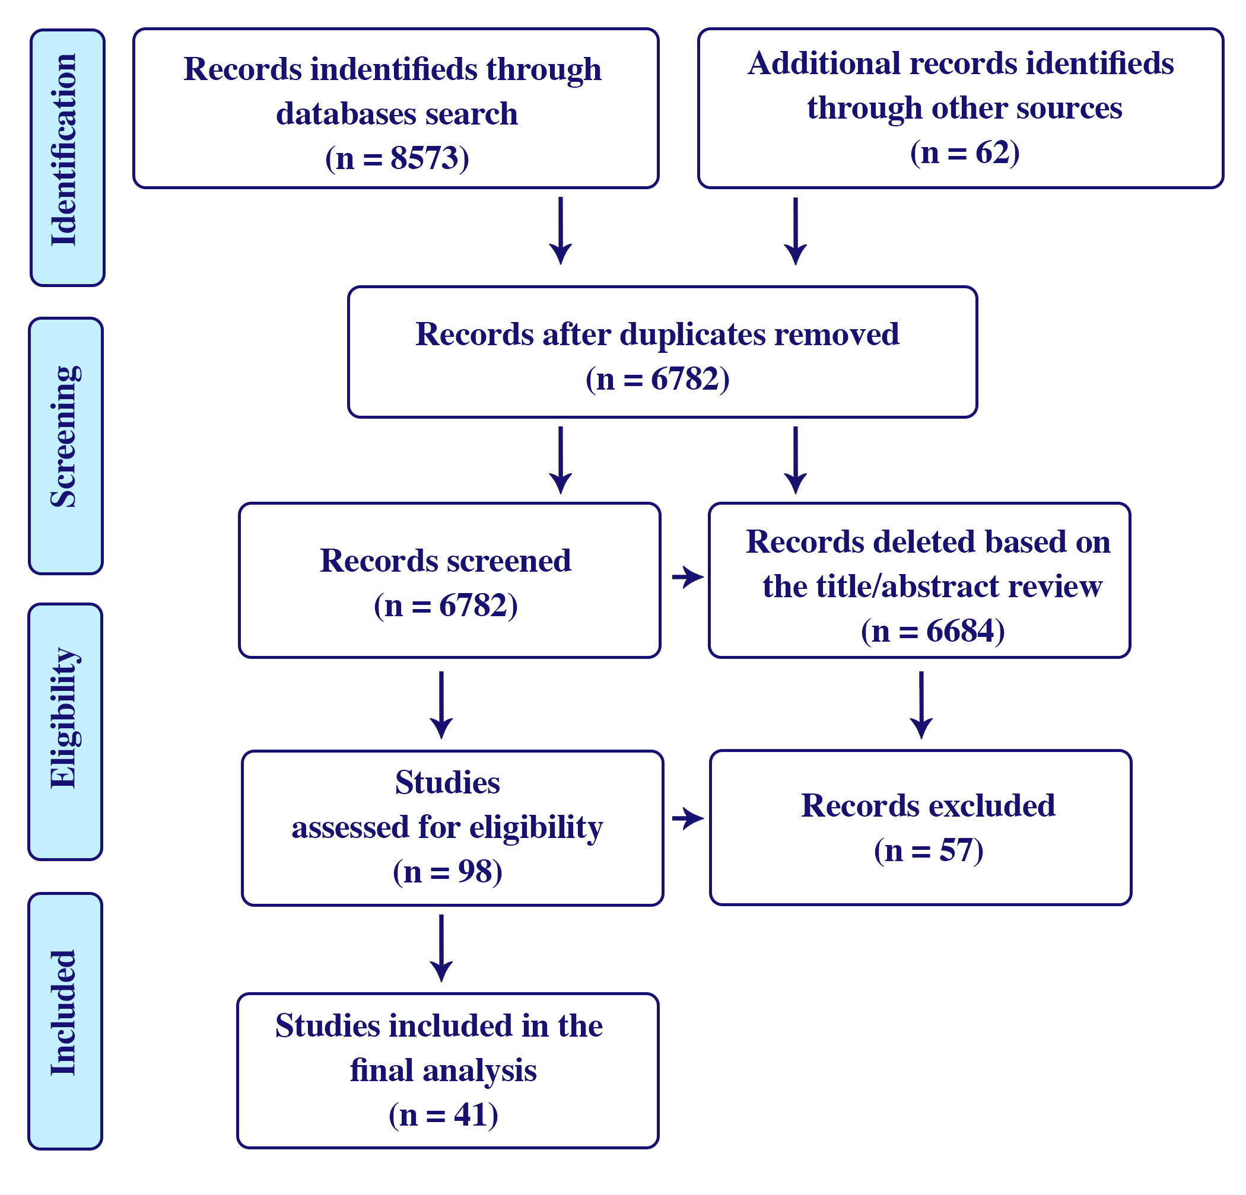

Figure S2. Baseline lipid profile in LLT group compared to control: A) TC; B) LDL-C.
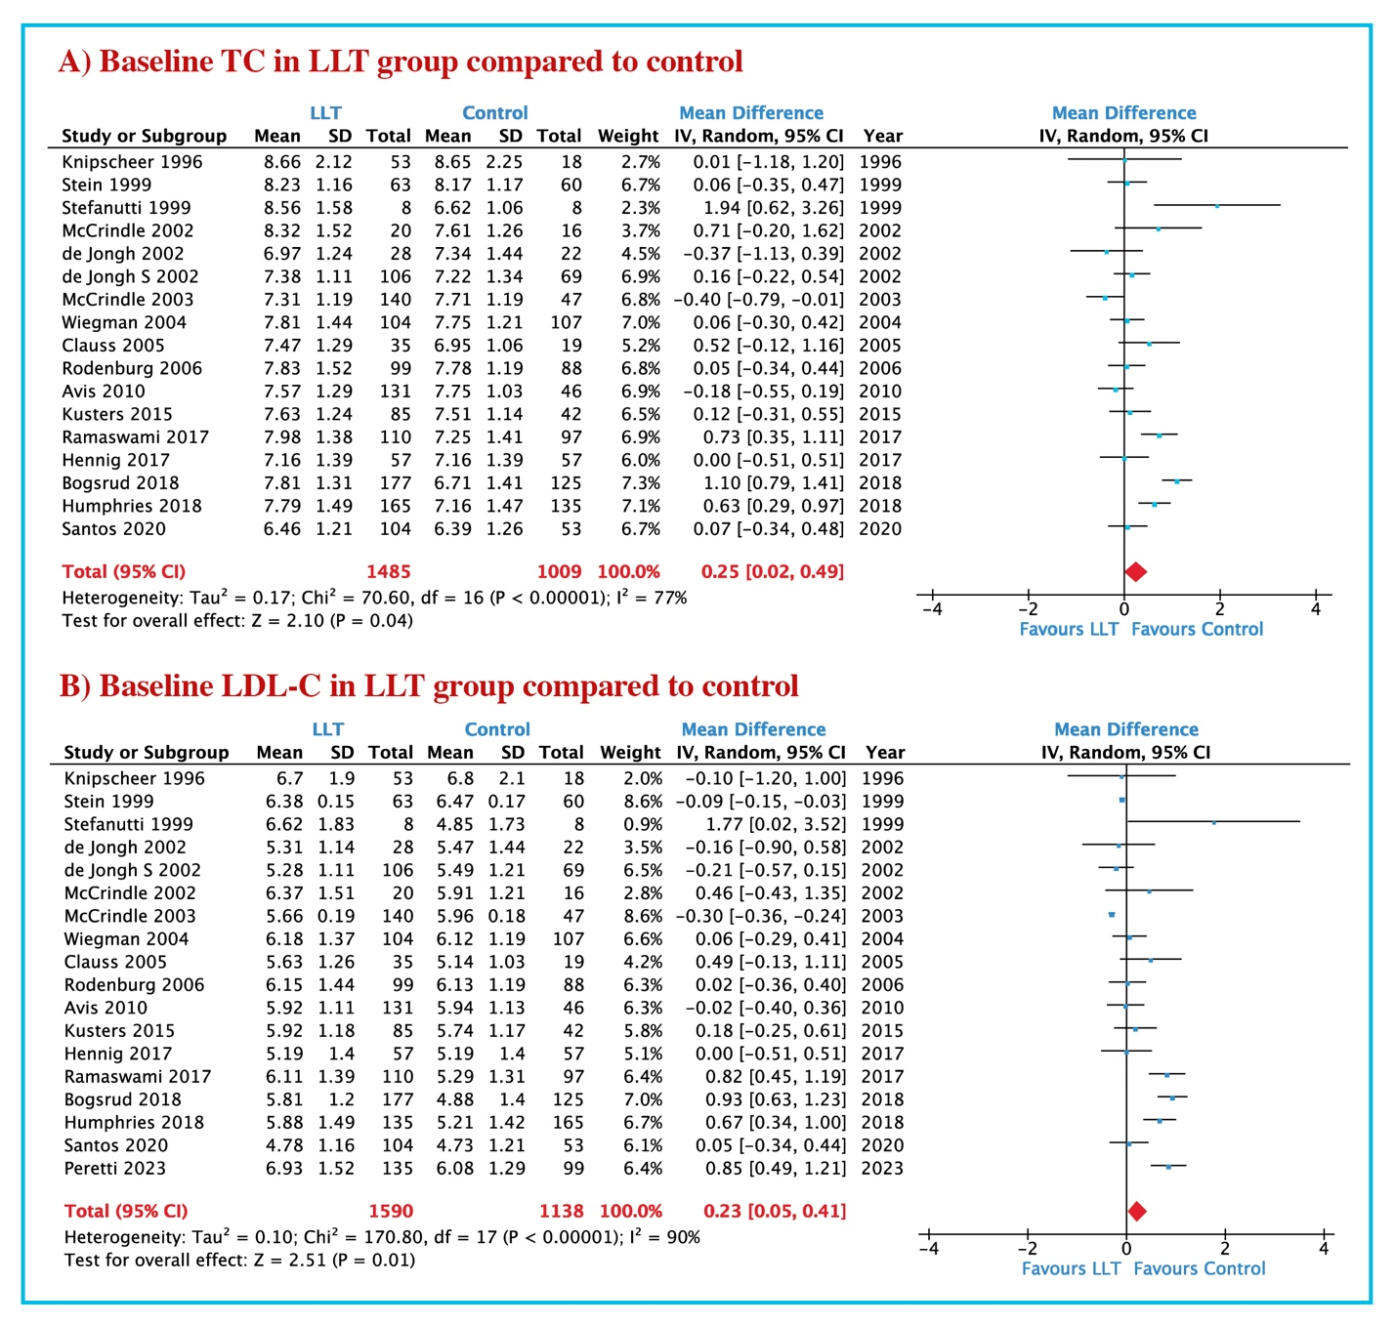
Abbreviations: LLT: Lipid lowering therapy; TC: Total cholesterol; LDL-C: Low-density lipoprotein cholesterol

Figure S3. Baseline lipid profile in LLT group compared to control: A) HDL-C; B) TG.
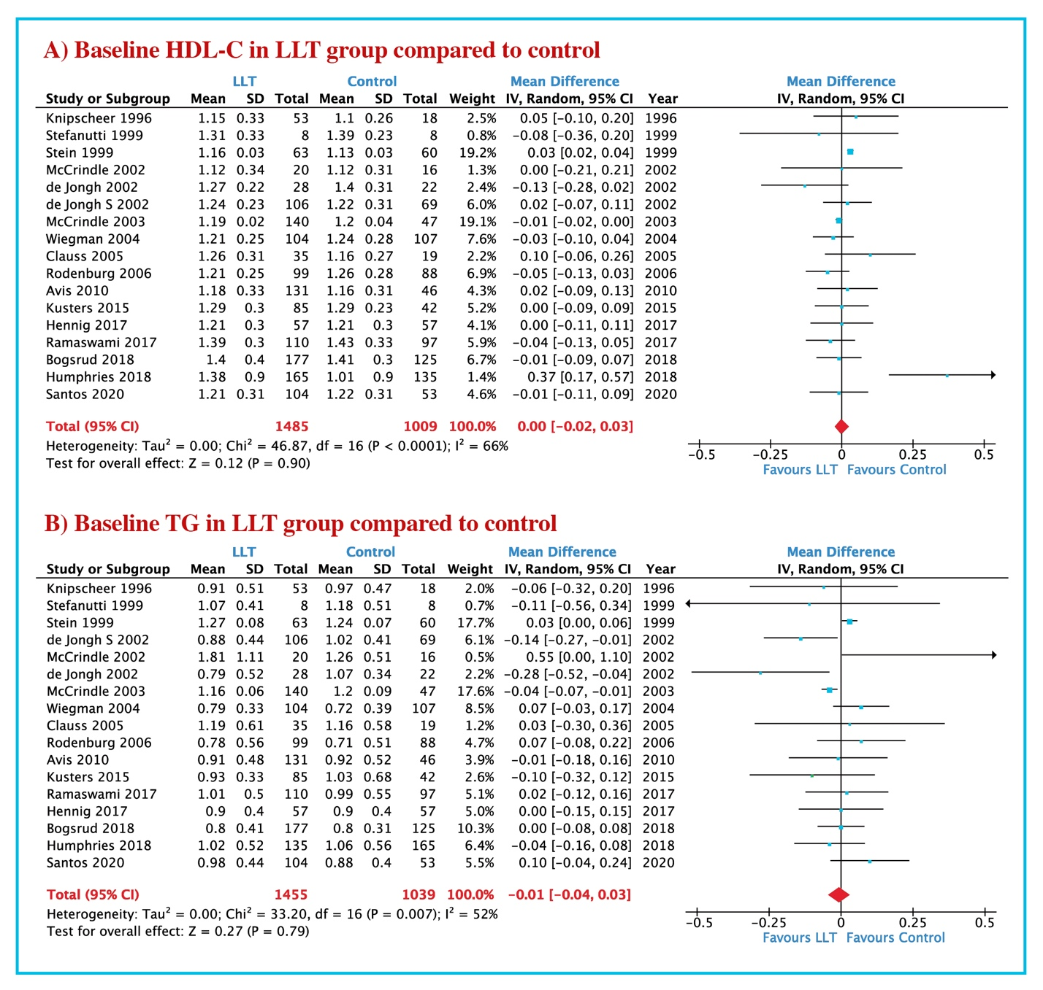
Abbreviations: LLT: Lipid lowering therapy; HDL-C: High-density lipoprotein cholesterol; TG: Triglyceride.

Figure S4. Baseline lipoproteins levels in LLT group compared to control: A) Lp(a); B) apoB; C) apoA.
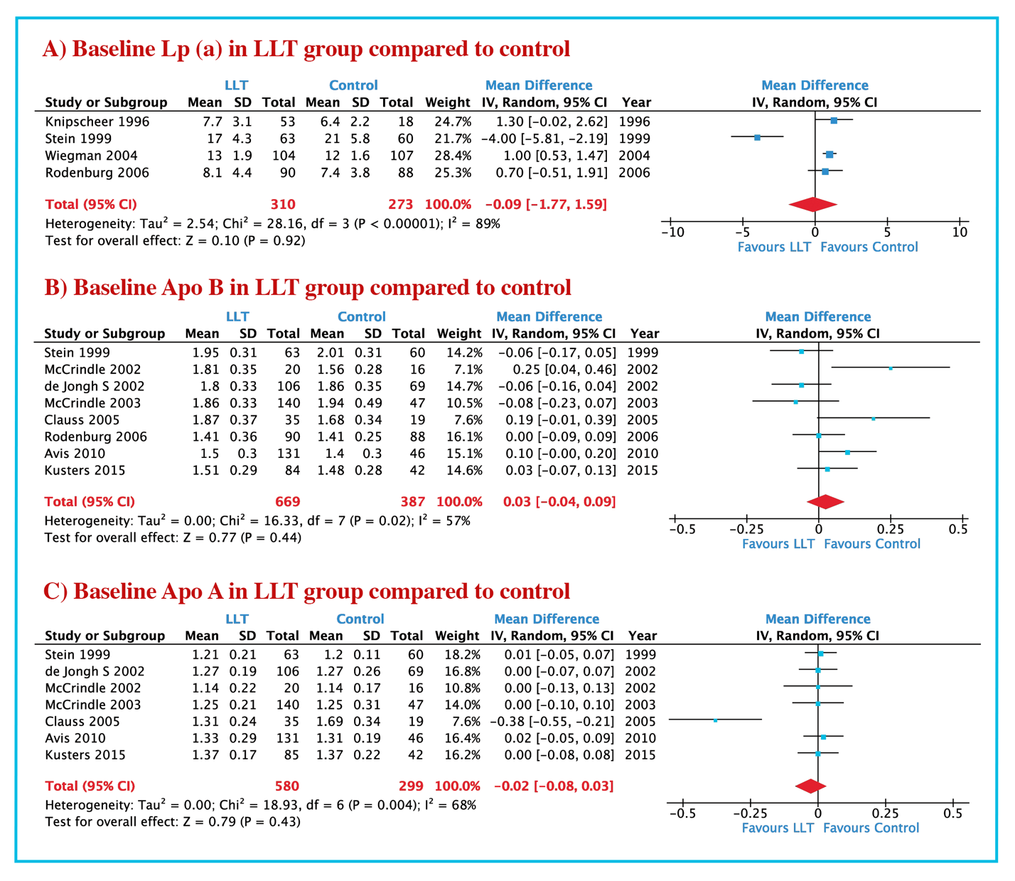
Abbreviations: LLT: Lipid lowering therapy; Lp(a): lipoprotein (a); apoB: Apolipoprotein B; apoA: Apolipoprotein A

Figure S5. Mean change of lipid profile in LLT group compared to control: A) TC; B) LDL-C.
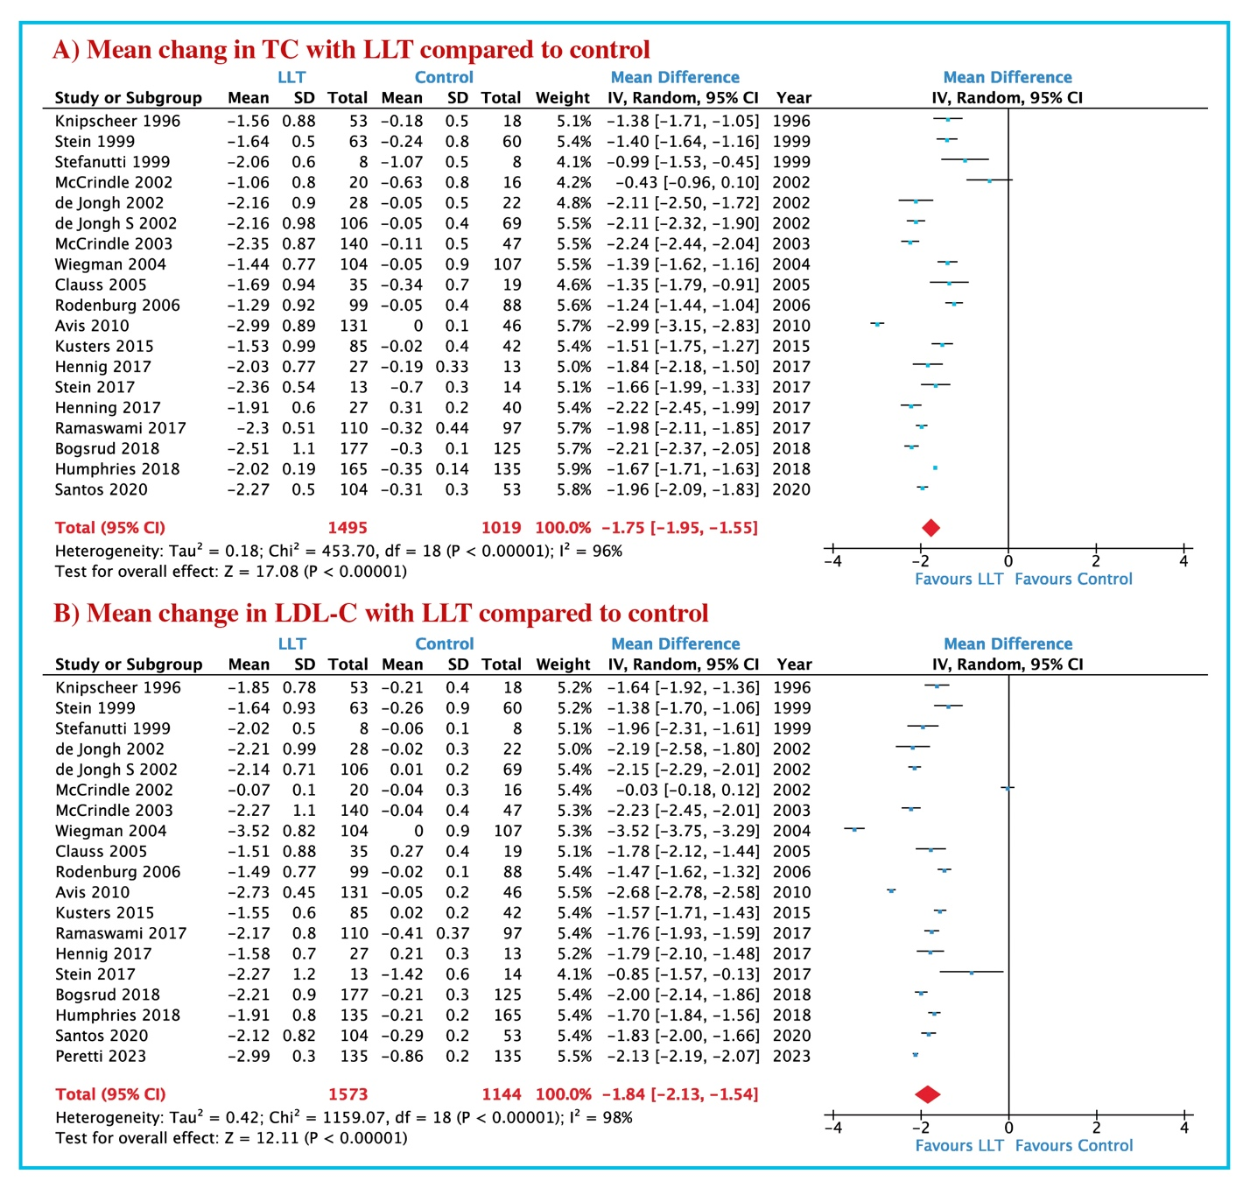
Abbreviations: LLT: Lipid lowering therapy; TC: Total cholesterol; LDL-C: Low-density lipoprotein cholesterol.

Figure S6. Mean change of lipid profile in LLT group compared to control: A) HDL-C; B) TG.

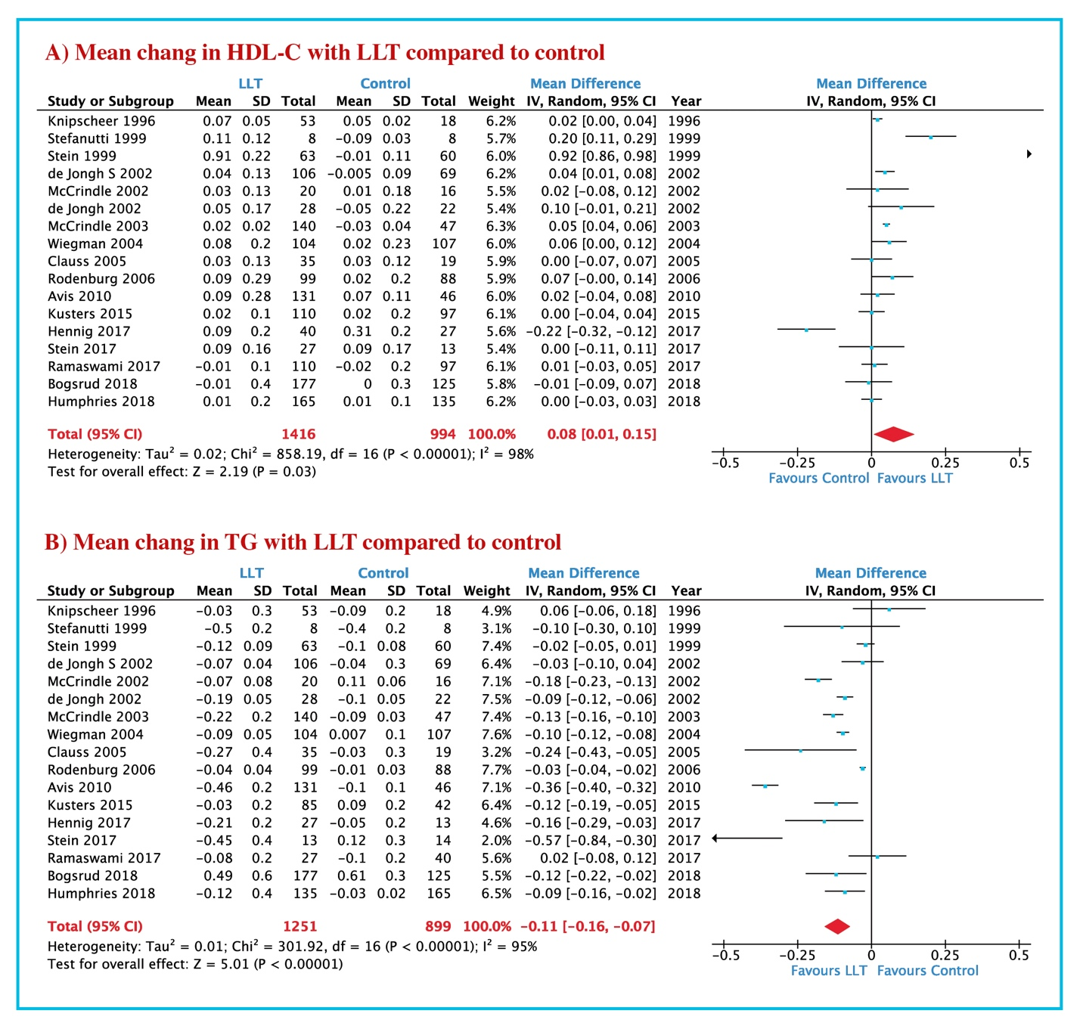
Abbreviations: LLT: Lipid lowering therapy; HDL-C: High-density lipoprotein cholesterol; TG: Triglyceride.

Figure S7. Mean change of lipoproteins levels in LLT group compared to control: A) Lp (a); B) apoB; C) apoA.

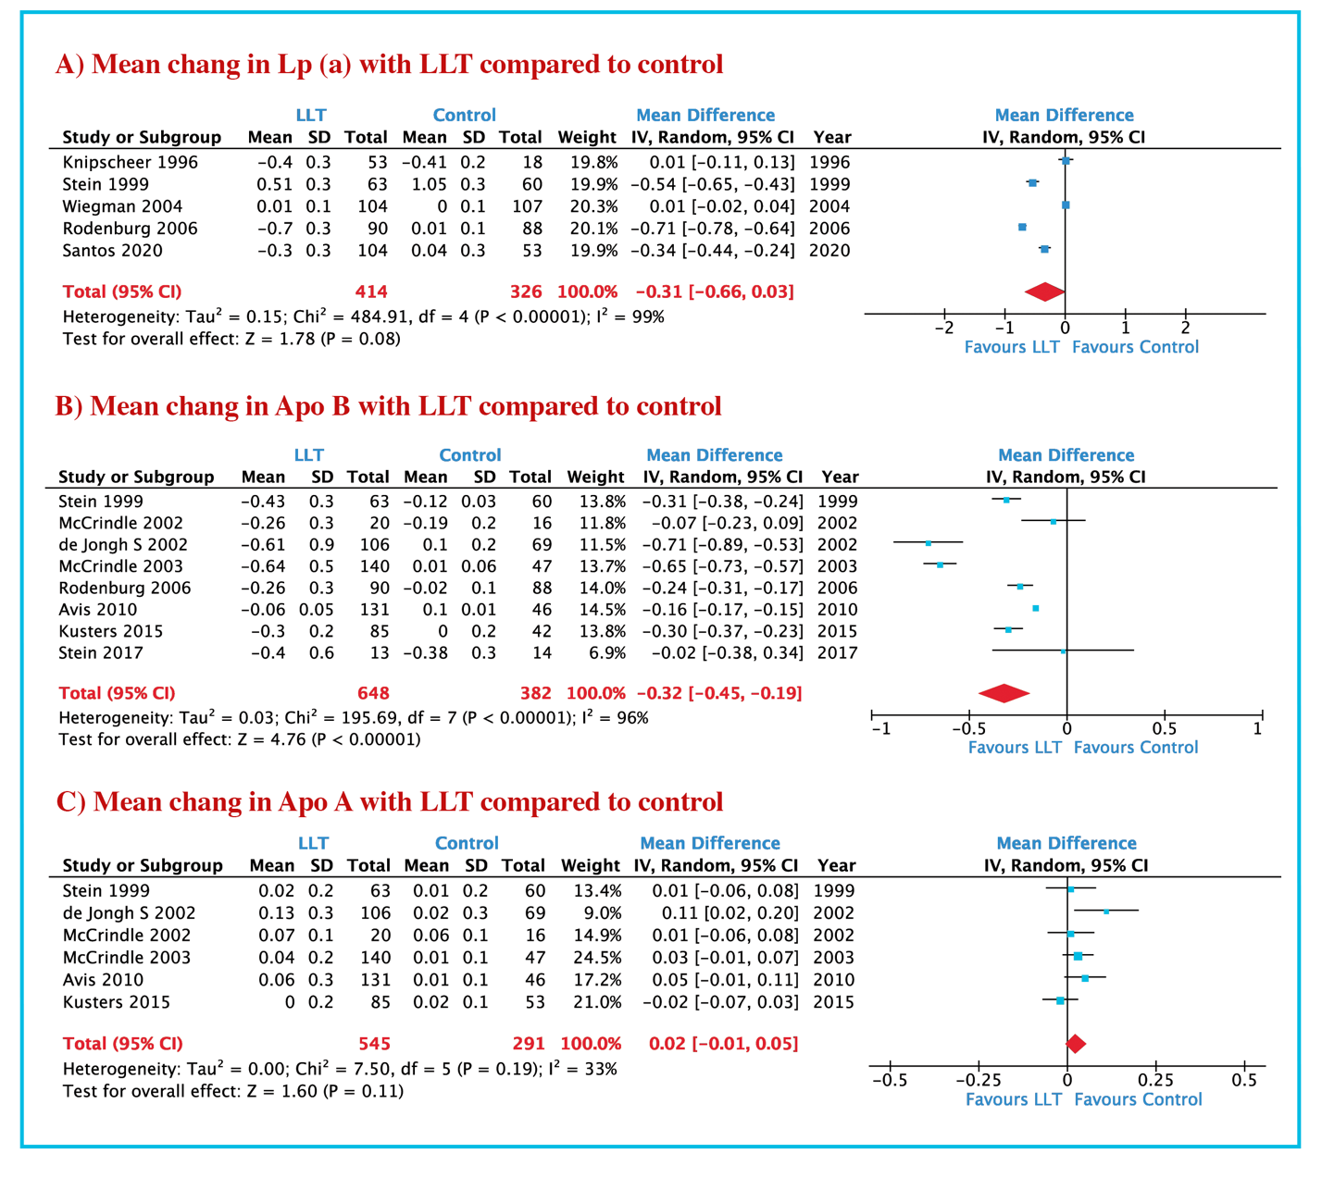
Abbreviations: LLT: Lipid lowering therapy; Lp(a): lipoprotein (a); apoB: Apolipoprotein B; apoA: Apolipoprotein A.

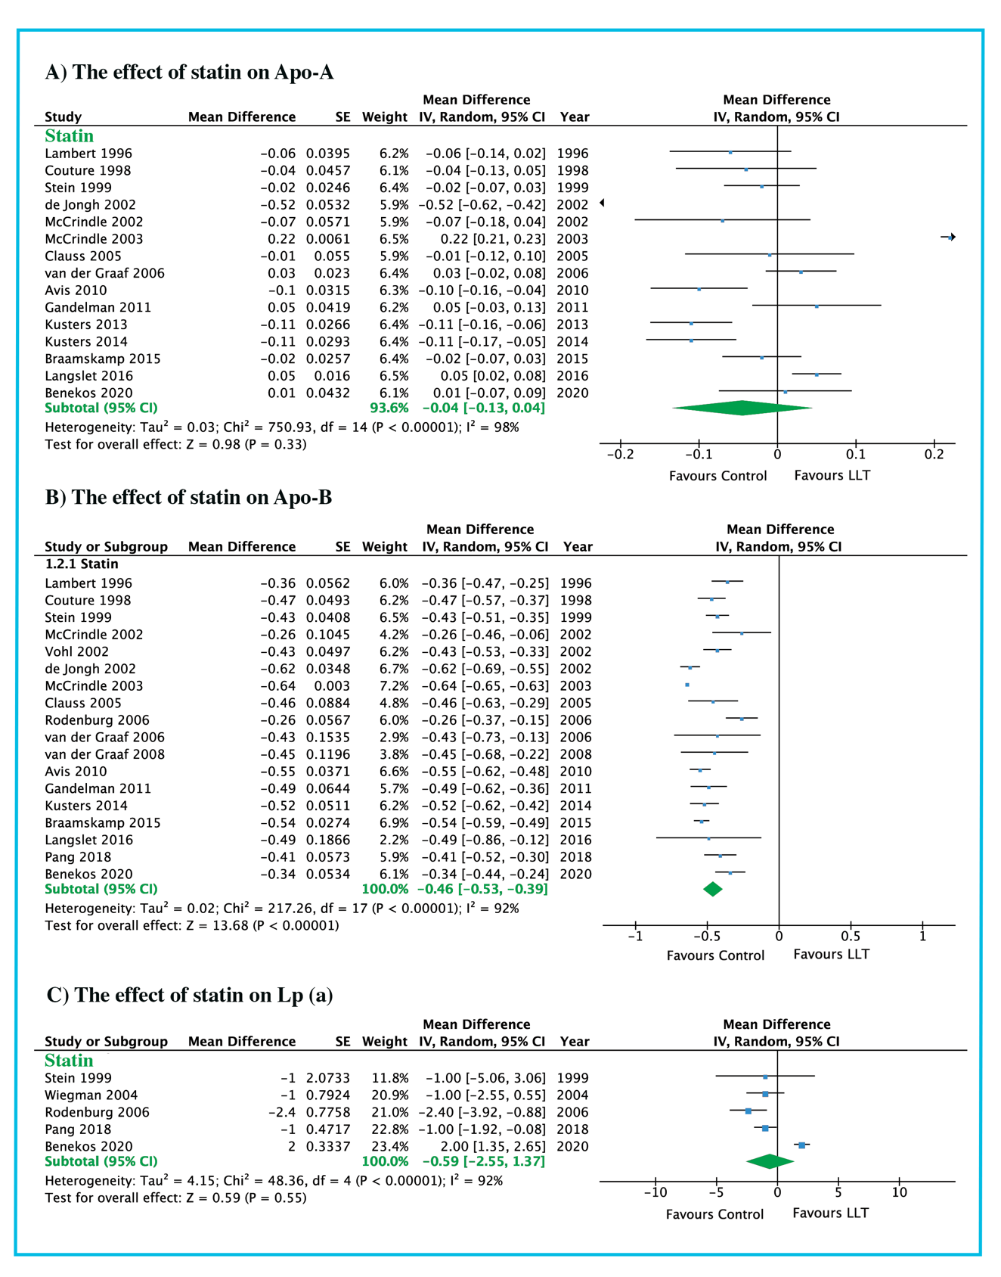
Figure S8. The effect of LLT on lipoproteins using inverse variance: A) Lp(a); B) apoB; C) apoA.
Abbreviations: LLT: Lipid lowering therapy; Lp(a): lipoprotein (a); apoB: Apolipoprotein B; apoA: Apolipoprotein A.

Figure S9. The effect of different LLT on TC levels using inverse variance.
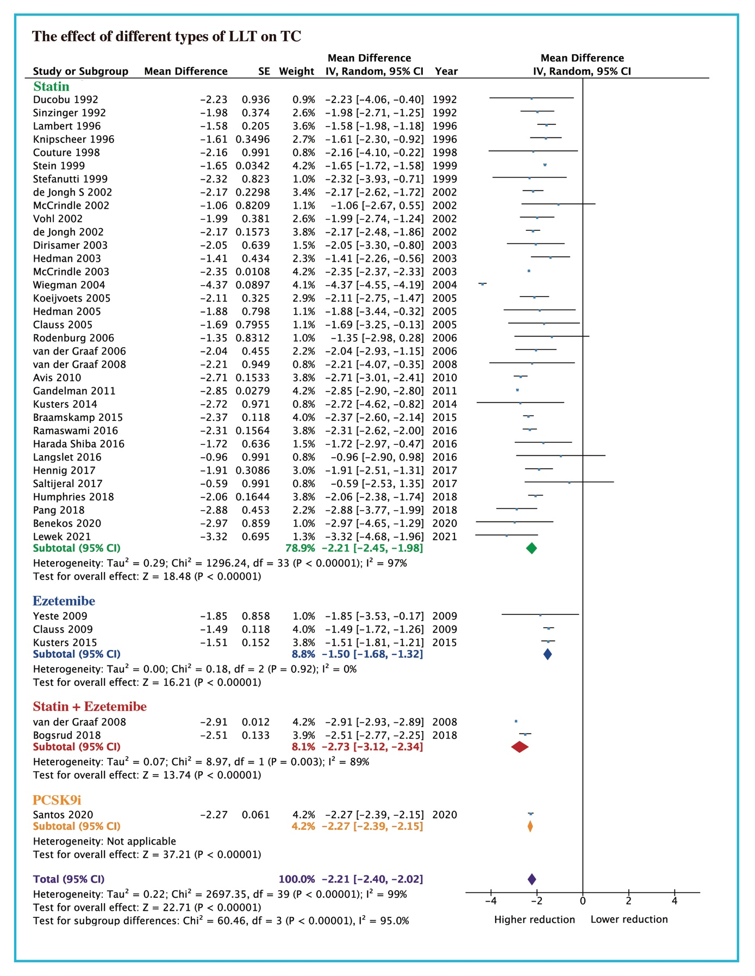
Abbreviations LLT: lipid lowering therapy; TC: total cholesterol.

Figure S10. The effect of different LLT on TG using inverse variance analysis.
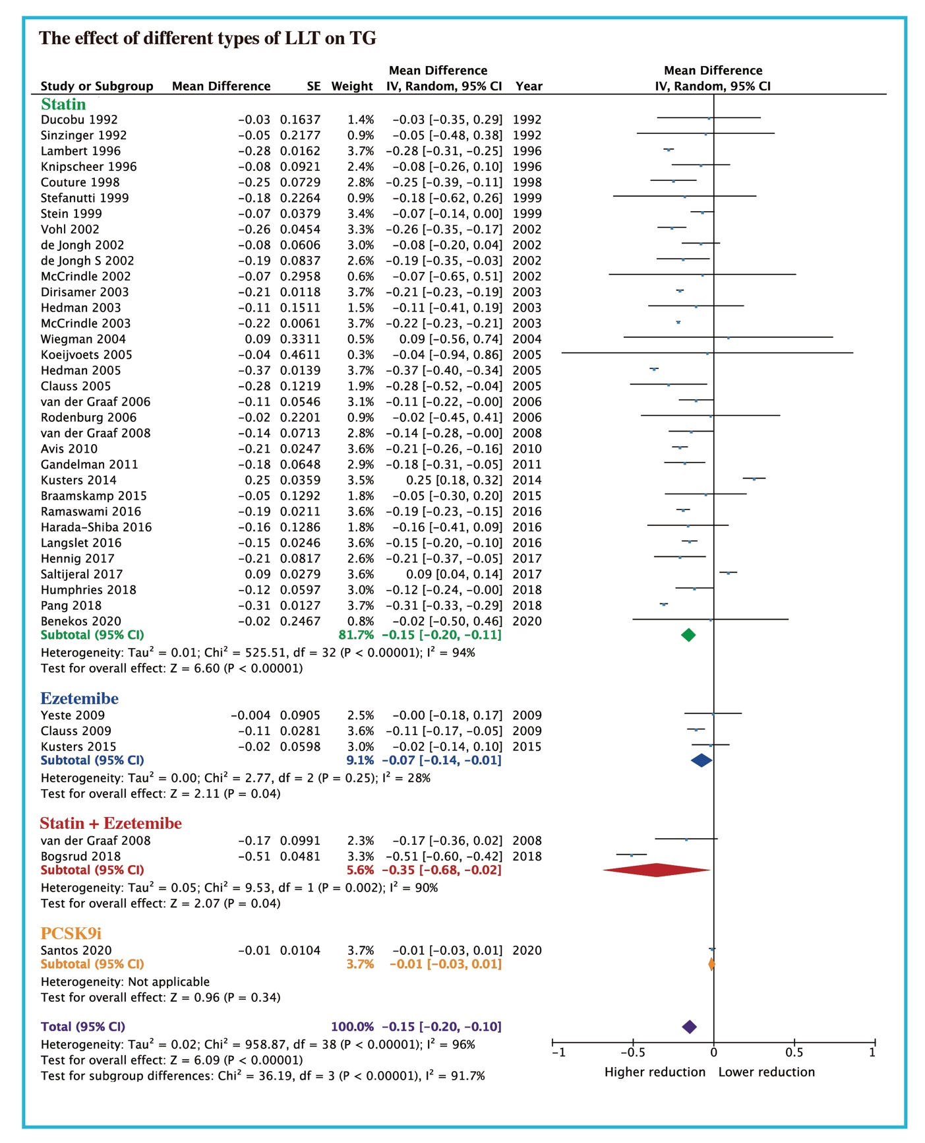
Abbreviations: LLT: lipid lowering therapy; TG: triglycerides.

Figure S11. The effect of different types of HDL-C on lipoproteins using inverse variance
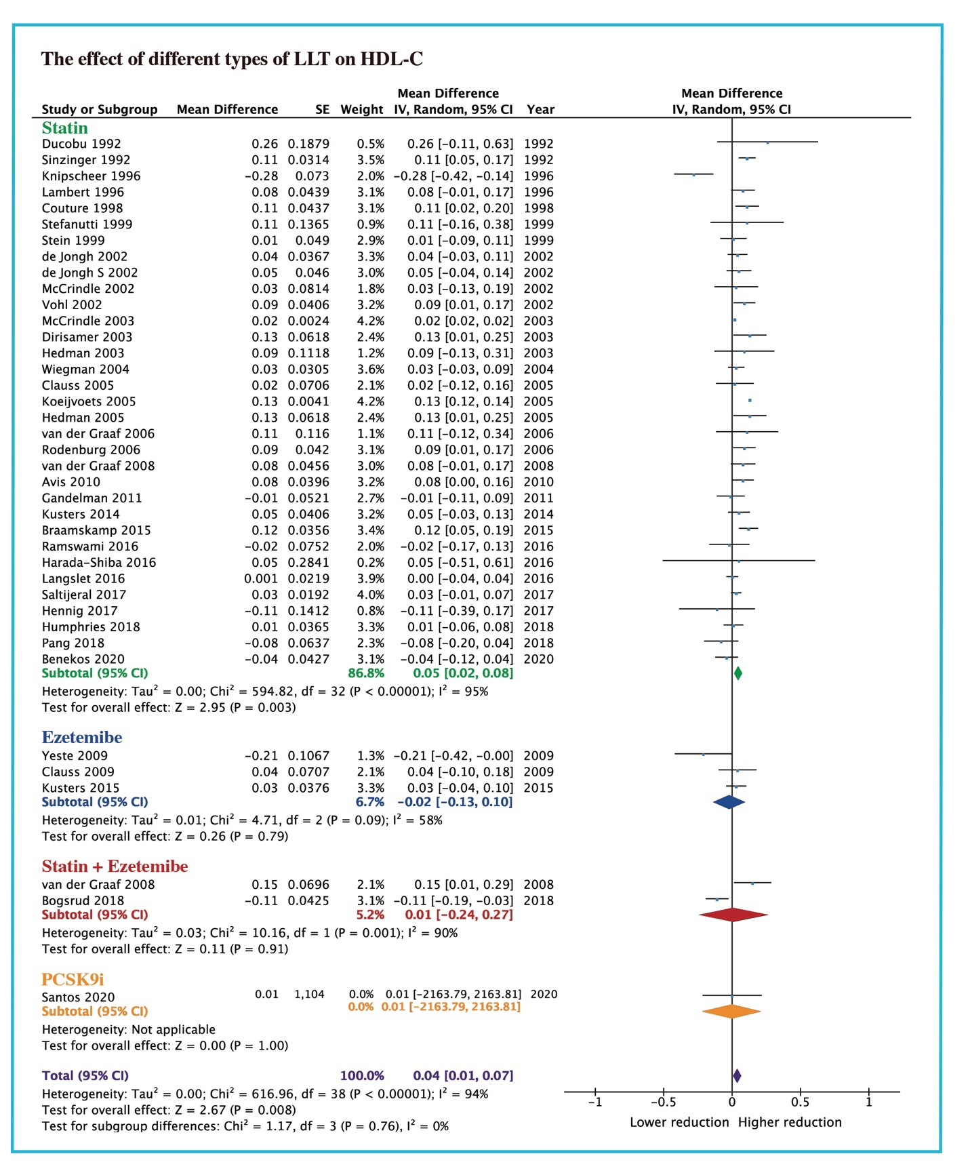
Abbreviations: LLT: lipid lowering therapy; HDL-C: high density lipoprotein-cholesterol.

Figure S12. LDL-C goal achievement using different types of LLT.

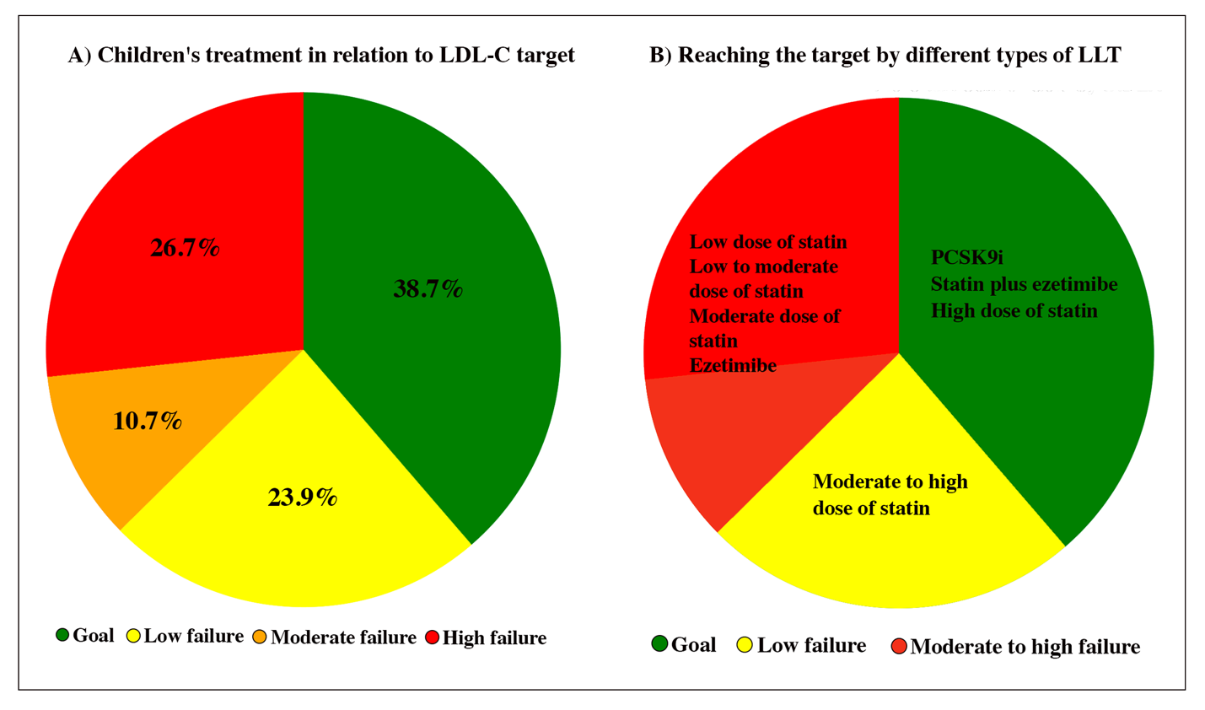
Abbreviations: LLT: lipid lowering therapy; LDL-C: low density lipoprotein-cholesterol.

Figure S13. Endocrine function among heFH patients’ treatment with LLT compared to diet only.
A) cortisol; B) DHEA-S; C) FSH; D) LH; E) estradiol; F) testosterone.
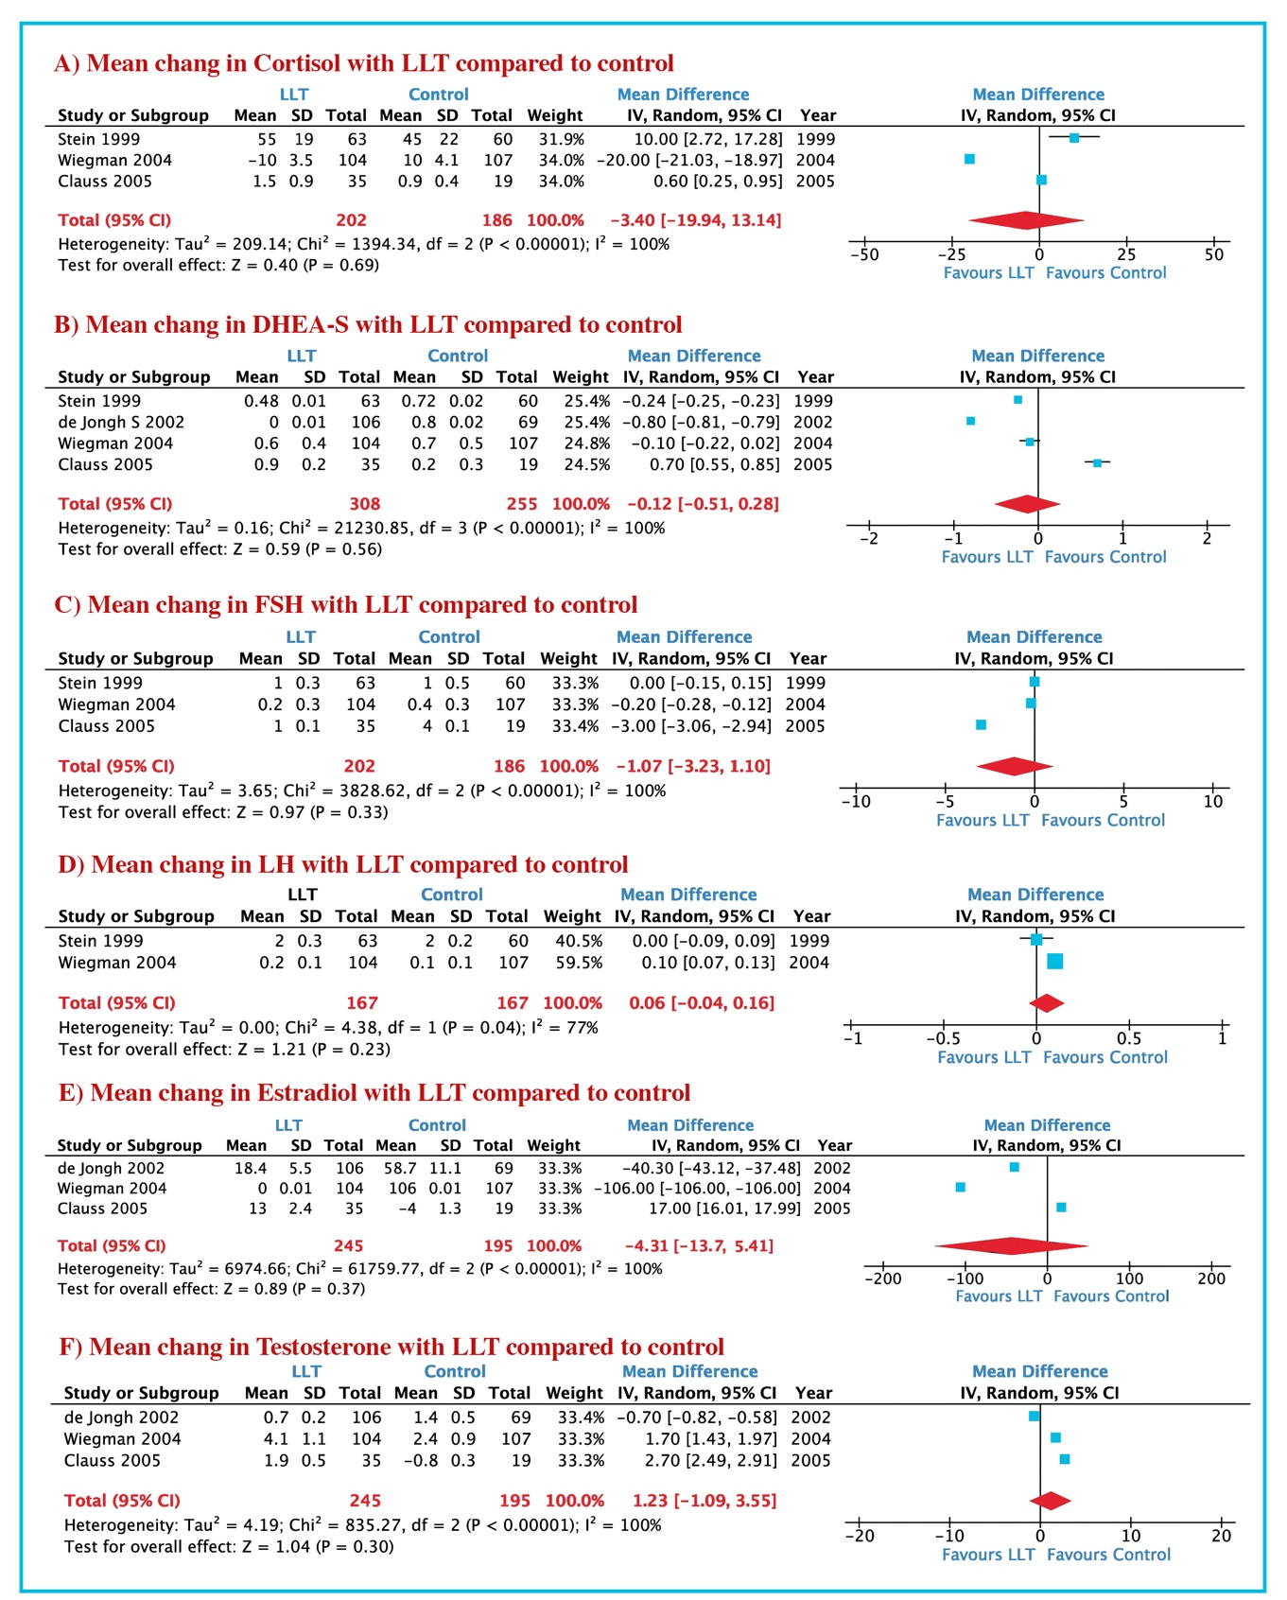
Abbreviations: DHEA-S: Dehydroepiandrosterone sulfate; FSH: Follicle-stimulating hormone; LH: luteinizes hormone.

Figure S14. Demographic indices among heFH patients treated with LLT compared to diet only.
A) weight; B) height; C) BMI; D) LH; BSA.
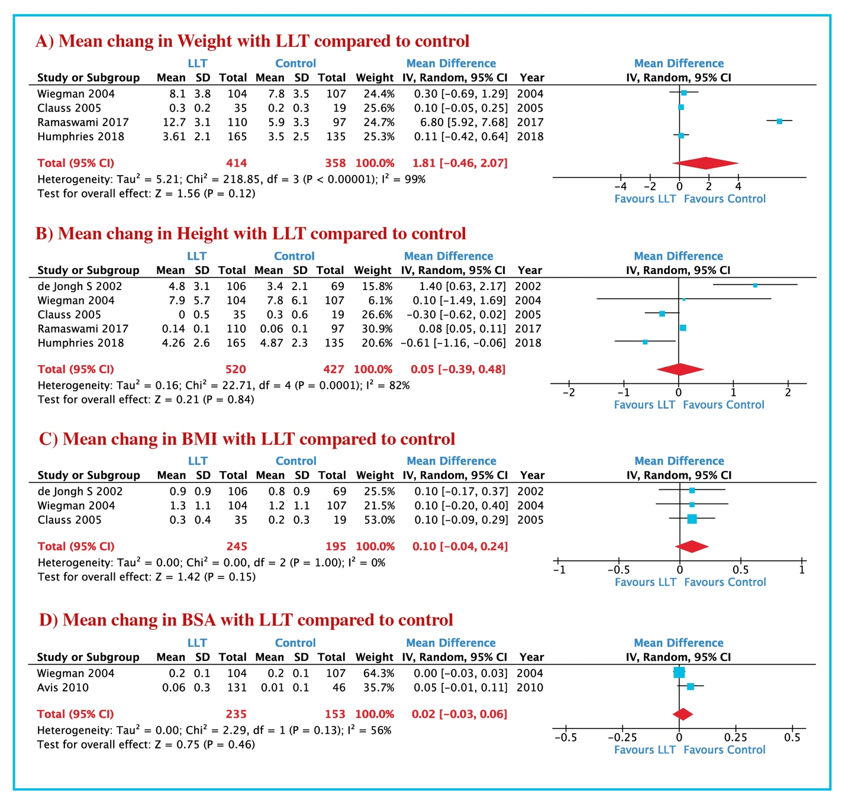
Abbreviations: BMI: body mass index; BSA: body surface area.

Figure S15. Liver/muscle enzymes among heFH patients treated with LLT compared to diet only.
A) ALT; B) AST; C) CK.

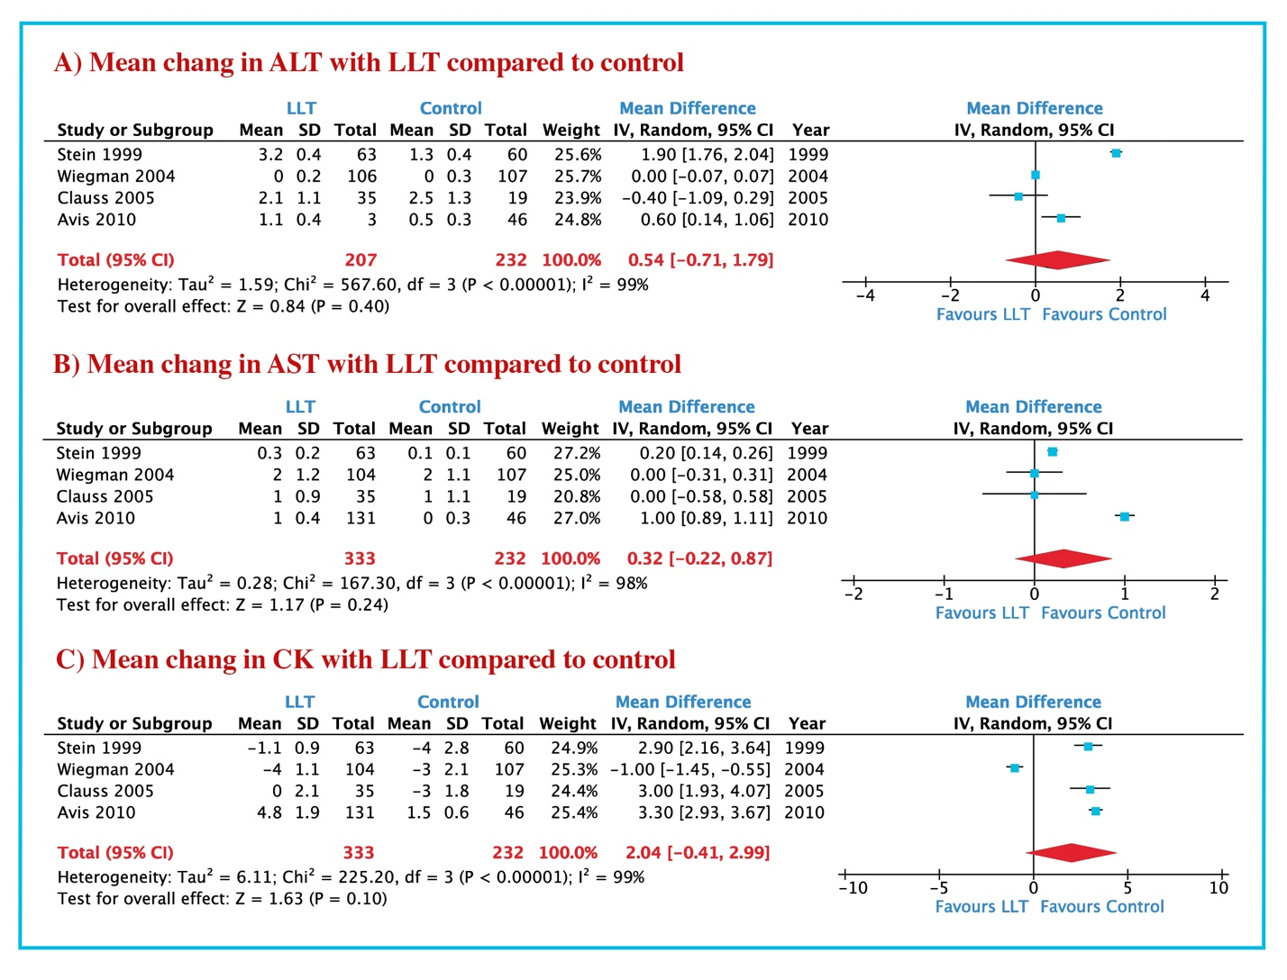
Abbreviations: ALT: alanine transaminase; AST: aspartate aminotransferase; CK: creatinine kinase.

Figure S16. GI adverse events in LLT group compared to control: A) GI events; B) abdominal pain;
C) constipation; D) nausea; E) diarrhea.
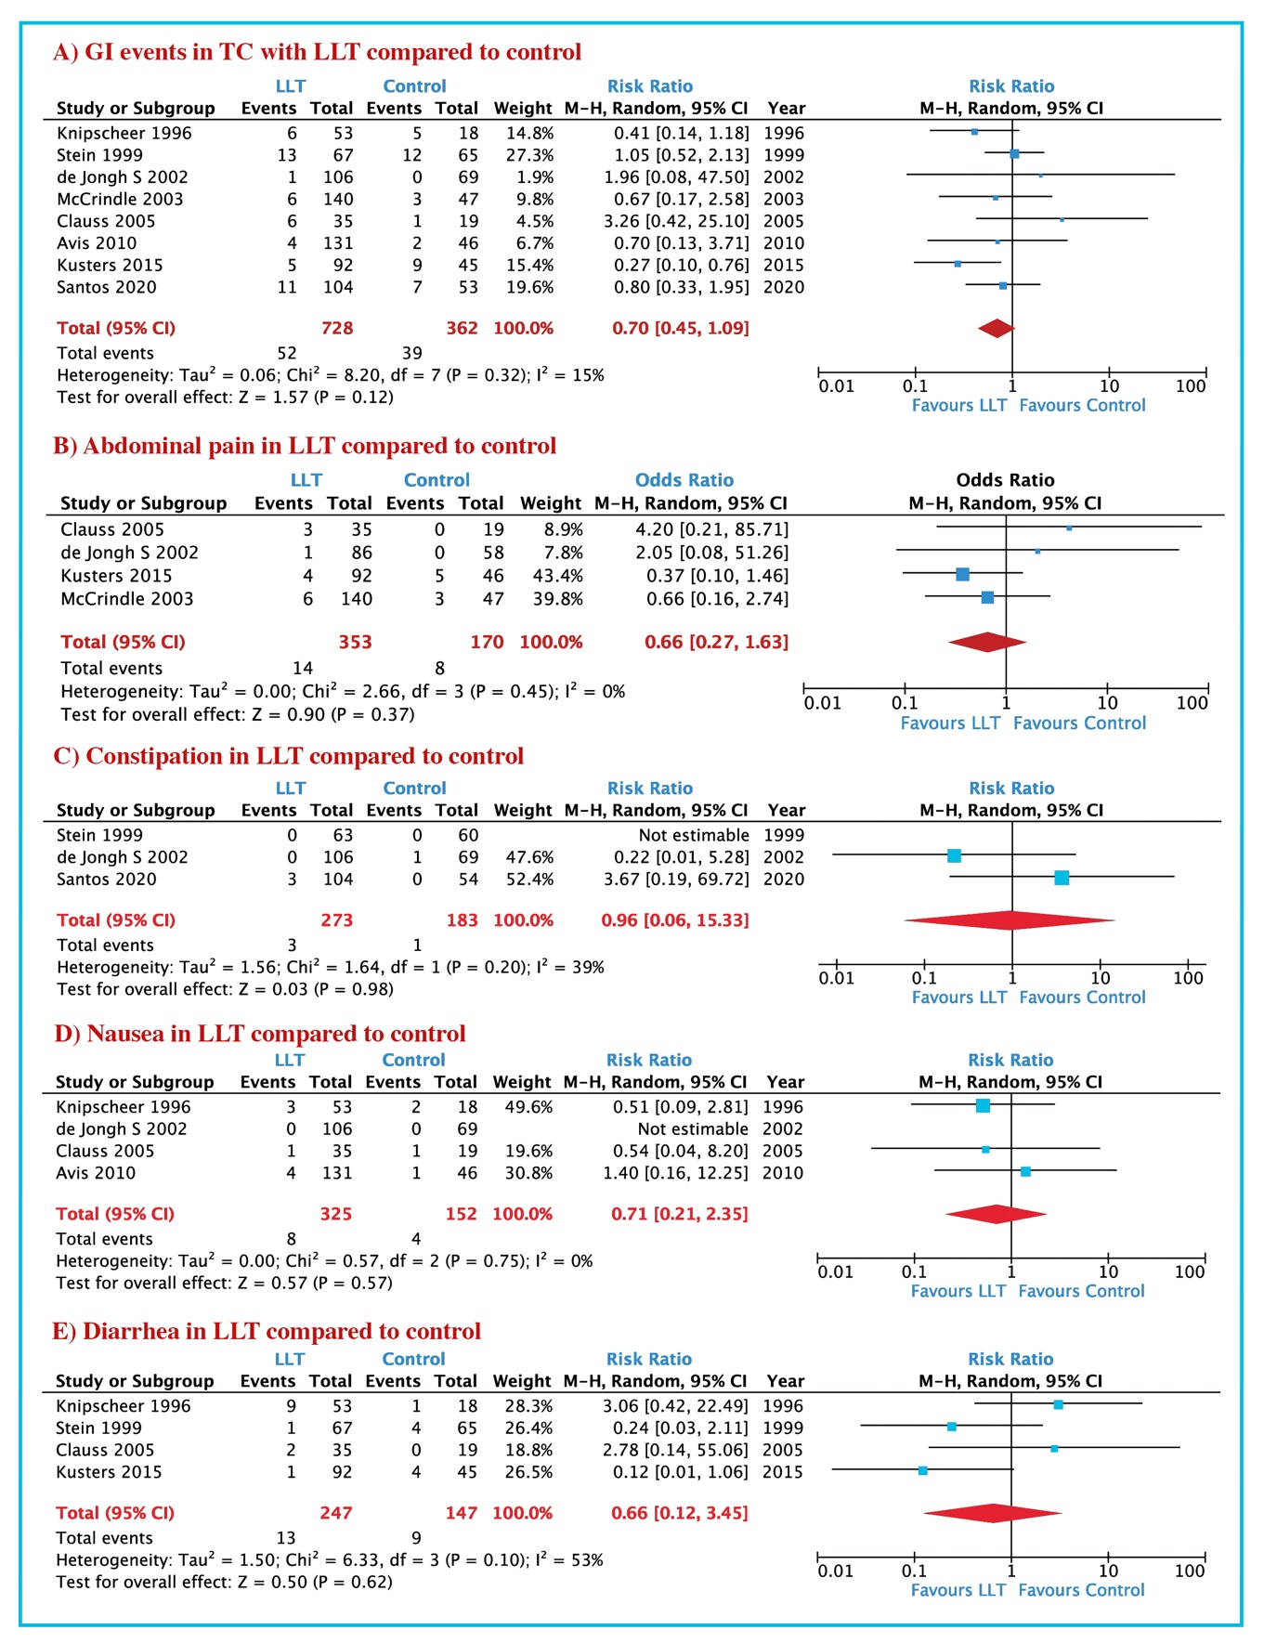

Abbreviations: GI: gastrointestinal, LLT: Lipid lowering therapy; GI: Gastrointestinal

Figure S17. Adverse events in LLT group compared to control: A) headache; B) myalgia;
C) influenza-like disease; D) skin disease; E) sleep disorders.

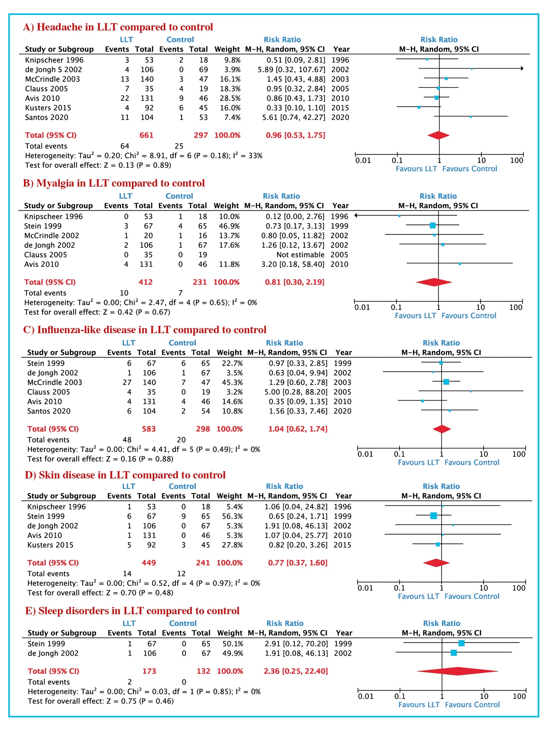
Abbreviations: LLT: Lipid lowering therapy
Figure S18. Laboratory abnormalities in LLT group compared to control: A) ALT > 3 ULN; B) AST >3; ULN; C) CK >5, <10 ULN; D) CK >10 x ULN.
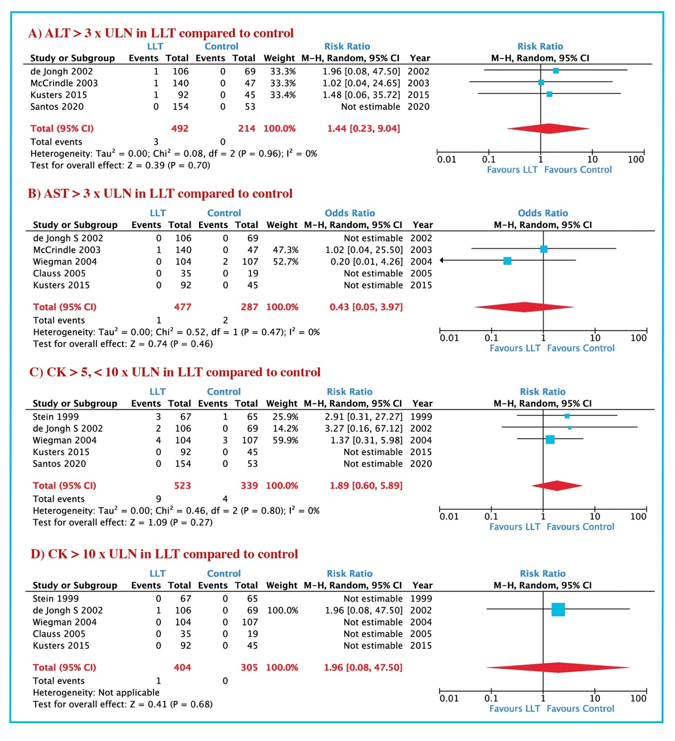 Abbreviations: ALT: Alanine aminotransferase; AST: Aspartate aminotransferase; CK: Creatinine kinase; ULN: upper limit normal.

Figure S19. Adverse events in LLT group compared to control: A) serious adverse events (SAE); B) discontinuation.

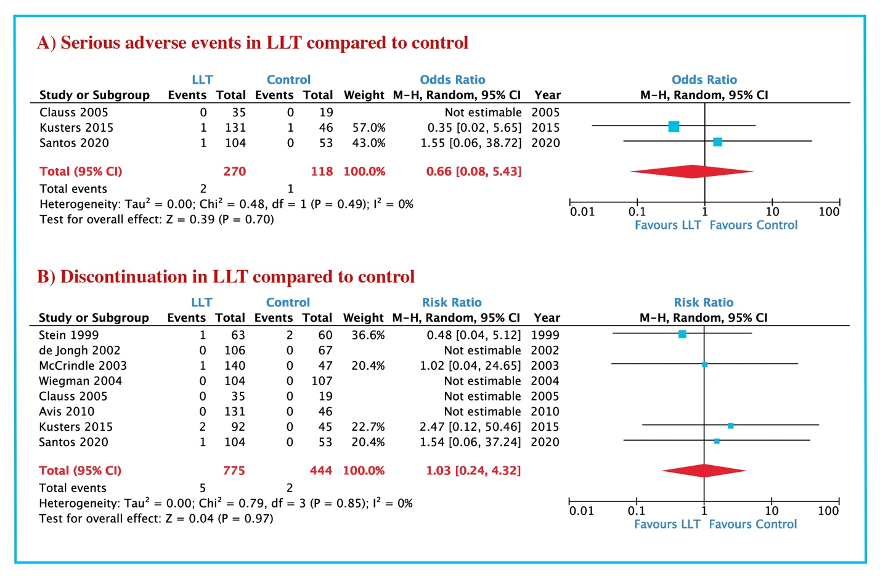
Abbreviations: LLT: Lipid lowering therapy

Table S3. Assessment of risk of bias in the included studies using Newcastle-Ottawa Quality Assessment Scale (NOS) for cohorts
(observational) studies.
Study, year | Selection | Selection | Selection | Selection | Comparability | Exposure | Exposure | Exposure | Quality
 | 1 | 2 | 3 | 4 | 1 | 1 | 2 | 3
Ducobu 1992 | a | a) | a) | a) | b) | a) | a) | a) | Good
Dirisamer 2003 | a) | a) | b) | a) | b) | a) | a) | b) | Good
Hedman 2003 | a) | a) | a) | b) | b) | b) | a) | b) | Good
Hedman M 2005 | a) | b) | a) | b) | b) | b) | a) | b) | Good
Van der Graaf 2006 | a) | a) | a) | a) | b) | a) | a) | a) | Good
Yeste 2009 | a) | a) | b) | b) | b) | a) | b) | b) | Good
Clauss 2009 | a) | a) | b) | b) | b) | a) | b) | b) | Good
Gandelman 2011 | a) | b) | a) | b) | a) | b) | a) | b) | Good
Langslet 2016 | a) | a) | a) | a) | b) | a) | a) | a) | Good
Henning 2017 | b) | b) | b) | b) | b) | a) | b) | b) | Fair
Saltijeral 2017 | a) | b) | a) | a) | b) | a) | b) | a) | Good
Ramaswami 2016 | a) | b) | a) | a) | a) | a) | b) | b) | Good
Humphries 2017 | a) | a) | b) | b) | b) | a) | b) | b) | Good
Bogsrud 2017 | a) | a) | b) | b) | a) | a) | b) | a) | Good
Pang 2018 | b) | b) | b) | b) | b) | b) | b) | b) | Fair
Benekos 2020 | a) | b) | a) | b) | a) | b) | b) | b) | Good
Lewek 2021 | b) | b) | b) | a) | b) | b) | b) | b) | Fair
Peretti 2023 | a) | b) | a) | b) | a) | a) | b) | b) | Good

Legend: NOS: Selection- 1: a), b) one star, c), d) no star; Selection- 2: a) one star, b, c) no star; Selection- 3: a), b) one star, c), d), e) no star, Selection- 4: a) one star, b) no star;
Comparability: a), b) one star, c) no star; Exposure-1: a), b) one star, c), d), e) no star; Exposure-2: a) one star, b) no star; Exposure-2: a), b) one star, c), d), no star.
Good quality: 3 or 4 stars in selection domain AND 1 or 2 stars in comparability domain AND 2 or 3 stars in outcome/exposure domain
Fair quality: 2 stars in selection domain AND 1 or 2 stars in comparability domain AND 2 or 3 stars in outcome/exposure domain
Poor quality: 0 or 1 star in selection domain OR 0 stars in comparability domain OR 0 or 1 stars in outcome/exposure do

Table S4. Assessment of risk of bias in the included studies using RoB2 for RCTs studies.
Study, year | Randomization | Deviation | Missing | Measurement | Selection | Overall
 | process | from intended | outcome | of the | of the reported
 |  | interventions | data | outcome | results
Sinzinger 1992 | S | L | L | L | L | S
Knipscheer 1996 | L | L | L | L | L | L
Lambert 1996 | L | L | L | L | L | L
Couture 1998 | S | L | L | L | L | S
Stein 1999 | L | L | L | L | L | L
Stefanutti 1999 | L | L | L | L | L | L
McCrindle 2002 | L | L | L | L | L | L
McCrindle 2003 | L | L | L | L | L | L
de Jongh, 2002 | L | L | L | L | L | L
de Jongh 2002 | L | L | L | L | L | L
Vohl 2002 | S | L | L | L | S | S
Wiegman 2004 | L | L | L | L | L | L
Koeijvoets 2005 | S | L | L | L | L | S
Rodenburg 2006 | L | L | L | L | L | L
Van der Graaf 2008 | L | L | L | L | L | L
Avis 2010 | L | L | L | L | L | L
Kusters 2013 | L | L | L | L | L | L
Kusters 2015 | L | L | L | L | L | L
Braamskam 2015 | L | L | S | L | L | S
Harada-Shiba 2016 | L | L | L | L | L | L
Daniels 2020 | L | L | L | L | L | L
Santos 2020 | L | L | L | L | L | L
L: Low; S: Some concerns; H: High
Overall risk-of-bias judgement Criteria
Low risk of bias | The study is judged to be at low risk of bias for all domains for this result.
Some concerns | The study is judged to raise some concerns in at least one domain for this result, but not to be at high risk of bias for any domain.
High risk of bias | The study is judged to be at high risk of bias in at least one domain for this result. The study is judged to have some concerns for multiple domains in a way that substantially lowers confidence in the result.

