Figure S1 Longitudinal patterns of the relative OTU abundances of the dominant genera in the NHAI and non-NHAI groups.

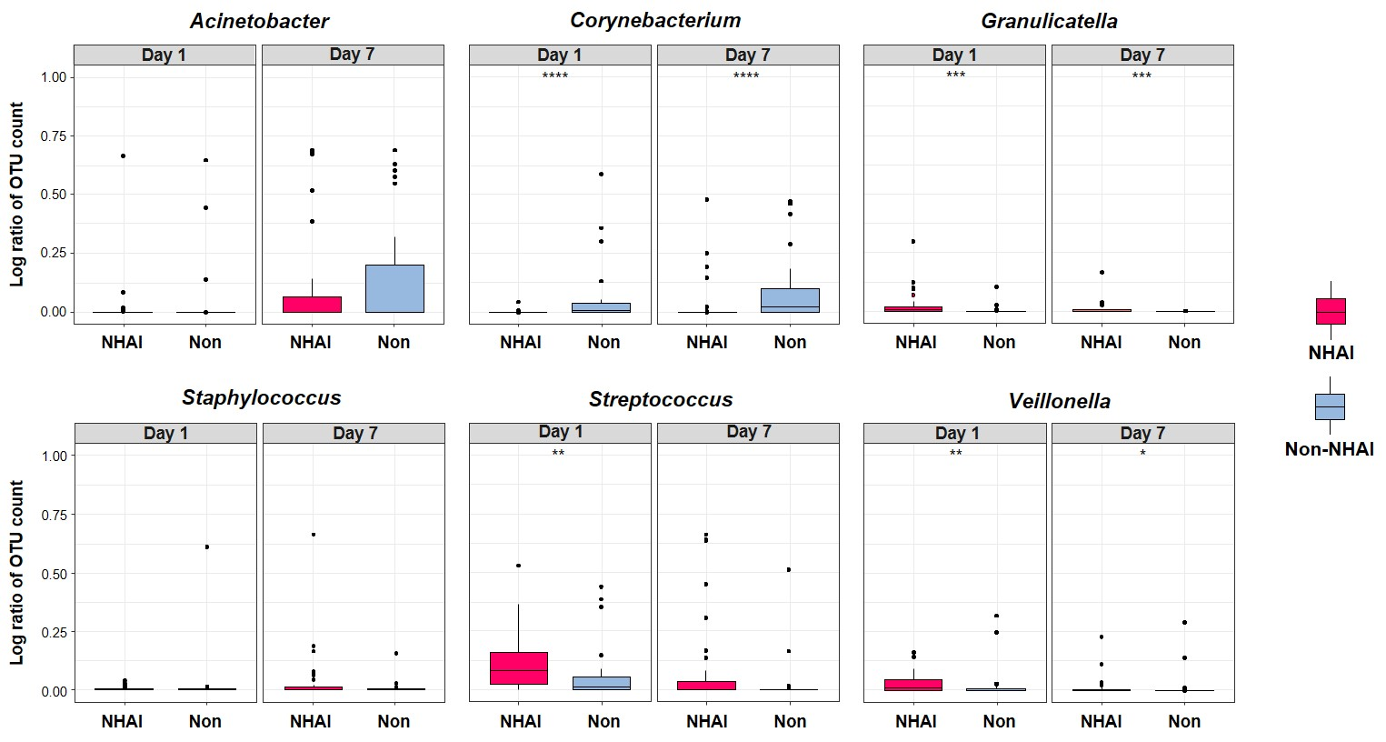

*P<0.05
**P<0.01
***P<0.001
**** P<0.0001

