Supplementary figure

Neutral buoyancy as a simple approach to implement microgravity

Ho Yong Kim¹, Sungwook Kang², and Se Heang Oh^{1, 3*}

¹Department of Nanobiomedical Science, Dankook University, Cheonan, 31116, Republic of Korea
²Department of Smart Ocean Mobility Engineering, Changwon National University, Changwon, 51140, Republic of Korea
³Department of Biomedical Sciences & Biosystems, Dankook University, Cheonan, 31116, Republic of Korea

*Corresponding author
E-mail: seheangoh@dankook.ac.kr

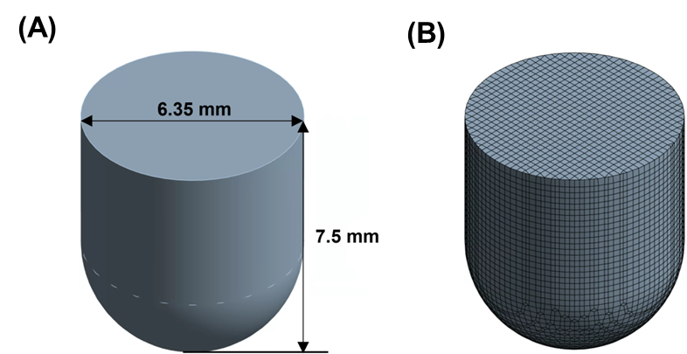

Supplementary figure 1. 3-dimensional geometry (A) and total node model (B) for Computational fluid dynamics (CFD) analysis.

