Venetoclax and azacitidine compared with intensive chemotherapy for adverse-risk acute myeloid leukemia patients receiving allogeneic hematopoietic stem cell transplantation in first complete remission: a multicenter study of TROPHY group.

Supplementary information
Contents
Supplementary Methods 3
MFC detection of MRD 3
Supplementary tables 4
Supplementary Table 1. The number of genetic abnormalities at diagnosis 4
Supplementary Table 2. The clinical outcomes between IC and VEN-AZA groups according to age, MRD status and HCT-CI before allo-HSCT 6
Supplementary Table 3. The clinical outcomes between IC and VEN-AZA groups according to major genetic abnormalities at diagnosis 8
Supplementary Table 4. Univariate analysis for clinical outcomes 12
Supplementary Table 5. Patient characteristics in PSM analysis 20
Supplementary figures 22
Supplementary Figure 1. Subgroup analysis of 3-year cumulative incidence of relapse in total cohort 23
Supplementary Figure 2. Subgroup analysis of 3-year cumulative incidence of NRM in total cohort 24
Supplementary Figure 3. Subgroup analysis of 3-year probability of OS in total cohort 25
Supplementary Figure 4. Subgroup analysis of 3-year probability of LFS in total cohort 26
Supplementary Figure 5. Subgroup analysis of 3-year probability of EFS in total cohort 27
Supplementary Figure 6. Subgroup analysis of 3-year cumulative incidence of relapse in PSM cohort. 28
Supplementary Figure 7. Subgroup analysis of 3-year cumulative incidence of NRM in PSM cohort. NA, not applicable 29
Supplementary Figure 8. Subgroup analysis of 3-year probability of OS in PSM cohort. NA, not applicable 30
Supplementary Figure 9. Subgroup analysis of 3-year probability of LFS in PSM cohort. NA, not applicable 31
Supplementary Figure 10. Subgroup analysis of 3-year probability of EFS in PSM cohort 32

Summary of supplementary information
Supplementary methods include the MFC detection of MRD. Supplementary figures include the subgroup analysis of 5 clinical outcomes in the total cohort and the PSM cohort respectively. Supplementary Tables include genetic abnormalities, patient characteristics in PSM analysis and comparison of clinical outcomes in VEN-AZA and IC group.

Supplementary Methods

MFC detection of MRD
Eight-color MFC was performed in all patients as a routine clinical test on bone marrow aspirate samples that were obtained as part of baseline assessment before and after HSCT according to previous studies [1-4]. A panel of eight antibody combinations that recognize CD7, CD11b, CD13, CD14, CD16, CD19, CD33, CD34, CD38, CD41, CD45, CD56, CD61, CD64, CD71, CD117, CD123, and HLA-DR was used for MRD detection, and 0.2–1 million events per tube were acquired on a FACS Cant II. The isotype control monoclonal antibodies were used. Positive MRD was considered when a cluster of more than 25 cells with leukemia-associated immunophenotypes (LAIP) and SSC characteristics identified in all plots of interest and carrying at least two LAIP markers identified at diagnosis was observed. For those without LAIP markers at diagnosis, MRD was identified as a cell population showing deviation from the normal patterns of antigen expression seen on specific cell lineages at specific stages of maturation compared with either normal or regenerating marrow [5]. A lower limit of detection (LOD) of 0.01% was targeted. When abnormal cells were identified, the cells were quantified as a percentage of the total CD45+ white cell events. Any measurable level of MRD was considered positive. The standardized assays and quality controls were performed according to previous reports [6, 7].

Supplementary tables

Supplementary Table 1. The number of genetic abnormalities at diagnosis
Genetic abnormality | Total |  | IC |  | VEN-AZA
 | Number | Proportion (%) | Number | Proportion (%) | Number | Proportion (%)
KMT1A-rearranged | 69 | 22.19 | 65 | 10.90 | 4 | 1.29
RUNX1 | 61 | 19.61 | 54 | 17.36 | 7 | 2.25
ASXL1 | 60 | 19.29 | 52 | 16.72 | 8 | 2.57
BCOR | 51 | 16.40 | 40 | 12.86 | 11 | 3.54
FLT3 | 49 | 15.76 | 43 | 13.83 | 6 | 1.93
TP53 | 48 | 15.43 | 36 | 11.58 | 12 | 3.86
DNMT3A | 41 | 13.18 | 31 | 9.97 | 10 | 3.22
CEBPA | 37 | 11.90 | 32 | 10.29 | 5 | 1.61
TET2 | 37 | 11.90 | 22 | 7.07 | 15 | 4.82
IDH2 | 36 | 11.58 | 27 | 8.68 | 9 | 2.89
NRAS | 32 | 10.29 | 29 | 9.32 | 3 | 0.96
NPM1 | 28 | 9.00 | 24 | 7.72 | 4 | 1.29
STAG2 | 24 | 7.72 | 19 | 6.11 | 5 | 1.61
KRAS | 21 | 6.75 | 17 | 5.47 | 4 | 1.29
U2AF1 | 19 | 6.11 | 11 | 3.54 | 8 | 2.57
PTPN11 | 17 | 5.47 | 15 | 4.82 | 2 | 0.64
SRSF2 | 13 | 4.18 | 10 | 3.22 | 3 | 0.96
GATA2 | 13 | 4.18 | 12 | 3.86 | 1 | 0.32
PHF6 | 13 | 4.18 | 12 | 3.86 | 1 | 0.32
SF3B1 | 11 | 3.54 | 7 | 2.25 | 4 | 1.29
CBL | 11 | 3.54 | 9 | 2.89 | 2 | 0.64
EZH2 | 10 | 3.22 | 8 | 2.57 | 2 | 0.64
ZRSR2 | 10 | 3.22 | 5 | 1.61 | 5 | 1.61
ETV6 | 9 | 2.89 | 7 | 2.25 | 2 | 0.64
c-KIT | 8 | 2.57 | 8 | 2.57 | 0 | 0
SETD2 | 8 | 2.57 | 8 | 2.57 | 0 | 0
KMT2A-PTD | 8 | 2.57 | 8 | 2.57 | 0 | 0
BCR-ABL | 6 | 1.93 | 5 | 1.61 | 1 | 0.32
SETBP1 | 5 | 1.61 | 5 | 1.61 | 0 | 0
SH2B3 | 5 | 1.61 | 4 | 1.29 | 1 | 0.32
NUP98 NSD-1 | 4 | 1.29 | 2 | 0.64 | 2 | 0.64
JAK3 | 4 | 1.29 | 4 | 1.29 | 0 | 0
DEK-NUP214 | 3 | 0.96 | 3 | 0.96 | 0 | 0
MLLT3-KMT2A | 3 | 0.96 | 3 | 0.96 | 0 | 0
MN1 | 2 | 0.64 | 1 | 0.32 | 1 | 0.32
HOX11 | 2 | 0.64 | 2 | 0.64 | 0 | 0
TLS-ERG | 2 | 0.64 | 2 | 0.64 | 0 | 0
CALR | 2 | 0.64 | 1 | 0.32 | 1 | 0.32
Others | 10 | 3.22 | 10 | 3.22 | 0 | 0

Supplementary Table 2. The clinical outcomes between IC and VEN-AZA groups according to age, MRD status and HCT-CI before allo-HSCT
Group | N | 3-year OS (95%CI) | P value | 3-year LFS (95%CI) | P value | 3-year EFS (95%CI) | P value | 3-year relapse (95%CI) | P value | 3-year NRM (95%CI) | P value
The total cohort
MRD negativity |  |  | 0.035 |  | 0.184 |  | 0.179 |  | 0.571 |  | 0.239
IC | 225 | 86.6 (81.7-91.9) |  | 74.4 (66.1-83.7) |  | 73.8 (65.7-82.8) |  | 19.3 (10.8-27.8) |  | 6.3 (2.9-9.7)
VEN-AZA | 40 | 79.0 (67.1-93.1) |  | 76.4 (63.9-91.2) |  | 74.3 (61.8-89.4) |  | 13.3 (2.2-24.4) |  | 10.3 (0.6-20.0)
MRD positivity |  |  | 0.033 |  | 0.101 |  | 0.347 |  | 0.838 |  | 0.051
IC | 39 | 86.1 (75.3-98.4) |  | 68.7 (54.5-86.6) |  | 57.9 (43.2-77.6) |  | 25.0 (10.1-39.9) |  | 6.2 (0-14.9)
VEN-AZA | 7 | 57.1 (30.1-100) |  | 42.9 (18.2-100) |  | 42.9 (18.2-100) |  | 28.6 (0-66.5) |  | 28.6 (0-65.0)
low-level MRD positivity |  |  | 0.026 |  | 0.207 |  | 0.398 |  | 0.350 |  | 0.012
IC | 30 | 85.3(72.70-100) |  | 71.6 (56.5-90.8) |  | 66.0 (50.9-85.7) |  | 20.2(5.4-35.0) |  | 8.1(0-19.4)
VEN-AZA | 4 | 50.0(18.8-100) |  | 50.0 (18.8-100) |  | 50.0 (18.8-100) |  | 0 |  | 50.0(0-100)
high-level MRD positivity |  |  | 0.442 |  | 0.213 |  | 0.607 |  | 0.220 |  | NA
IC | 9 | 88.9 (70.6-100) |  | 77.8 (54.9-100) |  | 53.3 (28.2-100) |  | 22.2(0-51.1) |  | 0
VEN-AZA | 3 | 66.7 (30.0-100) |  | 33.3 (6.7-100) |  | 33.3 (6.7-100) |  | 66.7(0-100) |  | 0
HCT-CI ≥ 1 |  |  | 0.006 |  | 0.004 |  | 0.026 |  | 0.052 |  | 0.098
IC | 86 | 83.9(75.6-93.0) |  | 81.9 (73.5-91.3) |  | 76.5 (67.2-87.1) |  | 11.1(3.5-18.7) |  | 7.0(1.6-12.4)
VEN-AZA | 22 | 61.1(43.0-86.8) |  | 56.4 (38.2-83.2) |  | 57.0 (38.9-83.4) |  | 25.1(4.9-45.3) |  | 18.4(1.6-35.4)
Age at allo-HSCT ≥ 55 |  |  | <0.001 |  | 0.007 |  | 0.032 |  | 0.364 |  | 0.013
IC | 54 | 84.7 (73.7-97.2) |  | 76.5 (64.3-91.1) |  | 73.0 (60.4-88.2) |  | 15.5 (4.4-26.6) |  | 8.0 (0-17.0)
VEN-AZA | 29 | 62.4 (46.1-84.5) |  | 58.4 (41.9-81.4) |  | 59.0 (42.6-81.6) |  | 20.3 (3.5-37.1) |  | 21.3 (5.8-36.8)
The PSM cohort
MRD negativity |  |  | 0.377 |  | 0.900 |  | 0.648 |  | 0.591 |  | 0.684
IC | 39 | 81.1 (67.8-97.8) |  | 67.3 (52.2-86.6) |  | 63.8 (49.4-82.4) |  | 25.1 (8.6-41.6) |  | 7.7 (0-16.2)
VEN-AZA | 40 | 79.0 (67.1-93.1) |  | 76.4 (63.9-91.2) |  | 74.3 (61.8-89.4) |  | 13.3 (2.2-24.4) |  | 10.3 (0.6-20.0)
MRD positivity |  |  | 0.055 |  | 0.178 |  | 0.438 |  | 0.903 |  | 0.117
IC | 8 | 100 |  | 64.3 (33.8-100) |  | 43.8 (15.9-100) |  | 35.7 (0-82.7) |  | 0
VEN-AZA | 7 | 57.1 (30.1-100) |  | 42.9 (18.2-100) |  | 42.9 (18.2-100) |  | 28.6 (0-66.5) |  | 28.6 (0-65.0)
low-level MRD positivity |  |  | 0.062 |  | 0.229 |  | 0.560 |  | 0.391 |  | 0.066
IC | 6 | 100 |  | 80.0 (51.6-100) |  | 41.6 (10.0-100) |  | 20.0 (0-59.2) |  | 0
VEN-AZA | 4 | 50.0(18.8-100) |  | 50.0 (18.8-100) |  | 50.0 (18.8-100) |  | 0 |  | 50.0 (0-100)
high-level MRD positivity |  |  | 0.414 |  | 0.199 |  | 0.502 |  | 0.196 |  | NA
IC | 2 | 100 |  | 100 |  | 50.0 (12.5-100) |  | 0 |  | 0
VEN-AZA | 3 | 66.7 (30.0-100) |  | 33.3 (6.7-100) |  | 33.3 (6.7-100) |  | 66.7 (0-100) |  | 0
HCT-CI≥1 |  |  | 0.343 |  | 0.373 |  | 0.939 |  | 0.529 |  | 0.667
IC | 22 | 70.8 (53.3-94.1) |  | 66.1 (48.2-90.8) |  | 51.9 (33.8-79.5) |  | 20.2 (1.4-39.0) |  | 13.6 (0-28.3)
VEN-AZA | 22 | 61.1 (43.0-86.8) |  | 56.4 (38.2-83.2) |  | 57.0 (38.9-83.4) |  | 25.1 (4.9-45.3) |  | 15.5 (0-32.4)
Age at allo-HSCT ≥ 55 |  |  | 0.024 |  | 0.179 |  | 0.467 |  | 0.777 |  | 0.038
IC | 29 | 82.2 (67.2-100) |  | 66.8 (49.6-89.9) |  | 58.4 (40.7-83.9) |  | 29.8 (9.7-49.9) |  | 3.4 (0-10.2)
VEN-AZA | 29 | 62.4 (46.1-84.5) |  | 58.4 (41.9-81.4) |  | 59.0 (42.6-81.6) |  | 20.3 (3.5-37.1) |  | 21.3 (5.8-36.8)
CI, confidence interval; HR, hazard ratio; OS, overall survival; LFS, leukemia free survival; EFS, event free survival, NRM, non-relapse mortality; MRD, minimal residual disease; HCT-CI, hematopoietic cell transplantation-specific comorbidity index. NA, not applicable (no event occurred).

Supplementary Table 3. The clinical outcomes between IC and VEN-AZA groups according to major genetic abnormalities at diagnosis
Group | N | 3-year OS, (95%CI) | P value | 3-year LFS, (95%CI) | P value | 3-year EFS, (95%CI) | P value | 3-year relapse, (95%CI) | P value | 3-year NRM, (95%CI) | P value
The total cohort
TP53 mutation
No |  |  | 0.019 |  | 0.163 |  | 0.190 |  | 0.893 |  | 0.040
IC | 228 | 89.3 (85.0-94.0) |  | 76.1 (68.2-85.0) |  | 73.5 (65.6-82.4) |  | 17.7 (9.7-25.7) |  | 6.2 (2.9-9.5)
VEN-AZA | 35 | 79.2 (66.7-94.2) |  | 76.0 (62.7-92.1) |  | 73.1 (59.4-89.9) |  | 9.3 (0-19.6) |  | 14.7 (2.6-26.8)
Yes |  |  | 0.289 |  | 0.466 |  | 0.677 |  | 0.676 |  | 0.594
IC | 36 | 71.8 (57.5-89.6) |  | 59.1 (43.4-80.4) |  | 57.8 (42.8-77.9) |  | 34.1 (16.3-51.9) |  | 6.8 (0-16.3)
VEN-AZA | 12 | 63.5 (40.2-100) |  | 54.7 (31.5-94.9) |  | 55.6 (32.5-95.0) |  | 37.0 (5.5-68.5) |  | 8.3 (0-24.6)
ASXL1 mutation
No |  |  | 0.045 |  | 0.192 |  | 0.198 |  | 0.606 |  | 0.198
IC | 212 | 86.7 (81.7-92.0) |  | 71.3 (61.8-82.4) |  | 69.5 (60.1-80.4) |  | 22.1 (12.0-32.2) |  | 6.6 (2.9-10.3)
VEN-AZA | 39 | 77.1 (64.1-92.8) |  | 71.3 (57.4-85.5) |  | 69.2 (55.2-86.6) |  | 18.1 (4.3-31.9) |  | 10.6 (0.6-20.6)
Yes |  |  | 0.023 |  | 0.070 |  | 0.202 |  | 0.752 |  | 0.062
IC | 52 | 86.3 (76.1-97.8) |  | 78.4 (65.9-93.3) |  | 74.0 (61.8-88.8) |  | 15.8 (3.0-28.6) |  | 5.8 (0-12.2)
VEN-AZA | 8 | 62.5 (36.5-100) |  | 62.5 (36.5-100) |  | 62.5 (36.5-100) |  | 12.5 (0-37.2) |  | 25.0 (0-57.5)
BCOR mutation
No |  |  | 0.018 |  | 0.049 |  | 0.069 |  | 0.128 |  | 0.359
IC | 224 | 86.2 (81.2-91.5) |  | 76.9 (70.6-83.7) |  | 74.4 (68.2-81.2) |  | 17.0 (11.1-22.9) |  | 6.1 (2.6-9.6)
VEN-AZA | 36 | 74.9 (60.8-92.4) |  | 68.2 (53.1-87.6) |  | 66.0 (51.0-85.5) |  | 23.4 (7.1-39.7) |  | 8.4 (0-17.7)
Yes |  |  | 0.091 |  | 0.610 |  | 0.744 |  | 0.168 |  | 0.054
IC | 40 | 89.7 (80.7-99.8) |  | 72.0 (56.8-91.2) |  | 70.0 (54.9-89.3) |  | 20.5 (4.1-36.9) |  | 7.6 (0-16.0)
VEN-AZA | 11 | 71.6 (48.8-100) |  | 71.6 (48.8-100) |  | 71.6 (48.8-100) |  | 0 |  | 28.4 (0-57.4)
RUNX1 mutation
No |  |  | 0.029 |  | 0.122 |  | 0.142 |  | 0.575 |  | 0.137
IC | 210 | 86.4 (81.5-91.7) |  | 66.8 (55.1-80.9) |  | 64.5 (53.1-78.3) |  | 25.7 (12.8-38.6) |  | 7.5 (3.6-11.4)
VEN-AZA | 40 | 75.8 (63.0-91.2) |  | 69.9 (56.2-86.9) |  | 67.8 (54.1-85.0) |  | 17.5 (4.3-30.7) |  | 12.6 (2.1-23.1)
Yes |  |  | 0.036 |  | 0.195 |  | 0.363 |  | 0.761 |  | 0.056
IC | 54 | 87.6 (77.5-99.1) |  | 79.1 (67.3-92.9) |  | 77.4 (66.2-90.3) |  | 19.1 (6.5-31.7) |  | 1.9 (0-5.5)
VEN-AZA | 7 | 66.7 (37.9-100) |  | 68.6 (40.3-100) |  | 68.6 (40.3-100) |  | 14.3 (0-42.3) |  | 17.1 (0-51.2)
KMT2A-rearranged
No |  |  | 0.009 |  | 0.063 |  | 0.126 |  | 0.501 |  | 0.074
IC | 199 | 85.4 (80.0-91.1) |  | 66.3 (55.1-79.8) |  | 63.1 (52.3-76.2) |  | 26.6 (14.3-38.9) |  | 7.1 (3.2-11.0)
VEN-AZA | 43 | 72.6 (59.8-88.2) |  | 67.4 (54.0-84.1) |  | 65.5 (52.1-82.4) |  | 18.5 (5.6-31.4) |  | 14.1 (3.5-24.7)
Yes |  |  | 0.652 |  | 0.504 |  | 0.495 |  | 0.536 |  | 0.791
IC | 65 | 90.5 (82.9-98.9) |  | 82.4 (72.9-93.2) |  | 83.4 (74.4-93.5) |  | 13.8 (4.7-22.9) |  | 3.9 (0-9.3)
VEN-AZA | 4 | 100 |  | 100 |  | 100 |  | 0 |  | 0
SF3B1 mutation
No |  |  | 0.029 |  | 0.265 |  | 0.312 |  | 1.000 |  | 0.104
IC | 257 | 86.3 (81.6-91.2) |  | 73.1 (65.8-81.1) |  | 71.6 (64.5-7.6) |  | 20.4 (13.1-27.7) |  | 6.5 (3.2-9.8)
VEN-AZA | 43 | 76.9 (64.4-91.8) |  | 74.2 (61.3-89.8) |  | 72.4 (59.4-88.1) |  | 13.8 (2.0-15.6) |  | 11.9 (1.9-21.9)
Yes |  |  | 0.044 |  | 0.007 |  | 0.090 |  | 0.051 |  | 0.186
IC | 7 | 100 |  | 100 |  | 64.3 (33.8-100) |  | 0 |  | 0
VEN-AZA | 4 | 50.0 (18.8-100) |  | 25.0 (4.6-100) |  | 25.0 (4.6-100) |  | 50.0 (0-100) |  | 25.0 (0-74.0)
Complex karyotype
No |  |  | 0.024 |  | 0.115 |  | 0.149 |  | 0.906 |  | 0.019
IC | 248 | 87.1 (82.5-92.0) |  | 70.4 (61.2-81.0) |  | 68.0 (59.1-78.4) |  | 22.8 (13.1-32.5) |  | 6.8 (3.4-10.2)
VEN-AZA | 39 | 78.9 (68.8-93.0) |  | 72.6 (59.4-88.8) |  | 70.5 (57.2-86.9) |  | 11.6 (0.7-22.5) |  | 15.8 (4.0-27.6)
Yes |  |  | 0.330 |  | 0.526 |  | 0.634 |  | 0.530 |  | NA
IC | 16 | 80.0 (62.1-100) |  | 74.0 (55.0-99.6) |  | 74.0 (55.0-99.6) |  | 26.0 (3.2-48.8) |  | 0
VEN-AZA | 8 | 62.5 (36.5-100) |  | 62.5 (36.5-100) |  | 62.5 (36.5-100) |  | 37.5 (1.1-73.9) |  | 0
The PSM cohort
TP53 mutation
No |  |  | 0.173 |  | 0.659 |  | 0.97 |  | 0.652 |  | 0.341
IC | 39 | 87.2 (75.5-100) |  | 67.8 (50.6-90.9) |  | 58.6 (41.2-83.5) |  | 24.5 (4.7-44.3) |  | 7.7 (0-16.2)
VEN-AZA | 35 | 79.2 (66.7-94.2) |  | 76.0 (62.7-92.1) |  | 73.1 (59.4-89.9) |  | 9.3 (0-19.6) |  | 14.7 (2.6-26.8)
Yes |  |  | 0.578 |  | 0.838 |  | 0.619 |  | 0.516 |  | 0.414
IC | 8 | 75.0 (50.3-100) |  | 50.0 (25.0-100) |  | 50.0 (25.0-100) |  | 50.0 (12.0-88.0) |  | 0
VEN-AZA | 12 | 63.5 (40.2-100) |  | 54.7 (31.5-94.9) |  | 55.6 (32.5-95.0) |  | 37.0 (5.5-68.5) |  | 8.3 (0-24.6)
ASXL1 mutation
No |  |  | 0.117 |  | 0.759 |  | 0.946 |  | 0.604 |  | 0.216
IC | 34 | 90.6 (81.0-100) |  | 63.2 (43.5-91.9) |  | 56.7 (37.7-85.3) |  | 33.8 (8.9-58.7) |  | 2.9 (0-8.7)
VEN-AZA | 39 | 77.1 (64.1-92.8) |  | 71.3 (57.4-88.6) |  | 69.2 (55.3-86.6) |  | 18.1 (4.3-31.9) |  | 10.6 (0.6-20.6)
Yes |  |  | 0.342 |  | 0.569 |  | 0.797 |  | 0.989 |  | 0.560
IC | 13 | 70.5 (46.0-100) |  | 64.1 (40.2-100) |  | 55.4 (31.4-97.8) |  | 20.5 (0-49.0) |  | 15.4 (0-35.9)
VEN-AZA | 8 | 62.5 (36.5-100) |  | 62.5 (36.5-100) |  | 62.5 (36.5-100) |  | 12.5 (0-37.2) |  | 25.0 (0-57.5)
BCOR mutation
No |  |  | 0.130 |  | 0.722 |  | 0.908 |  | 0.966 |  | 0.529
IC | 42 | 85.1 (73.2-98.8) |  | 61.8 (44.6-85.5) |  | 54.9 (37.4-80.7) |  | 33.5 (12.9-54.1) |  | 4.8 (0-11.3)
VEN-AZA | 37 | 75.8 (62.0-92.6) |  | 69.3 (54.6-88.0) |  | 67.1 (52.4-85.9) |  | 22.5 (6.8-38.2) |  | 8.2 (0-17.2)
Yes |  |  | 0.625 |  | 0.625 |  | 0.905 |  | 0.623 |  | NA
IC | 5 | 80.0 (51.6-100) |  | 80.0 (51.6-100) |  | 60.0 (29.3-100) |  | 20.0 (0-59.2) |  | 0
VEN-AZA | 10 | 68.6 (44.5-100) |  | 68.6 (44.5-100) |  | 68.6 (44.5-100) |  | 31.4 (0-63.1) |  | 0
RUNX1 mutation
No |  |  | 0.192 |  | 0.674 |  | 0.811 |  | 0.827 |  | 0.428
IC | 40 | 86.7 (76.5-98.3) |  | 64.8 (47.6-88.0) |  | 55.9 (38.1-82.0) |  | 27.7 (7.6-47.8) |  | 7.5 (0-15.8)
VEN-AZA | 40 | 75.8 (63.0-91.2) |  | 69.9 (56.2-86.9) |  | 67.8 (54.1-85.0) |  | 17.5 (4.3-30.7) |  | 12.6 (2.1-23.1)
Yes |  |  | 0.399 |  | 0.914 |  | 0.655 |  | 0.570 |  | 0.277
IC | 7 | 66.7 (30.0-100) |  | 57.1 (24.3-100) |  | 57.1 (30.1-100) |  | 42.9(0-100) |  | 0
VEN-AZA | 7 | 66.7 (37.9-100) |  | 68.6 (40.3-100) |  | 68.6 (40.3-100) |  | 14.3 (0-42.3) |  | 17.1 (0-51.2)
KMT2A-rearranged
No |  |  | 0.247 |  | 0.763 |  | 0.656 |  | 0.615 |  | 0.354
IC | 37 | 80.2 (66.5-96.7) |  | 62.8 (45.8-86.0) |  | 53.2 (36.2-78.2) |  | 29.1 (9.3-48.9) |  | 8.1 (0-17.0)
VEN-AZA | 41 | 73.9 (61.0-89.6) |  | 68.3 (54.7-85.3) |  | 68.7 (55.2-85.5) |  | 16.9 (4.1-29.7) |  | 14.8 (3.7-25.9)
Yes |  |  | 0.157 |  | 0.748 |  | 0.312 |  | 0.753 |  | NA
IC | 10 | 100 |  | 75.0 (49.6-100) |  | 75.0 (49.6-100) |  | 25.0 (0-58.6) |  | 0
VEN-AZA | 6 | 80.0 (51.6-100) |  | 80.0 (51.6-100) |  | 62.5 (32.0-100) |  | 20.0 (0-59.2) |  | 0
SF3B1 mutation
No |  |  | 0.230 |  | 0.845 |  | 0.739 |  | 0.349 |  | NA
IC | 43 | 83.5 (71.7-97.2) |  | 61.3 (45.0-83.5) |  | 58.0 (41.0-81.8) |  | 31.7 (12.6-50.8) |  | 0
VEN-AZA | 43 | 76.9 (64.4-91.8) |  | 74.2 (61.3-89.8) |  | 72.4 (59.4-88.1) |  | 13.8 (2.0-25.6) |  | 0
Yes |  |  | 0.128 |  | 0.040 |  | 0.355 |  | 0.134 |  | 0.317
IC | 4 | 100 |  | 100 |  | 37.5 (8.4-100) |  | 0 |  | 0
VEN-AZA | 4 | 50.0 (18.8-100) |  | 25.0 (4.6-100) |  | 25.0 (4.6-100) |  | 50.0 (0-100) |  | 25.0 (0-74.0)
Complex karyotype
No |  |  | 0.112 |  | 0.737 |  | 1.000 |  | 0.455 |  | 0.233
IC | 41 | 87.8 (76.6-100) |  | 64.3 (47.4-87.1) |  | 55.4 (38.4-79.9) |  | 28.4 (8.8-48.0) |  | 7.3 (0-15.4)
VEN-AZA | 39 | 78.9 (66.8-93.0) |  | 72.6 (59.4-88.8) |  | 70.5 (57.2-86.9) |  | 11.6 (0.7-22.5) |  | 15.8 (4.0-27.6)
Yes |  |  | 0.825 |  | 0.825 |  | 0.934 |  | 0.825 |  | NA
IC | 6 | 66.7 (37.9-100) |  | 66.7 (37.9-100) |  | 66.7 (37.9-100) |  | 33.3 (0-75.1) |  | 0
VEN-AZA | 8 | 62.5 (36.5-100) |  | 62.5 (36.5-100) |  | 62.5 (36.5-100) |  | 37.5 (1.1-73.9) |  | 0
CI, confidence interval; HR, hazard ratio; OS, overall survival; LFS, leukemia free survival; EFS, event free survival; NRM, non-relapse mortality. NA, not applicable (no event occurred).

Supplementary Table 4. Univariate analysis for clinical outcomes
 | IC (n=264) |  | VEN-AZA (n=47) |  | Total cohort (n=311) |  | PSM cohort (n=94)
Variables | HR (95%CI) | P value | HR (95%CI) | P value | HR (95%CI) | P value | HR (95%CI) | P value
3-year OS
Type of therapy
IC | NA |  | NA |  | 1.00 |  | 1.00
VEN-AZA | NA | NA | NA | NA | 2.59 (1.30-5.19) | 0.007 | 2.27 (0.83-6.19) | 0.109
Age at allo-HSCT
<55 yr | 1.00 |  | 1.00 |  | 1.00 |  | 1.00
≥55 yr | 0.89 (0.37-2.19) | 0.806 | 7.71 (0.99-60.35) | 0.052 | 1.83 (0.98-3.43) | 0.059 | 3.11 (0.89-10.83) | 0.074
Myeloid malignancies prior to AML
No | 1.00 |  | 1.00 |  | 1.00 |  | 1.00
Yes | 1.30 (0.40-4.31) | 0.662 | 1.21 (0.35-4.14) | 0.759 | 1.73 (0.76-3.89) | 0.189 | 1.94 (0.72-5.25) | 0.191
TP53 mutation
No | 1.00 |  | 1.00 |  | 1.00 |  | 1.00
Yes | 2.70 (1.24-5.89) | 0.013 | 1.67 (0.49-5.70) | 0.416 | 2.60 (1.34-5.01) | 0.004 | 2.04 (0.75-5.54) | 0.160
ASXL1 mutation
No | 1.00 |  | 1.00 |  | 1.00 |  | 1.00
Yes | 1.01 (0.41-2.48) | 0.978 | 2.08 (0.55-7.87) | 0.279 | 1.19 (0.57-2.49) | 0.646 | 2.03 (0.75-5.49) | 0.164
BCOR mutation
No | 1.00 |  | 1.00 |  | 1.00 |  | 1.00
Yes | 0.92 (0.32-2.65) | 0.881 | 1.49 (0.39-5.64) | 0.557 | 1.15 (0.51-2.59) | 0.742 | 1.76 (0.57-5.40) | 0.324
RUNX1 mutation
No | 1.00 |  | 1.00 |  | 1.00
Yes | 0.74 (0.28-1.94) | 0.544 | 1.29 (0.28-6.02) | 0.742 | 0.81 (0.36-1.82) | 0.604 | 1.18 (0.34-4.12) | 0.793
KMT2A-rearranged
No | 1.00 |  | 1.00 |  | 1.00 |  | 1.00
Yes | 0.49 (0.19-1.28) | 0.147 | 0.75 (0.10-5.85) | 0.782 | 0.47 (0.20-1.12) | 0.089 | 0.29 (0.04-2.17) | 0.227
SF3B1 mutation
No | NA |  | 1.00 |  | 1.00 |  | 1.00
Yes | NA | NA | 2.62 (0.57-12.16) | 0.218 | 1.48 (0.36-6.11) | 0.591 | 1.51 (0.34-6.59) | 0.586
Complex karyotype
No | 1.00 |  | 1.00 |  | 1.00 |  | 1.00
Yes | 1.71 (0.52-5.63) | 0.380 | 1.50 (0.40-5.69) | 0.547 | 2.01 (0.84-4.77) | 0.115 | 2.14 (0.75-6.08) | 0.153
HCT-CI scores before allo-HSCT
0 (low risk) | 1.00 |  | 1.00 |  | 1.00 |  | 1.00
≥1 (intermediate and high risk) | 1.35 (0.65-2.81) | 0.418 | 3.07 (0.81-11.59) | 0.097 | 1.80 (0.98-3.32) | 0.060 | 5.34 (1.53-18.59) | 0.009
MRD before allo-HSCT
Negativity | 1.00 |  | 1.00 |  | 1.00 |  | 1.00
Low-level positivity | 1.16 (0.40-3.34) | 0.783 | 3.24 (0.68-15.37) | 0.139 | 1.40 (0.59-3.35) | 0.447 | 1.14 (0.26-5.03) | 0.862
High-level positivity | 0.89 (0.12-6.58) | 0.909 | 1.36 (0.17-10.91) | 0.773 | 1.19 (0.28-4.94) | 0.815 | 0.91 (0.12-6.97) | 0.931
Donor Type
MSD | 1.00 |  | 1.00 |  | 1.00 |  | 1.00
Alternative donor | 0.98 (0.42-2.29) | 0.967 | 0.65 (0.20-2.14) | 0.481 | 0.79 (0.40-1.55) | 0.493 | 0.50 (0.19-1.30) | 0.157
3-year LFS
Type of therapy
IC | NA |  | NA |  | 1.00 |  | 1.00
VEN-AZA | NA | NA | NA | NA | 1.79 (0.98-3.29) | 0.060 | 1.21 (0.56-2.61) | 0.635
Age at allo-HSCT
<55 yr | 1.00 |  | 1.00 |  | 1.00 |  | 1.00
≥55 yr | 0.94 (0.48-1.81) | 0.843 | 4.23 (0.94-19.13) | 0.061 | 1.44 (0.86-2.39) | 0.165 | 1.87 (0.78-4.44) | 0.158
Myeloid malignancies prior to AML
No | 1.00 |  | 1.00 |  | 1.00 |  | 1.00
Yes | 0.88 (0.32-2.45) | 0.811 | 1.39 (0.45-4.25) | 0.565 | 1.27 (0.63-2.57) | 0.500 | 1.32 (0.55-3.14) | 0.531
TP53 mutation
No | 1.00 |  | 1.00 |  | 1.00 |  | 1.00
Yes | 2.37 (1.29-4.36) | 0.006 | 1.88 (0.61-5.75) | 0.269 | 2.39 (1.40-4.06) | 0.001 | 2.28 (1.01-5.13) | 0.046
ASXL1 mutation
No | 1.00 |  | 1.00 |  | 1.00 |  | 1.00
Yes | 0.87 (0.44-1.72) | 0.682 | 1.69 (0.46-6.14) | 0.427 | 0.96 (0.53-1.77) | 0.906 | 1.32 (0.55-3.15) | 0.528
BCOR mutation
No | 1.00 |  | 1.00 |  | 1.00 |  | 1.00
Yes | 1.19 (0.58-2.44) | 0.634 | 0.96 (0.26-3.49) | 0.949 | 1.15 (0.61-2.14) | 0.666 | 0.96 (0.33-2.79) | 0.939
RUNX1 mutation
No | 1.00 |  | 1.00 |  | 1.00 |  | 1.00
Yes | 0.71 (0.34-1.45) | 0.341 | 1.02 (0.23-4.61) | 0.981 | 0.73 (0.38-1.40) | 0.343 | 0.99 (0.34-2.87) | 0.983
KMT2A-rearranged
No | 1.00 |  | NA |  | 1.00 |  | 1.00
Yes | 0.65 (0.33-1.29) | 0.221 | NA | NA | 0.56 (0.29-1.10) | 0.094 | 0.61 (0.18-2.04) | 0.423
SF3B1 mutation
No | NA |  | 1.00 |  | 1.00 |  | 1.00
Yes | NA | NA | 3.98 (1.09-14.53) | 0.036 | 1.35 (0.42-4.28) | 0.616 | 1.42 (0.43-4.74) | 0.567
Complex karyotype
No | 1.00 |  | 1.00 |  | 1.00 |  | 1.00
Yes | 1.26 (0.45-3.49) | 0.657 | 1.29 (0.35-4.71) | 0.700 | 1.43 (0.65-3.13) | 0.371 | 1.30 (0.49-3.45) | 0.599
HCT-CI scores before allo-HSCT
0 (low risk) | 1.00 |  | 1.00 |  | 1.00 |  | 1.00
≥1 (intermediate and high risk) | 0.76 (0.42-1.38) | 0.363 | 2.71 (0.83-8.82) | 0.097 | 1.05 (0.63-1.72) | 0.859 | 1.84 (0.83-4.07) | 0.131
MRD before allo-HSCT
Negativity | 1.00 |  | 1.00 |  | 1.00 |  | 1.00
Low-level positivity | 1.59 (0.77-3.26) | 0.210 | 2.88 (0.62-13.40) | 0.178 | 1.68 (0.88-3.23) | 0.117 | 1.62 (0.55-4.74) | 0.381
High-level positivity | 1.01 (0.24-4.16) | 0.994 | 2.43 (0.52-11.28) | 0.257 | 1.47 (0.53-4.07) | 0.461 | 1.16 (0.27-5.02) | 0.838
Donor Type
MSD | 1.00 |  | 1.00 |  | 1.00 |  | 1.00
Alternative donor | 1.00 (0.52-1.90) | 0.988 | 0.88 (0.29-2.68) | 0.818 | 0.93 (0.54-1.62) | 0.810 | 0.79 (0.36-1.72) | 0.552
3-year EFS
Type of therapy
IC | NA |  | NA |  | 1.00 |  | 1.00
VEN-AZA | NA | NA | NA | NA | 1.63 (0.91-2.92) | 0.098 | 1.00 (0.49-2.05) | 0.999
Age at allo-HSCT
<55 yr | 1.00 |  | 1.00 |  | 1.00 |  | 1.00
≥55 yr | 0.99 (0.54-1.82) | 0.970 | 0.91 (0.48-1.75) | 0.784 | 1.36 (0.84-2.20) | 0.214 | 1.58 (0.72-3.44) | 0.253
Myeloid malignancies prior to AML
No | 1.00 |  | 1.00 |  | 1.00 |  | 1.00
Yes | 1.02 (0.41-2.55) | 0.961 | 1.24 (0.42-3.70) | 0.700 | 1.27 (0.65-2.48) | 0.476 | 1.36 (0.60-3.05) | 0.462
TP53 mutation
No | 1.00 |  | 1.00 |  | 1.00 |  | 1.00
Yes | 2.25 (1.26-4.02) | 0.006 | 1.99 (1.01-3.93) | 0.047 | 2.22 (1.33-3.69) | 0.002 | 1.95 (0.89-4.28) | 0.094
ASXL1 mutation
No | 1.00 |  | 1.00 |  | 1.00 |  | 1.00
Yes | 1.06 (0.58-1.96) | 0.848 | 0.75 (0.38-1.48) | 0.410 | 1.11 (0.64-1.93) | 0.712 | 1.25 (0.56-2.82) | 0.586
BCOR mutation
No | 1.00 |  | 1.00 |  | 1.00 |  | 1.00
Yes | 1.14 (0.58-2.24) | 0.707 | 1.29 (0.62-2.69) | 0.490 | 1.11 (0.61-2.02) | 0.724 | 0.99 (0.38-2.59) | 0.982
RUNX1 mutation
No | 1.00 |  | 1.00 |  | 1.00 |  | 1.00
Yes | 0.79 (0.41-1.53) | 0.490 | 0.81 (0.41-1.58) | 0.534 | 0.80 (0.44-1.45) | 0.462 | 1.12 (0.43-2.95) | 0.810
KMT2A-rearranged
No | 1.00 |  | 1.00 |  | 1.00 |  | 1.00
Yes | 0.45 (0.23-0.88) | 0.021 | 0.57 (0.28-1.19) | 0.137 | 0.50 (0.27-0.92) | 0.026 | 0.77 (0.27-2.20) | 0.623
SF3B1 mutation
No | 1.00 |  | 1.00 |  | 1.00 |  | 1.00
Yes | 1.21 (0.30-4.95) | 0.792 | 3.72 (1.03-13.43) | 0.044 | 2.09 (0.84-5.17) | 0.112 | 2.20 (0.84-5.77) | 0.107
Complex karyotype
No | 1.00 |  | 1.00 |  | 1.00 |  | 1.00
Yes | 1.13 (0.41-3.10) | 0.819 | 1.14 (0.39-3.34) | 0.811 | 1.27 (0.58-2.76) | 0.548 | 1.16 (0.44-3.02) | 0.769
HCT-CI scores before allo-HSCT
0 (low risk) | 1.00 |  | 1.00 |  | 1.00 |  | 1.00
≥1 (intermediate and high risk) | 0.89 (0.52-1.53) | 0.678 | 0.92 (0.52-1.64) | 0.780 | 1.11 (0.70-1.77) | 0.660 | 2.05 (0.97-4.33) | 0.058
MRD before allo-HSCT
Negativity | 1.00 |  | 1.00 |  | 1.00 |  | 1.00
Low-level positivity | 1.86 (0.96-3.59) | 0.065 | 1.99 (1.01-3.93) | 0.048 | 1.88 (1.03-3.44) | 0.040 | 1.38 (0.48-4.00) | 0.553
High-level positivity | 2.07 (0.75-5.77) | 0.163 | 2.67 (0.89-8.07) | 0.081 | 2.21 (0.95-5.14) | 0.065 | 1.56 (0.47-5.23) | 0.469
Donor Type
MSD | 1.00 |  | 1.00 |  | 1.00 |  | 1.00
Alternative donor | 0.96 (0.53-1.75) | 0.900 | 1.05 (0.35-3.14) | 0.927 | 0.95 (0.56-1.59) | 0.838 | 0.87 (0.42-1.80) | 0.698
3-year relapse
Type of therapy
IC | NA |  | NA |  | 1.00 |  | 1.00
VEN-AZA | NA | NA | NA | NA | 1.41 (0.63-3.16) | 0.406 | 0.89 (0.34-2.35) | 0.815
Age at allo-HSCT
<55 yr | 1.00 |  | 1.00 |  | 1.00 |  | 1.00
≥55 yr | 0.94 (0.43-2.04) | 0.873 | 2.04 (0.39-10.53) | 0.395 | 1.17 (0.61-2.22) | 0.638 | 1.68 (0.59-4.77) | 0.330
Myeloid malignancies prior to AML
No | 1.00 |  | 1.00 |  | 1.00 |  | 1.00
Yes | 0.58 (0.14-2.42) | 0.457 | 1.73 (0.39-7.73) | 0.474 | 1.00 (0.39-2.52) | 0.994 | 1.13 (0.37-3.47) | 0.829
TP53 mutation
No | 1.00 |  | 1.00 |  | 1.00 |  | 1.00
Yes | 3.02 (1.53-5.98) | 0.001 | 3.90 (0.87-17.44) | 0.075 | 3.25 (1.77-5.97) | <.001 | 4.02 (1.54-10.47) | 0.004
ASXL1 mutation
No | 1.00 |  | 1.00 |  | 1.00 |  | 1.00
Yes | 0.82 (0.36-1.87) | 0.641 | 0.97 (0.12-8.11) | 0.981 | 0.83 (0.39-1.78) | 0.636 | 0.76 (0.22-2.65) | 0.666
BCOR mutation
No | 1.00 |  | NA |  | 1.00 |  | NA
Yes | 1.09 (0.46-2.62) | 0.838 | NA | NA | 0.79 (0.34-1.87) | 0.594 | NA | NA
RUNX1 mutation
No | 1.00 |  | 1.00 |  | 1.00 |  | 1.00
Yes | 0.89 (0.41-1.94) | 0.772 | 0.94 (0.11-7.90) | 0.958 | 0.88 (0.43-1.83) | 0.740 | 1.14 (0.33-3.97) | 0.839
KMT2A-rearranged
No | 1.00 |  | NA |  | 1.00 |  | 1.00
Yes | 0.74 (0.34-1.60) | 0.440 | NA | NA | 0.67 (0.31-1.43) | 0.299 | 1.00 (0.29-3.50) | 0.998
SF3B1 mutation
No | NA |  | 1.00 |  | 1.00 |  | 1.00
Yes | NA | NA | 5.52 (1.07-28.55) | 0.042 | 1.31 (0.32-5.40) | 0.710 | 1.42 (0.32-6.23) | 0.640
Complex karyotype
No | 1.00 |  | 1.00 |  | 1.00 |  | 1.00
Yes | 1.82 (0.65-5.14) | 0.255 | 2.98 (0.66-13.40) | 0.155 | 2.24 (1.00-5.01) | 0.050 | 2.26 (0.79-6.45) | 0.127
HCT-CI scores before allo-HSCT
0 (low risk) | 1.00 |  | 1.00 |  | 1.00 |  | 1.00
≥1 (intermediate and high risk) | 0.58 (0.28-1.23) | 0.158 | 3.07 (0.59-15.86) | 0.180 | 0.81 (0.43-1.53) | 0.522 | 1.26 (0.48-3.28) | 0.638
MRD before allo-HSCT
Negativity | 1.00 |  | 1.00 |  | 1.00 |  | NA
Low-level positivity | 1.75 (0.77-3.99) | 0.184 | NA | NA | 1.58 (0.70-3.56) | 0.272 | 1.25 (0.28-5.56) | 0.769
High-level positivity | 1.38 (0.33-5.81) | 0.657 | 4.08 (0.79-21.14) | 0.094 | 2.09 (0.74-5.91) | 0.164 | 1.63 (0.36-7.34) | 0.522
Donor Type
MSD | 1.00 |  | 1.00 |  | 1.00 |  | 1.00
Alternative donor | 0.92 (0.43-1.94) | 0.824 | 1.36 (0.26-6.99) | 0.716 | 0.99 (0.50-1.95) | 0.968 | 0.84 (0.32-2.22) | 0.731
3-year NRM
Type of therapy
IC | NA |  | NA |  | 1.00 |  | 1.00
VEN-AZA | NA | NA | NA | NA | 2.66 (1.03-6.89) | 0.043 | 2.17 (0.54-8.67) | 0.274
Age at allo-HSCT
<55 yr | 1.00 |  | NA |  | 1.00 |  | 1.00
≥55 yr | 0.93 (0.26-3.29) | 0.906 | NA | NA | 2.16 (0.91-5.13) | 0.081 | 2.33 (0.48-11.22) | 0.292
Myeloid malignancies prior to AML
No | 1.00 |  | 1.00 |  | 1.00 |  | 1.00
Yes | 1.80 (0.41-8.01) | 0.437 | 1.06 (0.19-5.81) | 0.943 | 1.95 (0.66-5.79) | 0.230 | 1.70 (0.43-6.81) | 0.452
TP53 mutation
No | 1.00 |  | 1.00 |  | 1.00 |  | 1.00
Yes | 1.03 (0.23-4.56) | 0.972 | 0.62 (0.07-5.32) | 0.664 | 0.98 (0.29-3.33) | 0.976 | 0.50 (0.06-3.98) | 0.510
ASXL1 mutation
No | 1.00 |  | 1.00 |  | 1.00 |  | 1.00
Yes | 0.99 (0.28-3.50) | 0.983 | 2.69 (0.49-14.69) | 0.254 | 1.29 (0.47-3.52) | 0.620 | 2.92 (0.78-10.89) | 0.110
BCOR mutation
No | 1.00 |  | 1.00 |  | 1.00 |  | 1.00
Yes | 1.44 (0.41-5.11) | 0.571 | 3.24 (0.65-16.05) | 0.150 | 2.09 (0.81-5.38) | 0.128 | 4.25 (1.14-15.85) | 0.031
RUNX1 mutation
No | 1.00 |  | 1.00 |  | 1.00 |  | 1.00
Yes | 0.27 (0.04-2.04) | 0.204 | 1.10 (0.13-9.45) | 0.928 | 0.41 (0.10-1.78) | 0.236 | 0.71 (0.09-5.69) | 0.748
KMT2A-rearranged
No | 1.00 |  | NA |  | 1.00 |  | NA
Yes | 0.45 (0.10-1.98) | 0.287 | NA | NA | 0.35 (0.08-1.49) | 0.155 | NA | NA
SF3B1 mutation
No | NA |  | 1.00 |  | 1.00 |  | 1.00
Yes | NA | NA | 2.54 (0.29-21.85) | 0.397 | 1.43 (0.19-10.63) | 0.729 | 1.42 (0.18-11.35) | 0.741
HCT-CI scores before allo-HSCT
0 (low risk) | 1.00 |  | 1.00 |  | 1.00 |  | 1.00
≥1 (intermediate and high risk) | 1.36 (0.48-3.81) | 0.564 | 2.36 (0.43-12.89) | 0.322 | 1.73 (0.74-4.08) | 0.209 | 4.23 (0.88-20.36) | 0.072
MRD before allo-HSCT
Negativity | 1.00 |  | 1.00 |  | 1.00 |  | 1.00
Low-level positivity | 1.20 (0.27-5.32) | 0.810 | 5.90 (1.07-32.48) | 0.041 | 1.91 (0.64-5.69) | 0.244 | 2.29 (0.48-11.05) | 0.300
High-level positivity | NA | NA | NA | NA | NA | NA | NA | NA
Donor Type
MSD | 1.00 |  | 1.00 |  | 1.00 |  | 1.00
Alternative donor | 1.23 (0.35-4.36) | 0.749 | 0.55 (0.11-2.75) | 0.471 | 0.84 (0.33-2.16) | 0.717 | 0.70 (0.19-2.60) | 0.591
CI, confidence interval; HR, hazard ratio; OS, overall survival; LFS, leukemia free survival; EFS, event free survival; NRM, non-relapse mortality; allo-HSCT, allogeneic hematopoietic stem cell transplantation; MRD, minimal residual disease; HCT-CI, hematopoietic cell transplantation-specific comorbidity index. MSD, matched sibling donors. NA, not applicable (no event occurred).

Supplementary Table 5. Patient characteristics in PSM analysis
Characteristics | PSM (n=94) | VEN-AZA (n=47) | IC (n=47)
Age at allo-HSCT, n (%)
< 55 years | 36 (38.30) | 18 (38.30) | 18 (38.30)
≥ 55 years | 58 (61.70) | 29 (61.70) | 29 (61.70)
Gender, n (%)
Female | 66 (70.21) | 35 (74.47) | 31 (65.96)
Male | 28 (29.79) | 12 (25.53) | 16 (34.04)
Myeloid malignancies prior to AML, n (%)
No | 72 (76.60) | 40 (85.11) | 32 (68.09)
Yes | 22 (23.40) | 7 (14.89) | 15 (31.91)
MRD status before allo-HSCT, n (%)
Negativity | 79 (84.04) | 39 (82.98) | 40 (85.11)
Low-level positivity | 10 (10.64) | 6 (12.77) | 4 (8.51)
High-level positivity | 5 (5.32) | 2 (4.26) | 3 (6.38)
HCT-CI scores before allo-HSCT, n (%)
0 (low risk) | 50 (53.19) | 25 (53.19) | 25 (53.19)
1–2 (intermediate risk) | 36 (38.30) | 18 (38.30) | 18 (38.30)
≥ 3 (high risk) | 8 (8.51) | 4 (8.51) | 4 (8.51)
Donor type, n (%)
MSD | 35 (37.23) | 17 (36.17) | 18 (38.30)
HID | 56 (59.57) | 30 (63.83) | 26 (55.32)
MUD | 3 (3.19) | 0 (0.00) | 3 (6.38)
MNC counts in graft, median (range, ×10⁸/kg)* | 9.65 (3.00-26.51) | 8.93 (4.82-18.30) | 10.38 (3.00-26.51)
CD34⁺ cell counts in graft, median (range, ×10⁶/kg) | 3.66 (0.95-13.27) | 3.41 (0.95-13.27) | 4.09 (0.96-12.00)
Neutrophil engraftment, n (%) | 92 (97.87) | 47 (100.00) | 45 (95.74)
Median time from allo-HSCT to neutrophil engraftment, day (range) | 14 (9-54) | 14 (10-54) | 13 (9-22)
Platelet engraftment, n (%) | 90 (95.74) | 47 (100.00) | 43 (91.49)
Median time from allo-HSCT to platelet engraftment, day (range) | 14 (4-188) | 14 (9-188) | 14 (4-155)
Cumulative incidences of acute GVHD, n (%)
Overall | 38 (40.43) | 22 (46.81) | 16 (34.04)
Grade II-IV | 22 (23.40) | 13 (27.66) | 9 (19.15)
Grade III-IV | 9 (9.57) | 6 (12.77) | 3 (6.38)
Cumulative incidences of chronic GVHD, n (%)
Overall | 38 (40.43) | 22 (46.81) | 16 (34.04)
Moderate and severe | 70 (74.47) | 35 (74.47) | 35 (74.47)
Maintenance therapy after allo-HSCT, n (%) | 14 (14.89) | 5 (10.64) | 9 (19.15)
Allo-HSCT, allogeneic hematopoietic stem cell transplantation; AML, acute myeloid leukemia; MRD, minimal residual disease; HCT-CI, hematopoietic cell transplantation-specific comorbidity index; MSD, matched sibling donors; HID, haploidentical donors; MUD, matched unrelated donors; GVHD, graft versus host disease. * P <0.05, ** P <0.01, *** P <0.001

Supplementary figures

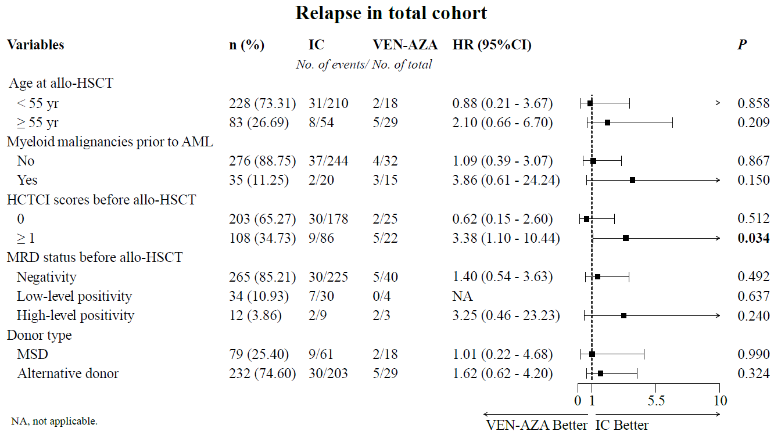
Supplementary Figure 1. Subgroup analysis of 3-year cumulative incidence of relapse in total cohort

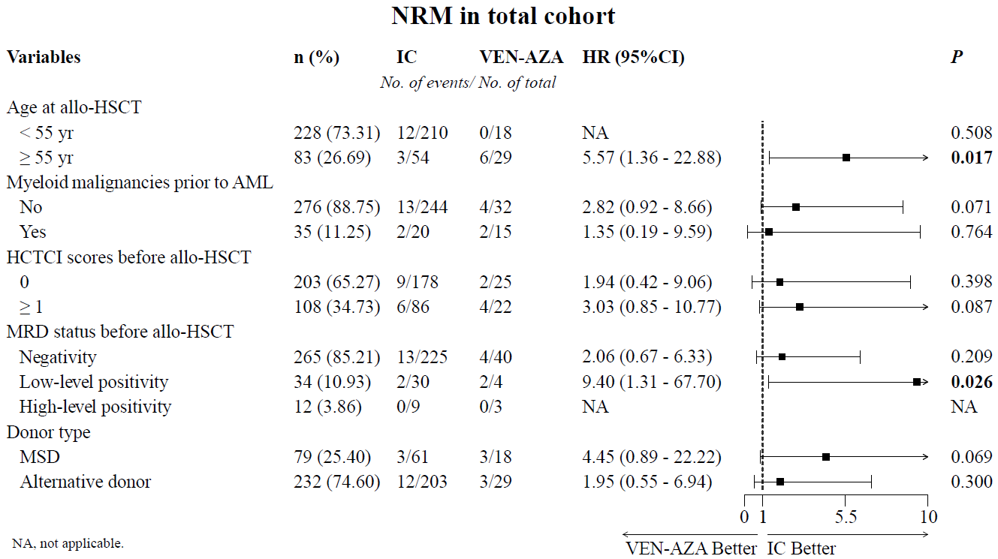
Supplementary Figure 2. Subgroup analysis of 3-year cumulative incidence of NRM in total cohort

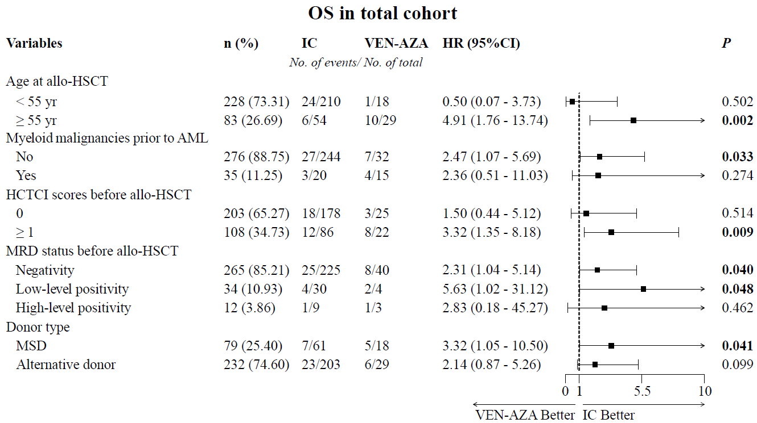
Supplementary Figure 3. Subgroup analysis of 3-year probability of OS in total cohort

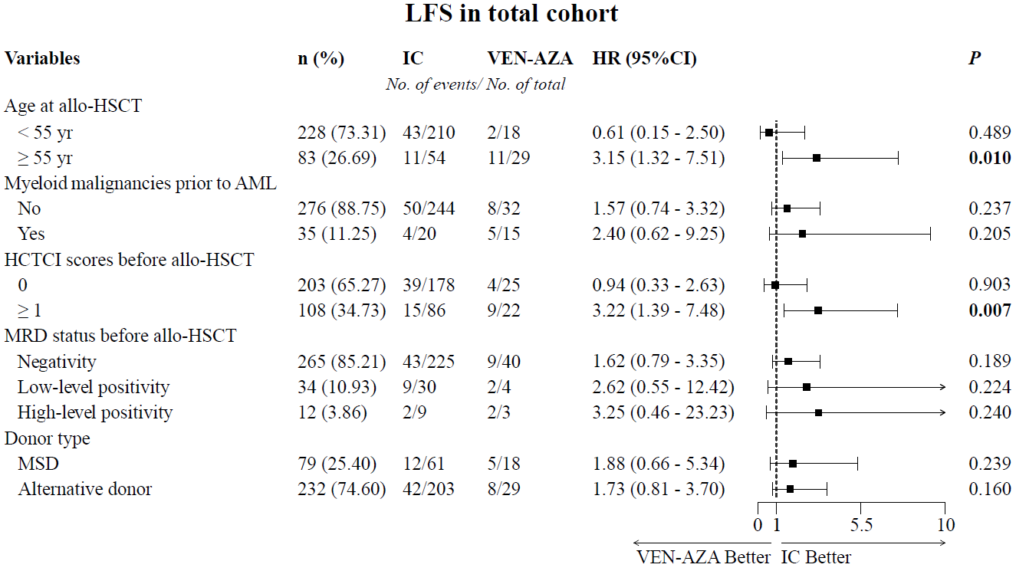
Supplementary Figure 4. Subgroup analysis of 3-year probability of LFS in total cohort

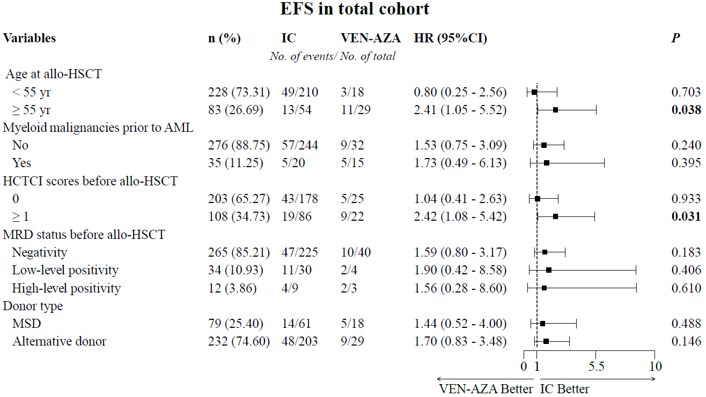
Supplementary Figure 5. Subgroup analysis of 3-year probability of EFS in total cohort

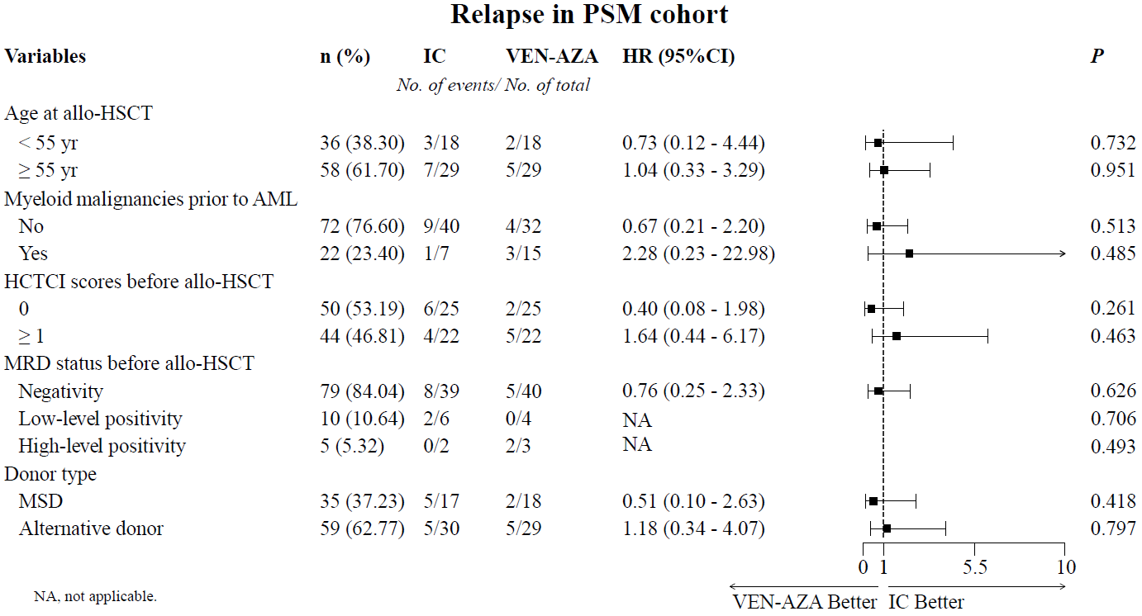
Supplementary Figure 6. Subgroup analysis of 3-year cumulative incidence of relapse in PSM cohort.

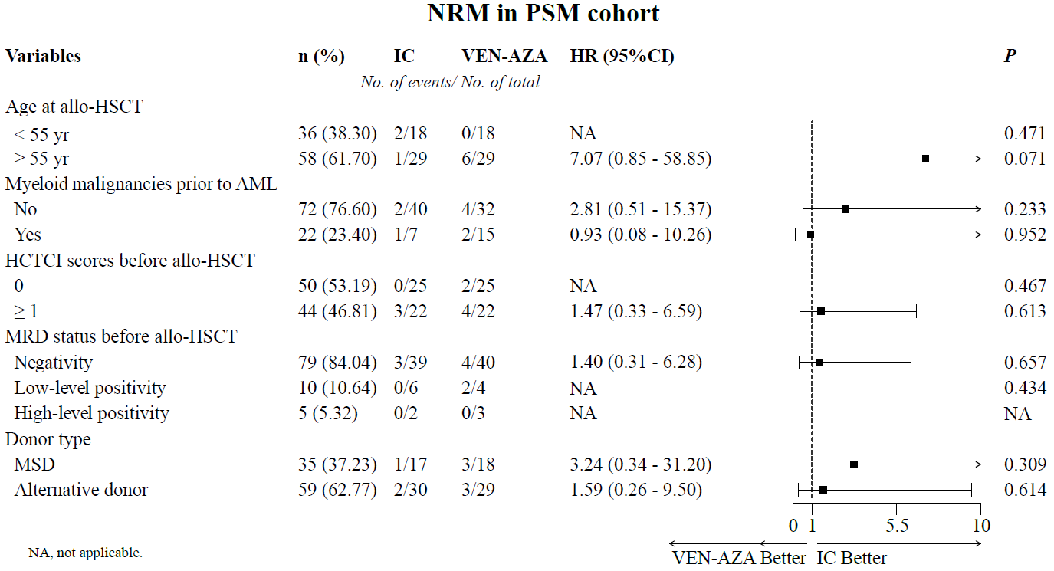
Supplementary Figure 7. Subgroup analysis of 3-year cumulative incidence of NRM in PSM cohort. NA, not applicable

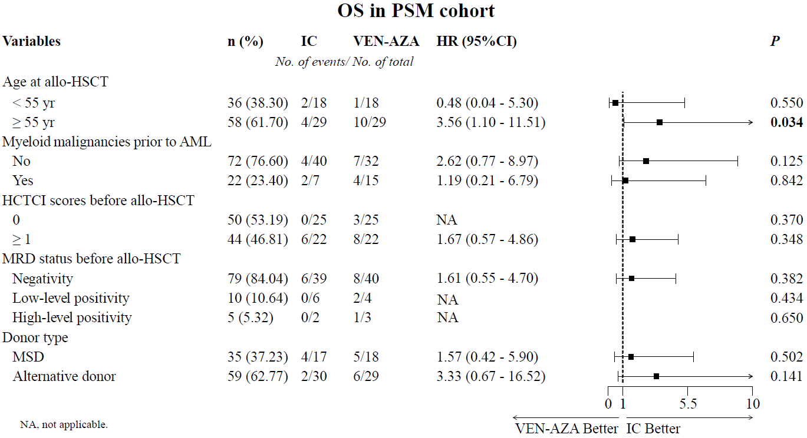
Supplementary Figure 8. Subgroup analysis of 3-year probability of OS in PSM cohort. NA, not applicable

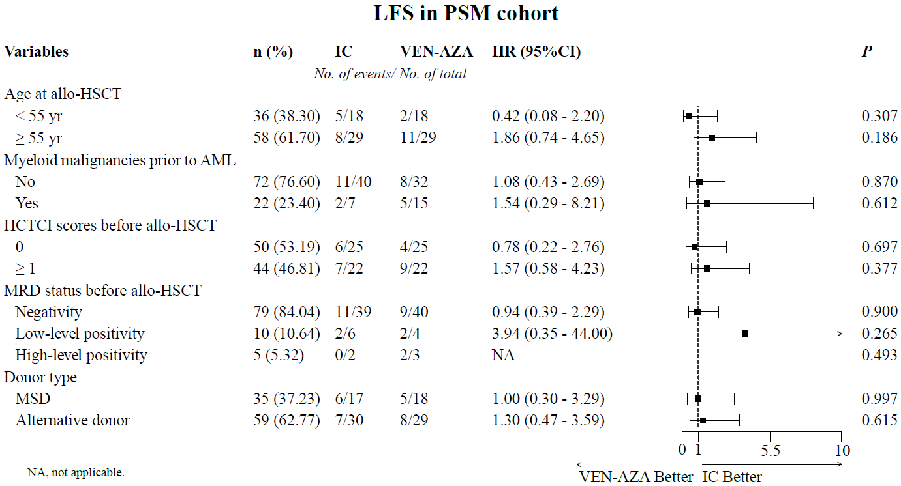
Supplementary Figure 9. Subgroup analysis of 3-year probability of LFS in PSM cohort. NA, not applicable

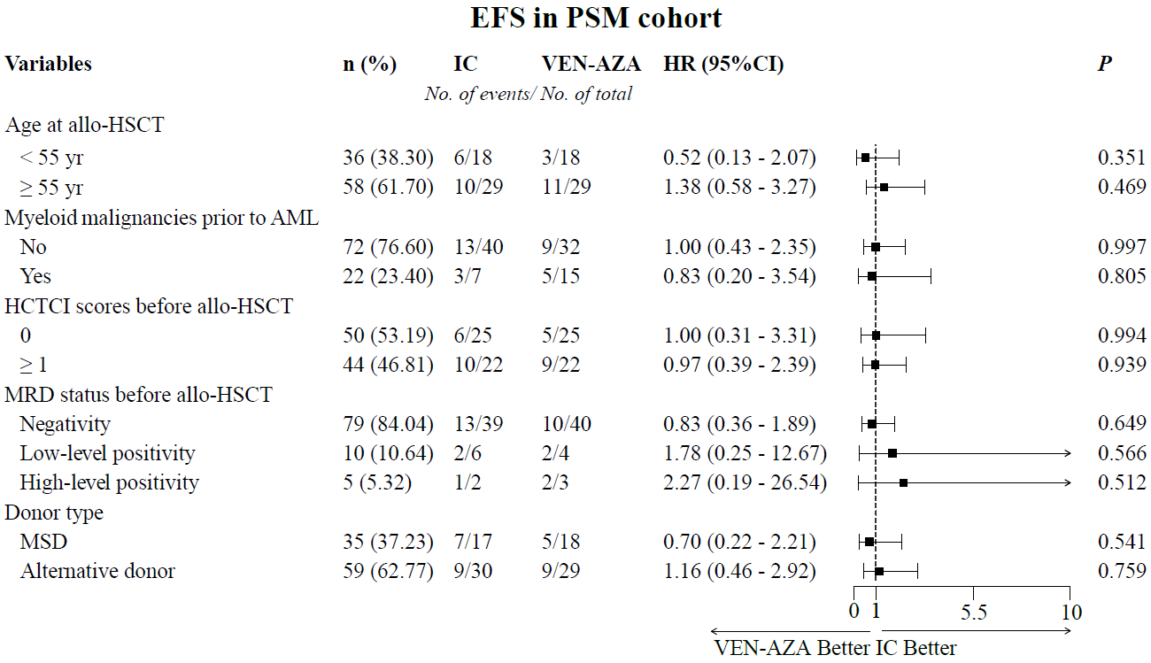
Supplementary Figure 10. Subgroup analysis of 3-year probability of EFS in PSM cohort
Reference
1. Walter RB, Buckley SA, Pagel JM, Wood BL, Storer BE, Sandmaier BM, et al. Significance of minimal residual disease before myeloablative allogeneic hematopoietic cell transplantation for AML in first and second complete remission. Blood. 2013;122(10):1813-21.
2. Walter RB, Gooley TA, Wood BL, Milano F, Fang M, Sorror ML, et al. Impact of pretransplantation minimal residual disease, as detected by multiparametric flow cytometry, on outcome of myeloablative hematopoietic cell transplantation for acute myeloid leukemia. J Clin Oncol. 2011;29(9):1190-7.
3. Wood BL. Flow cytometric monitoring of residual disease in acute leukemia. Methods in molecular biology (Clifton, NJ). 2013;999:123-36.
4. Chang YJ, Wang Y, Liu YR, Xu LP, Zhang XH, Chen H, et al. Haploidentical allograft is superior to matched sibling donor allograft in eradicating pre-transplantation minimal residual disease of AML patients as determined by multiparameter flow cytometry: a retrospective and prospective analysis. J Hematol Oncol. 2017;10(1):134.
5. Wood BL. Myeloid malignancies: myelodysplastic syndromes, myeloproliferative disorders, and acute myeloid leukemia. Clinics in laboratory medicine. 2007;27(3):551-75, vii.
6. Del Vecchio L, Brando B, Lanza F, Ortolani C, Pizzolo G, Semenzato G, et al. Recommended reporting format for flow cytometry diagnosis of acute leukemia. Haematologica. 2004;89(5):594-8.
7. Feller N, van der Velden VH, Brooimans RA, Boeckx N, Preijers F, Kelder A, et al. Defining consensus leukemia-associated immunophenotypes for detection of minimal residual disease in acute myeloid leukemia in a multicenter setting. Blood cancer journal. 2013;3(8):e129.

