Supplementary Materials for
Unveiling the atomistic mechanism of oxide scale spalling in heat-resistant alloys
Congcong Li^{1,2}, Wenjin Zheng³, Haonan Zhong¹, Yuan Wu^{1,2}, Xiongjun Liu^{1,2}, Huihui Zhu¹, Hui Wang¹, Xiaobin Zhang^{1*}, Zhiyang Yu^{3*}, Suihe Jiang^{1,2*}, Zhaoping Lu¹

¹ Beijing Advanced Innovation Center for Materials Genome Engineering, State Key Laboratory for Advanced Metals and Materials, University of Science and Technology Beijing, Beijing 100083, P. R. China
² Institute of Materials Intelligent Technology, Liaoning Academy of Materials, Shenyang, Liaoning 110167, P. R. China.
³ State Key Laboratory of Photocatalysis on Energy and Environment, College of
Chemistry, Fuzhou University, Fuzhou, Fujian 350002, P. R. China

*Corresponding author. Email: zhangxb@ustb.edu.cn (X. Z.), yuzyemlab@fzu.edu.cn (Z. Y.), jiangsh@ustb.edu.cn (S. J.)

This PDF file includes:
Figs. S1 to S4
Tables S1 to S2

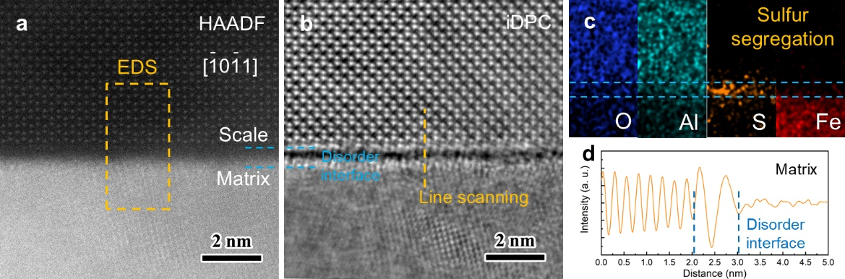
Fig. S1. a HAADF image, b iDPC image, c EDS mapping and d line scanning analysis of the disordered sulfur segregation layer at the $[\overline{1}0\overline{1}1]$ orientation, as indicated by blue dash lines.
Fig. S2. a The model of S-rich disordered layer constructed by a DFT simulation, which shows four S-atom pairs named P1, P2, P3 and P4. b-e statistical analysis of interatomic distance between S and its nearest atoms of the four S-atom pairs, indicating repulsive interaction with Al and O of sulfur in the disordered layer.

Fig. S3. a Atomic structure of the oxide-matrix interface containing sulfur after pre-straining 20% along the direction perpendicular to interface, suggesting that S-atom pairs are a source of cracks. b 2D ELF map and c differential charge maps of S atoms at the interface, showing a stronger charge interaction between Fe and S.

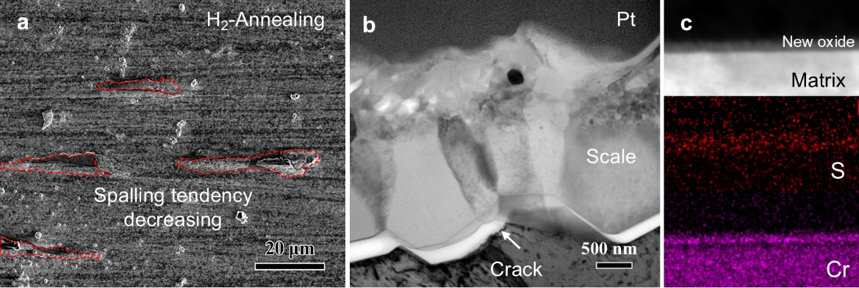
Fig. S4. a Top view, b cross section view morphology and c EDS mapping of the oxide scale grown spontaneously and the oxide-matrix interface of an AFA specimen after 100 h oxidation prepared by 100 hours H₂ annealing at 1200 ºC.

Table. S1 Nominal and actual compositions of the studied AFA steel measured by ICP-OES.
 | Fe | Ni | Cr | Al | Mo | Nb | Si | C | B | S
AFA | bal. | 25 | 18 | 3 | 0.8 | 0.5 | 0.08 | 0.08 | 0.01 | 0
actual | bal. | 25.02 | 17.90 | 2.98 | 0.82 | 0.51 | 0.11 | 0.10 | 0.01 | 0.0026

Table S2 Diffusion coefficient of sulfur in γ-Fe and α-Al₂O₃ at 900 ℃.
Location | D₀ (m²/s) | Q (kJ) | D (m²/s)
γ-Fe | 3.46E-03 | 231.5 | 1.69E-11
α-Al₂O₃ | 4.78E-07 | 194.0 | 6.30E-14

