Figure S1. the Body map of tone in each group and each tone.

Grand average of all participants

Figure S2. The result of pitch discrimination test

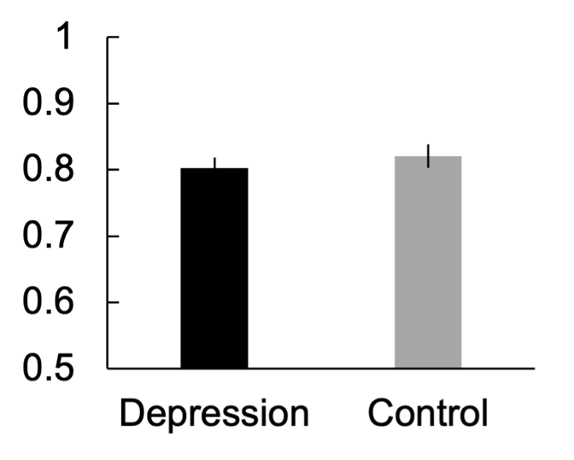
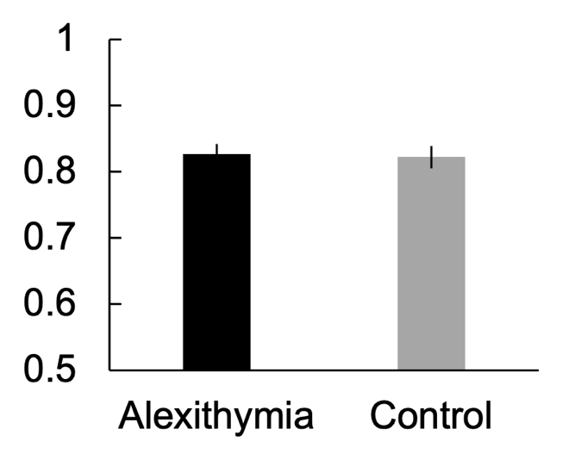

Figure S3. Body image and example of the clicks to the position in the body.

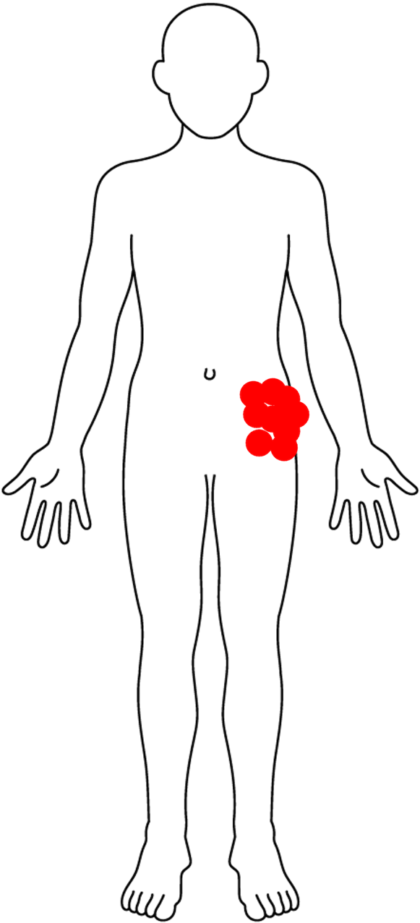
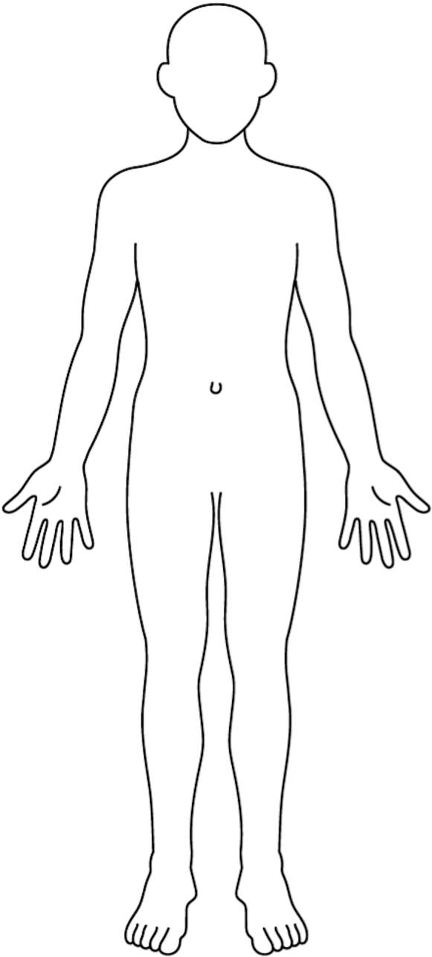

Figure S4. the row data of the click of the body.

Grand average of all participants
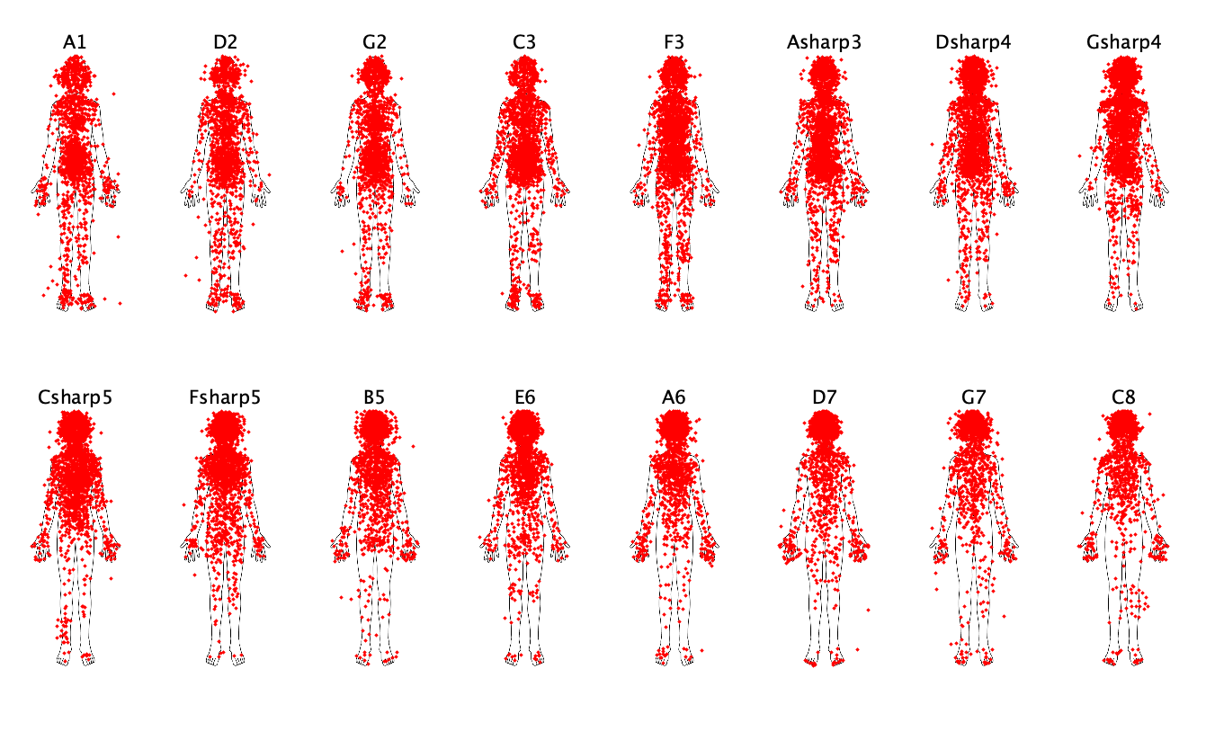

Depressive Group
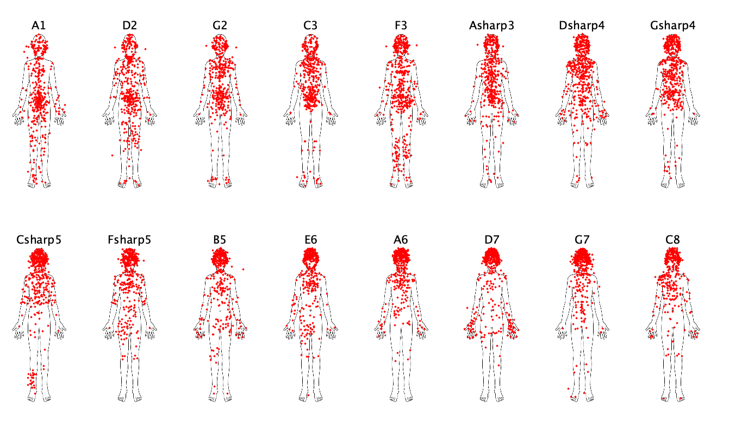

Non depressive Group
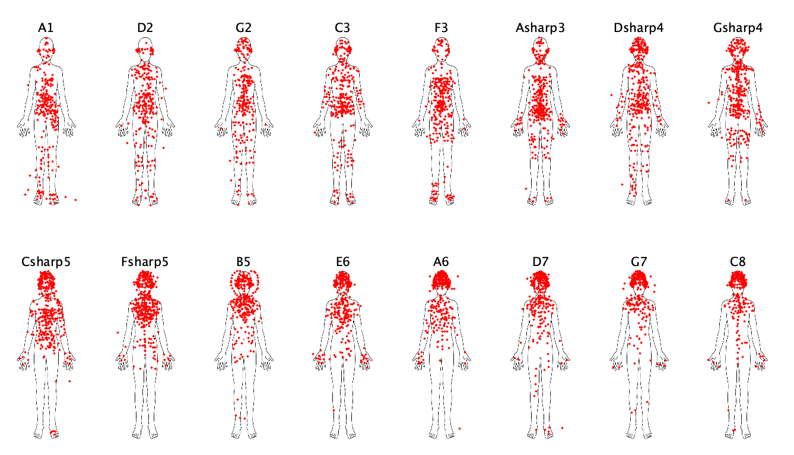

Alexithymic Group
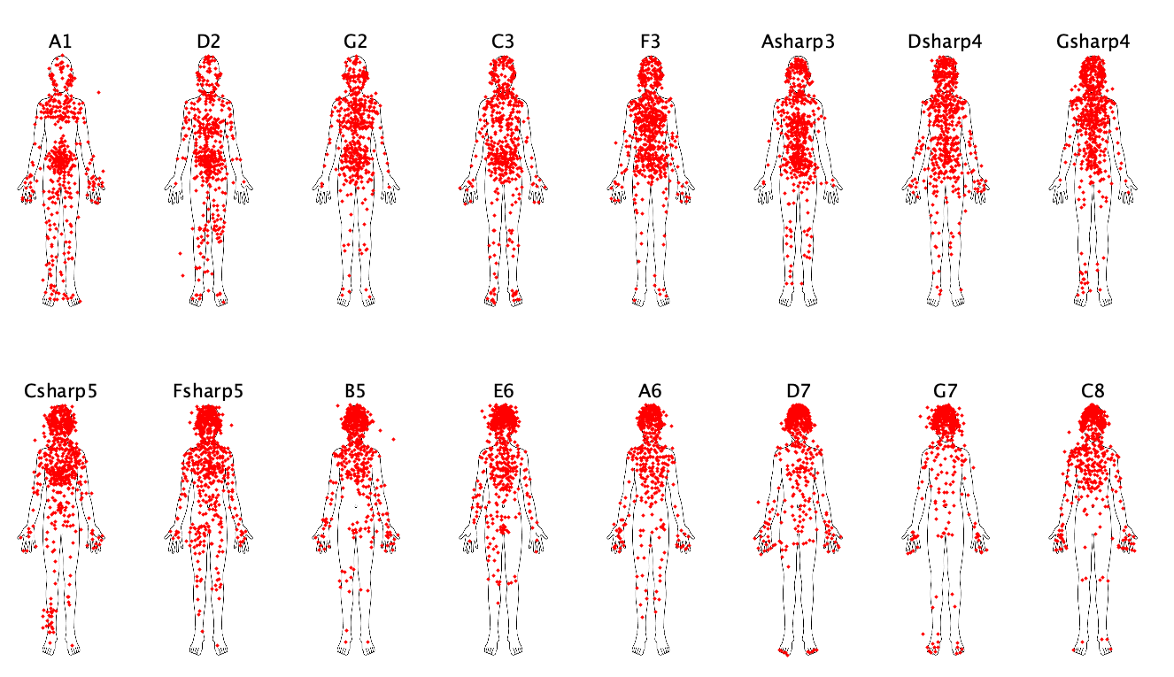

Non alexithymic Group
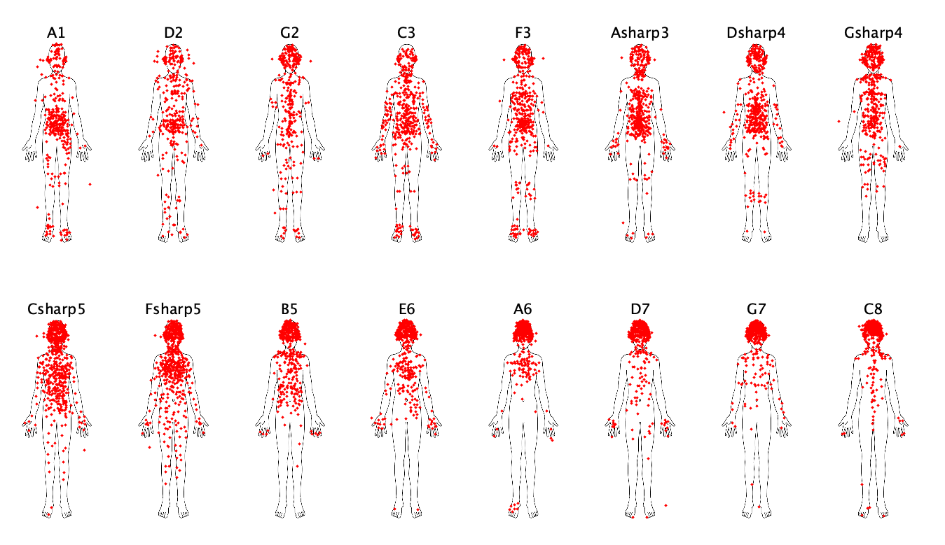
Figure S5. Valence and arousal for tone in each group.

Grand average of all participants

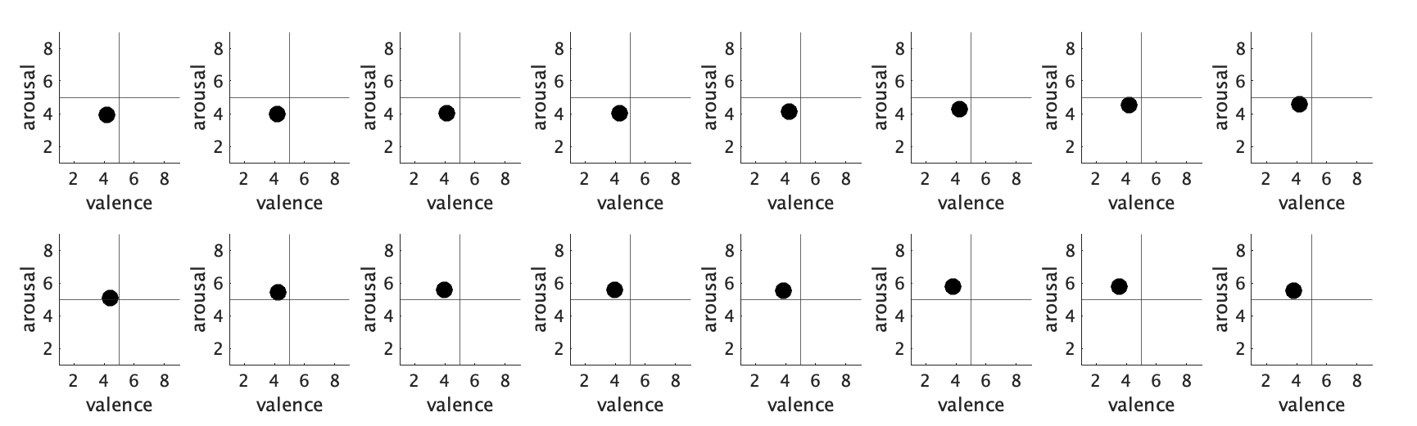
A1 D2 G2 C3 F3 Asharp3 Dsharp4 Gsharp4

Csharp5 Fsharp5 B5 E6 A6 D7 G7 C8

Depressive Group

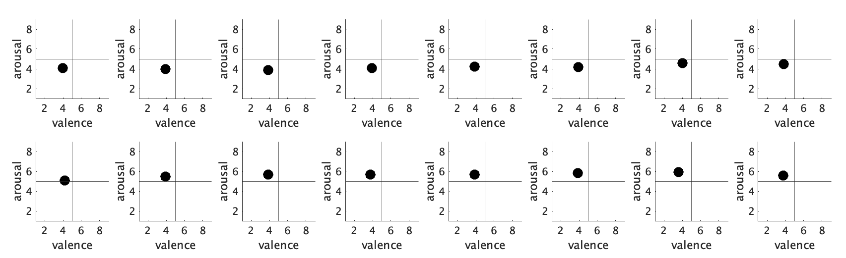
A1 D2 G2 C3 F3 Asharp3 Dsharp4 Gsharp4

Csharp5 Fsharp5 B5 E6 A6 D7 G7 C8

Non depressive Group
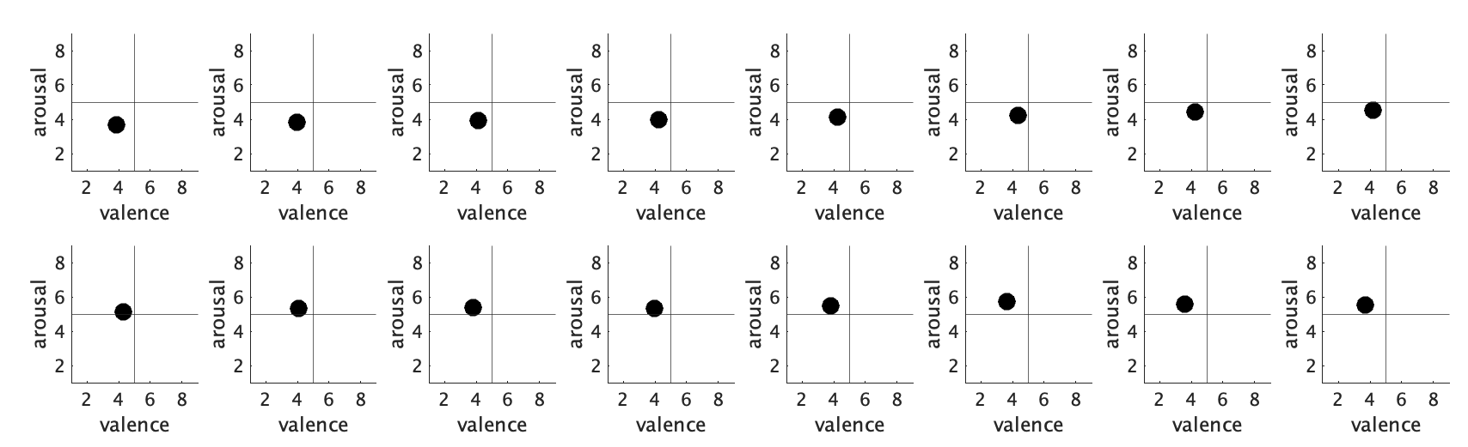
A1 D2 G2 C3 F3 Asharp3 Dsharp4 Gsharp4

Csharp5 Fsharp5 B5 E6 A6 D7 G7 C8

Alexithymic Group

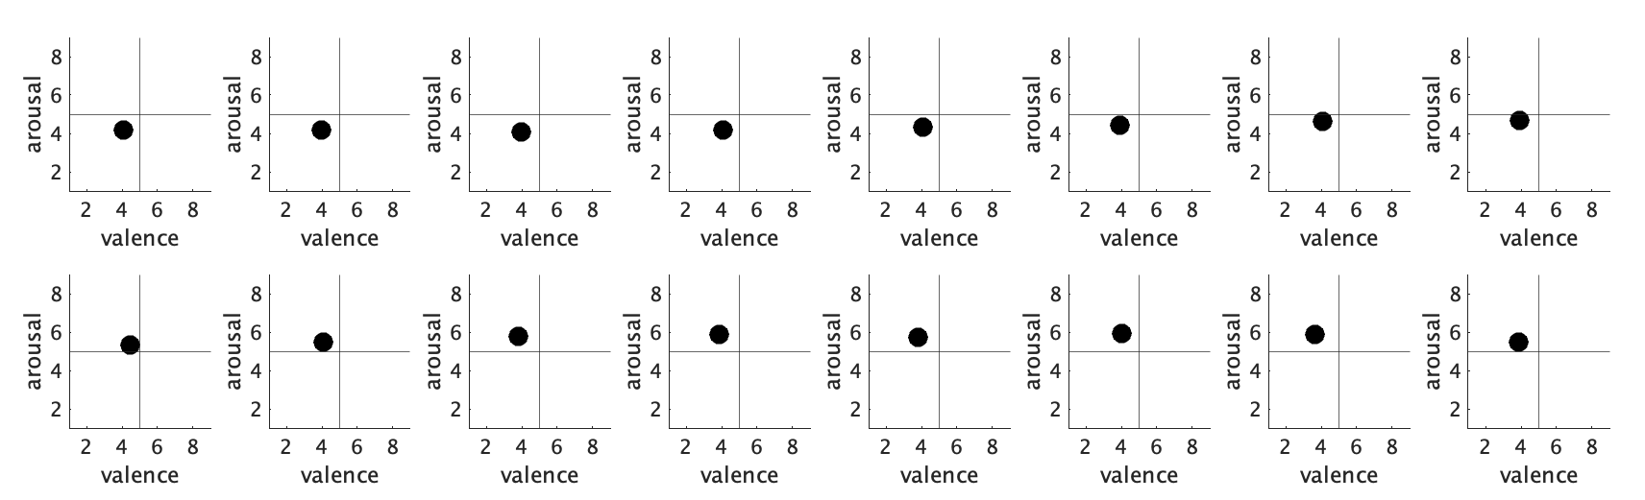
A1 D2 G2 C3 F3 Asharp3 Dsharp4 Gsharp4

Csharp5 Fsharp5 B5 E6 A6 D7 G7 C8

Non alexithymic Group
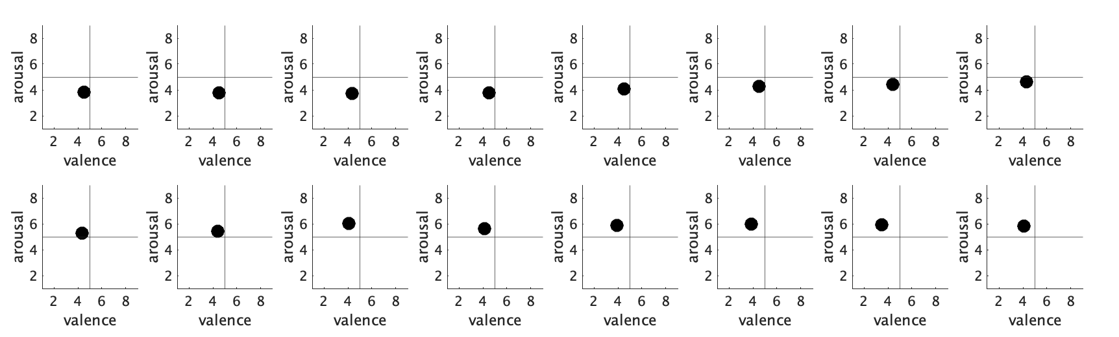
A1 D2 G2 C3 F3 Asharp3 Dsharp4 Gsharp4

Csharp5 Fsharp5 B5 E6 A6 D7 G7 C8

Table S1 categories of emotion
1 | Admiration
2 | Adoration
3 | Aesthetic appreciation
4 | Amusement
5 | Anger
6 | Anxiety
7 | Awe
8 | Awkwardness
9 | Boredom
10 | Calmness
11 | Confusion
12 | Contempt
13 | Craving
14 | Disappointment
15 | Disgust
16 | Empathy
17 | Entrancement
18 | Envy
19 | Excitement
20 | Fear/Horror
21 | Guilt
22 | Interest
23 | Joy
24 | Nostalgia
25 | Pride
26 | Relief
27 | Romance
28 | Sadness
29 | Satisfaction
30 | Sexual desire
31 | Surprise
32 | Sympathy
33 | Triumph

Figure S6. Categorical judgement of 33 emotions for tone in each group. The x-axes represent, from left to right, ascending pitches of the 16 notes. The Y axis represents strength of emotion based on the best 5 emotional categories in ranking.

Grand average of all participants

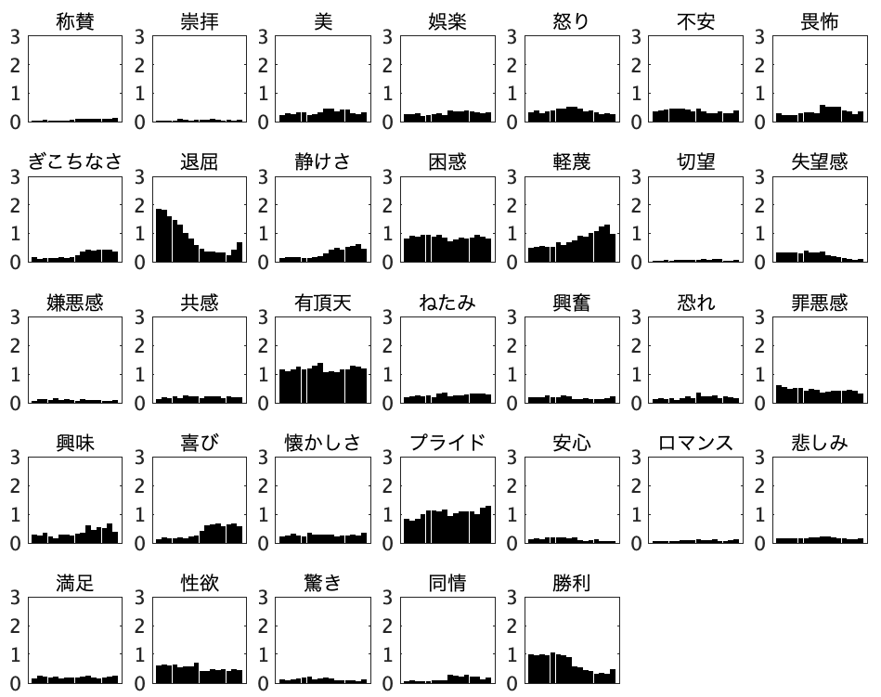
Admiration Adoration Aesthetic Amusement Anger Anxiety Awe
Strength of emotion

Awkwardness Boredom Calmness Confusion Contempt Craving Disappointment
Strength of emotion

Disgust Empathy Entrancement Envy Excitement Fear/Horror Guilt
Strength of emotion

Interest Joy Nostalgia Pride Relief Romance Sadness
Strength of emotion

Strength of emotion
Lower -> Higher
pitch
Lower -> Higher
pitch
Lower -> Higher
pitch
Lower -> Higher
pitch
Lower -> Higher
pitch
Satisfaction Sexual desire Surprise Sympathy Triumph
Depressive Group
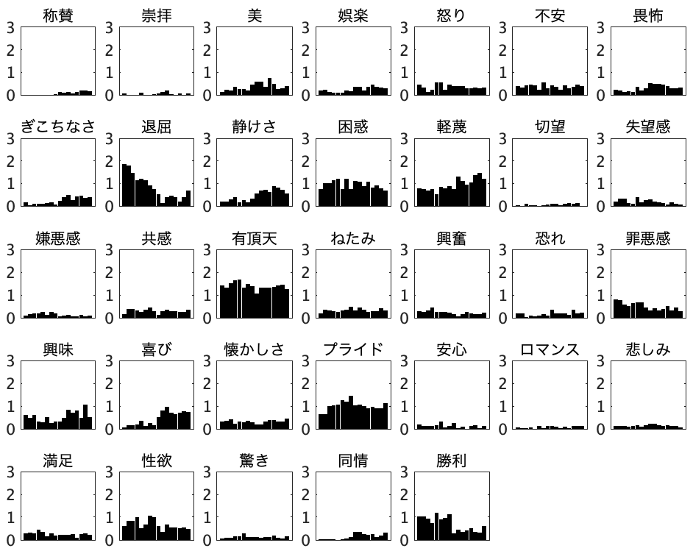
Admiration Adoration Aesthetic Amusement Anger Anxiety Awe

Lower -> Higher
pitch
Lower -> Higher
pitch
Lower -> Higher
pitch
Lower -> Higher
pitch
Lower -> Higher
pitch
Strength of emotion
Strength of emotion
Strength of emotion
Strength of emotion
Strength of emotion

Satisfaction Sexual desire Surprise Sympathy Triumph
Awkwardness Boredom Calmness Confusion Contempt Craving Disappointment

Disgust Empathy Entrancement Envy Excitement Fear/Horror Guilt

Interest Joy Nostalgia Pride Relief Romance Sadness

Non depressive Group
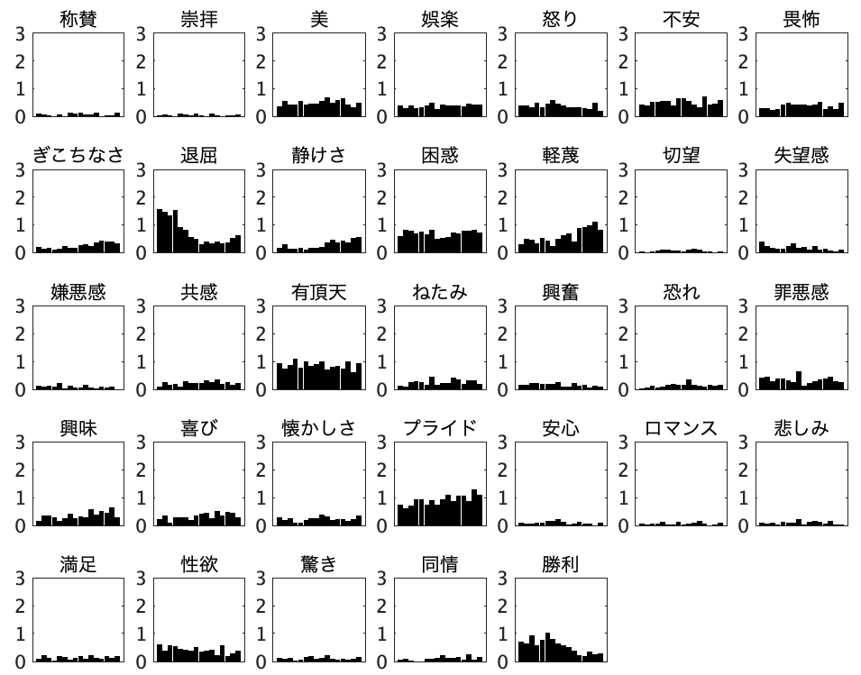
Admiration Adoration Aesthetic Amusement Anger Anxiety Awe
Strength of emotion
Strength of emotion
Strength of emotion
Strength of emotion
Strength of emotion
Lower -> Higher
pitch
Lower -> Higher
pitch
Lower -> Higher
pitch
Lower -> Higher
pitch
Lower -> Higher
pitch

Awkwardness Boredom Calmness Confusion Contempt Craving Disappointment

Disgust Empathy Entrancement Envy Excitement Fear/Horror Guilt

Interest Joy Nostalgia Pride Relief Romance Sadness

Satisfaction Sexual desire Surprise Sympathy Triumph

Alexithymic Group
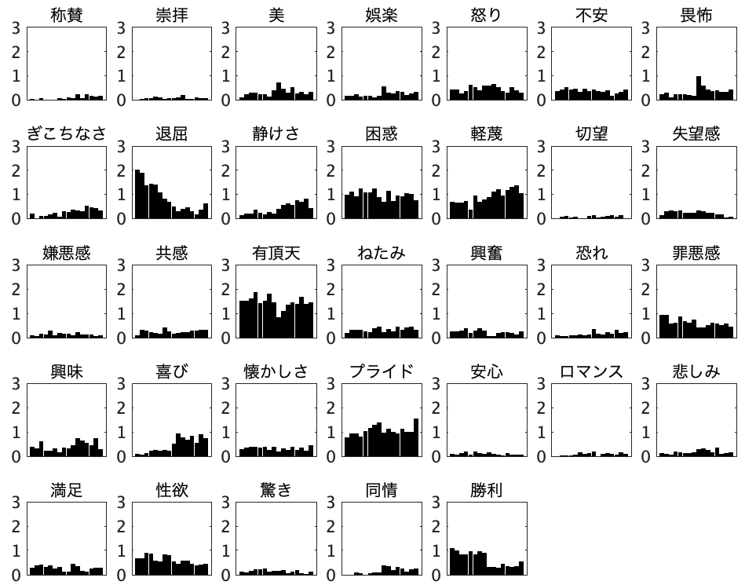
Admiration Adoration Aesthetic Amusement Anger Anxiety Awe
Lower -> Higher
pitch
Lower -> Higher
pitch
Lower -> Higher
pitch
Lower -> Higher
pitch
Lower -> Higher
pitch
Strength of emotion
Strength of emotion
Strength of emotion
Strength of emotion
Strength of emotion

Awkwardness Boredom Calmness Confusion Contempt Craving Disappointment

Disgust Empathy Entrancement Envy Excitement Fear/Horror Guilt

Interest Joy Nostalgia Pride Relief Romance Sadness

Satisfaction Sexual desire Surprise Sympathy Triumph

Non alexithymic Group
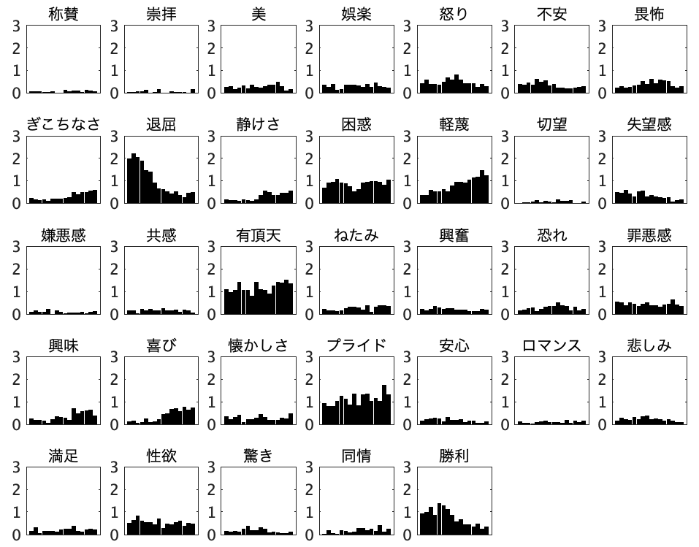
Admiration Adoration Aesthetic Amusement Anger Anxiety Awe
Lower -> Higher
pitch
Lower -> Higher
pitch
Lower -> Higher
pitch
Lower -> Higher
pitch
Lower -> Higher
pitch
Strength of emotion
Strength of emotion
Strength of emotion
Strength of emotion
Strength of emotion
Satisfaction Sexual desire Surprise Sympathy Triumph
Interest Joy Nostalgia Pride Relief Romance Sadness
Disgust Empathy Entrancement Envy Excitement Fear/Horror Guilt
Awkwardness Boredom Calmness Confusion Contempt Craving Disappointment
Difficulty describing feelings (DDF) Group
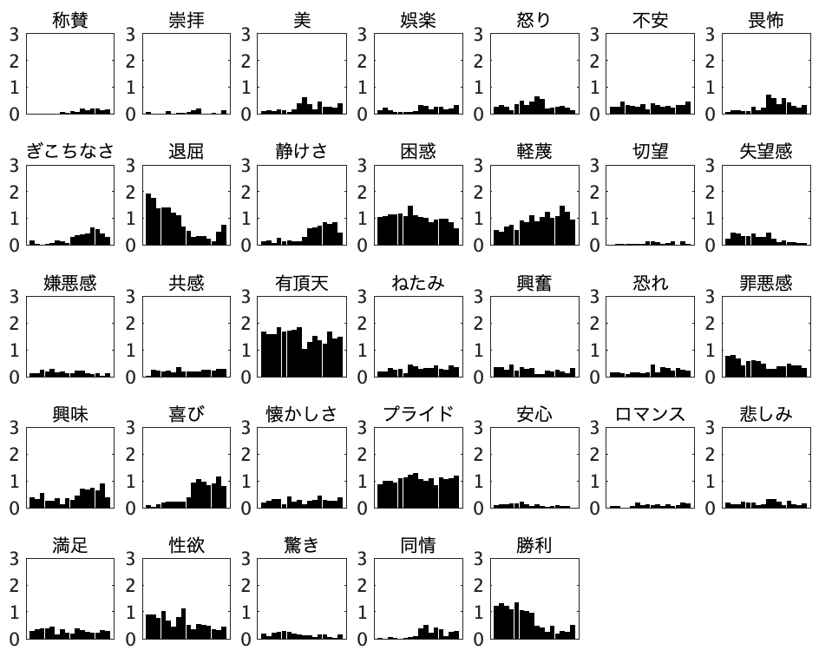
Admiration Adoration Aesthetic Amusement Anger Anxiety Awe

Awkwardness Boredom Calmness Confusion Contempt Craving Disappointment

Disgust Empathy Entrancement Envy Excitement Fear/Horror Guilt

Interest Joy Nostalgia Pride Relief Romance Sadness

Satisfaction Sexual desire Surprise Sympathy Triumph

Non difficulty describing feelings (Non-DDF) Group
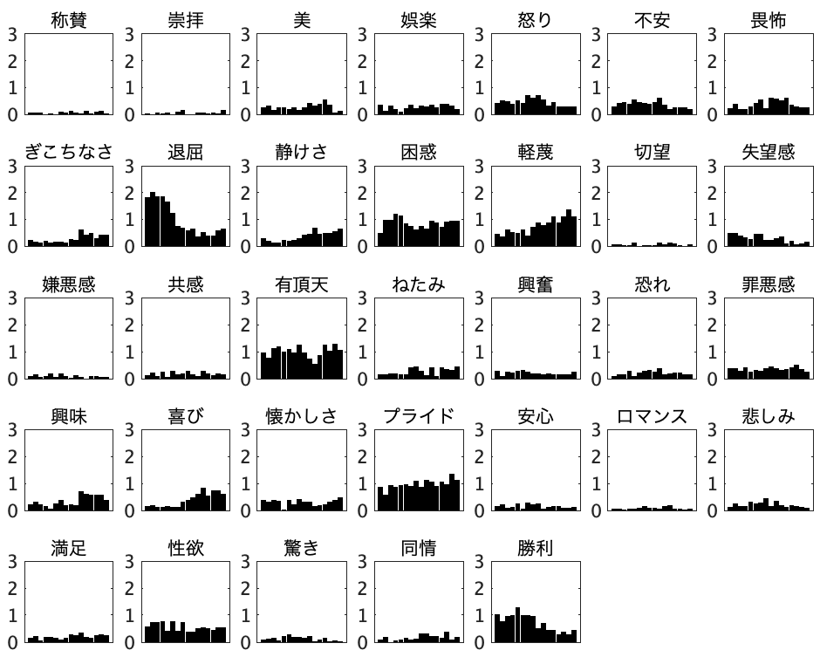
Admiration Adoration Aesthetic Amusement Anger Anxiety Awe

Awkwardness Boredom Calmness Confusion Contempt Craving Disappointment
Disgust Empathy Entrancement Envy Excitement Fear/Horror Guilt
Interest Joy Nostalgia Pride Relief Romance Sadness
Satisfaction Sexual desire Surprise Sympathy Triumph
Figure S7. The emotion based on sound of pitch. The x-axes represent, from left to right, ascending pitches of the 16 notes, while the colours denote Alexithymic (red), depressive (blue), and their respective control groups (grey). The valence and arousal based on the nine-point Likert scale and anxiety based on the multiple-choice categorical judgements test detected that the individuals with alexithymic trait and depressive state felt negative valence in response to several pitched sounds while no significant differences in arousal between the individuals with alexithymic trait and the controls and between the individuals with depressive state and the controls were observed. Further, the individuals with alexithymic trait and depressive state felt strong anxiety in response to several pitched sounds.

