Supplementary Materials for

Efficient active hydrogen delivery for drug-free radiation enteritis therapy

Xianggui Yin et al.

Corresponding author: Changfen Bi, bichangfen@irm-cams.ac.cn; Saijun Fan, fansaijun@irm-cams.ac.cn; Luntao Liu, liuluntao@irm-cams.ac.cn

The PDF file includes:

Materials and Methods
Figures S1 to S23
Table S1

Materials and Methods
Material
All chemical reagents were used in experiments without further purification. Ammonium molybdate tetrahydrate (AR), citric acid monohydrate (AR), sodium alginate (SA, AR), methylene blue (MB, AR), ferrous sulfate heptahydrate (AR), salicylic acid (AR), and agarose were purchased from Macklin Biochemical Co., Ltd (Shanghai, China). Concentrated hydrochloric acid (AR), laboratory-grade aluminum foil, and 30% hydrogen peroxide solution (H₂O₂, AR) were obtained from Sinopharm Chemical Reagent Co., Ltd (China National Pharmaceutical Group). FITC-labeled goat anti-rabbit IgG (H&L), anti-CD86 antibody, and anti-CD206 antibody were purchased from Wuhan Sanying Biotechnology (Abclonal, Wuhan, China). Mouse Tumor Necrosis Factor-α (TNF-α) ELISA Kit and Mouse Interleukin-6 (IL-6) ELISA Kit were obtained from Shanghai Enzyme-linked Biotechnology Co., Ltd (Shanghai, China). Total Antioxidant Capacity Assay Kit with ABTS method, Total Superoxide Dismutase Assay Kit with WST-8, Lipid Peroxidation MDA Assay Kit, Reactive Oxygen Species Assay Kit, Annexin V-FITC Apoptosis Detection Kit, DNA Damage Assay Kit by γ-H2AX Immunofluorescence, Cell Counting Kit-8, and Hoechst 33342 were acquired from Beyotime Biotechnology (Shanghai, China). Cy5 NHS Ester and Rhodamine-labeled Wheat Germ Agglutinin were purchased from Shanghai Maokang Biotechnology Co., Ltd (Shanghai, China). All experiments in this work were conducted using ultrapure Milli-Q water (18.2 MΩ·cm).

Characterization
Transmission electron microscopy (TEM) images were obtained using an HT7800 transmission electron microscope operating at 200 kV. High-resolution TEM (HRTEM) images were captured with a Titan Themis 200 transmission electron microscope. X-ray diffraction (XRD) patterns were recorded using a Rigaku D/MAX-2550 V X-ray powder diffractometer (parameters: Cu Kα radiation, λ = 1.5405 Å, 40 mA, 40 kV). X-ray photoelectron spectroscopy (XPS) measurements were conducted on an ESCAlab250 (Thermo Fisher Scientific). Fourier-transform infrared (FTIR) spectra were acquired with a Nicolet 7000-C spectrometer using KBr pellets for background correction. The size distribution and zeta potential of nanoparticles were determined via dynamic light scattering (DLS) using a Malvern Zetasizer Nano ZS. Ultraviolet-visible-near infrared (UV-vis-NIR) absorption spectra were measured with a PerkinElmer Lambda 950 spectrophotometer. All radiation experiments were conducted using a Gammacell 40 Exactor (Atomic Energy of Canada Ltd., Chalk River, Ontario, Canada) with a ¹³⁷Cs γ-ray dose rate of 0.88 Gy/min. Finite element simulations were performed by Shenzhen Huasuan Technology Co., Ltd. Immunohistochemistry (IHC) and tissue immunofluorescence (IF) were conducted by Servicebio (Wuhan Servicebio Technology Co., Ltd.).

Photothermal performance testing
As-prepared H_{x}MoO₃@SA aqueous dispersion was added in to the cuvette. Subsequently, an 808 nm NIR laser (BWT, Beijing) was introduced to irradiate the sample suspension. The temperature and images of the solution was recorded every 30 s with a thermal imager (UTi260E，UNI-T).

Photothermal conversion efficiency calculation
The photothermal conversion efficiency was determined following a previously established method (67, 68). Briefly, heating and cooling profiles of the H_{x}MoO₃@SA samples were obtained, and the efficiency (η) was computed using the following equation:
$$η=\frac{hS\left(T_{max}-T_{RT}\right)-Q_{dis}}{I(1-{10}^{-A_{808}})}$$
where hS denotes the thermal transfer coefficient, T_{max} is the equilibrium temperature of the sample, T_{RT} refers to room temperature, Q_{dis} accounts for heat loss from the system, I represents the laser power density, and A₈₀₈ is the absorbance at 808 nm. The value of hS can be derived from the equation:
​$hS=\frac{mc}{τ_{s}}$
where m represents the mass of the sample, c is the specific heat capacity of water, and τ_{s} is the time constant, which was calculated using the formula:
$$T=-τ_{s}ln⁡(θ)$$
Here, θ is a dimensionless parameter, defined as the difference between the sample temperature and the ambient temperature, commonly referred to as the driving force temperature:
$$θ=\frac{T-T_{RT}}{T_{max}-T_{RT}}$$
Accordingly, the photothermal conversion efficiency of H_{x}MoO₃@SA under 808 nm laser irradiation was calculated to be 46.5%.

Numerical simulation
The numerical simulation is implemented by COMSOL Multiphysics 6.1. The model of the nanomotor is constructed according to the morphology presented in SEM images. The calculation domain is a 600 × 600 × 600 nm region filled with air. In the middle of the computational domain, a sphere with a diameter of 200nm was added.
For the simulation of nanospheres, a boundary heat source from the heat transfer module is applied to the surface of the nanospheres to simulate the photothermal absorption of NIR light. According to the experimental setup, the heat flux is set as 10 W·cm⁻². The distribution of the temperature field is governed by heat conduction and heat convection, which is solved by:
$$Q=u_{t}∙∇T+∇∙q$$
$$q=K_{T}∇T$$
where Q is the heat flux multiplied by the emissivity efficiency (0.465), u_{t} is the velocity of the nanospheres, T is the temperature, and K_{T} is the coefficient of thermal conductivity.

Supplementary Figures and Tables

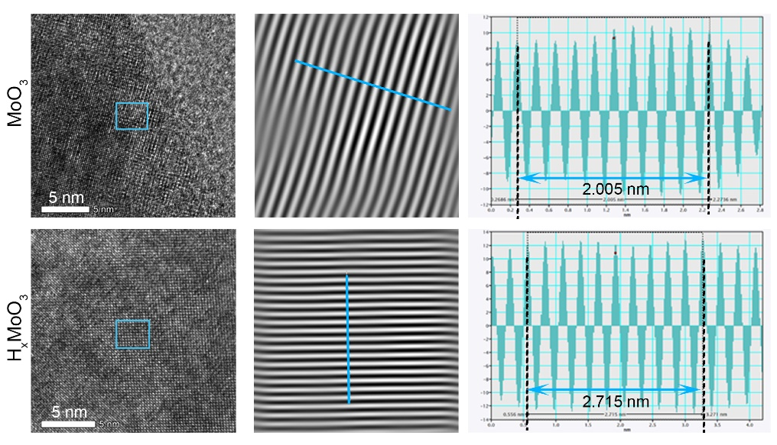
Fig. S1. Lattice fringes of MoO₃ and H_{x}MoO₃ and their corresponding Fast Fourier Transform (FFT) analysis.

Fig. S2. Hydrodynamic size (A) and Zeta potential values (B) of MoO₃, H_{x}MoO₃ and H_{x}MoO₃@SA.

Fig. S3. The XPS survey spectra (A) and VB spectra (B) of MoO₃ and H_{x}MoO₃. Source data are provided as a Source Data file.

Fig. S4. The pH stability of H_{x}MoO₃@SA nanomachines. UV-vis-NIR absorption spectra of H_{x}MoO₃@SA dispersed in PBS at (A) pH 1.2, (B) pH 6.5, and (C) pH 7.4 after 3, 12, and 24 hours of incubation.

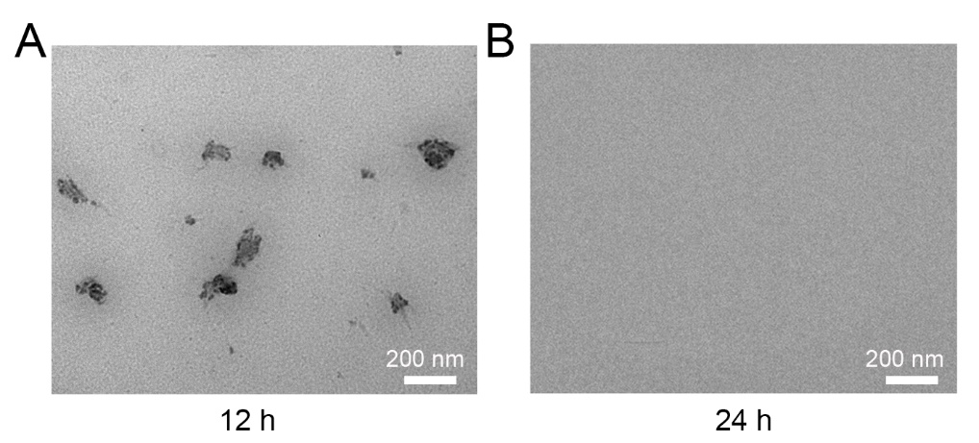
Fig. S5. TEM images of H_{x}MoO₃@SA after incubation in intestinal mucus for (A) 12 and (B) 24 hours.
Fig. S6. UV-vis-NIR absorption spectra of the supernatant from the reaction with MB after incubating H_{x}MoO₃@SA in simulated gastric fluid (SGF) for 2 hours and in simulated intestinal fluid (SIF) for 8 hours.

Fig. S7. UV-vis-NIR absorption spectra of ·OH scavenging by different concentrations of (A) MoO₃ and (B) H_{x}MoO₃@SA.

Fig. S8. UV-vis-NIR absorption spectra of H₂O₂ scavenging by different concentrations of MoO₃ (A) and H_{x}MoO₃@SA (B).

Fig. S9. UV-vis-NIR absorption spectra of ·O₂⁻ scavenging by different concentrations of MoO₃ (A) and H_{x}MoO₃@SA (B).

Fig. S10. UV-vis-NIR absorption spectra of ONOO⁻ scavenging by different concentrations of MoO₃ (A) and H_{x}MoO₃@SA (B).

Fig. S11. Standard curve of Trolox antioxidant capacity measured by Total Antioxidant Capacity Assay Kit.
Fig. S12. Reduction activity stability of H_{x}MoO₃@SA. The decolorization efficiency of MB by H_{x}MoO₃@SA stored at 25°C (room temperature) and -20°C for different durations was used for evaluation.

Fig. S13. (A) Temperature elevation of H_{x}MoO₃@SA in aqueous suspensions with different concentrations under 808 nm laser irradiation (1.0 W·cm⁻², 10 min). (B) Photothermal effect of H_{x}MoO₃ in aqueous suspensions upon 808 nm laser irradiation under different power densities for 10 min (150 μg/mL, 10 min).
Fig. S14. Fitting curve of the height change of H_{x}MoO₃@SA in MB solution under 808 nm laser irradiation as a function of time. The slope of the curve corresponds to the mobility of H_{x}MoO₃@SA.
Fig. S15. Gaussian fitting curve of the movement distance of H_{x}MoO₃@SA in agarose gel and the viscosity of the agarose gel.

Fig. S16. The effect of NIR-driven self-thermophoretic motion on the cellular uptake of H_{x}MoO₃@SA.

Fig. S17. Intracellular Mo⁶⁺ concentration in HIEC-6 cells with/without NIR treatment.
Fig. S18. Imaging of major organs at different time points after oral administration of Cy5-labeled H_{x}MoO₃@SA in mice.
Fig. S19. Total fluorescence signal intensity of intestinal tissue segments from the -NIR and +NIR groups as measured by the in vivo imaging system.

Fig. S20. Body weight of C57BL/6J mice treating with/without H_{x}MoO₃@SA, n = 3 biologically independent replicates.

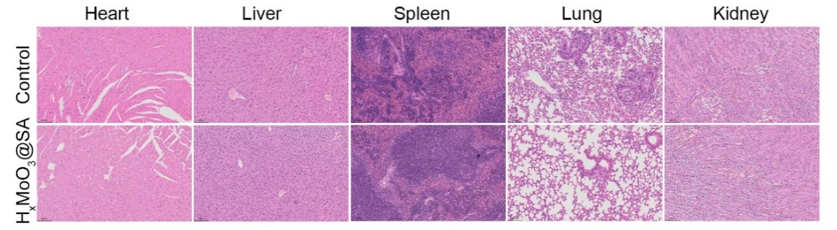
Fig. S21. Representative H&E staining of major organs of C57BL/6J mice treating with/without H_{x}MoO₃@SA.

Fig. S22. Hematological examination and blood biochemical analysis. Hematological examination including (A) WBC, (B) RBC, (C) HGB, (D) PLT, (E) HCT, (F) MCV, (G) MCH, (H) MCHC and blood biochemical analyses including (I) AST, (J) ALT, (K) UA, and (L) BUN were performed on C57BL/6J mice in different treatment groups, n = 3 biologically independent replicates.

Fig. S23. Lefse analysis. (A) LDA scores and (B) corresponding cladogram from the Lefse analysis of the Control group and the IR+H_{x}MoO₃@SA group. (C) LDA scores and (D) corresponding cladogram and phylogenetic tree from the Lefse analysis of the IR group and the IR+H_{x}MoO₃@SA group.

Tab. S1. List of Redox Potentials for various RONS and active hydrogen species.
RONS | Redox Potential | References
·OH/H₂O | 2.80 V_{RHE}  2.23 V_{NHE}  2.38 V_{SHE} | 69  70  71
H₂O₂/H₂O | 1.776 V_{NHE}  1.68 V_{SHE} | 70  71
·O₂⁻/H₂O₂ | 0.910 V_{NHE} | 72
ONOO⁻/NO₂ | 2.05 V_{SHE}  2.12 V_{NHE} | 71  73
H⁺/H₂ | 0.00 V_{RHE}
H⁺/H | -2.76 V_{SCE}  -2.1 V_{NHE} | 74  75
RHE: Reversible Hydrogen Electrode, NHE: Normal Hydrogen Electrode, SHE: Standard hydrogen electrode, SCE: Saturated calomel electrode.

