Supplementary Information
Simplified radar architecture based on information metasurface

Si Ran Wang¹, Zhan Ye Chen^{1,2,3,*}, Shao Nan Chen^{1,2,3}, Jun Yan Dai^{1,2,3}, Jun Wei Zhang^{1,2,3}, Zhen Jie Qi^{1,2,3}, Li Jie Wu^{1,2,3}, Meng Ke Sun^{1,2,3}, Qun Yan Zhou^{1,2,3}, Hui Dong Li^{1,2,3}, Zhang Jie Luo^{1,2,3,*}, Qiang Cheng^{1,2,3,*}, Tie Jun Cui^{1,2,3,4,*}

- State Key Laboratory of Millimeter Waves, Southeast University, Nanjing 210096, China
- Institute of Electromagnetic Space, Southeast University, Nanjing 210096, China
- Frontiers Science Center for Mobile Information Communication and Security, Southeast University, Nanjing 210096, China
- Suzhou Laboratory, Suzhou 215164, China
These authors contributed equally: Si Ran Wang, Zhan Ye Chen, Shao Nan Chen
E-mail: chenzhanye@seu.edu.cn; zjluogood@seu.edu.cn; qiangcheng@seu.edu.cn; tjcui@seu.edu.cn

Supplementary Note 1: Meta-atom design and simulation performances
As illustrated in Fig. S1a, the meta-atom consists of a three-layer structure, with a middle F4B substrate ($ε_{r}$=3.0 $\tan{σ}$=0.0015) sandwiched between the top and bottom copper layers. The top layer integrates four chip capacitors (0.1 pF, marked in dark blue) and four varactor diodes (SMV-2019, Skyworks, Inc., marked in red) that bridge adjacent metallic strips. By applying various reverse biasing voltages to the varactor diodes, the reflection phase of the meta-atom can be continuously tuned. Additionally, 16 metallic vias connect the top and bottom layers to extend the reflection phase range. The meta-atom’s overall dimensions are 5 mm in thickness, 24 mm in length, and 12 mm in width.

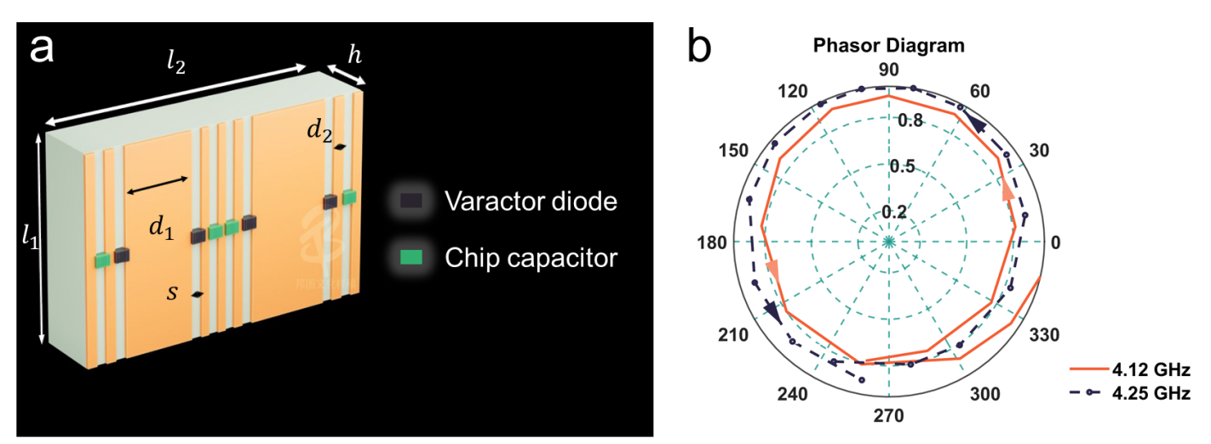
Fig. S1. Outlines of the designed meta-atom and its simulated reflection phases and amplitudes under various reverse biasing voltages. (a) The outlines of the meta-atom. $l_{1}=12$ mm; $l_{2}=24$ mm; $h=5$ mm; $d_{1}=5.6$ mm; $d_{2}=1.2$ mm; $s=0.7$ mm. (b) The reflectivity phasor diagram of the meta-atom under a linearly increasing bias voltage (counterclockwise) at frequencies of 4.12 GHz and 4.25 GHz, respectively

Full-wave simulations for the meta-atom are conducted using the commercial software, CST Microwave Studio 2016. The reflectivity phasor diagram of the meta-atom under a linearly increasing bias voltage (counterclockwise) at 4.12 GHz and 4.25 GHz, as shown in Fig. S1b, reveals that the reflection phase range exceeds 2π.

Supplementary Note 2: Beamforming at the harmonic frequencies of 4.1201 and 4.1202 GHz
The harmonic scattering patterns are measured in a microwave anechoic chamber. A horn antenna operating in the C-band is the excitation source, connected to a microwave signal generator (Keysight E8267D) that produces a monochromatic signal at 4.12 GHz. The metasurface and the feeding antenna are mounted on a turntable capable of automatic 360° rotation in the horizontal plane. On the receiving end, another horn antenna captures the scattered signals, which are recorded using a vector network analyzer.

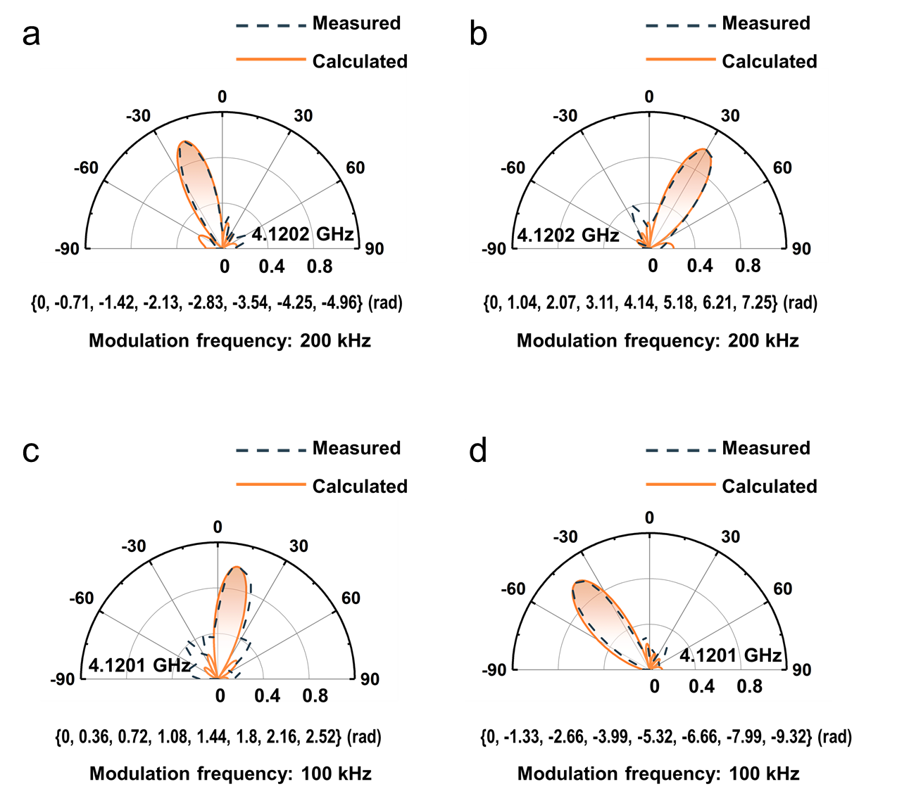
Fig. S2. Beamforming achieved by the STC metasurface at the 1st-order harmonic. (a-b) For a modulation frequency of 200 kHz: (a) The measured main lobe is at -20°; (b) The measured main lobe is at 30°. (c-d) For a modulation frequency of 100 kHz: (c) The measured main lobe is at 10°; (d) The measured main lobe is at -40°. The harmonic phase distributions that account for the scattering phenomena are presented along with the patterns

We use an STC metasurface prototype with eight meta-columns and interelement spacing of 24 mm to implement the beamforming at the 1st-order harmonic. It is controlled by the temporal modulation under the incident frequency of 4.12 GHz. Firstly, the modulation frequency is defined as 200 kHz, so the operational frequency is 4.1202 GHz. The desired angles of the main beams are -20° and 30°, respectively. According to Eq. (1) in the main text, the phase distributions should be {0, -0.71, -1.42, -2.13, -2.83, -3.54, -4.25, -4.96} (rad) and {0, 1.04, 2.07, 3.11, 4.14, 5.18, 6.21, 7.25} (rad), respectively, as shown in the figures. The corresponding phase gradients can be realized by introducing proper time shifts to the coding waveforms. Specifically, the coding waveform used can be given by
 | $C\left(t\right)=e^{jp×mod(t,T)}$, | (S1)
in which $mod(t,T)$ denotes the remainder of $t/T$ and $p$ is the phase slope. According to ref. S1, when $pT=2π$, the incident frequency will be perfectly shifted to the 1st-order harmonic. As shown in Figs. S2a and S2b, the scattering beams at 4.1202 GHz are steered to -20° and 30°, respectively.
Subsequently, the modulation frequency is defined as 100 kHz, so the operational frequency is 4.1201 GHz. The desired angles of the main beams are 10° and -40°, respectively. Accordingly, the phase distributions are {0, 0.36, 0.72, 1.08, 1.44, 1.8, 2.16, 2.52} (rad) and {0, -1.33, -2.66, -3.99, -5.32, -6.66, -7.99, -9.32} (rad), respectively, as shown in the figures. Figs. S2c and S2d illustrate the scattering beams at 4.1201 GHz being steered to angles of 10° and -40°. It is evident that the measured results (dotted lines) agree with the simulations (solid lines), as illustrated in Fig. S2.

Supplementary Note 3: Fundamental principle of frequency-modulated continuous wave (FMCW) radar
The FMCW radar’s^{S2} transmitting signal, known as the chirp signal, can be given by
 | $s_{t}\left(t\right)=rect\left(\frac{t}{T_{p}}\right)e^{j2π\left(f_{c}t+\frac{B}{2T_{p}}t^{2}\right)}$, | (S2)
in which $f_{c}$ represents the carrier frequency, $T_{p}$ and $B$ denote the duration and bandwidth of the chirp, respectively, and $rect\left(u\right)$ is described as
 | $rect\left(u\right)=\left\{\begin{aligned}1, \left|u\right|≤\frac{1}{2} \\ 0, \left|u\right|>\frac{1}{2} \end{aligned}\right.$. | (S3)
Then, a target echo can be given by
 | $s_{r}\left(t,k\right)=σrect\left(\frac{t−τ}{T_{p}}\right)e^{j2π\left(f_{c}\left(t−τ\right)+\frac{B}{2T_{p}}{\left(t−τ\right)}^{2}\right)}$, | (S4)
where $σ$ reflects the scattering characteristic of the n^{th} target, while $τ$ is the round-trip time of the target, that is
 | $τ=\frac{{{2R}_{0}+2v}_{0}(k−1)T_{c}}{c}$, | (S5)
in which $R_{0}$ represents the distance from the radar to the target. $v_{0}$ accounts for the velocity of the target. $k$ denotes the k^{th} chirp signal in one coherent processing interval (CPI). $T_{c}$ represents the interval between two adjacent chirps. $(k−1)T_{c}$ can be called the slow time. Accordingly, $t$ is the fast time. Assume $T_{c}=T_{p}$. $c$ is the light speed in free space.
Suppose that the systemic reference range is $R_{f}=0$. Thus, the reference signal can be written as
 | $s_{f}\left(t\right)=rect\left(\frac{t}{T_{p}}\right)e^{j2π\left(f_{c}t+\frac{B}{2T_{p}}t^{2}\right)}$. | (S6)
Then, the dechirp processing is performed at the receiving end, which can be expressed mathematically as follows
 | $s_{If}\left(t,k\right)=s_{r}\left(t,k\right)∙s_{f}^{∗}\left(t\right)$, | (S7)
in which $∗$ means a conjugate operation. $s_{If}$ can be expanded as
 | $s_{If}\left(t, k\right)=Ae^{j2π(\frac{2BR_{0}}{cT_{p}}t+\frac{2(R_{0}+v_{0}(k−1)T_{c})}{λ_{c}})}$, | (S8)
in which $A$ represents the signal amplitude after the dechirp processing. $λ_{c}=c/{f_{c}}$. For the sake of simplicity, we have assumed that the residual video phase has been disregarded. From Eq. (S8), $s_{If}$ is a single-tone signal with the frequency of ${2BR_{0}}/{cT_{p}}$ and the phase of ${2(R_{0}+v_{0}(k−1)T_{c})}/{λ_{c}}$. According to Ref. S1, $R_{0}$ and $v_{0}$ of the target can be acquired by performing a two-dimensional Fast Fourier Transform with respect to fast and slow time.

Supplementary Note 4: Radar echo simulator
The user interface of the radar echo simulator is shown in Fig. S3. This simulator allows for the integration of user-defined spatiotemporal data for multiple targets into the transmitted signals, which are then emitted as echo signals into the surrounding environment.
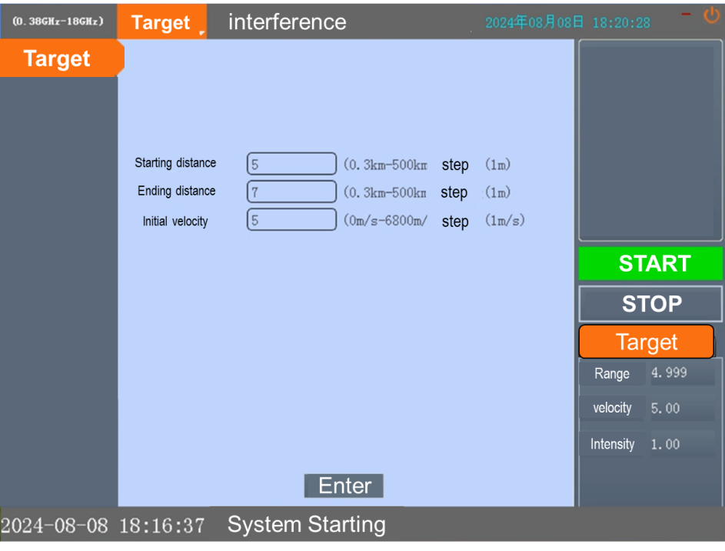
Fig. S3. The user interface of the radar echo simulator

To validate the reliability of the radar echo simulator, we employ a conventional FMCW radar with a chirp signal bandwidth of 1 MHz to receive the echoes generated by the simulator. Three scenarios are tested using the radar echo simulator: (1) a single target at 1 km with a velocity of 0 m/s; (2) two targets at 1 km and 2 km, both with velocities of 0 m/s; (3) a single moving target at 1 km with a velocity of 10 m/s. The measured results are presented in Fig. S4. The radar successfully detects and measures the targets within the range resolution generated by the radar echo simulator, demonstrating that the simulator is a suitable tool for testing the performance of the metasurface-based radar system.
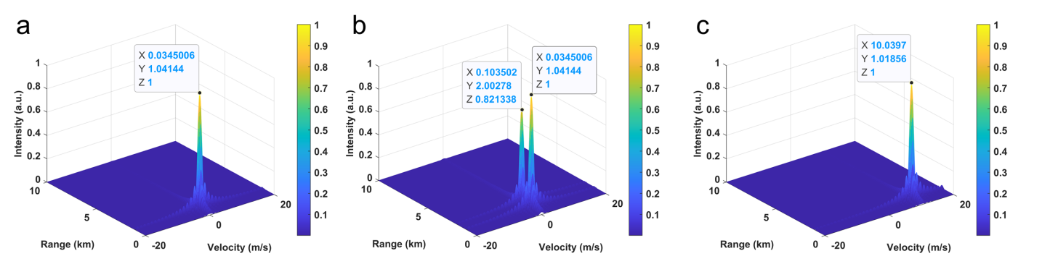
Fig. S4. The measured results of targets defined by the radar echo simulator. (a) Setting: (1 km, 0 m/s); measured: (1.02 km, 0.03 m/s). (b) Setting: (1 km, 0 m/s), (2 km, 0 m/s), measured: (1.04 km, 0.03 m/s), (2 km, 0.1 m/s). (c) Setting: (1 km, 10 m/s), measured: (1.01 km, 10.04 m/s)

References:
[S1]. Dai, J. Y. et al. High-efﬁciency synthesizer for spatial waves based on space-time-coding digital metasurface. Laser Photon. Rev. 14,1900133 (2020).
[S2]. Mohinder, J. FMCW Radar Design, Artech, (2018).

