Fe/N/C Catalysts with Hierarchical Porous Structure Derived from Fe-doped ZIF-8 for Accelerated ORR Activity
Kaixiang Liª, Jinyu Zhao^{b}, Ruipeng Yuan^{b}, Jiajun Chen^{b}, Huijun Li^{b}, Xiaomin Wang^{b,} *
a GAC AION NEW ENERGY AUTOMOBILE Co. Ltd. 36 Longyin Road Guangzhou Guangdong, China, 511436
b College of Materials Science and Engineering, Taiyuan University of Technology, Taiyuan 030024, China
Corresponding author: Xiaomin Wang^{b, *}
E-mail address: wangxiaomin@tyut.edu.cn（X Wang）
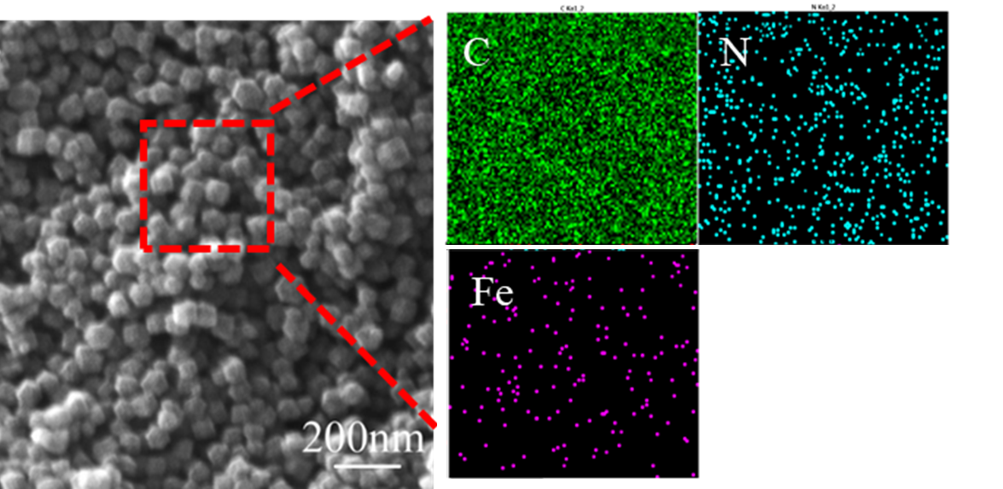
Figure S1 SEM image and EDS images of Fe-N-C 1000
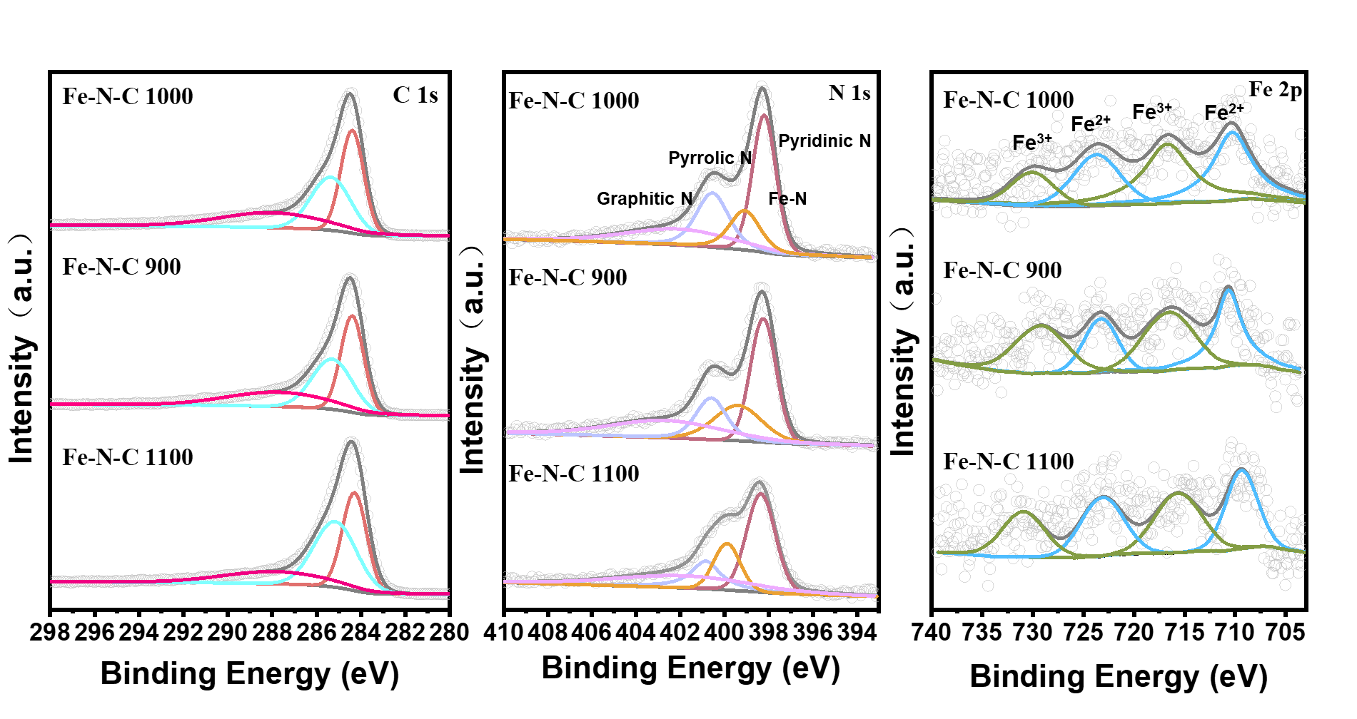
Figure S2 XPS spectra of N 1s and Fe 2p
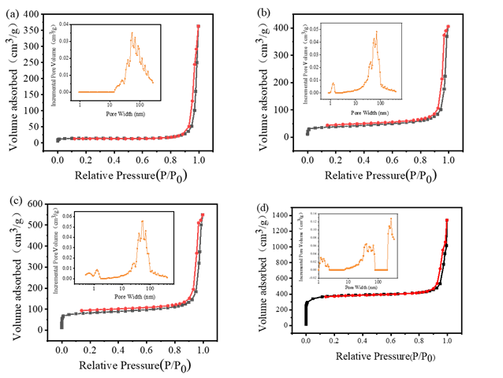
Figure S3 (a-d) N₂ adsorption/desorption isotherms of Fe-N-C 700, Fe-N-C 800, Fe-N-C 900, Fe-N-C 1100 and corresponding aperture distribution
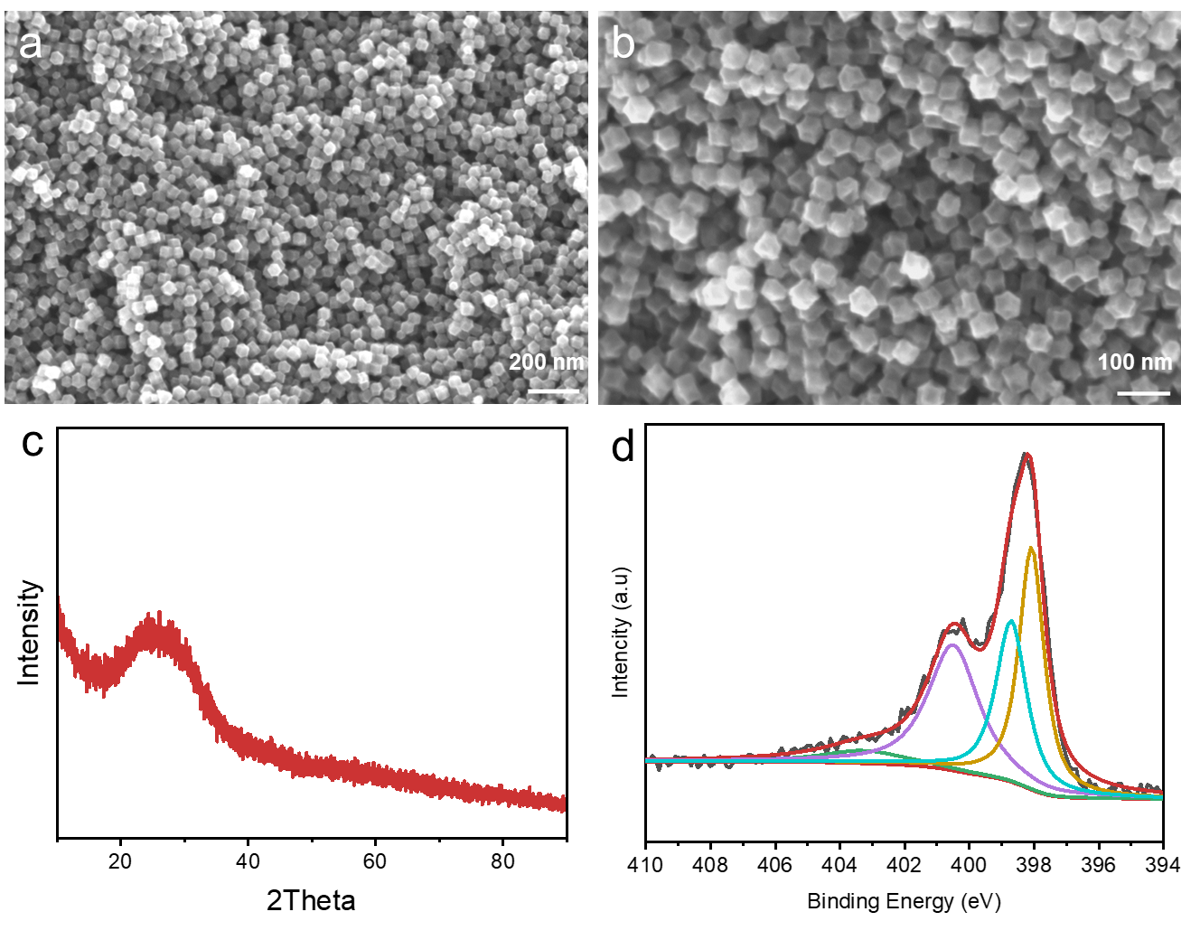
Figure S4 The morphology and structure after stability test of Fe-N-C 1000

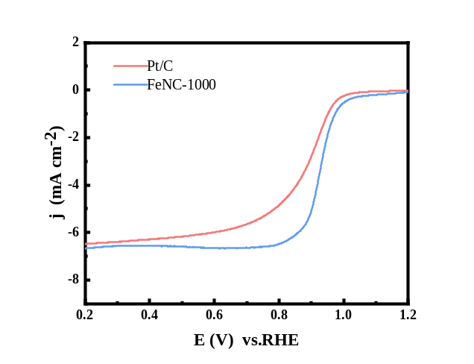
Figure S5 LSV curves of FeNC-1000 and Pt/C catalysts in 0.1 M HClO₄.

Table S1 Pore size analysis of Fe-N-C derived from Fe-ZIF-8 by a series of high temperature annealing treatments
Samples | S_{BET}  (m² g⁻¹) | V_{t}  (cm³ g⁻¹) | Pore Volume (cm³ g⁻¹) |  |  | Pore Volume (%)
Samples | S_{BET}  (m² g⁻¹) | V_{t}  (cm³ g⁻¹) | V_{micro} | V_{meso} | V_{macro} | V_{micro} | V_{meso} | V_{macro}
Fe-N-C 700 | 44.49 | 0.557 | 0.00582 | 0.164 | 0.349 | 1.1% | 32% | 66.9%
Fe-N-C 800 | 128.9152 | 0.617 | 0.036 | 0.254 | 0.308 | 6.0 % | 42.5% | 51.5%
Fe-N-C 900 | 271.0849 | 0.837 | 0.087 | 0.478 | 0.802 | 10.7% | 48.9% | 40.4%
Fe-N-C 1000 | 572.1957 | 1.106 | 0.205 | 0.882 | 1.055 | 19.4% | 64.1% | 16.2%
Fe-N-C 1100 | 1162.2 | 1.749 | 0.46 | 0.586 | 0.252 | 35.4% | 45% | 19.4%
a The specific surface area (SSA) was calculated by BET method.
b The total pore volume (TPV) was obtained at relative pressure p/p₀=0.99.
c The pore volume based on different pore size range was calculated by DFT model.

Table S2 Summary of obtained and other repored catalysts for ORR in acidic
Electrolytes

Catalyst | E_{1/2}（V） | J_{K}  （mA cm⁻²） | Tafel slopes  （mv dec⁻¹） | References
Fe-N-C 1000 | 0.791 | 10.1 | 52 | This work
Fe₂-N-C | 0.78 | 16.4 | 83 | ¹
HP-FeN4 | 0.80 | - | 72 | ²
Fe-Zn-SA/NC | 0.78 | - | 54.3 | ³
Mn-Fe@ NCNTs | 0.76 | - | 78.5 | ⁴
FeCu-SAC | 0.779 | 16.33 | 53.6 | ⁵
Fe_{SA/AC}@NC | 0.80 | - | 52 | ⁶
Fe(Cd)-N-C | 0.837 | - | 56 | ⁷
Fe/ZnS-SNC | 0.81 | 21.8 | 41.3 | ⁸
FeSNC-TA | 0.76 | 6.9 | 61.2 | ⁹
Fe@Fe-N-C | 0.829 | 11.1 | 76.3 | ¹⁰
References
1. Ye, W.; Chen, S.; Lin, Y.; Yang, L.; Chen, S.; Zheng, X.; Qi, Z.; Wang, C.; Long, R.; Chen, M.; Zhu, J.; Gao, P.; Song, L.; Jiang, J.; Xiong, Y., Precisely Tuning the Number of Fe Atoms in Clusters on N-Doped Carbon toward Acidic Oxygen Reduction Reaction. Chem 2019, 5 (11), 2865-2878.
2. Zhang, N.; Zhou, T.; Chen, M.; Feng, H.; Yuan, R.; Zhong, C. a.; Yan, W.; Tian, Y.; Wu, X.; Chu, W.; Wu, C.; Xie, Y., High-purity pyrrole-type FeN4 sites as a superior oxygen reduction electrocatalyst. Energy & Environmental Science 2020, 13 (1), 111-118.
3. Xu, J.; Lai, S.; Qi, D.; Hu, M.; Peng, X.; Liu, Y.; Liu, W.; Hu, G.; Xu, H.; Li, F.; Li, C.; He, J.; Zhuo, L.; Sun, J.; Qiu, Y.; Zhang, S.; Luo, J.; Liu, X., Atomic Fe-Zn dual-metal sites for high-efficiency pH-universal oxygen reduction catalysis. Nano Research 2021, 14 (5), 1374-1381.
4. Guo, X.; Xue, S.; Zhang, X.; Qin, J.; Hong, M.; Chen, Q.; Liu, W.; Du, C.; Chen, J., Mn atomic clusters and Fe nanoparticles in-situ conﬁned nitrogen carbon nanotubes for efficient and durable ORR electrocatalysts in both alkaline and acidic media. Journal of Alloys and Compounds 2023, 953, 169992.
5. Yang, H.; Huang, H.; Wang, Q.; Shang, L.; Zhang, T.; Wang, S., Fe, Cu dual-metal single atom catalyst on commercial carbon black for efficient oxygen reduction reaction. Journal of Materials Chemistry A 2023, 11 (12), 6191-6197.
6. Chen, C.; Wu, Y.; Li, X.; Ye, Y.; Li, Z.; Zhou, Y.; Chen, J.; Yang, M.; Xie, F.; Jin, Y.; Jones, C.; Wang, N.; Meng, H.; Chen, S., Modulating Fe spin state in FeNC catalysts by adjacent Fe atomic clusters to facilitate oxygen reduction reaction in proton exchange membrane fuel cell. Applied Catalysis B: Environmental 2024, 342, 123407.
7. Luo, Z.; Zhou, T.; Guan, Y.; Zhang, L.; Zhang, Q.; He, C.; Sun, X.; Ren, X., Building Atomic Scale and Dense Fe─N4 Edge Sites of Highly Efficient Fe─N─C Oxygen Reduction Catalysts Using a Sacrificial Bimetallic Pyrolysis Strategy. Small 2023, n/a (n/a), 2304750.
8. Pei, F.; Li, M.; Huang, Y.; Guo, Q.; Song, K.; Kong, F.; Cui, X. Constructing FeS and ZnS Heterojunction on N,S-Codoped Carbon as Robust Electrocatalyst toward Oxygen Reduction Reaction Nanomaterials [Online], 2023.
9. Liu, H.; Jiang, L.; Sun, Y.; Khan, J.; Feng, B.; Xiao, J.; Zhang, H.; Xie, H.; Li, L.; Wang, S.; Han, L., Revisiting the Role of Sulfur Functionality in Regulating the Electron Distribution of Single-Atomic Fe Sites Toward Enhanced Oxygen Reduction. Advanced Functional Materials 2023, 33 (35), 2304074.
10. Li, L.; Wen, Y.; Han, G.; Kong, F.; Du, L.; Ma, Y.; Zuo, P.; Du, C.; Yin, G., Architecting FeNx on High Graphitization Carbon for High-Performance Oxygen Reduction by Regulating d-Band Center. Small 2023, 19 (22), 2300758.

