Supporting Information for
[Increasing drying changes the relationship of biodiversity and community assembly with ecosystem multifunctionality in temporary streams]
[Chaoran Li¹, Jun Hou¹, Mingkong², Yu Yao³, Tanveer M. Adyel⁴, Jun Wu¹, Guoxiang You¹, Yue Yu⁵, Songqi Liu⁶, Zijun Yang¹, Lingzhan Miao^{*1}]
[1Key Laboratory of Integrated Regulation and Resources Development on Shallow Lakes, Ministry of Education, College of Environment, Hohai University, Nanjing, People’s Republic of China, 210098
2Nanjing Institute of Environmental Sciences, Ministry of Ecology and Environment, Nanjing 210042, China
3School of Environment, Nanjing Normal University, Nanjing, 210023, China
4University of South Australia, Mawson Lakes, SA 5095, Australia
5Department of Civil, Environmental, and Geomatic Engineering, ETH Zürich, Zürich 8092, Switzerland
6School of Environmental Science and Engineering, Suzhou University of Science and Technology, Suzhou 215009, PR China]

Contents of this file

Text S1 to S3
Figures S1 to S9
Tables S1 to S3

Introduction
[The following figures are mentioned in the manuscript as supplementary work to illustrate the main conclusions]

Text S1.
Biofilm colonization was performed on the Qin Huai River (32°03 36.2 N; 118°44 38.1 E) in Nanjing, Eastern China, a tributary of the Yangtze River, which is under the control of the subtropical monsoon climate with annual average precipitation at 1038 mm. The water supply of this region’s run-off is mainly from rainfall, which varies with the climate and is primarily concentrated in summer (June-August). The biofilm colonization device or wire cages 30 cm in diameter and 30 cm in height with cobbles (2–3 cm in diameter) were designed. All incubation devices (wire cages with cobbles) were suspended 50 cm below the surface and attached to the shore railings by a fishing line to ensure the same flow conditions. Each device was cultured for 44 days under natural conditions to obtain mature biofilm on the cobbles ^{1,2}.
Surface and free pore water in cobbles were drained from the experimental channels after flow cessation following the procedures in the previous study ³. The biofilm was rewetting from small flows, avoiding destroying the biofilm on the surface of the cobbles. Then, the water column was filled to the control level using the pump ³.

Text S2.
16S and 18S amplicon sequencing
0.5 g biofilm samples were collected at every sampling time and stored at -80 ℃. The total DNA was extracted using a MagaBio Soil/Fecal Genomic DNA purification kit (Bioer, Hangzhou, China). The quality and concentration of DNA were measured by Thermo NanoDrop One. For bacteria, the V4 hypervariable regions of the 16S rRNA gene were amplified using primer pair 515F(5`-GTGCCAGCMGCCGCGGTAA-3`) and 806R (5`-GGACTACHVGGGTWTCTAAT-3`)^{4,5}; for Eukaryote, the V4 region was amplified using 528F (5’ GCGGTAATTCCAGCTCCAA) and 706R (5’ AATCCRAGAATTTCACCTCT) primer sequences ⁶. Amplicons were generated using specific primers with barcode and TaKaRa Premix Taq® Version 2.0 (TaKaRa Biotechnology Co., Dalian, China) and pooled. The thermal cycle conditions were as follows: 94℃ for 5min, 30 cycles of 94℃ for the 30s, 52℃ for 30s, 72℃ for 30s, and a final extension at 72℃ for 10min to complete the reaction, finally hold in 4℃. Three replicates were performed for each sample, and PCR products from the same sample were mixed by BioRad S1000 (Bio-rad Laboratory, CA).
After 1% agarose gel electrophoresis detection of PCR product fragment length and concentration, the concentration of PCR products was compared by GeneTools Analysis Software (Version 4.03.05.0, SynGene). The required volume of each sample was calculated according to the equal quality principle, and each PCR product was mixed. The PCR mixture was recovered using the E.Z.N.A.® Gel Extraction Kit (Omega, USA) Gel Recovery Kit, and the target DNA fragment was eluted with TE buffer. Finally, the library was constructed according to the NEBNext® Ultra™ II DNA Library Prep Kit for Illumina® (New England Biolabs, USA) standard process, and PE250 sequencing was performed on the IlluminaHiseq2500 platform (Guangdong Magigene Biotechnology Co., Ltd. Guangzhou, China)

Statistical analyses of sequencing data
Sequenced paired-end Raw Reads were cut with sliding window quality (-W 4-M 20) using the fast (an ultra-fast all-in-one FASTQ preprocessor, version 0.14.1, https://github.com/OpenGene/fastp). Meanwhile, according to the fore and aft ends of the sequence, the primers were removed using cutadapt software (https://github.com/marcelm/cutadapt/) to obtain the quality paired-end Clean Reads. According to the relation between the overlap of PE reads, usearch- fastq_mergepairs (V10, http://www.drive5.com/usearch/ preset parameters include the minimum length of overlap set as 16bp, the maximum error allowed in the overlap area of the overlapping sequence is 5bp, etc) is used to filter disconfirmed tags. Paired-end Clean Reads stitching is carried out to obtain the Raw Tags. Finally, fastq (an ultra-fast all-in-one FASTQ preprocessor, version 0.14.1, https://github.com/OpenGene/fastp) is used to cut Raw Tags by sliding window quality (-W 4-M 20) and obtain Clean Tags.
Operational taxonomic units were clustered according to UPARSE ((RC Edgar. highly accurate OTU sequences from microbial amplicon reads. DADA2⁷ and Deblur ⁸ provided in qiime2 (version 2020.11.0) process are used for denoising. Representative sequences for each OTU were taxonomically assigned by SILVA (16S/v132) and SILVA (18S/v132) Classifiers with a bootstrap threshold of 0.5 ^{9,10}. Finally, singleton OTU, chimera, and contaminated OTU were removed to obtain the effective sequence number of Tags (No. of seqs) and the comprehensive information table of OTU taxonomy (OTU_table) for each sample.

Microbial community network analysis
Network analyses of different biofilm components (bacteria, fungi, and algae) were conducted on species abundance data at the OTU level¹¹, with Pearson’s correlation p-value ≤0.05 (|cor|>0.5). Topological parameters were calculated following the equation (1-5), such as average degree (Avg K, indicating the species connectivity in the community ^{11,12}), average path distance (GD, indicating the closeness of the network), Average clustering coefficient (AvgCC, indicating the extent of modular structure in the network) and Modularity (which is calculated to measure how well a network can be separated into modules) of networks. The visualization of ecological networks also via Gephi (v0.9.2).
$k_{i}=\sum_{j≠i}{a_{ij}}$ (1)
$AvgK=\frac{\sum_{i=1}^{n}{k_{i}}}{n}$ (2)
$GD=\frac{1}{n\left(n-1\right)}\sum_{i≠j}{d_{ij}}$ (3)
$CC_{i}=\frac{2l_{i}}{k_{i}^{'}\left(k_{i}^{'}-1\right)}$ (4)
$Avgcc=\frac{\sum_{i=1}^{n}{c_{i}c_{i}}}{n}$ (5)
where $a_{ij}$ is the strength of the connection between nodes $i$ and $j$, $k_{i}$ is the degree of node i and $n$ is the number of all nodes; $d_{ij}$ is the shortest path between nodes $i$ and $j$; $l_{i}$ is the number of links between neighbouring nodes of node $i$ and $k_{i}^{'}$is the number of neighbouring nodes of node $i$.
Microbial community stability analysis
In addition, the microbial community stability was expressed by the Average Variation Degree of the microbial community network (AVD)¹³, which was calculated following the equation (6-7). Generally, lower AVD values represent higher community stability¹³.
$AVD=\frac{\sum_{i=1}^{n}{\left|a_{i}\right|}}{k×n}$ (6)
$\left|a_{i}\right|=\frac{\left|x_{i}-\overline{x_{i}}\right|}{δ_{i}}$ (7)
where$k$ is the number of samples (if the AVD of a single sample is sought, $k$ is 1; if the AVD of a group of samples is sought, $k$ is the number of samples in the group), and $n$ is the number of OTUs. $a_{i}$ represents the varbility of ${OTU}_{i}$ . $x_{i}$ is the abundance of ${OTU}_{i}$ in each sample, a $\overline{x_{i}}$ and $δ_{i}$ are the mean andstandard deviatio of${OTU}_{i}$ abundance in all samples, respectively.
Microbial Community Assembly analysis
To estimate the effects of the stochastic processes on the biofilm community assembly, a neutral community model was used¹⁴, applying non-linear least-squares to generate the best fit between the frequency of OTUs applying nonlinear least-squares to generate the best fit between the frequency of OTUs occurrence and their relative abundance. The R2 value indicates the goodness of fit to the model, which was calculated following the “Östman’s method” ¹⁵. When R2 is close to 1, the community assembly is fully consistent with stochastic processes. When it does not describe the community composition, R2 can be ≤ 0. Model computations were performed with R version 3.6.1¹⁶.
Within the null model, we calculated the betaMNTD, Raup-Crick, Bray-curtis, and the beta-nearest taxon index (betaNTI) to infer the community assembly mechanisms index¹⁷. Ecological processes are divided into five variants: heterogeneous selection, homogeneous selection, dispersal limitation, homogenizing dispersing, and undominated processes. Heterogeneous selection results in high compositional turnover, where environmental factors (biotic and abiotic) shift temporally or spatially. In contrast, homogeneous selection leads to low compositional turnover, where the selection is consistent through time and space¹⁸. Dispersal also shows two variants: at low dispersal rates, dispersal limitation combined with drift leads to a large community turnover; whereas, at high dispersal rates, it causes a homogenization of community composition (i.e., homogenizing dispersal)¹⁹. Finally, when dispersal and drift contribute equally to community composition, the variant is called an undominated process²⁰.

Text S3 Biofilm functions
The corresponding ELISA kit is a double antibody sandwich assay for the determination of the activity levels of various elemental metabolic enzymes in specimens. A solid phase antibody is made by coating a microtiter plate with purified metabolic enzyme (eg. α-D-Glu) antibodies, adding metabolic enzymes to the wells of the monoclonal antibody, and then combining them with the HRP-labelled metabolic enzyme antibody to form an antibody-antigen-enzymatic antibody complex. After thorough washing, the colour is developed by the addition of the substrate TMB, which is converted to blue by the enzyme HRP and to final yellow by the presence of acid. TMB is converted to blue by the enzyme HRP, and then to the final yellow colour by the action of acid. To prepare the standards for the assay, the kit provides an undiluted standard solution. Dilutions were performed in microtubes following a serial dilution scheme: 150 μl of undiluted standard was mixed with 150 μl of diluent to make the 200 U/L standard. This process was repeated down the line, each time using 150 μl of the previous dilution mixed with 150 μl of diluent, to prepare standards of 100 U/L, 50 U/L, 25 U/L, and 12.5 U/L. For sample addition, three types of wells were prepared on an enzyme-linked immunosorbent assay (ELISA) plate: blank wells with no sample or enzyme conjugate, standard wells with 50 μl of each standard, and test sample wells. In the test sample wells, 40 μl of sample diluent was added followed by 10 μl of the test sample, resulting in a 5x dilution. Samples were carefully added to the bottom of the wells to avoid touching the walls and were gently mixed by shaking. The plate was sealed with an adhesive film and incubated at 37°C for 30 minutes. Meanwhile, a 30x concentrated wash buffer was diluted to 1x using distilled water. After incubation, the sealing film was removed, the liquid was discarded, and the plate was flicked dry. Each well was filled with wash buffer, left for 30 seconds, and then emptied. This washing step was repeated five times, followed by tapping dry. 50 μl of enzyme conjugate was added to each well, except for the blank wells. The plate underwent a second incubation at 37°C for 30 minutes and was washed as described previously. For colour development, 50 μl of substrate solution A and 50 μl of substrate solution B were added to each well, mixed by gentle agitation, and incubated in the dark at 37°C for 10 minutes. The reaction was stopped by adding 50 μl of stop solution to each well, changing the solution colour from blue to yellow. Optical density (OD) at 450 nm was measured for each well using the blank wells to zero the plate reader. Measurements were taken within 15 minutes of adding the stop solution to ensure accuracy. The shade of colour correlates positively with the metabolic enzymes present in the sample. The absorbance (OD) was measured at 450nm using a Microplate Reader (Labsystems Multiskan MS 352, Finland) and the concentration of the metabolic enzyme activity of each element in the sample was calculated from the standard curve.
CO₂ and N₂O emissions
The CO₂ emission rate is measured by placing cobbles covered with biofilm into a sealed chamber (20 cm in diameter and 20 cm in height), ensuring that the total biofilm area on the cobbles matches the chamber's bottom area. And pressure gauges are equipped on the top of the static chamber to detect changes in air pressure inside the static chamber. Water from an artificial stream is added to fully submerge the cobbles, and the chamber is sealed to prevent gas exchange with the environment. Air samples are drawn from the chamber's headspace every ten minutes and transferred to sealed bottle. These samples are then injected into a gas chromatograph (GC) to measure the concentrations of CO₂ and N₂O. The CO₂ emission rate is calculated based on the change in CO₂ concentration over time, expressed in mg m⁻² h⁻¹, which represents the amount of CO₂ emitted per square meter of biofilm-covered surface area per hour. The flux was determined by a linear regression based on the change in CO₂ (N₂O) partial pressure (pCO₂) (p N₂O) over time ^{21,22}. The CO2 (N₂O) flux (mg m⁻²h⁻¹) was calculated according to Eq. (8); positive values represent emissions from the cobbles to the atmosphere, while negative values indicate an inflow from the atmosphere to the artificial stream channel ^{23,24}. This method allows for precise monitoring of CO2 emissions, reflecting the metabolic activity of the biofilm under controlled conditions.
$F_{{CO}_{2}(N_{2}O/CH_{4})}=ρ*\frac{V}{A}\left(\frac{ΔC({CO}_{2}/N_{2}O/CH_{4})}{Δt}\right)*(\frac{273}{T})$ (8)
where ${ΔC({CO}_{2} /N_{2} O/CH_{4}) }/{Δt}$ is the slope of the change in pCO₂ (p N₂O/p CH₄) with time [μatm d⁻¹], V is the volume of the chamber [m³], A is the surface area covered by the chamber [m²], T is the air temperature [K] and ρ is the ideal gas density.
Ecosystem metabolism
Ecosystem metabolism refers to the balance between energy production (Gross Primary Production, GPP) and energy consumption (Community Respiration, CR) within an ecosystem. The process begins with collecting cobbles covered with biofilm from a natural river and placing them evenly on the bottom of a sealed chamber (20 cm in diameter and 20 cm in height), ensuring that the total area of biofilm on the cobbles is approximately equal to the area of the chamber’s bottom. Water from an artificial stream is then added to the chamber, and a dissolved oxygen sensor (miniDO2T Logger, PME, USA) is placed in the water. The chamber is sealed, and the dissolved oxygen concentration is recorded every ten minutes for 120 minutes under constant light (to simulate daytime) and in the dark (to simulate nighttime). The Community Respiration (CR) and Net Ecosystem Production (NEP) were measured from the drop and rise in dissolved oxygen concentration in chambers for 120 minutes in constant dark and light conditions (plant growth light; 1058mm×24mm×36.5mm; 18w; and 220v), respectively ^{25,26}. Metabolic rates were calculated as described by Acuña and others ^{3,27}. The Gross primary productivity (GPP), CR and ecosystem metabolism were calculated as Eq. (9-12).
$CR={\left(\frac{ΔC_{treatment}}{Δt}\right)}_{night}*\left(\frac{V_{water}}{A_{sed}}\right)$ (9)
$NEP={\left(\frac{ΔC_{treatment}}{Δt}\right)}_{day}*\left(\frac{V_{water}}{A_{sed}}\right)$ (10)
$GPP=NEP-CR$ (11)
$Ecosystem metabolism=\frac{GPP}{CR}$ (12)
Where C_{treatment} is oxygen (mg/L), t is time(min), night and day represent the dissolved O2 concentration data set used in the dark and light conditions (the measurement time is 120 min), V_{water} is the total water volume (L) in the metabolism chamber, and Ased is the measuring bed surface (estimated by the size and number of cobbles at the bottom of the chambers, m²).

References:
1 Battin, T. J., Besemer, K., Bengtsson, M. M., Romani, A. M. & Packmann, A. I. The ecology and biogeochemistry of stream biofilms. Nature Reviews Microbiology 14, 251-263 (2016). https://doi.org:10.1038/NRMICRO.2016.15
2 Wu, Y., Xia, L., Yu, Z., Shabbir, S. & Kerr, P. G. In situ bioremediation of surface waters by periphytons. Bioresource Technology 151, 367-372 (2014). https://doi.org:10.1016/J.BIORTECH.2013.10.088
3 Zlatanovic, S., Fabian, J., Premke, K. & Mutz, M. Shading and sediment structure effects on stream metabolism resistance and resilience to infrequent droughts. Sci Total Environ 621, 1233-1242 (2018). https://doi.org:10.1016/j.scitotenv.2017.10.105
4 Caporaso, J. G. et al. Global patterns of 16S rRNA diversity at a depth of millions of sequences per sample. Proceedings of the National Academy of Sciences 108, 4516-4522 (2011). https://doi.org:10.1073/pnas.1000080107
5 Zhou, Y. Q. et al. Warming reshaped the microbial hierarchical interactions. Global Change Biology 27, 6331-6347 (2021). https://doi.org:10.1111/gcb.15891
6 Coleine, C., Stajich, J. E. & Selbmann, L. Fungi are key players in extreme ecosystems. Trends in Ecology & Evolution (2022). https://doi.org:10.1016/j.tree.2022.02.002
7 Callahan, B. J. et al. DADA2: High-resolution sample inference from Illumina amplicon data. Nature Methods 13, 581-+ (2016). https://doi.org:10.1038/NMETH.3869
8 Amir, A. et al. Deblur Rapidly Resolves Single-Nucleotide Community Sequence Patterns. Msystems 2 (2017). https://doi.org:10.1128/mSystems.00191-16
9 Vries, F. T. d. et al. Soil bacterial networks are less stable under drought than fungal networks. Nature Communications 9, 3033-3033 (2018). https://doi.org:10.1038/S41467-018-05516-7
10 Wang, Q., Garrity, G. M., Tiedje, J. M. & Cole, J. R. Naive Bayesian classifier for rapid assignment of rRNA sequences into the new bacterial taxonomy. Applied and Environmental Microbiology 73, 5261-5267 (2007). https://doi.org:10.1128/AEM.00062-07
11 Wagg, C., Schlaeppi, K., Banerjee, S., Kuramae, E. E. & van der Heijden, M. G. A. Fungal-bacterial diversity and microbiome complexity predict ecosystem functioning. Nature Communications 10 (2019). https://doi.org:10.1038/s41467-019-12798-y
12 Jiao, S., Zhang, B., Zhang, G., Chen, W. & Wei, G. Stochastic community assembly decreases soil fungal richness in arid ecosystems. Molecular Ecology 30, 4338-4348 (2021). https://doi.org:10.1111/mec.16047
13 Xun, W. et al. Specialized metabolic functions of keystone taxa sustain soil microbiome stability. Microbiome 9 (2021). https://doi.org:10.1186/s40168-020-00985-9
14 Sloan, W. T. et al. Quantifying the roles of immigration and chance in shaping prokaryote community structure. Environmental Microbiology 8, 732-740 (2006). https://doi.org:10.1111/j.1462-2920.2005.00956.x
15 Ostman, O. et al. Regional invariance among microbial communities. Ecology letters 13, 118-127 (2010). https://doi.org:10.1111/j.1461-0248.2009.01413.x
16 Mo, Y. et al. Low shifts in salinity determined assembly processes and network stability of microeukaryotic plankton communities in a subtropical urban reservoir. Microbiome 9 (2021). https://doi.org:10.1186/s40168-021-01079-w
17 Shade, A. et al. Fundamentals of Microbial Community Resistance and Resilience. Frontiers in Microbiology 3 (2012).
18 Dini-Andreote, F., Stegen, J. C., van Elsas, J. D. & Salles, J. F. Disentangling mechanisms that mediate the balance between stochastic and deterministic processes in microbial succession. Proceedings of the National Academy of Sciences 112 (2015).
19 Leibold, M. A. et al. The metacommunity concept: a framework for multi-scale community ecology. Ecology letters 7, 601-613 (2004). https://doi.org:10.1111/j.1461-0248.2004.00608.x
20 Stegen, J. C., Lin, X., Fredrickson, J. K. & Konopka, A. E. Estimating and mapping ecological processes influencing microbial community assembly. Frontiers in Microbiology 6 (2015). https://doi.org:10.3389/fmicb.2015.00370
21 Keller, P. S. et al. Global CO2 emissions from dry inland waters share common drivers across ecosystems. Nature Communications 11 (2020). https://doi.org:10.1038/s41467-020-15929-y
22 Gómez-Gener, L. et al. When Water Vanishes: Magnitude and Regulation of Carbon Dioxide Emissions from Dry Temporary Streams. Ecosystems 19, 710-723 (2016).
23 Campeau, A. & del Giorgio, P. A. Patterns in CH4 and CO2 concentrations across boreal rivers: Major drivers and implications for fluvial greenhouse emissions under climate change scenarios. Global Change Biology 20, 1075-1088 (2014). https://doi.org:https://doi.org/10.1111/gcb.12479
24 Yang, Z., Che, Z., Liu, F. & Chen, K. Precipitation gradient influence on daily greenhouse gas emission fluxes from a Qinghai Lake wetland. Arid Zone Research 39, 754-766 (2022).
25 Adyel, T. M., Hipsey, M. R. & Oldham, C. E. Temporal dynamics of stormwater nutrient attenuation of an urban constructed wetland experiencing summer low flows and macrophyte senescence. Ecological Engineering 102, 641-661 (2017). https://doi.org:10.1016/J.ECOLENG.2016.12.026
26 Liu, K. et al. Different community assembly mechanisms underlie similar biogeography of bacteria and microeukaryotes in Tibetan lakes. FEMS Microbiol Ecol 96 (2020). https://doi.org:10.1093/femsec/fiaa071
27 Acuña, V., Wolf, A., Uehlinger, U. & Tockner, K. Temperature dependence of stream benthic respiration in an Alpine river network under global warming. Freshwater Biology 53, 2076-2088 (2008). https://doi.org:10.1111/J.1365-2427.2008.02028.X

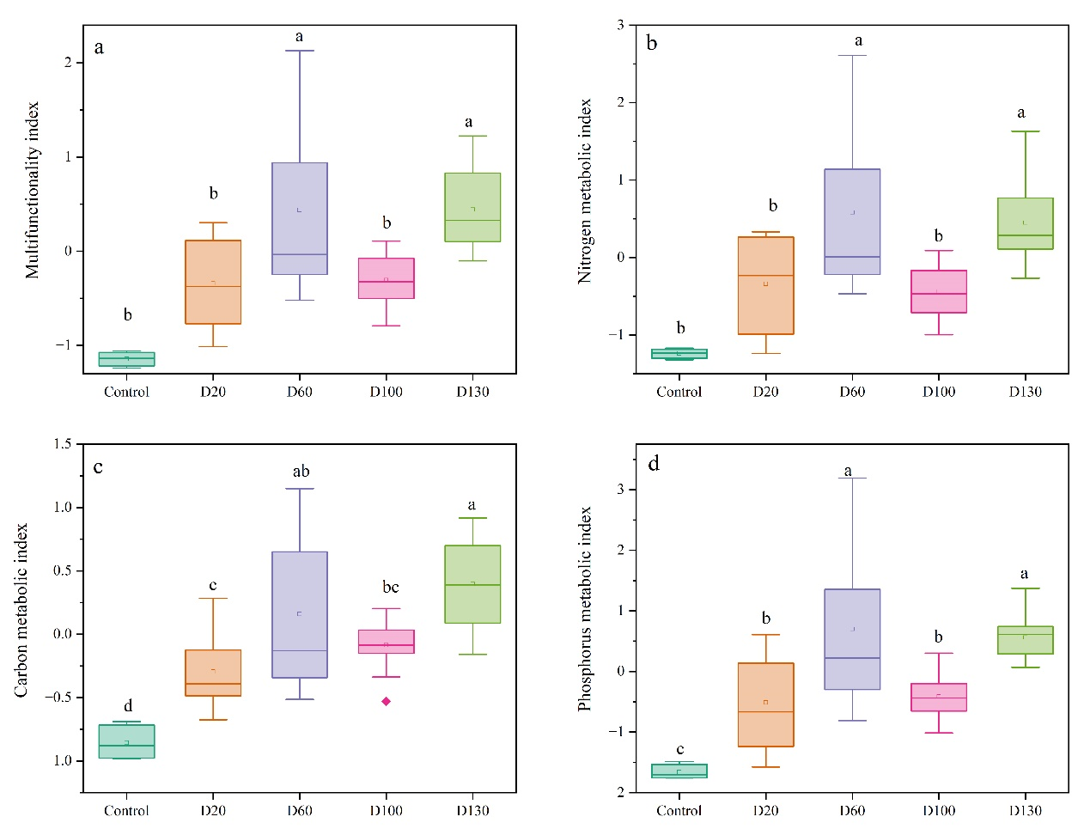
Figure S1. Biofilm metabolic multifunctionality index(a). Biofilm metabolism multifunctionality index of nitrogen (b), carbon (c) and phosphorus (d). D20 is the experimental group that rewetting after 20 days of drought. R1 indicates the first day after rewetting. Different letters (g) indicate significant differences within the biofilm community stability (ANOVA, P <0.05) across drought gradients.
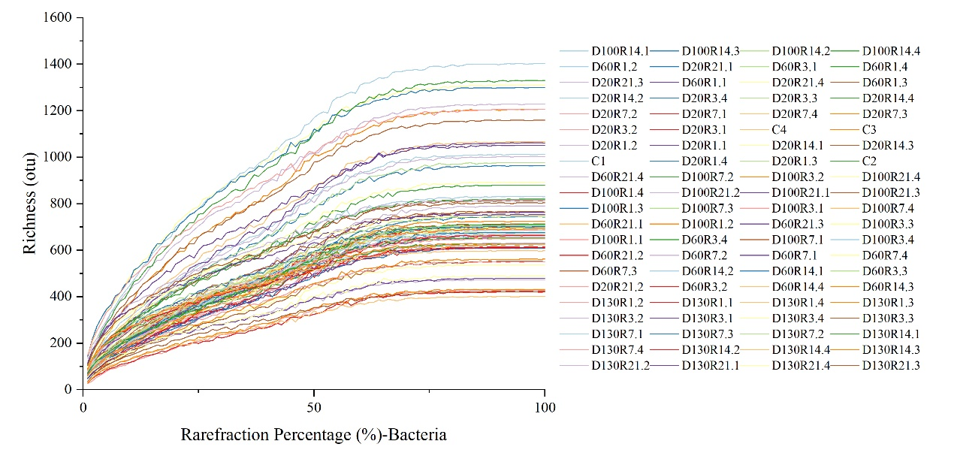 Figure S2. The rarefaction curve of bacterial richness index at OTU level.

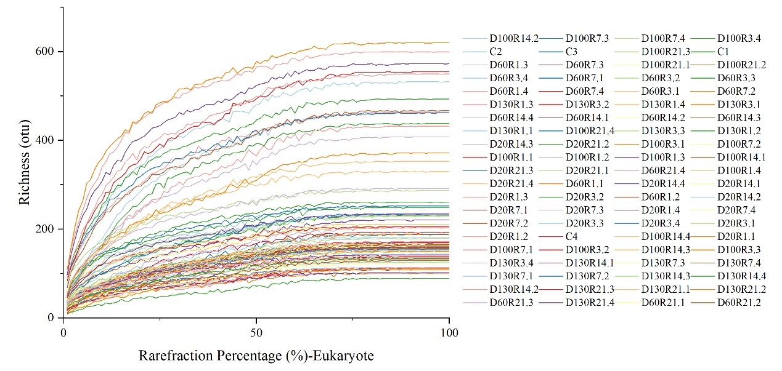

Figure S3. The rarefaction curve of eukaryotic richness index at OTU level.

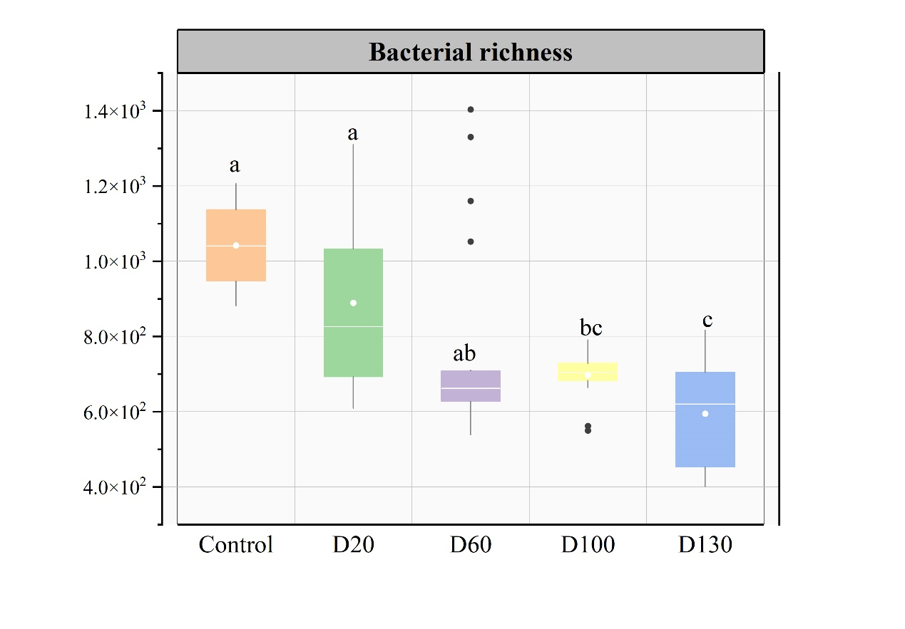Figure S4. The richness of bacteria at the OTU level. The error bars indicated the standard deviation between parallel samples. The alphabetical letters a, b, and c over the bar indicate significant differences between samples (ANOVA, p<0.05). D20 is rewetting after 20 days of drought.

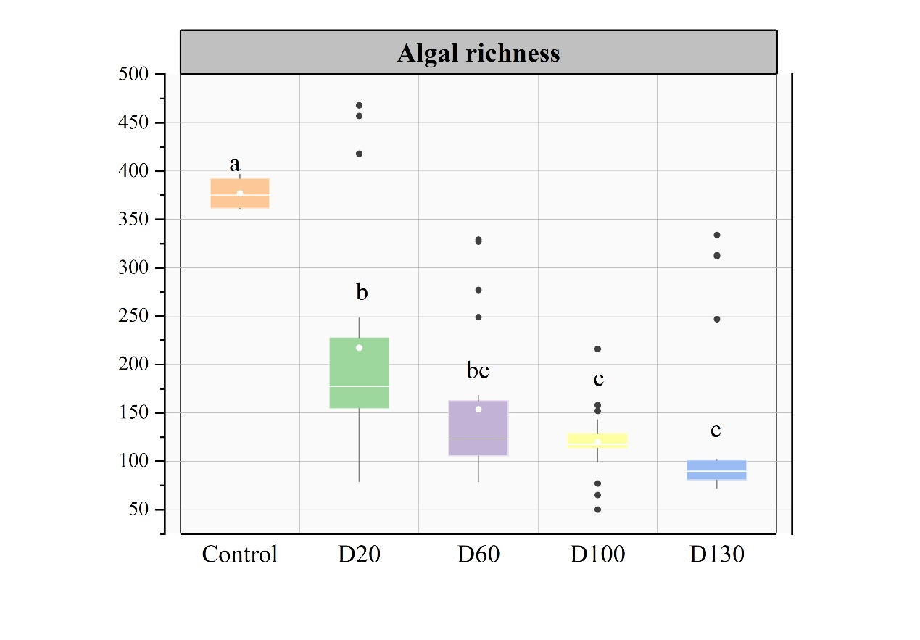Figure S5. The richness of algae at the OTU level. The error bars indicated the standard deviation between parallel samples. The alphabetical letters a, b, and c over the bar indicate significant differences between samples (ANOVA, p<0.05). D20 is rewetting after 20 days of drought.

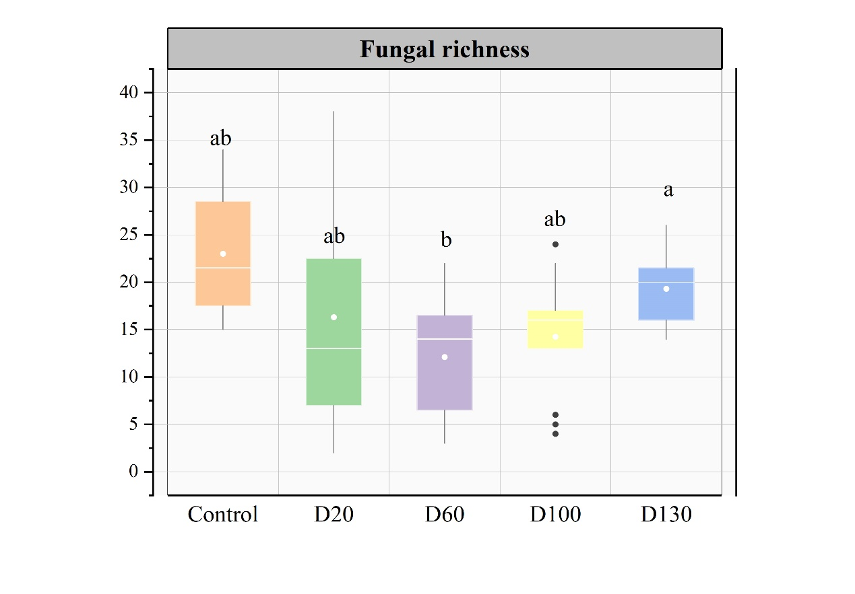Figure S6. The richness of fungus at the OTU level. The error bars indicated the standard deviation between parallel samples. The alphabetical letters a, b, and c over the bar indicate significant differences between samples (ANOVA, p<0.05). D20 is rewetting after 20 days of drought.

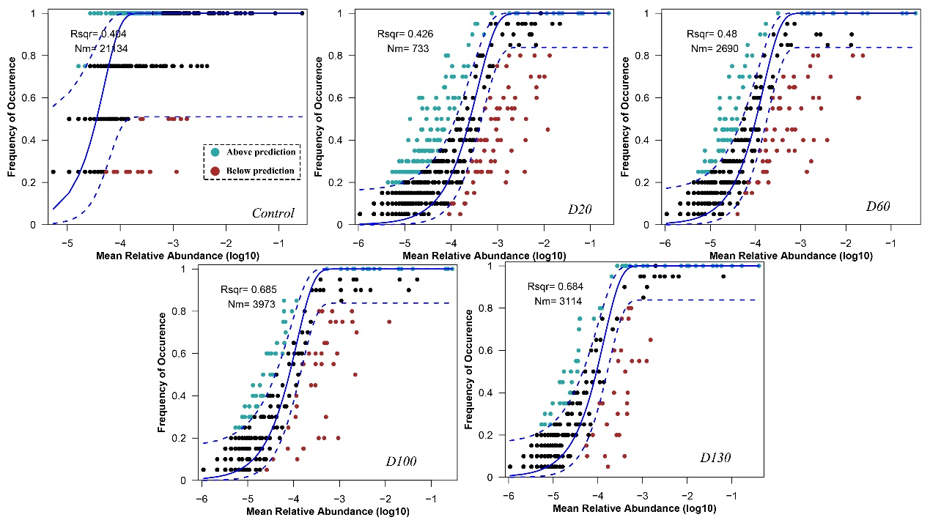FigureS7. The predicted occurrence frequencies for algal communities after different drought gradients. The solid blue line is the best fit for the neutral community model (NCM), and the dashed blue line indicates 95% confidence intervals around the NCM prediction. OTUs that occur more or less frequently than predicted by the NCM are shown in green and red, respectively. R² represents the fit of this model.

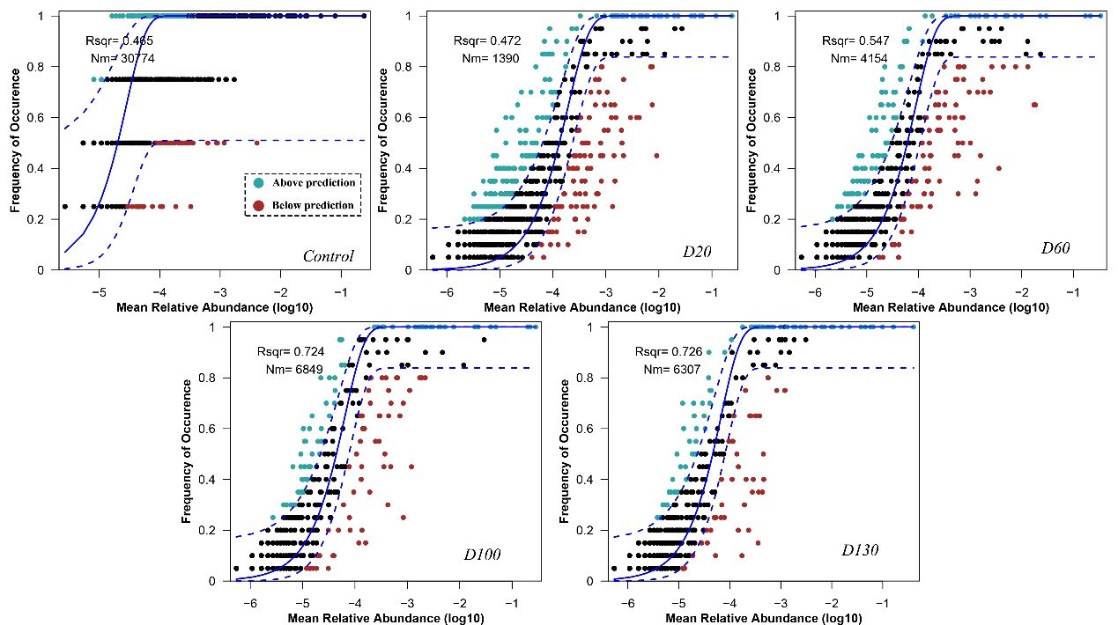FigureS8. The predicted occurrence frequencies for bacterial communities after different drought gradients. The solid blue line is the best fit for the neutral community model (NCM), and the dashed blue line indicates 95% confidence intervals around the NCM prediction. OTUs that occur more or less frequently than predicted by the NCM are shown in green and red, respectively. R² represents the fit of this model.

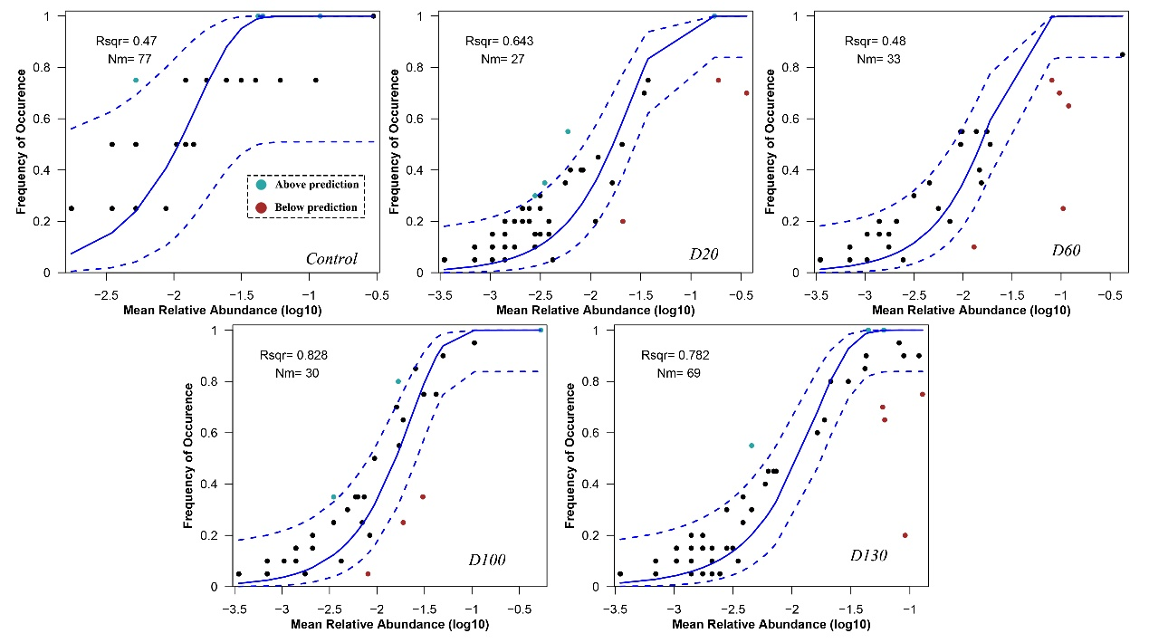FigureS9. The predicted occurrence frequencies for fungal communities after different drought gradients. The solid blue line is the best fit for the neutral community model (NCM), and the dashed blue line indicates 95% confidence intervals around the NCM prediction. OTUs that occur more or less frequently than predicted by the NCM are shown in green and red, respectively. R² represents the fit of this model.

Table S1 The significant difference between different experimental groups of biofilm functions based on the Partial Least-Squares Discriminant Analysis (PLS-DA) (PERMANOVA, p<0.01).
group | Multifunction |  | Carbon cycle |  | Nitrogen cycle |  | Phosphorus cycle
group | R² | P | R² | P | R² | P | R² | P
control-vs-D20 | 0.032 | 0.766 | 0.024 | 0.55 | 0.255 | 0.009 | 0.345 | 0.005
control-vs-D60 | -0.200 | 0.809 | 0.994 | 0.002 | 0.366 | 0.003 | 0.459 | 0.001
control-vs-D100 | 0.983 | 0.006 | 0.993 | 0.002 | 0.460 | 0.002 | 0.693 | 0.001
control-vs-D130 | 0.970 | 0.003 | 1.000 | 0.002 | 0.660 | 0.002 | 0.829 | 0.001
D20-vs-D60 | -0.997 | 0.858 | 0.999 | 0.002 | 0.228 | 0.002 | 0.295 | 0.001
D20-vs-D100 | 0.924 | 0.003 | 0.999 | 0.002 | 0.017 | 0.45 | -0.003 | 0.999
D20-vs-D130 | 0.999 | 0.003 | 1.000 | 0.002 | 0.291 | 0.002 | 0.420 | 0.001
D60-vs-D100 | -0.239 | 0.766 | 0.875 | 0.004 | 0.307 | 0.002 | 0.341 | 0.001
D60-vs-D130 | -0.986 | 0.809 | -0.392 | 1 | 0.036 | 0.262 | 0.014 | 0.546
D100-vs-D130 | 0.948 | 0.006 | 0.167 | 0.104 | 0.450 | 0.002 | 0.606 | 0.001

Table S2 The beta diversity of biofilm different components at the OTU level.
Community heterogeneity | Algae |  | Bacteria |  | Fungi
Community heterogeneity | Average | Standard deviation | Average | Standard deviation | Average | Standard deviation
Control | 0.58866 | 0.06962 | 0.40114 | 0.12809 | 0.57128 | 0.10103
D20 | 0.57451 | 0.24213 | 0.13152 | 0.12382 | 0.01694 | 0.31901
D60 | 0.46333 | 0.2592 | 0.12778 | 0.0846 | -0.2376 | 0.3248
D100 | 0.64832 | 0.17156 | 0.09059 | 0.01975 | -0.30799 | 0.23761
D130 | 0.39732 | 0.1518 | 0.11248 | 0.05111 | 0.41439 | 0.13357

Table S3. The Model_Fit of the partial least squares path models.
Index | Figure3(BEF and CAF) |  | Figure4(B-EMf and CAMf)
Index | Short-term  drought | Long-term drought | Short-term  drought | Long-term drought
SRMR | 0.082 | 0.064 | 0.097 | 0.098
D_ULS | 0.187 | 0.114 | 0.199 | 0.270
D_G | 0.185 | 0.271 | 0.162 | 0.291
Chi-Square | 50.477 | 53.523 | 43.270 | 65.958
Rms Theta | 0.321 | 0.322 | 0.471 | 0.403
NFI | 0.879 | 0.849 | 0.708 | 0.757

