Orchestrating Improbable Chemistries: Structural Snapshots of B₁₂-Dependent Methionine Synthase's Catalytic Choreography
Johnny Mendoza^{1‡}, Kazuhiro Yamada^{1,2‡†*}, Carmen Castillo³, Catherine A. Wilhelm^{1§}, Markos Koutmos^{1,2,3*}

¹Department of Chemistry, University of Michigan, Ann Arbor, MI, 48109
²Program in Biophysics, University of Michigan, Ann Arbor, MI, 48109
³Department of Biological Chemistry, University of Michigan, Ann Arbor, MI, 48109
‡Johnny Mendoza and Kazuhiro Yamada contributed equally to this work
†Current Address: Department of Biological Chemistry, University of Michigan, Ann Arbor, MI, 48109
§Current Address: Department of Chemistry, Wayne State University, Detroit, MI, 48202
*To whom correspondence should be addressed: yamadak@umich.edu (co-corresponding), mkoutmos@umich.edu (corresponding)

Supplementary Figures

Supplementary Figures
1. Captured Methionine Synthase Cap-on states are gateway conformations
2. Methionine Synthase gateway states are en route to catalysis
3. Cap-off MS structures highlight the preorganized/conserved nature of the Cob and Cap domains
4. Fol-on conformation represents a ‘right-after-catalysis’ state
5. Folate activation mechanism
6. Hcy-on conformation demonstrates the role of five coordinate Cbl in catalysis
7. Mutations introduced to tMS^{HcyFolCapCob} to aid in crystallization
8. Methionine Synthase cofactor changes associated with the Hcy-gate to Hcy-on transition.
9. Homocysteine methylation mechanism confirms Zn inversion/elasticity
10. The role of the Fol domain in guiding catalytic transitions
11. Methionine Synthase (MS) conformational ensemble as determined from this study
12. Structural alignment of the domains in the gateway and catalytic states of tMS
13. Unified models for MS catalysis provide a predictive framework for focused hypothesis testing
14. Expanded MS catalytic model including conformation ensemble and potential transitions.
15. tMS electron density around the cobalamin cofactor
16. Substrate binding sites and electron density in tMS
17. Methionine synthase (MS) amino acid alignment

Supplementary Tables
Table 1. X-Ray Data Collection and Refinement Statistics
Table 2. Bacterial and insect strains, plasmids, and synthetic oligonucleotides used in this study

Supplementary Figures

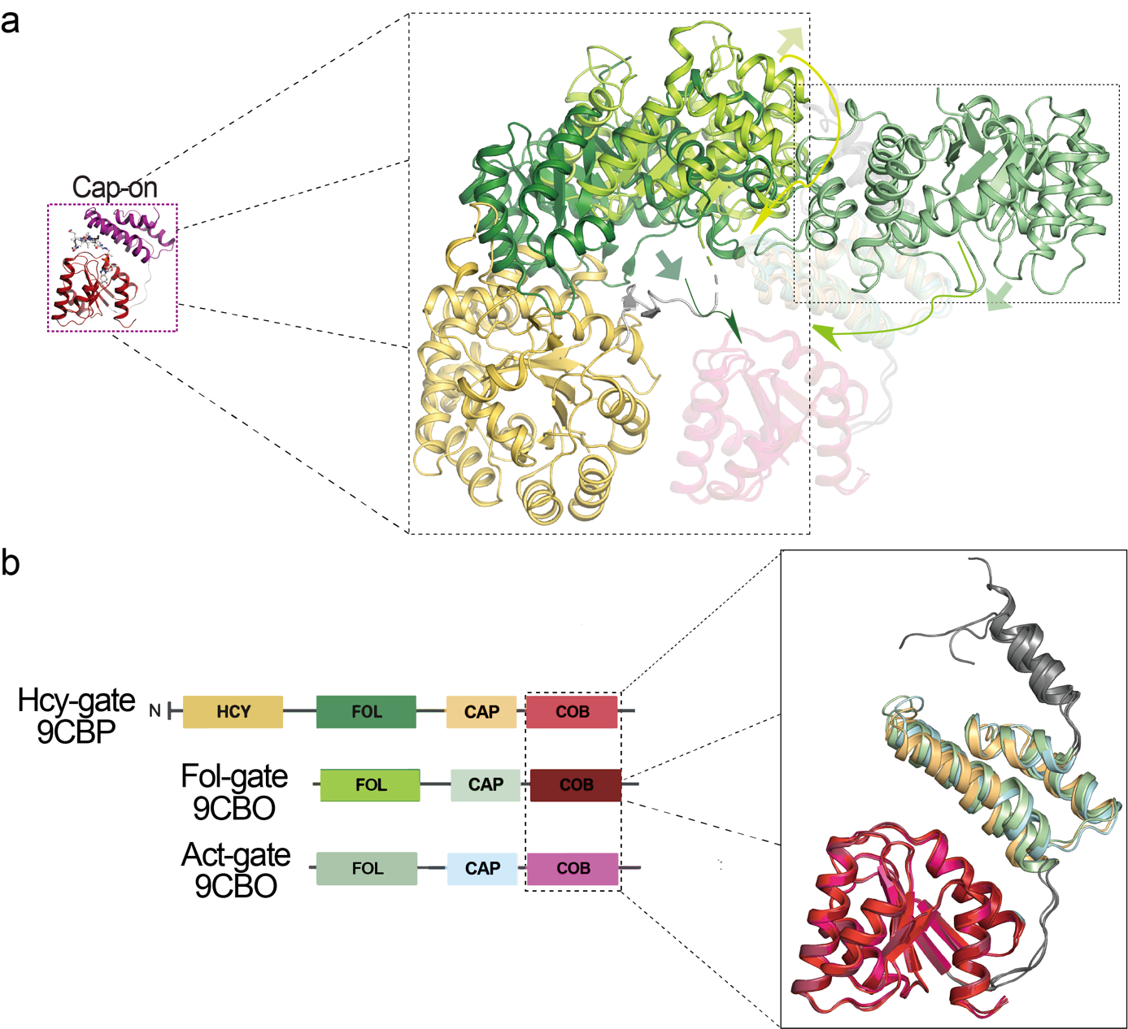
Supplementary Figure 1. Captured Methionine Synthase Cap-on states are gateway conformations. Cap-on states captured in this paper. All structures are aligned using the Cob domain as reference and color-coded according to the scheme shown in b. Note, the main difference is with regards to the helicity/structuring of the Fol:Cap linker, being most-structured in the Hcy-gate state and undergoing a helix-loop transition that shrinks the helical linker by 6 amino acids in the Fol-gate state and similarly in the Act-gate state. Note, a demonstrates the Fol domain active site and the movement that must accompany its transition to face the Cob domain. Notably, the Fol-gate state has the Fol domain and its active site primed for ternary complex formation with the Cob domain; the Hcy-gate structure has the Fol domain and its active site completely facing away from the Cob domain, though the Hcy domain is primed to form a ternary complex with the Cob domain. The Act-gate structure has the Fol domain facing towards the Cob domain, but would require a much larger translation to interact with the Cob domain.

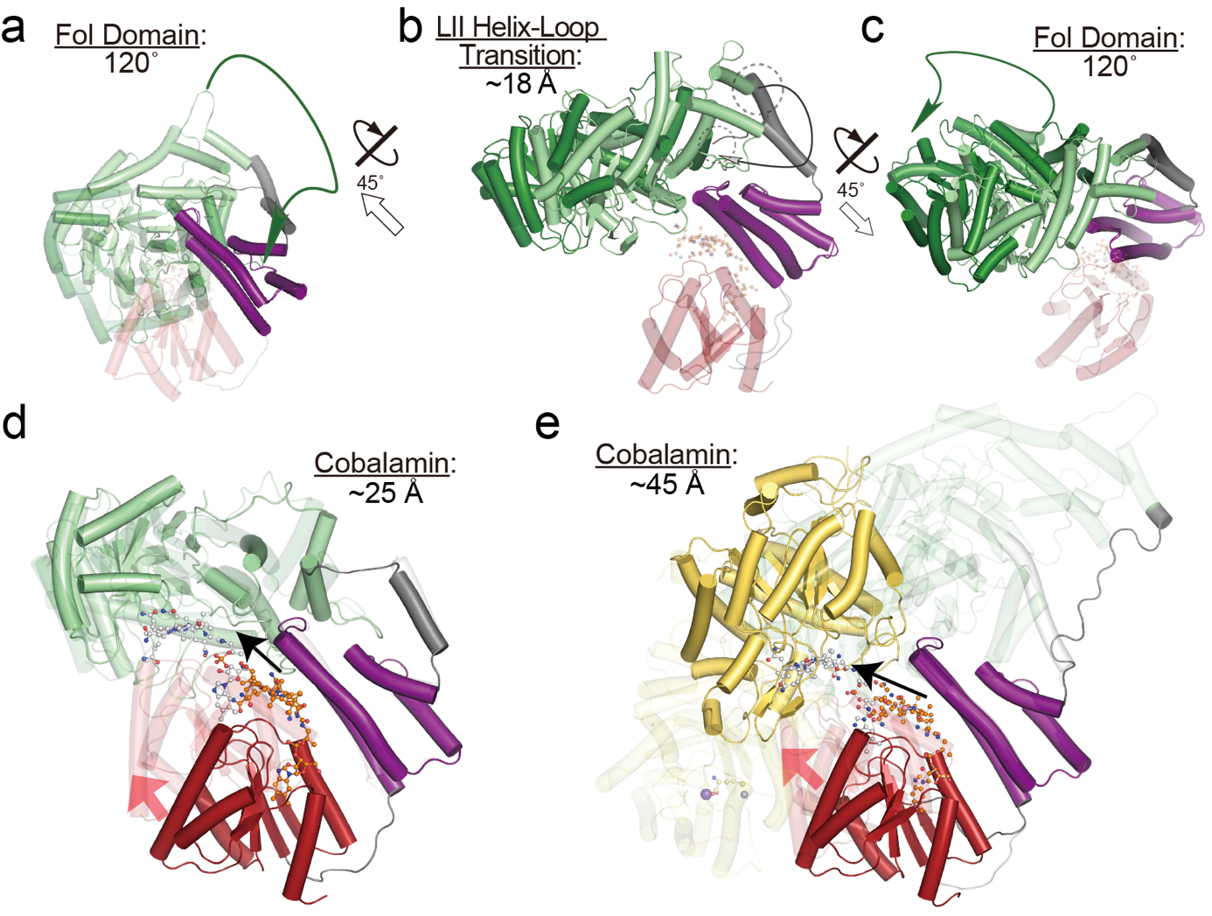
Supplementary Figure 2. Methionine Synthase gateway states are en route to catalysis. a Alignment of Hcy-gate (9CBP) and Fol-gate (9CBO) with respect to the Cob domain using the coloring scheme from Figures 2 and 3. The Hcy domain is not shown for simplicity. Note that the Cap domain remains essentially unchanged. Transition between the Hcy-gate to Fol-gate state would require coupled helix-loop transition of the Fol:Cap linker (Linker II), which would amount to a 18 Å translation of Linker II (b) and 120° rotation of the Fol domain (c). d Fol-gate (9CBO) and Fol-on (9CBQ) states aligned using the Fol domain as reference. The Cob domain must traverse 25 Å following ‘uncapping’ to form a ternary complex with the Fol domain. e Hcy-gate (9CBP) and Fol-on (9CBR) states aligned using the Fol domain as reference. The Cob domain must traverse 45 Å following ‘uncapping’ to form a ternary complex with the Hcy domain.

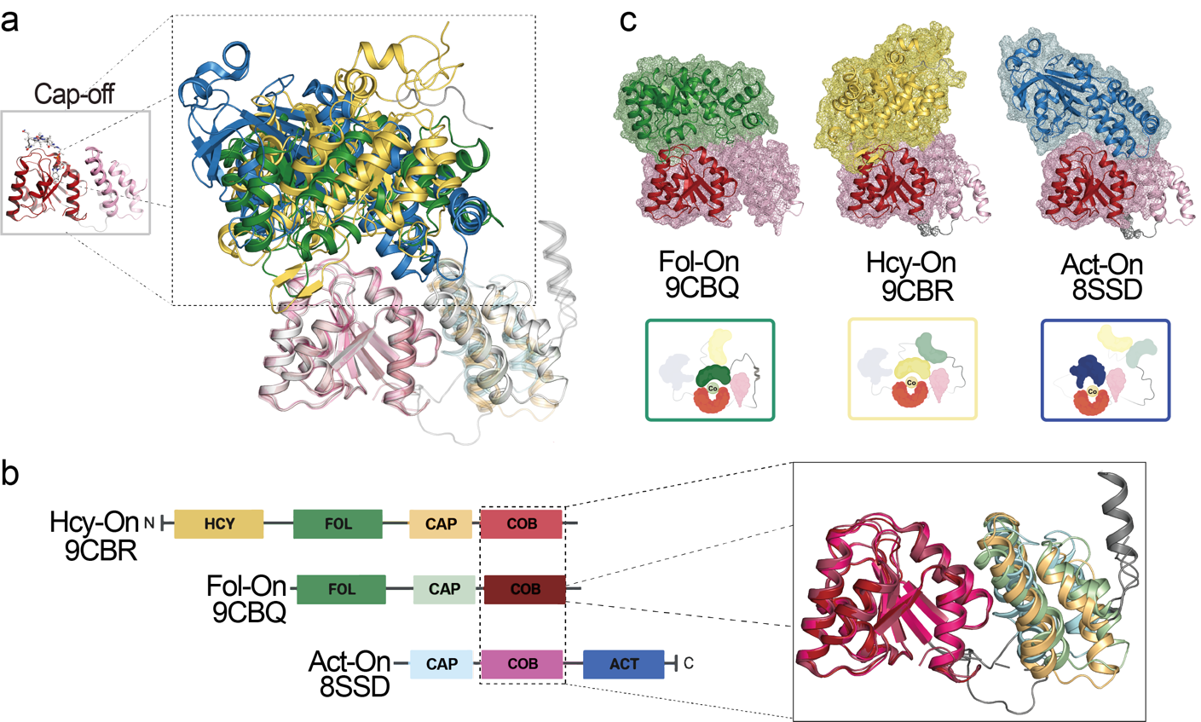
Supplementary Figure 3. Cap-off MS structures highlight the preorganized/conserved nature of the Cob and Cap domains. Cap-off states captured in this paper as compared to a previously captured Act-on structure (8SSD). All structures are aligned using the Cob domain as reference and color-coded according to the scheme shown in b. Note, the main difference is with regards to the helicity/structuring of the Fol:Cap linker, being most-structured in the Fol-on state and undergoing a helix-loop transition that unstructures the helical linker in the Hcy-on state and similarly in the Act-on state. Note, a demonstrates that the associated substrate binding domain forms a ternary complex with the Cob domain, with the associated surface renderings highlighting a novel ternary active site formed depending on the reactive state/conformation (b). The Cap domain adopts a similar position relative to the Cob domain, and the associated Cob:Cap linker is more flexible as compared to the gateway conformations.

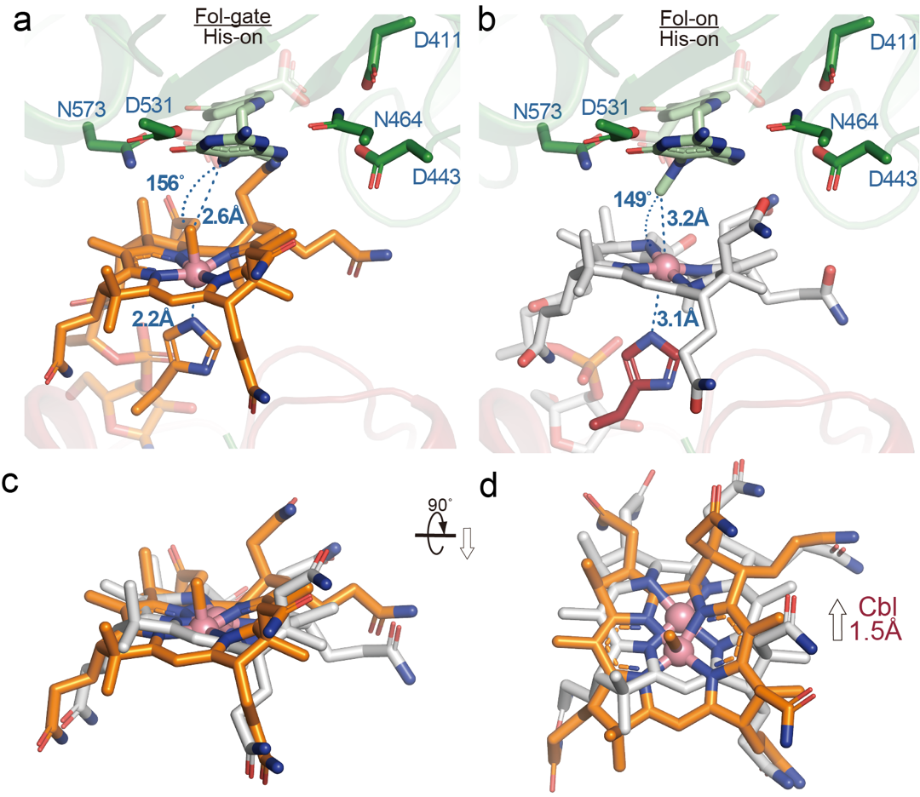
Supplementary Figure 4. Fol-on conformation represents a ‘right-after-catalysis’ state. Folate was docked manually by aligning the Fol domain of 9CBP (Hcy-gate) (this paper) to the Fol domain of the Fol-gate (9CBO, Cbl, orange) and Fol-On model (9CBQ, Cbl, light grey). a Folate docked model of Fol-gate state (9CBO) and b Fol-on state (9CBQ). Note the increased His761 distance in the Fol-on state (Δ0.9 Å) and lateral shift of the cobalt center (c, d). The Cbl cofactor is shifted laterally 1.5 Å, and the corrin ring is more planar in the Fol-on vs. Fol-gate state.

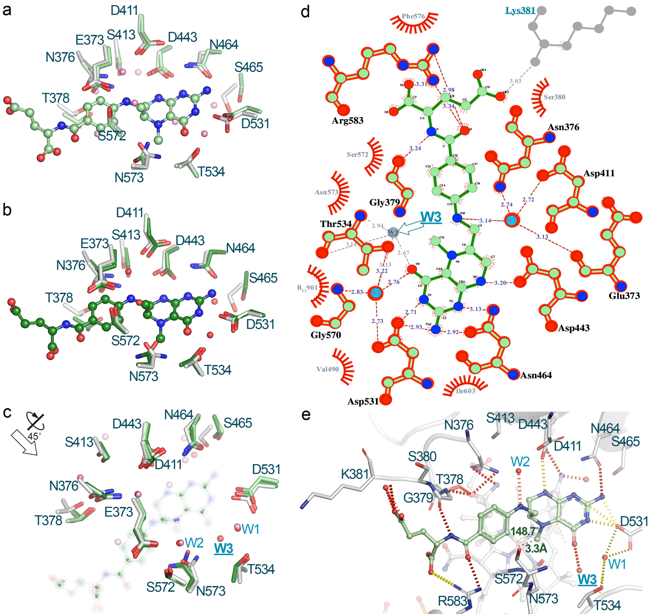
Supplementary Figure 5. Folate activation mechanism.
Folate was docked manually by aligning the Fol domain of 5VOP (dark green, b, c) and 9CBP (light green, a, c). (this paper) to the Fol domain of the Fol-On model (light grey, 9CBQ). Water 3 (W3) coordinated via Thr534 directly interacts with O4 of the pterin ring of methyltetrahydrofolate in the manually docked folate Fol-On model (using 5VOP) (c, d, e). Water 1 (W1), coordinated via Asp531, Thr534, and Gly570 also interacts with O4 of the pterin ring, while Water 2 (W2), coordinated via Glu373, Asn376, Asp411 interacts with N10 of the folate moiety; these water-mediated interactions are conserved in both the Hcy-gate manually docked folate Fol-On model (9CBP) and the aforementioned model using 5VOP (c, d, e). Notably, no direct residue or water interacts with C10 or N5 of the pterin ring, indicating that direct protonation cannot occur without substantial changes in the Fol domain or that activation of N5 bearing the C10 methyl group occurs via an indirect hydrogen bonding network. The distance between C10 and the Co center is 3.3 Å, with a corresponding angle of ~148.7°, with a linear arrangement consistent with an S_{N}2 mechanism proposed for methyltetrahydrofolate demethylation by cob(I)alamin.
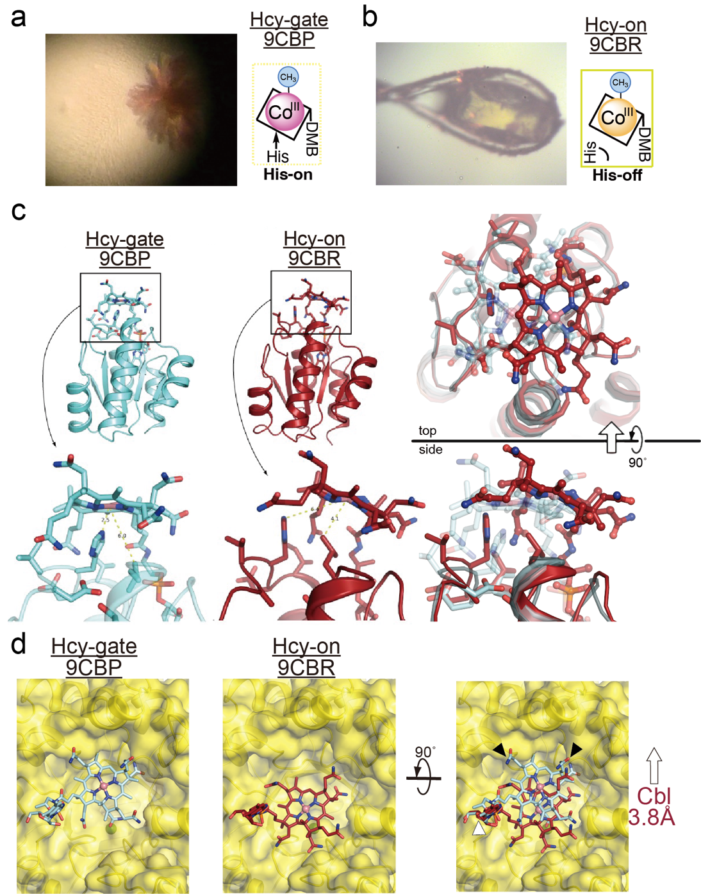
Supplementary Figure 6. Hcy-on conformation demonstrates the role of five coordinate Cbl in catalysis.
a Color of the crystal which captured the Hcy-gate (9CBP) conformation versus b that of the crystal used to capture the Hcy-on (9CBQ) conformation. Note the change in color from red to yellow associated with the His-on to His-off ligation associated with the Co(III) state. Superposition of those structures are illustrated in c and d using the Cob domain was used as reference. c The His761 distance between gateway (light cyan, Hcy-gate) and catalytic states in tMS^{HcyFolCapCob} (brick red, Hcy-on). d Surface depiction of the Hcy domain (yellow) using the same colors as c. Note that the DMB tail of Cbl remains unchanged between states (white arrows); black arrows indicate the steric clashes observed with the corrin ring of the Hcy-gate state. The Hcy-on state and its associated His-off ligation allows for the Cbl cofactor to move 3.8 Å laterally into the Hcy domain and its active site with an associated 4.2 Å tilt, relieving the steric clashes.

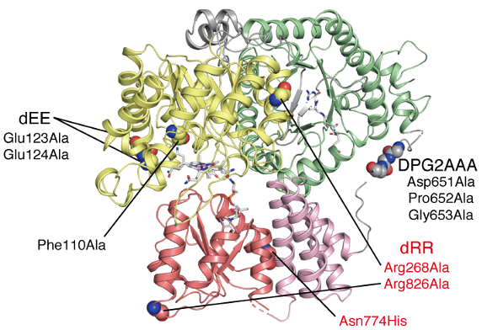
Supplementary Figure 7. Mutations introduced to tMS^{HcyFolCapCob} to aid in crystallization.
The structure of tMS^{HcyFolCapCob} in the Hcy-on mode is depicted in the ribbon diagram, colored using yellow, green, pink, and brown used to denote the Hcy, Fol, Cap, and Cob domains, respectively. Gray is used to denote interdomain linkers. Glu123Ala and Glu124Ala substitutions (dEE) are incorporated to enhance the crystal contact through reduction in surface energy¹. Furthermore, mutations Asp651Ala, Pro652Ala, and Gly653Ala (denoted as DPG2AAA) lie in the Fol:Cap linker (Linker II) and were introduced to promote the formation of a helix, favoring the Hcy-gate conformation over the Fol-gate conformation. The side chain of Phe110, proximate to the homocysteine-binding site, is replaced with Ala to reduce steric clashes that would allow for it to accommodate the bulky upper ligand of cobalamin analogs. All crystals of tMS^{HcyFolCapCob} in Hcy-gate and Hcy-on modes contain those mutations, represented by black letters. Crystals of tMS in the Hcy-on conformation were obtained with additional mutations indicated in red, such as Arg268Ala and Arg826Ala (dRR), along with the Asn774His mutation. The dRR mutations are expected to attenuate the Hcy:Cob domain interaction observed in the Cap-on Hcy-gate state; the His residue possesses a slightly bulkier side chain compared to Asn, abd the Asn774His mutant is presumed to lead to steric clashes with nearby amino acid side chainsm thereby destabilizing the Cap-on conformation. The Hcy-on structure has an additional Asp759Ala mutation, which interacts with His761 as part of the ligating triad (Ser812 being the third residue), in addition to the mutations shown in black letters. This construct is designed to preferentially bind cobalamin in the five-coordinate, His-off state by weakening the His-Cbl interaction.

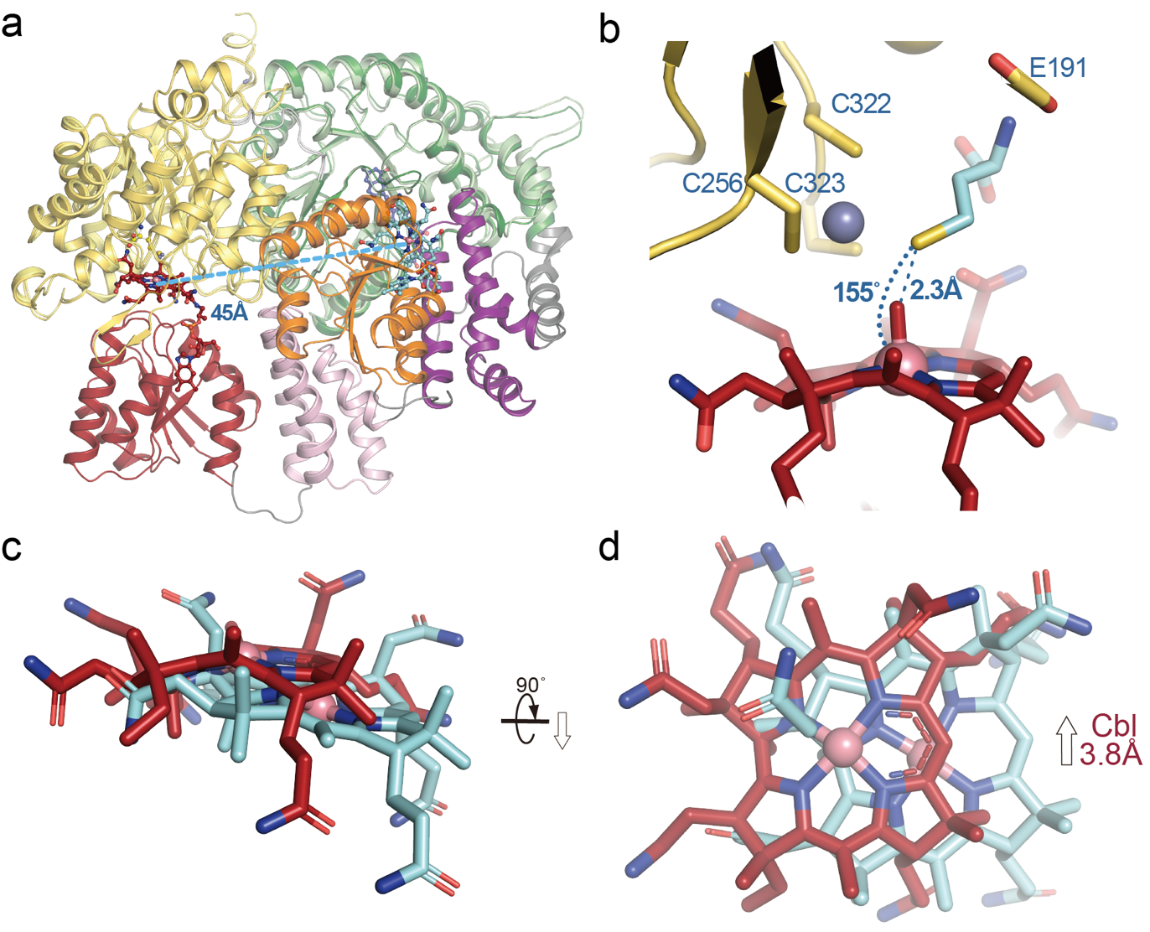
Supplementary Figure 8. Methionine Synthase cofactor changes associated with the Hcy-gate to Hcy-on transition.
a Hcy-gate (9CBP) and Hcy-on (9CBR) states aligned using the Fol domain as reference color coded according to Fig. 3. The Cob domain must traverse 45 Å following ‘uncapping’ to form a ternary complex with the Hcy domain. b Homocysteine was docked manually by aligning the Hcy domain of 9CBP and 9CBR (yellow) using the Hcy domain as reference. c, d Hcy-gate (9CBP, cyan) and Hcy-on (9CBR, brick red) Cbl corrin ring comparison. Note the lateral shift of the cobalt center. The Cbl cofactor is shifted laterally 3.8 Å with an associated tilt of ~18°, and the corrin ring is more planar in the Hcy-on vs. Hcy-gate state.

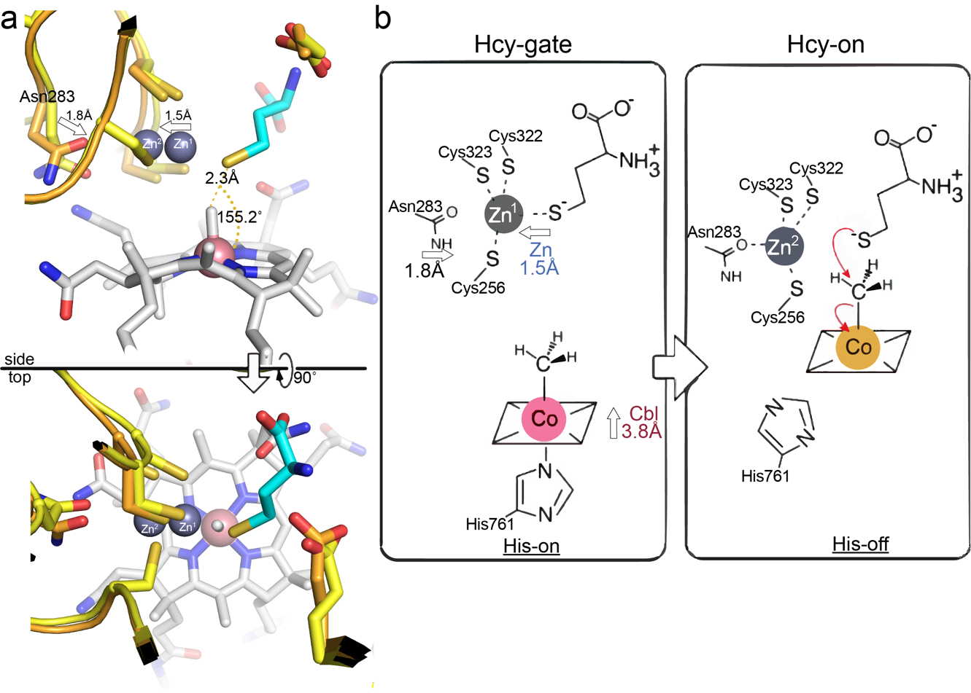
Supplementary Figure 9. Homocysteine methylation mechanism confirms Zn inversion/elasticity.
Homocysteine was docked manually by aligning the Hcy domain of 9CBP (orange) and 9CBR (yellow) using the Hcy domain as reference. Consistent with a previously proposed zinc inversion mechanism, the Zn ion shifts 1.5 Å away from the thiol, aided by a new coordinating interaction with Asn283. This Zn “inversion” is coupled with a His-on to His-off ligation between the Hcy-gate and Hcy-on states, which simultaneously yields a five coordinate Cbl that is laterally shifted 3.8 Å towards the Hcy domain. The distance between the thiol and the Co center is 2.3 Å, with a corresponding angle of ~155.2°, with a linear arrangement consistent with an S_{N}2 mechanism proposed for homocysteine methylation by methylcobalamin.

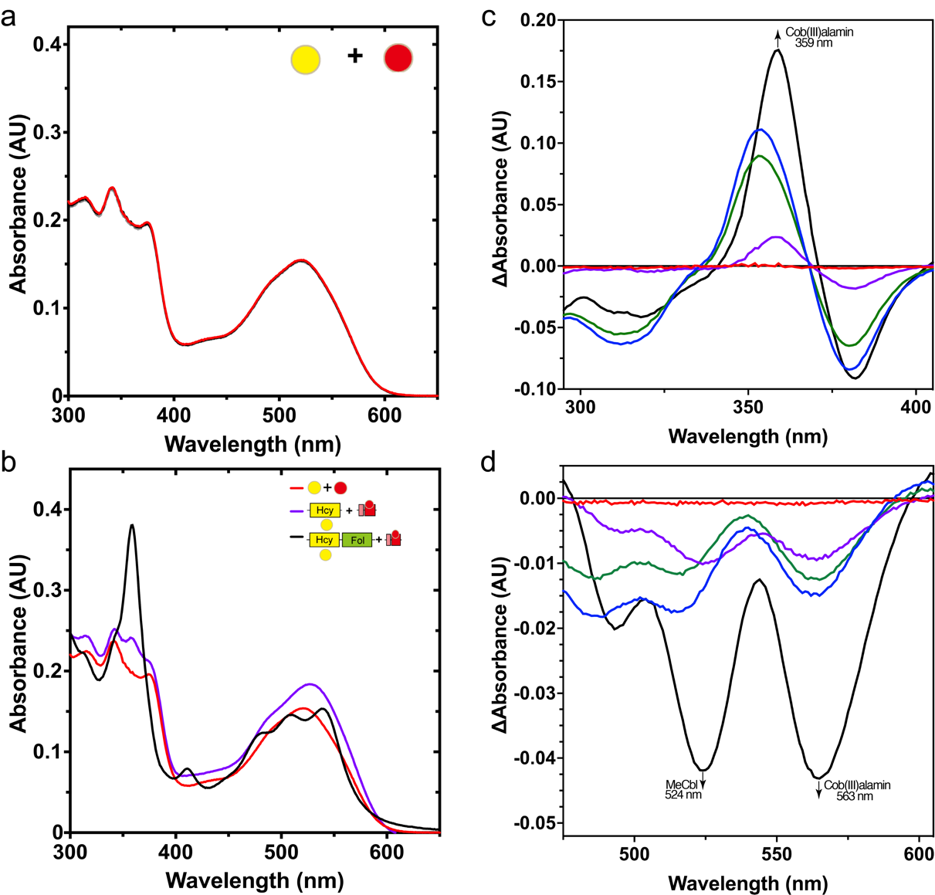
Supplementary Figure 10. The role of the Fol domain in guiding catalytic transitions.
Effects of tMS domain fragments on MeCbl:homocysteine methyltransferase reaction. The time-dependent spectral changes of CH₃-Cbl in the presence of homocysteine were monitored at 50 ˚C for up to 10 minutes after adding homocysteine (final concentration of 100 µM) using 20 µM of free (non-protein bound) MeCbl incubated in the presence of 2 µM tMS constructs or MeCbl (23 µM) was bound to the isolated tMS^{CapCob} domains first. a Free homocysteine and MeCbl did not react. b Final time points associated with free homocysteine + MeCbl, tMS bound Hcy (ΔN35Hcy) and MeCbl, and tMS bound Hcy (HcyFol) and MeCbl. Note that the presence of the Fol domain results in the associated consumption of MeCbl and production of aquacob(III)alamin. c Difference absorbance spectra of the MeCbl:homocysteine transferase assay, highlighting the importance of the Fol domain in the homocysteine methyltransferase reaction (black line) (300-400 nm) and d 450-600 nm. Data are of representative experiments, which have been repeated ≥2 times.
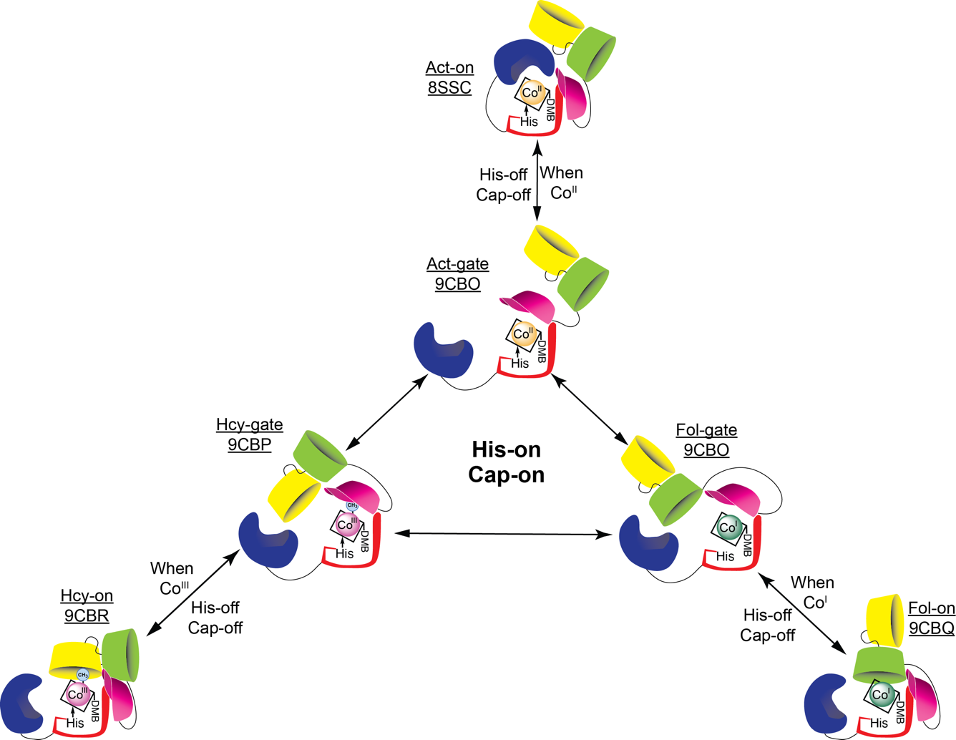
Supplementary Figure 11. Methionine Synthase (MS) conformational ensemble as determined from this study. The conformational ensemble of MS shown in cartoon form as determined from our tMS model. Yellow, green, pink, red, and blue are used to denote the Hcy, Fol, Cap, Cob, and Act domains, respectively. Corresponding state assignments and their respective PDB codes are shown; all structures save for Act-on (8SSC) are from this work. Cap-on states (Hcy-gate, 9CBP; Fol-gate, 9CBO; Act-gate, 9CBO) act as gateway conformations to their respective reactive conformations (Hcy-on, 9CBR; Fol-on; 9CBQ; Act-on, 8SSC). Note that the Cap-on gateway conformations are found to bind the cobalamin cofactor in the His-on form (methylcob(III)alamin) and can freely interchange, allowing for MS conformational ‘resetting’. Uncapping corresponds with His-off ligation of the cobalamin cofactor, and each methylation is associated with a distinct cobalamin redox state (Co(III) for homocysteine methylation, Reaction I; Co(I) for methyltetrahydrofolate demethylation, Reaction II; Co(II) for reductive methylation via SAM/AdoMet, Reaction III).

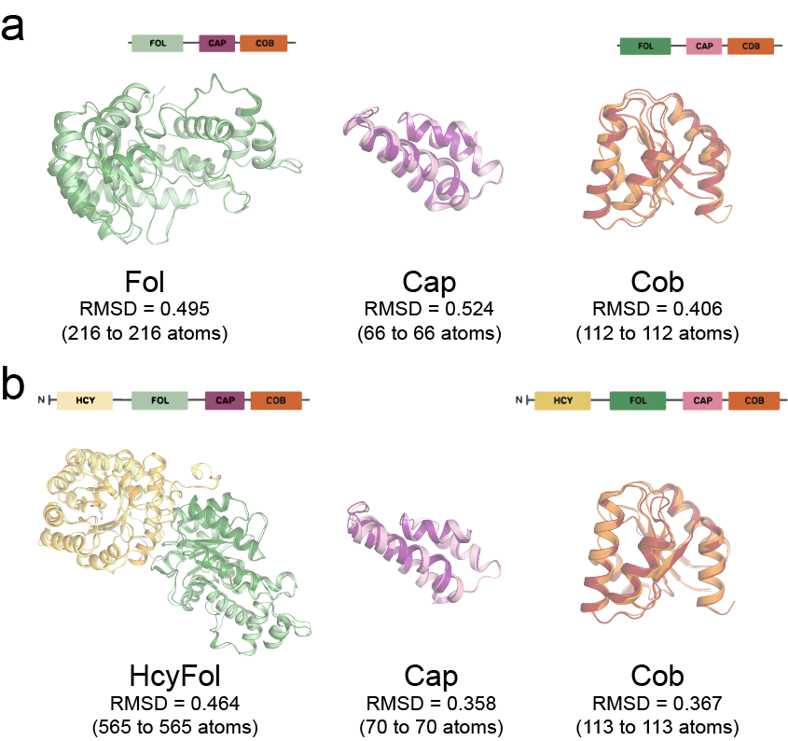
Supplementary Figure 12. Structural alignment of the domains in the gateway and catalytic states of tMS. a Comparison of individual domains from the Fol-gate (left) and Fol-on (right) structures are superimposed, with their respective root mean square deviation (RMSD) shown. b Comparison of individual domains from the Hcy-gate (left) and Hcy-on (right) structures are superimposed, with their respective root mean square deviation (RMSD) shown. Note that the individual domains are essentially identical, indicating that the structural differences lie primarily in the interdomain linkers and intradomain contacts.

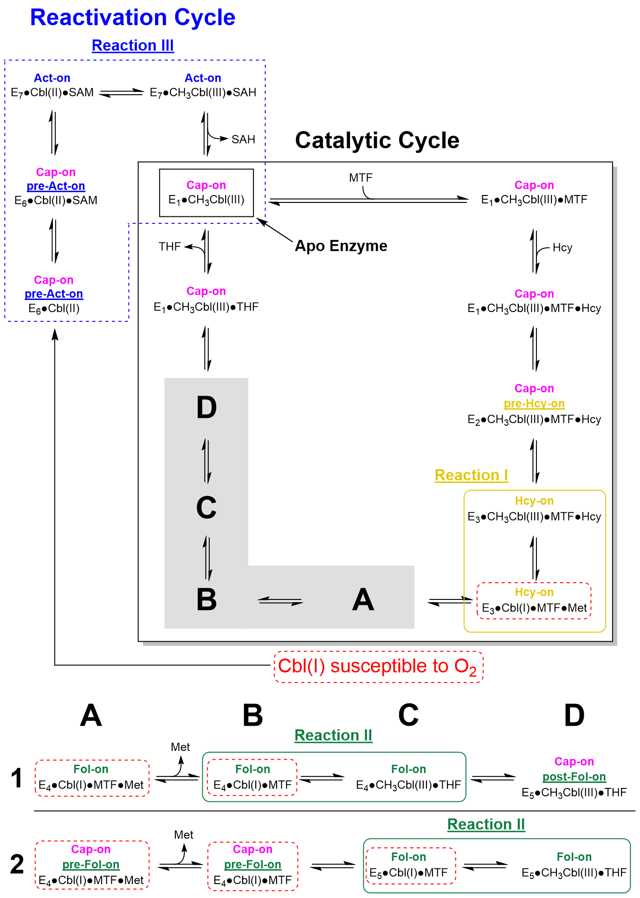
Supplementary Figure 13. Unified models for MS catalysis provide a predictive framework for focused hypothesis testing. States captured in this current study are highlighted in bold, while those predicted by this revised model are shown in dashed boxes. Note that while the gate states (Fol-gate, 9CBO; Act-gate, 9CBO) were captured in this study, their respective His-on ligation states were not. The same holds true for the catalytic Fol-on state (9CBQ), for which a His-off, Co(I) cofactor state is predicted in Model 2, but has not been observed. Model 1 precludes the need for Cap-on transitions during catalysis, while Model 2 assumes multiple Cap-on/off transitions occur during catalysis.

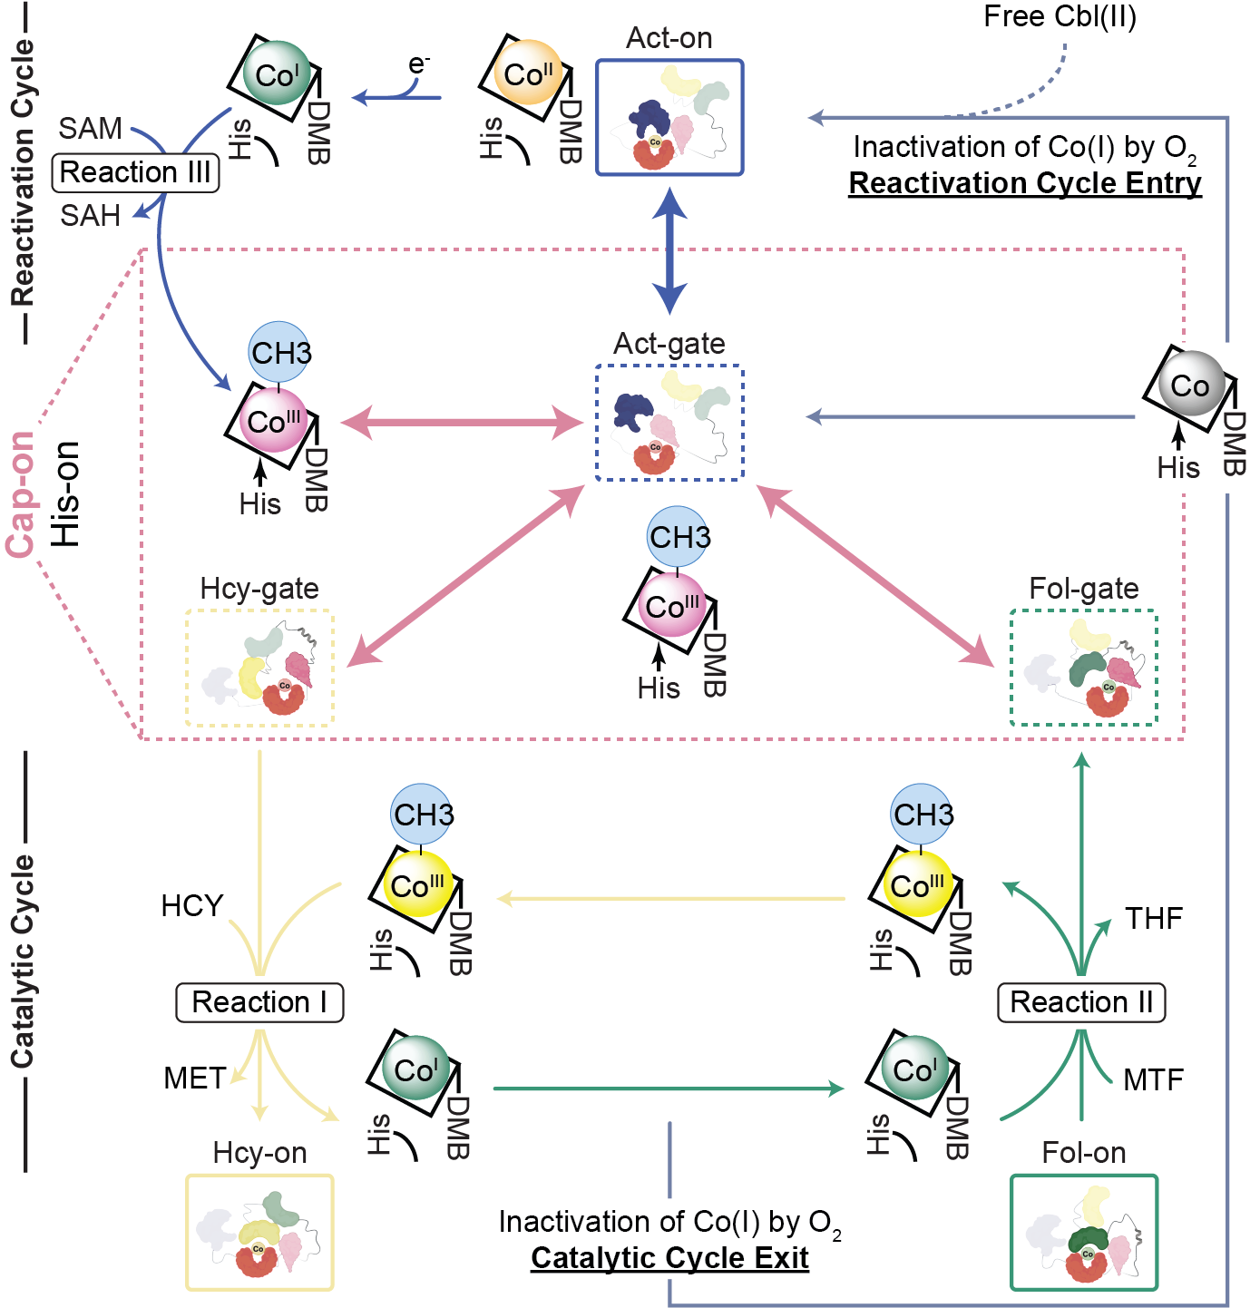
Supplementary Figure 14. Expanded MS catalytic model including conformation ensemble and potential transitions. This model is an expanded and more detailed map of the model shown in Fig. 7. Methionine synthase can cycle through Cap-on, His-on states that function as gateway conformations, obviating the need for uncapping. Linker II (Fol:Cap linker) allows for facile transition between these gateway states, what we term ‘resetting’. In our gateway conformations, hexacoordinate, His-on methylcobalamin (Co(III)) highlight its role as a bridge between the primary catalytic and reactivation cycles. Depending on the cobalamin cofactor’s status (redox state, coordinate number), the appropriate gateway state can grant entry to reactive conformations by uncapping and allowing for cobalamin flexibility by binding in the His-off state. Notably, the active methylating agent for methionine formation has been revised from hexa- to penta-coordinate His-off methylcob(III)alamin. Each methylation is associated with a distinct cobalamin redox state (Co(III) for homocysteine methylation, Reaction I; Co(I) for methyltetrahydrofolate demethylation, Reaction II; Co(II) for reductive methylation via SAM/AdoMet, Reaction III). The primary catalytic cycle of methionine synthase involves cycling between Co(III) and Co(I) states; Co(I) productions acts to lock MS to either the catalytic cycle (homocysteine methylation) or the reactivation cycle (Co(II) reductive alkylation) until methylcobalamin is regenerated or Co(I) undergoes oxidative inactivation.

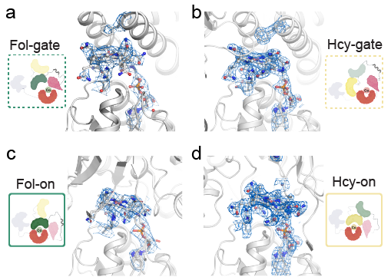
Supplementary Figure 15. tMS electron density around the cobalamin cofactor. a tMS^{FolCapCobD759A•MeCbl} and its cobalamin cofactor (gray), along with Phe713 and His761 in the axial cofactor positions. Their corresponding electron density (2F_{o}-F_{c}) contoured at 1.5 σ are shown in blue. b tMS^{HcyFolCapCobmut1•prCbl} and its cobalamin cofactor shown using the same coloring scheme as in a. c tMS^{FolCapCobD762G•cpCbl} and its cobalamin cofactor shown using the same coloring scheme as in a. d tMS^{HcyFolCapCobmut2•aeCbl} and its cobalamin cofactor shown using the same coloring scheme as in a. Cartoon insets in panels a-d were created with BioRender.com.

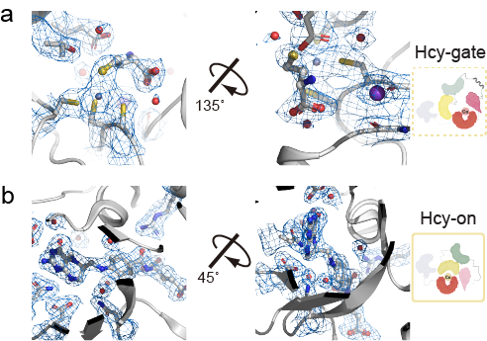
Supplementary Figure 16. Substrate binding sites and electron density in tMS. a Homocysteine binding site captured in 9CBP (Hcy-gate). b Methyltetrahydrofolate binding site captured in 9CBR (Hcy-on). Their corresponding electron density (2F_{o}-F_{c}) contoured at 1.5 σ are shown in blue. Each substrate is shown in gray.

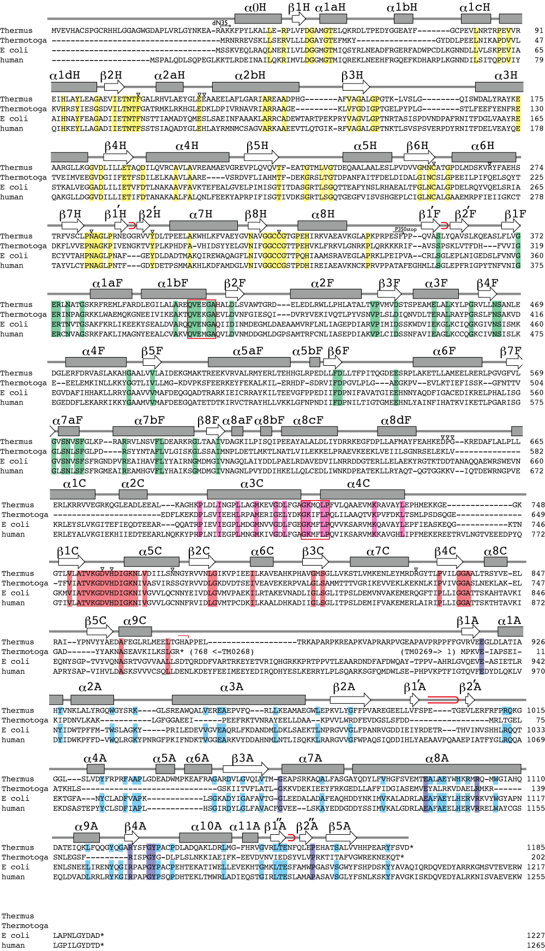
Supplementary Figure 17. Methionine Synthase (MS) sequence alignment. Schematic illustration of the secondary structure of tMS and alignments with the amino acid sequence of methionine synthase (MS) from Thermus thermophilus [Genbank accession number NC_00646], Thermotoga maritima [NC_000853], Escherichia coli [J04975], and human [U73338]. α-helices and β-sheets are shown in boxes and arrows, respectively. Red loops indicate β-hairpins. Conserved amino acid residues are highlighted by yellow, green, pink, red, and blue for the Hcy, Fol, Cap, Cob, and Act domains, respectively. In the activation (Act) domain, cyan is used to highlight conserved amino acid residues in T. thermophilus, E. coli, and human MS, while purple is used to highlight residues conserved among tetradomain MS.

Supplementary Table 1. X-Ray Data Collection and Refinement Statistics
 | tMS^{FolCapCobD759A•MeCbl} |  | tMS^{HcyFolCapCobmut1•prCbl} | tMS^{FolCapCobD762G•cpCbl} | tMS^{HcyFolCapCobmut2•aeCbl}
Data collection
Beamline |  | APS, GMCA 23-IDB | APS, LS-CAT 21-IDD | APS, GMCA 23-IDB | APS, GMCA 23-IDD
Wavelength (Å) |  | 1.0332 | 1.2713 | 1.0332 | 1.0332
Temperature (K) |  | 100 | 100 | 100 | 100
Resolution (Å) |  | 325.55-3.34 (3.40-3.34)* | 8 3.82-2.44 (2.54-2.44)* | 5 2.72-2.87 (3.03-2.87)* | 120.79-2.38 (2.47-2.38)*
Space group  Cell dimensions |  | P4₁2₁2 | P2₁2₁2₁ | P6₁22 | P2₁2₁2₁
a, b, c (Å)  α, β, γ (°) |  | 187.77, 187.77, 325.55  90, 90, 90 | 69.95, 83.82, 163.72  90, 90, 90 | 95.16, 95.16, 274.34  90, 90, 120 | 70.81, 115.10, 120.80  90, 90, 90
Observed reflections |  | 702,906 (36,503) | 228,743 (21,780) | 236,810 (35,228) | 222,476 (19,913)
Unique reflections |  | 85,017 (4,350) | 35,755 (3,794) | 17,680 (2,476) | 39,748 (3,707)
R_{meas} (%) |  | 25.6 (233.3) | 13.0 (67.90) | 12.6 (235.6) | 60.5 (460.4)
R_{merge} (%) |  | 24.0 (219.4) | 12.0 (61.70) | 12.1 (227.2) | 54.9 (416.6)
<I/σ> |  | 6.7 (1.2) | 9.4 (2.5) | 11.7 (0.7) | 3.8 (0.6)
CC(1/2) |  | 0.986 (0.428) | 0.996 (0.880) | 0.999 (0.893) | 0.908 (0.221)
Multiplicity |  | 8.3 (8.4) | 6.4 (5.7) | 13.4 (14.2) | 5.6 (5.4)
Completeness (%) |  | 99.9 (98.1) | 98.2 (93.7) | 99.8 (98.7) | 98.8 (83.4)
Wilson B-factor (Å²) |  | 100.1 | 38.7 | 100.5 | 24.2
Refinement
Resolution (Å) |  | 163.18 - 3.34 | 81.99 - 2.45 | 47.58 - 2.87 | 83.33 - 2.38
No. reflections |  | 80,679 (4,225)‡ | 35,588 (2,652)‡ | 17,608 (2,831)‡ | 37,675 (2,019)‡
R_{work}/R_{free} (%) |  | 17.3/21.6 | 16.1/23.7 | 20.8/26.8 | 23.7/24.8
No. of non-H atoms
Protein |  | 23,836 | 6,631 | 3,867 | 6,642
Water |  | 110 | 198 | 45 | 261
Ligand |  | 588 | 148 | 116 | 124
B-factors (Å²)
Protein |  | 120.10 | 64.75 | 132.05 | 34.34
Water |  | 62.95 | 60.97 | 101.55 | 23.16
Ligand |  | 102.96 | 67.16 | 118.24 | 23.13
R.m.s. deviations
Bond lengths (Å) |  | 0.015 | 0.015 | 0.019 | 0.011
Bond angles (°)  Ramachandran Plot |  | 2.31 | 2.29 | 2.69 | 1.97
Favored/allowed/outliers |  | 97.27/2.66/0.07 | 97.9/2.1/0.0 | 95.92/3.67/0.41 | 96.30/3.70/0.0
MolProbity Score |  | 1.44 (100th percentile) | 1.27 (100th percentile) | 1.42 (100th percentile) | 0.92 (100th percentile)
PDB |  | 9CBO | 9CBP | 9CBQ | 9CBR
* Highest-resolution shell is shown in parentheses.
‡ Number of reflections used for cross-validation

Supplementary Table 2. Bacterial and insect strains, plasmids, and synthetic oligonucleotides used in this study
Strains, Plasmids, Primers Relevant characteristics Ref. or Sources
E. coli strains
XL1-Blue Routine cloning strain, tetracycline resistance Stratagene
BL21star(DE3) Widely used T7 expression system, no antibiotic resistance Invitrogen
Plasmids
pET11a(tMS^{wt}) wild-type tMS in pET11a vector, containing the T. Riken
thermophilus gene MetH, Amp^{R}

pMCSG7 – tMS Clones
wt wild-type tMS in pMCSG7 vector, encoding an Mendoza et al. 2023
N-terminal His-tag with TEV cleavage site, Amp^{R}

ΔN35Hcy tMS N-terminal 35aa truncation (ΔN35), Hcy domain This Work
(Ala36-Phe349)
HcyFol tMS N-terminal half, Hcy and Fol domains This Work
(Met1-His648)
CapCob tMS Cap and Cob domains This Work
(Leu660-Ala874)

FolCapCob tMS Fol, Cap, and Cob domains (tridomain) This Work
(Gln364-Ala874)
FolCapCob^{D759A} tMS tridomain Asp759Ala mutant This Work
FolCapCob^{D762G} tMS tridomain Asp762Gly mutant This Work

HcyFolCapCob tMS Hcy, Fol, Cap, and Cob domains (tetradomain) This Work
(Met1-Ala874)
HcyFolCapCobF110A,E123A,E124A,Y296A,D651A,P652A,G653A tetradomain, Phe110Ala, Glu123Ala, Glu124Ala, Tyr296Ala, This Work
Asp651Ala, Gly653Ala mutant (mutant 1)
HcyFolCapCobF110A,E123A,E124A,R268A,N283G,D651A,P652A, tetradomain, Phe110Ala, Glu123Ala, Glu124Ala, Arg268Ala, This Work
^{G653A,D759A,N774H,R826A} Asn283Gly, Asp651Ala, Pro652Ala, Gly653Ala, Asp759Ala,
Asn774His, Arg826Ala mutant (mutant 2)
Oligonucleotides
Primer Names Sequences Descriptions
pMCSG7(tMS^{wt})
tMS_LIC-f 5' - ACTTCCAATCCAATGCCATGGTGGAGGTCCACGCCTG - 3' LIC, wt, vector
tMS_LIC-r 5' - TTATCCACTTCCAATGCTAGTCCACGCTGAAGTAGCG - 3' pET(tMS^{wt}) template

pMCSG7(tMS^{ΔN35Hcy})
ΔN35Hcy-f 5' - TACTTCCAATCCAATGCGAAGAAGTTTCCCTACCTCAAG - 3' LIC, tMS^{HcyFol} template
ΔN35Hcy-r 5' - TTATCCACTTCCAATGCTAGAAGCTTTCAGGCCTTGG - 3'
pMCSG7(tMS^{HcyFol})
HcyFol-f 5' - TACTTCCAATCCAATGCCATGGTGGAGGTCCACGCCTG - 3' LIC, pET(tMS^{wt}) template
HcyFol-r 5' - TTATCCACTTCCAATGCTAGTGGGCCTCAAAGTAGGC - 3'

pMCSG7(tMS^{CapCob})
CapCob-f 5' - TACTTCCAATCCAATGCCCTGGCCCTTCCCCTCCTGGAG - 3' LIC, tMS^{FolCapCob} template
CapCob-r 5' - TTATCCACTTCCAATGCTAGGCGTGGCCCGTGAGCTC - 3'

pMCSG7(tMS^{FolCapCob})
FolCapCob-f 5' - TACTTCCAATCCAATGCGCAGGAGGCGAGCCTTTTCCTC - 3' LIC, pET(tMS^{wt}) template
FolCapCob-r 5' - TTATCCACTTCCAATGCTAGGCGTGGCCCGTGAGCTC - 3'

D759A-f 5' - CGTCAAGGGGGCCGTGCACGACATC - 3' Site-directed mutagenesis
D759A-r 5' - GATGTCGTGCACGGCCCCCTTGACG - 3'
D762G-f 5' - GGGACGTGCACGGCATCGGCAAGAA - 3' Site-directed mutagenesis
D759G-r 5' - TTCTTGCCGATGCCGTGCACGTCCC - 3'

pMCSG7(tMS^{HcyFolCapCob})
HcyFolCapCob-f 5' - TACTTCCAATCCAATGCCATGGTGGAGGTCCACGCCTG - 3' LIC, pET(tMS^{wt}) template
HcyFolCapCob-r 5' - TTATCCACTTCCAATGCTAGGCGTGGCCCGTGAGCTC - 3'

D651A, P652A, G653A-f 5' - GAGGCCCACAAGGAGGCCGCGGCGAAGAGGGAGGACGCC - 3' Site-directed mutagenesis
D651A, P652A, G653A-r 5' - GGCGTCCTCCCTCTTCGCCGCGGCCTCCTTGTGGGCCTC - 3' DPG2A
E123A, E124A-f 5' - CGCCGAGTACGGCCTGGCGGCGGCGGCGGAGGAGCTCGCC - 3' Site-directed mutagenesis
E123A, E124A-r 5' - GGCGAGCTCCTCCGCCGCCGCCGCCAGGCCGTACTCGGCG - 3' dEE
F110A-f 5' - CATAGAGACCAACACCGCCGGGGCCCTGCGCC - 3' Site-directed mutagenesis
F110A-r 5' - GGCGCAGGGCCCCGGCGGTGTTGGTCTCTATG - 3'
Y296A-f 5' - GAGGGTGGTCGCCGACCTCACCCCC - 3' Site-directed mutagenesis
Y296A-r 5' - GGGGGTGAGGTCGGCGACCACCCTC - 3'
R268A-f 5' - CATGGACAGCAAGGTGGCCTACTTCGCCGAGCAC - 3' Site-directed mutagenesis
R268A-r 5' - GTGCTCGGCGAAGTAGGCCACCTTGCTGTCCATG - 3' dRR (1/2)
R826A-f 5' - GAGTACATGCGGGATGCGGGCTACACCCTCCCCG - 3' Site-directed mutagenesis
R826A-r 5' - CGGGGAGGGTGTAGCCCGCATCCCGCATGTACTC - 3' dRR(2/2)
N283G-f 5' - CCTGCCTCCCGGGCGCGGGCCTGCCCCGG - 3' Site-directed mutagenesis
N283G-r 5' - CCGGGGCAGGCCCGCGCCCGGGAGGCAGG - 3'
D759A-f 5' - CGTCAAGGGGGCCGTGCACGACATC - 3' Site-directed mutagenesis
D759A-r 5' - GATGTCGTGCACGGCCCCCTTGACG - 3'
N774H-f 5' - GACATCATCCTCAGCCACAACGGCTACCGGGTGG - 3' Site-directed mutagenesis
N774H-r 5' - CCACCCGGTAGCCGTTGTGGCTGAGGATGATGTC - 3'

