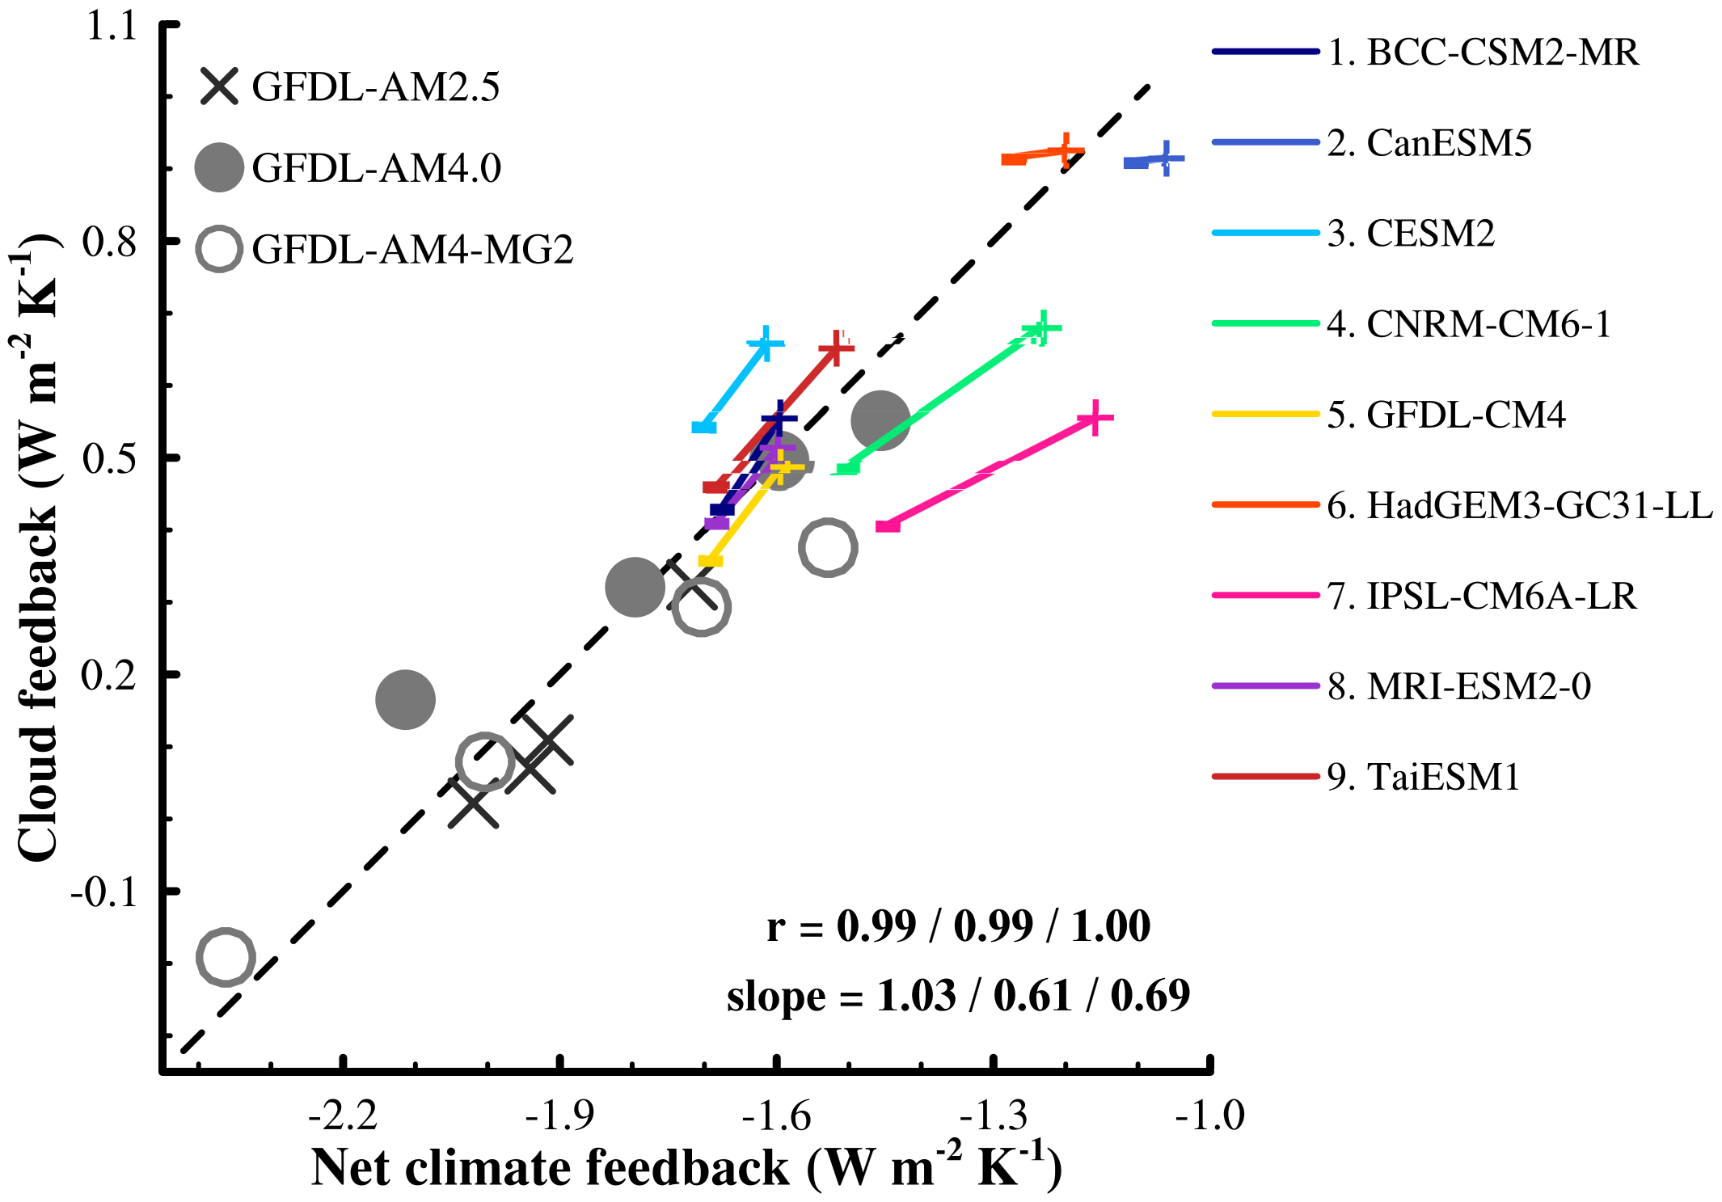
Extended Data Fig. 1 A scatterplot of cloud feedback versus net climate feedback parameter. The black crosses, solid dots, and open circles represent results from GFDL-AM2.5, GFDL-AM4.0, and GFDL-AM4-MG2, respectively. The color lines connect the feedback values obtained from the cooler base-state (minus sign) to the feedback values from the warmer base-state (plus sign) for the CMIP6 models. Slash-separated values in the bottom right are displayed for models in the order of GFDL-AM2.5, GFDL-AM4.0, and GFDL-AM4-MG2. The cloud feedback results presented are obtained using the radiative kernel method (Materials and Methods).

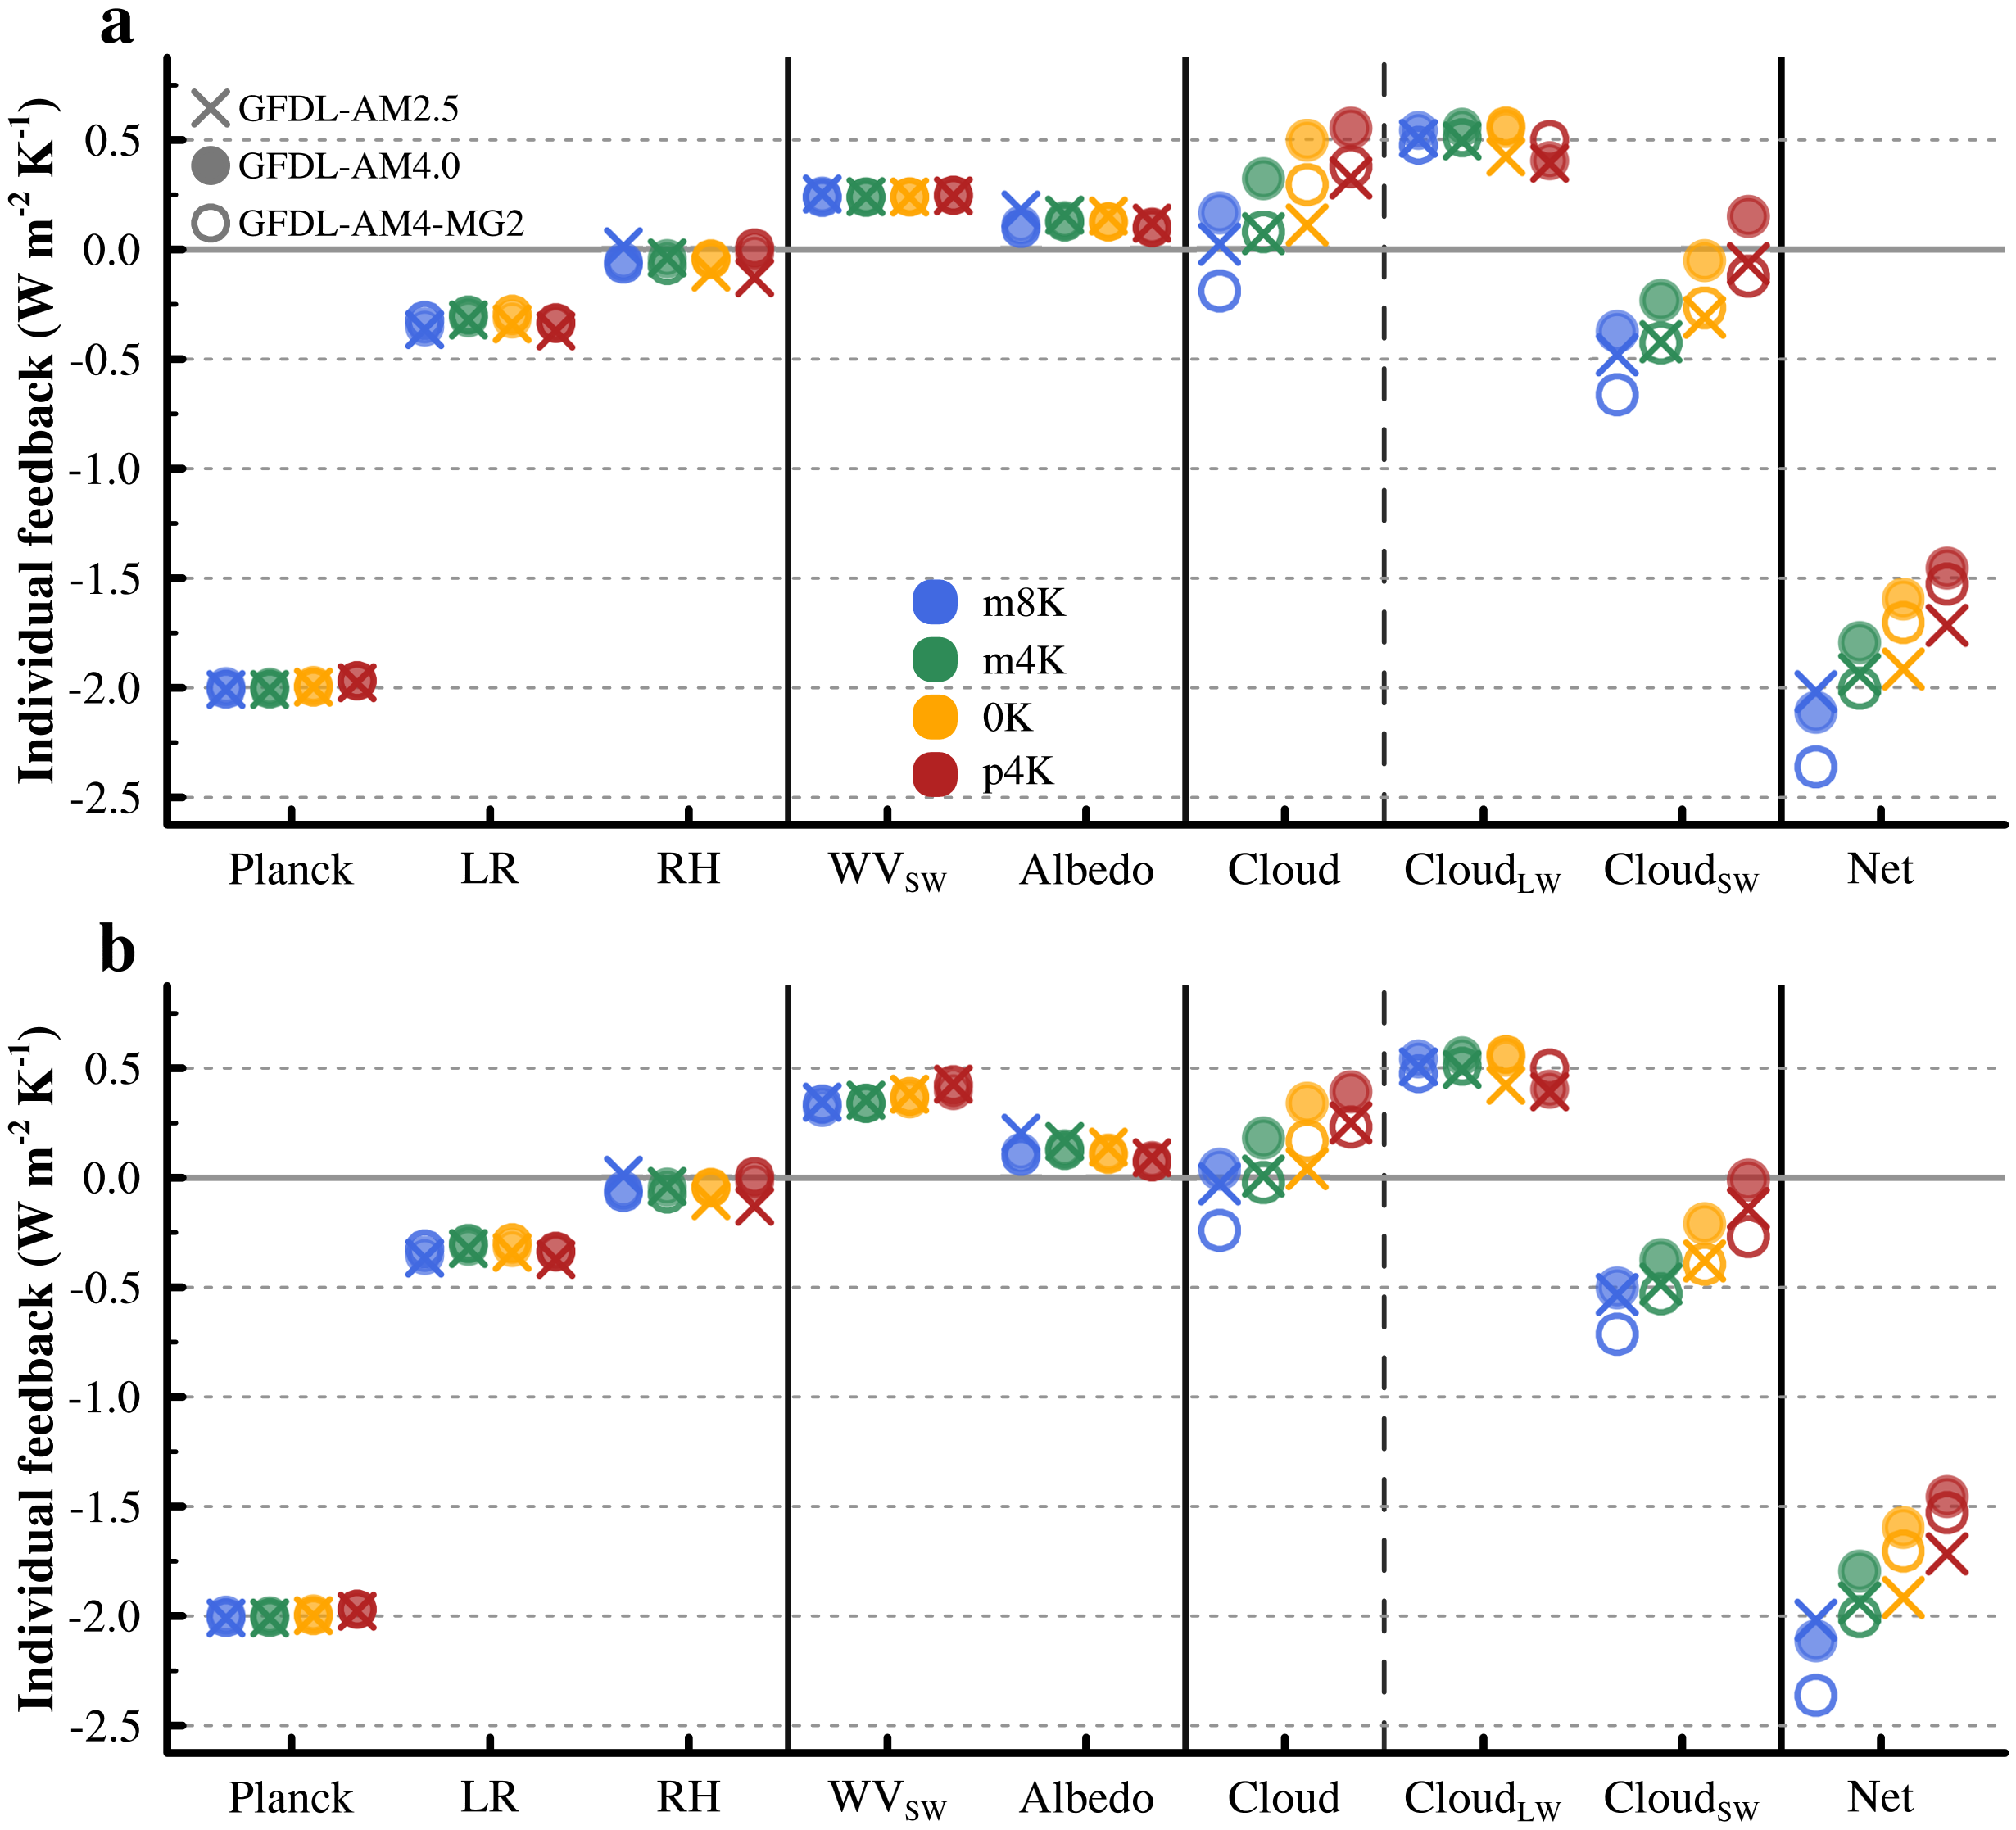
Extended Data Fig. 2 Comparisons of individual feedbacks in response to a uniform 4K SST warming perturbation under different base-state experiments, following Soden et al. (2008) and Held & Shell (2012), where the Planck and lapse-rate (LR) feedbacks are computed holding relative humidity (RH) fixed. The whole results in (a) are calculated using radiative kernel method. The (b) is same as (a), except that the shortwave results are obtained using the approximate partial radiative perturbation (APRP) method (Materials and Methods).

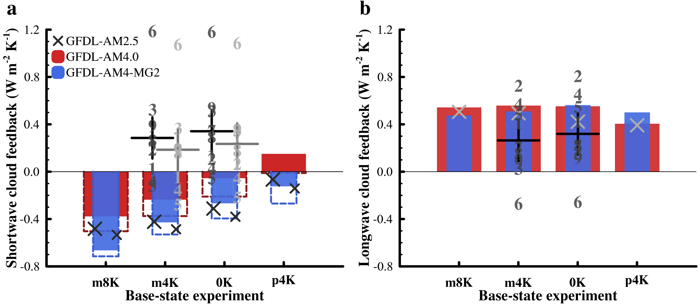
Extended Data Fig. 3 Comparisons of (a) shortwave and (b) longwave cloud feedbacks in response to a uniform 4K SST warming perturbation under different base-state experiments. The large cross markers and solid bar charts in (a) and (b) represent the results obtained from the radiative kernel method, while the small cross markers and open bar charts in (a) show the results calculated from the approximate partial radiative perturbation (APRP) method. Similarly, the dark number markers and corresponding plus signs in (a) and (b) represent results of CMIP6 model simulations obtained from the radiative kernel method, while the light number markers and corresponding plus signs in (a) show the results calculated from the APRP method.

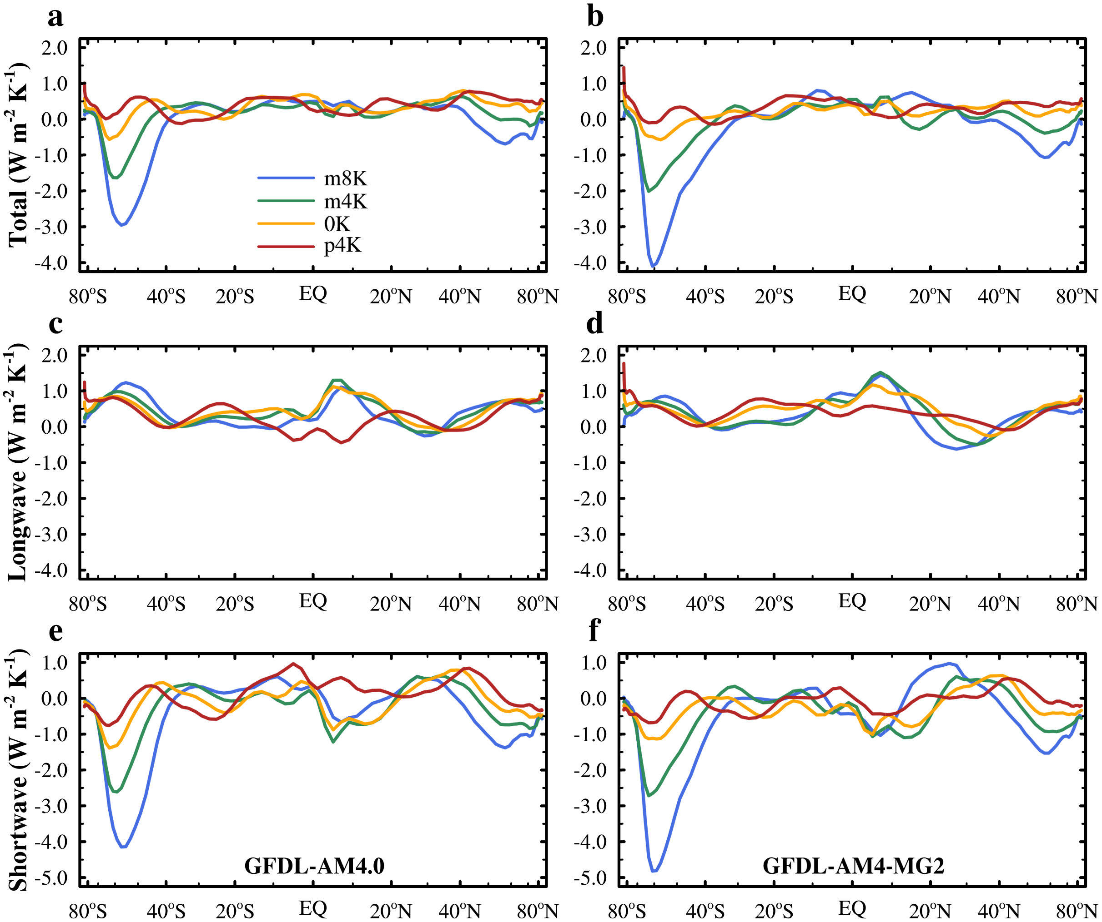
Extended Data Fig. 4 The same as Fig. 2, except the results are obtained with the cloud radiative kernel method (Materials and Methods) and only for models GFDL-AM4.0 and GFDL-AM4-MG2.

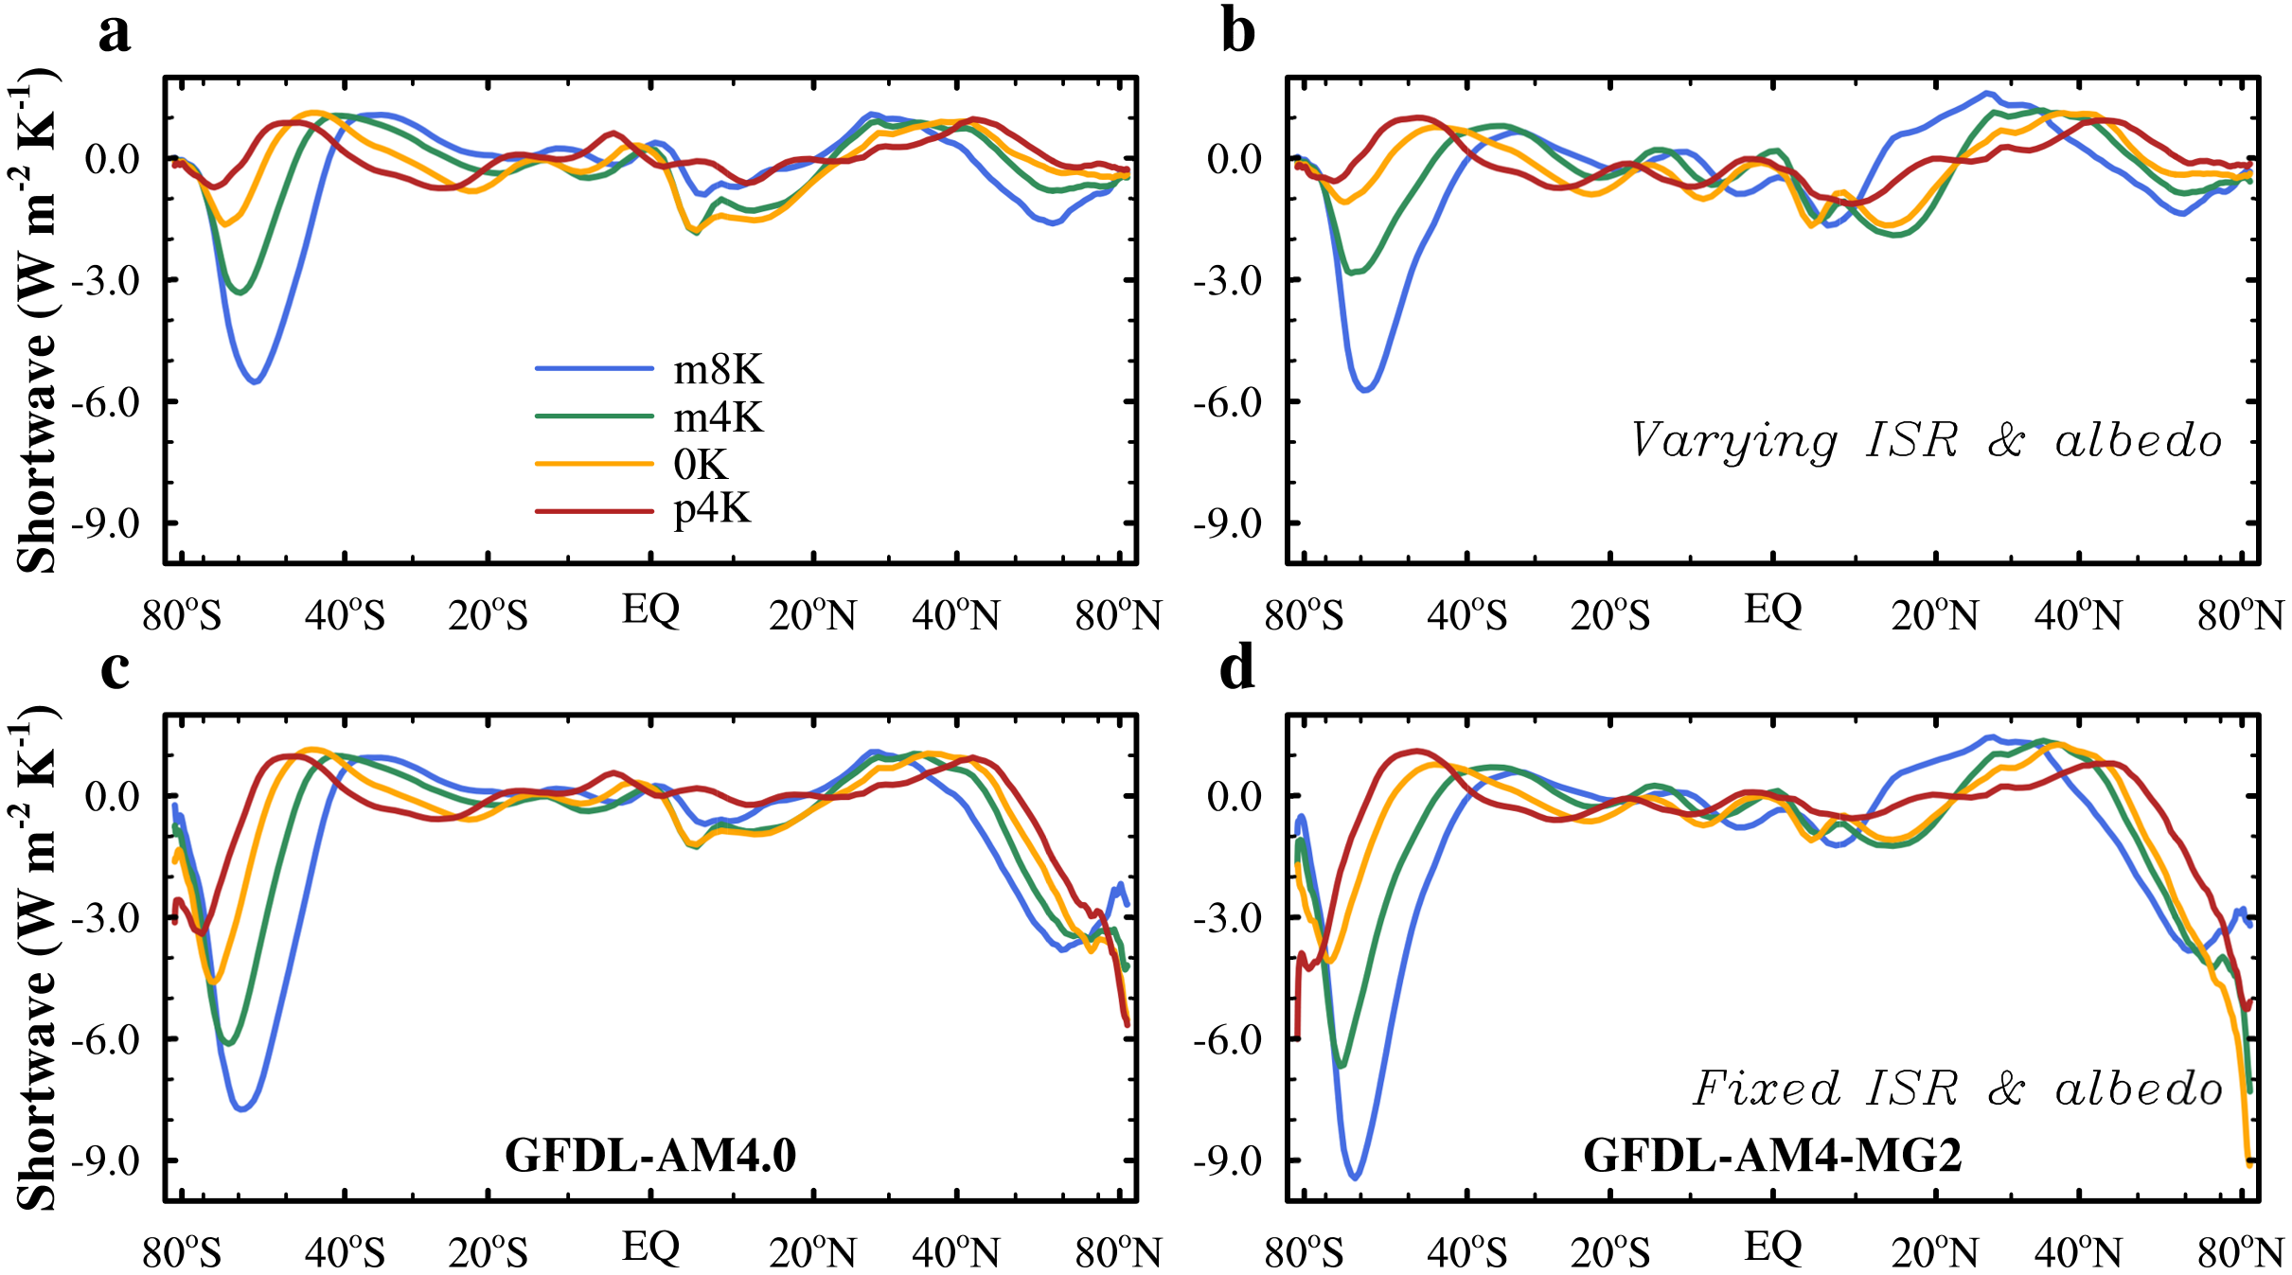
Extended Data Fig. 5 Zonal mean distributions of shortwave cloud feedback from (left) GFDL-AM4.0 and (right) GFDL-AM4-MG2, respectively. The results are obtained with the two-way partial radiative perturbation (PRP) method (Materials and Methods). The results shown at the top are obtained from offline radiative flux calculations using realistic, seasonally varying incoming solar radiation (ISR) and surface albedos. However, the results at the bottom are obtained from offline radiative flux calculations, using fixed and almost global mean (hemispherical-uniformly seasonal) ISR and annually global-average surface albedo everywhere. Results are plotted against the sine of latitude to display uniform area weighting.

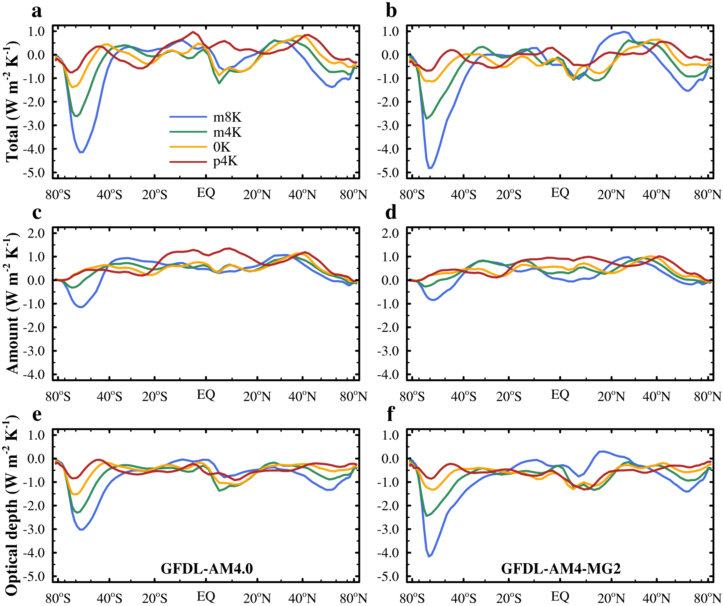
Extended Data Fig. 6 The same as Fig. 3, except the results are obtained with the cloud radiative kernel method and only for models GFDL-AM4.0 and GFDL-AM4-MG2. The values of altitude component from the cloud radiative kernel method are too small to distinguish either from zero or between different base-states, therefore, not shown.

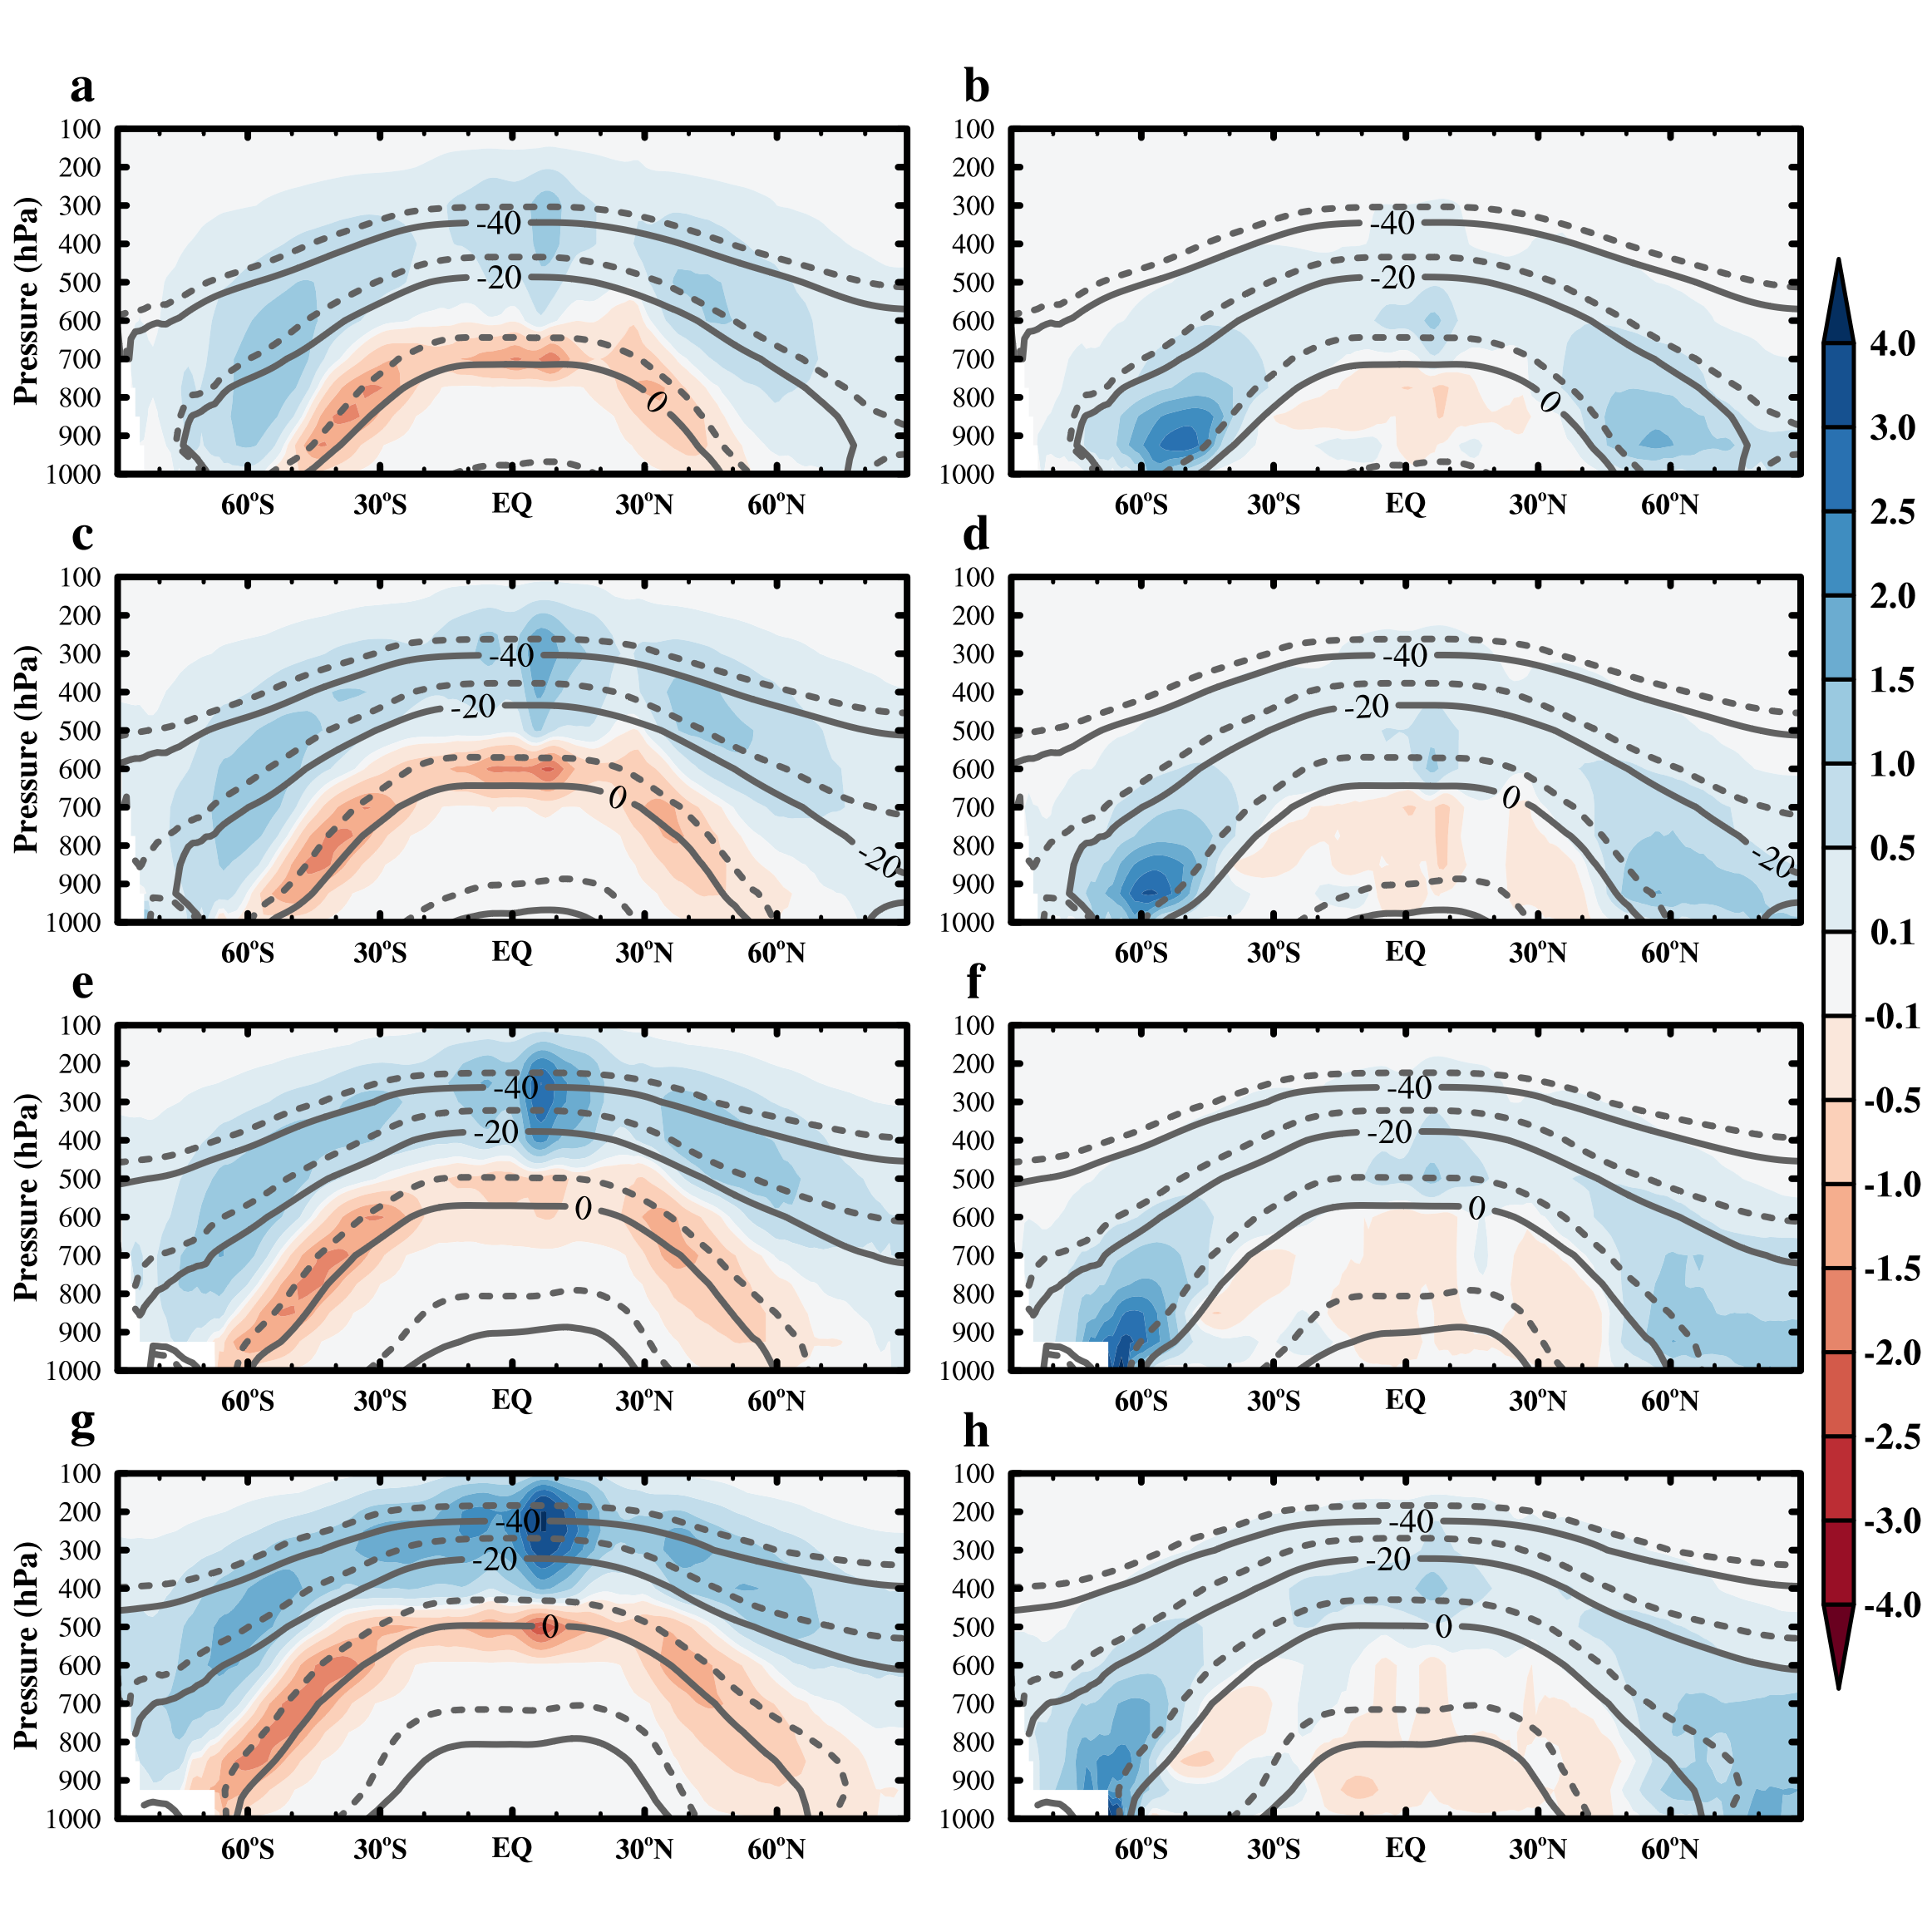
Extended Data Fig. 7 Pressure-latitude cross-sections of the cloud (left) ice and (right) liquid water sensitivity (10⁻⁶ kg kg⁻¹ K⁻¹) of model GFDL-AM4.0 to per global mean surface air temperature change under different base-state experiments, (a & b) m8K, (c & d) m4K, (e & f) 0K, and (g & h) p4K. Isotherms in the control simulations are displayed as solid lines; isotherms in the perturbed simulations are shown as dashed lines. Here the cloud ice (liquid) water refers to the mass fraction of cloud ice (liquid), which is calculated as the mass of cloud ice (liquid) in the grid cell divided by the mass of air, including the water in all phases in the grid cell.

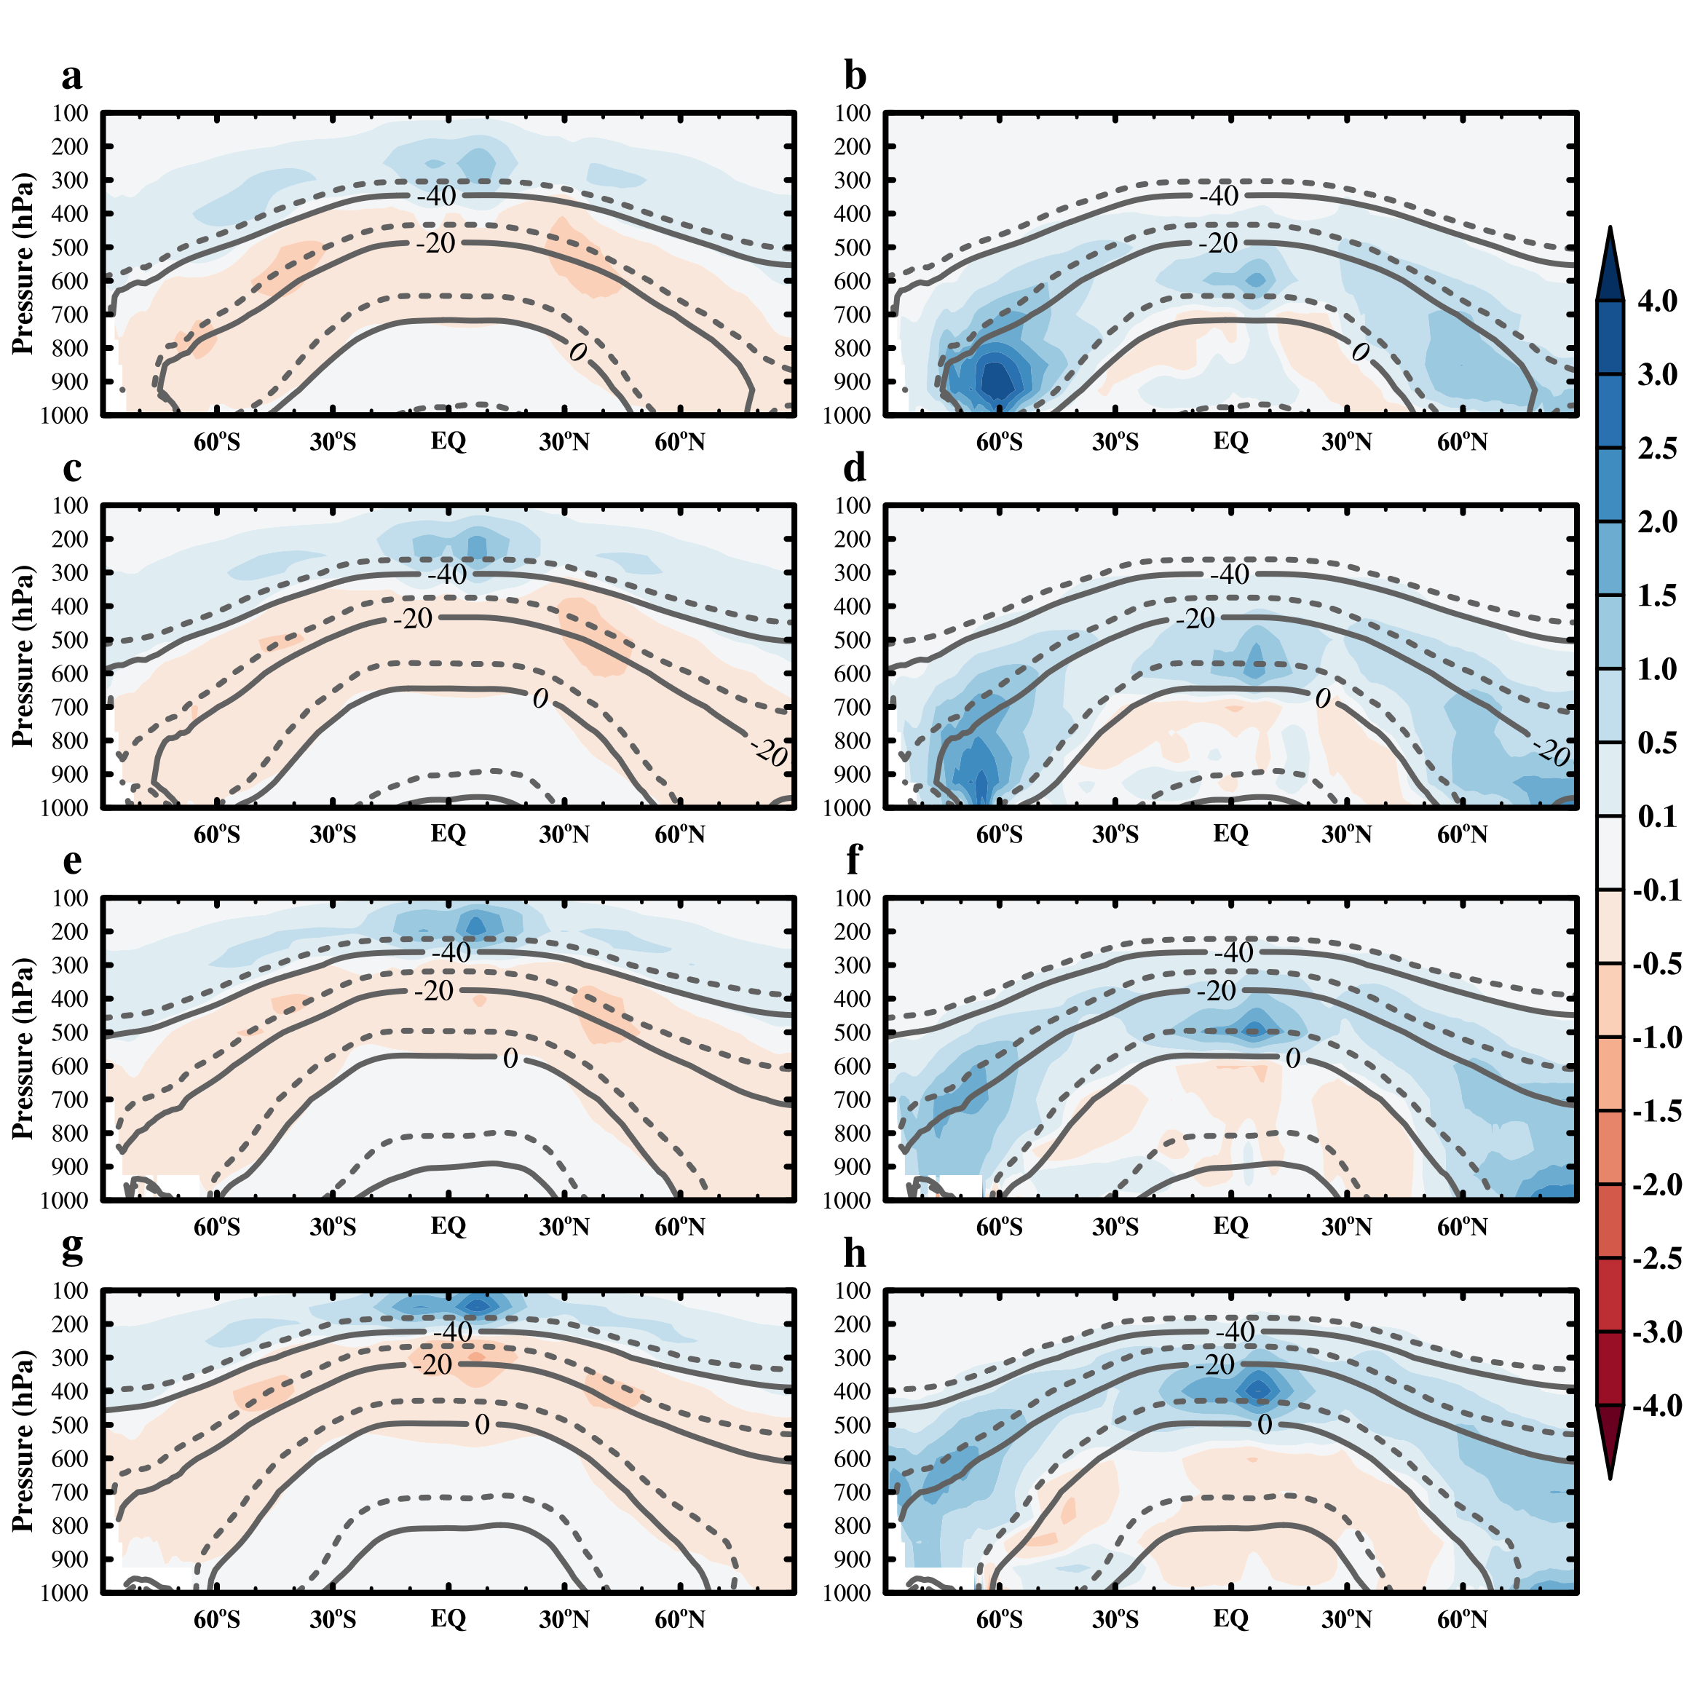
Extended Data Fig. 8 The same as Extended Data Fig. 7, except for model GFDL-AM4-MG2.

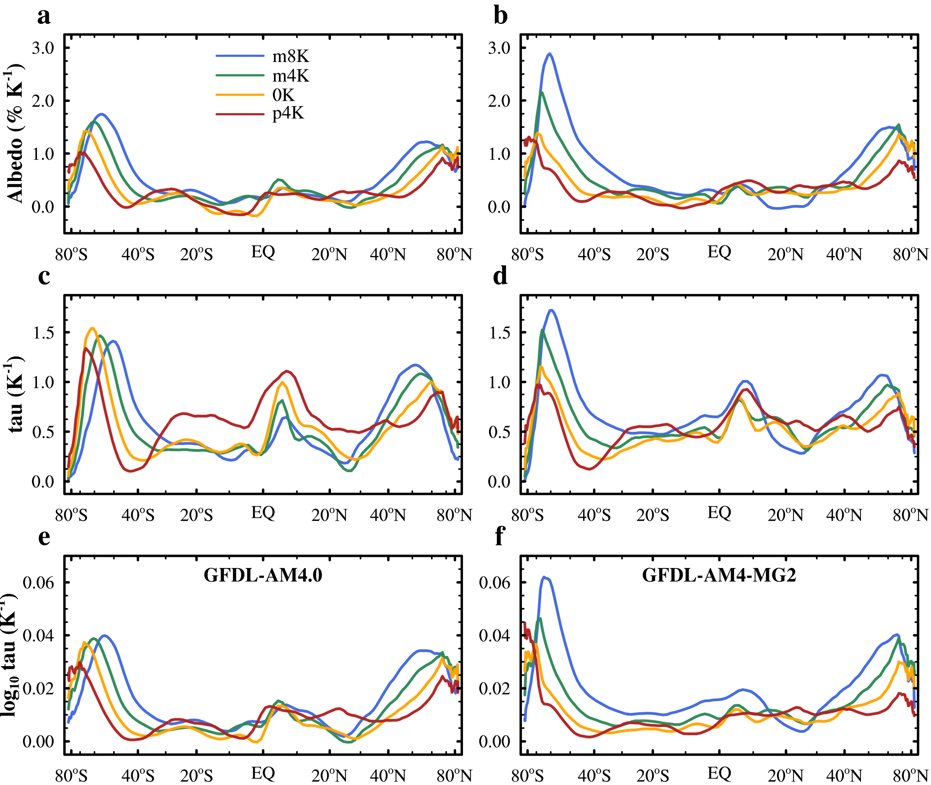
Extended Data Fig. 9 The same as Fig. 5, except that cloud optical depth in (c–f) is simulated by the Moderate Resolution Imaging Spectroradiometer (MODIS) simulator.

