Supplementary Information for:
State dependence of cloud feedback and its implications for climate sensitivity

Haozhe He, Brian J. Soden, Bosong Zhang, Gabriel A. Vecchi, Wenchang Yang
Corresponding author: Haozhe He (haozhe.he@princeton.edu)

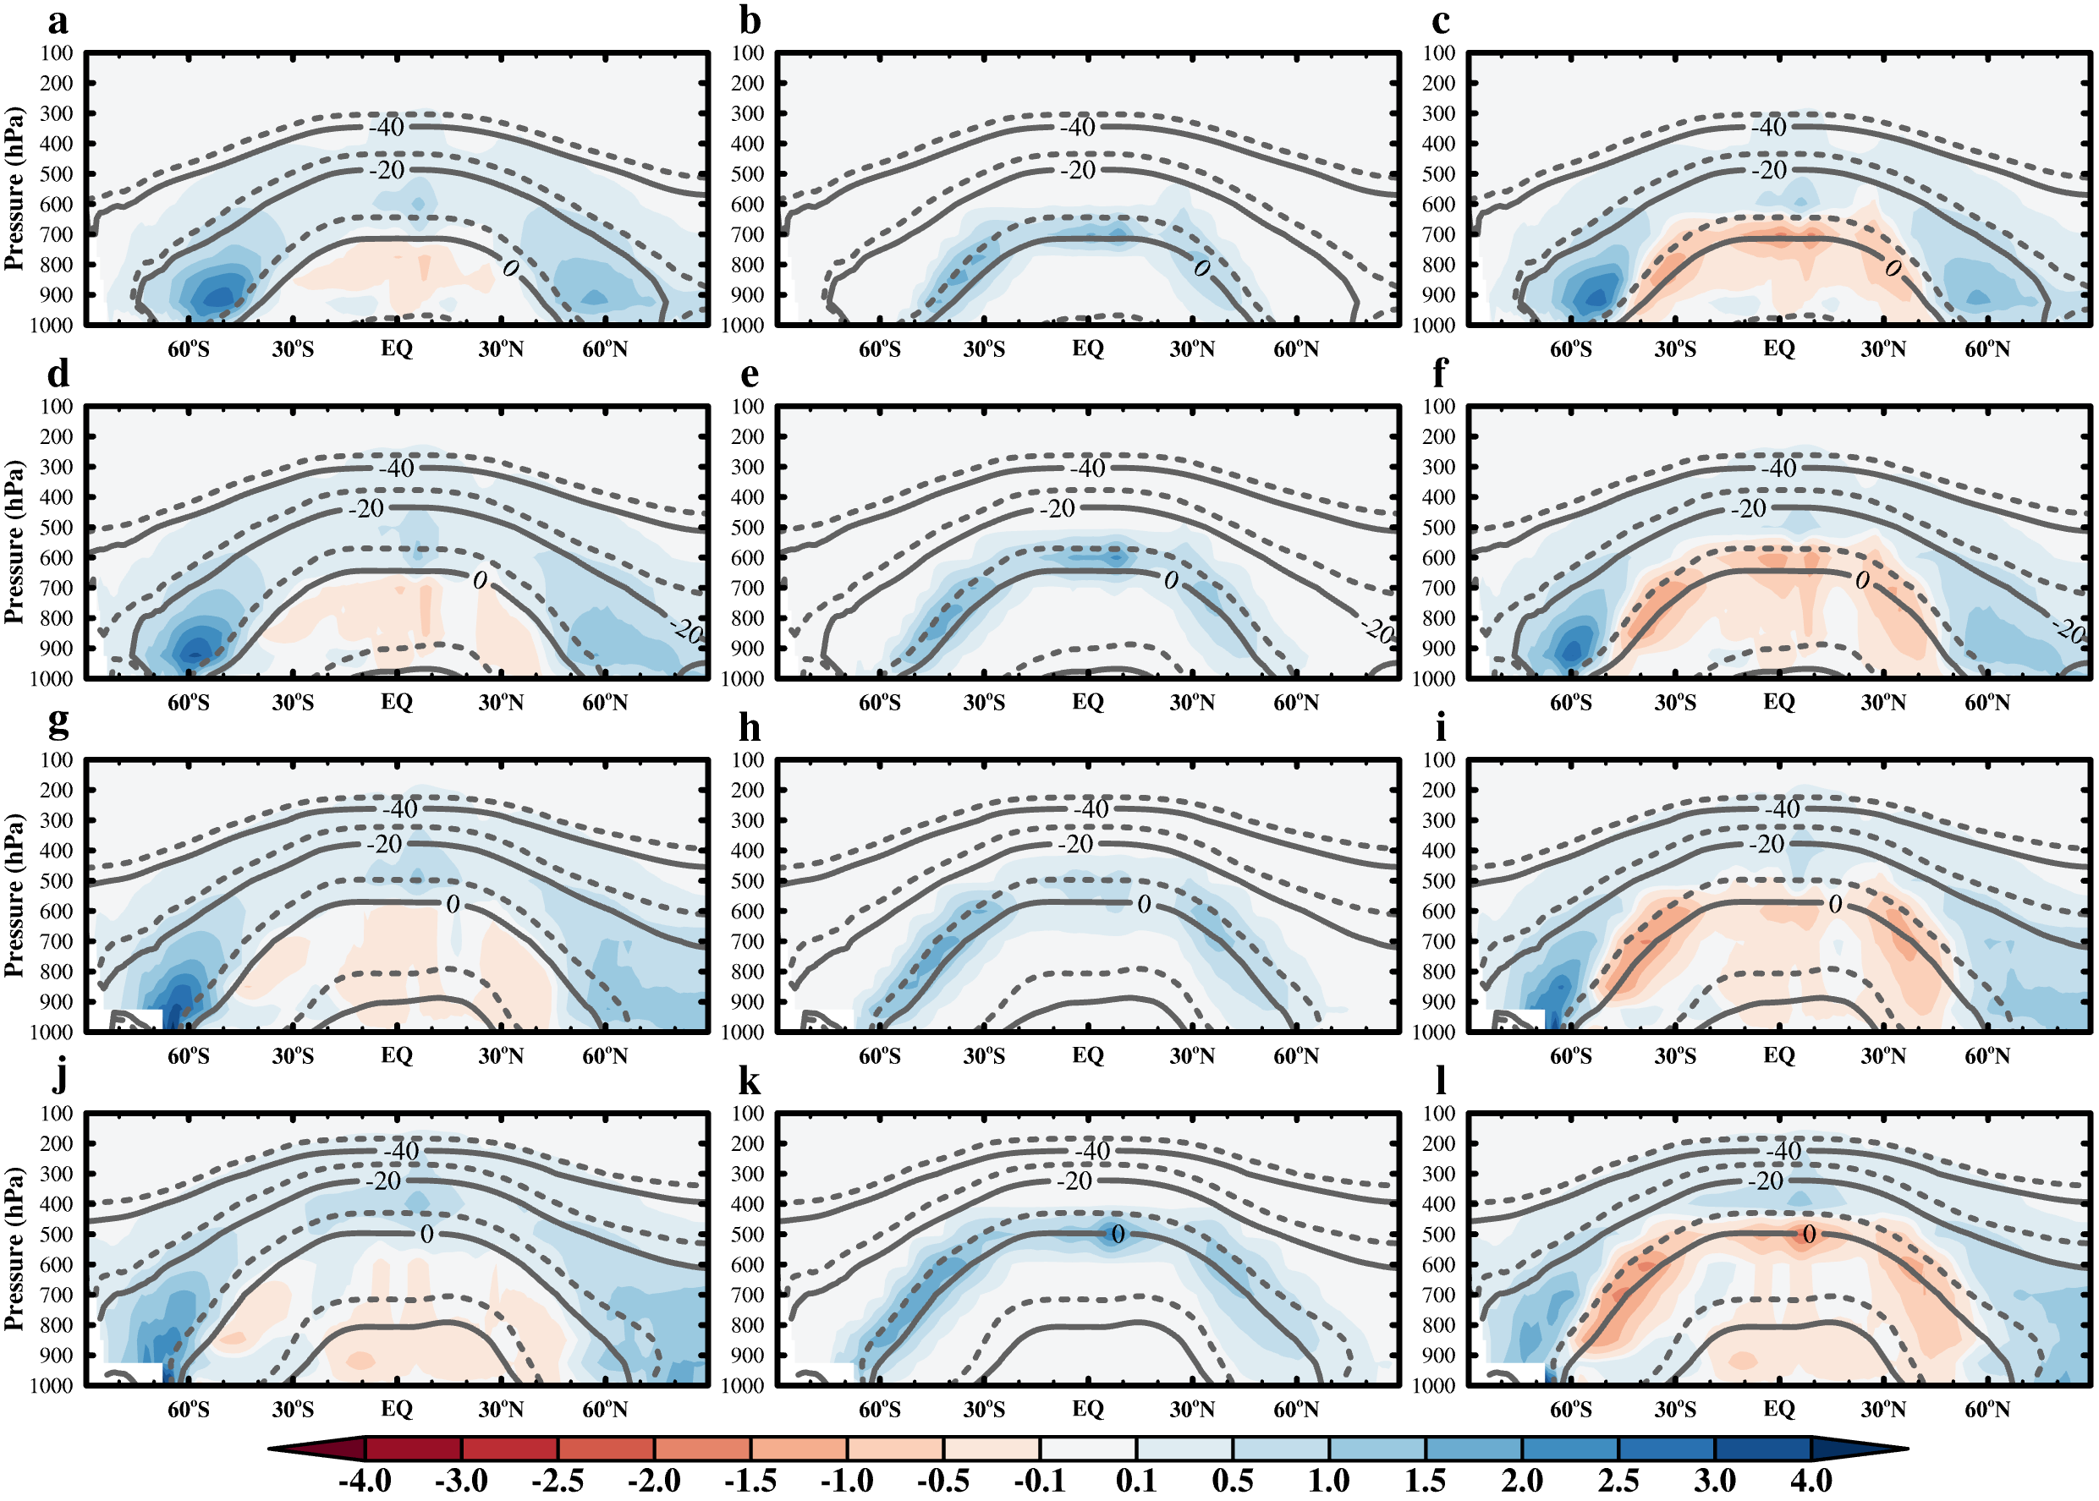
Supplementary Fig. 1. Raw decomposition of the cloud liquid water sensitivity shown in right column of Extended Data Fig. 7. Pressure-latitude cross-sections of the (left) total cloud liquid water sensitivity (10⁻⁶ kg kg⁻¹ K⁻¹) and the contributions from (middle) the approximate thermodynamic phase shift component and (right) the residuals to the total cloud liquid water sensitivity, to per global mean surface air temperature change under different base-state experiments, (a–c) m8K, (d–f) m4K, (g–i) 0K, and (j–l) p4K, in GFDL-AM4.0. Note that the contribution of the thermodynamic phase shifts to cloud liquid water (middle) is estimated by assuming all the decrease in cloud ice converts to the increase in cloud liquid water by the melting process, i.e., flipping the negative values in the left column and counting as the positive contribution to the right column of Extended Data Fig. 7. The residual cloud liquid water sensitivities (right) represent the combined contributions of both the warmer moist adiabat and weakened adiabaticity. Isotherms in the control simulations are displayed as solid lines; isotherms in the perturbed simulations are shown as dashed lines. Here the cloud ice (liquid) water refers to the mass fraction of cloud ice (liquid), which is calculated as the mass of cloud ice (liquid) in the grid cell divided by the mass of air, including the water in all phases in the grid cell.

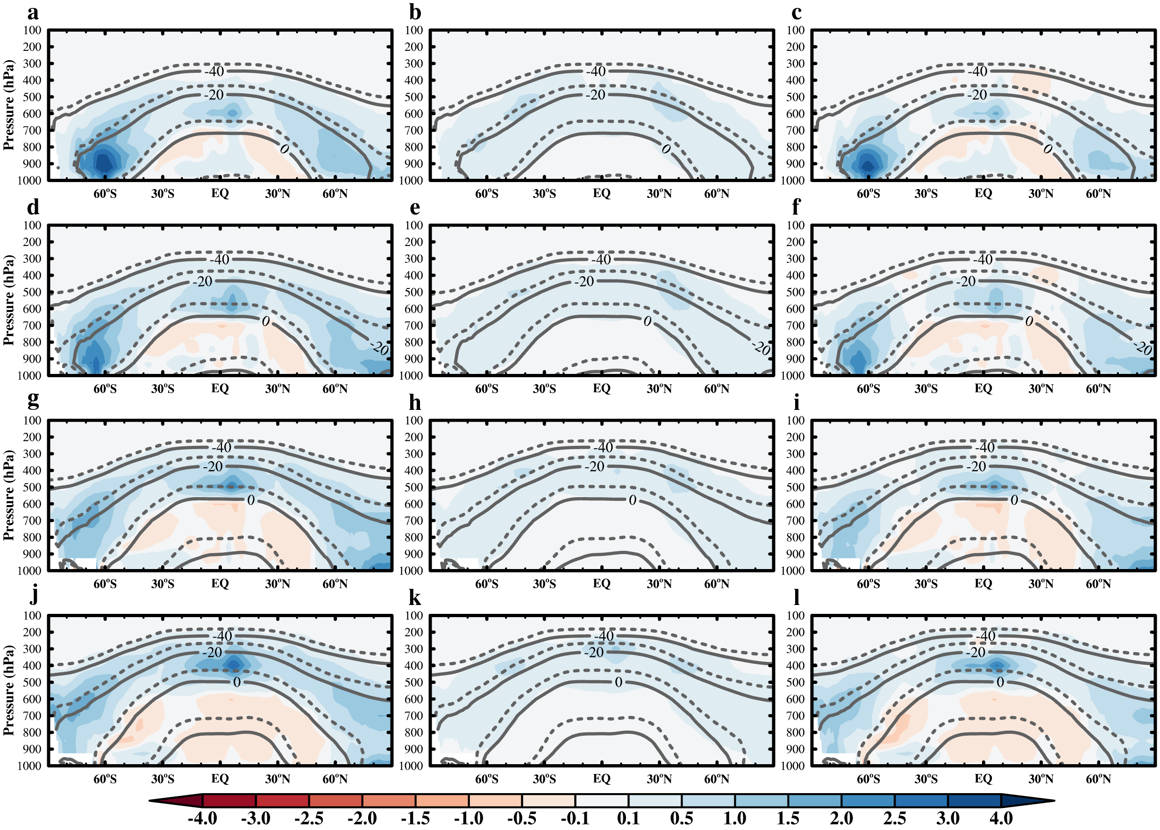
Supplementary Fig. 2. The same as Supplementary Fig. 1, except for model GFDL-AM4-MG2.

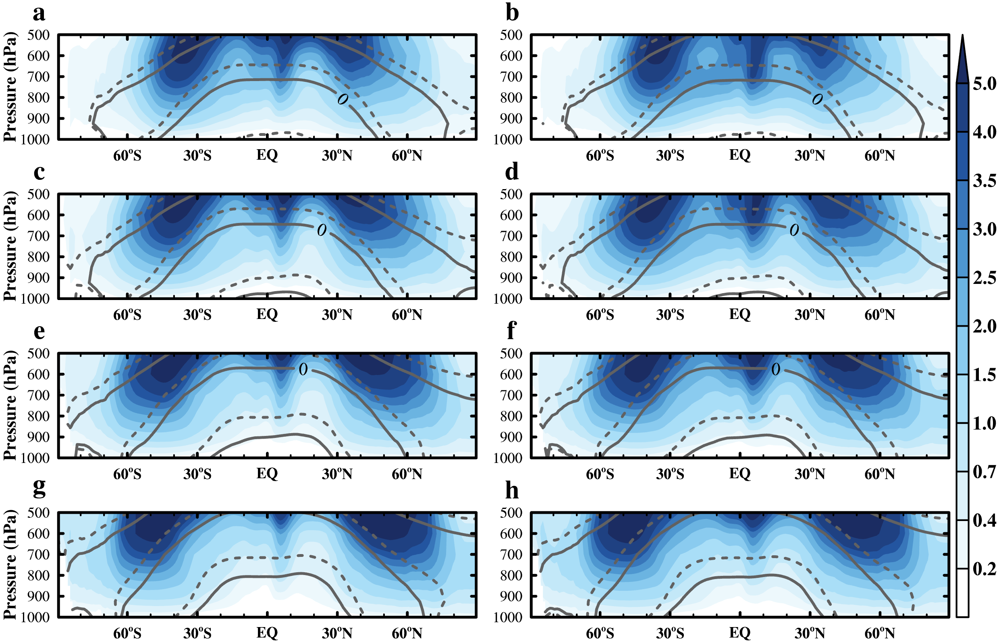
Supplementary Fig. 3. Pressure-latitude cross-sections of the adiabatic cloud water sensitivity (10⁻⁵ kg kg⁻¹ K⁻¹) of model (left) GFDL-AM4.0 and (right) GFDL-AM4-MG2 to per global mean surface air temperature change under different base-state experiments, (a & b) m8K, (c & d) m4K, (e & f) 0K, and (g & h) p4K. The adiabatic cloud water content is calculated using the equation (5) of Betts & Harshvardhan (1987), from the model-simulated cloud base to the cloud top. Isotherms in the control simulations are displayed as solid lines; isotherms in the perturbed simulations are shown as dashed lines.

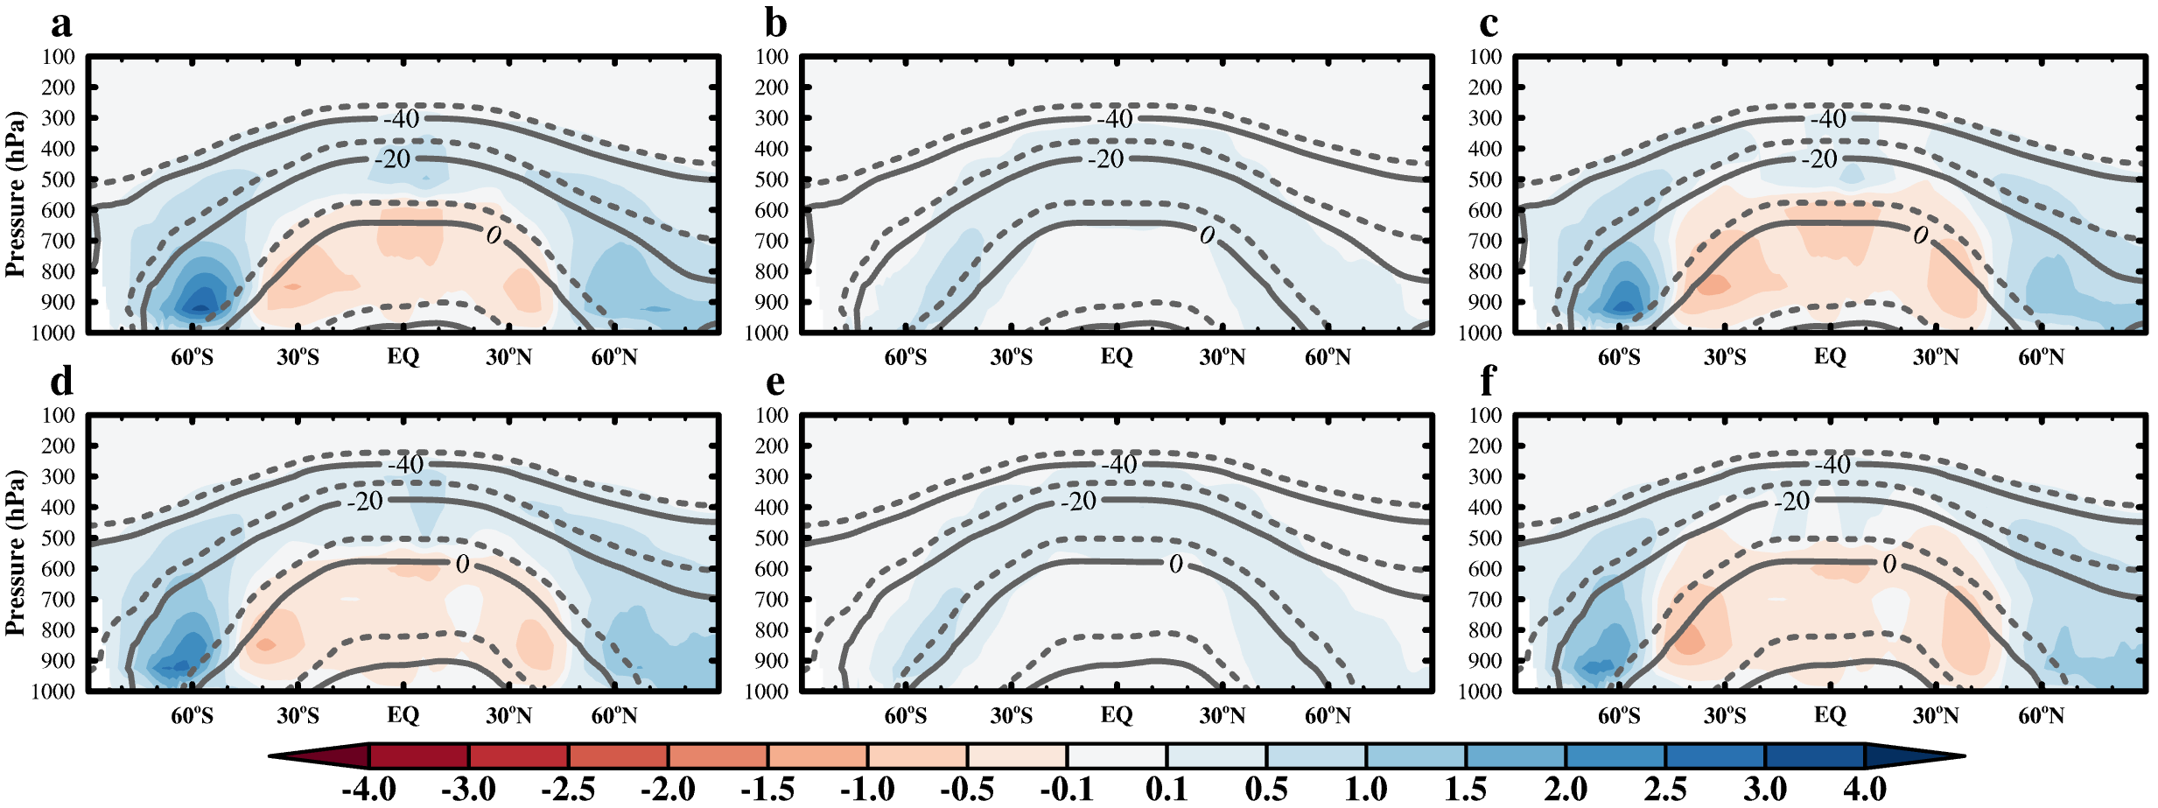
Supplementary Fig. 4. The same as Supplementary Fig. 1, except it shows the CMIP6 model ensemble mean and includes results from only two different base states: (a–c) m4K and (d–f) 0K.

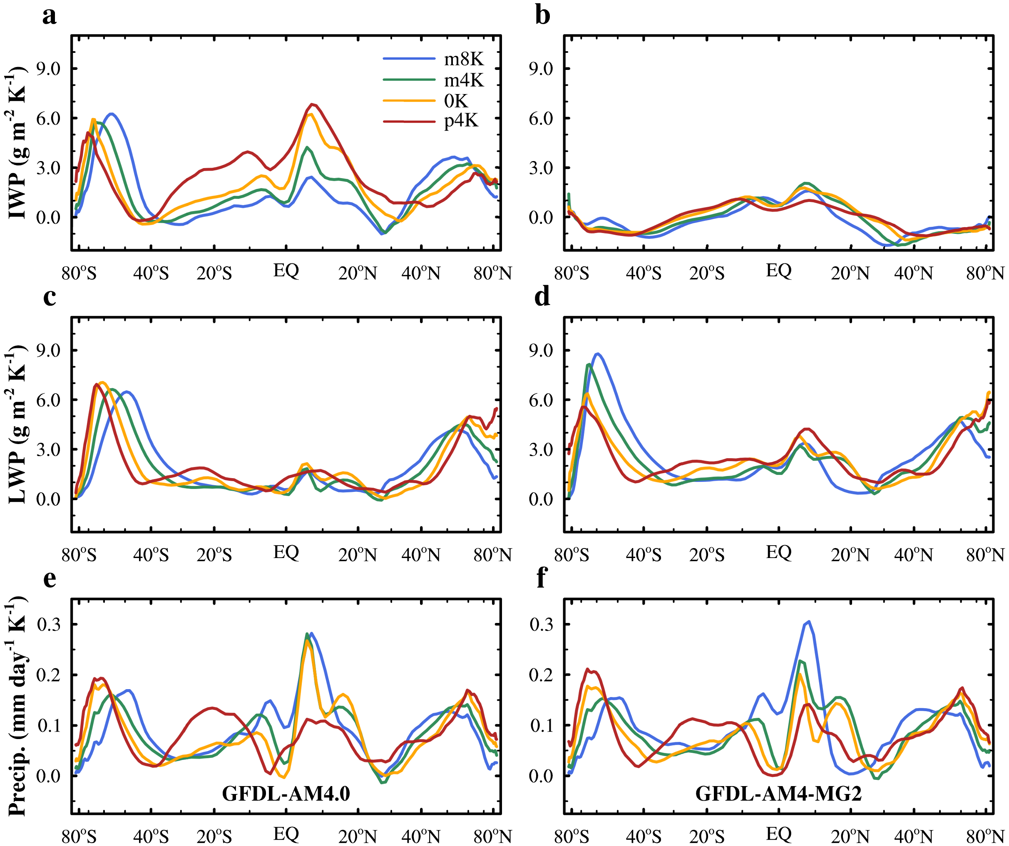
Supplementary Fig. 5. Zonal mean sensitivity distributions of (a & b) ice water path (IWP), (c & d) liquid water path (LWP), and (e & f) precipitation rate (precip.), to per global mean surface air temperature change under different base-state experiments from (left) GFDL-AM4.0 and (right) GFDL-AM4-MG2, respectively. Results are plotted against the sine of latitude to display uniform area weighting.

Supplementary Table 1. A list of AMIP simulations of the CMIP6 climate models analyzed in this study, to help understand the state-dependence of both the net climate feedback and cloud feedback.
 | Institution | Model | DOI amip-m4K | DOI amip | DOI amip-p4K
1 | BCC | BCC-CSM2-MR | doi:10.22033/ESGF/CMIP6.2863 | doi:10.22033/ESGF/CMIP6.2850 | doi:10.22033/ESGF/CMIP6.2864
2 | CCCma | CanESM5 | doi:10.22033/ESGF/CMIP6.3547 | doi:10.22033/ESGF/CMIP6.3535 | doi:10.22033/ESGF/CMIP6.3548
3 | NCAR | CESM2 | doi:10.22033/ESGF/CMIP6.7536 | doi:10.22033/ESGF/CMIP6.7522 | doi:10.22033/ESGF/CMIP6.7537
4 | CNRM-CERFACS | CNRM-CM6-1 | doi:10.22033/ESGF/CMIP6.3937 | doi:10.22033/ESGF/CMIP6.3922 | doi:10.22033/ESGF/CMIP6.3938
5 | NOAA-GFDL | GFDL-CM4 | doi:10.22033/ESGF/CMIP6.8507 | doi:10.22033/ESGF/CMIP6.8494 | doi:10.22033/ESGF/CMIP6.8508
6 | MOHC | HadGEM3-GC31-LL | doi:10.22033/ESGF/CMIP6.5872 | doi:10.22033/ESGF/CMIP6.5853 | doi:10.22033/ESGF/CMIP6.5873
7 | IPSL | IPSL-CM6A-LR | doi:10.22033/ESGF/CMIP6.5125 | doi:10.22033/ESGF/CMIP6.5113 | doi:10.22033/ESGF/CMIP6.5126
8 | MRI | MRI-ESM2-0 | doi:10.22033/ESGF/CMIP6.6770 | doi:10.22033/ESGF/CMIP6.6758 | doi:10.22033/ESGF/CMIP6.6771
9 | AS-RCEC | TaiESM1 | doi:10.22033/ESGF/CMIP6.9722 | doi:10.22033/ESGF/CMIP6.9713 | doi:10.22033/ESGF/CMIP6.9723

