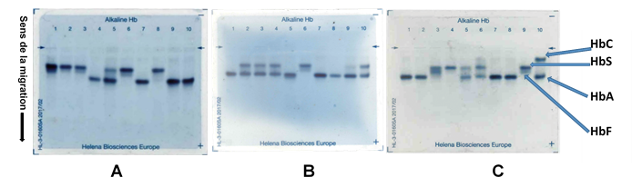
Figure : qualitative electrophoresis reading gel

