Extended data
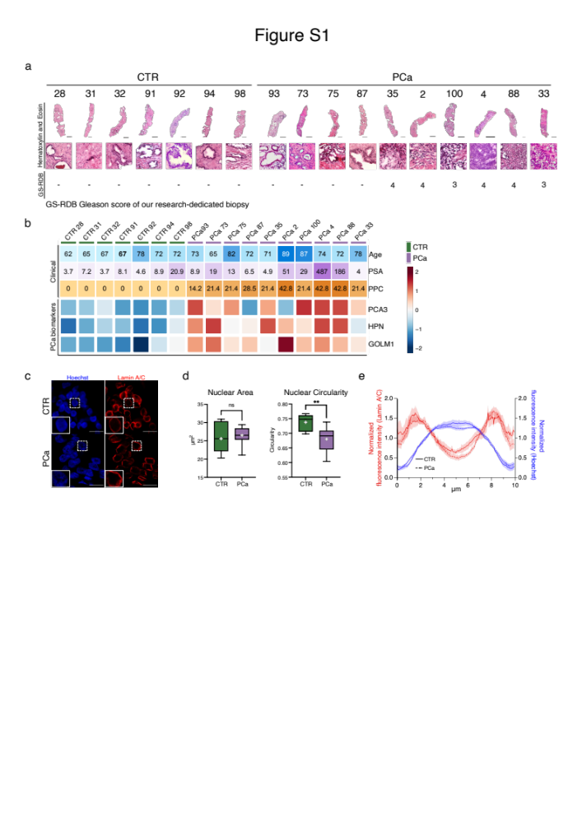

Extended data Figure 1. Cellular and molecular characteristics of the cohort of patients
a. Photomicrographs reconstruction at Leica DMI6000 of Hematoxylin and Eosin staining (H&E) at 10x magnification of prostate biopsies of non-neoplastic patients (CTR) and confirmed cancer patients (PCa). Below each image, a representative area at 20X magnification. GS-RDB indicate Gleason Score assigned to our research-dedicated biopsy.
b. Integrative clinicopathological and molecular profiling of the patients ordered according to Gleason Score (GS). Each sample is annotated for Age, prostate specific antigen (PSA) level, percentage of positive cores (PPC), heatmap of Log₂ (TPM) and expression values of key PCa markers (PCA3, HPN, GOLM1) estimated from RNA-seq data.
c. Representative confocal microscopy images of immunostaining for the nucleus with Hoechst (blue) and Lamin A/C (red) in non-neoplastic (CTR) and PCa samples. On bottom-left, outlined nuclei enlarged. Scale bars, 25 and 5 μm in the main and magnified images, respectively.
d. Quantification of the nuclear area (left) and nuclear circularity (right) of non-neoplastic (green) and PCa (purple) samples. The box plots indicate median values (middle lines), first and third quartiles (box edges) and minimum and maximum values (whiskers) and the mean is indicated by the white plus. Statistical significance was determined by unpaired two-tailed Student’s t-test, (** p-value < 0.005 and ns p-value>0.05).
e. Quantification of Hoechst (blue) and Lamin A/C (red) distribution across nuclei. The graph indicates normalized fluorescence intensity (see Methods) of Hoechst and Lamin A/C in 7 control samples (solid line) and 10 tumor samples (dashed line). Data are presented as mean, shadows represent ± 1 Standard Error of the Mean (SEM).
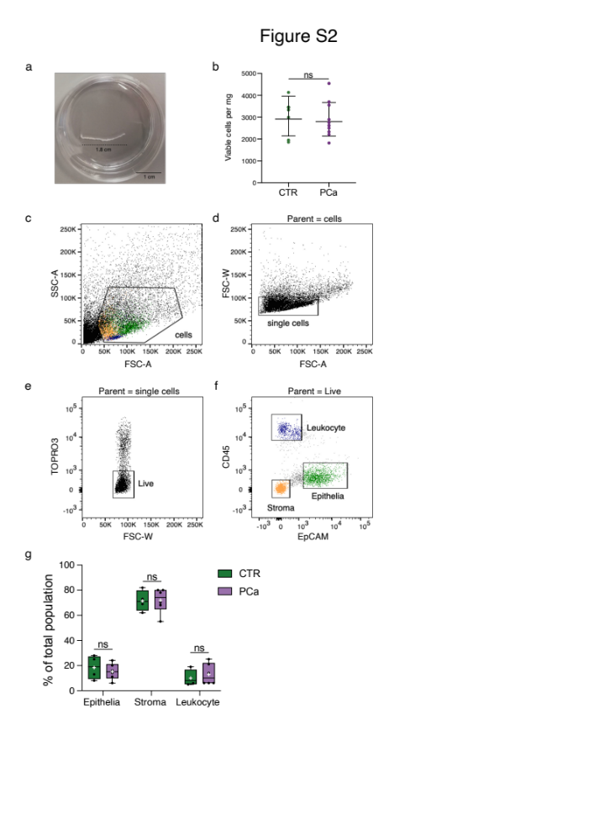

Extended data Figure 2. Cell composition of prostate biopsies
a. Representative image of needle prostate biopsy specimen in a petri dish (35x15mm). Scale bar length=1cm.
b. Number of viable cells recovered per mg of each tissue biopsy. 7 non-neoplastic and 10 PCa samples are indicated in green and purple, respectively. The lines represent geometric mean and whiskers the geometric standard deviation. Statistical significance was determined by unpaired two-tailed Student’s t-test (ns p-value > 0.05).
c-f. Cells are analyzed by flow cytometry through distinct steps: identification of viable cells (FSC-A vs SSC-A); removal of debris (FSC-A vs FSC-W); removal of doublets (FSC-W vs TO-PRO-3); identification of tissue resident leukocytes (blue, CD45+), epithelia (green, EpCAM+) and stroma (brown, double negative).
g. Box plot showing the percentage of 3 distinct prostate cell types (epithelial cells, stromal cells and leukocytes) in non-neoplastic patients (CTR-green box) and PCa samples (PCa-purple box). The whiskers extend from the minimum value to the maximum value, the box extends from the 25th to the 75th percentiles, the middle line of the box is the median and the mean is indicated by the white plus. Statistical analysis was performed by unpaired two-tailed Student’s t-test (ns, p-value > 0.05).

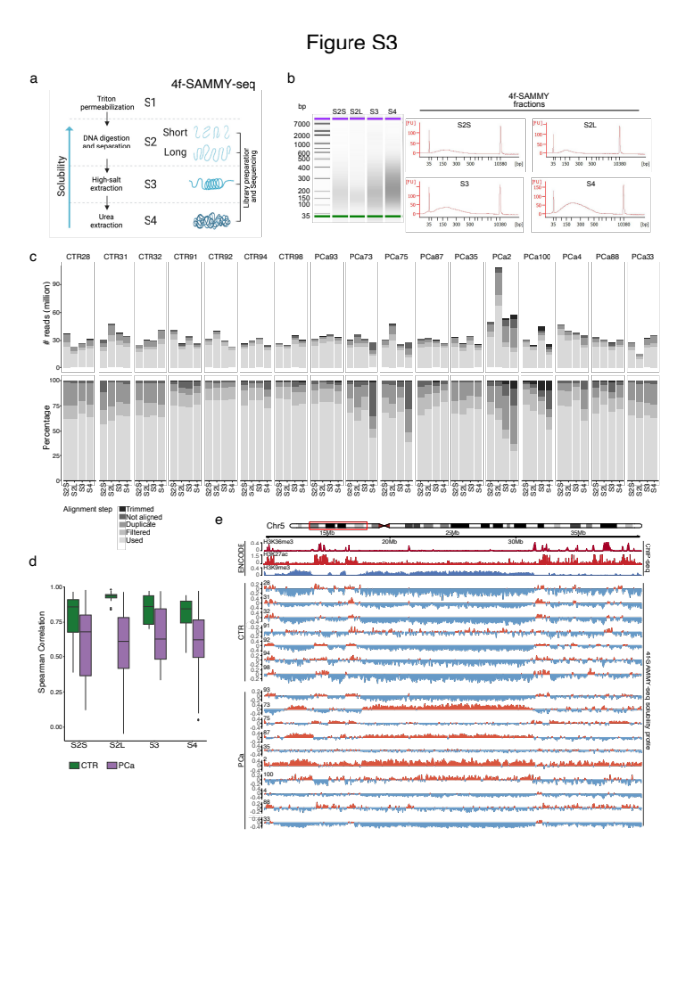

Extended data Figure 3. High-throughput sequencing reads quality and alignments of DNA sequence
a. Schematic illustration of the 4f-SAMMY-seq protocol representing the sequential extraction of chromatin fractions (numbered from S1 to S4) that results in a separation of euchromatic and heterochromatic regions that are then mapped to their genomic coordinates by high-throughput sequencing.
b. Representative bioanalyzer assay after S2 size selection and S2L, S3, S4 sonication.
c. Stacked barplots for the number of sequencing reads obtained for each sample and chromatin fraction, divided in trimmed, not aligned, duplicated, filtered (discarded) and used reads (retained for downstream analyses).
d. Boxplot reporting the distribution of genome-wide Spearman correlation Coefficient (y axis) of each SAMMY-seq fraction (S2S, S2L, S3, S4) (x-axis) in non-neoplastic (CTR, green) and PCa (purple) samples. The horizontal lines mark the median, the boxes mark the interquartile range (IQR) and whiskers extend up to 1.5 times the IQR.
e. Visualization of 4f-SAMMY-seq solubility profiles (S2LvsS3) of all samples along a representative region (chr5:10000000-40000000). The solubility profile is labelled in light red for positive values and in light-blue for negative values. Publicly available ChIP-seq enrichment profiles on normal prostate gland of euchromatin H3K36me3 (dark red) and H3K27ac (red) marks and heterochromatin H3K9me3 mark (blue) of the same region are also shown.

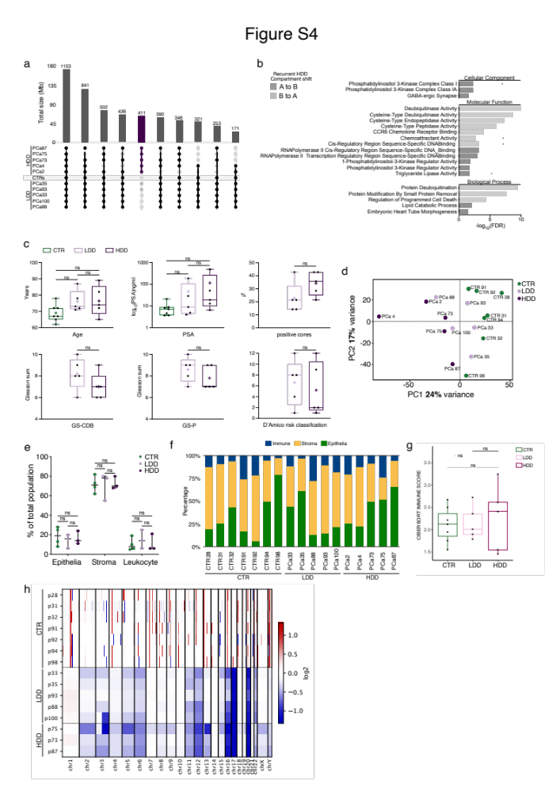

Extended data Figure 4. Pathological and molecular differences between HDD and LDD samples.
a. Barplot showing the total size of "A" compartment regions concordant across different groups of samples. The dark dots intersections in the bottom part of the plot are used to mark the samples with concordant A compartment regions, while the grey dots represent samples with B compartment. The barplot is obtained with the UpsetR package and only the ten most frequent groups in terms or recurrent A compartments are shown. The total size (y-axis values) and number of genomic 150kb bins (number on top of each bar) for each group is shown. The dark purple bar is used to highlight regions that are in the A compartment across all HDD samples and in the B compartment across all LDD samples and the CTR consensus.
b. Gene Ontology enrichment analysis of genes identified within the recurrent "A to B" or "B to A" compartment shifts in the HDD subtype. Bar plots depict significantly enriched cellular component, molecular function, and biological process terms for recurrent shifts from "A to B" (grey) and "B to A" (lighter grey) in HDD subtype (n=59 for “A to B” shift and n=538 for “B to A” shift).
c. Box plot showing the distribution of the clinicopathological features between non-neoplastic (CTR, green), LDD (light purple) and HDD (dark purple) PCa subgroups. Each sample is annotated for Age, Prostate Specific Antigen (PSA) blood level, Percentage of Positive Cores (PPC), Gleason Score (GS-CDB and GS-P) and D’Amico risk classification. In the box plots, the whiskers of the box extend from the minimum value to the maximum value, the box extends from the 25th to the 75th percentiles, the middle line of the box is plotted at the median and the mean is indicated by the plus symbol. Statistical analysis was performed by one-way ANOVA and unpaired two-tailed Student’s t-test (ns, p-value > 0.05).
d. Principal Component Analysis (PCA) on RNA-seq data of non-neoplastic control samples (green), LDD (light purple) and HDD (dark purple) PCa subgroups.
e. Distribution of distinct prostate cell types (epithelial cells, stromal cells and leukocytes) in non-neoplastic (CTR, green), LDD (light purple) and HDD (dark purple) measured by flow-cytometry. Data are represented as the median (horizontal line) with range (whiskers). Statistical significance was determined by one-way ANOVA (ns, p-value > 0.05).
f. Relative percent of different cell subsets (epithelia, stroma and immune cell infiltrate) in each non-neoplastic and PCa biopsy derived from Cibersort bulk deconvolution analysis (see Methods).
g. Boxplot showing the distribution of the CIBERSORT Immune Score in non-neoplastic (CTR, green), LDD (light purple) and HDD (dark purple) samples. Statistical significance was determined by Wilcoxon-Mann-Whitney test (ns, p-value > 0.05).
h. Whole-genome profiles of log₂ copy ratio generated by CNVkit (see Methods). The heatmap shows the copy number alteration present in each non-neoplastic and PCa biopsy for each chromosome.

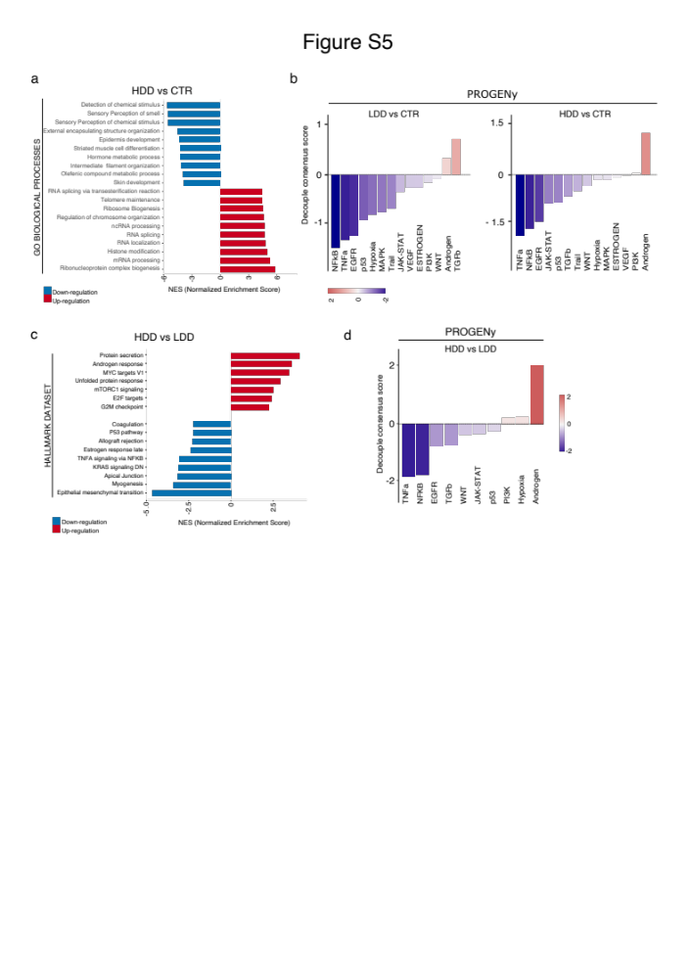

Extended data Figure 5. Functional analysis in HDD and LDD subtypes
a. Normalized Enrichment Scores (NES) from GSEA analysis on Biological Processes gene set of HDD vs CTR. 104 out of 4220 biological processes gene sets are significantly up-regulated with adj.p-value (FWER) < 0.05 in HDD; 103 out of 4220 gene sets are significantly down-regulated with adj.p-value (FWER) < 0.05 in HDD
b. Pathway activity score of LDD vs CTR and HDD vs CTR comparisons derived from PROGENy compendium (see Methods). Purple bars show decreased pathway activities in LDD or HDD. Red bars represent increased pathway activities in LDD or HDD.
c. GSEA analysis of MSigDB Hallmark gene sets collection within the expression data of HDD compared to LDD. Positive NES (red bars) indicate enriched gene set in HDD group. Negative NES (blue bars) indicate enriched gene set in LDD group. 7 out of 50 gene sets are significantly up-regulated with adj.p-value (FWER) < 0.05 in HDD; 9 out of 50 gene sets are significantly down-regulated with adj.p-value (FWER) < 0.05 in HDD.
d. Pathway activity score of HDD vs LDD comparison derived from PROGENy compendium. Blue bars show decreased pathway activities in HDD. Red bars represent increased pathway activities in HDD.

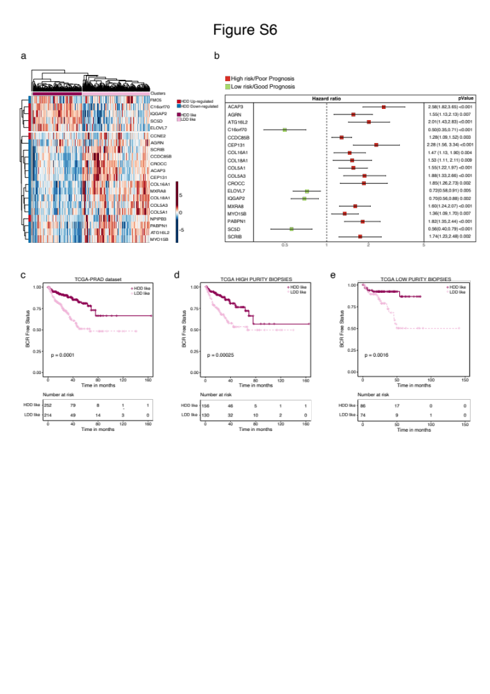

Extended data Figure 6. Signature validation
a. Unsupervised clustering showing the transcriptomic expression values of 21 prognostic genes (rows) across the TCGA cohort (columns). The slide bar on the top discriminates the transcriptomic clusters HDD-like (deep pink) and LDD-like (light pink). The slide bar on the left shows up-regulated (red) and down-regulated (blue) DEGs in HDD.
b. Univariate Cox regression analysis results showing only genes with significative association to patient good (green square) or bad (red square) prognosis (BH adjusted p-value < 0.05) in the TCGA cohort.
c. Kaplan-Meier plot based on the 18 genes refined signature on TCGA patients (panel B, p-value = 0.0001).
d-e. Kaplan-Meier plots showing Biochemical Recurrence Free (BCR) status outcome of TCGA samples with high (panel C) and low (panel D) tumor purity (ABSOLUTE score ≥ 0.5 and < 0.5, respectively).

