Degradable Mesoporous Semimetal Antimony Nanospheres for Near-Infrared II Multimodal Theranostics
Yu Chen,^{1#} Zhongzheng Yu,^{2#} Yaguang Ren,³ Kai Zheng,⁴ Meng Wang,¹ Qiang Wu,¹Feifan Zhou,¹ Chengbo Liu,³ Liwei Liu,¹ Jun Song,¹* and Junle Qu^{1,5}*

#These authors contributed equally

¹Center for Biomedical Optics and Photonics (CBOP) & College of Physics and Optoelectronic Engineering, Key Laboratory of Optoelectronic Devices and Systems, Shenzhen University, Shenzhen 518060, P. R. China
²School of Chemical and Biomedical Engineering Nanyang Technological University, Singapore, 637459
³Research Laboratory for Biomedical Optics and Molecular Imaging, Shenzhen Institutes of Advanced Technology, CAS Key Laboratory of Health Informatics, Chinese Academy of Sciences, Shenzhen 518055, China
⁴Northwestern Polytechnical University, School of Civil Aviation, 127 West Youyi Road, Beilin District, Xi&apos; Shanxi, 710072, P.R.China.
⁵National Research Nuclear University MEPhI (Moscow Engineering Physics Institude), Moscow 115409, Russian Federation.
E-mail: songjun@szu.edu.cn; jlqu@szu.edu.cn

Keywords: Mesoporous Antimony, Photodegradable, Photothermal therapy, Photoacoustic imaging

FDTD Calculations
Herein, to confirm the spatial electric field distribution of as-prepared MSbNSs under the irradiation of a beam of linearly polarized light, the finite-difference-time-domain (FDTD) simulation (8.11.337 version, Lumerical Solutions, Inc.) was performed as an effective approach. The complex refractive indexes of Sb was adopted from the book “The Handbook on Optical Constants of Metals: In Tables and Figures” edited by Sadao Adachi. [1] M. Cardona and D. L. Greenaway, Phys. Rev. 133, A1685 (1964). [2] B. L. Henke, E. M. Gullikson, and J. C. Davis, At. Data. Nucl. Data Tables 54, 181 (1993); http://henke.lbl.gov/optical_constants. [3] Adachi, S. (2012). The handbook on optical constants of metals: in tables and figures. World Scientific. The complex refractive indexes of the media H₂O was adopted from the simulation database “H₂O (water) - Palik” All geometric parameters for simulations were consistent with the average actual size of as-prepared samples shown in TEM image. In the FDTD simulations, the diameter and pore diameter of MSbNSs-2 were set as 55 nm and 3.7 nm, while MSbNSs-3 were set as 55 nm and 3.7 nm/11.5 nm. For the detailed FDTD parameter setting, the simulation region was set as a unit 700 nm × 700 nm × 700 nm in 3Ds. Herein, boundary conditions were set as perfectly matched layers (PML) in all simulations. To save computational resources while improving computational accuracy, a refined mesh grid near the structure was set as 0.3 nm in a 3D dimension 70 nm x 70 nm x 70 nm. Total-field scattered-field (TFSF) linearly polarized light waves, which was polarized in line with X-axis with a wavelength range of 400 - 1400 nm, were injected into the unit cell along the -Z direction. The amplitude of the electric field vector of the TFSF linearly polarized light vector was set to be 1 V m⁻¹. Two frequency-domain field profile monitors and two frequency-domain field and power monitors were localized at Z = 0 nm in the x-y plane and Y = 0 nm in the x-z plane, respectively. All the frequency-domain field profile monitors were utilized to collect electric field profile data of the surface and interior of and MSbNSs while keeping the excitation wavelength 835 nm and 1200 nm, respectively. Furthermore, the frequency-domain field and power monitors were utilized to collect the absorption power profile data of and MSbNSs under the excitation wavelength 1200 nm.
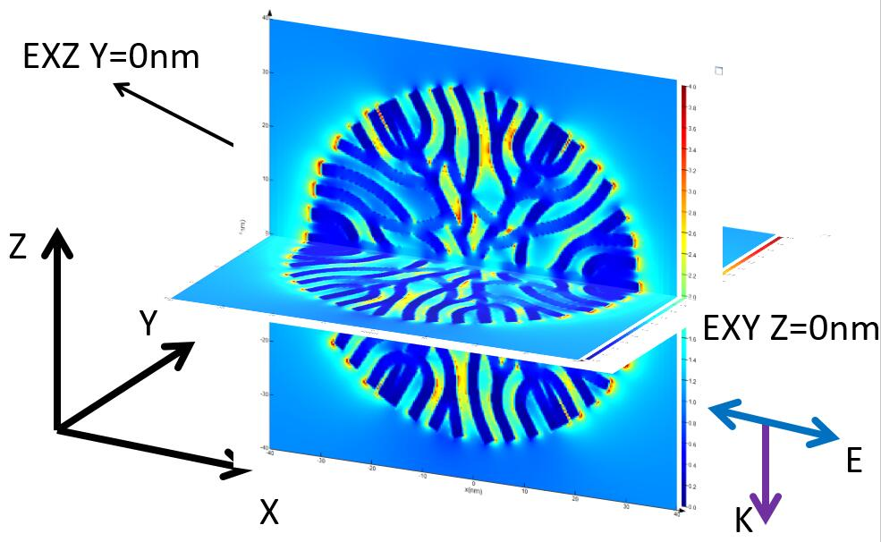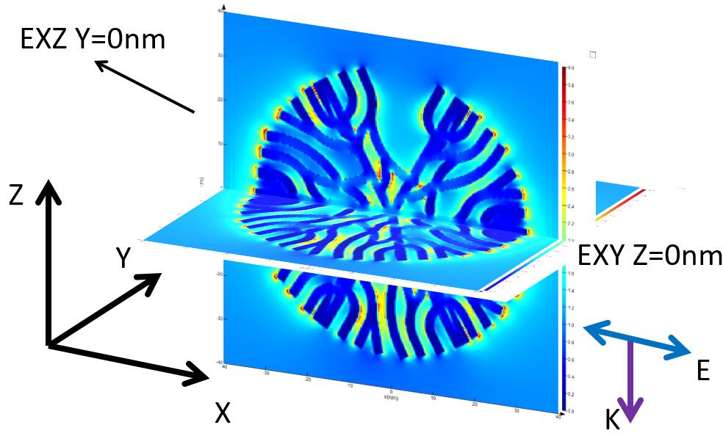

Figure S1. Low-magnification (a)TEM and (b) STEM images of MSbNSs. (c) High-magnification STEM image of MSbNSs.
Figure S2. The average diameters of (a) MSbNSs-1, (b) MSbNSs-2, (c) MSbNSs-3, (d) MSbNSs-4.
Figure S3. Low and high-magnification STEM images of SbNSs prepared without oxygen.
Figure S4. TEM image of MSbNSs prepared with higher reaction temperature.
Figure S5. EDS mapping of MSbNSs-1, MSbNSs-2, MSbNSs-3, MSbNSs-4, respectively.
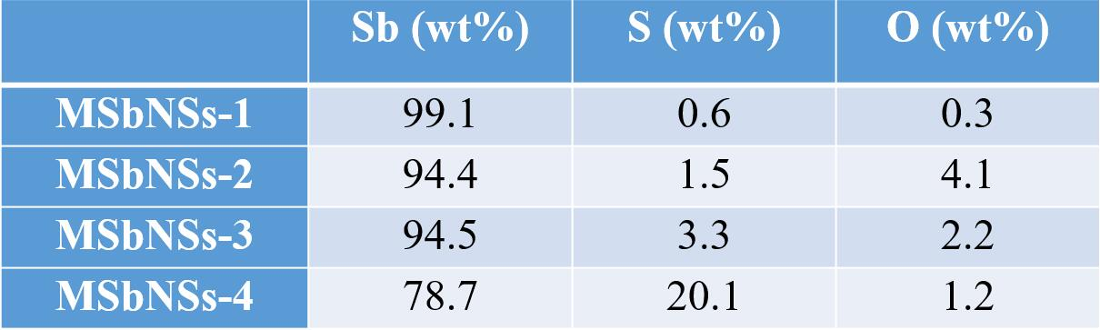
Figure S6. The mass percentages of Sb, O, and S elements in MSbNSs-1, MSbNSs-2, MSbNSs-3, MSbNSs-4, respectively.
Figure S7. (a) Photothermal stability of MSbNSs-2 under the irradiation of 1210 nm. (b)(c) STEM images of MSbNSs-2 before and after irradiation.
Figure S8. Photothermal stability of MSbNSs-1 under the irradiation of 1210 nm.

Figure S9. The photothermal heating curve and the linear relationship between –lnθ and time obtained from the cooling of the PEGylated (a)(b)MSbNSs-1and (c)(d)MSbNSs-2 under laser irradiation (1210 nm, 1W cm⁻²) and cooling curve after turning off the laser.

Figure S10. Confocal images of calcein AM (green, live cells) and PI (red, dead cells) co-stained panc02 cells after exposed to NIR irradiation (1210 nm, 1 W cm⁻²).

Figure S11. The change of PA intensity over time with PEGylated MSbNSs-3/DOX being injected at the tumor site.

Figure S12. The change of the PA intensity with and without laser irradiation.
Figure S13. Representative H&E-stained images of major organs including heart, liver, spleen, lung and kidney of mice receiving different treatments. Scale bar=100μm.

