SUPPLEMENTARY INFORMATION

Supplementary Methods

Inclusion and exclusion criteria
We included patients aged ≥18 years who were both willing and capable of signing a written consent form and who underwent pancreatectomy for either benign or malignant conditions. Patients who had undergone neoadjuvant chemotherapy, were pregnant or breastfeeding, or had a history of autoimmune diseases were excluded from the study. Forty patients were enrolled, and one withdrew consent before the surgical procedure. The whole IMMUNOPANC cohort was used to analyze the immune landscape variation after pancreatectomy and to establish unsupervised lymphocyte clustering. This side-study focused on PD and preoperative POPF prediction; thus, patients who underwent explorative laparotomy (n=2), total pancreatectomy (n=1), or distal pancreatectomy (n=14) were subsequently excluded from the POPF analysis.

Data collection
Surgery was performed using subcostal laparotomy, and all pancreatectomy procedures were performed with curative intent. The variables evaluated in all patients were age, sex, coronavirus disease status (as the trial occurred in 2021, preoperative coronavirus was frequent and could change the immune status), operative duration, blood loss, intraoperative pancreatic parenchymal characteristics (main pancreatic duct size was measured with a ruler, and pancreatic texture was assessed subjectively by the surgeon), final pathology, pre- and postoperative blood samples with neutrophil and lymphocyte counts, and postoperative DFA. Postoperative complications were graded using the Clavien–Dindo classification,¹ including POPF,² ISGPS hemorrhage,³ 90-day postoperative mortality rates, and length of hospital stay were recorded.

Peripheral blood mononuclear cell (PBMC) and staining
Peripheral blood mononuclear cells (PBMCs), cryopreserved in 90% fetal calf serum + 10% dimethyl sulfoxide, were obtained 1 day before surgery (preoperative day [PreopD]; n=39), immediately after the abdominal incision (POD0, before pancreatectomy [POD-0B]; n=39), after pancreatectomy (POD-0A; n=39), and on POD1 (n=39). Handling, conditioning, and storage of samples were performed by the Paoli-Calmettes Tumor Bank, which operates under authorization #AC-2007–33 granted by the French Ministry of Research. PBMCs were washed with Roswell Park Memorial Institute (RPMI) medium 1640 with 10% fetal calf serum (FCS), incubated in RPMI 1640 with 2% FCS and Pierce Universal Nuclease 25 kU (Thermo Fisher Scientific), diluted at 1:10,000, and incubated at 37°C with 5% CO₂ for 30 min. Cells were incubated with 1 µM cisplatin to stain dead cells (Standard Biotools, San Francisco, California, USA). Phenotype markers were simultaneously assessed to characterize major innate and adaptative immune cell subsets, including two panels of 32 and 37 antibodies developed for deep phenotyping of NK, CD4⁺ T, CD8⁺ T, and Vδ2⁺ γδ T cells (Supplementary Table 1). Mass cytometry antibodies were either purchased from Standard Biotools or were conjugated from commercially available purified antibodies to the appropriate metal isotope using the MaxPar X8 Polymer or MCP9 Polymer kits (Standard Biotools).
Staining was performed as previously described by Ben Amara et al.⁴ Overall, 0.5–3 million PBMCs were incubated for 1 h at 4°C with the extracellular antibodies. Subsequently, cells were fixed using 2% paraformaldehyde (PFA), washed, and permeabilized with the Foxp3 Staining Buffer Set (eBioscience) for 10 min at 4°C. Intracellular aspecific epitopes were blocked with 0.5 mg/mL Human Fc Block for 10 min at 4°C before incubation with the mix of intracellular antibodies for 30 min at 4°C in Foxp3 Staining Buffer. Cells were washed, and samples were incubated with intracellular antibodies, then washed again and incubated overnight with 125 nM iridium intercalator (Standard Biotools) in 2% PFA. Finally, cells were diluted in EQ™ Four Element Calibration Beads (Standard Biotools), which were used for normalization over time.
Reference samples comprising buffy-coat-derived PBMCs (purchased from Etablissement Français du Sang [EFS], Marseille, France) were adapted to a concentration of 1.0 x 10⁶ cells/mL. Anchor samples were treated in the same manner as patient samples, and one anchor was included in each batch of measured patient samples.

Univariate analysis
Data were analyzed using IBM SPSS Statistics for Windows, version 29 (IBM Corp., Armonk, NY, USA). Data are summarized as counts (frequencies) for categorical variables and as median [range] or mean (standard deviation) for quantitative variables. The characteristics of the populations were compared using Fisher’s exact test or the chi-square test for qualitative variables and the Mann–Whitney or t-test for quantitative variables. We employed analysis of variance with subsequent pairwise group comparisons, using either the post-hoc Tukey or Games–Howell test for immune cluster comparison. All tests were two-sided. The alpha for all tests was set at 0.05, with P<0.05 required for significance.

Stabl preprocessing
The preprocessing of each of the omics was performed using the following steps:
1. Application of a variance threshold to filter out all covariates with a variance under
the threshold,
2. Application of a missing value filter to filter out all features with a proportion of
missing values above the threshold,
3. Imputation of missing values of each feature, and
4. Standardization of the covariates by z-scoring the dataset.
The specific preprocessing strategy applied to each omic was as follows:
• NK, variance threshold = 0, missing value filter 0.2 and imputing strategy = Median
• T8, variance threshold = 0, missing value filter 0.2 and imputing strategy = Median
• T4, variance threshold = 0, missing value filter 0.2 and imputing strategy = Median
There was no missing value. Each preprocessing pipeline item was implemented using the Python package scikit-learn v.1.2

Supplementary Figures and Tables

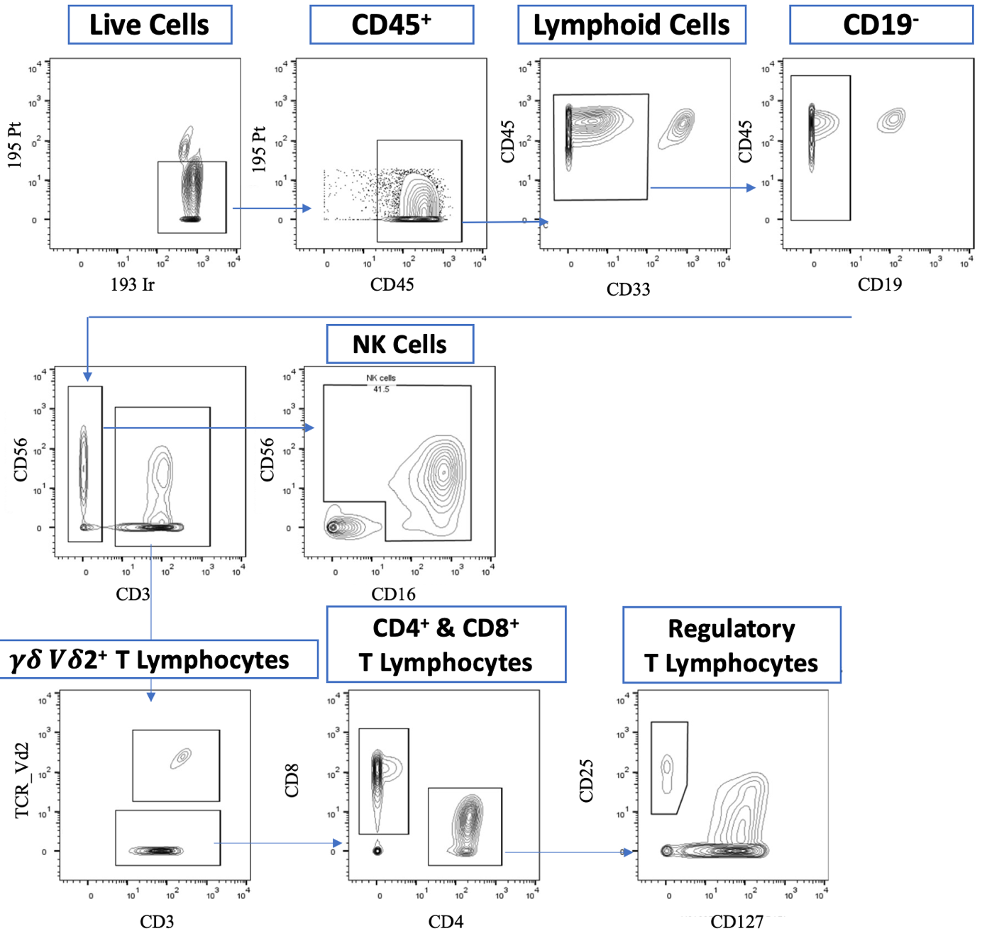
Supplementary Figure 1. Gating strategy to identify immune cells of interest in mass cytometry.
Iridium identifies cells, ¹⁹⁵Pt positivity enables the exclusion of dead cells, and CD45 enables the identification of leukocytes. Myeloid and B cells are excluded based on CD33 and CD19 expression, respectively. NK cells are defined as CD3⁻ CD56⁺ cells or CD3⁻ CD56⁻CD16⁺ cells. T cell populations are defined as CD3⁺ cells, which are further classified into CD4⁺ T, CD8⁺ T, and Vδ2⁺ γδ T cells. Regulatory T cells are defined as CD3⁺ CD4⁺ CD25^{high} CD127^{low} cells. NK, natural killer.

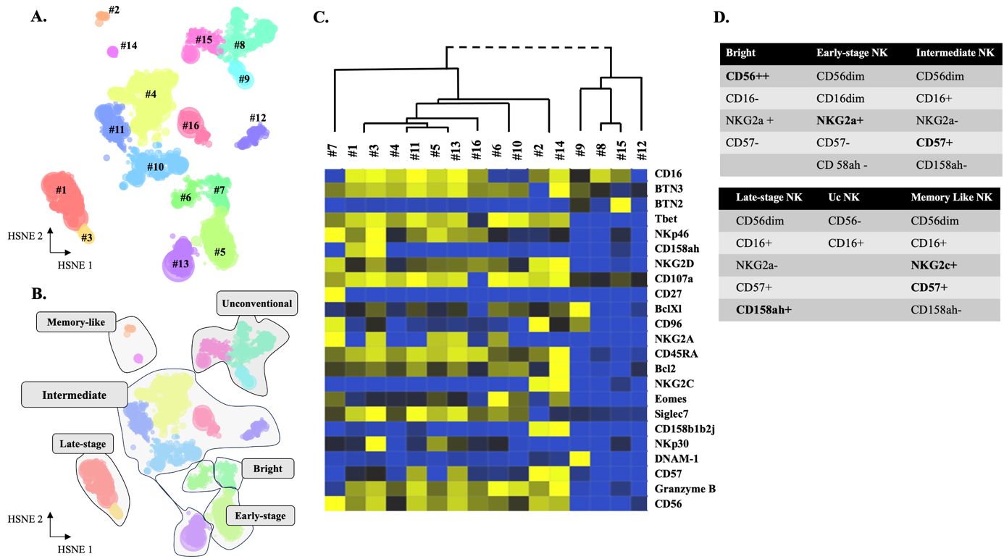

Supplementary Figure 2. Annotation of NK cell clusters.
(A) NK cells are clustered based on the expression of phenotypic markers using unsupervised h-SNE analysis. The clusters are projected into two dimensions, and 16 NK cell clusters are identified based on phenotypic marker expression. (B) Identification of six subpopulations of NK cells. (C) Heatmap showing normalized and batch-corrected expression of phenotypic markers for the 16 NK cell h-SNE clusters. (D) Summary of the main phenotypic characteristics used to define subsets of NK cells. NK, natural killer; Uc, unconventional.

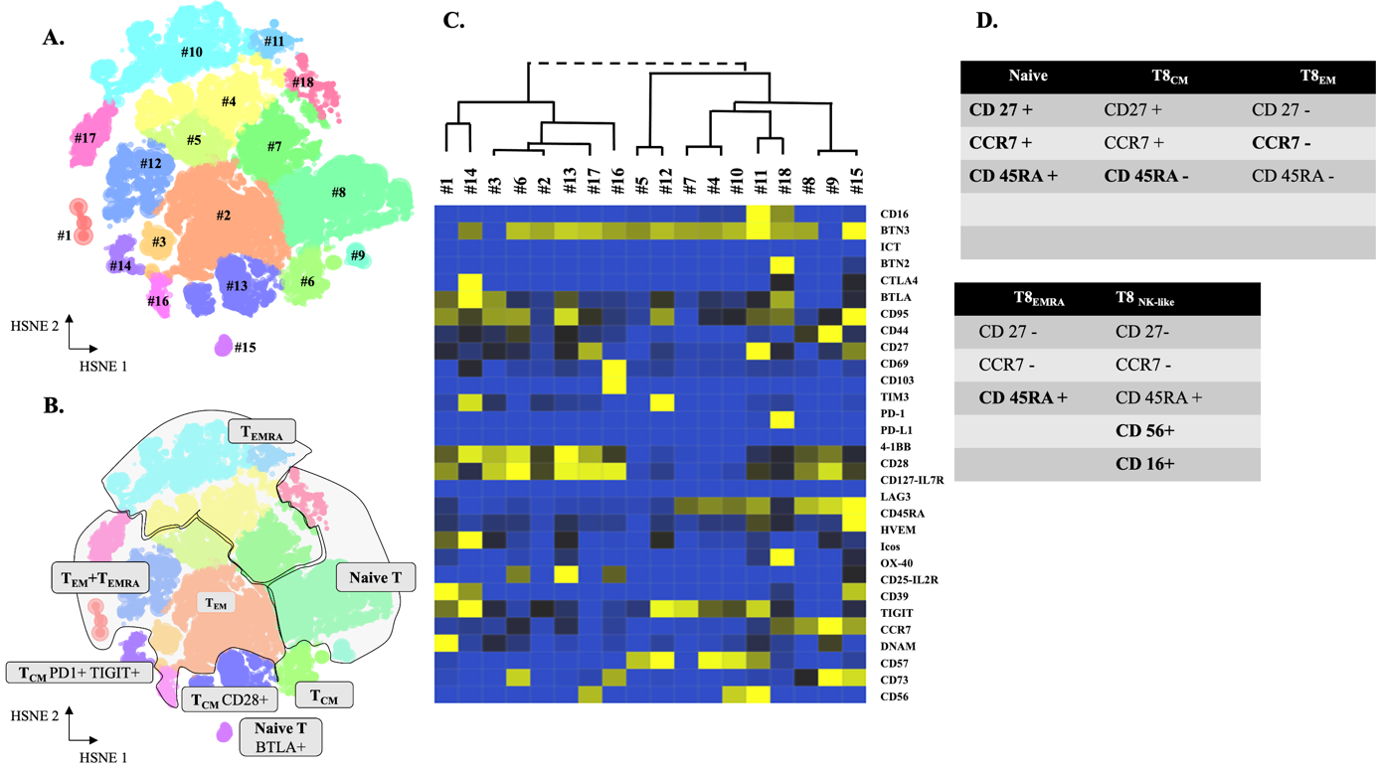

Supplementary Figure 3. Annotation of CD8+ T cell clusters.
(A) CD8⁺ T-cells are clustered based on the expression of phenotypic markers using unsupervised h-SNE analysis. The clusters are projected into two dimensions, and 18 CD8⁺ T cell compartments are identified based on phenotypic marker expression. (B) Identification of four main subpopulations of CD8⁺ T cells. (C) Heatmap showing the normalized and batch-corrected expression of markers for 18 CD8⁺ T cell Cytosplore clusters. Clusters were formed based on surface marker expression profiles. (D) Surface marker combinations used to identify CD8⁺ T cell subsets. CM, central memory; EM, effector memory; EMRA, effector memory CD45RA⁺; NK, natural killer.
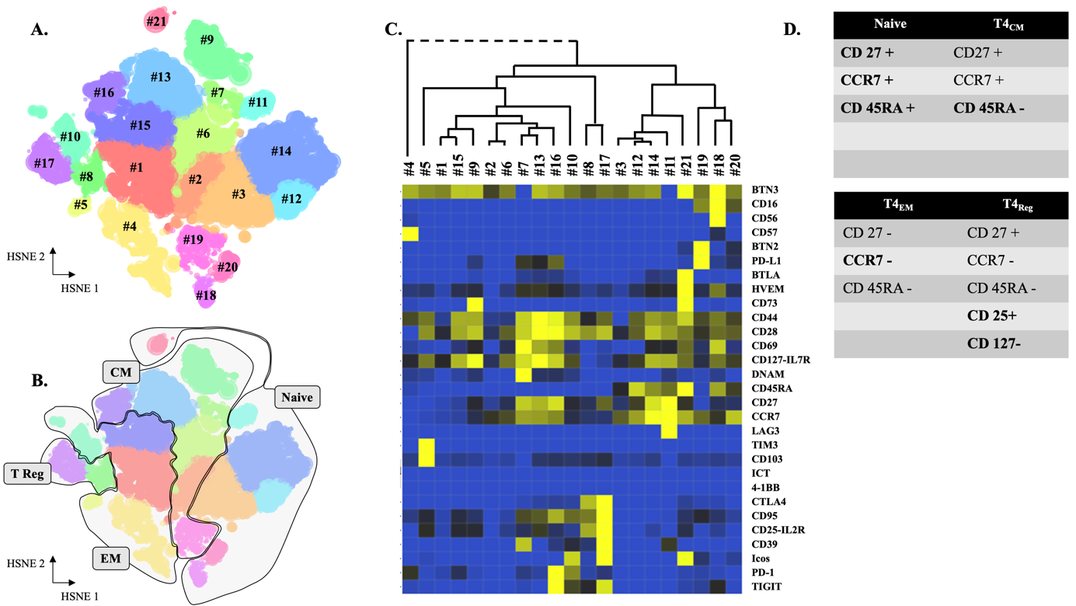

Supplementary Figure 4. Annotation of CD4+ T cell clusters.
(A) CD4⁺ T-cells are clustered based on the expression of various phenotypic markers using unsupervised h-SNE analysis with Cytosplore. The clusters are projected into two dimensions, and 21 CD4⁺ T cell compartments are identified based on phenotypic marker expression. (B) Identification of four main subpopulations of CD4⁺ T cells. (C) Heatmap showing the normalized and batch-corrected expression of the markers for the 21 CD4⁺ T cell Cytosplore clusters. Clusters are formed based on surface marker expression profiles. (D) Surface marker combinations used to identify CD4⁺ T cell subsets. CM, central memory; EM, effector memory; Tregs, regulatory T cells.

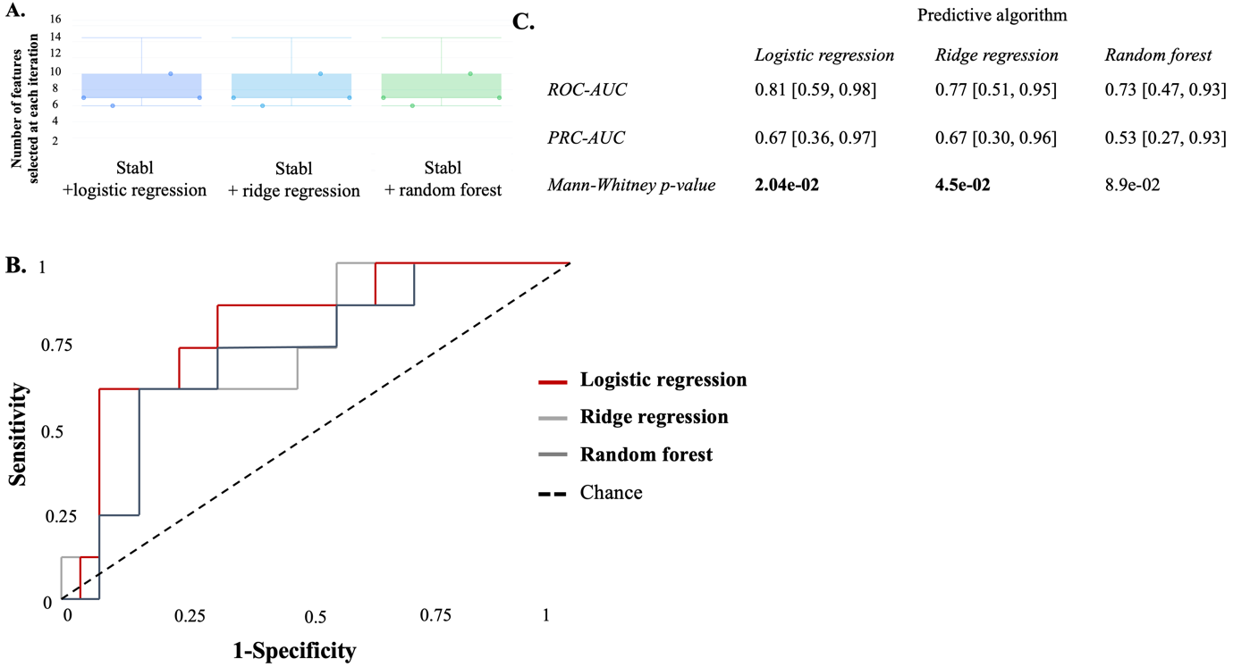

Supplementary Figure 5. Comparison of machine learning-derived models for preoperative POPF prediction with logistic regression, ridge regression, and random forest algorithms.
The reference line represents the performance of a random guess. (A) Number of selected features over cross-validation. Graph representing the number of selected features at each iteration over the cross-validation process (five-fold). Notably, each algorithm finally selects the same 11 features. (B) ROC curves of derived models for preoperative POPF prediction. (C) Score predictions over cross-validation. Bold characters indicate statistical significance, set at P<0.05 required for significance. AUC, area under the curve; PRC, precision-recall; ROC, receiver operating characteristic.

Supplementary Tables

Supplementary Table 1. Mass cytometry panel

Panel 1. Natural killer lymphocyte-oriented

Antigen | Metal |  | Company
CD45 | 89Y | Extracellular | Standard Biotools
BTN3 | 106Cd | Extracellular | Home made*
BTN2 | 112Cd | Extracellular | Home made*
CD3 | 115In | Extracellular | Home made*
TCRVd2 | 141Pr | Extracellular | Beckman Coulter*
CD19 | 142Nd | Extracellular | Standard Biotools
CD45RA | 143Nd | Extracellular | Standard Biotools
CD4 | 145Nd | Extracellular | Standard Biotools
CD8a | 146Nd | Extracellular | Standard Biotools
NKG2C | 147Sm | Extracellular | Miltenyi
EOMES | 149Sm | Intracellular | BD Biosciences
BCL-2 | 150Nd | Intracellular | Cell Signaling*
CD107a | 151Eu | Intracellular | Standard Biotools
SIGLEC 7 | 152Sm | Extracellular | Immunomonitoring*
TCRpangd | 153Eu | Extracellular | Miltenyi
CD158b1/b2j | 154Sm | Extracellular | Beckman Coulter*
CD27 | 155Gd | Extracellular | Standard Biotools
BCL-Xl | 158Gd | Intracellular | Cell Signaling*
Ki-67 | 159Tb | Intracellular | BioLegend
CD96 | 160Gd | Extracellular | BD Pharmigen
Tbet | 161Dy | Intracellular | Standard Biotools
NKp46 | 162Dy | Extracellular | Standard Biotools
CD158a/h | 163Dy | Extracellular | Beckman Coulter*
NKG2A | 165Ho | Extracellular | Miltenyi
NKG2D | 166Er | Extracellular | Standard Biotools
NKp30 | 169Tm | Extracellular | Beckman Coulter*
CD33 | Er170 | Extracellular | Biolegend
DNAM-1 | 171Yb | Extracellular | Standard Biotools
CD57 | 172Yb | Extracellular | Standard Biotools
Granzyme B | 173b | Intracellular | Standard Biotools
CD56 | 176Yb | Extracellular | Standard Biotools
CD16 | 209Bi | Extracellular | Standard Biotools

Panel 2. T Lymphocyte oriented
Antigen | Metal/  Fluorochrome |  | Company
CD45 | 89Y | Extracellular | Standard Biotools
BTN3 | 106Cd | Extracellular | Home made*
BTN2 | 112Cd | Extracellular | Home made*
CD3 | 115In | Extracellular | Home made*
Ki-67 | 141Pr | Intracellular | BioLegend
CD45RA | 143Nd | Extracellular | Standard Biotools
HVEM | 144Nd | Extracellular | Standard Biotools
CD8a | 146Nd | Extracellular | Standard Biotools
CD278 (ICOS) | 148Nd | Extracellular | Standard Biotools
CD25 | 149Sm | Extracellular | Standard Biotools
OX-40 | 150Nd | Extracellular | Standard Biotools
CD103 | 151Eu | Extracellular | Standard Biotools
CD39 | 152Sm | Extracellular | Standard Biotools
TIM-3 | 153Eu | Extracellular | Standard Biotools
TIGIT | 154Sm | Extracellular | Standard Biotools
PD-1 | 155Gd | Extracellular | Standard Biotools
PD-L1 | 156Gd | Extracellular | Standard Biotools
4-1BB | 158Gd | Extracellular | Standard Biotools
CCR7 | 159Tb | Extracellular | Standard Biotools
CD28 | 160Gd | Extracellular | Standard Biotools
CTLA-4 | 161Dy | Intracellular | Standard Biotools
FOXP3 | 162Dy | Intracellular | Standard Biotools
BTLA | 163Dy | Intracellular | Standard Biotools
CD95 | 164Dy | Extracellular | Standard Biotools
CD127 | 165Ho | Extracellular | Standard Biotools
CD44 | 166Er | Extracellular | Standard Biotools
CD27 | 167Er | Extracellular | Standard Biotools
CD69 | 168Er | Extracellular | Standard Biotools
TCRVd2 | 169Tm | Extracellular | Standard Biotools
DNAM-1 | 171Yb | Extracellular | Standard Biotools
CD57 | 172Yb | Extracellular | Standard Biotools
CD73 | 173Yb | Extracellular | Standard Biotools
CD4 | 174Yb | Extracellular | Standard Biotools
LAG3 | 175Lu | Extracellular | Standard Biotools
CD56 | 176Yb | Extracellular | Standard Biotools
CD16 | 209Bi | Extracellular | Standard Biotools

*Purified antibodies labeled with a Maxpar® antibody labeling kit. IT, Immunomonitoring platform (Paoli-Calmettes Institute, Cancer Research Center of Marseille).

Supplementary Table 2. Study participant characteristics and postoperative outcomes depending on the POPF group

 | No POPF, No (%)  n=14 | POPF, No (%)  n=8 | Univariable analysis,  P value
Sex |  |  | 1
Male | 7 (50) | 4 (50)
Female | 7 (50) | 4 (50)
Age, mean (SD), years | 67.3 (± 14) | 68.5 (± 7) | 0.62
BMI, mean (SD), kg/m² | 24.3 (± 5) | 24.1 (± 2) | 0.52
FRS score*, median (IQR 25–75) | 17 [11.2;26.8] | 33.5 [31;36.8] | 0.014
Operative duration, mean (SD), min | 420 (± 63) | 484 (± 95) | 0.12
Blood loss, median (IQR 25–75), ml | 250 [200;300] | 200 [188;250] | 0.59
Soft pancreatic texture | 6 (43) | 8 (100) | 0.018
Main pancreatic duct, median (IQR 25–75), mm | 3.5 [2.25;7.00] | 2 [1.75;4.00] | 0.24
PreopD Lymphocytes, mean (SD), G/L | 2.12 (±1.10) | 1.93±0.97 G/L | 0.69
Lymphocytes POD1, mean (SD), G/L | 1.36 (±0.68) | 1.19 (±0.49) | 0.17
Lymphocytes POD3, mean (SD), G/L | 1.25 (±0.48) | 0.84 (± 0.25) | 0.05
Lymphocytes POD7, mean (SD), G/L | 1.34±0.57 G/L | 0.96±0.22 G/L | 0.029
NLR POD3, median (IQR 25–75) | 7.68 [4;10.3] | 13.3 [6.97;15.8] | 0.074
CRP POD3, median (IQR 25–75) | 98 [72;201] | 255 [239;276] | <0.01
PCT POD1, median (IQR 25–75) | 0.27 [0.16;0.46] | 1.45 [0.63;2.65] | 0.014
PCT POD3, median (IQR 25–75) | 0.35 [0.23;0.50] | 1.43 [0.58;2.64] | 0.017
DFA POD1, median (IQR 25–75) | 100 [18;932] | 2313 [958;5571] | 0.012
Outcomes
Clavien ≥3 (%) | 1 (7.1) | 3 (37.5) | 0.044
Hemorrhage | 1 (7.1) | 2 (25) | 0.53
Reintervention | 7.1 | 25 | 0.53
Length of stay, mean (SD), days | 16.4 (± 5) | 22 (± 4.5) | 0.02
90-day mortality | 0 | 1 (12.5) | 1

CRP, C-Reactive Protein; DFA, drain fluid amylase; FRS, Fistula Risk Score; IQR, interquartile range; NLR, neutrophil-to-lymphocyte ratio; PCT, procalcitonin; POD, postoperative day; POPF, postoperative pancreatic fistula; PreopD, preoperative day; SD, standard deviation. * either ua-FRS for pancreatoduodenectomy or D-FRS for distal pancreatectomy. Fisher’s exact test or the Chi-square test for qualitative variables and the Mann–Whitney test for quantitative variables are used. Bold characters indicate statistical significance, which is set with P<0.05 required for significance.

Supplementary Table 3. Multivariate analysis of confounding factors

 | Multivariate analysis
 |  | OR [95%CI] | P value
Male sex |  | 1.2 [0.34, 4.40] | 0.76
BMI |  | 0.8 [0.24, 2.50] | 0.66
Soft Pancreatic texture |  | 786 [0, inf] | 0.95
Main pancreatic duct diameter |  | 1.1 [0.24, 5.40] | 0.87
PFLS with STABL |  | 1.3 [0.41, 4.00] | 0.67

CI, confidence interval; BMI, body mass index; OR, odds ratio; PFLS, Pancreatic Fistula Lymphocytes Signature. Bold characters indicate statistical significance, set at P<0.05 required for significance.

Supplementary Table 4. Predictive score of POPF in the pre (PFLS), intra (ua-FRS), and post (DFA and NLR) operative setting

 | Predictive scores
 | AUROC [95%CI] | P value
PFLS with STABL | 0.81 [0.59; 0.98] | 0.02
ua-FRS | 0.82 [0.60; 0.99] | 0.017
DFA POD1 | 0.86 [0.67; 0.98] | 0.008
NLR POD3 | 0.72 [0.44; 0.94] | 0.10
PFLS + ua-FRS | 0.86 [0.68;0.99] | 0.0074

CI, confidence interval; AUROC, area under the receiver operating characteristic curve; DFA, drain fluid amylase; ua-FRS, updated alternative fistula risk score; NLR, neutrophil-to-lymphocyte ratio; PFLS, pancreatic fistula lymphocyte signature on preoperative day; POD, postoperative day. Bold characters indicate statistical significance, set at P<0.05 required for significance. The derived models are validated with five-fold cross validation.

References
1. Dindo, D., Demartines, N. & Clavien, P. A. Classification of surgical complications: A new proposal with evaluation in a cohort of 6336 patients and results of a survey. Ann. Surg. 240, 205–213 (2004).
2. Bassi, C., et al. The 2016 update of the International Study Group (ISGPS) definition and grading of postoperative pancreatic fistula: 11 years After. Surgery 161, 584–591 (2017).
3. Wente, M. N., et al. Postpancreatectomy hemorrhage (PPH): an International Study Group of Pancreatic Surgery (ISGPS) definition. Surgery 142, 20–25 (2007).
4. Ben Amara, A., et al. High-throughput mass cytometry staining for deep phenotyping of human natural killer cells. Star Protoc. 3, 101768 (2022).

