Supplementary Materials
Supplementary Table1. Real-time PCR sequences
Gene | Forward Primer (5’-3’) | Reverse Primer (5’-3’)
β-actin | GATTACTGCTCTGGCTCCTAGC | GACTCATCGTACTCCTGCTTGC
GFAP | CGGAGACGCATCACCTCTG | AGGGAGTGGAGGAGTCATTCG
Iba1 | ATCAACAAGCAATTCCTCGATGA | CAGCATTCGCTTCAAGGACATA
CD31 | ACGCTGGTGCTCTATGCAAG | TCAGTTGCTGCCCATTCATCA
IL-1β | GCAACTGTTCCTGAACTCAACT | ATCTTTTGGGGTCCGTCAACT
IL-6 | TAGTCCTTCCTACCCCAATTTCC | TTGGTCCTTAGCCACTCCTTC
TNF-α | CCCTCACACTCAGATCATCTTCT | GCTACGACGTGGGCTACAG
TGF-β2 | TCGACATGGATCAGTTTATGCG | CCCTGGTACTGTTGTAGATGGA
Caspase-1 | ACAAGGCACGGGACCTATG | TCCCAGTCAGTCCTGGAAATG
Caspase-3 | TGGTGATGAAGGGGTCATTTATG | TTCGGCTTTCCAGTCAGACTC
VEGFA | GCACATAGAGAGAATGAGCTTCC | CTCCGCTCTGAACAAGGCT
VEGFR2 | TTTGGCAAATACAACCCTTCAGA | GCAGAAGATACTGTCACCACC
VCAM-1 | AGTTGGGGATTCGGTTGTTCT | CCCCTCATTCCTTACCACCC
ICAM-1 | GGCCTCAAGTCTCACCATTCC | ATAAGAGGCTGCCATCACGAG
Supplementary Table 1. Animal primers sequence.
Supplementary Figure 1 Open field test and Y maze test results of different sex mice. (A) Both types of mice moved a total distance across the box, including the periphery and central area. The total distance reflects the autonomous activity of mouse. Both males and females decreased their autonomous activity ability at 9-month-old APP/PS1 mice. (B and C) The speed of the mice when moving in the region was faster when exploring and slower when immobile. Female mice had lower mobility and were more depressed. (D) The total distance traveled in the peripheral area reflected the distance the mice walked to the side, and the more anxious they were more in the peripheral area. Anxiety was more pronounced in female mice. (E) Mice with good spatial memory traversed more times. Time (F) and number (G) of entries into the novel arm. Mice with good learning memory were trained to remember the two arms visited, they were more explore to the novel arm. Female mice had poor spatial memory and male mice had poor learning memory at 9-month-old mice. * for comparison between two groups of mice in the same age, and # for comparison between APP/PS1 mice in different months. (*p < 0.05, **p < 0.01, ***p < 0.001. #p < 0.05, ##p < 0.01, ###p < 0.001).

Supplementary Figure 2 Aβ₁₋₄₂ deposition in the cerebral cortex of APP/PS1 mice in 1-, 3-, 6-, 9-, 12-month-old. Left column shows Aβ₁₋₄₂ (red), the middle column indicates DAPI (blue) and the right column is confocal. Scale bars: 100 μm. n = 3 mice/group for staining.
Supplementary Figure 3 Cortex Aβ₁₋₄₂/Aβ₁₋₄₀ ratios and CSF Aβ₁₋₄₂ in different sex mice. Cortex Aβ₁₋₄₂/Aβ₁₋₄₀ ratios were measured in 1-, 3-, 6-, 9-, 12-month-old APP/PS1 mice. CSF Aβ₁₋₄₂ was measured in the same month APP/PS1 mice. (A) The Aβ₁₋₄₂ and Aβ₁₋₄₂/Aβ₁₋₄₀ ratios (C) in cortex showed a significant increase from 9-month-old, the Aβ₁₋₄₂ in CSF (D) was significant declined from 3-month-old in the female.

Supplementary Figure 4 Left column shows WT mice, the middle and right column indicates APP/PS1 mice of different ages. Brain frozen sections of 10 μm were stained with NeuN (red), CD31 (red), Tunel (green), and DAPI (blue). Scale bar: 100 μm. n = 3 mice/group for staining.

Supplementary Figure 5 CD31 (green), Aβ₁₋₄₂ (red), DAPI(blue) in the cerebral cortex of APP/PS1 mice at 6-, 9-, 12-month-old. Some blood vessels are co-localized with Aβ₁₋₄₂, Aβ₁₋₄₂ surrounded with the microvessels. Scale bars: 100 μm. n = 3 mice/group for staining.
Supplementary Figure 6 GFAP in the cerebral cortex of mice in 1-, 3-, 6-, 9-, 12-month-old. Left column shows WT mice and the right column is age-matched APP/PS1. Scale bars: 100 μm. n = 3 mice/group for staining.
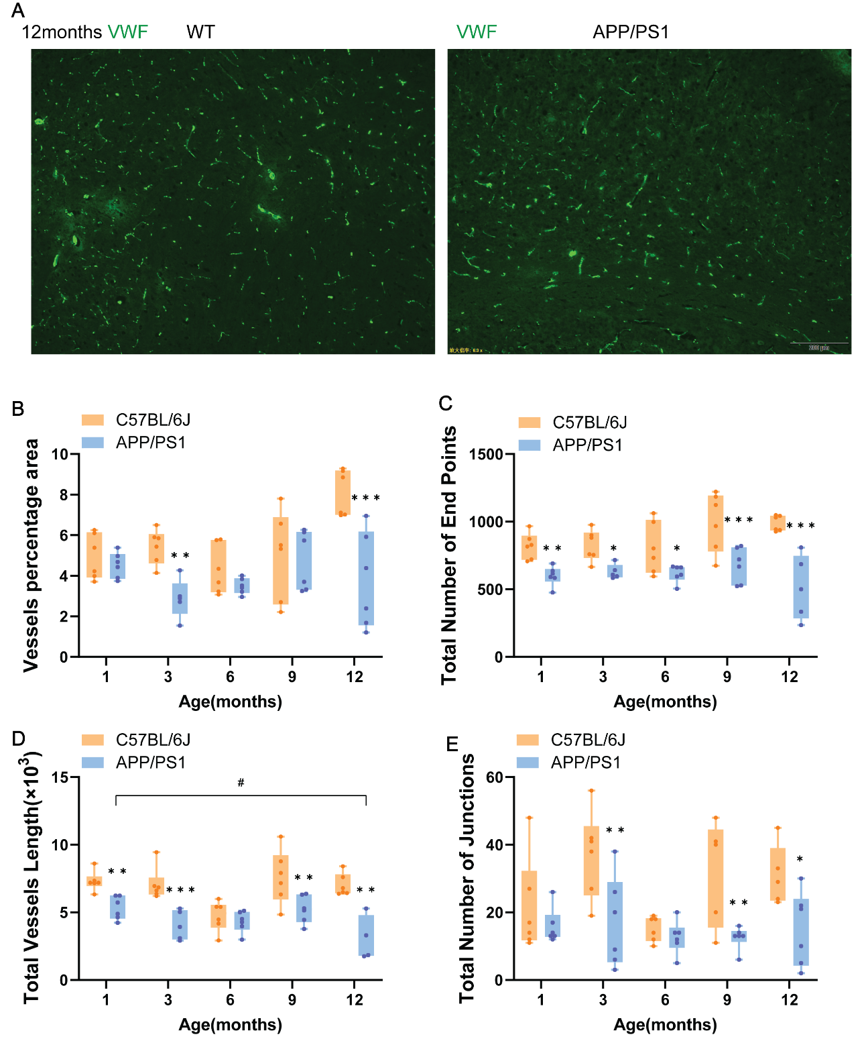
Supplementary Figure 7 Vascular network number and function of APP/PS1 mice was worse in the cortex. (A) Left column shows control mice and the right column indicates APP/PS1 mice of 12-month-old. Brain frozen sections of 10 μm were stained with vWF (green), and DAPI (blue). (B) Vascular density is the vascular percentage area, defined as the percentage of area occupied by vessels inside the explant area. (C) Total Number of End Points, defined as the number of open ended segments. (D) Total lengths of all the vessels in the cortex. (E) Branch index (total number of branches/ the explant area of vascular network), the node formed at the branch is the junction density. n = 3 mice/group for staining
Supplementary Figure 8 CD31 (red), VEGFR2 (green), and DAPI (blue) in the cerebral cortex of mice in 1-, 3-, 6-, 9-, 12-month-old. Left column shows WT mice and the right column is age-matched APP/PS1. Scale bars: 100 μm. n = 3 mice/group for staining.

Table2. Correlation analysis of microvascular and Aβ amyloid level in APP/PS1 mice
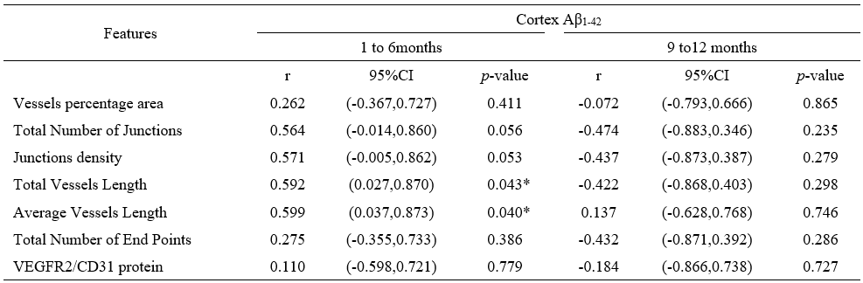
Supplementary Table 2. Correlation analysis in APP/PS1 mice. Vascular network indicators showed a positive correlation during development (1 to 6 months) but a negative correlation during disease (9 to12 months) with the concentration of Aβ₁₋₄₂. The total and average vessel lengths were positively correlated with cortical Aβ₁₋₄₂, with correlation coefficients of 0.592 and 0.599.

Supplementary Figure 9 Expression of intercellular cell adhesion molecules in 1-, 3-, 6-, 9-, 12-month-old mice. (A) Relative mRNA expression levels of ICAM-1 in mouse cortex. (B) ICAM-1 were corrected for results using cortical capillary relative expression. (C) Relative mRNA expression levels of VEGFA in mouse cortex. Abbreviations: ICAM-1, Intercellular Cell Adhesion Molecule-1; VEGF, Vascular endothelial growth factor. Data indicate the mean ± SD. n = 3-5 mice/group for RT-qPCR. Two-way ANOVA with Bonferroni multiple-comparison test. * for comparison between two groups of mice in the same age, and # for comparison between APP/PS1 mice in different months. (*p < 0.05, **p < 0.01, ***p < 0.001. #p < 0.05, ##p < 0.01, ###p < 0.001).

