Supplementary Information
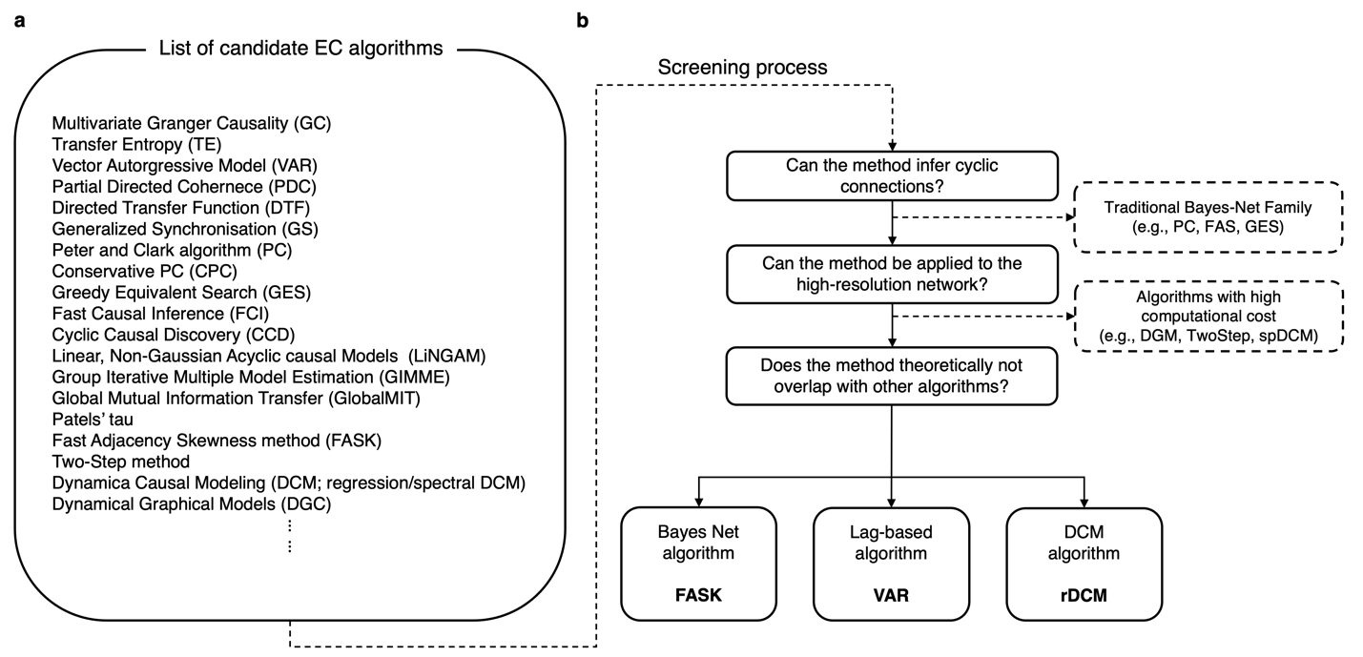
Supplementary Figure 1. Schematic of screening procedure to select individual EC algorithms
a, A (non-exhaustive) list of existing EC algorithms. We focused on the algorithms included in the two large-scale benchmark studies^{1,2}, allowing for a systematic survey of individual EC algorithms’ overall performance and characteristics. b, A flowchart of the screening procedure. Initially, we screened for algorithms capable of detecting cyclic connections, which eliminated most Bayesian network methods due to their limited inference to only the acyclic graphs. The second criterion assessed applicability to high-resolution networks such as MMP-360 atlas³. This step excluded algorithms requiring substantial computational resources, such as the Two-Step algorithm from Bayesian network category (which takes two orders of magnitude more computation time compared to FASK²) and the spectral DCM from DCM category (which takes approximately 40 hours to estimate effective connectivity for a network of 32 nodes⁴). The final selection criterion was the mathematical uniqueness; we chose one algorithm per category to avoid theoretical redundancy. These criteria collectively resulted in the selection of three final algorithms: Fast Adjacency Skewness method (FASK), Vector AutoRegressive model (VAR), and regression DCM (rDCM). Notably, VAR was chosen over granger causality (GC) because the latter measures information transmission rate rather than connectivity per se, and the post-hoc analysis showed significantly higher accuracy of EC mapping in VAR compared to GC (see Supplementary Fig 10 for more details).
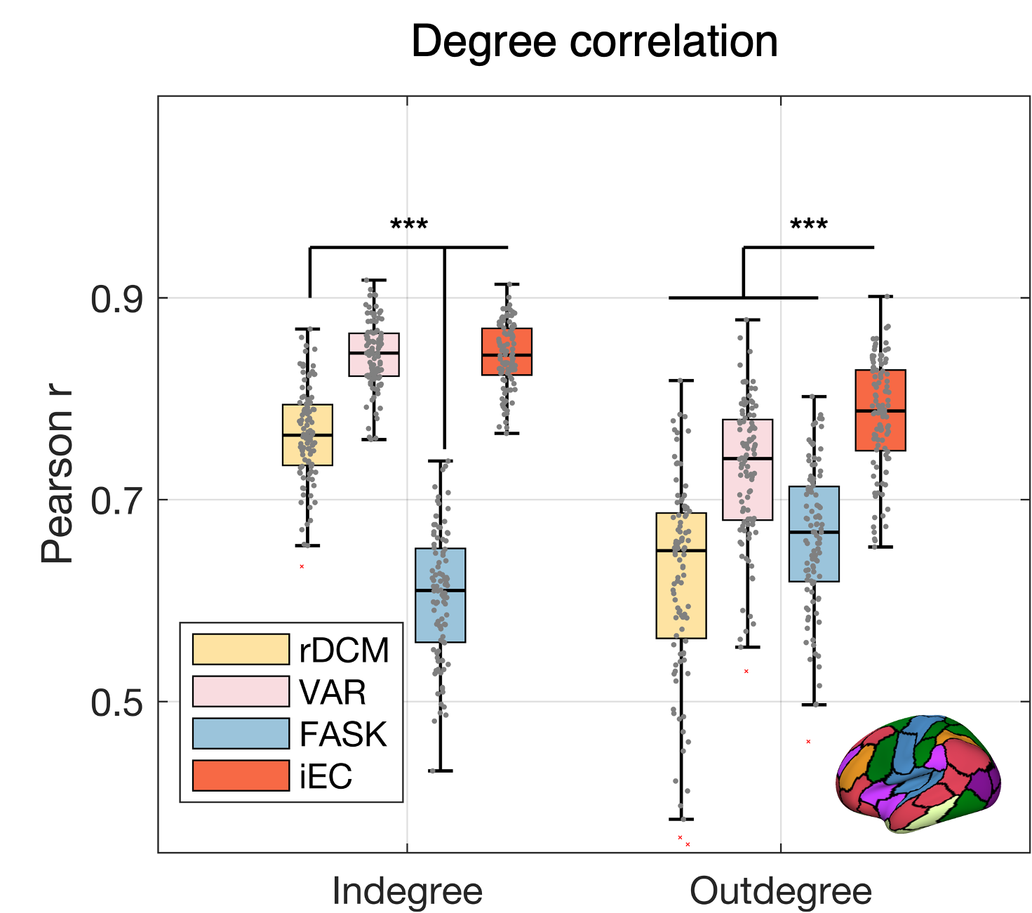
Supplementary Figure 2. Correlation of degree distribution when using Schaefer-100
The correlation of in- and out-degree distributions between the outcomes of EC algorithms and ground truth when using the Schaefer-100 atlas. The pattern emphasizes iEC's improved correlation in accurately capturing both in- and out-degree distributions, albeit a comparable performance with VAR in in-degree accuracy.

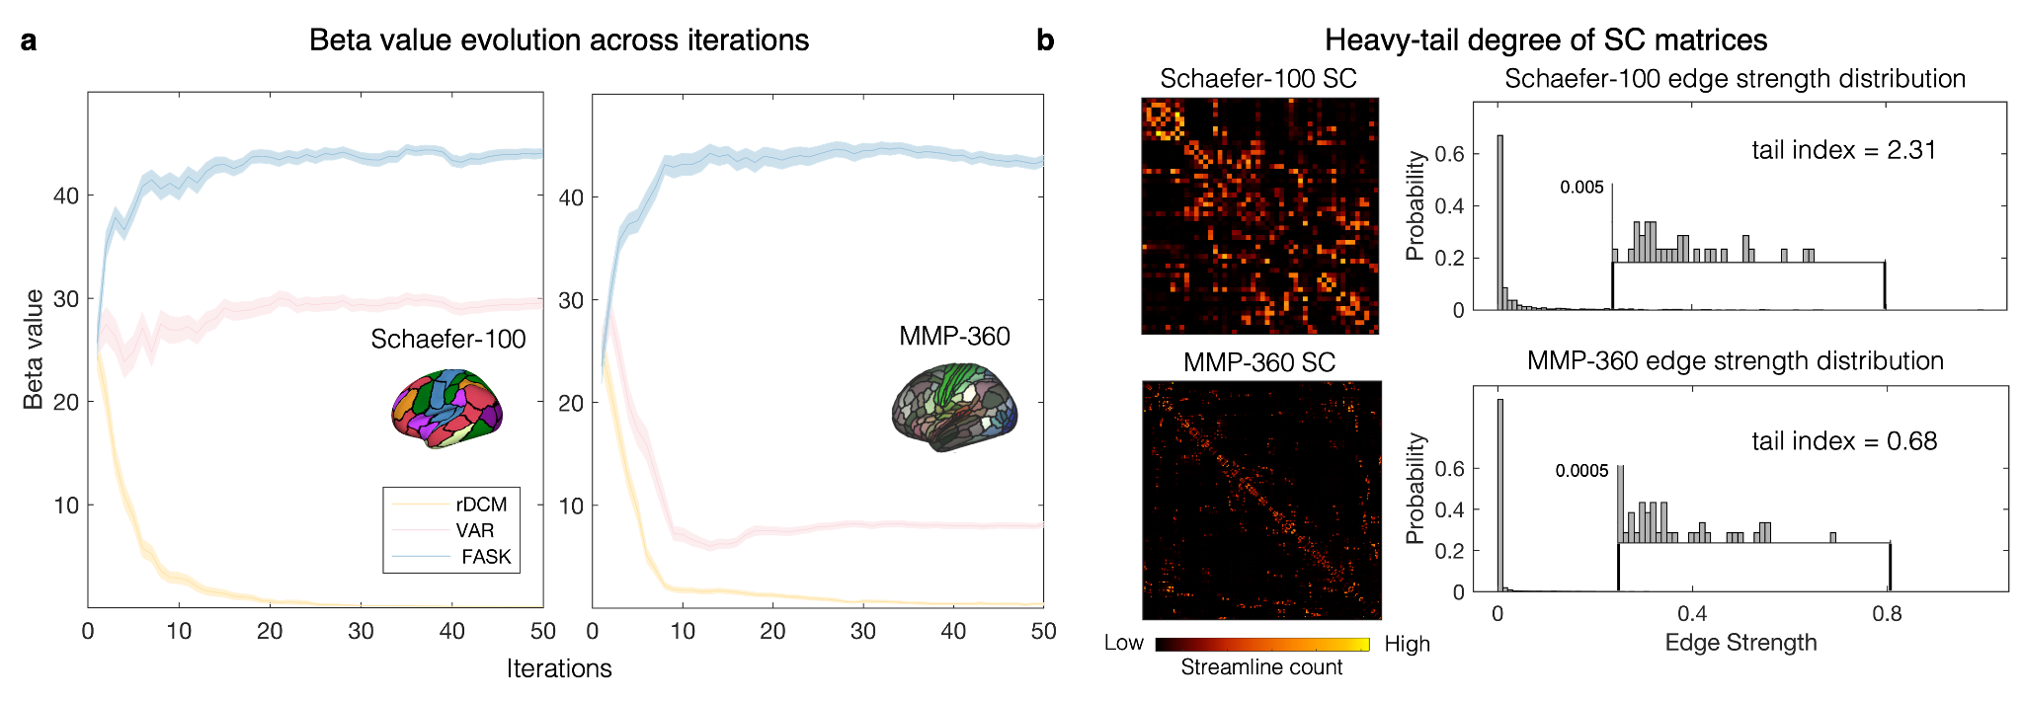
Supplementary Figure 3. Evolution of beta values in the simulation analysis
a. Evolution of β values over iterations. The results were obtained from the simulation analysis of Schaefer-100 and MMP-360 atlases. The middle solid line represents the mean β values across iterations, while the shaded area denotes the standard error of the mean over 100 iterations. The β of each algorithm consistently converges across the iterations in both atlases. Note the increased gap between converged βs between FASK and VAR in MMP-360, (highlighting a higher contribution of FASK). Moreover, the magnitude of βs was aligned with the EC detection performance ranking of the individual algorithms, demonstrating efficacy of our iEC framework in synergistically weight-summing individual algorithms depending on their accuracy. b. Post-hoc analysis for interpreting results in panel a. In panel a, the evolution of βs showed a unique pattern, where the gap between the first (FASK) and second (VAR) ranks drastically increased as the parcellation resolution increased from Schaefer-100 to MMP-360. We hypothesized that this increased gap (particularly highlighting FASK) was to capture the underlying edge strength distribution, where the sparse but potent connections make the distribution heavy-tailed (indicated by tail index, where a lower tail index value represents a more heavy-tailed distribution). Indeed, when we measured the tail index of the edge strength distribution, MMP-360 displayed a 3-fold higher tail index than for Schaefer-100. This suggests that FASK, which infers a sparse connection matrix (approximately 5% density for MMP-360), identifies potent and sparse connections that lie in the heavy-tail side of the distribution. Consequently, the β value of FASK was increased to better capture the heavy-tail distribution.
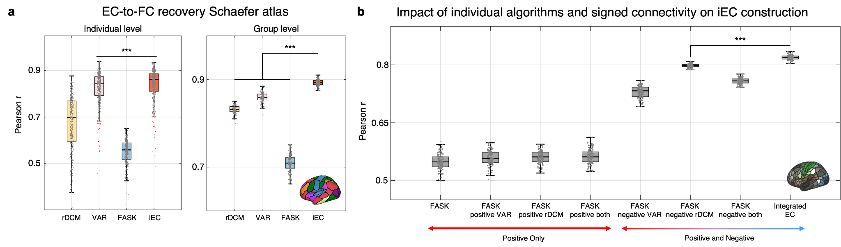
Supplementary Figure 4. EC-to-FC recovery from Schaefer 100 atlas and impact of negative connections
a, EC-to-FC recovery results from the Schaefer-100 at individual (left) and group level (right). At this coarse-level resolution, VAR already yields a simulated FC that shows a high correlation of 0.84 with the empirical FC. The performance increase of iEC is only marginal at the individual level (left), although the difference is statistically significant (p<0.001). At the group level, the efficacy of all algorithms, including iEC, is heightened due to the improved signal-to-noise ratio, and iEC significantly outperforms individual algorithms (right). b, To explore the effects of connection polarities on the iEC estimation, we constructed the iEC matrix by sequentially incorporating different EC components. We started our test with FASK, due to its high 𝛽 values across all evaluations. The order of incorporation was following: i) FASK alone, ii) FASK combined with positive ECs from VAR or rDCM or both, iii) FASK combined with negative ECs from VAR or rDCM or both, iv) all algorithms including both positive and negative EC (equivalent to iEC). This analysis revealed that the positive EC did not enhance the accuracy of EC-to-FC recovery beyond what FASK already achieved, whereas the negative ECs appeared to substantially enhance the accuracy of capturing underlying network dynamics. Please note that however, in constructing the final iEC, the incorporation of positive ECs is still proven as advantageous compared to the accuracy from FASK+negative rDCM (indicated by the asterisk).
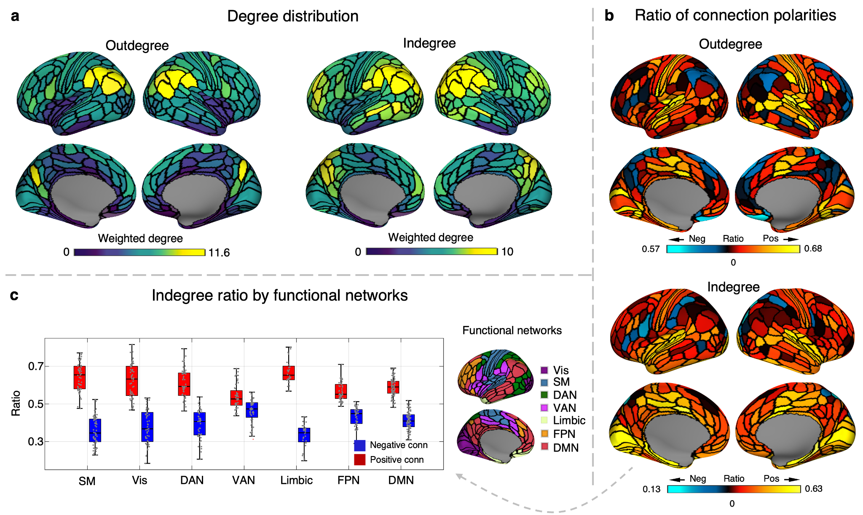
Supplementary Figure 5. The iEC network profiling of the resting state human brain
a, The degree distribution of the iEC. While the angular gyrus and precuneus show increase in both out- and in-degree, the indegree was more pronounced in a wider coverage of DMN (e.g., frontal and temporal cortex) during the resting state. b, The positive-negative ratio of outdegree and indegree connections is shown. (Outdegree) Heteromodal and basal forebrain regions are skewed toward negative connections, while the primary sensory areas predominantly feature positive connections. (Indegree) The dorsal and ventral attention networks receive more negative than positive connections, while the early visual area, medial temporal lobe, and insula show a higher proportion of positive connections. c, The distribution of positive and negative ‘incoming’ connections profiled according to the Yeo-Krienen atlas. The ventral attention network displays the most balanced ratio of positive to negative connections, while the limbic areas receive the fewest negative connections.
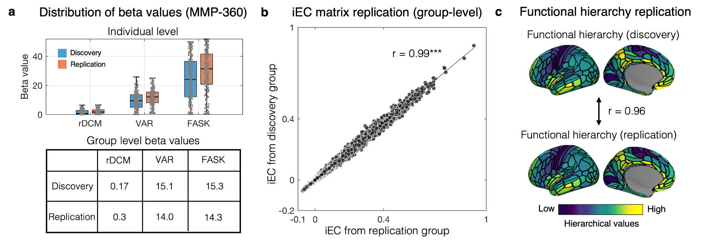
Supplementary Figure 6. Replication of iEC framework across different sample groups
a, The distributions of 𝛽 values for individual algorithms across two different groups of data (discovery / replication: n=220, respectively) at the individual (top) and group levels (bottom). At the individual level, the 𝛽 values show a consistent pattern between the two groups: rDCM has consistently low 𝛽 values (median 𝛽= 1.7 / 0.7 for discovery / replication), VAR shows intermediate 𝛽 values (median 𝛽 = 12.0 / 9.5 for discovery / replication), and FASK has the highest 𝛽 values (median 𝛽 = 31.4 / 24.1 for discovery / replication). A similar pattern is observed at the group level, although the 𝛽 value for FASK show a slight decrease. b, A scatter plot illustrating the correlation pattern between the iEC matrices derived from two independent groups. Group-level iEC matrices were generated by averaging individual EC matrices for each algorithm within each group. The 𝛽 values estimated from one group were applied to the other group to produce two different iEC matrices to test generalizability. Reflecting the high SNR at the group level and the nearly identical 𝛽 value patterns, the iECs from the two groups showed an almost perfect alignment (r = 0.99). c, Functional hierarchies derived from the two groups also displayed an excellent reproducibility (r=0.96).
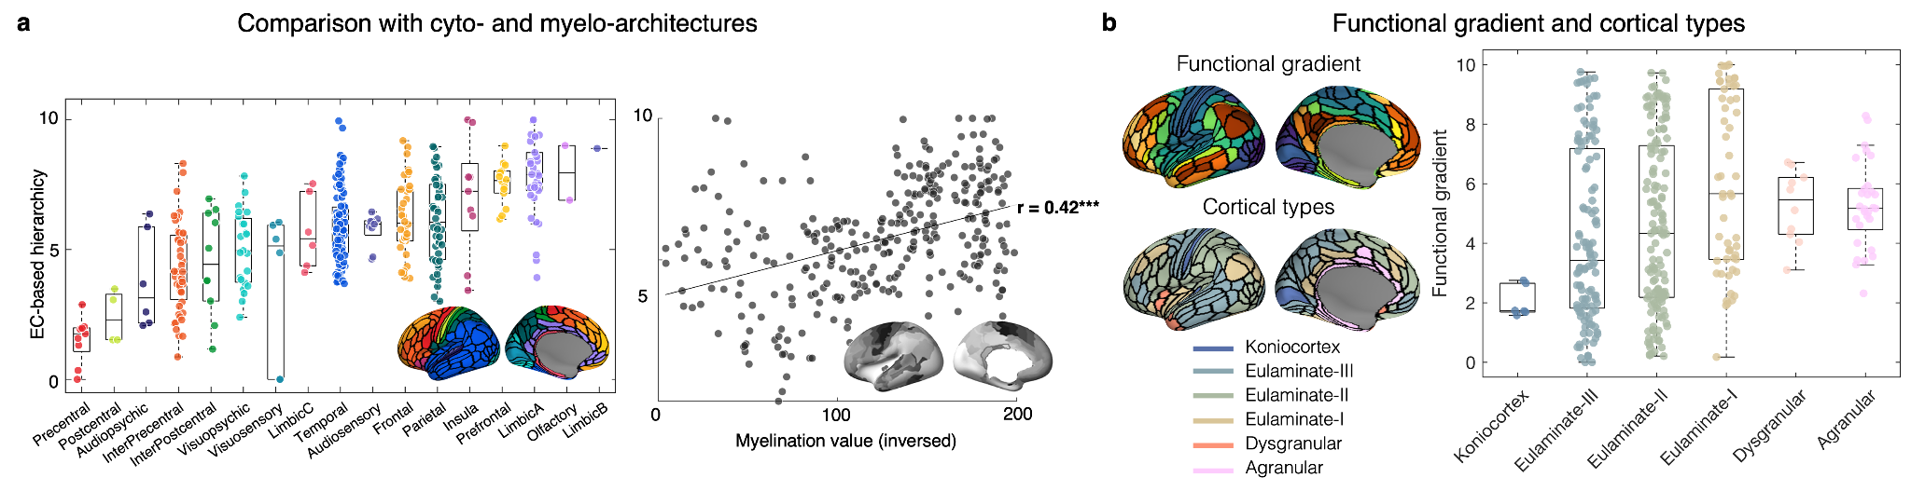
Supplementary Figure 7. Functional gradient measured using cortical type atlas
a, The relationship between the identified signal flow hierarchy and cyto- and myelo-architectural^{5,6} features derived from histological atlases. b, Functional connectivity gradient sorted out according to hierarchically ordered cortical types. Unlike our iEC-derived functional hierarchy, which shows a gradual increase towards dysgranular and agranular areas, the gradient value showed i) generally larger variability across cortical types and ii) a peak at the eulaminate-I, which encompasses largely the default mode network regions.
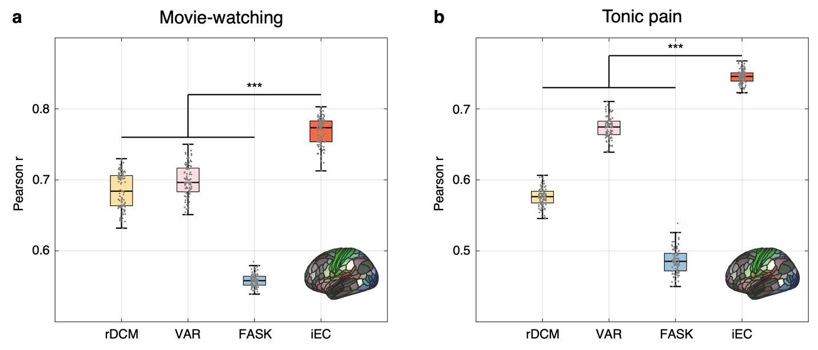
Supplementary Figure 8. FC recovery results of movie-watching and tonic pain fMRI data at the group level
a, Group-level FC recovery results from movie-watching fMRI. Overall pattern of the performance of individual algorithms is in line with our results from resting fMRI. The optimal βs are 𝛽_{rDCM}=0.7, 𝛽_{VAR}=13.5, 𝛽_{FASK}= 31.6 showing a similar pattern with β values from resting fMRI. b, Group-level FC recovery results from tonic-watching fMRI. Although the pattern of the individual algorithms is similar to other results, there is a significant increase of VAR’s performance. Reflecting this change, the optimal beta values are 𝛽_{rDCM}=0.1 𝛽_{VAR}=24.9, 𝛽_{FASK}= 7.4. In all states, iEC shows significantly higher performance compared to individual algorithms (p_{FDR}<0.001).

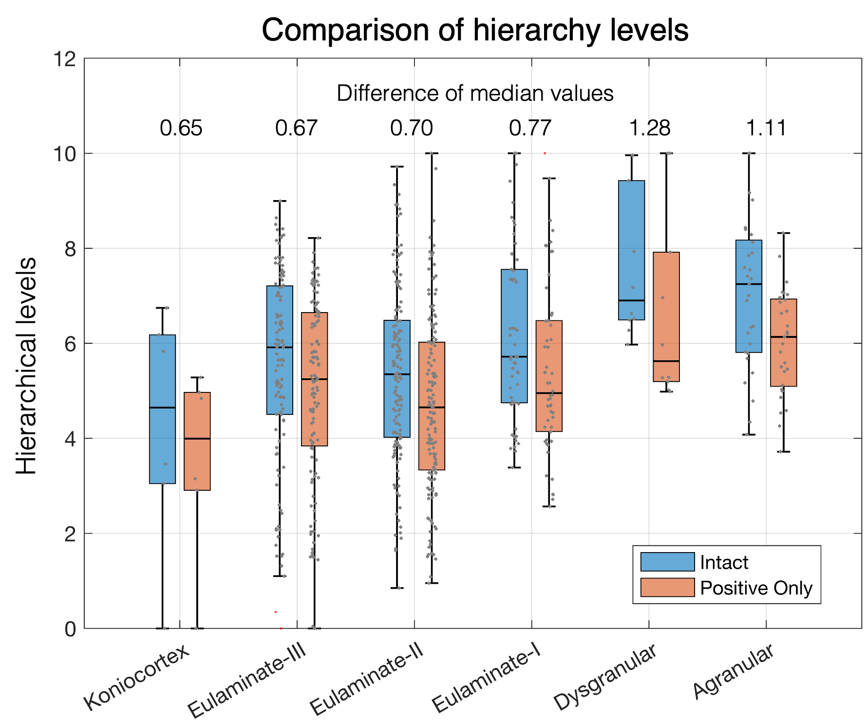
Supplementary Figure 9. Impact of negative connections on the signal flow hierarchy
To assess the impact of negative connections on hierarchy estimation, we compared the signal flow hierarchy derived from the original intact iEC and the one constructed by only positive iEC. Significant differences in hierarchy were observed across all cortical types except for the koniocortex. Notably, the disparity in median values increased as cortical types transitioned toward less or non-granular regions, suggesting that the inclusion of negative connections enhances hierarchy estimation in the higher-order cortical areas.

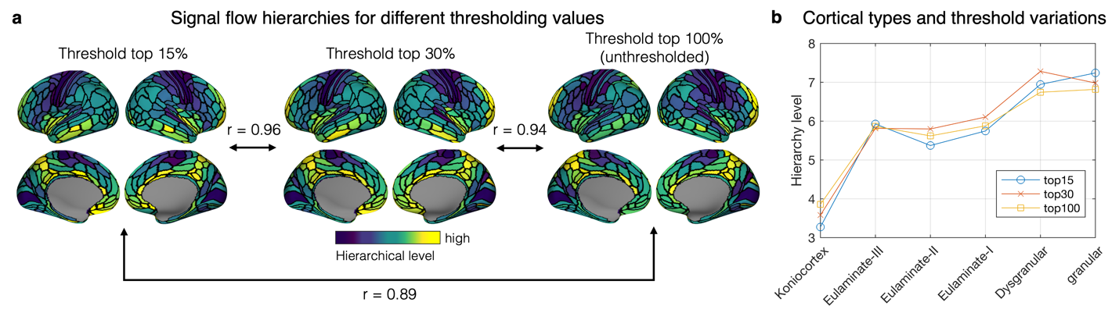
Supplementary Figure 10. Comparison of signal flow hierarchies for different threshold values
a, Signal flow hierarchy maps constructed based on the iEC thresholded by various cut-off values (15, 30, 100%). The organizational structure of the signal flow hierarchy remains robust across different thresholds, exhibiting a high correlation of >0.9 r-values between the maps. b, Median values for each cortical type were measured from the signal flow hierarchy maps derived from different thresholding values. The patterns show a highly significant overlap, indicating a stable and robust detection of our signal flow hierarchy against different network thresholds.

References
1. Smith, S. M. et al. Network modelling methods for FMRI. Neuroimage 54, 875–891 (2011).
2. Sanchez-Romero, R. et al. Estimating feedforward and feedback effective connections from fMRI time series: Assessments of statistical methods. Netw Neurosci 3, 274–306 (2019).
3. Glasser, M. F. et al. A multi-modal parcellation of human cerebral cortex. Nature 536, 171–178 (2016).
4. Razi, A. et al. Large-scale DCMs for resting-state fMRI. Netw Neurosci 1, 222–241 (2017).
5. Pijnenburg, R. et al. Myelo- and cytoarchitectonic microstructural and functional human cortical atlases reconstructed in common MRI space. Neuroimage 239, 118274 (2021).
6. Foit, N. A. et al. A whole-brain 3D myeloarchitectonic atlas: Mapping the Vogt-Vogt legacy to the cortical surface. Neuroimage 263, 119617 (2022).

