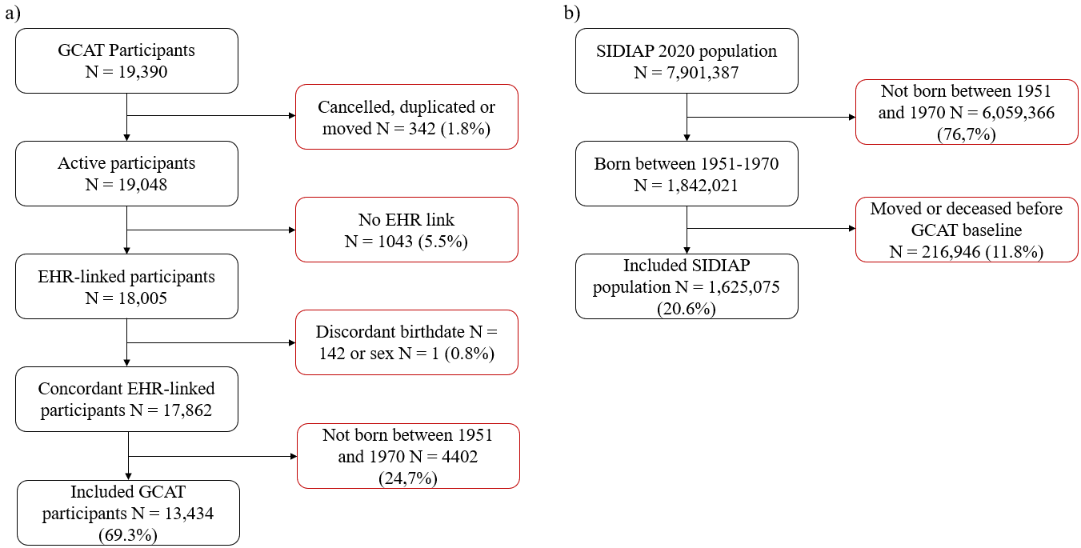
Supplementary Figure 1. Flowchart of the inclusion and exclusion criteria of (a) GCAT and (b) SIDIAP.

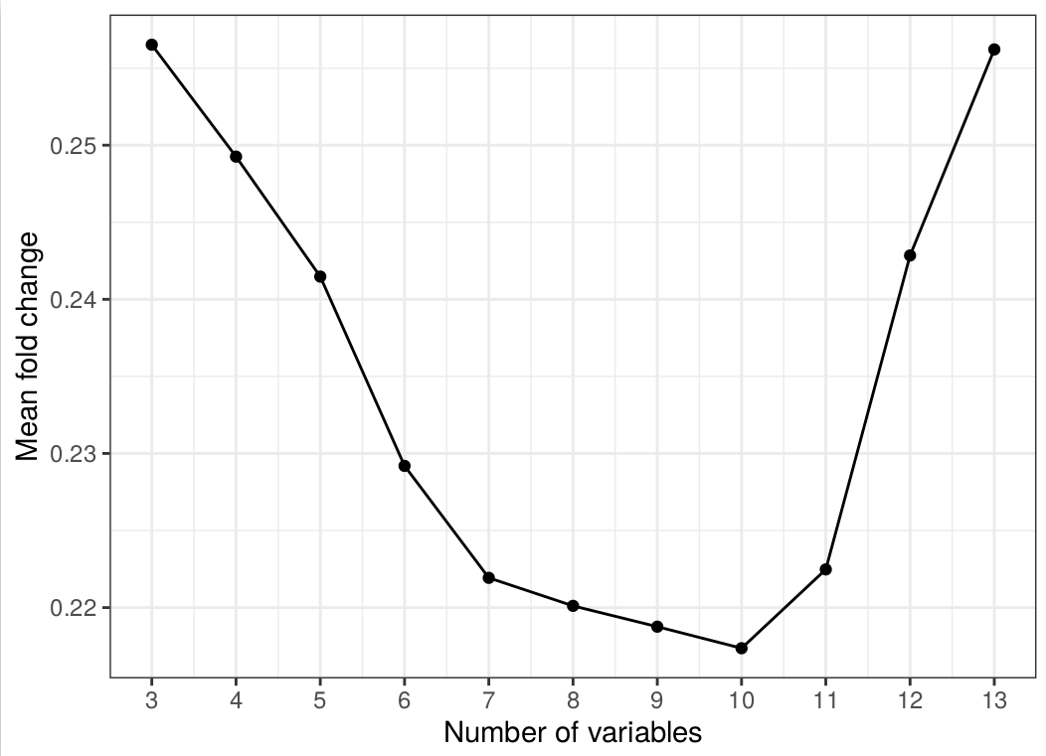
Supplementary Figure 2. Results of the best iteration for each number of variables included in the model. In the x-axis the number of variables used to calculate the weights, and in the y-axis the best average absolute fold change of disease prevalence between GCAT weighted and SIDIAP.

