Additional Results

Table 1. Was there a ChIP call in ED?
 | n | %
Yes ChIP | 500 | 91.58
ChIP missed (No ChIP but eligible) | 13 | 2.38
Got ChIP call but not eligible | 33 | 6.04
Total | 546 | 100.0

Table 2. Characteristics of the 3 ChIP groups: Patients who got ChIP and eligible (ChIP group), Patients who did not get ChIP though they were eligible (ChIP-missed); and patients who got ChIP but were not eligible (ChIP not eligible)
n=546 | ChIP  n = 500 | ChIP missed  n = 13 | ChIP (not eligible)  n = 33
Age median [IQR] | 68.3 [52.5-82] | 81.6 [63.7-88.8] | 70 [39 - 79.5]
Females n (%) | 194 (38.8%) | 10 (76.9%) | 13 (39.3%)
Hospital n (%)  A  B | 288 (57.6%)  212 (42.4%) | 11 (84.6%)  2 (15.4%) | 15 (45.5%)  18 (54.5%)

Table 3. Uptake of ChIP at hospital sites
Hospital | ChIP calls (admitted) |  | ChIP missed
n = 453 | n | % | n | %
Site A (n=281) | 270 | 96.1 | 11 | 3.9
Site B (n=172) | 170 | 98.8 | 2 | 1.2
Total | 440 | 97.1 | 13 | 2.9

Figure 1. ChIP activations vs missed activations over time

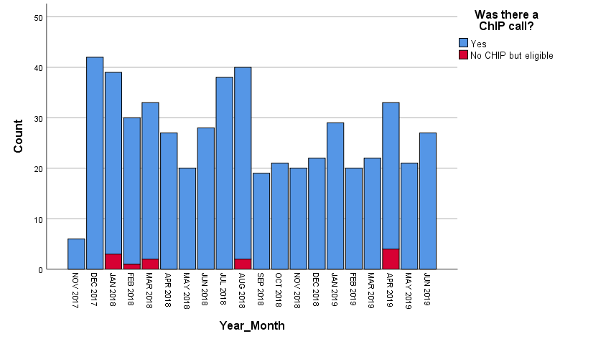

Time to Activation
This part will include analysis of patients who had a ChIP call and were eligible (n=500). 25.4% of activations were made within 60 minutes of arrival.

Table 4. Time to activation – all ChIP patients (n=500)
 | Yes | No | P value, difference (95% CI)ª
Site A | 146 [60-259] | 117 [56-239] | 0.048, 11.00 (-9.0,34.0)
Arrival out hours | 147 [67-255] | 114 [52.5-236.5] | 0.145, -19.0 (-42.0,1.0)
COPD | 129.0 [44.5 – 253.0] | 134.5 [61.0 – 249.5] | 0.930, 6.0 (-24.0,36.0)
Trauma call | 124.0 [62.3 – 241.5] | 135.5 [56.0 – 254.3] | 0.866, 5.0 (-20.0,32.0)
Ambulance | 137.0 [65.0 – 261.0] | 121.0 [49.8 – 228.8] | 0.353, 19.0 (-4.0, 43.0)
Analgesia pre-hospital | 111.0 [49.0 – 226.0] | 165.0 [85.0 – 282.5] | <0.001, 41.0 (18.0,63.0)
Transferred in | 46.0 [19.0 – 115.5] | 155.0 [76.0 – 272.0] | <0.001, 88.0 (63.0,116.0)
ª P value based on test of sample medians, difference and 95% CIs based on Hodges-Lehmann estimator, representing difference between population medians, not sample medians

Table 5. Association between activation time and clinical/demographic variables
Analysis using Spearman’s rho (r) coefficient for continuous variables and Hodges-Lehmann estimate for categorical variables.
n=472  missing 28 | Correlation coefficient(r) | P value
CCI | 0.08 | 0.081
ISS | 0.023 | 0.623
Age | 0.088 | 0.057

Figure 2. Time to activation of ChIP in minutes
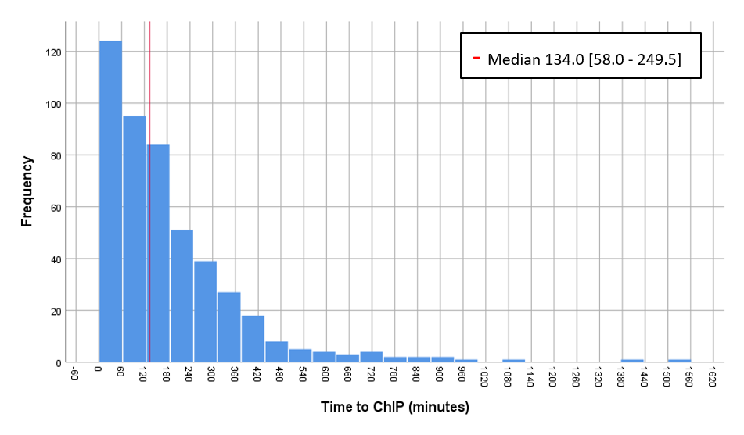

Sub-analysis: Got ChIP but not eligible
These are patients who had a ChIP call recorded in eMR by use of the eMR ChIP icon but did not meet criteria for a ChIP call, n = 33.

Table 6. Baseline characteristics of ‘Got ChIP but not eligible
n =33 |  | Total  n | %
ChIP exclusion criteria:
 | No Blunt thoracic trauma | 29 | 87.9
 | Less than 18 years | 2 | 6.1
 | No clinical or radiological rib fracture | 3 | 9.1
 | Injury in hospital | 0 | 0
Other
ChIP cancelled |  | 19 | 57.6
Atraumatic rib fracture eg due to steroids or cancer |  | 3 | 9
Discharged from ED |  | 11 | 33.3
 | Departed | 10 | 30.3
 | Did not wait | 1 | 3

Issues with ChIP activation

Table 7. Dispatch of patients with ChIP activation
n = 500 |  | n | % | LOS (hours)  Median [IQR]
Admitted |  | 440 | 88 | 105.5 [51.0 – 176.0]
Discharged |  | 60 | 12 | 5.0 [3.3 – 8.0]
 | Transferred to another hospital | 21 | 4.2 | 8.0 [5.0 - 11.0]
 | D/C against medical advice (DAMA) | 10 | 2 | 4.5 [3.8 – 8.3]
 | Discharged home | 29 | 5.8 | 4.0 [3.0 -5.5]

Figure 3. ChIP calls discharged over time. (N.B November only had 8 days as implementation started 22 November)
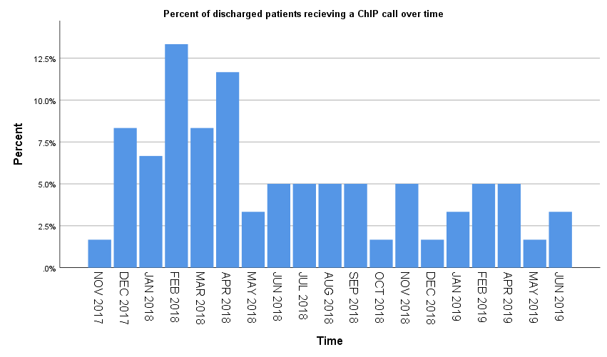

Figure 4. Proportion of discharged ChIP patients during post-implementation period

Adherence/ compliance with ChIP components
This phase evaluates the adherence to ChIP components for ChIP and ChIP missed groups. A stated above length of stay for discharged patients was too short for most components to have been activated so discharged patients were excluded in this analysis.

Table 8. Time to be seen by health services post arrival (minutes): ChIP vs ChIP missed

n = 453 | CHIP  minutes Median [IQR], (n) |  | ChIP missed  minutes Median [IQR], (n) |  | P, difference (95% CI)^{b}
Surgical review | 228 | [126-369], (411) | 370.5 | [107-482], (6) | 0.677, -69.5 (-243.0,105.0)
Pain review | 456.5 | [222-1011.3], (378) | 3751 | [2426.5-6100] (5) | 0.071, -2244.0 (-2761.0,-1770.0)
Physiotherapist review | 960.5 | [416-1238], (420) | 1492 | [1102-2760.5] (9) | 0.043, -788.5, (-1338.0,-202.0)
ICU liasion | 1014 | [365-1553], (237) | (n=0) |  | N/A
ICU doctor | 250.5 | [147-404.3], (264) | 411 | [411-411] (1) | N/A
^{b} P value based on test of sample medians, difference and 95% CIs based on Hodges-Lehmann estimator, representing difference between population medians, not sample medians

Table 9. Health service reviews for admitted ChIP patients presenting In-hours vs Out-of-hours (minutes)
Time to review is time from arrival to review by health care provider in minutes.
N = 440  Time to review (minutes) | Arrival in hours |  | Arrival out of hoursª |  | P value, difference (95% CI )^{b}
N = 440  Time to review (minutes) | Median | [IQR] | Median | [IQR]
Surgical team | 259 | [134-378.3] | 222 | [124.5-368.5] | 0.104, 19.0 (-16.0,57.0)
Pain team (or anaesthetics after hours) | 373 | [191.5-1083.5] | 591 | [243.5-980] | 0.002, -77.0 (-171.0, 3.0)
Physiotherapists | 1078 | [211-1330] | 929 | [594-1194.5] | 0.217, -50.0 (-186.0,69.0)
ICU liaison | 715 | [330.3-1725] | 1037 | [380-1437] | 0.511, -27.0 (-285.0,195.0)
ICU medical review | 285 | [183-464.8] | 240 | [137-368] | 0.138, 52.0 (1.0,102.0)
ª Out-of-hours presentations include weekdays 4pm-8am, weekends and public holidays.
^{b} P value based on test of sample medians, difference and 95% Cis based on Hodges-Lehmann estimator, representing difference between population medians, not sample medians

Figure 5. Multi-disciplinary review over study period
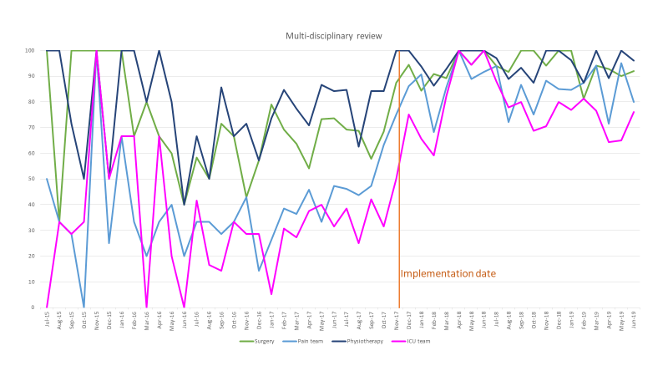
Figure 6. ChIP components over study period
