Table of Content
Variation in the internal quality factor (Qi) of superconducting resonators within a single chip is crucial for reliable qubit operations. In this work, we demonstrated that controlling the surface roughness of the superconducting film minimizes variation in Qi across the chip, paving the way for further attention from the superconducting quantum community.

Senthil kumar karuppannan,^{1∗} Naga Manikanta Kommanaboina,¹ Adrian Nugraha Utama,¹ and Manas Mukherjee^{1,2∗}

Reducing surface roughness for consistent Qi in superconducting resonators with oxygen plasma

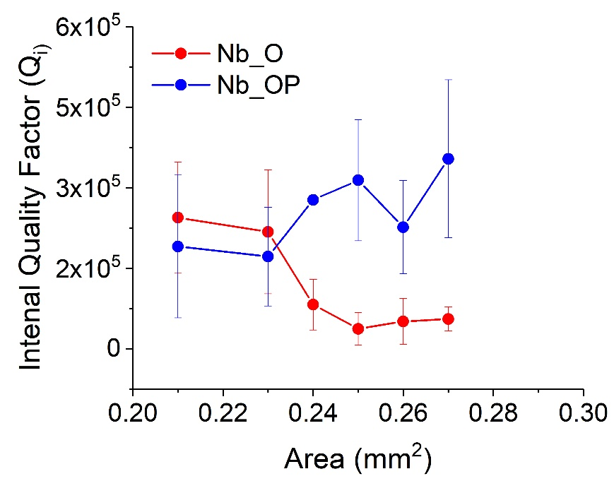

Supporting Information
Impact of surface roughness on consistent resonator performance
Senthil kumar karuppannan,^{1∗} Naga Manikanta Kommanaboina,¹ Adrian Nugraha Utama,¹ and Manas Mukherjee^{1,2∗}

¹NQFF, Institute of Materials Research and Engineering, Technology and Research (A*STAR), 2 Fusionopolis Way, Innovis Building, Singapore 138634, Republic of Singapore.
²Centre for Quantum Technologies, National University Singapore, Singapore, 117543, Republic of Singapore.
E-mail: senthil_karuppannan@imre.a-star.edu.sg; manas_mukherjee@imre.a-star.edu.sg

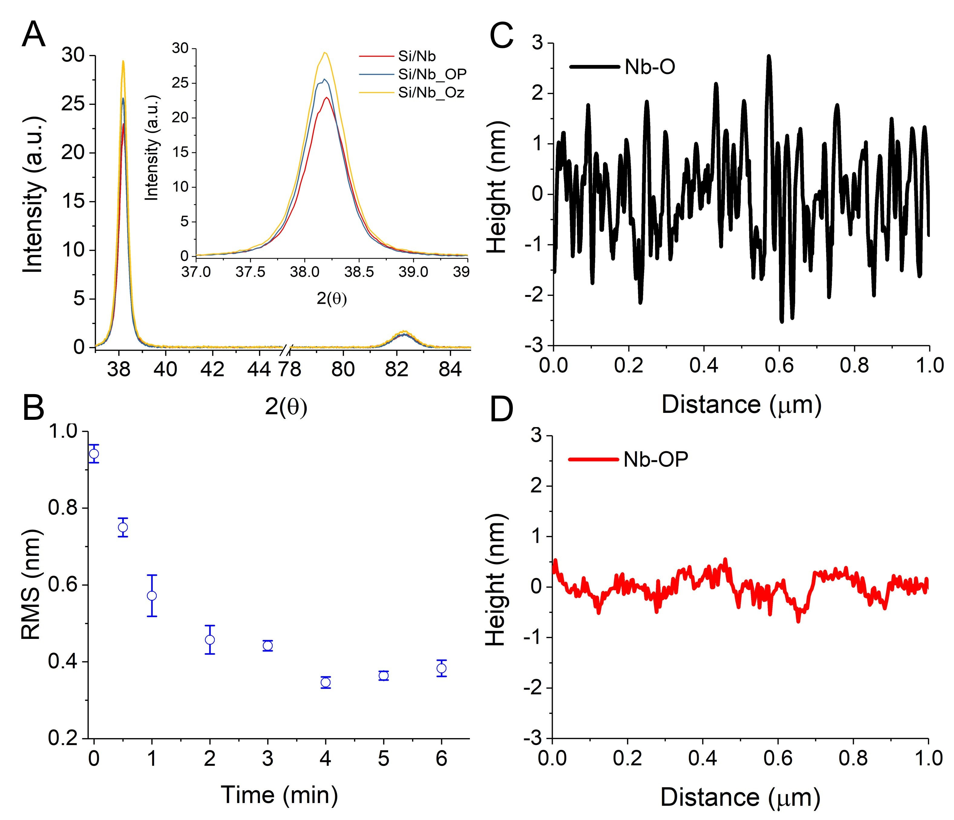
Figure S1: A) XRD patterns for deposited Nb films, ozone exposed (Nb-O), and 6 min oxygen plasma exposed (Nb-OP), B) the RMS surface roughness of Nb film as a function of oxygen plasma exposure (error bar represents standard deviation obtained from three independent samples), (C and D) AFM line profile of Nb-O and Nb-OP samples.

Annexure 1
All resonators were characterized using a vector network analyzer (Rohde & Schwarz ZNL14) inside a DRY ICE 1.0 K cryostat (Figure S2) from Oxford Instruments, which provides a base temperature of ~ 1.0 K without magnetic shielding. The samples were connected to the VNA using RF cables, and the measurements were controlled using automated Python scripts.

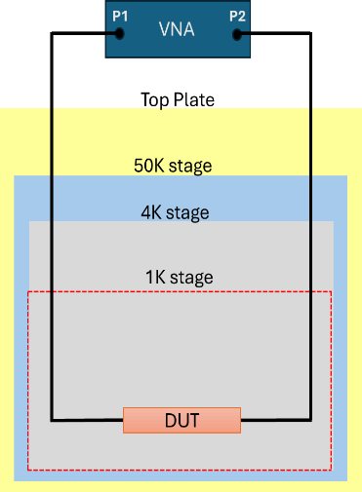
Figure S2. Schematics of cryogenic measurement setup
The average number of photons (n) was calculated based on the previously described in the reference ^{[1]}; briefly, input power applied to the resonator, denoted as $P_{app}$ ¹:
$n=\frac{2}{ ℏω_{0}^{2}} \frac{Z_{0}}{Z_{r}}\frac{Q^{2}}{Q_{c}}P_{app}$ (S1)
where Z₀ is the characteristic impedance of the microwave environment coupled to the resonator, Z_{r} is the characteristic impedance of the resonator, Q loaded quality factor, $Q_{c}$ is the coupling quality factor, $ℏ$ is the reduced Planck's constant, and $ω_{0}$ is the angular frequency of the resonator.

Annexure 2
To analyze the complex $S_{21}$ scattering parameters that were experimentally measured, we use a model previously reported² that accounts for both the intrinsic response of the resonator and the environmental effects introduced by the measurement setup. The scattering parameter $S_{21}$is described by the following equation S2:
$S_{21}=ae^{iα}e^{-2πfτ} \left[1-\frac{(Q_{l}/\left|Q_{c}\right|)e^{iϕ}}{1+2iQ_{l}\left(\frac{f}{f_{r}}-1\right)}\right]$ (S2)
where $f_{r}$ is the resonance frequency, f the probe frequency, $ϕ$ the impedance mismatch, Qc the coupling quality factor, and Ql the loaded quality factor.

Annexure 3
Here, we will discuss the basic loss mechanisms associated with a 2D planer superconducting circuit and the origin of those losses. The superconducting planer circuits that we are interested in in this study mainly consist of half-wave resonators and a coupling capacitor between the microwave source and the resonator. The resonator's quality factor is measured from the microwave power transmission at the incident port, also called the S21 parameter. The S21 shows a dip in the transmitted power when the input impedance matches the resonator circuit impedance, e.g., at the resonance frequency. A typical resonance curve, shown in Figure 4C, is described well by equation S2. The total quality factor of the resonator Q_{T} denotes the total time average energy that the resonator can store. Thus, the inverse of it $(\frac{1}{Q_{T}})$ quantifies the total loss in a circuit. This loss comprises of two components: coupling loss (or external loss) and the internal loss of the resonator.
$\frac{1}{Q_{T}}=\frac{1}{Q_{i}}+\frac{1}{Q_{ext.}}$ (S3)
The coupling loss (Q_{ext}) is generally designed to be such that it can be either made negligible by design or calculated well. Thus, we will only consider the measured internal loss in this discussion. The resonator's internal loss consists of various loss mechanisms, which depend on external parameters like input power, ambient temperature, magnetic field, etc. For ease of discussion, we can also express the losses as resistances. The fundamental limit of the loss comes from the Bardeen–Cooper–Schrieffer (BCS) theory of superconductivity as the residual resistance (R_{res}) comprising of the Cooper pair resistance and quasi-particle resistance as determined by the two-component theory^{3,4} In the case of low input power and temperatures below T_{c}, the resistance is dominated by two-level systems (TLS), which have been studied extensively.¹ The TLS resistance saturates quickly as the input power increases and the temperature rises. In particular, for T/10 < T < T_{c}, the dominant contributions come from quasi-particles (QP), grain boundaries (GB) effects, and magnetic vortices (MV). It is also known qualitatively that surface roughness plays a role in the loss mechanism at higher powers and temperatures. Here, we show how roughness may lead to distinct characteristics that could be uniquely assigned to specific loss mechanisms originating solely due to rough interface or surface roughness (SR). The equation S3 can be re-written in terms of total resistances at high power and temperature regimes as

R_{T} = R_{QP} + R_{GB} + R_{MV} + R_{SR} (S4)
The loss due to QP consists of both thermal and non-equilibrium factors. From the BCS theory,^{5,6} Mattis-Bardeen derived the expression for the loss due to thermal QP originating from the thermal excitation of Copper pairs and their eventual breaking up. The non-equilibrium QP formation is only significant at mK when thermal QP saturates and can be neglected. Therefore, we will only consider the thermal QP in our discussion. The thermal QP density n_{QP} is given by
$n_{QP}=2N(0)(2πk_{BT}∆)^{\frac{1}{2 }}exp⁡(-\frac{∆}{k_{B}T})$ (S5)
N(0) is the single spin density at the Fermi energy and ∆ the superconducting energy gap. This n_{QP} will lead to a complex impedance. On the contrary, the vortices lead to a complex surface impedance that is Z_{s} = R_{s} + iX_{s}. We are concerned about the real part, leading to resistance and loss. In the case of Nb with an operating frequency of 5 GHz, the penetration depth and correlation length are about 38 nm, which is significant compared to the thickness of 100 nm. Therefore, surface resistivity is related to vortex resistivity, as Pompeo and Silva show⁷. Consequently, it is still a bulk property with significantly less impact below the penetration depth.
The roughness on the top interface between the superconductor and air/vacuum will cause loss by two distinct processes, grain boundaries and contributions due to boundary states as obtained from BCS theory^{3,4,5-9}. Both of these mechanisms are less studied experimentally. Considering roughness in terms of peak density per unit area leads to the variation of edge states along the boundary. Therefore, the Cooper pairs observe a varying gap along its path, leading to surface resistance. Similarly, roughness leads to a higher number of grain boundaries per unit area, leading to the generation of another contribution to surface resistance. Therefore, in both cases, the loss is expected to depend on the resonators' surface area in case of significant surface roughness compared to a relatively smooth surface.
Reference

1. McRae, C. R. H. et al. Materials loss measurements using superconducting microwave resonators. Rev. Sci. Instrum. 91, (2020).
2. Probst, S., Song, F. B., Bushev, P. A., Ustinov, A. V. & Weides, M. Efficient and robust analysis of complex scattering data under noise in microwave resonators. Rev. Sci. Instrum. 86, (2015).
3. Andrews, J. & Mathew, V. Vortex dynamics effects on microwave propagation in high temperature superconducting coplanar waveguides. J. Appl. Phys. 114, (2013).
4. Gittleman, J. I. & Rosenblum, B. Radio-frequency resistance in the mixed state for subcritical currents. Phys. Rev. Lett. 16, 734–736 (1966).
5. Mattis, D. C. & Bardeen, J. Theory of the Anomalous Skin Effect in Normal and Superconducting Metals. Phys. Rev. 111, 412 (1958).
6. Bardeen, J., Cooper, L. N. & Schrieffer, J. R. Theory of Superconductivity. Phys. Rev. 108, 1175–1204 (1957).
7. Pompeo, N. & Silva, E. Reliable determination of vortex parameters from measurements of the microwave complex resistivity. Phys. Rev. B 78, 094503 (2008).
8. Coffey, M. W. & Clem, J. R. Unified theory of effects of vortex pinning and flux creep upon the rf surface impedance of type-II superconductors. Phys. Rev. Lett. 67, 386–389 (1991).
9. Brandt, E. H. Linear a.c. response of high- T c superconductors and the irreversibility line. Phys. Scr. T45, 63–68 (1992).

