Supplementary materials for “Recurrent and Concurrent Patterns of Regional BOLD Dynamics and Functional Connectivity Dynamics in Cognitive Decline ”

Appendix A: dfALFF and dFC States
- Estimation of dfALFF states
In our study, the fALFF was used to measure the pattern of local neural activity. The dynamic patterns in fALFF were characterized by using the sliding window approach, which sliced ROI time courses into several short data segments to estimate the dfALFF matrix. A 25-TR (50s) rectangle window with a step of 1 TR was used, resulting in 151 windows or data segments. The dfALFF matrix had a dimension of 164×151, where 164 was the number of ROIs and 151 was the number of windows. Next, k-means clustering was used to group the dfALFF matrices into a limited number of clusters, which are referred to as “states” in dynamic analysis. The centers of states represent recurring patterns, and the occurrence frequency of each state could be extracted. More precisely, the dynamic matrices of all participants (combining HC, SCD and MCI) were first concatenated for k-means with squared Euclidean distance at the group-level. Then, the k-means was achieved in two steps. In the first step, the initial points of clustering were randomly set, which was repeated 100 times, and the result with the lowest within-cluster sums of point-to-centroid distances was retained. In the second step, the initial points were set as the centroids of the first-step k-means so that the adverse impact of small fluctuations can be avoided. The optimal number of clusters (i.e., the number of dynamic states) was determined by the elbow method, which calculated the ratio between inter-class distance and intra-class distance. In the present study, the number of states was set to 4 by using the elbow method. After the dynamic states for dfALFF were identified, the occurrence frequency of each state was obtained by calculating the percentage of the corresponding state among all time points for each participant.
- Estimation of dFC states
The FC was used to measure the pattern of coupling neural connectivity. The dynamic patterns in FC were also characterized by using the sliding window approach with the same parameters in dfALFF estimation. The dFC matrix had a dimension of 164×164×151, where 164 and 151 were the number of ROIs and the number of windows. Due to the symmetry of dFC matrix, the subsequent analysis only used the upper triangle of the matrices at each time point. The k-means clustering with same parameters in dfALFF estimation was used to obtain the dynamic states for FC. The occurrence frequency of each dFC state was also obtained by calculating the percentage of the corresponding state among all time points for each participant.
- Co-occurrence of dfALFF and dFC states
After identifying reoccurring patterns of dALFF and dFC, the co-occurrence frequency between any two types of state were obtained by calculating the percentage of two types of state occurring at the same time among all time points for each participant. In the time point where dfALFF states and dFC states coexisted, the co-occurrence dfALFF states and co-occurrence dFC states could be represented by the average. Notably, in the process of calculating the occurrence frequency and the co-occurrence frequency, only subjects with at least one window belonging to the state were used.

Supplementary Tables
Table S1. Comparisons of occurrence frequencies of dFC and dfALFF states between HC, SCD, and MCI.
 | dFC |  |  |  |  | dfALFF
 | state 1 | state 2 | state 3 | state 4 |  | state 1 | state 2 | state 3 | state 4
ANOVA | 0.75 | 0.71 | 0.0006* | 0.54 |  | 0.52 | 0.60 | 0.07 | 0.14
* : p-value < 0.05 (FDR corrected)

Table S2. Comparisons of co-occurrence frequencies of the dFC state 3 and dfALFF states between HC, SCD, and MCI.
 | dFC state 3
 | dfALFF state 1 | dfALFF state 2 | dfALFF state 3 | dfALFF state 4
ANOVA | 0.31 | 0.02* | 0.03* | 0.04
* : p-value < 0.05 (FDR corrected)

Supplementary Figures

Figure S1. The flowchart of subject diagnostic criteria.
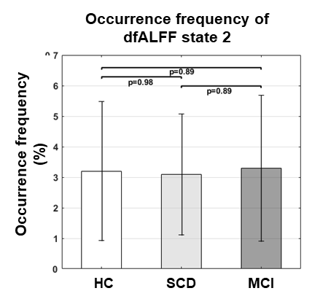
Figure S2. Group difference of dfALFF states between HC, SCD and MCI.

