Online Appendix for:
Global Spillovers of US Monetary Policy: New Insights from the Remittance Channel

- Appendix

Fig. A. 1 Stability of group categories based on average remittances-to-GDP over period 1997-2017
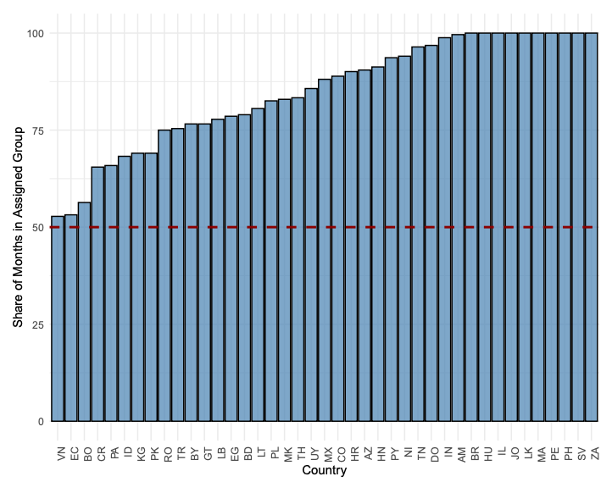
Note: Countries are classified based on the average remittances-to-GDP ratio over the 1997-2017 period. The histogram shows the average share of months in which each countries’ remittance-togdp ratio is within its whole period average group. For instance El Salvador has a remittance-to-gdp ratio over 4 percent of GDP over the whole sample period.

Fig. A. 2 Robustness to controlling for commodities - Median IRF responses by degree of reliance to remittances as a share of GDP
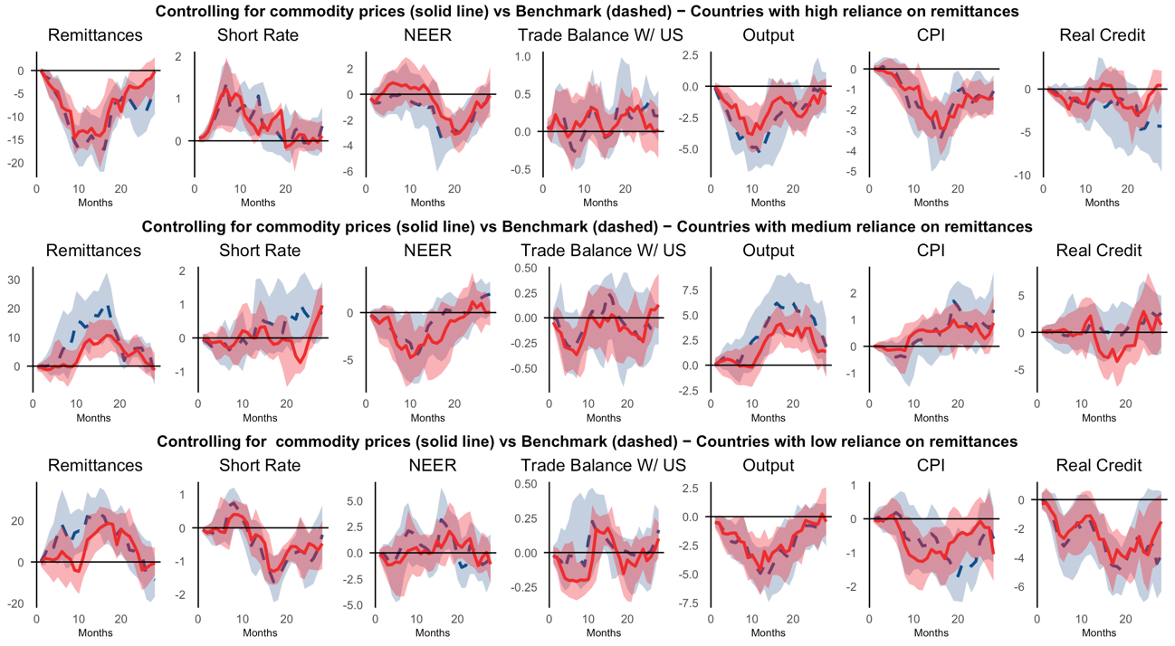
Note: Median of country-by-country responses to a contractionary one standard deviation US monetary policy shock resorting to local projections with 12 lags and Newey-West corrected standard errors and 1 standard deviation error bands. Monthly sample 1997:01-2017:12. Countries are classified based on the average remittances-to-GDP ratio over the 1997-2017 period. In each graph we show the median and standard errors for the US monetary policy shock estimated by including the world bank real commodity price index (solid line and red shade) and the benchmark without controls (dash line and blue shade).
Fig. A. 3 Robustness to controlling for financial crises - Median IRF responses by degree of reliance to remittances as a share of GDP
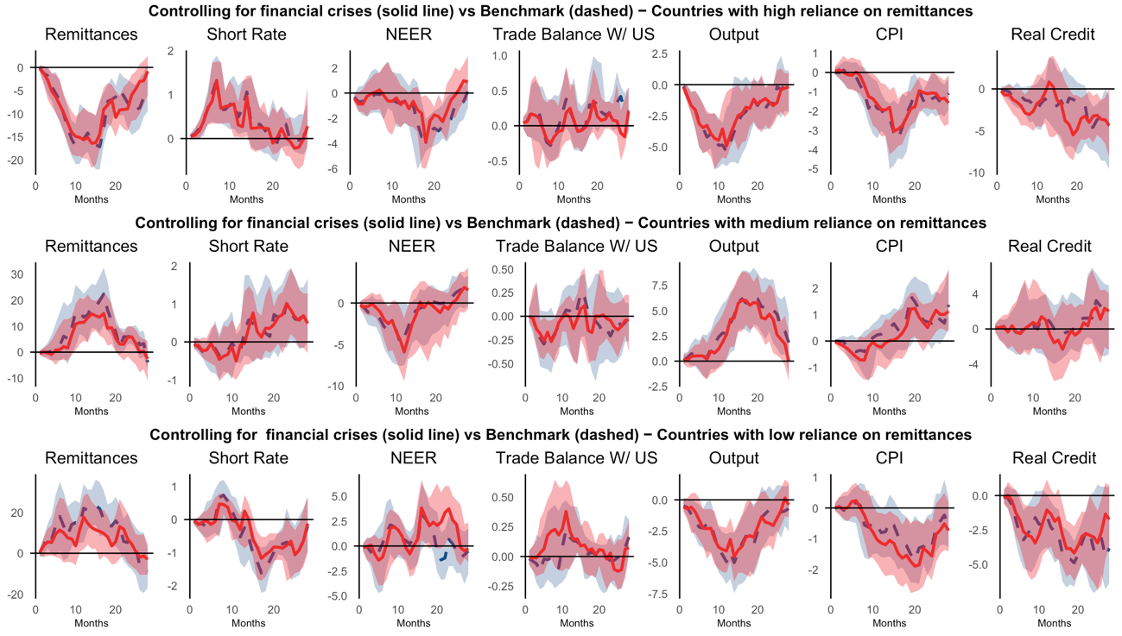
Note: Median of country-by-country responses to a contractionary one standard deviation US monetary policy shock resorting to local projections with 12 lags and Newey-West corrected standard errors and 1 standard deviation error bands. Monthly sample 1997:01-2017:12. Countries are classified based on the average remittances-to-GDP ratio over the 1997-2017 period. In each graph we show the median and standard errors for the US monetary policy shock estimated by including the Financial Stress Indicator (solid line and red shade) and the benchmark without controls (dash line and blue shade).
Fig. A. 4 Robustness to controlling for the Excess Bond Premium (Gilchrist and Zakrajsek, 2012) – Median IRF responses by degree of reliance to remittances as a share of GDP
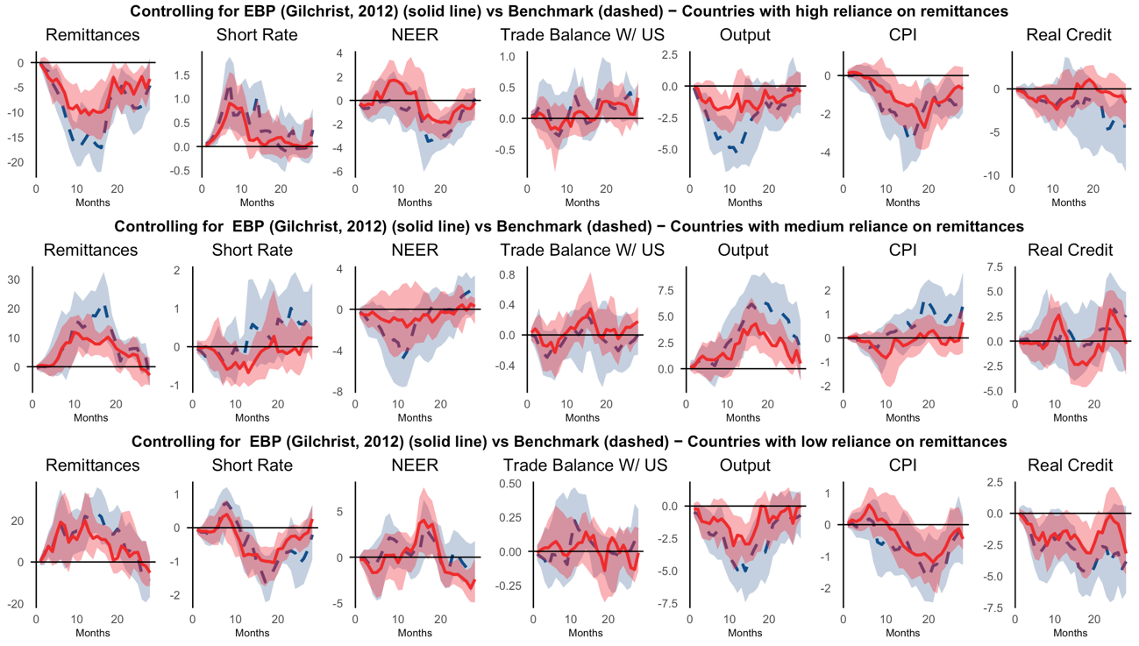
Note: Median of country-by-country responses to a contractionary one standard deviation US monetary policy shock resorting to local projections with 12 lags and Newey-West corrected standard errors and 1 standard deviation error bands. Monthly sample 1997:01-2017:12. Countries are classified based on the average remittances-to-GDP ratio over the 1997-2017 period. In each graph we show the median and standard errors for the US monetary policy shock estimated by including the Excess Bond Premium indicator (solid line and red shade) and the benchmark without controls (dash line and blue shade).
Fig. A. 5 Robustness to controlling for foreign reserves - Median IRF responses by degree of reliance to remittances as a share of GDP
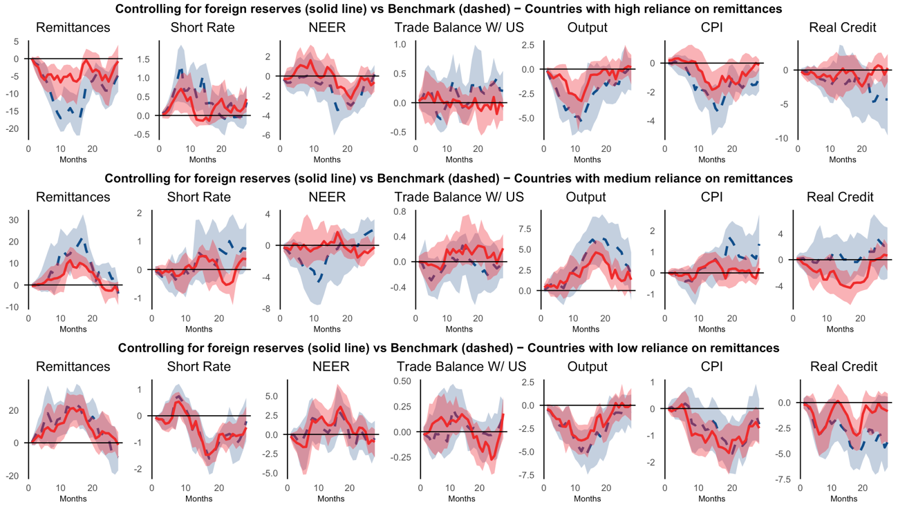
Note: Median of country-by-country responses to a contractionary one standard deviation US monetary policy shock resorting to local projections with 12 lags and Newey-West corrected standard errors and 1 standard deviation error bands. Monthly sample 1997:01-2017:12. Countries are classified based on the average remittances-to-GDP ratio over the 1997-2017 period. In each graph we show the median and standard errors for the US monetary policy shock estimated by including the Financial Stress Indicator (solid line and red shade) and the benchmark without controls (dash line and blue shade).

