“If I go down, if I crumble, then everybody does” — Identity Crisis and Emotional Strain in Parents of Children with Rare and Undiagnosed Conditions: A Qualitative Study

Tara Maria Hoffmann¹, MD, Bettina Friedrich, PhD^{1,3}, Celine Lewis, PhD^{1,2,*}
¹Population, Policy and Practice Department, UCL Great Ormond Street Institute of Child Health
²London North Genomic Laboratory Hub, Great Ormond Street Hospital for Children NHS Foundation Trust, London, UK
³Department of Epidemiology and Health Care, UCL

*PI, corresponding author
Dr. Celine Lewis
celine.lewis@ucl.ac.uk
+442031082918

Word count: 9886 (excluding references, title and author affiliations)
Tables: 4
Figures: 2 (in separate word file)

Abstract
Background: Caring for a child with a rare condition can significantly impact parents’ emotional health, yet research on the emotional impact is limited. This qualitative interview study sought to investigate the lived experiences of parents who are experiencing higher psychological burden. Participants were parents of undiagnosed children undergoing whole genome sequencing (WGS) through the Genomic Medicine Service (GMS) across multiple NHS sites in England and Wales. Parents were purposively sampled to select those scoring poorly on validated measures of anxiety, family impact and/or resilience (GAD-7, PEDSQL family functioning, BRS).. We interviewed 24 parents after testing but prior to the return of WGS results. Questions focused on understanding the lived experience of parents, in particular the emotional impact of their child’s condition and how they coped day-to-day.
Results: Semi-structured interviews were transcribed and analysed using reflexive thematic analysis, leading to the generation of the central organising concept: "The construction of a caregiver identity: Torn between being a ‘hero(ine)’ and being a parent.” Parents’ experiences as caregivers often involved a significant re-evaluation of their parental role, as they sought to provide love and support while also adjusting to changes in their envisioned family life. Societal expectations, along with the complex challenges of navigating the health and social care systems, contributed to emotional strain. In particular, mothers often adapted their personal identities to embody a ‘heroic’ caregiving role. The anxiety caused by the uncertainty surrounding their child’s condition was also found to affect parents’ mental health. Areas for psychological interventions and recommendations to support parents’ mental health are identified.
Conclusions: Further research is needed to explore how the return of genomic sequencing results impacts parents’ emotional wellbeing, and whether and which psychological counselling modalities throughout the journey might reduce emotional distress.

Keywords

Rare condition, undiagnosed condition, mental health, emotional wellbeing, parent caregivers, uncertainty, genomic sequencing, psychological counselling, psychosocial insights, family dynamics

Background
Caring for a child with a rare and undiagnosed condition
Individuals affected by rare conditions often experience a diagnostic delay, with the average time to achieve an accurate diagnosis being approximately 4-5 years (1). Recent research is beginning to uncover the mental health impact on families undergoing this diagnostic journey and what caring for a child with a rare and undiagnosed condition is like for caregivers. Research has shown that for some parents it is associated with anxiety and depression (2,3). They have also been found to experience a lower quality of life in some cases (4) as well as worries regarding their child’s quality of life (5). Despite the fact that some families may benefit from mental health support services, awareness of those amongst families is limited (6). Additionally, parents reported a lack of access to support groups (7), leading to a sense of isolation (8).
Barriers to accessing support services may be because of family members not identifying as carers, or “invisibility” due to lack of diagnosis or informal care-giving by family members, leading to the need to define the term “carer” (9,10). Parents struggle to reconcile their role as caregivers additional to being a parent, resulting in ambivalence about their own identity, as shown in a geriatric caregiving context (11). Approximately 50% of carers have never been asked about their emotional wellbeing by health professionals (5), highlighting a lack of awareness of the mental health impact on parenting a child with a rare and undiagnosed condition.

Whole Genome Sequencing: A path to answers or more questions?
Whole genome sequencing (WGS) can determine the complete DNA sequence (protein-coding and non-coding regions) of a genome. Launched by the NHS England in 2012, the 100,000 Genomes Project used WGS to generate genomic data that provided actionable insights for those with rare conditions and other diseases, influencing patient care and treatment decisions (12). The project’s success led to the establishment of the Genomic Medicine Service (GMS), which now allows WGS to be offered as a clinical service by specialists other than clinical geneticists (13). As over 70% of rare conditions have a genetic cause, this technology may facilitate an earlier diagnosis with a diagnostic yield of WGS of 38.6% compared to usual care of 7.8% (14). However, this will still leave a significant number of parents without a genetic cause for their child’s condition.
Research has shown that parents want a diagnosis for a range of reasons including having a better understanding of the underlying genetic cause of their child’s condition, to alleviate feelings of guilt and to connect with other parents of children with the same condition. Yet, even with diagnosis, parents can still experience anxiety and uncertainty about the future, often because the condition is so rare that very little information is available (6,15,16). Even when a diagnosis is not found, parents may not regret the decision to undergo genetic testing, despite still feeling anxious towards the future (16,17). These findings emphasize that the support parents need should not be based on WGS results alone (17). Irrespective of a diagnosis, parents often experience stress and anxiety.

Rationale for this study
Caring for a child with a rare condition has been found to have a significant emotional impact on some parents. However, research in this area is relatively sparse, particularly when compared to research on the clinical impact of genomic testing, such as the clinical change of management and diagnostic yield (18). Moreover, while many studies to date have focused on the use of quantitative questionnaires to understand parents’ emotional wellbeing, a qualitative body of evidence is only now beginning to emerge, primarily focusing on parents’ experiences accessing health care services and emotions related to challenges of caregiving (19). Understanding the lived experiences and root causes behind poor emotional wellbeing (5) is crucial, particularly during the period when the condition has not yet been diagnosed and when uncertainty is therefore heightened.
The primary aim of the study is to understand parents’ lived experience as caregivers with a particular focus on the mental health impact of caring for a child with a rare and undiagnosed condition. The second aim is to identify areas where improvements may be needed to enhance the overall support provided to families and provide recommendation for practice. The information derived from this study is intended to be of value to those involved in caring for parents of children with rare and undiagnosed conditions and provide insights about those who might be struggling to cope, that can inform and guide future practical guidelines. It should also be useful for health service providers in optimising the quality of care and support provided to this specific population.

Methods

Study Design

This study is embedded in a mixed methods longitudinal patient-centred evaluation of the Genomic Medicine Service with collaborating NHS sites across England and Wales, details of which have been previously published (20).
A qualitative research methodology was used to gain an in-depth, rich account of the lived experiences of parents whose children are affected by a rare and undiagnosed condition. Semi-structured interviews allow participants the freedom to articulate their perspectives in their own language (21), which is invaluable when dealing with a highly sensitive topic amongst a marginalised group.

Data Sampling
A subset of parents who had completed a survey within four weeks of consenting for WGS as part of this patient-centred evaluation of the Genomic Medicine Service (20) (n = 394) were purposively sampled based on their scores on three validated measures related to emotional and family wellbeing. These were:
- The Generalised Anxiety Disorder - 7 (GAD - 7) (22) which is a seven-item measure that assesses the frequency with which the responder has experienced symptoms of anxiety over the past two weeks;
- The Paediatric Quality of Life Questionnaire, Family Impact Module (PedsQL Family Impact Module) (23); which assess family impact from a physical, emotional, social, cognitive, communication and worry perspective;
- The Brief Resilience Scale (BRS) (24); which relates to the responders’ ability to cope or recover from stress.
We judged these three measures to provide a multi-dimensional view of parents experiencing higher psychological burden; high anxiety levels reflect significant psychological distress, while lower family impact scores suggest that the child’s condition substantially disrupts family life and parental functioning. Lower resilience indicates a reduced capacity to recover from or adapt to stress. Therefore, the majority of our parents had scored moderate to severe anxiety on the GAD-7, and/or lower scores on the PedsQL Family Impact Module indicating lower functioning and/or lower scores on the Brief Resilience Scale indicating lower resilience.

Further selection was based on ensuring diverse geographical and ethnic backgrounds of participants as well as socio-economic background because the time-consuming carer burden may lead to unemployment (25–27). The ethnic categories were carefully selected based on the UK government's official classification of ethnic groups (“White or White British”, “Asian or Asian British”, “Black or Black British”, “Mixed”, “Other ethnic group”) (25). In addition, we aimed to include both mothers and fathers as whilst mothers are often reported to be the primary caregiver, making them more vulnerable to poor mental health compared to fathers (2,3,28), research about fathers’ emotional wellbeing is scarce. A final factor we considered was the child’s condition (e.g. neurological, metabolic) due to some conditions being more often associated with behavioural problems which strongly correlate with parents feeling stressed (29,30).
Interviews were conducted with primary caregivers (one per parental dyad).

Recruitment
Overall, 74 potential interviewees were invited to participate in the study by email or via text message (as indicated by themselves in the survey). After two weeks without response, parents were followed up. This resulted in 27 parents considering participation, 11 decliners and 36 non-responders. The final sample consisted of 24 of 27 parents being included in the study (63% recruitment rate among responders). The remaining three declined further participation due to unforeseen circumstances.
All 24 interviews were conducted via telephone or using virtual meeting software between 27th June 2023 to 28th of March 2024 (n = 7 were conducted by BF; n = 17 were conducted by TMH). Participants were offered a £10 voucher for their participation.

Data Collection

The initial idea and focus of the study were developed in consultation with a patient advisory team. This team contributed to the overall mixed-methods study by helping to shape the study aims and objectives, reviewing and providing feedback on data collection tools, and supporting the interpretation of findings. The advisory group included parents of undiagnosed children, clinicians, genetic counsellors, and researchers.

During early discussions, the team proposed initial ideas for the interview topic guide (see Supplementary Material – topic guide). Authors CL and BF then developed the first draft of the semi-structured interview guide, which was reviewed with the founder of Rareminds, a UK non-profit organisation specialising in psychological counselling for those affected by rare conditions (31) as well as a researcher from the organisation. This collaboration helped ensure that the questions were appropriate and sensitively worded.
Additionally, author TMH received brief psychological training from a therapist at Rareminds specialising in rare disease counselling, to support the handling of sensitive topics during interviews. Based on this training, minor revisions were made to further improve the wording of the interview guide.
All interviews were either recorded using an encrypted audio device or digitally via online virtual software and lasted between (20 to 100 min, mean = 55 min) and transcribed verbatim. According to best practice guidelines, interviews were conducted alongside data analysis, focusing on data quality to meet study objectives rather than data saturation (32).

Data Analysis
A reflexive thematic analysis (33–35) was undertaken as it is not bound to a single underlying theoretical framework; using deductive and inductive codes mirroring a descriptive and interpretivist approach, meaning that the analysis does not aim to separate description from interpretation but rather to make the interpretative lens transparent and grounded in the data.
In reflexive thematic analysis, the Results section typically includes both descriptive summaries of patterns across the data and the authors’ interpretative insights about what these patterns mean in the context of the research question — supported by participants’ direct quotes as evidence. Our intention in including interpretative commentary is to make visible how we constructed the themes and to show how we derived our analytic insights from participants’ own words. Ultimately, reflexive thematic analysis was chosen because it aligns with our interpretivist stance, which views knowledge as co-constructed and meaning as shaped by context. This method enabled us to explore how parents make sense of their experiences, consistent with this study’s aims, while acknowledging the active role of the researchers in the analytic process.

A subset analysis for inter-coder reliability was not performed due to the nature of the paradigm applied (36). The analysis was facilitated through the Nvivo14 software. Following an initial listening of all interviews and multiple readings of the transcripts for data familiarisation, all interviews were coded three times in total. During the second round of coding, an iterative process involving the creation of mind maps based on the codes was used. This process led to the development of the central organising concept.
Furthermore, descriptive statistics were generated using SPSS mac 29.0.2.0. PedQL scores were calculated according to the protocol (23).

Research Paradigm and Researcher Reflexivity
This study can be situated within a post-positivist research paradigm (37), adopting a critical realist ontology and contextualist epistemology (38). Parents’ experiences are seen as their individual lived truth, influenced by socio-economic and cultural factors and the nature of the child’s condition, as opposed to relying on there being one objective truth. In order to account for this individual truth, a contextualist positionality towards the data was adopted to facilitate the existence of certain concepts, while simultaneously giving rise to new streams of thought (38).
In line with recommendations (33), TMH was engaged in reflexive journaling and designed mind maps to enable others to follow her streams of thoughts. In reflexive thematic analysis, the researcher takes on an active role in knowledge production, meaning that their own positionality to the data provides both advantages and challenges. TMH acknowledged her lack of personal experience in caring for a child with a rare condition and her position as a female researcher. However, she drew on her limited clinical experience of communicating as a training physician with families who care for a child with a rare condition .

Following recommendations for researchers unfamiliar with the research area of interest (39) TMH sought regular guidance through fortnightly debriefings with the supervisor with expertise in the field of genetic and genomic medicine as a behavioural scientist (CL). During the early analysis phase TMH also received helpful input from a psychologist from Rareminds as well as the study advisory team (see below), to support the trustworthiness of data interpretation.

Patient and Public Involvement and Advisory Team
The evaluation project has a dedicated advisory team which meets every six months with the aim to ensure that the research questions are relevant, and the interests of the population being studied are adequately considered. For this particular sub-study, the topic guide content was discussed by the advisory team and the founder of the charity Rareminds(see above). Early interpretations from the analysis were also discussed with the advisory team as well as with the founder and a researcher from Rareminds (see Acknowledgements).

Results

Participants Characteristics
Study participants consisted of 4 men and 20 women (n = 24), ranging in age from 21 to 54 years (mean = 38 years). The majority identified as white British, those ethnic categories with a response count greater than zero were reported in Table 1.
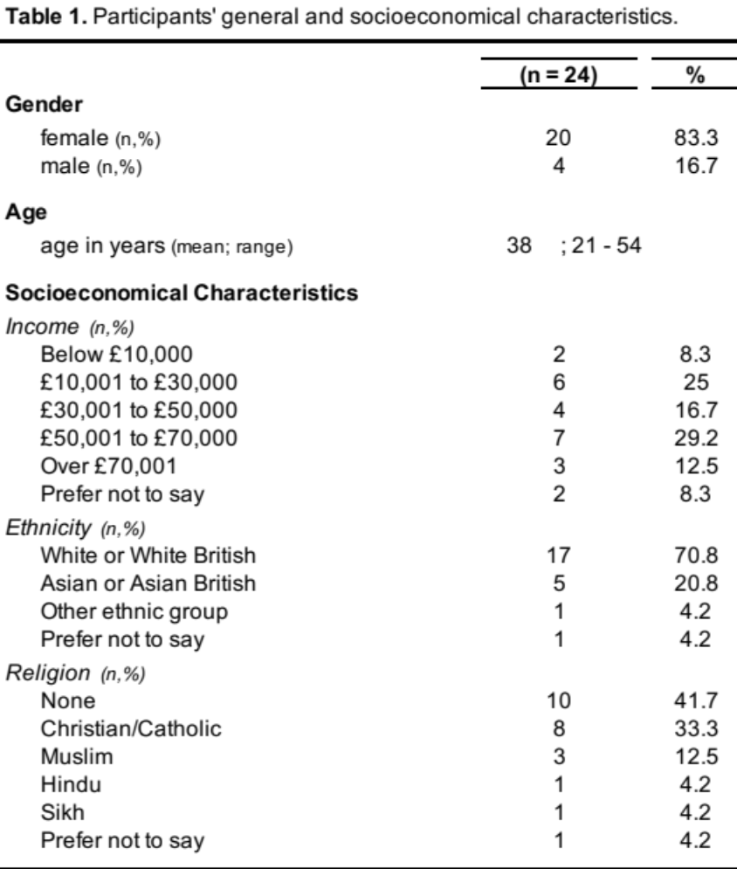

Participants” mean anxiety score was “moderate” (12.8, range 0 - 21) and mean resilience was reported as “low” (2.7, range 1 - 4). Cognitive Functioning was the most impacted aspect of the PedsQL Family Impact Module, followed by family relationships and communication (see Table 2).
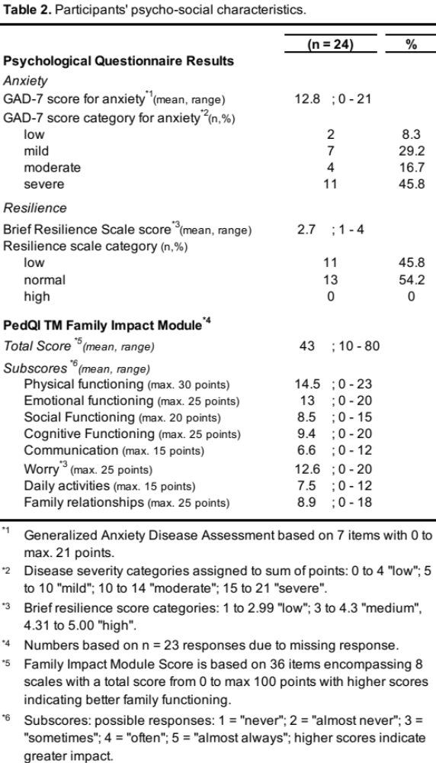

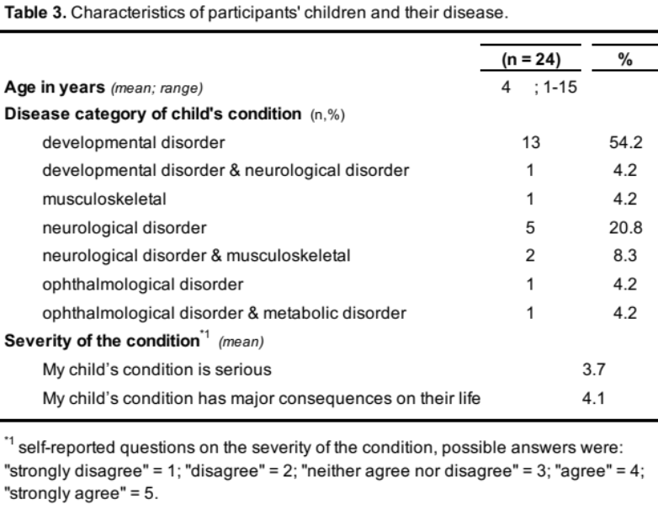

In terms of the clinical indication of the participants’ children, developmental conditions were most commonly reported, while ophthalmological conditions were less common (see Table 3). Most participants agreed that the child’s condition had a serious impact on their lives (mean = 4.1; “agree to strongly agree”) and perceived their child’s condition as severe (mean = 3.7; “neither agree nor disagree to agree”) (see Table 3).

Qualitative Results
The central organizing concept, “Constructing a caregiver identity: Torn between being a ‘hero(ine)’ and being a parent”, was shaped by four key underlying themes. Serving as an overarching interpretative concept, it encapsulates the lived experiences of caring for a child with a rare and undiagnosed condition, as outlined in the study’s first aim (see Figure 1).
All themes were supported by data from all interviews. Representative quotes from participants (names replaced by pseudonyms) have been used.

The central organizing concept: “Constructing A Caregiver Identity: Torn Between Being A “Hero(ine)” And Being A Parent”
When parents find themselves in the unexpected role of being a caregiver for a child with a rare, undiagnosed condition, some undergo a significant reevaluation of their identity. While balancing their unconditional love for their child, they mourn aspects of their envisioned life for their family. This can cause an internal struggle which can make acceptance of the unanticipated caregiver role, challenging, as it diverges from their pre-planned life trajectory. Yet, societal expectations and their need to be a responsible parent guides them to embrace this new reality. Caregivers, particularly mothers, immerse themselves in their new role, often reshaping or setting aside their prior identities, leading them to embody a “heroic” archetype, which is associated with new expectations. Thus, parents find themselves amidst an identity crisis: torn between being a “hero(ine)” and being a parent as they construct this new identity.

Their caregiver role introduces parents to novel tasks, which they look to accomplish, despite difficulties adapting to these new circumstances. Due to the uniqueness of their situation, parents often face societal judgment and can find it hard to maintain relationships, exacerbating their sense of isolation. Furthermore, the uncertainty surrounding rare conditions complicates future planning for affected families. This perpetual state, combined with the multifaceted responsibilities they are required to take on, can generate significant emotional strain. Failure to manage these emotions can precipitate an imbalance detrimental to parents’ mental health.

Theme 1: The Battlefield Of Uncertainty And Medical Chaos
This theme describes the meaning of being a caregiver in the context of rare conditions. The beginning of parents’ journey may have come as a shock: “So when they told us I was shocked because...I didn’t even know that I had to be worried about it” [Anjali]; or parents realized more gradually “...that something was not right” [Mary]. Both scenarios share the element of unforeseen disruption, leaving parents unprepared in the face of health system as well as personal challenges around their child’s condition.

Subtheme 1: Adapting To A Life With Uncertainty
Subtheme 1 dives into the emotional impact on families, which leads to some parents feeling “like your future’s been taken away..." [Ingrid]. Due to the lack of a diagnosis, parents frequently spoke of fearing the worst but remaining hopeful for the best: ”...suddenly you’re faced with the very real possibility that your child might pass away...and all the time you’re hoping for the best but fearing the worst.” [Ingrid]

Some seek control over their child’s situation, trying to make the best out of uncertainty: “...I need to understand what I’m dealing with and there wasn’t a lot of that...I do worry about what’s going to happen to [child’s name] ...but nobody has told us this is going to happen ...so I just feel a bit lost...” [Emily]

This feeling of being “lost”, was exacerbated by parents feeling that knowledge was not being shared by medical professionals. Uncertainty around when parents would receive diagnostic test results was commonly expressed, which led to parents feeling helpless by the lack of knowledge about the condition.
Participants appeared to have mixed feelings about getting a diagnosis. Fearful of being presented with a “fait accompli” diagnosis, some hope “that it doesn’t show anything” [Eric]. For other, living in an uncertain state may also be preferable: “it’s like burying your head in the sand” [Lisa]. While uncertainty may evoke feelings of anxiety, it can provide a sense of comfort. Some parents subscribe to the notion that “ignorance is bliss” [Ingrid]. This intrinsic defense mechanism helps parents remain optimistic and protects them from the potentially upsetting prognosis of a definitive diagnosis. This may be seen as an adaptive response to the stimulus of uncertainty. However, such resilience appears fragile in the face of adversity, as demonstrated by Samipa, who stresses the emotional burden that uncertainty places on parents: "...I just tell myself [my child will] be fine and ... [my child is] going to have a good quality of life, but the truth and the reality when you think about it, it really brings you down... I cry a lot some days."

Furthermore, Ingrid reflects on her statement “ignorance is bliss”: "...the days following when you’ve had contact with the hospital and maybe hadn’t had the news that you were hoping... those days are particularly hard."

This sentiment, that appointments can be particularly difficult emotionally, was very frequently expressed by other parents. Harroop describes how her resilience is tested when she has a clinical appointment coming up, and that this leads to anxiety because of the worry that something has been found that she was not hoping for: "...it still stresses me out like when we have an appointment...the week before I will be stressed out, ...because I’m thinking ‘have they found something...is there something bad’, there’s always that anxiety whenever an appointment’s coming up just because I don’t know..."

Subtheme 2: Medical Chaos Can Leave Parents Emotionally Drained
Parents frequently encounter barriers to receiving medical support, thus this subtheme describes the “medical chaos”, which leads these parents to a feeling of being in a “relentless fight”, leaving them feeling emotionally drained, as described by Laura: “...I’m usually the one that will take people to task if needs be – but sometimes I’ve just run out of steam completely.”

The use of the term “usually” indicates that she not only perceives herself as the person that needs to fight for the best medical care for her child, but also suggests that overcoming obstacles is not an exception to her. However, as she describes, sometimes it becomes too overwhelming, and she runs “out of steam”.
Parents had various experiences related to the quality of care and support they received. Laura is grateful for the care received from the medical team in a tertiary care setting who acknowledge her as an expert in her child’s care, commenting “that staff are much more willing to listen to me and trust what I’m saying”. However, she has had “bad experiences” due to the “much lower quality” of care in her primary care setting, where she wasn’t taken seriously by medical professionals. She also feels that there is a lack of understanding among medical professionals about what it is like for her being a carer for her child: “...many therapists say to me ‘oh we won’t do the therapy with [child], we’ll teach you how to do it and then you can build it into your everyday life’ – that’s just asking an awful lot of someone who has been thrust into this journey without any warning...” In this case, Laura felt put under pressure by the medical team to take on additional care roles.

This discrepancy in the quality of care was reiterated throughout the interviews. Victor’s experience expands our understanding of discrepancies in quality of care, whereby the leading symptoms of his child’s rare and undiagnosed condition were assigned to a different specialty (cancer), resulting in his child’s referral and reclassification within the hospital organization. He describes how, unlike with more established care pathways like those for children with cancer, children with rare conditions don’t have an established care pathway to guide them:
“...there’s a real contrast between the support ... and help afforded to families who are dealing with cancer, complete contrast with the stuff that is out there for kids with rare genetic conditions...obviously your kid having cancer is the last thing that anyone wants to hear but,...it kind of unlocked this door...”

Theme 2: The Ambivalence Of Becoming A “Hero(ine)”
The second theme describes an expectation that these parents are seen, either by themselves or others, as “hero(ine)s”, depicting parents’ achievements as superhuman. For Laura, by distinguishing herself from others by saying: “...my fellow medical mums and me, endearingly call everyone else “muggles” from Harry Potter!”, she internalizes the “heroic” role as a form of recognition. Reconceptualizing one’s identity as a “hero(ine)” may be seen as a way to take charge or recover a sense of destiny or purpose, but at the same time the need to be strong and fight for their child can be an exhausting emotional and physical burden, often carried by mothers.

Subtheme 1: The Female Burden
Subtheme 1 looks at the experience of mothers, like Susan, many of whom carry the responsibility of being the primary carer, often having given up their careers in order to become full-time carers.: “I had a 21 year career and I’ve stopped that..., I will no longer be working at all because I just cannot cope with the demands on me.” She puts emphasis on the significant role that her career played in shaping her identity, which she now feels has had to end because her new role as the primary caregiver.
Substituting their job with the perhaps ‘invisible’ job of caregiving adds to mothers feeling pressured to succeed in that role, as described by Laura: “...especially as a woman [it] is ingrained into you, ...I felt a deep self-inflicted pressure that OK my husband’s at work all day, because I do work as well but it’s not paid, because I’m caring for my son, he’s at work all day so I must achieve everything...”

Interestingly, Laura’s husband’s willingness to share the caregiving responsibilities demonstrates an awareness of the “female burden”: “...my husband kept saying to me ‘why are you all of a sudden do you think you’ve got responsibility for everything – you don’t..’ .”.
In contrast, Ralph’s recognition of his wife’s dedication highlights the asymmetry in their contributions to their child’s care: “...she’s doing I would say at least 90 % of the hard work...I’m only doing about 10 % of the work that she is doing and even though that 10 % I feel so tired so I can only imagine how she feels...”

This incongruency around caregiving responsibilities between both partners involved in the child’s care is also evident in the dynamic evolution of Anjali’s relationship with her husband. Her initial expectation of a shared experience transitions to resentment when she perceives her husband’s struggles as self-centered: “...at first it was like...we’re both going through the same thing, but then when he was finding it very difficult, I became quite resentful towards him, because I couldn’t understand how he was making it about himself – so I thought he was being selfish...I didn’t feel that I could relate to him...”

Her comment resonates with the archetype of the self-sacrificing mother who is inclined puts her own needs aside for the sake of her child, which is why, perhaps, she was unable to empathise with her husband’s emotional situation. This hints at an imbalance in the emotional burden associated with caring for a child with a rare condition, with potential implications for family and relationship dynamics.
Harroop, who is a single mother and the main caregiver, also expresses her dissatisfaction related to balance of care-giving responsibility not equally shared with her ex-partner: “We’re separated but I expressed a lot of the time to him that I find it really unfair that I’m taking on so much responsibility and mental load.”; hinting at a gender disparity in family caregiving.

Some mothers expressed envy that their partners were able to continue to work unlike they were, because they had taken on the primary role of a caregiver:
“when... we both were working, it was almost arguing about who would be the one to care for [child] ...you feel torn...between everything, which is why I gave up work, but then...I probably resent that...” [Ingrid] Her comment suggests a sense of resignation to societal expectations placed on women.

Subtheme 2: Fighting The Battle You Haven’t Signed Up For
Subtheme 2 looks deeper into the complex emotions underlying parents’ emotional connection to their child’s well-being, and at the same time their reluctance to being forced into the role of a “hero(ine)” which is bound to sacrifice.

Laura admires the resilience of single mothers going through the “heroic” journey of caring for a child with a rare condition, just like her. She expresses discomfort and reveals ambivalence towards this “heroic” journey:
“...single mums doing this journey on their own...I just think they’re heroes because - I don’t like saying I don’t know how they do it because when people say that to me, I feel like saying I’ve got no choice –...but I certainly wouldn’t want to...” She seems to understand that these mothers, much like herself, have no choice but to keep going. She empathises with the sentiment of having to rise to the occasion out of necessity rather than necessarily desire. Her statement reflects respect for the single mothers’ taking on the caregiving role and relief that she is not in their position.

Susan admits that there have been moments when she felt tempted to abandon her caregiving role: “...there have been points when I’ve just wanted to walk out. And I’ve literally been like I could just walk out now and not come back.” Similarly, Harroop acknowledges that she has no choice but to embrace the caregiver role, revealing her sense of ‘duty’ in caring for her child.
“...I don’t rely on anyone, ...it’s just...that I’ve gotten used to it, but I just feel annoyed...that I’m in a situation where I have to do it on my own because there is no other choice.”

The perception among parents that they have “no choice” in being the main caregiver were sometimes challenged by intrusive thoughts which do not conform with society’s expectations on parenthood, nor fit with the “heroic” persona. These thoughts could be particularly distressing and stigmatizing, as illustrated by Laura’s internal conflict:
“...it can feel very scary to say some of the things you feel out loud about feeling resentful towards your child...intrusive thoughts are a scary thing to talk about

Laura’s confession evokes feelings of fear being labeled and judged a ‘bad mother’. This highlights the limited space parents have to express negative emotions, reinforcing the societal expectation that they must embody the ‘heroic’ persona who sacrifices their own wellbeing for their child. These thoughts are not indicative of a lack of commitment but rather of the emotional strain parents experience

Similarly, Anna further highlights the internal conflict between societal expectations of parents to wholeheartedly embrace the caregiver role and the legitimate struggles parents at times face in doing so: “...I hate it when people say, when you’ve got a child with special needs, that there’s a grieving process because I think that’s not fair on the child to say things like that, because I wouldn’t not have [my child], but I’d make the world easier for her and for us a little bit...”

At the same time, parents were also keen to express the unconditional love they had for their child, as highlighted by Maya who comments: “...Because as far as I’m concerned, as long as he’s happy, that’s all that matters to me.” [Maya]
This statement stresses the selfless nature inherent in parenthood, where parents often gain personal fulfillment from the happiness of their offspring. These interlacing emotions reflect the deep emotional investment of parents. Anjali offers further insight into this dynamic, expressing how her child’s enduring happiness and love serve as catalysts for a shift in perspective: “[child] ...has made us change our way of thinking because [child]’s just always so happy and...loves us both to pieces and what more could you ask for...so I think...let’s enjoy our lives together.”

Hence, for certain parents, their commitment in caring for their child provides a profound sense of purpose, yet at the same time it is intertwined with more complex, difficult emotions including at times, anger and resentment towards the caregiving role and the situation they find themselves in.

Theme 3: Becoming A “Hero(ine)” Is Set Up To Failure
The third theme highlights how becoming the “hero(ine), which is inherently subject to many trials and hardships, can lead to parents feeling pressured to take on more than they would otherwise be expected, as Susan explains: “Well if I go down, if I crumble, then everybody does, the whole family will so I have to [cope].” Again, this quote creates a sense that Susan is a “hero(ine)”, a super-human who has no choice but to cope . The emotional pressure of being the primary caregiver can result in parents experiencing isolation, as they may refrain from sharing their thoughts and emotions with others. Mala articulates this sentiment: “I didn’t want to put everybody else into that worrying frame of mind, so I would...just keep it to myself.”

Subtheme 1: Fighting Multiple Battles Simultaneously
This subtheme describes the myriad challenges faced by parents, as articulated by Valentina who describes having to perform super-human acts: “I tried to pretty much multiply myself to try and be present for everybody...”, which evokes a desire for acknowledgment as well as an expectation from those around her to be a “hero(ine)”. The demand for superhuman abilities is doomed to failure. Anna provides insights into her feelings of self-doubt and guilt regarding her work performance. “I was having to drive [my child],...and try and get my work done, because I can’t do it in the evenings because of how [my child] is, ... not pulling my weight at all really at work...I knew that I wasn’t doing my job very well.”

Daily organisation plays a major role in meeting the demands parents face so that they can fit in the many tasks required in both their work life and parenting life. Organisation is also key to ensuring the child’s medical safety. For instance, Catlyn adopts a proactive approach to ensuring safety by implementing certain measures: “...So the nursery have got that [an action plan in case of seizures]. I also showed them a video of what [child’s name]’s seizures look like because they’re not typical seizures so you might not be aware that it’s happening. ...if [child’s name]’s even slightly poorly...[child] stays at home with me.” Catlyn demonstrates her expertise in navigating her child’s condition, drawing upon her personal experiences as she explains how the nursery team can know when her child looks “poorly”.

Parents are sometimes confronted with the requirement to becoming overly protective, as a result of their child’s condition. Harroop gives an explanation for her protective behaviour: “If anything, I feel like I’m more overprotective of [my child] because I have no idea what’s going on...”. This reflects a deep concern for her child’s wellbeing in the face of uncertainty. However, this protective behaviour is sometimes medically justified, as illustrated by Ralph’s description of the need for constant supervision to prevent potential risks: “...you have to supervise [child] all the time, you can’t let your guard down,...You need to be aware all the time to try and avoid certain situations because once they happen then it’s too late.”
Ralph’s acknowledgment that any lapse in supervision can result in immediate and irreversible consequences, illustrates the heightened level of responsibility and stress these parents endure, resulting in a ’hyper-vigilant’ state of mind.

Subtheme 2: The Lonely Battle
Subtheme 2 elucidates the additional factors contributing to the perceived isolation frequently reported by parents. For Emily, a sense of isolation stems from a perceived lack of understanding (“...people just don’t understand...”), which she finds frustrating, thus she tries to “raise awareness” for her child’s condition to combat societal ignorance. Ingrid’s experience navigating societal expectations while confronting personal limitations exemplifies the complex interplay between individual struggles and societal pressures faced by parents:
“...it took so much to actually ask for help…you feel lack of pride, you feel worthless and then to be told ‘well actually you don’t need help’, I thought well I wouldn’t be asking for help if I didn’t need it....”.

Asking for help meant for her stepping out of Ingrid’s “heroic” role, since she felt a lack of self-worth alongside a perceived lack of independence which again plays an important part of her identity. Naturally, this only offers a glimpse of very nuanced individual perceptions of what might be viewed heroic or not.
In contrast, Anjali’s assertion that she and her partner “obviously...know [our child] the best” implies a strong sense of self-efficiency and confidence in her and her partner’s caregiving abilities. In stating that: “...we know how to look after [child] – so I don’t rely on a lot of people for help.”, Anjali fully embraces the “heroic” role by placing herself and her partner on a pedestal since they do not rely heavily on others. However, further along the conversation she recognizes the impact on her emotional wellbeing: “I guess [it] takes a toll on my mental health too because I don’t really have that much time to myself”.

Stigma is another factor contributing to parents’ isolation, involving (perceived) negative attitudes towards parents and children with disabilities due to deviation from societal norms, leading to their marginalization. Eric shared his experience with comparisons he found hurtful:
“...my cousin... had a baby born... prior than Emma but ...normal ...And there was a lot of comparisons,...comments along the lines of “..Look at the size difference”... And I don’t think there was any malice to it but that really upset me. ...it makes you think well, you don’t want to see these people because you don’t want to expose yourself to those sorts of comments.”
His vulnerability arises from comparisons that reinforce his sense of being “different”. Withdrawing himself from “these people” and managing the emotional consequences of perceived differences, comes at the price of isolation. Some parents also reported feeling shunned by friends and family who stopped socializing with them or inviting them to events, for instance, Ingrid shared: “people are fed up of hearing things about [the condition] and I get it...some people don’t know how to cope with disability...some people...have definitely backed off, you're not invited to things sometimes or they won't come to things that you arrange....”

Moreover, some parents faced system-wide challenges as a result of their child’s condition, Anna, for instance, struggled with her child’s school that she felt was not inclusive: “...they’d made a decision already - and they weren’t trying their best for [my child].” Anna perceives a predetermined lack of effort from the school, stressing her sense of betrayal resulting in anger. Her subsequent expressions of feeling "lost, struggling, [and] alone" underline the emotional isolation resulting from this perceived neglect. Barbara’s concern about societal stigma, articulated as being “worried about society more than anything”, highlights the anxiety stemming from public scrutiny, illustrated by her observation of people who “stare at [her child]...and shake their heads”. Barbara is being pushed into isolation by her anxiety, as it appears further along the conversation.

Theme 4: Finding Emotional Equilibrium
Yet, as exemplified in theme 3, pedestaled “hero(ine)s” can falter, placing considerable strain on emotional well-being, as parents push themselves to their own mental and physical limits. Being the hero(ine) can be seen as a psychological defense mechanism against more vulnerable, difficult and complex feelings such as helplessness, anger, guilt that result from being subject to forces outside one’s control. This can result in parents denying their own needs around care and comfort, which can in some cases lead to destructive behaviours in order to have those needs met.

Subtheme 1: Emotional Pressure Build-Up
Subtheme 1 looks deeper into the roots of the emotional distress that may be caused by obstacles attributed to the “heroic” role. Jessica’s comment "...And they [the affected children] dominate every moment of your life..." suggests that the intense demands placed on her permeate every aspect of her life, leaving little room for personal time. Some parents maintain a façade of emotional stability to remain “functional”; as Emily reflects, her maintained unconscious façade crumbles: “I realise that...it’s a lot harder to digest than what I try and have to portray. So I try to pretend I’m doing OK.”

Emily’s delusion (“pretending”) highlights the pressure to appear resilient despite underlying difficulties, accentuating the tension between genuine emotions and the socially expected image of the “heroic” caregiver. This cognitive dissonance can exacerbate parents’ emotional strain. Moreover, pressure and vulnerability can be caused by the expectation of “expertise” as part of the “heroic” role, as illustrated by Mary’s experience of feeling judged and unsupported by medical professionals when navigating her child’s treatment: “... then the nurse turns round and almost makes you feel like you’ve done wrong when actually I’ve never been in this world doing chemo on my child. So I need your support in the hospital to help me get through this.”

This pressure may drive parents like Samipa to immerse themselves in research and information-seeking behaviors: “I go and look up on Google what is the medicine or is there going to be a cure, are they doing any research in the future, is there going to be any cure for this condition – I keep on reading up.”

Moreover, the self-imposed act of parents pushing themselves to mental and physical limits is in itself an emotional burden. For instance, although Harroop admits that she needs a break, she pushes herself to function like a “robot” by neglecting her needs: “I just want to be alone, but obviously because I have children I can’t be alone...it’s like I’m in that mode of it’s just robotic, ...I’m just doing the daily things of what I know I have to be doing.”

Harroop’s comment suggests she has found a way to emotionally disengage from many of her daily tasks. This super-human existence ultimately results in a profound sense of losing oneself, which resonates in Jessica’s statement that caring for her child “takes its toll”. Ralph reflects on the loss of his former identity, as he describes a dramatic shift from an active, independent lifestyle to a state of perpetual exhaustion, representing the “toll” that Jessica referred to: “I was good, I was doing things on my own, ...a lot of that has changed, I had lots of energy, it’s just the stuff all disappeared now which, like I said,..I wake up feeling tired, I go to sleep feeling tired.”

Talking about his identity in the past and present tense suggests that he has sacrificed his past self, as he refers to feeling 'good' in the past because he now feels drained, implying that this shift in identity was made unwillingly and is preventing him from realising his need for self-actualisation.

In addition, the burden of feeling guilty, not being able to tend to more than one child at the same time leaves some parents emotionally torn. Valentina highlights how her obligation to spend much of her time in hospital enhanced her sense of guilt towards her unaffected child:
“Obviously guilt was already a feeling that you have as a mother of a second child... particularly if you are breastfeeding because you have to spend 90 % of the time with the new one, so that’s like a standard feeling for a mother, imagine if you have to be away for twenty days [in the hospital] and also pay extra attention...”

Subtheme 2: Emotional Pressure Release
To alleviate the pressure of losing themselves and denying their need for care and comfort, parents develop coping mechanisms. For instance, some parents engage in short-term comfort behaviors that are ultimately destructive, such as “drinking a bit too heavily” [Victor] or "go[ing] to the kitchen cupboard if things are overwhelming" [Jessica]. Harroop notices the inability to process her emotional distress around her child’s appointment, highlighting the unsustainable nature of her habit: “...I would go to the shopping centre and start spending money in order to get [emotional release]...I...didn’t know how to process...every time [child] had an appointment I was spending beyond my means...”

Recognizing these destructive habits, some parents shift to adopting healthier long-term strategies for emotional release, such as cognitive disengagement and physical exercise: ”...sometimes just having a break away from [my child] and not thinking about it does my mental health and my anxiety that little bit of good.” [Emma]
“We have to...make some time for ourselves and...get some exercise and get out...into the garden to try and stay positive”. [Thomas]

Some parents recognize that living up to the “heroic” role requires nurturing their own needs, thus they remodel their attitudes towards their caregiving role. Samipa describes her thoughts related to this intricate change of mind set: “...because if we are good and healthy...I can be there for my [child], so...I need to...[look] after my health a bit more and be strong mentally and physically for [my child]...for this family as a whole...”

She suggests that regaining a balance between self-care and the demands of caring for a child with complex needs is important to her, emphasizing her self-worth by prioritizing her own needs.

Similarly, Laura sets high expectations for herself, evident in her daily routine: “...I must make sure the house is spick and span, do all the washing, get all my son’s medical admin done...”. Letting go of this mindset is challenging for Laura because it induces a sense of guilt: “... So that’s been one of the biggest challenges, is not feeling guilt for resting and for not having the whole house under control all the time, that’s been a huge shift for me...”.

The “huge shift” represents a significant change in her mindset and enables her to ask others for support: “...And I guess that’s at the root of all of it, is asking people for what I need is the most important thing to my mental health.” [Laura]

Some parents were found to cognitively restructure the way they thought about their situation as a way of coping. For instance, Nilay reflects on her child's condition by comparing it to that of other children with, from her point of view, more severe challenges and reframes her situation through a lens of gratitude: “I’m just like we are so grateful to be here [England], to be able to get those things [therapies] because I know maybe in different countries or whatever they don’t do such things and we are very grateful that ... [child]’s able to progress.”

This cognitive reframing also involves making an introspective evaluation of one’s emotional state: “...if I feel myself getting upset and uptight then I have to stop and just think OK I just need to go about this a totally different way.” [Anna] In some cases, parents sought psychological support externally: “...[the mental health team] just help[s] me in regards to my emotions...” [Louise].

Moreover, support groups were found to provide the comfort of a safe space to share experiences, combating the social withdrawal that threatens emotional wellbeing. Emma describes this opportunity of gaining mutual understanding: “...I think it’s more relating to the situation and that they understand the stresses that it can bring to you as a parent. They can empathise with you and they’re walking in the same shoes as you...”

Social networks and supportive work colleagues were also important, as emphasised by Nilay who commented: “...but having someone like family or a good friend with you at all times that you can talk to about your feelings has helped me a lot...”.

In contrast, Catlyn left her online support groups after finding the discussions “quite distressing”. She felt exposed to a lot of negativity, which she sought to avoid: “...a lot of people talking about the worst case scenarios that happened with their children. I thought it’s not helpful...”. By reducing her exposure to these anxiety-provoking stimuli, she managed her anxiety more effectively.
Laura also experienced frustration from feeling like she and her child did not really fit in any support groups due to the uniqueness of her child’s condition: "I don't attend support groups for specific conditions because there are so many comorbidities that it just doesn't help—I find it frustrating instead."

Recommendations for Practice
A second aim of the study was to develop a set of recommendations for practice, which relate to obstacles parents most frequently experienced along their journey (see Table 4).

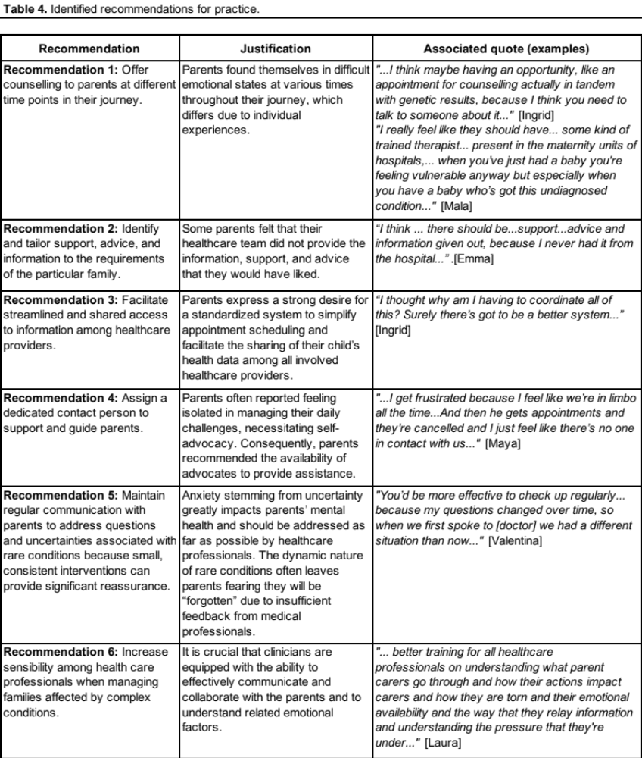
These recommendations were also grounded in the themes identified through our analysis and reflect the societal and organisational challenges described by parents. They address key areas such as ununified care pathways, lack of emotional and psychological support, poor communication from professionals, and the burden of navigating complex systems. By highlighting these systemic issues, the recommendations aim to inform more responsive, coordinated, and compassionate care practices that recognise and address the broader structural barriers impacting families. It is important to situate parental distress as highlighted throughout the central organising theme’s narrative within a wider systems context — by highlighting societal gaps such as insufficient support services reflected in parents’ recommendations, and prevailing societal attitudes that exclude or marginalize those families coping with disabilities. Labels or specific attributes (e.g. “hero(ine)”) may further skew societal perceptions of challenges families face, hindering the implementation of much needed support services.

Discussion
Summary
The central organising concept "The Construction Of A Caregiver Identity: Torn Between Being A ‘Hero(ine)’ And Being A Parent” encompasses parents’ reconceptualization of their role in the context of caring for a child with a rare and undiagnosed disease. Becoming the ”hero(ine)” enables parents to recover a sense of purpose borne from a perceived identify crisis around what it means to be a parent or caregiver in the context of parenting a child with a rare and undiagnosed condition. At the same time, it also confers ‘moral value’ both internally in how one sees oneself, as well as externally in the ‘eyes of the world’. Feeling consumed at times by the challenges of caregiving, parents are placed in a stressful, yet vulnerable state. Rather than giving in to intrusive or negative thoughts, we propose that parents, and mothers in particular, find it helpful to adopt the ‘heroic’ persona as a psychological defense mechanism against societal expectations and the challenges they face. This study also highlights the negative impact of anxiety related to uncertainty and isolation on parents’ mental health. The interviewed parents offered novel perspectives on family and relationship dynamics, providing intriguing psychological insights at a unique timepoint during the “diagnostic odyssey”, as parents await WGS results for their child.

Application to Mental Health Research and Theory
Parents finding themselves in the role of a caregiver report a spectrum of emotions as they navigate the ambiguous process of redefining their identity. Many of our findings resonate with those highlighted in a recent review (19). These include: shock (40), which evolves into pervasive anxiety for the entire family due to uncertainties surrounding their child’s condition (41), feelings of frustration as they struggle with the loss of anticipated parenthood (42), renewed hope while awaiting results from genomic testing (17), and a desire for information about their child’s condition (15). Interviewed parents experienced emotional exhaustion as a result of the intensity of caring for their child, which in turn can undermine confidence in their parenting abilities. This is contrasted by the need to “portray” emotional stability, or even a “heroic” role, as exemplified in the super-human narrative explored in the analysis.

Parent caregivers are increasingly depicted as heroes in both media and research to make their efforts “visible” (43–46). This portrayal may motivate parents to embrace the “heroic” role for recognition, but it can also exacerbate their isolation as society places more responsibility on them, as recently discussed in a report by Care Alliance Ireland (47). Our findings shed new light on this scarcely investigated phenomenon among parent caregivers. The “heroic” role places the normative task of parenting into a super-human context due to the challenges of caring for a child with a rare disease. This often leads to parents feeling, or even desiring, isolation, as expressed in this study. The feeling of isolation may be particularly heightened in mothers who experience a disrupted narrative of “typical” motherhood, e.g. due to the behavioural differences of neurodiverse children (48).

Referring to the “The Caregiver Model” by Montgomery et al (49), initially developed for geriatric family caregiving, caregiving is seen as a dynamic process. It progresses from existing familial roles through several phases, culminating in an almost full caregiver identity, until they receive external support which reduces the workload, and the original identity becomes more prominent again. Loss of identity due to “engulfment” in the caregiver role was reported to be more common among female caregivers in the geriatric setting (50).

Our proposal differs in that parents in this cohort may never achieve “full” transition (see Figure 2). Consequently, psychological counselling should aim to assist parents in accepting this ongoing emotional state. The significant distinction from Montgomery’s model is articulated in theme 4: parents perceive a lifelong obligation to care for their child, unlike Montgomery’s final phase, where the caregiver experiences relief when the care recipient moves to a different setting such as a nursing home (49). Similar caregiver models for children with disabilities and elderly people (51), or specifically caring for a child with a rare disease (52) have been proposed without consensus so far. The proposed model contributes to the discussion by emphasizing the dynamic emotional processes linked to the evolving and unpredictable nature of a child’s condition over time. Unlike Gómez-Zúñiga and colleagues (52), this model does not delineate distinct pathways that parents follow in reconceptualizing their identity; instead, our model highlights the turbulent process of identity development for caregivers of children with undiagnosed and rare conditions.

Implications for Psychological Counselling and Health Care Services
The present findings highlight areas for psychological intervention to better address parents’ mental health needs in the context of caring for a child with a rare and undiagnosed condition. Whilst some of the negative experiences described by parents likely relate to service issues such as long turnaround times for receiving genomic results or long waiting times for appointments, psychological interventions rooted in communication practices and training to improve awareness amongst the workforce is also likely to have a positive impact. This is highlighted by recent research by Genetic Alliance UK which indicates a need to improve the adequacy of professional psychological support (53). Identifying and understanding the mental health of caregivers in general is crucial, particularly as significant changes occur during the transition to unpaid caregiving, especially for those living with the care recipient (54).

In a time-constrained clinical setting, screening tools may help identify parents in need of emotional support (55). However, these tools often do not account for the dynamic nature of mental health in parents caring for a child with a rare and undiagnosed condition. Therefore, we recommend the regular application of these measures, if used, rather than a “one and done” approach. Additionally, these measures may only provide a partial view of parents’ emotional well-being. The pressure to appear “heroic” can lead to overlooked needs, as we found in this study. Long-term psychological guidance in multiple sessions from the moment parents embark the “diagnostic odyssey”, before receiving a diagnosis, may be required, not only at the time of diagnosis as highlighted in previous research (56). Our recommendations 1, 2, and 6 align with recent suggestions from Rareminds UK, specifically that families need access to support at various time points during “the rare disease journey to help address family dynamics and personal life choices”. Additionally, as our results on relationship dynamics similarly suggest, Rareminds advocates the need for support to help couples and families manage the impact of rare conditions on personal relationships (57).

The UK Government is actively pursuing recommendation 6 through mental health awareness training for healthcare professionals, facilitated by workforce education initiatives such as webinars and resources developed with patient input within the National Genomics Education platform. Additionally, NHS England’s service specifications for patients with rare diseases now mandate the consideration of users’ psychosocial needs and the implementation of coordinated pathways for accessing mental health support, as outlined in the “England Rare Diseases Action Plan 2024” (58).

Suggested Recommendations 3, 4 and 5 will further help inform health care policy makers on designing future strategies. Genetic Alliance UK has proposed practical steps for Recommendations 3 and 4, they advocate for the establishment of unified communication pathways like “Team Around the Child” meetings and agreed-upon care plans to potentially mitigate financial barriers (59), at the same time highlighting the necessity of investigating economic risks. The UK Government has committed to investing £2.3 billion in additional funding to expand and enhance mental health services across England, aiming to provide essential mental health support to an additional 2 million people, including those with rare conditions (60).

Lastly, our findings may contribute to the discussion of defining and understanding the term “family caregiver”, relating to a recent update on a discussion led by Care Alliance Ireland, who acknowledged the variability of the term across sectors, with its meaning and impact varying by context (11). This discussion has important implications for policy making and conducting research providing comparable methodology.

Strength and Limitations
A key strength of this research is that thematic power was reached in terms of adequate depth of understanding to meet the study aims, in line with recommendations by Braun and Clarke (33). Another strength is that we were able to involve a particularly vulnerable group of parents who are struggling with their mental health, as reflected by the questionnaire results, and are often overlooked in the rare disease literature, and that they given the opportunity to share their experiences and have their story heard for the purposes of this study.

We purposively sampled parents with medium to high anxiety as well as parents who had lower health-related quality of life and family functioning and/or lower resilience, so our participants were experiencing mental health challenges more acutely compared with those who were less anxious and/or had higher quality of life, family functioning and/or higher resilience. Our findings therefore need to be interpreted as reflecting a very particular group of parents at a particular timepoint (undergoing WGS). Given that most children in the study had developmental delay, our findings may not be generalisable to parents of children with other rare conditions. Additionally, since most parents reported that their child's condition had a significant impact on them, the results may not be applicable to parents of less severely affected children. For instance, results from a quantitative meta-analysis demonstrated that parents of children affected by autism spectrum disorders experience significantly more stress than parents of children with other disabilities (61).

The majority of participants in this study were white British, highlighting the need for further research involving ethnic minority groups to determine if the findings are generalizable. In our sample, 32.1% (n = 17) of the 53 white British individuals invited to participate agreed to be interviewed. Among the 11 Asian or Asian British individuals invited, 45.5% (n = 5) agreed to participate, while none of the 4 Black or Black British individuals contacted chose to participate, highlighting the importance of further work with this group in particular. Shea et al. (62) found that amongst African Americans, factors such as limited awareness of research participation opportunities and mistrust of clinical research played a major role in why they were underrepresented in research.

Furthermore, only four fathers agreed to participate, perhaps reflecting known gender inequalities in family caregiving as also reported in this study. Based on our sampling criteria for poor mental health, fathers tended to score lower on the scales employed in this study. Consequently, only a limited number of fathers were invited to participate, nonetheless we also found that these fathers were less responsive to our interview invites. This outcome may relate to the perceived lower emotional burden experienced by fathers, as suggested by our findings. These results align with a report of fathers that exhibit lower levels of emotional distress compared to mothers, particularly in the context of depression and anxiety (3). It is not possible to make general statements about caregiving and fatherhood based on such a small sample.

Conclusion
In conclusion, recognising caregivers as “hero(ine)s” increases emotional pressure on parents. This study highlights the complexity associated with the emotional wellbeing and mental health impact of parenting a child with an undiagnosed and rare condition, in particular amongst parents who may be coping less well. This group of parents may benefit from psychological support at various time points, warranting further research on when and how this might most effectively be delivered. Additionally, it raises the question of whether returning WGS results and improving current health-care services could alleviate the burden of uncertainty and increase parents’ emotional wellbeing, a major factor contributing to poor mental health, which could be explored in future follow-up interviews.

List of abbreviations
BRS Brief Resilience Scale
GAD-7 General Anxiety Disorder 7
GMS Genomic Medicine Service
NHS National Health Service
PPI Patient and public involvement
PED-QL Pediatric Quality of Life Questionnaire
(W)GS (whole) genome sequencing

Declarations

Ethics approval and consent to participate

This study was reviewed and gained approval by the NHS Research Ethics Committee [London - Bloomsbury Research Ethics Committee, REC reference: 21/PR/0678]. An amendment was submitted to include my name and CV on the research ethics.

Parents who wished to participate received a participant information sheet about the study, and gave consent to take part in the study including for the interview to be audio-recorded and transcribed.

The option of speaking to a trained psychotherapist from Rareminds was provided to any participant who was adversely affected from taking part in the interview, with referral organized by the interviewer. It was communicated to the interviewee that they could stop or withdraw from the study at any time. The debriefing process for the interviewing researcher included regular fortnightly meetings with the PI, CL, to discuss the interview experience (de-briefing discussions).

Consent for publication

Parents agreed that data can be published after removing identifying feature and anonymisation. All authors agreed with this manuscript to be published.

Clinical Trial Number

Not applicable

Availability of data and materials

The qualitative data from this study, consisting of anonymized interview transcripts, are not publicly available due to the sensitive nature of the topics discussed and participant consent agreements. However, excerpts of transcripts relevant to the study findings can be shared upon reasonable request to the corresponding author.

Competing interests

None of the authors have any competing interests to disclose.

Funding

This research is funded through an NIHR Advanced Fellowship Grant (NIHR300099), awarded to Celine Lewis. The views expressed are those of the author(s) and not necessarily those of the NIHR or the Department of Health and Social Care.

Acknowledgements

We would like to thank Kym Winter and Lauren Roberts from Rareminds UK and the PPI group involved in the project for their invaluable insights, shared expertise and comments on the draft, which have significantly guided our work.

Authors' contributions

1) Conceptualisation: Celine Lewis, Bettina Friedrich; 2) Data curation: all; 3) Formal analysis: Tara Maria Hoffmann; 4) Funding acquisition: Celine Lewis; 5) Data aquisition: Bettina Friedrich, Tara Maria Hoffmann; 6) Writing original draft: Tara Maria Hoffmann; 7) Review & editing: Celine Lewis, Bettina Friedrich

References
1. Yan X, He S, Dong D. Determining How Far an Adult Rare Disease Patient Needs to Travel for a Definitive Diagnosis: A Cross-Sectional Examination of the 2018 National Rare Disease Survey in China. International Journal of Environmental Research and Public Health. 2020 Jan;17(5):1757.
2. Malm-Buatsi E, Aston CE, Ryan J, Tao Y, Palmer BW, Kropp BP, et al. Mental health and parenting characteristics of caregivers of children with spina bifida. J Pediatr Urol. 2015 Apr;11(2):65.e1-7.
3. van Oers HA, Haverman L, Limperg PF, van Dijk-Lokkart EM, Maurice-Stam H, Grootenhuis MA. Anxiety and depression in mothers and fathers of a chronically ill child. Matern Child Health J. 2014 Oct;18(8):1993–2002.
4. Boettcher J, Boettcher M, Wiegand-Grefe S, Zapf H. Being the Pillar for Children with Rare Diseases-A Systematic Review on Parental Quality of Life. Int J Environ Res Public Health. 2021 May 8;18(9):4993.
5. Spencer-Tansley R, Meade N, Ali F, Simpson A, Hunter A. Mental health care for rare disease in the UK – recommendations from a quantitative survey and multi-stakeholder workshop. BMC Health Serv Res. 2022 May 14;22:648.
6. Witt S, Schuett K, Wiegand-Grefe S, Boettcher J, Quitmann J. Living with a rare disease - experiences and needs in pediatric patients and their parents. Orphanet J Rare Dis. 2023 Aug 11;18:242.
7. Anderson M, Elliott EJ, Zurynski YA. Australian families living with rare disease: experiences of diagnosis, health services use and needs for psychosocial support. Orphanet J Rare Dis. 2013 Feb 11;8:22.
8. Baumbusch J, Mayer S, Sloan-Yip I. Alone in a Crowd? Parents of Children with Rare Diseases’ Experiences of Navigating the Healthcare System. Journal of Genetic Counseling. 2019;28(1):80–90.
9. Doebler S, Ryan A, Shortall S, Maguire A. Informal care-giving and mental ill-health - differential relationships by workload, gender, age and area-remoteness in a UK region. Health Soc Care Community. 2017 May;25(3):987–99.
10. Henderson J. ‘He’s not my carer—he’s my husband’: Personal and policy constructions of care in mental health. Journal of Social Work Practice. 2001 Nov;15(2):149–59.
11. Hughes Z. Defining Carers: Update June 2022. 2022 June [cited 2024 May 7]; Available from: https://www.lenus.ie/handle/10147/634324
12. 100,000 Genomes Project Pilot Investigators, Smedley D, Smith KR, Martin A, Thomas EA, McDonagh EM, et al. 100,000 Genomes Pilot on Rare-Disease Diagnosis in Health Care - Preliminary Report. N Engl J Med. 2021 Nov 11;385(20):1868–80.
13. NHS England » National genomic test directory [Internet]. [cited 2024 May 10]. Available from: https://www.england.nhs.uk/publication/national-genomic-test-directories/
14. Nurchis MC, Altamura G, Riccardi MT, Radio FC, Chillemi G, Bertini ES, et al. Whole genome sequencing diagnostic yield for paediatric patients with suspected genetic disorders: systematic review, meta-analysis, and GRADE assessment. Archives of Public Health. 2023 May 25;81(1):93.
15. Pelentsov LJ, Laws TA, Esterman AJ. The supportive care needs of parents caring for a child with a rare disease: A scoping review. Disabil Health J. 2015 Oct;8(4):475–91.
16. Peter M, Hammond J, Sanderson SC, Gurasashvili J, Hunter A, Searle B, et al. Participant experiences of genome sequencing for rare diseases in the 100,000 Genomes Project: a mixed methods study. Eur J Hum Genet. 2022 May;30(5):604–10.
17. Gurasashvili J, Silverio SA, Hill M, Peter M, Stafford-Smith B, Lewis C. The disequilibrium of hope: A grounded theory analysis of parents’ experiences of receiving a ‘no primary finding’ result from genome sequencing. J Genet Couns. 2024 Oct;33(5):1089–102.
18. Callahan KP, Mueller R, Flibotte J, Largent EA, Feudtner C. Measures of Utility Among Studies of Genomic Medicine for Critically Ill Infants. JAMA Netw Open. 2022 Aug 10;5(8):e2225980.
19. von der Lippe C, Neteland I, Feragen KB. Children with a rare congenital genetic disorder: a systematic review of parent experiences. Orphanet Journal of Rare Diseases. 2022 Oct 17;17(1):375.
20. Lewis C, Buchanan J, Clarke A, Clement E, Friedrich B, Hastings-Ward J, et al. Mixed-methods evaluation of the NHS Genomic Medicine Service for paediatric rare diseases: study protocol. NIHR Open Res. 2021;1:23.
21. Burgess RG. In the Field: An Introduction to Field Research. London: Routledge; 1984. 272 p.
22. Spitzer RL, Kroenke K, Williams JBW, Löwe B. A brief measure for assessing generalized anxiety disorder: the GAD-7. Arch Intern Med. 2006 May 22;166(10):1092–7.
23. Varni JW, Sherman SA, Burwinkle TM, Dickinson PE, Dixon P. The PedsQLTM Family Impact Module: Preliminary reliability and validity. Health Qual Life Outcomes. 2004 Sept 27;2:55.
24. Smith BW, Dalen J, Wiggins K, Tooley E, Christopher P, Bernard J. The brief resilience scale: assessing the ability to bounce back. Int J Behav Med. 2008;15(3):194–200.
25. List of ethnic groups [Internet]. [cited 2025 July 24]. Available from: https://www.ethnicity-facts-figures.service.gov.uk/style-guide/ethnic-groups/
26. Editor DU. Diversity UK. 2023 [cited 2024 Apr 12]. Census 2021 data reveals ethnic make up of UK population. Available from: https://diversityuk.org/census-2021-data-reveals-ethnic-make-up-of-uk-population/
27. Heuyer T, Pavan S, Vicard C. The health and life path of rare disease patients: results of the 2015 French barometer. Patient Relat Outcome Meas. 2017;8:97–110.
28. Boettcher J, Denecke J, Barkmann C, Wiegand-Grefe S. Quality of Life and Mental Health in Mothers and Fathers Caring for Children and Adolescents with Rare Diseases Requiring Long-Term Mechanical Ventilation. Int J Environ Res Public Health. 2020 Dec 2;17(23):8975.
29. Pinquart M. Parenting stress in caregivers of children with chronic physical condition-A meta-analysis. Stress Health. 2018 Apr;34(2):197–207.
30. Pinquart M. Posttraumatic Stress Symptoms and Disorders in Children and Adolescents with Chronic Physical Illnesses: a Meta-Analysis. J Child Adolesc Trauma. 2020 Mar;13(1):1–10.
31. About Us - Rareminds [Internet]. 2020 [cited 2024 June 26]. Available from: https://www.rareminds.org/about-us/
32. Braun V, Clarke V. To saturate or not to saturate? Questioning data saturation as a useful concept for thematic analysis and sample-size rationales. Qualitative Research in Sport, Exercise and Health. 2021 Mar 4;13(2):201–16.
33. Braun V, Clarke V. One size fits all? What counts as quality practice in (reflexive) thematic analysis? Qualitative Research in Psychology. 2021 July 3;18(3):328–52.
34. Braun V, Clarke V. Reflecting on reflexive thematic analysis. Qualitative Research in Sport, Exercise and Health. 2019 Aug 8;11(4):589–97.
35. Braun V, Clarke V. Using thematic analysis in psychology. Qualitative Research in Psychology. 2006 Jan 1;3(2):77–101.
36. Stenbacka C. Qualitative research requires quality concepts of its own. Management Decision. 2001 Jan 1;39(7):551–6.
37. E.Howell K. An Introduction to the Philosophy of Methodology [Internet]. SAGE Publications Ltd; 2013 [cited 2024 July 24]. Available from: https://methods.sagepub.com/book/an-introduction-to-the-philosophy-of-methodology
38. Braun V, Clarke V. Successful Qualitative Research: A Practical Guide for Beginners. SAGE; 2013. 402 p.
39. Berger R. Now I see it, now I don’t: researcher’s position and reflexivity in qualitative research. Qualitative Research. 2015 Apr 1;15(2):219–34.
40. Somanadhan S, Larkin PJ. Parents’ experiences of living with, and caring for children, adolescents and young adults with Mucopolysaccharidosis (MPS). Orphanet Journal of Rare Diseases. 2016 Oct 10;11(1):138.
41. Carmichael N, Tsipis J, Windmueller G, Mandel L, Estrella E. “Is it Going to Hurt?”: The Impact of the Diagnostic Odyssey on Children and Their Families. Journal of Genetic Counseling. 2015;24(2):325–35.
42. Myrin Westesson L, Sparud-Lundin C, Wallengren C, Baghaei F. A tortuous route to a capable fatherhood: the experience of being a father to a child with severe haemophilia. Haemophilia. 2015 Nov;21(6):799–805.
43. Nygård C, Clancy A. Unsung heroes, flying blind—A metasynthesis of parents’ experiences of caring for children with special health-care needs at home. Journal of Clinical Nursing. 2018;27(15–16):3179–96.
44. Sandler I, Gaffney D. Parents and Caregivers: The Everyday Heroes Behind Superheroes. In: Superhero Grief. Routledge; 2020.
45. Scaccia J. This Week In Public Health. 2024 [cited 2024 July 3]. Unseen Heroes: Caregivers of Rare Disease Patients. Available from: https://thisweekinpublichealth.com/blog/2024/06/27/unseen-heroes-caregivers-of-rare-disease-patients/
46. Standing out in the storm: Caregiving in rare disease [Internet]. [cited 2024 July 3]. Available from: https://www.science.org/content/webinar/standing-out-storm-caregiving-rare-disease
47. Care Alliance Ireland. Family Carers and Being A Hero. December 2022. CAI_DiscussionPaper12_FamilyCarersAsHeroes.pdf [Internet]. [cited 2024 Jul 3]. Available from:https://www.carealliance.ie/userfiles/files/CAI_DiscussionPaper12_FamilyCarersAsHeroes.pdf
48. Carpenter L, Austin H. Silenced, Silence, Silent: Motherhood in the Margins. Qualitative Inquiry. 2007 July 1;13(5):660–74.
49. Montgomery RJV, Kosloski KD. Pathways to a Caregiver Identity and Implications for Support Services. In: Talley RC, Montgomery RJV, editors. Caregiving Across the Lifespan: Research • Practice • Policy [Internet]. New York, NY: Springer; 2013 [cited 2024 July 20]. p. 131–56. Available from: https://doi.org/10.1007/978-1-4614-5553-0_8
50. Skaff MM, Pearlin LI. Caregiving: Role Engulfment and the Loss of Self1. The Gerontologist. 1992 Oct 1;32(5):656–64.
51. Raina P, O’Donnell M, Schwellnus H, Rosenbaum P, King G, Brehaut J, et al. Caregiving process and caregiver burden: Conceptual models to guide research and practice. BMC Pediatrics. 2004 Jan 14;4(1):1.
52. Gómez-Zúñiga B, Pulido R, Pousada M, Armayones M. The Role of Parent/Caregiver with Children Affected by Rare Diseases: Navigating between Love and Fear. Int J Environ Res Public Health. 2021 Apr 2;18(7):3724.
53. The Policy Team at Genetic Alliance UK. The Coordinating Care Report. Genetic Alliance UK [Internet]. 2023 Feb 28 [cited 2025 July 20]; Available from: https://geneticalliance.org.uk/wp-content/uploads/2024/01/Coordinating-Care-Report-2023.pdf
54. Lacey RE, Xue B, Gessa GD, Lu W, McMunn A. Mental and physical health changes around transitions into unpaid caregiving in the UK: a longitudinal, propensity score analysis. The Lancet Public Health. 2024 Jan 1;9(1):e16–25.
55. Pelentsov LJ, Fielder AL, Laws TA, Esterman AJ. Development of the parental needs scale for rare diseases: a tool for measuring the supportive care needs of parents caring for a child with a rare disease. J Multidiscip Healthc. 2016 Sept 9;9:425–33.
56. Kenny T, Bogart K, Freedman A, Garthwaite C, Henley S, Bolz-Johnson M, et al. The importance of psychological support for parents and caregivers of children with a rare disease at diagnosis. Rare Dis Orphan Drugs J. 2022;1(1):7.
57. Raremind. Rare Disease & Mental Health 2023 Survey Results. May 2024. RaremindsMatterSurveyReport.pdf [Internet]. [cited 2024 Jul 3]. Available from: https://www.rareminds.org/wpcontent/uploads/2024/04/RaremindsMatterSurveyReport.pdf
58. GOV.UK [Internet]. 2024 [cited 2025 July 25]. England Rare Diseases Action Plan 2024. Available from: https://www.gov.uk/government/publications/england-rare-diseases-action-plan-2024
59. Walton H, Hudson E, Simpson A, Ramsay AIG, Kai J, Morris S, et al. Defining Coordinated Care for People with Rare Conditions: A Scoping Review. Int J Integr Care. 2020 June 25;20(2):14.
60. GOV.UK [Internet]. [cited 2025 July 25]. Mental health and wellbeing plan: discussion paper. Available from: https://www.gov.uk/government/calls-for-evidence/mental-health-and-wellbeing-plan-discussion-paper-and-call-for-evidence/mental-health-and-wellbeing-plan-discussion-paper
61. Hayes SA, Watson SL. The impact of parenting stress: a meta-analysis of studies comparing the experience of parenting stress in parents of children with and without autism spectrum disorder. J Autism Dev Disord. 2013 Mar;43(3):629–42.
62. Shea L, Pesa J, Geonnotti G, Powell V, Kahn C, Peters W. Improving diversity in study participation: Patient perspectives on barriers, racial differences and the role of communities. Health Expectations. 2022 Aug;25(4):1979–87.

