Supporting Information
Table

Table S1. Notations in the 76 lifespan scenarios average of residential buildings
Lifespan change | Notation of each scenario
$-25$ year | $$k=1$$
$-24$ year | $$k=2$$
$-23$ year | $$k=3$$
$-22$ year | $$k=4$$
$-21$ year | $$k=5$$
$-20$ year | $$k=6$$
$-19$ year | $$k=7$$
$-18$ year | $$k=8$$
$-17$ year | $$k=9$$
$-16$ year | $$k=10$$
$-15$ year | $$k=11$$
$-14$ year | $$k=12$$
$-13$ year | $$k=13$$
$-12$ year | $$k=14$$
$-11$ year | $$k=15$$
$-10$ year | $$k=16$$
$-9$ year | $$k=17$$
$-8$ year | $$k=18$$
$-7$ year | $$k=19$$
$-6$ year | $$k=20$$
$-5$ year | $$k=21$$
$-4$ year | $$k=22$$
$-3$ year | $$k=23$$
$-2$ year | $$k=24$$
$-1$ year | $$k=25$$
No change | $$k=26$$
$+1$ year | $$k=27$$
$+2$ year | $$k=28$$
$+3$ year | $$k=29$$
$+4$ year | $$k=30$$
$+5$ year | $$k=31$$
$+6$ year | $$k=32$$
$+7$ year | $$k=33$$
$+8$ year | $$k=34$$
$+9$ year | $$k=35$$
$+10$ year | $$k=36$$
$+11$ year | $$k=37$$
$+12$ year | $$k=38$$
$+13$ year | $$k=39$$
$+14$ year | $$k=40$$
$+15$ year | $$k=41$$
$+16$ year | $$k=42$$
$+17$ year | $$k=43$$
$+18$ year | $$k=44$$
$+19$ year | $$k=45$$
$+20$ year | $$k=46$$
$+21$ year | $$k=47$$
$+22$ year | $$k=48$$
$+23$ year | $$k=49$$
$+24$ year | $$k=50$$
$+25$ year | $$k=51$$
$+26$ year | $$k=52$$
$+27$ year | $$k=53$$
$+28$ year | $$k=54$$
$+29$ year | $$k=55$$
$+30$ year | $$k=56$$
$+31$ year | $$k=57$$
$+32$ year | $$k=58$$
$+33$ year | $$k=59$$
$+34$ year | $$k=60$$
$+35$ year | $$k=61$$
$+36$ year | $$k=62$$
$+37$ year | $$k=63$$
$+38$ year | $$k=64$$
$+39$ year | $$k=65$$
$+40$ year | $$k=66$$
$+41$ year | $$k=67$$
$+42$ year | $$k=68$$
$+43$ year | $$k=69$$
$+44$ year | $$k=70$$
$+45$ year | $$k=71$$
$+46$ year | $$k=72$$
$+47$ year | $$k=73$$
$+48$ year | $$k=74$$
$+49$ year | $$k=75$$
$+50$ year | $$k=76$$

Figures
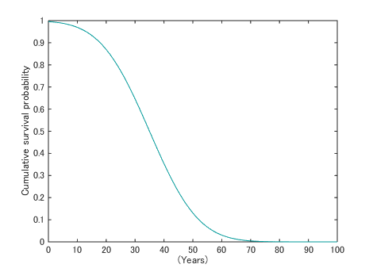
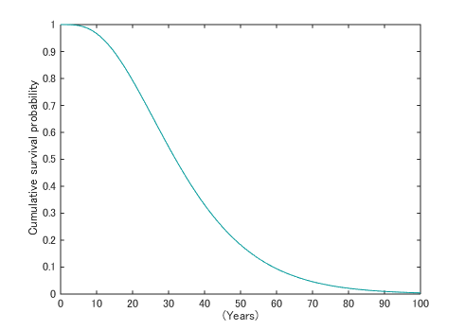
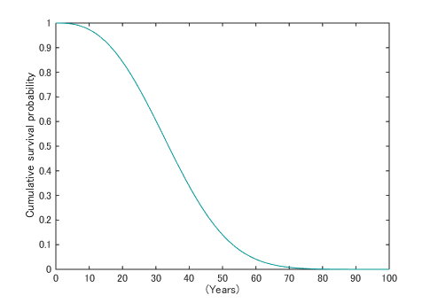
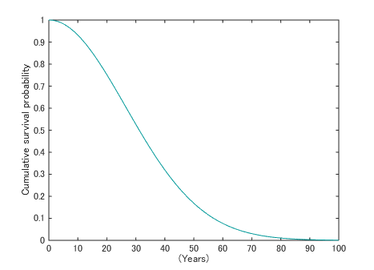
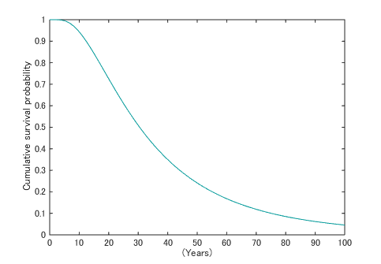
e)
c)
d)
b)
a)

Figure S1. Cumulative survival probability distribution curves for detached residential buildings in Japan, based on five lifetime distribution probability densities: a) normal distribution, b) gamma distribution, c) Weibull distribution, d) Rayleigh distribution, and e) log-normal distribution.

